Accounting Fundamentals
LCBB4001
Name: Veaceslav Stanciu
Student ID :2131027
University: University of Wales Trinity Saint David
Course Name: Business Management
Module Name: Accounting Fundamentals

Table of content
Introduction 3
Question 1 3
a) Prepare an income statement for the year ended 31st December 2022 for Wales plc and a statement of financial position as of that date? 3
b) Why does the statement of financial position balance? 6
Question 2 6
a. Calculate the following ratios for Sweet's plc for 2021 and 2020, showing the formulas and workings: 6
b. Using the information in the financial statements and the ratios you have calculated, comment on the financial performance and position of Sweet's plc. 12
Conclusion 12
Reference 13

Introduction
The purpose of the report is to prepare the income statement and balance sheet for the year ended 31st December 2022 for Wales plc. Income statements are disclosed by every company to get information about the revenue incurred through the business transaction for a particular period. Further, this report deals with the preparation of the Balance Sheet for Wales plc and the motivation of preparing it to know the financial position of the business and it is very helpful in comparing the result with the previous year's balance sheet. After that, the reason will be provided for why the balance sheet is tallied. Further, the report deals in the calculation of several ratios through which liquidity, profitability, and efficiency of the business organisation can be concluded.

Question 1

a) Prepare an income statement for the year ended 31st December 2022 for Wales plc and a statement of financial position as of that date?
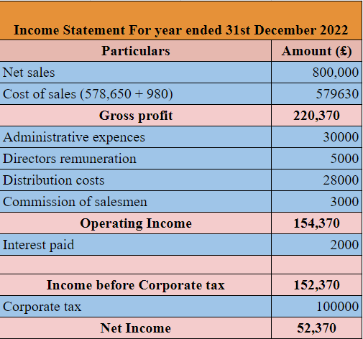
Figure 1: Income Statement for the year ended 31st December 2022
Source: (Self-Developed, 2023)
Income statements are prepared by the company to reveal its revenue, profits, and expenses related to a particular period. In order words the income statement of the business organisation provides the overall picture of the business organisation of a particular period. Income statements need to be disclosed by every business organisation publicly as it provides information about the revenue generated during the particular year which could be beneficial for investors in decision-making. Income statements also provide information about the cost associated to regenerate the target sales. Through income statements, the business owner can decide whether the combination of lowering the expenditure, growth of revenue, or both will lead to profit or not (studysmarter, 2023). The above figure shows the income statement of Wales plc for the year ended 31 December 2022 the net sales of the company are £800000 after deducting the cost of goods sold of £579630 which gives the gross profit of £220370. After deducting the operating expenses from the Gross profit gives the operating income of £154370 further deducting the interest and tax the company generates the Net Income of £52370. As the company generates positive net income the information concluded that the company is profit-making.
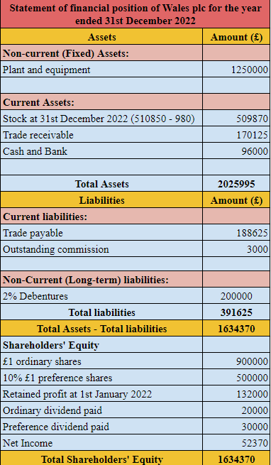
Figure 2: Statement of Financial Position
Source: (Self-Developed, 2023).
A statement of financial position is also known as the Balance Sheet. It is used to show the financial position of the business organisation at a particular point in time with the summary of the business equity, liabilities, and assets (Campion, 2022). The above shows the balance sheet of Wales plc for the year ended 31 December 2022 which reflects the Assets, liabilities, and equity of the business organisation. As per the balance sheet, the company has worth of £ 2025995 total assets along with a total liability worth £391625. The balance sheet reflects the total shareholder's equity of £1634370.

b) Why does the statement of financial position balance?
The main reason behind balancing the statement of financial position is following the concept of the double-entry accounting principle. As per this accounting principle, all transactions are recorded in two different accounts which makes sure the entries are consistent. It is called double entry as it always records every transaction on the debit as well as credit side. This accounting system is undertaken by any business organisation as it makes understanding all the transactions easy. This makes it easy for the business to keep track of their money and makes sure they do not overspend. As the balance sheet gets balanced due to following double entry accounting principle because:
Double-entry bookkeeping balanced all accounts: A business balanced all its accounts through double-entry bookkeeping as it makes sure that every debit transaction must have a corresponding credit transaction.
Double-entry bookkeeping makes insure having proper capital: It makes it easy to detect the flowing of money in and out of the business which makes it easy to detect any potential problem. It is very helpful in determining the excess flow of cash in the business.
Double-entry bookkeeping helps in detecting missing or double-counted transactions: By checking equations balanced on both sides, double-entry makes sure that no missing or double-counting transactions are being recorded.
Double entry helps in tracking the assets and liabilities: It is difficult to track the assets and the liabilities in case of a growing business. Double entry bookkeeping helps in providing the method of keeping track of assets and liabilities of the business organisation (uk.indeed, 2023).

Question 2

a. Calculate the following ratios for Sweet's plc for 2021 and 2020, showing the formulas and workings:
1- Return on Capital Employed (ROCE)
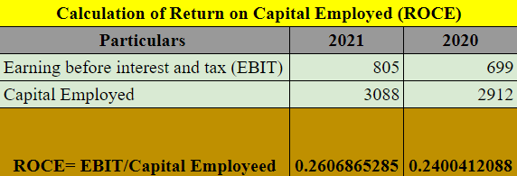
Figure 3: Calculation of Return on Capital Employed
Source: (Self-Developed, 2023).
Return on Capital Employed is the ratio of long-term profitability which is used in measuring the business efficiency in utilising its capital. It can be calculated by using earnings before interest and tax by employed capital. A return on capital employed of 20% is considered to be good. In the above figure, ROCE has been provided by the company for the two years 2021 and 2020 which is 0.2606865285 and 0.2400412088 respectively. It is clearly described that the company has a ROCE of above 20% in both the year which is good and it is increasing in the coming years (ig, 2023).
2- Return on Equity (ROE)
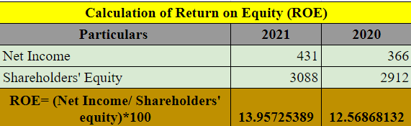
Figure 4: Calculation of Return on Equity
Source: (Self-Developed, 2023).
Return on Equity helps in measuring the performance of the business related to finance. Any company can easily calculate its ROE by dividing its Net Income by shareholders' equity. ROE of between 15-20% are considered to be good and from the above figure, it concluded that in both the year the ROE is less than the recommended cent. So the return on equity is not good for the company (Kornbluth, 2021).
3- Earnings per share
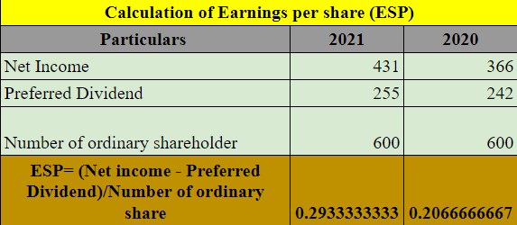
Figure 5: Calculation of Earnings per share.
Source: (Self-Developed, 2023).
It can be defined as a dividend deducted from the net income divided by the number of ordinary shareholders. It can be used in measuring the company's profitability. It serves as the basic tool for the investor in the decision-making of the investment (Martin, 2023).
4- Net profit margin
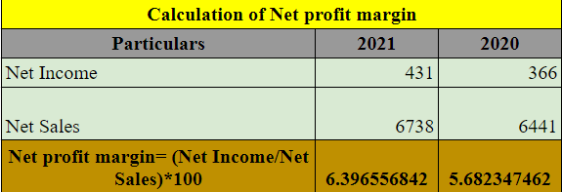
Figure 6: Calculation of Net Profit Margin
Source: (Self-Developed, 2023).
It is part of the profit left after paying off all the expenses related to sales and taxes. It indicates the percentage of profit made in every pound of sales. It can be expressed in terms of percentage by dividing the net income of the company by net sales and then multiplying the result by a hundred. In the above figure, the net profit margin for two years is 5.682347462 and 6.396556842 respectively for the years 2020 and 2021. The net profit margins are increasing in the coming year (bbc, 2023).
5- Asset turnover
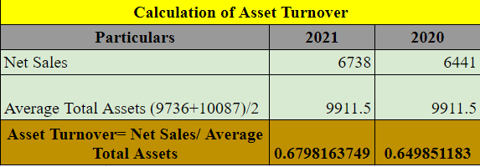
Figure 7: Calculation of Asset Turnover
Source: (Self-Developed, 2023).
Asset turnover ratio helps in understanding the stakeholder the value of revenue the company made about the value of the assets. Through this, the efficiency of the company can be concluded by turning its assets into profits. A high assets turnover ratio indicates the business organisation is more efficient in transforming its asset into profits (uk.indeed, 2023)
6- Stock holding days
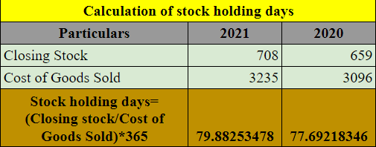
Figure 8: Calculation of Stock holding days
Source: (Self-Developed, 2023).
Stock holding day is the average number of days a business organisation takes to sell its inventory. It helps in showing how efficient the manager of the business is in controlling the inventory of the business. It can be calculated by dividing the closing stock by the cost of goods sold and the resultant will be multiplied by 365 days (Stanley, 2023).
7- Debtors collection period
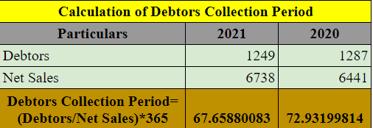
Figure 9: Calculation of Debtors Collection Period
Source: (Self-Developed, 2023).
This is the process of determining the collection period that the company takes to get back the money. It is sometimes called a performance ratio and helps in indicating the efficiency of the business organisation. In other words, it is the time taken by the business organisation in collecting the trade debts. The above figure shows the collection period from the debtors for two years. And it concluded that the number of days is decreasing year after year which shows good efficiency in collecting debts (aibni, 2023)
8- Current ratio
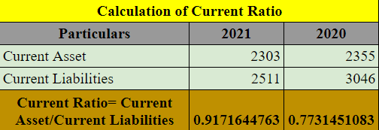
Figure 10: Calculation of Current Ratio
Source: (Self-Developed, 2023).
The current ratio helps a business organisation in comparing its current assets to its current liabilities. It is used in showing the ability of the business in achieving its short-term obligation related to its finance. A current ratio of less than 1 indicates that the business organisation is suffering more to meet its financial requirement. From the above figure it concluded that the business is failing in meeting its financial requirement as its current ratio is less than one (novuna, 2023).
9- Gearing ratio
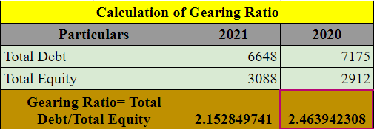
Figure 11: Calculation of Gearing Ratio
Source: (Self-Developed, 2023).
It is a measure which is used by the investor to establish the financial leverage of the business organisation. The optimum gearing ratio lies between 25% to 50%. In the above figure, the gearing ratio in both the year does not fall in the above percentage range which shows that the company is not good at establishing its financial leverage (ig, 2023).
10- Interest cover
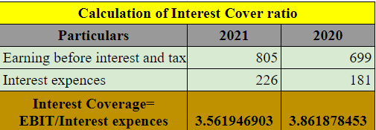
Figure 12: Calculation of Interest Coverage Ratio
Source: (Self-Developed, 2023).
It is also referred to as the interest coverage ratio. It is used to determine the ability of the company to pay the outstanding debts. The interest coverage ratio helps in stating how many times a company is eligible in paying interest with the current level of earnings. From the above figure, it is stated that the company interest coverage ratio is decreasing with the year.

b. Using the information in the financial statements and the ratios you have calculated, comment on the financial performance and position of Sweet's plc.
From the financial statement of Sweet's plc, the information concluded that the net income from the two years 2020 and 2021 are in positive figures. And it has declared a dividend of £255 million in the year 2021 which gives earnings per share of £0.2933. The return of capital employed is 0.266068 of the year 2021 which is more than the previous year. Further, the return on equity for the year 2021 is 13.95 which is more than the last year's 12.56. The company has kept a net profit margin of 6.39% in the current year which indicates that the company is making a profit in its business operation.

Conclusion
From this report, the information concluded that the income statement and balance sheet meet the purpose of analysing the financial position of the business organisation. This helps in deciding in order to achieve growth in the operation of the business. The information through the income statement helps in providing better strategies in case of incurring losses, and it also helps in taking the best decision which leads to the growth of the business organisation. Balance Sheet helps in comparing the financial position of the business with the previous year. It serves as the essential tool in knowing the financial health of the company through which sound decisions can be taken to retain the growth rate and the investor of the business organisation.

Reference
bbc (2023) Net profit margin - business calculations - edexcel - GCSE business revision - edexcel - BBC bitesize, BBC News. BBC. Available at: https://www.bbc.co.uk/bitesize/guides/zd2fpg8/revision/4 (Accessed: April 27, 2023).
Campion, N. (2022) What is a company's statement of financial position?, Quality Formations Blog. Quality Company Formations. Available at: https://www.qualitycompanyformations.co.uk/blog/statement-of-financial-position/ (Accessed: April 27, 2023).
ig (2023) Roce definition, IG. Available at: https://www.ig.com/uk/glossary-trading-terms/roce-definition (Accessed: April 27, 2023).
Kornbluth, H. (2021) Return on equity (ROE) guide - learn how to calculate your Roe, Return on Equity (ROE) Guide - Learn How To Calculate Your ROE. Available at: https:(Accessed: April 27, 2023).
Martin, V. (2023) Earnings per share (EPS) - definition, calculation, formula, Investing.com UK. Available at: https://uk.investing.com/academy/analysis/earnings-per-share-definition/ (Accessed: April 27, 2023).
Stanley, H. (2023) Inventory days on hand: How to calculate and strategies for 2023, Shopify. Available at: https://www.shopify.com/uk/retail/inventory-days-on-hand (Accessed: April 27, 2023).
studysmarter (2023) Income statements, StudySmarter UK. Available at: https://www.studysmarter.co.uk/explanations/business-studies/financial-performance/income-statements/ (Accessed: April 27, 2023).
uk.indeed (2023) What is double entry accounting? (definition plus benefits). Available at: https://uk.indeed.com/career-advice/career-development/double-entry-accounting (Accessed: April 27, 2023).
aibni (2023) Debtor collection period tool, AIB. Available at: https://aibni.co.uk/business/help-and-guidance/debtor-collection-tool (Accessed: April 27, 2023).
novuna (2023) What is current ratio? current ratios explained, Novuna. Available at: https://www.novuna.co.uk/business-cash-flow/cash-flow-finance-resource-hub/finance-terms/current-ratio (Accessed: April 27, 2023).

