Financial Management

Student Name: Sezen Mustanova

Student ID: 2210266
Tutor: Tristan Hawkins

Executive Summary
This report has analysed a comparison between two global brand hotels based on their strategies of marketing, potential barriers and opportunities in the markets based on their unique business features. The overall revenue of the hotels has been explored based on the trends of revenue in current years, revenue development factors and the process that causes the decline of the revenue. This also has discussed the demographics of the consumers, perception of the brand and share of the market that has determined the market position of these hotels. The comparative analysis has also explained the practices of the CSR of these businesses.

Table of Contents
Introduction 4
Comparison of annual revenue 5
Examining revenue of Corinthia Hotels 5
Examining revenue of Ibis hotel 6
Identifying final results 7
Comparison of market position 7
Examining the assets and liabilities of Corinthia Hotel 7
Examining the assets and liabilities of Ibis hotel 9
Identifying final results 10
Discuss the development Potential of the referred Hotels with a comparative analysis of opportunities in the market, strategies to expand and growth barriers 11
Explaining the financial commitments to CSR of the mentioned companies 15
Discussing the financial commitments of Corinthia Hotels 15
Discussing the financial commitments of Ibis Hotels 15
Conclusion and Recommendation 17
Conclusion 17
Recommendations 17
References 18

Introduction
Corinthia Hotel Group is a well reputed hotel chain based in Europe that provides autistic accommodation and food experience to its guests. On the other hand, Ibis hotel chain is also a very popular multinational company that generates high amounts of profitability. Moreover, the comprehensive business report is prepared to highlight the revenue and other trends of both the businesses. Future possibilities of growth and declination will be presented in the report as well. Additionally, the market position of both the business in terms of market share, customer demographics and brand position will be examined in the report. Furthermore, the report will elucidate financial commitment of both the business towards fulfilling corporate social responsibilities of business.

Comparison of annual revenue

Examining revenue of Corinthia Hotels
Corinthia Hotel has secured an annual turnover of £ 238,207 and a net profit of almost £ 2342. In the previous year of 2021, the respective business has secured annual revenue of £ 129,266 and in the year of 2020 due to the pandemic and other restrictions the rate of revenue was almost £ 91,909. In the year of 2019, the rate of total business revenue was almost £ 268,286. Hence, it can be analysed from the below mentioned data that the revenue of the respective business has a very organic growth. However, due to the pandemic, the revenue was decreased at an adverse rate. Moreover, after reviving the loss of the pandemic, the respective business is making enough net profit. Moreover, the future prospects of the respective hotel chain are very much bright as organic growth of business is the main driving factor of potential business growth.
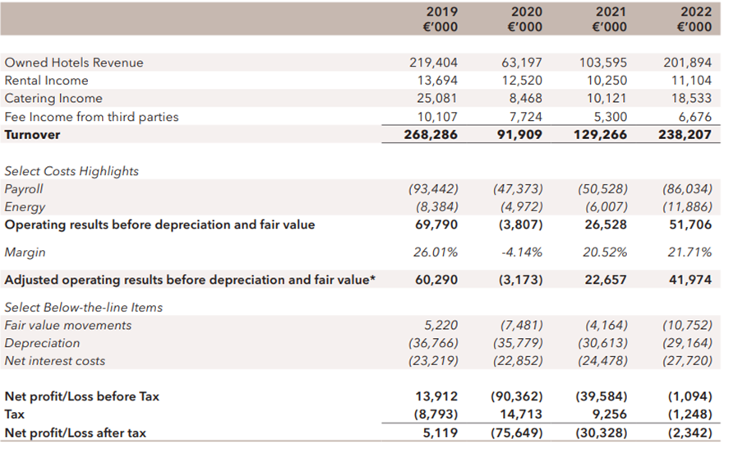
Figure: Total revenue of Corinthia Hotel in different year
Source: (Corinthia Group, 2024)

Examining revenue of Ibis hotel
Ibis hotel is a multinational business that has multiple fully owned subsidiary businesses as well. Hence, appropriate revenue of the total earnings is not available through external sources. However, the official website of the company has stated that the revenue of the respective company in the financial year 2022 was almost £ 308 million (James et al., 2022). Moreover, in the year of 2021 the annual revenue was 151. Hence, it can be analysed that the respective business’s revenue has increased twice within a year. Moreover, it can be examined from the below mentioned data that the growth potential of Ibis hotel chain is very much upwards. In the upcoming years, the revenue of the respective business will increase a lot.
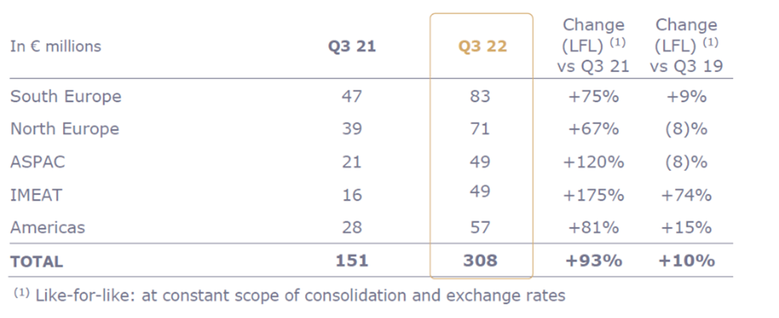Figure: Total revenue of Ibis hotels
Source: (Ibis, 2024)

Identifying final results
After analysing the total revenue trends and growth of both the businesses it can be examined that Ibis has generated more annual revenue than Corinthia Hotel. Marketing strategies, using innovation and digital tools for boosting sales has worked wonderfully for Ibis hotel. Moreover, the comparison has also shed light on the fact that Ibis hotel will provide more returns.

Comparison of market position

Examining the assets and liabilities of Corinthia Hotel
According to research, the existing market share of Corinthia Hotel is almost 0.454 in the year 2023. Additionally, total issued Capital of the respective business is almost €616 million while the total value of assets is €1.7 billion (James et al., 2022). Moreover, the respective business has adjusted its EBITDA to more than €238.2 million the year of 2022. The current market shares of Corinthia Hotel successfully showed that the business has a very good brand perception between the targeted audience. Moreover, reaching the attention of different demographic of consumers has able the respective business to generate a high growth potential.
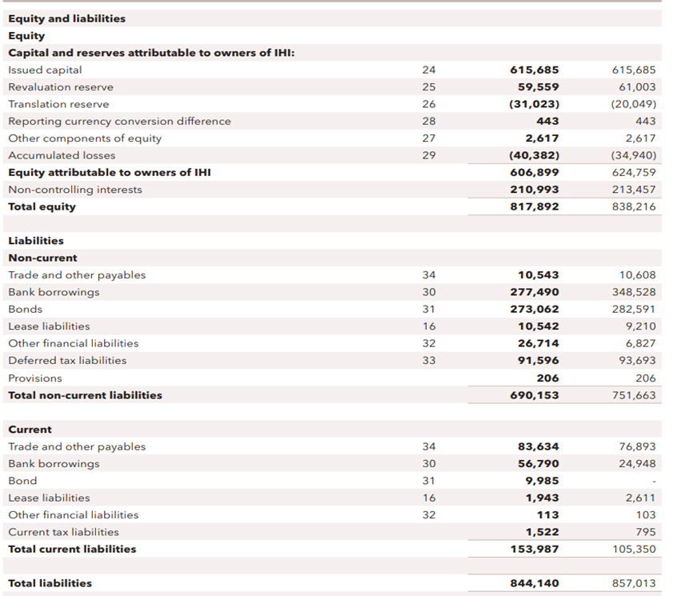
Figure: Market position of Corinthia Hotel
Source: (Corinthia Group, 2024)
As per the above-mentioned calculation. The respective business has total liabilities of £ 844,140 in the year of 2021. In the next year, the respective business was owned and had liabilities of £ 857,013. Hence, the data has successfully showcased that the liabilities of the respective business is huge in comparison to the total percentage of revenue (Mantulenko and Aleshkova, 2020). Furthermore, it can be examined that the respective business is required to buy new assets to enhance its profit rate. At the contemporary time, investing in the shares of the company may not provide good returns as per expectations.

Examining the assets and liabilities of Ibis hotel
Ibis is a very prestigious and profitable hotel chain that is considered as the leaders that have the maximum number of business shares. It indicates that the respective business enjoys its huge amount of profitability itself. It is one of the potential reasons that Ibis is very much successful in running a billion-dollar multinational hotel chain business. The brand positioning of the respective business is huge as well.
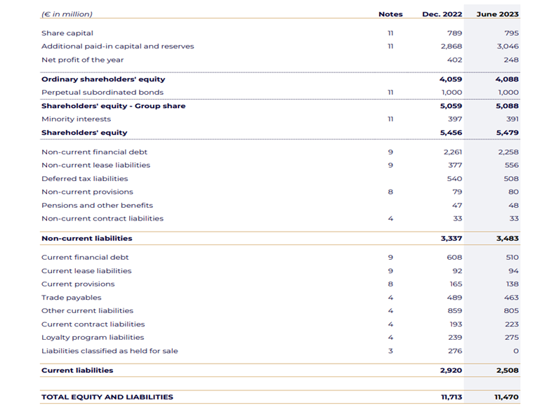
Figure: Financial position of Ibis hotel
Source: (Ibis, 2024)
According to the above-mentioned data, the respective business owns liabilities of £ 11,713 in the year of 2021. In the next year, the amount of business liability for the respective company was almost £ 11470 (Mantulenko and Aleshkova, 2020). Hence, a slight decrease in the amount of liability was captured within a year. Hence, the respective business has a high potential of enhancing future market position. Additionally, adaptation of new digital tools and innovation has able the respective business to smoothen the path of future business success. Furthermore, reaching towards different kinds of demographic audiences has increased financial performance. Hence, the future path of the respective business is very much promising and profitable as well.

Identifying final results
After analysing the trends, assets, liabilities, market position of both the businesses the decision is very much obvious that Ibis has less amount of business liabilities. Additionally, the respective company owns a higher amount of commercial assets as well. Both the business is very successful in identifying its targeted audience. However, Ibis hotel has more possibilities and potential of enhancing financial performance than Corinthia Hotel. Additionally, Ibis hotel owns most of its market share in the respective industry. On the other hand, Corinthia Hotel has less market share in comparison to Ibis. Hence, the final result states that Ibis has more future girth potential.

Discuss the development Potential of the referred Hotels with a comparative analysis of opportunities in the market, strategies to expand and growth barriers
The hotels have appropriate industry features that make both the business grow individually and present individualistic features for developing in the market and other barriers to grow.
Corinthia Hotels
Potential for Development
The business has been recognised as a luxury brand with its outstanding services and accommodation of extravagant features. The development prospect of the business has stressed the international market and luxury and excellence make the brand reputation. The capitalisation of the Corinthia makes the luxury-seeking traveler more attracted to choose this hotel among other luxury brand hotels within the market.
Expansion Strategies
1. Global Expansion: The hotel has multiple opportunities within the new markets like China and Middle East Asian Countries and has travelled a successful journey with an inclination of the luxury brand. The partnership is strategic to make another with based on conglomerate business opportunities with other luxury brands. This can also align with the facilitation of decreasing market risk with mitigation features (Mallia, 2022).
2. Portfolio Diversification: The conventional properties of the hotel includes the luxury hotels’ exploration with Corinthia includes the private villas, travel offerings experiences and diverse preferences of the consumers that enhance the stream of revenues.
3. Brand Partnerships: Proper conglomerate business based on the fashion brand collaboration including the joint business product lines of wellness and cuisine can make the appeal of the brand more unique among visited guests and foster the loyalty of the brand and attract the clientele’s high value (Mallia, 2022).
Market Opportunities
1. Segment of Luxury Travel: The worthiness of the high number of exclusive experiences of the travel can include the opportunity of the segmented market with a significant opportunity that can cater with the discerning travellers of luxury brands (Lagarias et al., 2022).
2. MICE and Corporate Segment: The corporate meeting with the target audience segment including conferences, exhibitions and incentives that are called as MICE includes the revenue drive including the conference business, events of the corporation and retreats of executives.
Growth Barriers in Future
1. High cost for Operation: The luxury standards’ association with Corinthia Hotels can include the costs of operation including amenities, staffing and overall maintenance that includes the profitability and plans for expansion (Lagarias et al., 2022).
2. Market Competition: The luxury hotel’s competition includes the luxury hotel network and boutiques posing challenges that differentiate including the penetration of the market and require the hotels’ stream of revenue and projection growth.
Ibis Hotels
Potential of Growth
The hotel is part of the renowned Accor Group with a segment of mid-range of target budget includes travellers who prefer budget-friendly and quality service with affordable prices of accommodation. The development potential includes the international footprint expansion including diverse segments of the market and the segment of diverse market including digitalisation leveraging process for enhancing the overall experience of the guests.
Strategical Expansion
1. International Expansion: The focus of the Ibis Hotel can be underlined with the emerging market’s presence with a destination of high demand including standardisation of the operational efficiency and new market penetration effectively.
2. Brand Segmentation: The sub-brand concepts include the specific market catering process including the budget of Ibis and give permission to the hotel to make offerings that are diversified and varying the preferences of the consumers for completion of travel with budgets (Bacari et al., 2021).
Market Opportunities
1. Segment of Developing Travel: The budget-consciousness with inclined trends of conscious travelers’ accommodation that includes money value have gained proper opportunity regarding the case of Ibis Hotels and make market emergence with middle-class travellers.
2. Corporate Travelers: The corporate traveller's segment includes within the competitive sales budget including convenient locations for conferences with the rate of occupancy making the hotels of Ibis a business hub for urban business.
Potential Growth Barriers
1. Saturated Market: The segment of mid-range hotels includes the competitiveness with numerous players of the share of the market including the competition intensified process regarding strategies for pricing and requirements for profitability that can differentiate with effective offerings of the hotel (Dumoulin and Giacomel, 2020).
2. Brand Perception: The reputation of the brand is maintained based the standards of the service with proper enormous networks related to property and gain proper loyalty and trust of the consumers. The overall guest experiences’ inconsistency can create hinderance in the brand image.

Explaining the financial commitments to CSR of the mentioned companies

Discussing the financial commitments of Corinthia Hotels
Sustainability practices- Corinthia Hotel takes various initiatives to welcome sustainability. They use LED lights and smart heating systems and give importance to the efficiency of energy. This hotel reduces its water consumption through structured fixtures and decreases waste with recycling programmes (corinthia, 2024). They use seasonal ingredients in their restaurants, which supports nearby communities and helps in reducing carbon footprint.
Community engagement- This hotel is strongly committed to community engagement. They offer local organizations to partner with them and support charitable initiatives and community development projects. Corinthia Hotel actively involves its staff in giving back to the community through various volunteering programmes. In addition, the hotel organises events and fundraisers to bring funds and awareness for various causes.
Ethical business practices- Corinthia Hotel sustains ethical business practices by giving importance to integrity, justice and transparency in all aspects of the operation. They follow strict ethical standards in their day-to-day activity and ensure fair labour practices as well as responsible sourcing. The hotel carries a culture of diversity, fairness and incorporation within its workforce and supports initiatives that encourage social responsibility and ethical conduct in the hospitality industry.

Discussing the financial commitments of Ibis Hotels
Sustainability practices- Ibis Hotels initiates sustainable practices by prioritising energy efficiency, waste reduction and community engagement (accor, 2019). They use certain energy-saving technologies such as LED light and motion sensors to lessen the consumption. Apart from that, the hotel partners with the local community and supports environmental projects to reduce the environmental footprint.
Community engagement- The hotel is committed towards community engagement and promotes relationships with the local organisation. With the help of these partnerships, Ibis Hotel tries to make a meaningful impact on their neighbourhood.
Ethical business practices- Ibis Hotel endorses ethical business by giving importance to honesty, fairness and responsibility in all aspects of its operation (Trisos et al., 2021). They stick to strict ethical standards in their daily activity while ensuring fair labour conditions and responsible sourcing.

Conclusion and Recommendation

Conclusion
The report that has been discussed in the above part has shed light on the comparison that has been made on both the mentioned business entity that is Corinthia Hotel and Ibis Hotel. As per the elaborations, it can be seen that the report has covered the details made on the total revenues and market share of the respective business entities. Other than this, the elaborations made in the report have also covered the growth potential that enables the different strategies that can be implemented by the business giants to grab further opportunities. Furthermore, the financial commitments to CSR has been covered in the report for the mentioned business entities that can enable them to survive in the long competitive market.

Recommendations
Corinthia Hotel and Ibis Hotel both include fair practices in their business which makes them different from other hospitality industries. They can incorporate more sustainable practices such as renewable energy sources which will help them in the long run and also save electricity. On the other hand, Ibis Hotel can use the recycling method to reduce waste which will assist them to lessen negative effects on the environment.

References
Accor, (2019). bis London Stratford. [Online] Available at: https://all.accor.com/hotel/3099/index.en.shtml [Accessed 2 February 2024].
Bacari, C., Séraphin, H. and Gowreesunkar, V.G., (2021). Sustainable development goals and the hotel sector: Case examples and implications. Worldwide Hospitality and Tourism Themes, 13(1), pp.9-21.
Corinthia Group, (2024). COMPANY FINANCIAL REPORTS. [Online] Available at: https://www.corinthiagroup.com/investors/financial-report/ [Accessed 25 January 2024].
Corinthia, (2024). SUSTAINABILITY AT CORINTHIA. [Online] Available at: https://www.corinthia.com/en-gb/sustainability/ [Accessed 2 February 2024].
Dumoulin, R. and Giacomel, A., (2020). Disruption and the strategy of hotel groups. Shapes of Tourism Employment: HRM in the Worlds of Hotels and Air Transport, 4, pp.9-21.
Ibis, (2024). Financial Result. [Online] Available at: https://group.accor.com/en/finance/results-and-publications/financial-result [Accessed 24 January 2024].
James Holtum, P., Irannezhad, E., Marston, G. and Mahadevan, R., (2022). Business or pleasure? A comparison of migrant and non-migrant Uber drivers in Australia. Work, Employment and Society, 36(2), pp.290-309.
Lagarias, A., Zacharakis, I. and Stratigea, A., (2022). Assessing the coastal vs hinterland divide by use of multitemporal data: Case study in Corinthia, Greece. European Journal of Geography, 13(2), pp.001-026.
Mallia, A., (2022). The Competency Levels and Occupational Standards in the Hospitality Industry: A study of the Receptionist role in 5 Star Hotels in Malta. The Online Open Access Repository of the Institute of Tourism Studies (Malta).
Mantulenko, V.V. and Aleshkova, D.V., (2020). Comparison of leading business schools in Russia and in the world. European Proceedings of Social and Behavioural Sciences.
Trisos, C.H., Auerbach, J. and Katti, M., (2021). Decoloniality and anti-oppressive practices for a more ethical ecology. Nature Ecology & Evolution, 5(9), pp.1205-1212.

