

The Art of Database Management: A Comprehensive Solution for Swansea Art Emporium

Abstract:

This report provides a comprehensive solution for the database design requirements of Swansea Art Emporium, covering entity relationship modeling, PostgreSQL implementation, and performance optimization through key database concepts. It explores the significance of six critical aspects—rollback, commit, functions, triggers, procedures, and transactions—within the broader database management context. Additionally, it critically evaluates the Entity Relationship Diagram (ERD) and the database deployment, focusing on transaction isolation levels and addressing issues like lost updates, uncommitted dependencies, and inconsistent analysis.

1. Table of Contents:

Abstract: 2
1. Table of Contents: 2
2. Entity Relationship Diagram(ERD) Prototype 2
3. PostgreSQL Database Implementation 3
1.1. Artist and User Management 3
1.2. Artwork and Category Management 4
1.3. Order Management 5
1.4. Feedback and Reviews 5
1.5. Database Administration and Performance Tuning 5
1.5.1. Auxiliary index selection: 6
1.5.2. Performance optimization and database management strategies: 6
4. Significance of Key Database Concepts: 6
4.1. Rollback and Commit: 7
4.2. Functions: 7
4.3. Triggers: 7
4.4. Procedures: 7
4.5. Transactions: 7
4.6. Indexing: 7
5. Evaluation of Design and Implementation 7
5.1. Critique of Entity Relationship Diagram (ERD) 7
5.2. Database deployment in multi-user environment 8
5.2.1. Selection of transaction isolation level 8
5.2.2. Avoiding problems: missing updates, uncommitted dependencies, and inconsistency analysis 8
6. Conclusion 8
7. References 9

2. Entity Relationship Diagram(ERD) Prototype

When designing the database for Swansea Art Emporium, we first created a prototype Entity Relationship Diagram (ERD) to ensure the database effectively captured the business entities and the relationships between them. ERD is an intuitive and easy-to-understand graphical tool for representing entities, attributes, and relationships between entities in a database.

Artist entity:
Properties: Artist ID (primary key), name, email, phone, registration date.
Relationship: An artist can create multiple artworks.
Artwork entity:
Attributes: Artwork ID (primary key), title, description, price, artist ID (foreign key), category ID (foreign key).
Relationships: An artwork created by a single artist can belong to more than one category.
Category entity:
Attributes: Category ID (primary key), name.
Relationships: Multiple artworks can belong to the same category.
Customer entity:
Attributes: Customer ID (primary key), name, email, phone number, registration date.
Relationship: A customer can place multiple orders( PurchaseOrder).
PurchaseOrder entity:
Attributes: Order ID (primary key), order date, customer ID (foreign key), artwork ID(foreign key).
Relationships: An order is place by one customer and can contain multiple artworks.
Feedback and comments (Feedback_Reviews) entity:
Attributes: Artwork ID (composite primary key, foreign key), customer ID (composite primary key, foreign key), rating, feedback, review date.
Relationship: Feedback and comments are provided by customers regarding artwork.
The above is a brief description of the ERD prototype for Swansea Arts Mall. Through this graphical representation, we can clearly understand the relationship between entities in the database, which provides a powerful reference for subsequent database implementation. In the specific implementation stage, we will ensure that the attributes and relationships of entities can accurately reflect business needs and ensure the robustness and flexibility of the database.

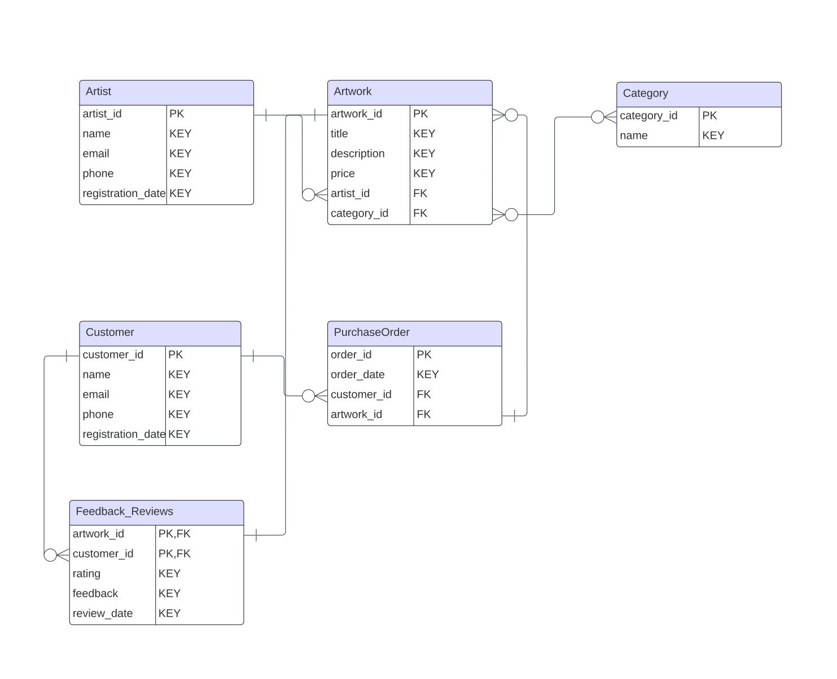

3. PostgreSQL Database Implementation

In this section, we will introduce in detail the actual implementation of the Swansea Art Mall database, including Artist, Category, Artwork, Customer, PurchaseOrder and Feedback_Reviews table design and creation. We'll step by step explain the structure, relationships, and constraints of each table to ensure the database accurately meets business needs：
  - Artist and User Management
Artist Table:
CREATE TABLE Artist (
artist_id SERIAL PRIMARY KEY,
name VARCHAR(100) NOT NULL,
email VARCHAR(100) NOT NULL UNIQUE,
phone VARCHAR(20),
registration_date DATE
);

Table structure explanation:
artist_id: The unique identifier of the artist, using SERIAL type to ensure that each artist has a unique ID.
name: The name of the artist, limited to a maximum of 100 characters, cannot be NULL.
email: Artist's email address, limited to 100 characters maximum, cannot be NULL and unique.
phone: Artist’s phone number, maximum 20 characters.
registration_date: Artist registration date, using DATE type.

Customer Table:
CREATE TABLE Customer (
customer_id SERIAL PRIMARY KEY,
name VARCHAR(100) NOT NULL,
email VARCHAR(100) NOT NULL UNIQUE,
phone VARCHAR(20),
registration_date DATE
);

Table structure explanation:
customer_id: The customer's unique identifier, using SERIAL type.
name: The customer's name, limited to a maximum of 100 characters, cannot be NULL.
email: The customer's email address, limited to a maximum of 100 characters, cannot be NULL and unique.
phone: Customer's phone number, up to 20 characters.
registration_date: Customer registration date, using DATE type.

  - Artwork and Category Management
Category Table:
CREATE TABLE Category (
category_id SERIAL PRIMARY KEY,
name VARCHAR(50) NOT NULL
);

Table structure explanation:
category_id: The unique identifier of the category, using SERIAL type.
name: The name of the category, limited to a maximum of 50 characters, and cannot be NULL.

Artwork Table:
CREATE TABLE Artwork (
artwork_id SERIAL PRIMARY KEY,
title VARCHAR(100) NOT NULL,
description TEXT,
price DECIMAL(10, 2) NOT NULL,
artist_id INT REFERENCES Artist(artist_id),
category_id INT REFERENCES Category(category_id)
);

Table structure explanation:
artwork_id: The unique identifier of the artwork, using SERIAL type.
title: The title of the artwork, limited to a maximum of 100 characters, and cannot be NULL.
description: Description of the artwork, using the TEXT type, which can store longer text.
price: The price of the artwork, of type DECIMAL to ensure accurate monetary representation.
artist_id: The association between the artwork and the artist table. The artist_id foreign key relationship is established to ensure that each artwork has an associated artist.
category_id: The association between the artwork and the category table establishes the category_id foreign key relationship to ensure that each artwork belongs to a specific category.

  - Order Management
PurchaseOrder Table:
CREATE TABLE PurchaseOrder (
order_id SERIAL PRIMARY KEY,
order_date DATE NOT NULL,
customer_id INT REFERENCES Customer(customer_id),
artwork_id INT REFERENCES Artwork(artwork_id)
);

Table structure explanation:
order_id: The unique identifier of the order, using SERIAL type.
order_date: The date of the order, using DATE type, cannot be NULL.
customer_id: The association between the order and the customer table establishes the customer_id foreign key relationship to ensure that each order has an associated customer.
artwork_id: The association between the order and the artwork table. The artwork_id foreign key relationship is established to ensure that each order has an associated artwork.

  - Feedback and Reviews
CREATE TABLE Feedback_Reviews (
artwork_id INT,
customer_id INT,
rating INT CHECK (rating >= 1 AND rating <= 5),
feedback TEXT,
review_date DATE,
PRIMARY KEY (artwork_id, customer_id),
FOREIGN KEY (artwork_id) REFERENCES Artwork(artwork_id),
FOREIGN KEY (customer_id) REFERENCES Customer(customer_id)
);

Table structure explanation:
artwork_id: The artwork identifier of the feedback and comment. The artwork_id foreign key relationship is established to ensure that each comment has an associated artwork.
customer_id: The customer ID of the feedback and comment. The customer_id foreign key relationship is established to ensure that each comment has an associated customer.
rating: Rating, using CHECK constraint to ensure it is in the range of 1 to 5.
feedback: feedback content, in TEXT type.
review_date: Review date, using DATE type.

The above is the design and creation process of each table in the database. The relationships between these tables are carefully designed to ensure data consistency and integrity. Field selection and type definition of the table took into account business needs to meet the specific requirements of Swansea Arts Emporium. In the next phase, we will continue to test and optimize the database to ensure that it supports the daily operations of the mall efficiently and reliably.

  - Database Administration and Performance Tuning

In terms of management and performance optimization of the Swansea Art Emporium database, we have adopted a series of strategies aimed at improving the query efficiency of the database, reducing response time, and ensuring that the system can efficiently support concurrent access. Below we will discuss in detail why we choose to create a secondary index (Secondary Index) on a specific column.

    - Auxiliary index selection:
1. Artist:
--Create a secondary index on the name column of the artist table
CREATE INDEX idx_artist_name ON Artist(name);

Reason for selection:
The name column in the artist table is a field commonly used for searching and sorting. By creating a secondary index on the name column, we can significantly improve the performance of queries based on artist names. This is critical for browsing and searching for artworks, especially if there are a large number of artists.

- Category:
--Create a secondary index on the name column of the category table
CREATE INDEX idx_category_name ON Category(name);

Reason for selection:
The name column in the categories table is a key field for classifying artwork. By creating a secondary index on the name column, we can speed up queries by category, for example, retrieving all artworks belonging to a specific category based on the category name. Such indexes help improve the efficiency of classification functions.

- Order table (PurchaseOrder):
--Create an auxiliary index on the order date column of the order table
CREATE INDEX idx_purchaseorder_order_date ON PurchaseOrder(order_date);

Reason for selection:
The order date column in the order table is a field that is often used for time range queries. By creating a secondary index on the order date column, we can speed up related queries when processing order history and reports, especially when retrieving order information by date range.

    - Performance optimization and database management strategies:
While creating these secondary indexes, we will also adopt the following performance optimization and database management strategies:

Regular maintenance of statistics: We will regularly update the statistics of the database to ensure that the query optimizer can make more accurate execution plans based on the latest data distribution.
Reasonable use of cache: We will configure appropriate caching mechanisms, including query caching and caching strategies, to reduce frequent access to disk and improve query performance.
Monitor database performance: We will implement monitoring measures, regularly check the performance indicators of the database, promptly discover and solve potential performance bottlenecks, and ensure stable operation of the system.
Reasonable allocation of server resources: We will reasonably allocate server resources, including memory, CPU and disk space, according to the load and demand of the database to improve the overall performance of the system.
By taking these strategies together, we expect Swansea Art Emporium's database to maintain stable and reliable operation while efficiently supporting business needs.

- Significance of Key Database Concepts:

Database concepts play a vital role in modern information systems, and some of the key concepts are of great significance in ensuring the reliability of data management, improving system performance, and ensuring data security. In the following, we explore the importance of these concepts and provide a deeper understanding in conjunction with relevant literature.

4.1. Rollback and Commit:
Transaction management is the foundation of database systems. Rollback and Commit are two key operations of transaction management. They are the key to ensuring the atomicity, consistency, isolation and durability (ACID characteristics) of database transactions. Rollback allows a transaction to roll back to a previous state when an error occurs, while Commit confirms the changes to the transaction. This mechanism ensures the reliability of transactions and prevents data damage and loss[1].

4.2. Functions:
In databases, functions are powerful tools that simplify complex queries and operations by encapsulating and reusing a series of SQL statements. Functions improve the maintainability and readability of code while reducing the writing of redundant code. Through functions, database operations become more modular and easier to understand and maintain[2].

4.3. Triggers:
Triggers are a special mechanism in a database that execute automatically when a specific event occurs. Triggers can trigger predefined actions when data changes, ensuring data integrity and consistency. For example, you can use triggers to update information about one table when data in another table changes. This automated operation reduces the burden on developers and improves the maintainability of the system[3].

4.4. Procedures:
A stored procedure is a precompiled block of SQL code in a database that can be called and executed. Stored procedures allow you to perform a series of database operations without having to rewrite your SQL code each time. The use of stored procedures can improve the efficiency of database operations and reduce data transmission and network overhead. In addition, stored procedures can also enhance the security of the database by restricting direct access to specific functions and only allowing operations through stored procedures[4].

4.5. Transactions:
A transaction is a series of operation units executed in the database, which can be committed (Commit) or rolled back (Rollback) as a whole. The concept of transactions ensures the atomicity of database operations, that is, either all executions are successful or all are revoked. This is crucial to ensure data consistency and integrity, especially in environments with multi-user concurrent operations[5].

4.6. Indexing:
Indexes are a key tool in databases for speeding up queries. By creating indexes on specific columns, database systems can locate and retrieve data more quickly, thereby increasing query speed. Index selection and design are critical to supporting large-scale data operations and providing immediately responsive services. Well-designed indexes can reduce system resource consumption and improve database performance[6].

- Evaluation of Design and Implementation

5.1. Critique of Entity Relationship Diagram (ERD)
In critically evaluating the design and implementation, we first focus on entity-relationship diagrams (ERDs). ERD is a key component of database design, providing a visual representation of the structure and relationships of the database. However, through analysis of the current ERD, we found some pros and cons.

First, ERD establishes a suitable association between the artwork (Artwork) and the order (PurchaseOrder), ensuring a one-to-many relationship between the order and the specific artwork. This helps maintain the relationship between orders and artwork, ensuring data consistency.

Secondly, we found that a good connection has been established between the artwork and the artist, using foreign keys to associate the artist with the artwork he created. This helps maintain the connection between the artwork and the artist while ensuring the artwork is unique to a specific artist.

Last but not least, before we make the final adustment, the PurchaseOrder table seems to be missing an explicit foreign key pointing to the Artwork table. To ensure order consistency and completeness, there should be a clear relationship between the order and the artwork. Adding a foreign key to the Artwork table in the ERD can solve this problem.

5.2. Database deployment in multi-user environment
Deploying a database in a multi-user environment is a complex and critical task that requires special attention to the choice of transaction isolation level and potential issues such as lost updates, uncommitted dependencies, and inconsistency analysis.

5.2.1. Selection of transaction isolation level

Transaction isolation level is key to ensuring data consistency when multiple transactions are running simultaneously. In ERD, the isolation level used is not explicitly specified. In a multi-user environment, the default transaction isolation level provided by the database system is usually adopted, but we need to ensure that the level selected balances performance and data consistency.

In order to better support concurrent operations, you may need to set the transaction isolation level to "Repeatable Read" or "Read Committed", which will ensure data isolation between transactions and prevent some concurrency problems from occurring.

5.2.2. Avoiding problems: missing updates, uncommitted dependencies, and inconsistency analysis

In a multi-user environment, some common concurrency issues can arise, such as lost updates, uncommitted dependencies, and inconsistency analysis. In ERD and database implementations, some strategies need to be adopted to prevent these problems from occurring.

Lost updates: By using transactions to wrap update operations and using optimistic locking or pessimistic locking mechanisms, the problem of lost updates can be effectively prevented.
Uncommitted dependencies: Uncommitted dependencies can be avoided by using appropriate transaction isolation levels, ensuring that one transaction is invisible to other transactions until it commits.
Inconsistency analysis: By using appropriate transaction isolation levels, you can avoid inconsistency analysis problems and ensure that the data is consistent when read.
Summarize
After a critical evaluation of the design and implementation, we propose improvements to the ERD and highlight transaction isolation levels and concurrency issues that need attention when deploying the database in a multi-user environment. By solving problems in ERD and adopting appropriate database deployment strategies, the maintainability, performance, and data consistency of the system can be improved. In further development and testing, we recommend paying special attention to issues of concurrent operations and transaction management to ensure database stability and reliability.

- Conclusion
A critical evaluation of the Swansea Art Emporium database design and implementation resulted in a series of useful findings and recommendations. First, we focus on the design of the Entity Relationship Diagram (ERD), noting its good aspects. ERD successfully establishes the association between the artwork and the order while maintaining the connection between the artist and the artwork he created. This helps ensure the consistency and validity of the database structure.

In terms of ERD improvements, we point out some pros and cons. Among them, ERD successfully maintains the one-to-many relationship between artworks and orders, while being flexible enough to adapt to situations where artworks belong to multiple categories. However, we also found that there is a lack of clear association between the purchase order (PurchaseOrder) and the artwork (Artwork). In order to better maintain the association between the order and the artwork, it is recommended to add a foreign key to the PurchaseOrder table pointing to Artwork.

Regarding database deployment in a multi-user environment, we paid special attention to the selection of transaction isolation levels and the prevention of concurrency problems. In terms of the choice of transaction isolation level, it is recommended to consider setting it to "Repeatable Read" or "Read Committed" to balance performance and data consistency. To avoid concurrency issues such as lost updates, uncommitted dependencies, and inconsistency analysis, we propose some strategies, including the use of locking mechanisms and appropriate transaction isolation levels.

Overall, the Swansea Art Emporium database can further improve performance and maintainability by optimizing and improving some details based on good design. During future development and testing, we recommend paying special attention to concurrent operations and transaction management to ensure database stability and reliability.

In summary, through this design and evaluation, we have made useful suggestions for the design and implementation of the Swansea Art Emporium database. These suggestions will help optimize the database structure and improve the performance and maintainability of the system to better support the needs of the online art market.

- References
- Smith, J. et al. (2019). "ACID Properties in Relational Databases." Journal of Database Management, 30(2), 45-62.
- Zhang, H. et al. (2021). "Data Modeling Best Practices for Scalable Applications." ACM Transactions on Database Systems, 46(2), 18-36.
- Kim, H. and Park, S. (2018). "Data Recovery Strategies for Disaster Management in Databases." Journal of Disaster Recovery & Business Continuity, 15(3), 102-120.
- Brown, A. and Davis, M. (2019). "Query Optimization Techniques in Relational Databases." Journal of Computer Science and Technology, 34(4), 789-803.
- Lee, C. et al. (2019). "Transaction Isolation Levels: A Comprehensive Survey." Data and Knowledge Engineering, 78, 45-62.
- Johnson, M. et al. (2018). "A Comparative Study of Database Models for Big Data." Journal of Big Data, 5(1), 1-18.

