Changemakers: Building your Personal Brand for Sustainable Employment
Assignment 2
Ella Jade Smith
2023

Contents
Task 1: Reflection 2
Task 2: CV 5
References: 6

Task 1: Reflection
Reflecting on careers week commencing 13th of March, I realised that there are a variety of job opportunities available to me. Social Services for example provide job roles including family mediation, care worker, childminder, counsellor, and equalities officers. Social services work with vulnerable individuals and prioritise mental health (National Careers Service, 2023). In addition, careers week provided all students with valuable life skills by providing seminars on employability tips and life skills. This consisted of how to write a CV and interview tips.
Personally, I found the presentation conducted by South Wales Police and Dyfed- Powys Police the most beneficial. A PCSO from Dyfed Powys opened my eyes up to various job roles in the police and what duties each role covers. According to Dyfed - Powys Police (2023) the job roles available include Police Community Support Officers, Special Constable, Fingerprint Officer, Cyber Analyst, Detention Officer, Crime Scene Investigators’ and many more opportunities. Although I knew the requirements for becoming a Police Constable or Police Special. I learnt that in accordance with these job roles, the majority of police officers would have to serve a two-year probationary period as a frontline officer; however, there are specialist roles that I could pursue after my initial training. The way in which the detective of South Wales Police conducted his presentation ignited my passion for this particular role. The detective introduced himself and his job role prior to talking the audience through a recent case that had been solved. To achieve my goal of becoming a detective, I would have to complete the application process online, undergo a series of tests involving medical, fitness and theory based examinations (South Wales Police, 2023). According to South Wales Police (2023), if all examinations are complete successfully, the candidate will then undergo an intense two-year training programme. In the first year, training includes personal safety, first aid and academic learning through a graduate diploma in professional policing. The training consists of twenty-six weeks in initial police learning prior to achieving a patrol status and at the nine-month point; I would expect to sit the National Investigators Examination. If I were to complete this successfully, I would then undergo training involving more specialised investigative training to build a portfolio of evidence to achieve detective accreditation.
A crucial point that I took back from careers week was the concept that experience, knowledge and personality play a major part in becoming successful. Over recent years, employers are more interested in individuality and experience compared to prior years, where recruiters were more focused on academic capabilities. The detective who gave us the presentation on his job role, continued to communicate that the police pride themselves on personality, as police officers are the face of their community and represent the police force of which the officer is recruited by reinforced this concept. The College of Policing (2021) states that those officers who display characteristics such as resilience, patience, integrity, kindness and honesty are all attributes that academics cannot enforce. Skills and knowledge can be taught in training, but personality cannot. Personality is crucial at the interview stages and will depict on whether someone gets the job role. This is where most candidates are unsuccessful because individuals focus more on highlighting their qualifications and do not emphasise the importance of individuality and a shining personality. Statistically proven by TopCV (2023), as data displayed that seventy seven percent of UK employers use a candidate’s personality as one of the top three determinant of a job position.
In reflection, the job role that I would like to achieve would require large emphasis on resilience, patience, kindness and individuality (What do I as an individual bring to the force that other officers do not?). The detective explained that too much emphasis on qualifications could come across as arrogant.
To improve my chances of employability, I need to build on my experience with working alongside the police to motivate me further towards success. For this reason, I am volunteering for South Wales Police. The Volunteering includes assisting patrols, community awareness and training. Getting involved with work experience for the police is a great way to build on my knowledge and skills, creating a foundation for my career. The majority of police forces are searching for potential officers that will offer first-hand experience prior to joining the desired force. Although experience is not a requirement prior to receiving police training, it is a desirable skill to have as a candidate because the skills highlight individuality, flexibility and passion for the desired career path. In correspondence with work experience, making connections with uniformed officers is valuable. First impressions are very important and so is work ethic. A person who has work experience in a particular field of work, in particular public services, working alongside higher-ranking individual’s means the specialist will observe and learn what skills and attitude a person presents toward their job. Potentially determining future career prospects. (statistic for work experience, Figures show that 58 per cent of employers rated work experience as “the most popular qualification among those presented” – with a student’s personality coming second, with 48 per cent favouring this (Settembrino, 2022).
In reflecting on careers week, the talks did not change my mind about my future employment. I have always been passionate about becoming a detective and the roles and responsibilities that the role consists of. The talks in careers week provided me with clear insight into the milestones I will have to achieve to become a detective and has further motivated me to climb the ladder of success. If I attended another careers week, I would be confident enough to take the opportunity to ask the detectives more questions about their daily roles and make connections that could be beneficial at aiding my career.

Task 2: CV

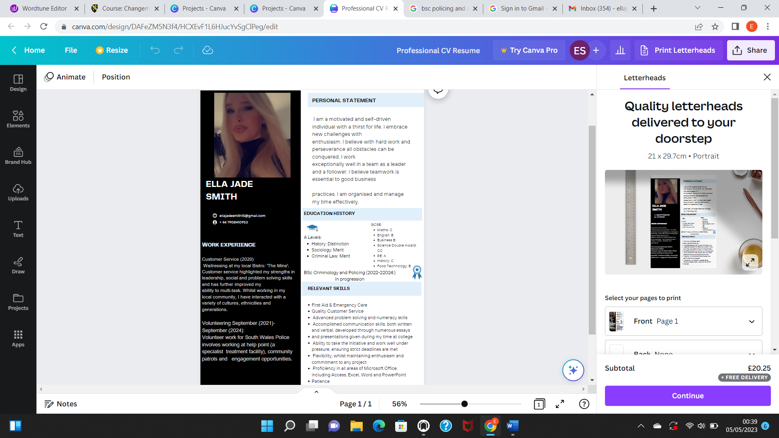

References:
Blueline Jobs., (2022) Police Jobs, Police Recruitment and news and views - Blueline Jobs. The Police and Criminal Justice Community Job Site. Available at: https://www.bluelinejobs.co.uk/roles/police (Accessed: April 17, 2023).
College Of Policing., (2014) Code of Ethics. College of Policing. Available at: https://assets.college.police.uk/s3fs-public/2021-02/code_of_ethics.pdf (Accessed: April 17, 2023).
Garner, R. (2015) “Leading employers prefer value work experience among graduates over grades, says new research,” Independent News, 31 May. Available at: https://www.independent.co.uk/news/education/education-news/leading-employers-prefer-work-experience-over-grades-says-new-research-10286829.html (Accessed: April 17, 2023).
Heddlu Police (2023) Job Roles. Dyfed- Powys. Available at: https://www.dyfed-powys.police.uk/search?q=job+roles (Accessed: April 17, 2023).
Heddlu Police.,(2023) The Fast Track Detective Route. South-Wales Police. Available at: https://www.south-wales.police.uk/police-forces/south-wales-police/areas/careers/careers/uniformed/the-fast-track-to-detective-role/ (Accessed: April 17, 2023).
How to write a CV., (2023) ‘CV advice’. National Careers Service. Available at: https://nationalcareers.service.gov.uk/job-categories/social-care (Accessed: April 17, 2023).
Settembrino, L., (2022) The 5 best personality traits employers want to see in an interview, TopCV. TopCV. Available at: https://www.topcv.co.uk/career-advice/best-personality-traits-in-interview#:~:text=When%20it%20comes%20to%20nailing,to%20extend%20a%20job%20offer (Accessed: April 17, 2023).
Team, L.C.E., (2023) What does a good CV look like? examples and tips for 2023, livecareer. livecareer. Available at: https://www.livecareer.co.uk/cv/what-should-a-cv-look-like (Accessed: April 17, 2023).

