

ASSIGNMENT 1

NAME: YOANNA MIHAYLOVA
NUMBER: 1818183
SUBJECT: INTRODUCING THE MODERN WORKPLACE(LCBB4003)
TOPIC: TESCO
LECTURER: HUSAM HELMI

CONTENT

1.Introduction 3
2. Exploration of TESCO 3
3. Organisational Structure 3
4. Culture - Hofstede’s Framework 5
5. People and Motivation 6
Theory X and Theory Y 6
6. Motivational Theories 7
Maslow’s Hierarchy of Needs 7
Herzberg’s Motivation-Hygiene Theory 8
7. Performance Management 8
8. Recommendations 9
9. Conclusion 10
References 11

TABLE OF FIGURES

Figure 1: Functional Organisational Structure 4
Figure 2: Matrix Organisational Structure (Source: HubSpot.com) 5
Figure 3: Maslow's Needs Hierarchy (Source: SimplyPsychology.org) 7

1.INTRODUCTION
The purpose of this essay is to explore the structure and work culture of TESCO – a large supermarket and retailer organisation in the UK. This essay will briefly explore; (1); A case study of TESCO (2); Organisational structure used by TESCO (3); The culture of the organisation, and (4); The performance (and people) management strategies used by TESCO. This essay aims to provide recommendations on how TESCO can improve its work culture and performance strategy.

2.EXPLORATION OF TESCO
TESCO is the largest retail organisation in the United Kingdom by several measures; it has the largest revenue in the retail sector (£63 billion) with net profits of £3.4 billion. TESCO operates more than 2,200 stores around the UK and other countries in the world, however the mainstay of its operations is in the UK. TESCO is also one of the biggest employers in the world, with a workforce in excess of 460,000 employees. Asides from retail, TESCO also has operations in online shopping, insurance, telecommunication, and financing. It is also one of the oldest retailers in the UK, with its origins dating back to 1919 with a humble market stall (TESCO, n.d.).

3.ORGANISATIONAL STRUCTURE
As a large multinational corporation, TESCO has a complex organisational structure that comprises layers of national and international management. For this reason, this essay will explore the organisational structure of the retail component of TESCO’s business operations in the UK. From a theoretical standpoint, TESCO’s apparent organisational structure is a functional one. An organisational function is a department that has been dedicated to a single function of the organisation’s operations. Examples of a function can include marketing, human resources, customer support, shelf management, cashier and sales, and other specialised functions.
Figure 1: Functional Organisational Structure
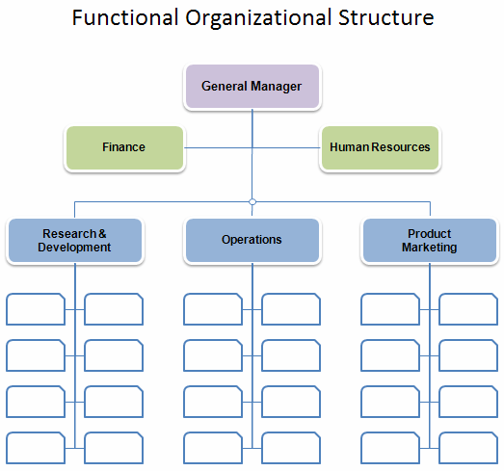
In a functional organisational structure, each function has its own dedicated duty, and the size of each function depends on the operational needs of the organisation. These functions are headed by dedicated managers and supervisors (demonstrating an established hierarchy). In this hierarchical structures, on-ground employees (general and specialised positions) report to their supervisors (i.e. Meat department, Food department, Electronics department), and these supervisors report to their functional manager (i.e. Shelf management function). Each functional manager then reports to the Branch manager, who reports to the TESCO corporate managers.
A functional structure is what TESCO arguably uses. One prominent structure alternative includes the Matrix-based structure. This structure uses a combination of functional elements (i.e. an hierarchy of supervisors and managers), as well as an horizontal structure of specialised teams for each function. The hierachical structure is for routine operational elements (i.e. daily operations) head by a conventional supervisor/manager, whereas the horizonal structure is for specialised, inter-function operations (i.e. expansion, special projects) that are localised within an organisational function. This approach, although multi-layered and complex, allows for organisations to pursue deeper and complex projects.
Figure 2: Matrix Organisational Structure (Source: HubSpot.com)
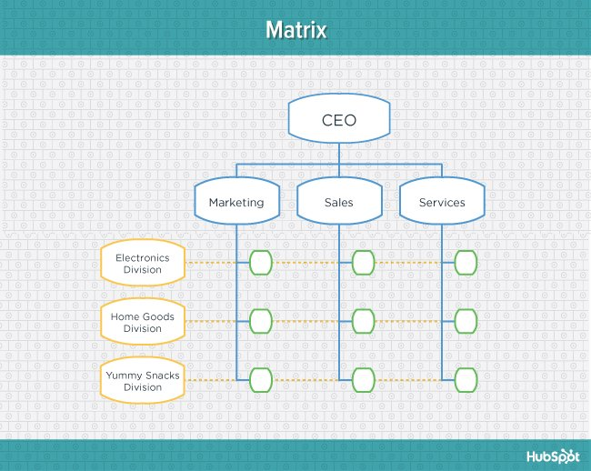

4.CULTURE – HOFSTEDE’S FRAMEWORK
Business organisations develop their own work cultures that dictate their operational scope, practices, and policies. One major influencer on organisational culture is national cultures – it is theorised in Hofstede’s dimensions of cultures that national cultures influence how people behave, both in their social life and in the organisational environment. Hofstede’s dimensions include six elements of culture; (i) Power distance, (ii) Individualism, (iii) Masculinity, (iv) Uncertainty avoidance, (v) Long-term orientation, and (vi) Indulgence (Hofstede-Insights, n.d.).
The Power distance dimension refers to the extent to which people of a culture accept that power is unevenly distributed within the society; in high-power culture countries, people are not afraid of speaking against authority (i.e. socio-economic differences, political differences) as they feel that power is more equally distributed. In this dimension, the UK scores 35 (of total 100) indicating that UK has a low power distance. The Individualism dimension refers to extent to which people in a culture prefer to cohabitate and work together (i.e. a collectivist society) or alone (i.e. individualistic society). In this dimension, the UK scores 89, demonstrating that the UK has an overwhelmingly individualistic culture with a focus on individualism (Hofstede-Insights, n.d.).
The Masculinity dimension refers to the extent to which people of a society are competitive and value ambition and success over quality of life and social care (Femininity). In this dimension, the UK scores 66, demonstrating that UK is a Masculine society where people are success and competition-oriented, valuing advancements and achievements over a more equitable society. The Uncertainty avoidance dimension refers to how people of a society behave about their future. In an uncertainty avoidant culture, people tend not to take risky decisions and prefer to follow social codes and traditions, whereas people are more risk-oriented and open to new experiences in non-avoidant cultures. In this culture, the UK scores 35, demonstrating that the UK has a low-avoidant culture as British people are often willing to take risks and accept uncertainty in their life (Hofstede-Insights, n.d.).
The Long-term orientation dimension refers to extent to which people of a society are focused on the long-term when dealing with challenges. In long-term oriented cultures, people refer to past mistakes and take conservative approaches with how they develop in life, whereas in short-term cultures people focus on the immediate challenges. In this dimension, the UK scores 51, which means it is moderate in both spheres, neither short nor long-term. The Indulgence dimension refers to the extent to which people of a culture control their desire and impulses. In indulgent cultures, people focus more on present achievements and life enjoyment. In this dimension, the UK scores 69, demonstrating that it is a highly indulgent culture in which people prefer to splurge on personal happiness and enjoyment (Hofstede-Insights, n.d.).

5.PEOPLE AND MOTIVATION

Theory X and Theory Y
The Theory X and Theory Y are two opposite perspectives in leadership and personnel management. Theory X provides a pessimistic approach to personnel management, asserting that employees dislike having to work and dislike following responsibilities. The theory also asserts that employees have no internal motivation to work hard, but rather must be enticed with rewards and benefits to make them work harder (Şahin, 2012).
Theory Y provides an opposing perspective – that employees are motivated to work from the inside, see work as challenging but engaging, and that they like taking responsibility for their work. These two contrasting perspectives if what leaders in business organisations choose to manage their employees. In the perspective of TESCO, it is arguable from the various feedback mechanisms, performance appraisal systems, and an emphasis on creating a collective workforce, the TESCO management is focused on the use of theory Y, with arguably the assertion that workers want to work hard, and do so when the company is willing to provide them with the appreciation and acknowledgement they desire from working hard (TESCO, n.d.).

6.MOTIVATIONAL THEORIES
TESCO’s operations place a strong emphasis on people management, employee motivation, and employee engagement. TESCO utilises two theoretical frameworks to enhance employee’s welfare and motivation, Maslow’s Hierarchy of Needs and Herzberg’s Motivation-Hygiene Theory.

Maslow’s Hierarchy of Needs
Maslow’s theory of needs asserts that all humans have a hierarchy of needs that they need to fulfil before they are satisfied and can fulfil their potential. This hierarchy is based on five levels; (i) Basic/physical needs (food, pay, water), (ii) Security needs (shelter, safety), (iii) Social needs (family, friends, social interactions), (iv) Self-esteem (respect, authority), and (v) Self-fulfilment (pursuit of ambitions) (McLeod, 2007).
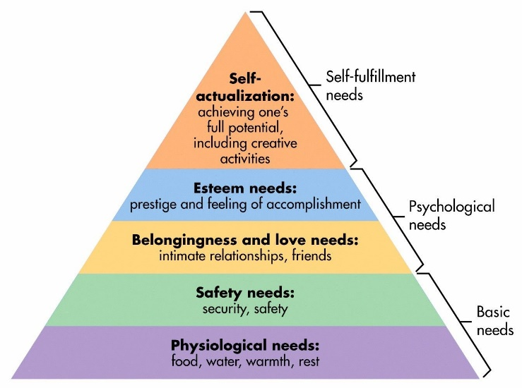
Figure 3: Maslow's Needs Hierarchy (Source: SimplyPsychology.org)

TESCO appears to maximise on all these needs for employees; from the base level, TESCO provides employees with pay and food, secure employment, a team-oriented and human workplace, feedback and appraisal systems, and finally career progression plans (TheTimes100, 2019).

Herzberg’s Motivation-Hygiene Theory
Herzberg’s theory of motivation asserts that there are two elements to employee motivation – hygiene and motivators. Hygiene factors are workplace features that although do not increase employees’ motivation, their absence reduces their motivation (thus, hygiene). Examples of these include pay and benefits, job security, proper work conditions, and safe work environment. Motivator factors are different hygiene, as they direct improve employees’ motivation to work. Examples of motivators include promotions, recognition, achievements, and career growth (Bassett-Jones & Lloyd, 2005). The policies used by TESCO to improve employees’ motivation is explored in the following section.

7.PERFORMANCE MANAGMENT
Alongside the influence from national cultures, organisations also develop their own unique cultures as a result of their operational policies, management, and managerial ethics. TESCO’s organisational culture can be evaluated from its policies; as per the publicised company policies, there appears to be considerable focus on employee motivation and welfare. TESCO’s operational policies include appraisal systems to monitor employees’ performance and feedback systems to ensure information flows freely through the organisation. This creates a trackable and transparent culture where every employee goes appreciated for their efforts.
The company’s operational policies also include a ‘Steering wheel’ policy in which employees are encouraged to work together as a team, as per their skillsets and proficiencies. This creates a culture of teamwork and collaboration, as opposed to competition. Apart from these policies, TESCO’s mission statement also reflects on its culture – ‘To be the most highly valued business by: the customers we serve, the communities in which we operate, our loyal and committed colleagues and of course, our shareholders.’ This mission statement shows that TESCO wants to create a culture where employees feel valued for being part of TESCO (TheTimes100, 2019).
TESCO also operates employees’ performance management programs. These include provisions for flexible working hours (allowing employees to set their own hours to work the best for work/life balance and personal stress), personal development plans (i.e. allowing employees to have clear career progression), performance-based pay programs (i.e. rewarding employees for working exceptionally well) (TESCO, 2019).
This shifts TESCO towards a performance-based culture, where employees have opportunities for progression ahead of them, but when viewed in with other policies (as explored above), TESCO’s culture is one where employees are valued, have clear progression, and encouraged to collaborate well together to create a positive and progressive work environment.

8.RECOMMENDATIONS
Based on the observation and evaluation of TESCO’s operating structure, organisational culture, people management policies, and performance management policies, the following recommendations are rendered to improve performance in these spheres:
- TESCO currently employs both financial and non-financial rewards as part of its performance-based benefits programs. This is a reasonable and recommendable approach to reward management because it encourages the concept that hard work is acknowledged and appreciated, and that money is not the sole motivator of workforce satisfaction. Creating a work culture that is based on achievement and respect is more relevant to TESCO because the UK has a masculine culture and its people are more motivated at the prospect of ambition, acknowledgement, and status.

- TESCO’s operational policies appear to create a team-focused, collectivist work environment. Arguably, some modifications to this cultural feat might be useful for TESCO. As observed in Hofstede’s score, the UK has a very individualistic society that values personal ambition and growth, with social and collectivist elements having minimal relevance to the people. It could be useful for TESCO to promote more individualistic elements in daily operations (i.e. adding an individual work path, similar to the Steering Wheel program).

- The UK has a highly indulgent culture and people want instant-gratification and short-term success to motivate them and to keep themselves happy. It could be helpful to promote a work-indulgent culture in the workplace by emphasising more on career progression routes so that workers can keep scope of when their next promotions are due. With an indulgent mindset, employees will be more motivated to work harder at the prospect of receiving more rewards.

9.CONCLUSION
The purpose of this essay was to explore the operational policies and organisational culture of TESCO, with the intent to explore what policies TESCO uses to manage its operations, employees, and their motivation. This essay has explored that TESCO utilises a wide portfolio of policies and initiatives that are designed to deliver competitive value to employees – from performance-based pay to performance management strategies and policies that emphasise a collective and collaborative workforce. However, this essay also notes some cultural conflict (using Hofstede’s model) between UK’s culture and TESCO’s organisational culture, particularly in the values of individualism and indulgence. Recommendations are noted for how TESCO can further improve its organisational culture, policies, and performance.

References
1.Bassett-Jones, N. & Lloyd, G. C., (2005). Does Herzberg's motivation theory have staying power?. Journal of Management Development, , 24(10), pp. 929-943.
2.Hofstede-Insights, n.d. United Kingdom. [Online]
Available at: https://www.hofstede-insights.com/product/compare-countries/
(Accessed 27.11.2019)
3.McLeod, S. A., (2007). Maslow's Hierarchy of Needs. [Online]
Available at: http://www.simplypsychology.org/maslow.html
[Accessed 27. 11. 2019].
4.Şahin, F., (2012). The Mediating Effect of Leader-Member Exchange on the Relationship between Theory X and Y Management Styles and Affective Commitment: A Multilevel Analysis. Journal of Management & Organization, , 18(02), pp. 159-174.
5.TESCO, (2019). Our approach to pay and reward. [Online]
Available at: https://www.tescoplc.com/sustainability/downloads/our-approach-to-reward/
(Accessed 25.11.2019) TESCO, n.d. Annual Report 2019, 2019: TESCO.
6.TheTimes100, (2019). Motivational theory in practice at TESCO. [Online]
Available at: https://businesscasestudies.co.uk/tesco/
(Accessed 26.11.2019)

