:
Name: Krutiben Rajeshbhai Patel
Student id: 2506595
Module : Health Care System, Organisation and Leadership (LCHS7002)I
Lecture’s name: Shepherd Ziko
Assignment title. Case Study Analysis Report: Comparative report on
COVID19 leadership Responses

Executive Summary
This report will provide a comparative study of how healthcare systems and leadership have responded to the COVID 19 pandemic in Spain, South Korea and Canada. The aim of the report is to critically analyse how the extent of centralisation and decentralisation influenced the national pandemic responses and the impact on the population health. The three nations were chosen since they have different systems of governance and leadership in dealing with the crisis. The report examines the impact of systems-thinking perspective on preparedness, response efficiency, and outcomes related to the coordination mechanisms, decision-making authority, and healthcare organisation. Besides, the report also assesses leadership styles embraced in the respective countries with emphasis on crisis leadership, transparency and adaptability. Some of the main themes are the benefits and drawbacks of centralized and decentralized health systems, how leadership contributes to uncertainty management, and the interplay between governance systems and leadership performance in times of a public health crisis.

Table Of Contents
Executive Summary 2
1. Introduction 4
2. Centralised and Decentralised Healthcare System Responses to the COVID-19 Pandemic 4
2.1 Overview of Healthcare Systems and Pandemic Governance 4
2.2 Spain: Decentralisation Tested by Crisis and the Push for Recentralisation 6
2.3 South Korea: Centralised Agility and Technocratic Governance 7
2.4 Canada: Federalism and the Challenge of Coordinated Decentralisation 8
2.5 Comparative Analysis and Synthesis: Toward Adaptive Governance 10
3. Leadership Styles in COVID-19 Pandemic Management 13
3.1 Leadership Theories Relevant to Public Health Crises 13
3.2 Leadership Styles in Spain: Political Fragmentation and the Struggle for Coherent Authority 15
3.3 Leadership Style in South Korea: Technocratic Efficiency, Transparency, and Public Trust 16
3.4 Leadership Style in Canada: Empathetic Communication Amidst Jurisdictional Complexity 18
3.5 Comparative Analysis of Leadership Approaches: Structure, Style, and Synergy 19
4. Conclusion 22
References 23

1. Introduction
The COVID-19 pandemic has presented the world with a challenge to the healthcare system like no other, revealing the system’s structural vulnerabilities, gaps in governance, and constraints in leadership in different nations. It was necessary not just the clinical capacity to manage an incredibly fast-changing public health crisis but also the efficient organising, coordinating, and leading of the system at both national and sub-national levels (Sachs et al., 2022). The varying ways in which the countries organized the authority to make decisions and the way they exercised leadership played a major role in the success of their response to the pandemic.
The three countries that are addressed in this report are Spain, South Korea, and Canada, which have various healthcare governance structures and leadership styles. Spain has a very decentralised healthcare system with very high regional autonomy, South Korea has a highly centralised and coordinated model of public health response, and Canada has a federal system in which provincial governments have the primary role in delivering healthcare (Royo, 2020; Kim et al., 2021; Allin et al., 2021). The differences offer a good point of comparative analysis.
Centralisation is the process of decision-making power being concentrated at the national level so that uniform policies could be made and coordination is quicker, but decentralisation is the process of distributing authority among regional or provincial governments so that they are flexible and more responsive to their consumers (Carroll, 2023). In the case of a public health crisis, leadership becomes essential because it determines communication, public trust, compliance, and alignment of the system actors in a situation of uncertainty (Sanders et al., 2021). The report is designed in such a way that it will first examine the responses of healthcare system organisation and governance, then critically examine the leadership styles that have been adopted in each of the countries and finally reach some comparative conclusions.

2. Centralised and Decentralised Healthcare System Responses to the COVID-19 Pandemic

2.1 Overview of Healthcare Systems and Pandemic Governance
The healthcare systems structure is important in determining the national response to emergencies in public health. Governments had to make speedy decision-making on the issue of surveillance, testing, contact tracing, lockdowns, and vaccination rollout during the COVID 19 pandemic. The decision-making of these was based on the concentration of authority at the national level or the decentralization of authority among the regional or provincial governments. A centralised system can be more effective in co-ordination, consistency in policy application and communication can be simplified as compared to a decentralised system which may be flexible, locally adaptive and responsive to regional demands (Carroll, 2023).
Nonetheless, both models are not necessarily better than each other. Centralisation might introduce bureaucratic inflexibility and slow reactions in case national institutions are overwhelmed, and decentralisation can cause fragmentation in decision-making, inconsistency in policies, and health disparity across regions (Smith et al., 2022). The COVID-19 crisis is thus a chance to critically analyze the mechanisms of functioning of various structures of governance under the most severe pressure. Spain, South Korea, and Canada are three different in terms of their methods of healthcare organisation and dealing with pandemics, so they are appropriate to be compared.

(Source: Compiled from national public health data and WHO summaries).

Rich Picture: 01
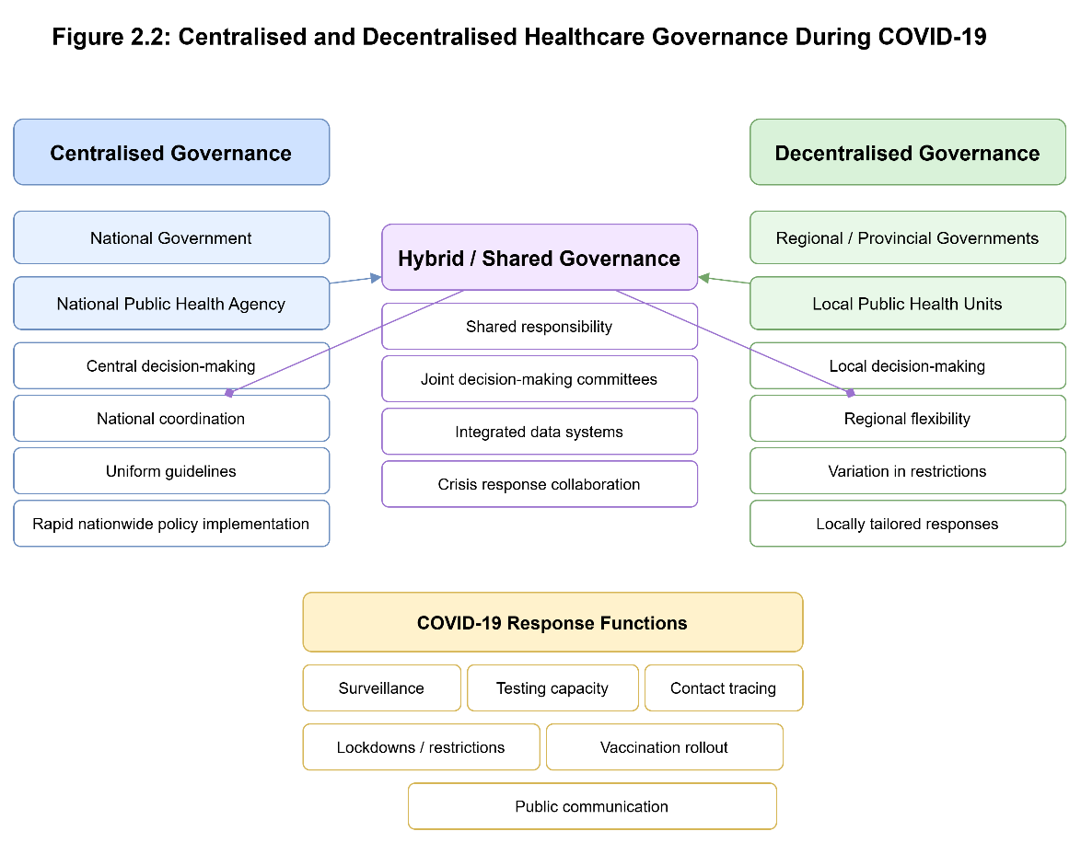

2.2 Spain: Decentralisation Tested by Crisis and the Push for Recentralisation
Spain has a highly decentralised system of national health, and much of the responsibility of healthcare planning, financing, and delivery is devolved to its 17 autonomous communities. This decentralised form was previously considered to provide the flexibility and responsiveness to health needs at the regional level (Royo, 2020). Nonetheless, the COVID-19 crisis revealed the coordination issues, which were inherent to the governance model of Spain.
The response to the pandemic in Spain was marked by a slow central response and inconsistent regional responses at the onset of the pandemic. The first surveillance and containment efforts were primarily left to regional authorities, which led to disjointed efforts and unequal preparedness by regions (Garcia -Basteiro et al., 2020). In March 2020, the central government has declared a national state of alarm, which has temporarily centralised some of the key decision-making authorities, such as mobility restrictions and emergency procurement, as infection rates soared (Erkoreka, 2022).
This change to centralisation had mixed results. On the one hand, the national coordination enhanced the distribution of resources, eased the application of the uniform lockdown, and enhanced communication between regions. Conversely, conflict arose between the central and the regional authorities, especially when it came to the timing and extent of restrictions, affecting the consistency of policies and citizen confidence (Sanchez-Bayon et al, 2022). The example of Spain is characterized by high mortality rates in the early waves of the pandemic, which emphasizes the impact of the lack of coordination and integration of systems.
Notwithstanding such hurdles, the vaccination policy of Spain showed how effective a centralised government could be. The national government was in charge of procurement and distribution, making sure that there was fair distribution across the regions and that the vaccination coverage was high within a comparatively short period (European Commission, 2021). This comparison demonstrates the effectiveness of centralisation in the strategic use of this approach and the inability of excessive decentralization at the time of crisis to respond in time.

2.3 South Korea: Centralised Agility and Technocratic Governance
The Republic of Korea reaction to the COVID-19 pandemic is clearly a sharp contrast to the first challenges of the Spanish experience and presents a model of rapid, centralised, and technocratic crisis management. The health system of the country, despite having a strong privatized provider sector, is based on the Korea Disease Control and Prevention Agency (KDCA), a strong central public health agency. The nature of national containment was a high level of preparedness, institutional memory based on the 2015 outbreak of MERS, and a centralised command structure that allowed quick and data-driven responses (Moradi et al., 2020).
In the first instance of cases identification, the KDCA and central government had monopolized executive power. This centralisation enabled an instant implementation of a national playbook. South Korea created an extensive, centralised testing system within a short period and integrated new drive-through and walk-in testing facilities, thus creating a uniform testing system and pricing nationally. A comprehensive, labour-intensive system of contact tracing was organized on national level, whereby the local health departments acted as extensions of the central command. In addition, South Korea introduced digital technology at the national level, which uses credit card history, mobile phone GPS tracks, and CCTV cameras to recreate patient movements with an extremely high level of accuracy. This centralised aggregation of data allowed real-time epidemic modelling and delivery of specific public alerts (Kim et al., 2021).
The merits of such a course were immense. It provided uniformity in policies, eradicated the harmful inter-regional competition or policy dispersion and promoted concise and coherent communication by citizens. South Korea preserved both the health of the population and its economy to a high extent by not implementing a long, economically devastating countrywide lockdown with the help of targeted interventions. The trust of the government and scientific institutions in the community, which was supported by the openness of daily briefings and the spread of information, contributed to the majority of people adhering to the recommendations of the public health (Jeong et al., 2020). The outcome was a low mortality rate among OECD countries with minimal harsh blanket restrictions witnessed in most of the Western countries.
Nonetheless, the South Korean model too emerged with major ethical and legal issues, and this is where the possible negative side of highly centralised, technocratic control was pointed out. The large-scale digital monitoring and the fact that the detailed, anonymised movement information of infected people was publicly disclosed brought serious concerns about the privacy and data protection, as well as the balance between the collective security and civil liberties of the individuals (Lim and Sohn, 2023). Although mostly agreeable to the masses given the emergency scenario, this was a precedence to state spying that may be abusive in lesser able or less democratic haste. Besides, the system, though mostly performing well, was strained during outbreaks, including the ones associated with the Shincheonji religious sect or Seoul nightlife establishments, which indicated that the most prepared central system might still be tested by outbreaks of the explosive, localised chains of transmissions.
Overall, South Korea showed that an existing, adequately funded, and credible central authority overseeing the nationwide response, given the power to be the lead in the fight, can prove to be exceptionally powerful in controlling the pandemic. Its success was not just centralisation but centralisation that was supported by a base of institutional capacity, technological integration and the trust of the people. However, it is also a warning story of how such centralisation requires strong legal and ethical systems to regulate the wide prerogative that such centralisation implies even in a situation of a public health crisis.

2.4 Canada: Federalism and the Challenge of Coordinated Decentralisation
The response to the pandemic in Canada was organized in a traditional system of split jurisdiction in the healthcare system. Canada Health Act provides national principles, whereas the constitutional power of healthcare delivery is virtually left solely in the ten provinces and three territories. The role of a federal government is mainly the role of funder (via fiscal transfers), border protector, nationwide regulator (e.g. of vaccines and therapeutics), and national health advisor. This deeply rooted decentralisation essentially was at the heart of a response that was heavily regionalised, in terms of policy and performance (Allin et al., 2021).
During the pandemic, the provinces took a decisive approach, which led to a patchwork of public health measures. As an example, Atlantic Canada (New Brunswick, Nova Scotia, Prince Edward Island, and Newfoundland and Labrador) created an "Atlantic Bubble," enabling free movement in the region with severe isolation conditions imposed on outsiders- a successful example of decentralisation that made cases and deaths exceptionally low throughout much of 2020 (Chapman, 2021). On the other hand, other provinces, including Ontario and Quebec, enforced and then removed lockdowns, school shutdowns and business restrictions on varied schedules and to varying degrees, which are not a nationwide approach but rather a reflection of the politics of the individual province and the capacity of the local hospital system.
The federal government, through the Public Health Agency of Canada (PHAC), was the issuer of guidelines and modelling and had no power to impose actions. Its most essential functions were in global vaccine acquisition, administration of frontier limitations and isolation, and provision of comprehensive economic support programmes like the Canada Emergency Response Benefit (CERB). Although the centralised buying of vaccine proved successful in the end, initial miscalculations such as the use of international supply chains that failed and delayed shipments slowed the initial rollout in contrast to other G7 countries (Government of Canada, 2023). Moreover, the lack of a strong national health agency similar to the KDCA in South Korea was exposed in an extremely obvious way. PHAC was also accused of sluggish, piecemeal data collection on the part of the provinces, which was impeding national situational awareness in real-time. Different messages to the general public by federal and provincial leaders were also confusing, including on travel warnings and the use of specific therapeutics (Bubela et al., 2023).
The Canadian experience reveals the strength of a decentralised model of a nationwide crisis as well as its shortcomings. The flexibility enabled provinces such as Atlantic region to develop very effective and locally tailored strategies. But the absence of coordination mechanisms that were mandatory led to a scattered response that tended to appear as thirteen mini-pandemics. Inequities were worsened, with the provinces that had better infrastructure in terms of public health and fiscal ability doing better. The pandemic highlighted the constraints of federal health governance in Canada, showing that the system is optimized to handle the regular daily healthcare operations rather than a rapid, consistent, and legally cohesive national emergency response.

2.5 Comparative Analysis and Synthesis: Toward Adaptive Governance
The comparison between Spain, South Korea and Canada illustrates that the dichotomy of centralised versus decentralised is not sufficient in describing the performance in the pandemic. Rather, a triad of factors, including (1) pre-existing institutional capacity and readiness, (2) the possibility to adjust governance on a real-time basis, and (3) the quality of leadership and intergovernmental relations, is the determinant of the outcomes.
South Korea performed well due to its institutional capability that was defined by a well-endowed central agency that had recent experience of outbreaks and operated in a centralised structure. It also had little to adjust in its governance since the default crisis mode worked. On the other hand, Spain had the disadvantage of a low initial coordination capacity in its decentralised system, which resulted in a strained, conflict-laden adaptation (temporary recentralisation) which achieved success only in part. Canada exhibited moderate institutional capability at both levels but structural failure to wholly transform its decentralised template to either more coercion or coordination; rather it depended on voluntary collaboration which was often inconsistent.
Based on such cases, a model of resilient pandemic governance is created, which is inevitably a hybrid and adaptive one. A system that is best would include:
- Centralised strategic functions: There must be a powerful, well-funded national authority in charge of international procurement, equitable inter-regional resource distribution, border control, national level data monitoring and research and minimum standards or frameworks of public health action.
- Decentralised operation implementation: The implementation of the core elements of the public health approach, the functioning of local healthcare systems, the need to adapt the responses to the needs and circumstances of each community (e.g. localised lockdowns, the location of testing sites, etc.) should remain the primary responsibility of sub-national governments.
- Strong systems of compulsory coordination: More importantly, the system should have forums of continuous data exchange, strategic consultation, and dispute resolution between levels of government, which are pre-established and legally supported. This will avoid fragmentation and make the local activities consistent with national strategic objectives.
Effective management of the pandemic, as Smith et al. (2022) insist, does not only presuppose an adequately designed system on paper, but also adaptable leadership that would allow establishing collaboration, developing trust, and coordinating the actions of various actors of the system towards a common objective in a situation of fundamental uncertainty. The pandemic has demonstrated that the centralisation or decentralisation of a system is less important than does it have the tools, the trust, and the leadership to effectively coordinate in response to a shared, invisible threat.

(Source: WHO and national epidemiological reports).
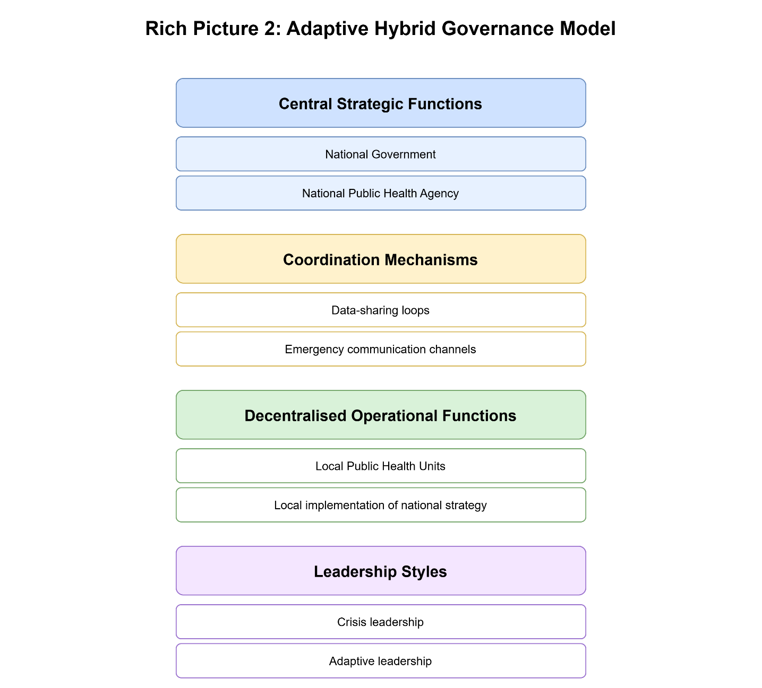

3. Leadership Styles in COVID-19 Pandemic Management

3.1 Leadership Theories Relevant to Public Health Crises
Pandemics like the COVID-19 pandemic represent a special and acute crisis to leadership, requiring response in radical uncertainty, severe time pressure, entire societal shock, and significant public attention. The use of conventional methods of management frequently fails to be sufficient and the leadership theory becomes a vital tool to examine the impact of decision-makers on the coordination of the system, trust of the people and eventually, health and social outcomes. There are a number of leadership models that can be used specifically to break down the responses to the pandemics: transformational leadership, situational leadership, adaptive leadership, and the synthesised notion of crisis leadership (Sanders et al., 2021).
Transformational leadership focuses on influencing and encouraging the followers to go beyond self-interest in pursuit of a common cause. This includes the expression of a clear, strong vision (e.g., flatten the curve, protect the vulnerable), establishment of trust through regular and truthful communication, as well as the display of moral authority and empathy in a pandemic. Transformational leaders enable institutions and the populace, instill a feeling of common cause needed to sustain compliance in the long term of the painful measures taken to maintain public health. The style plays a vital role in ensuring social cohesion and a whole-of-society response on a long-term basis (Santoso et al., 2022).
Situational leadership is based on the idea that no one best leadership style exists; good leaders have to be flexible to the maturity of his/her followers as well as the situation at hand. During the COVID-19, this translated into the modification of strategies depending on the changing variables: the severity of the local outbreak, the capacity of the healthcare system, the degree of the population knowledge and fear, the stage of the pandemic (e.g., the initial containment versus the vaccination rollout). A leader may have to be extremely directive in the acute hospital crisis and more collaborative and participatory in a recovery and planning phase.
The theory of adaptive leadership, which was coined by Heifetz and Laurie is very applicable to a complex issue such as a pandemic, where the task is not technical and has no pre-defined answers, and learning should be a real-time experience. Adaptive leaders are interested in recruiting individuals to address hard issues, promoting experimentation, coping with distress, and organising conflict without oppressing it. They do not give all the answers but they design a holding environment where systems have the chance to learn, be innovative and adapt. This means questioning the strongly held beliefs, reassigning roles, and respecting different viewpoints to make our way through unexplored land (Laur et al., 2021).
Crisis leadership combines the aspects of the theories mentioned above into an acute emergency system. It values speed in the sense making process, acting decisively when under pressure, communicating clearly and frequently, and coordinating disparate actors. Leaders of crisis are required to exude confidence and a sense of calm to control the fear of people around them, make decisions under high stakes with imperfect information, and develop resilient response systems. Nevertheless, unlike a disaster in the short term, a pandemic is a slow-burn crisis, and leaders have to maintain such measures over months or years to avoid crisis fatigue among the population and the institutions (Sachs et al., 2022).
The case of leadership responses of Spain, South Korea and Canada provides excellent case studies through which the theoretical styles were put into practice and most importantly, how they interacted with and were limited or facilitated by the underlying healthcare systems of governance. The pandemic has shown that leadership is not just a role of personal character but a role that is played in a complicated system of institutions, politics, and public trust.

(Source: Government vaccination dashboards and WHO).

3.2 Leadership Styles in Spain: Political Fragmentation and the Struggle for Coherent Authority
The COVID-19 leadership path of the Spanish nation is a good example demonstrating the risks of political fragmentation and the difficulties of overcoming the decentralized business-as-usual posture and switching to a centralized crisis command model. The first leadership approach, which was implemented both on the national and regional scale, was flawed in its basic facets of crisis governance, such as the lack of risk assessment, decisive pre-emptive action, and poor communication.
At the beginning of 2020, leaders of the country and several regional ones publicly downplayed the threat publicly and focused on its preparedness of the system in sharp contrast to the newly occurring reality. This oversight of situational risk, which was a false assessment of the current situation, led to leadership styles that were passive and managerial and not proactive and directive in terms of crisis mode. Lack of a strong, unifying national story, which was worsened by the existing political tension between the left-wing mainstream government and the different regions that were led by the opposition (most prominently Madrid and Catalonia) left a vacuum. The governments of the regions, as a result of statutory autonomy, introduced unequal measures, thus creating a cacophony of policies, which disoriented the population and increased the spread of the virus (Garcia-Basteiro et al., 2020).
When the hospitals in Madrid and Catalonia were on the brink of collapse in March 2020, the national leadership had to implement an urgent situational adaptation. The declaration of national state of alarm marked the transition to a more directive, centralized crisis leadership model. Prime Minister Pedro Sanchez took on the emergency powers and enforced a uniform lockdown throughout the country. Although such a move was needed, its untimely nature made the shift a forced recentralization that created a lot of political tension (Erkoreka, 2022).
The ongoing conflict between the central and regional governments highlighted a strong lack of transformational leadership in the intergovernmental level. Although there was a common existential threat, leaders were unable to build an authentic collaborative, trust-based coalition across the political lines. Media controversies on how lockdown easements, regional border closures and economic aid packages should be managed went on without unifying policy and weakening public trust. The management of the virus was not the leadership problem, however, but the management of a multifaceted, warring federation (Royo, 2020). Colliding authorities were seen by the masses, which undermined the perceived validity of restrictions and led to compliance fatigue.
The significant change in the effectiveness of leadership has also appeared during the vaccination campaign. This was a period of stronger transformational leadership by the national leadership. The government was able to position vaccination as a civic, patriotic effort, a kind of shield to everyone, and conduct an open, fair program by age and risk factors. It combined centralized administrative functions (by using the primary care networks of the regions) with local implementation by centralizing procurement and distribution functions. It was a phase of adaptive learning to the initial failures of the initial fragmentation efforts, with more coherent, assertive, and efficient leadership yielding one of the best vaccination rates in Europe (European Commission, 2021).
Overall, the experience of Spain shows that in a decentralized system, successful leadership of the pandemic requires unusual abilities to build coalitions, intergovernmental relations, and create a single public discourse at the very beginning. In the absence of these capabilities, the system falls to a state of conflict and leadership can only restore it by use of the crude tool of emergency powers- in most cases at a huge cost to political and social capital.

3.3 Leadership Style in South Korea: Technocratic Efficiency, Transparency, and Public Trust
The reaction of South Korea to COVID-19 is generally considered a model of an effective crisis management approach, which successfully incorporates adaptive and transformational strategies. Since the very first cases were detected, leadership has been proactive, transparent, and focused on evidence and technology. This strategy was not a spontaneous idea but a continuation of institutional experience based on the 2015 MERS outbreak that had revealed deadly defects in secrecy and bad coordination.
The Korea Disease Control and Prevention Agency (KDCA), and senior government officials took an open, data-based communication approach at the very outset of national leadership. The briefings that were given every day were extremely detailed in terms of the number of cases, the routes of transmission, and the possible places of exposure. It was a radical transparency that acted as a planned transformational leadership approach to establish public trust and agency. Considering citizens as rational participants in the response, providing them with the information to evaluate their personal risk, the leaders achieved exceptionally high rates of adherence to the social distancing measures and testing instructions without any punitive measures (Jeong et al., 2020). Competence and honesty were the main assets that earned the public its trust during the crisis.
The leadership in South Korea also demonstrated the adaptive leadership style in the speed at which innovation was integrated. Technocrats and the private sector were empowered by leaders to come up and implement solutions at an unprecedented pace. The establishment of drive-through testing stations, the acceptance and expansion of new diagnostic kits, and the adoption of a complex digital contact tracing infrastructure all showed that this was a system that could learn, experiment, and change in real-time. The hold environment of this innovation was developed by leaders, who removed bureaucratic obstacles and promoted the development of public-private partnership (Kim et al., 2021). This flexibility became situation-dependent, with the approach changing between large-scale testing and tracing to dealing with particular outbreaks of clusters and eventually overcoming the difficulties of the Delta and Omicron variants.
The leadership was also decisively centralized and directive in strategy and collaborative in implementation. The national playbook was established by the KDCA and implemented by local governments, as well as thousands of contact tracers, which served as its effective weapons. This unified chain of command removed the harmful policy inconsistency that was witnessed in federations like Spain and Canada. This strategy was supported by the fact that it was a societal consensus established in the wake of the MERS that robust, centralized community health power was the key to national survival, which was a strong fit between leadership style and social expectation (Moradi et al., 2020).
Nonetheless, this model posed some serious ethical concerns that put democratic leadership to the test. Through the wide-scale digital surveillance, based on credit-card purchases, cell-phone positioning, and CCTV recordings, both effective, raised significant questions on privacy and civil rights. These were justified as within the current laws of the infectious disease and people were willing to accept it as there was a perceived trade-off of being safe and avoiding long lockdowns. However, critics pointed out that the strategy was a bad precedent in terms of state monitoring (Lim and Sohn, 2023).

3.4 Leadership Style in Canada: Empathetic Communication Amidst Jurisdictional Complexity
The constitutional reality of Canada which made its leadership reaction to this response is that the matter of public health was a provincial affair. This introduced a game where the national and provincial leaders had to play a fine, sometimes uncomfortable, duet. The dominant style, which developed on the federal level, was that of emphatic transformational leadership that values communication, empathy, and economic assistance but had little direct control over the fundamental public health policies.
The daily conferences of Prime Minister Justin Trudeau at his home, often opened with a statement of solidarity and recognition of sacrifice by the people, created a sense of understanding, inclusive leadership. The communications always positioned the response as a national effort of collective action- we are all in this together- and focused on the need to depend on science and experts in the field of public health. This was a deliberate communication approach to maintain the social cohesion and the trust of people in a large and diverse nation, with it being the glue to an ineffective response system (Government of Canada, 2023). The fiscal was the main tool of the federal government as it used massive economic support programmes like CERB which also fulfilled a public health role of letting people stay at home.
However, this transformational front frequently come across with the fact of situational leadership variance at the provincial level. As long as the premiers were in real power, 13 parallel crises were witnessed in Canada. The quality and style of leadership was radically different. Others like the Atlantic provinces had cautious, proactive and communitarian crisis leadership, which was very effective in containing the virus over long durations. In other provinces, especially Ontario and Quebec, reactive, inconsistent, and even politically biased decisions on lockdowns, school closures, and protection of long-term care homes were criticised (Bubela et al., 2023). This patchwork created dramatically disparate experiences and outcomes between citizens based on their postal code, which damaged the federal discourse of a national effort.
This meant that the role of the federal government changed to being one of coordination and suasion and not command. Organizations like the Special Advisory Committee and the Council of the Federation were places of discussion, but they did not have the power of taking action. This required some kind of an adaptive leadership on the intergovernmental level- conflict management, mutual goal setting and trying to reconcile the different approaches. Success was mixed. The success of provincial cooperation in the form of the Atlantic Bubble and the lack of unanimity regarding travel restrictions, data disclosure, and the organization of vaccine distributions demonstrated the existence of certain fault lines.
These leadership dynamics were solidified by the vaccination campaign. The federal leadership was proud of centralised procurement system, which it presented as a national success. Nevertheless, initial delays as a result of supply-chain problems hurt its reputation. The following rollout was a complicated negotiation of federal supply and provincial delivery and after it first failed, it showed better adaptive coordination. The apparent difference between a federally procured vaccine and provincial different prioritization schedules and booking systems was still a symbol of the decentralized leadership reality in Canada.

3.5 Comparative Analysis of Leadership Approaches: Structure, Style, and Synergy
The comparison of Spain, South Korea, and Canada proves that the effectiveness of leadership in the COVID-19 was not predetermined only by the style but by the crucial combination of the leadership style and the framework of governance in which the leaders acted. The interaction between these factors, or their absence, turned out to be one of the main factors of results.
South Korea is a perfect example of a perfect structure and style. Its centralised governance form of the public health was based on quick and unified crisis management. The leaders utilized this structure successfully through transparent, technocratic and adaptive style. The leadership style was enabled by the design of the system, and the style was exhaustively exploiting the capabilities of the system and developed a virtuous circle of competence and trust. This convergence is the achievement of success in Korea.
Spain is a case of extreme misalignment and then followed by painful correction. Its highly devolved form, along with political polarisation that existed in advance, was not well suited to an effective first response. The default leadership style was regionally fragmented and initially in denial which made the weaknesses of the system worse. It was not until a forced re-alignment in the form of an interim centralised crisis command structure (state of alarm) was put in place that effectiveness was restored. This fixed the structural discrepancy at a high price in political warfare which again proves that changing the rules of governance during a crisis is a traumatic process but at times a necessary adaptive leadership position.
Canada is a structural limitation to leadership. The division of powers of its federalism is permanent and not temporary. The federal leaders embraced a transformational approach that highly valued communication and cohesion but was structurally barred to use a directive, integrative approach to leadership of the crisis to the national effort on the front of health. The provincial leaders practiced situational leadership with some levels of competence. What was achieved was a mediated, frequently uncongruent reaction where national leadership was able to inspire and support but not to coordinate or standardise. The system was designed in such a way that the possible influence of a single national leadership style was limited.
Important theoretical insights are revealed. To begin with, structure mediates between the potency of transformational leadership and structure. It flourished in the unified atmosphere of South Korea and failed in the communicative federal position of Canada but failed in the early political divisiveness in Spain. Second, adaptive leadership is the most important in federated or decentralised systems, where leaders need to negotiate and recalibrate across jurisdictional boundaries, on a continuous basis. Third, crisis leadership presupposes a previously established or swiftly defined clarity of command; any lack of authority, which was witnessed in early Spain and all of Canada, is a fatal weakness.
Rich Picture: 03
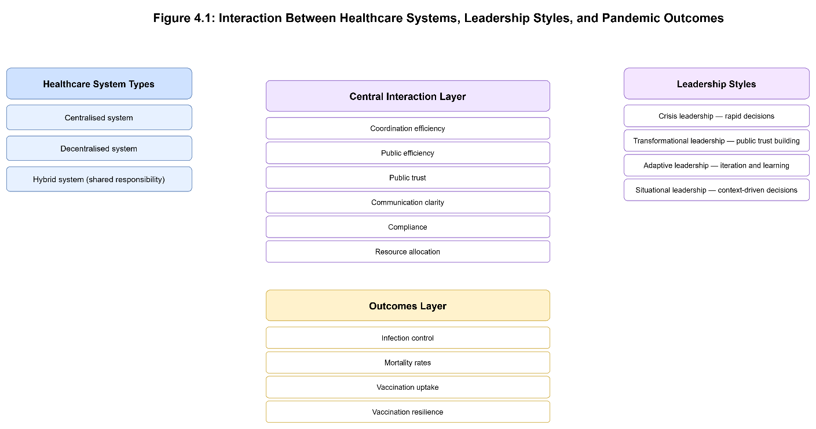

4. Conclusion
This report has critically analysed the role of the organization of healthcare systems and leadership styles in influencing the way countries responded to the COVID-19 pandemic in Spain, South Korea, and Canada. The comparative analysis proves that the level of centralisation or decentralisation was a significant factor of coordination, consistency of policies, and health outcomes but was not the only factor of success. The extremely centralised nature of South Korea, enabled by the institutional capacity to make decisions and the adaptive leadership, allowed making decisions fast, coordinating them, and maintaining the trust of the population. Conversely, the timely response and coherence was initially not possible in Spain because of its decentralised system, but temporary re-centralisation during the vaccination phase enhanced the outcomes. The federal and decentralised system in Canada provided the regions with flexibility however, fragmented responses and uneven results across the provinces.
The leadership analysis also indicates that effective management of a pandemic is subject to leadership styles, which are in line with governance structures. The emergence of transparency, decisiveness, and involvement of the people in leadership, transformational and crisis leadership, came in handy especially in South Korea. Spain and Canada had shown adaptive and situational leadership during the years; though, the political complexity and split authority limited the effectiveness of leadership in their early years. In general, the results indicate that effective pandemic responses should be based on the hybrid form of governance, which integrates central coordination and local implementation with adaptive, trustful leadership that can steer healthcare systems through the long-term uncertainty.

References
Allin, S., Marchildon, G. and Peckham, S., 2021. Canada’s COVID-19 response: federalism and health policy. Canadian Public Policy, 47(2), pp.1–15. Available at: https://www.ncbi.nlm.nih.gov/pmc/articles/PMC8326669/ (Accessed: 13 December 2025).
Bubela, T., Flood, C.M., McGrail, K. and Straus, S.E., 2023. How Canada’s decentralised COVID-19 response affected public health decision-making. Policy Report, pp.1–40. Available at: https://www.researchgate.net/publication/372600014 (Accessed: 13 December 2025).
Carroll, B.J., 2023. Multilevel governance and responses to COVID-19: a systematic review. Policy and Society, 42(4), pp.1–18. Available at: https://www.tandfonline.com/doi/full/10.1080/13597566.2023.2292997 (Accessed: 13 December 2025).
Chapman, M., 2021. Economic impacts and future pathways: COVID-19 in Atlantic Canada. Island Studies Journal Report, pp.1–28. Available at: https://islandstudies.com/files/2021/07/Economic_Impacts_and_Future_Pathways__COVID-19_in_Atlantic_Canada.pdf (Accessed: 13 December 2025).
Dadich, A., Fulop, L. and Fitzgerald, J.A., 2023. Health service management and leadership during COVID-19. Frontiers in Health Services, 3, pp.1–6. Available at: https://www.ncbi.nlm.nih.gov/pmc/articles/PMC10011686/ (Accessed: 13 December 2025).
Erkoreka, M., 2022. Decentralization as a handicap in fighting COVID-19: the response of regional governments in Spain. European Journal of Public Health, 32(5), pp.1–7. Available at: https://www.ncbi.nlm.nih.gov/pmc/articles/PMC9349406/ (Accessed: 13 December 2025).
European Commission, 2021. Spain: health system review – Country health profile. Brussels: European Union. Available at: https://health.ec.europa.eu/system/files/2021-12/2021_chp_es_english.pdf (Accessed: 13 December 2025).
García-Basteiro, A.L., Moncunill, G., Tortajada, M., Vidal, M., Guinovart, C., Jiménez, A. and Bassat, Q., 2020. Evaluation of the COVID-19 response in Spain: principles and requirements. BMJ Global Health, 5(9), pp.1–9. Available at: https://www.ncbi.nlm.nih.gov/pmc/articles/PMC7505572/ (Accessed: 13 December 2025).
Government of Canada, 2023. Chief Public Health Officer’s report on the state of public health in Canada. Ottawa: Government of Canada. Available at: https://www.canada.ca/en/public-health/corporate/publications/chief-public-health-officer-reports-state-public-health-canada/state-public-health-canada-2023/report.html (Accessed: 13 December 2025).
Inter-American Development Bank., 2024. The Republic of Korea’s digital tools for fighting COVID-19. Washington DC: IADB. Available at: https://publications.iadb.org/publications/english/document/The-Republic-of-Koreas-Digital-Tools-for-Fighting-COVID-19.pdf (Accessed: 13 December 2025).
Jeong, B.G. and Kim, S., 2024. The collaboration dynamics of government and civil society during COVID-19 in South Korea. ICNL Report. Available at: https://www.icnl.org/wp-content/uploads/2024-Korea-Pandemic-Report-vf.pdf (Accessed: 13 December 2025).
Jeong, E., Hagose, M., Jung, H. and Ki, M., 2020. Understanding South Korea’s response to the COVID-19 outbreak. International Journal of Environmental Research and Public Health, 17(24), pp.1–15. Available at: https://www.mdpi.com/1660-4601/17/24/9571 (Accessed: 13 December 2025).
Kim, W., Moon, J. and Choi, Y., 2021. Governance and preparedness in South Korea’s COVID-19 response. International Journal of Infectious Diseases, 110, pp.1–8. Available at: https://www.ncbi.nlm.nih.gov/pmc/articles/PMC8382722/ (Accessed: 13 December 2025).
Korea Disease Control and Prevention Agency., 2022. COVID-19 response and management report. Cheongju: KDCA. Available at: https://kdca.go.kr/filepath/boardDownload.es?bid=0034&list_no=720267&seq=1 (Accessed: 13 December 2025).
Laur, C.V., Agarwal, G., Mukerji, G. and Gagliardi, A.R., 2021. Adaptive leadership and health service innovation during COVID-19. Healthcare Policy, 16(4), pp.1–14. Available at: https://www.ncbi.nlm.nih.gov/pmc/articles/PMC7808765/ (Accessed: 13 December 2025).
Lim, S. and Sohn, M.J., 2023. How to cope with emerging viral diseases: lessons from South Korea’s strategy for COVID-19. Lancet Regional Health – Western Pacific, 31, pp.1–10. Available at: https://pubmed.ncbi.nlm.nih.gov/36093123/ (Accessed: 13 December 2025).
Moradi, H., Vaezi, A. and Behzadifar, M., 2020. Lessons learned from Korea’s COVID-19 response. Journal of Global Health, 10(2), pp.1–6. Available at: https://www.ncbi.nlm.nih.gov/pmc/articles/PMC7167487/ (Accessed: 13 December 2025).
Oliver, N., Barber, X., Roomp, K. and Roomp, K., 2020. Assessing the impact of the COVID-19 pandemic in Spain. Journal of Medical Internet Research, 22(9), pp.1–12. Available at: https://www.jmir.org/2020/9/e21319/ (Accessed: 13 December 2025).
Public Health Agency of Canada., 2022. COVID-19 epidemiological summary. Ottawa: Government of Canada. Available at: https://health-infobase.canada.ca/src/data/Covidlive/epidemiological-summary-of-Covid-19-cases-in-Canada-Canada.ca.pdf (Accessed: 13 December 2025).
Public Health Agency of Canada., 2023. Federal, provincial and territorial public health response plan for COVID-19. Ottawa: Government of Canada. Available at: https://www.canada.ca/en/public-health/services/diseases/2019-novel-coronavirus-infection/guidance-documents/federal-provincial-territorial-public-health-response-plan-ongoing-management-covid-19.html (Accessed: 13 December 2025).
Royo, S., 2020. Responding to COVID-19: the case of Spain. Public Administration and Development, 40(5), pp.256–271. Available at: https://www.ncbi.nlm.nih.gov/pmc/articles/PMC7753436/ (Accessed: 13 December 2025).
Sachs, J.D., Karim, S.S.A., Aknin, L., Allen, J., Brosbøl, K. and Cuevas Barron, G., 2022. The Lancet Commission on lessons for the future from the COVID-19 pandemic. The Lancet, 400(10359), pp.1224–1280. Available at: https://www.thelancet.com/article/S0140-6736(22)01585-9/fulltext (Accessed: 13 December 2025).
Sánchez-Bayón, A., Lominchar, J. and Trincado, E., 2022. Spanish healthcare sector management during the COVID-19 pandemic. Healthcare, 10(4), pp.1–18. Available at: https://www.ncbi.nlm.nih.gov/pmc/articles/PMC8971546/ (Accessed: 13 December 2025).
Sanders, J., Hayes, C., Johnson, M. and Huxley, C., 2021. Clinical leadership during the COVID-19 pandemic: a systematic review. BMJ Leader, 5(2), pp.1–9. Available at: https://www.ncbi.nlm.nih.gov/pmc/articles/PMC8547230/ (Accessed: 13 December 2025).
Santoso, N.R., Fisher, R. and Garcia, P., 2022. Transformational leadership during the COVID-19 pandemic. Frontiers in Psychology, 13, pp.1–14. Available at: https://www.ncbi.nlm.nih.gov/pmc/articles/PMC9019500/ (Accessed: 13 December 2025).
Smith, R.W., Silva, D.S. and Upshur, R., 2022. Centralisation and integration of public health systems during COVID-19. BMC Public Health, 22, pp.1–12. Available at: https://www.ncbi.nlm.nih.gov/pmc/articles/PMC9681988/ (Accessed: 13 December 2025).
Spanish Ministry of Health., 2022. Public Health Strategy 2022. Madrid: Government of Spain. Available at: https://www.sanidad.gob.es/ciudadanos/pdf/Public_Health_Strategy_2022_Pending_NIPO.pdf (Accessed: 13 December 2025).
Viguria, U.A., Santana, R., Pizarro, J.L. and Arrieta, J., 2021. Early interventions and impact of COVID-19 in Spain. International Journal of Environmental Research and Public Health, 18(7), pp.1–14. Available at: https://www.ncbi.nlm.nih.gov/pmc/articles/PMC8068943/ (Accessed: 13 December 2025).
World Bank., 2023. Republic of Korea: COVID-19 preparedness and response case study. Washington DC: World Bank. Available at: https://thedocs.worldbank.org/en/doc/214261388bdfa468bd8d180cb8ecb907-0070012023/original/Korea-case-study.pdf (Accessed: 13 December 2025).
World Health Organization., 2021. Strategic preparedness and response plan for COVID-19. Geneva: WHO. Available at: https://www.who.int/docs/default-source/coronaviruse/who_sprp-eoyr_2020_24022021.pdf (Accessed: 13 December 2025).
.

