Contemporary Human Resources in Practice Assignment 1
M6X00873

The future of HR

Yijun Liu 1904772

Introduction
The development of technology and networks has a tremendous impact on people's daily lives, and people's lives have become more convenient (AgingInPlace,2019). Convenient communication and shared resources invisibly promote new trends in economy like the gig economy, and new methods of business management. The background of economy and technology has a close relationship with the labor market (Investopedia,2019). Human resources are an important part of enterprise management, changing conditions require the focus and model of human resource management to improve constantly, especially in the context of the development of AI, the requirements for human resources has become more and more. For enterprises, it is necessary to clarify the inherent nature of human resource management in current conditions before they can actively respond. For human resources professionals, they should improve their own skills and be fully prepared to meet unknown challenges. This following essay will start with analysising the megatrends of the world and its impact on human resources management, trends of human resource management in this environment and new human resource roles created for the future workfoce, then links with the reality, puts forward what skills human resources professionals should master, aims to provide some valuable suggestions for the future development of HR.

Main body
1. Global Megatrends
1.1AI
Margarer (2018) notes that Artificial intelligence (AI) is a technique used to accomplish a task that requires a certain amount of intelligence to complete. Specifically, it is based on a large amount of data and accurate algorithms to quickly complete the calculation process, which can provide better accuracy and stability services for daily processes. Artificial Intelligence plays an important role in HR, “Estimates indicate that 20% of human resources workers will specialise in activities that are related to AI by 2020” (Livingston, 2018, p. 14) Fortunately, robots can’t completely replace HR. However, artificial intelligence will provide us with more time and more accurate information for HR to make those important decisions (Gulliford & Parker Dixon, 2019, p. 54) Clare Barclay, chief operating officer of Microsoft UK says “Embracing AI is now an essential element of any successful business strategy and in HR it can deliver rapid value,” (Oliver, 2018)
1.2gig economy
With the continuous progress of science and technology, the Internet has been widely used in human life, and the economic situation has changed with it. Gig economy is a new type of economic form produced in the current complex environment, which refers to resource sharing for the purpose of obtaining economic benefits. In this way, if enterprises want to achieve better goals and survive in fierce competition, they should not only optimize and upgrade the quality of their products, but also change the internal management, especially take appropriate ways to maximize the benefits of human resources and actively face the difficulties and challenges brought about by gig economy. (Rosenblat, 2016, p. 55)
1.3globalization
Economic globalization is an obvious trend in the 21st century. In order to increase sales, many companies explore foreign markets, they need employ foreign managers and staffs, use foreign management methods. The position of human resources in companies is also constantly improving, more and more companies realize that human resources plays an important role in enhancing their competitiveness. (Elisabeth, 2018, p. 25) In this way, different values, ideological management ideas, the diversification of staff composition which push human resources management must be changed to adapt to new changes.
1.4Millennials and changing demographics
According to the United Nations population Fund, rapid population growth has become a trend, especially in developing countries. This also means that it is particularly necessary for the systematic training and comprehensive quality improvement of staff in human resources management. Millennials are moving into the workplace, which increases the awareness of generational differences. Wooldridge (Wooldridge, 2017, p.1) notes that significantly different styles of work among the various age groups bring challenges to HR professionals in today's workforce.
1.5VUCA
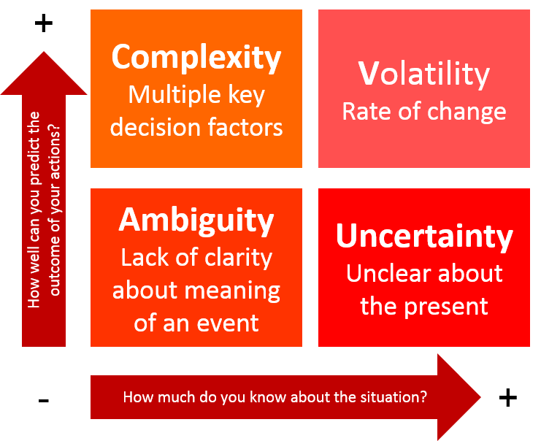
VUCA (short for volatility, uncertainty, complexity, and ambiguity) was proposed by the United States military to describe the environment at the time of the collapse of the Soviet Union in the early 1990s. In the VUCA era, technology explodes, the processes, tools, and methods needed to deal with the same problems are constantly changing, using past experience and skills to solve new problems, or always trying to deal with problems with the same process pattern, which is likely to be completely ineffective, or unable to come up with the ideal answers we need. (Millar, et al., 2018)Enterprises are faced with the new challenges of rapid response to the changes in the external environment, and human resources management is facing change.(Lori Kleiman,2018)
2. Organization needs in the future
More than 90 percent of the organizations surveyed said that the Ulrich model had made a huge contribution to the development of human resources over the past decade.(Orion Partners) However, with the growth of economy and the development of technology, the relationship between organizations is getting closer and closer. The environment is changing, and the organizational structure of human resources should be changed to adapt to the environment (Josh Bersin,2015). At present, because each company has its own unique needs and lacks innovation in the Ulrich HR model, it can’t adapt to the organizational structure and changing needs of the company. (Tonmoy Shingal, 2019) Even though Ulrich is not a perfect one, but it’s a good starting point. (NGA Human Resources, 2018)
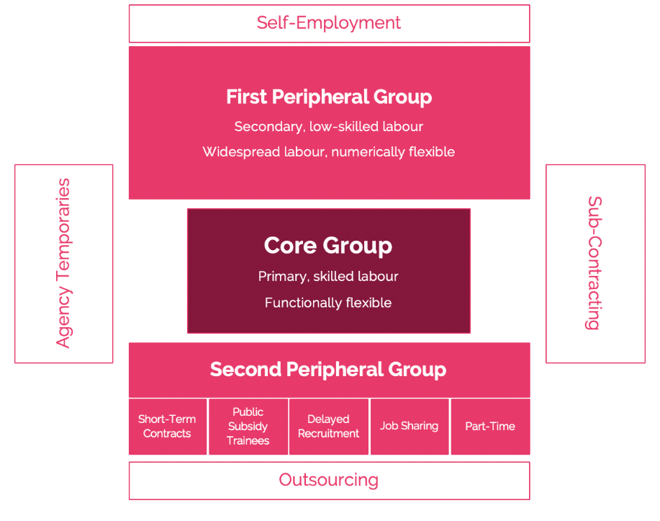
The Flexible-Firm Model was proposed by John Atkinson in 1984. He argues that the model is mainly through the arrangement of staff and the adjustment of organizational structure, flexibly response to the changing and unpredictable market environment. (Businessballs,2019) Executives often make decisions about layoffs based on this model. First Peripheral Group is the first choice for layoffs, because they are not part of the organization and usually only complete specific tasks signed in advance. If the organisation needs further enrichment, that will be second peripheral group. In this mode, core members are safe because their functions are recognized as important and irreplaceable by the organization.
In the era of VUCA, due to the rapid development of digital technology, a lot of work can be done by robots or AI technology alone, so the size of the organization is getting smaller and smaller. In the shape of the organization, the internal workforce will become less important. Complex and changeable environment requires human resources professionals to have high quality and unique professional skills.
3.Trends of HRM in the future
3.1 Based on big data
In the light of being subjected to the limitations of external conditions, the traditional human resources management needs to consume a lot of manpower, material and financial resources, and the managers who engage in human resources management departments tend to have a relatively high labor intensity and low work efficiency. However, the Internet is also changing the human resource management approach with the rapid advancement of information technology. For example, without the need to go for all over the world in reality, human resources managers can carry out recruitment, employee training and other modules online which shows an inevitable trend that human resources management tends to be virtualized. (Angrave, et al., 2016)Therefore, the future human resource management should not only establish and perfect the technical system to adapt to the virtualization management, but also establish the enterprise network culture to adapt to the development of information technology.
3.2 Cross-cultural management has become a new trend
Today the business environment is competitive, the products need to meet different needs, and the workforce has become diversified. The company employs workers with different ethnic and cultural backgrounds and educational backgrounds. Therefore, cross-cultural management is an important content that can’t be ignored in human resource management.
3.3 Attach importance to the recruitment of talents
With the increase of the world population, the competition in the human resources market is becoming more and more fierce. Due to the development and popularization of high technology, many simple jobs are no longer operated by human beings, but replaced by robots.(Arthur H.& Michael S, 2018) Talents can enter the core departments of enterprises and play an irreplaceable role, which is conducive to promoting the rapid development of enterprises and improving competitiveness in the market.
3.4 HR will need to become more like Marketing
Marketing has become one of the best popular trends in the market, and marketers learn to post interesting advertisements in order to attract, transform and retain customers. In fact, human resources are also marketing. Human resources professionals should introduce the brand, culture and future development plan of the enterprise to job seekers, sell talent strategies and forward-looking strategies to bosses, and sell their own services and specialties to other departments. The sales plan is to greatly increase the scope of product promotion. Similarly, human resources are creating the shared content that employees want, to help build more connections between employees and leaders, so that employees can be happy in their careers.(Michael B,2017)
4. Essential Skills of HR professionals
4.1Complex problem solving
The skill of solving complex problems means without previous experience, based on critical thinking, objectively understand things from all angles and correctly handle sudden or difficult problems in complex and ever-changing environments(Arnaud. Chevallier, 2016, p.35). It is a prerequisite to think about whether the difficulty matches your ability before solving complex problems, Human resources professionals should enrich their professional knowledge and enable themselves to solve the difficulties (Emily McCafferty,2013)
4.2Critical thinking
Critical thinking is an objective analysis of facts, considering different points of view, and finally come up with a reasonable and logical conclusion. And Critical thinking is not innate, in other words that it is a skill. Most people make decisions based on personal prejudice and irrational emotions, which is human nature (Jessica L,2019). HR professional should not only timely observe environmental changes, but also maintain critical thinking and eliminate subjectivity. Give practical consideration to the consequences and impact of each solution. Critical thinking is one of the necessary skills for human resources professionals. At the same time, human resources professionals should also advocate and support all employees to cultivate critical thinking.
4.3Creative thinking
HR should timely sense the changes in the outside world and constantly innovate and break through the working mode and method. Creative thinking means constantly negate their original work experience, optimize and innovate the working methods and management tools according to the conditions in the internal and external of the enterprise. At the same time, don’t be mislead by the changing external environment, because no matter how the times change, many basic laws of human nature rarely change, so it is more important to master these psychological laws of human nature and the underlying behavior logic of human beings, which is precisely the foundation of our iterative innovation.
4.4Learning in the flow of life
“Organisation have to change the way of learning is the number-one trend in 2019, 86% of respondents regard it as an urgent problem” (Deloitte ,2019, p. 4). There is no denying that with the development of economy and technology, the demand of talent who have unique skills or master high technology is increasing, In order to find talents quickly, HR should also make full use of learning opportunities to improve themselves in daily life. HR professional should not complain that demand has changed, but should follow the market and operational data, actively embrace change, adjust strategies and mentality, and think with the times.
4.5 Strategic Planning
The role of HR professionals is not only promoting and implementing corporate strategies, but also participating in the formulation and decision-making of corporate strategies. Specifically, put forward the feasible plans for the current and future development of the company and suggestions for the management. Predicting the future of the company from the perspective of development, constructing the human resource management system suitable for different development stages of the company, formulating the relatively dynamic human resources work strategy, and constantly adjusts and optimizes it.
4.6 Emotional intelligence
Emotional intelligence is a kind of invisible wisdom, which can make human beings adapt to all kinds of emotions and skillfully adjust their behavior according to each other's emotions and even psychological feelings (Grishina, et al., 2018). Mahesh Nair (2016) says that in today's social environment, the role of emotional intelligence cannot be ignored. In the management of the company, it is very important to retain outstanding talents. The best way for human resources professionals to retain employees is incorporating emotional intelligence into the management idea of individuals and organizations. Human beings are emotional animals, their real life and emotion will affect their thinking. Human resources professionals with emotional intelligence understand that their staff members are people first and worker second.

Bibliography
1.AgingInPlace (2019) Technology in our life today and how it has changed. Available at: https://www.aginginplace.org/technology-in-our-life-today-and-how-it-has-changed/ (Accessed: Nov 2019).
2.Investopedia (2019) Employability, the Labor Force, and the Economy. Available at: https://www.investopedia.com/articles/economics/12/employability-labor-force-economy.asp (Accessed: 25 July 2019).
3.Deloitte (2019) 2019 Global Human Capital Trends. Available at: https://www2.deloitte.com/us/en/insights/focus/human-capital-trends.html(Accessed: 11 April 2019).
4.Gulliford, F. & Parker Dixon, A.(2019) ‘AI: the HR revolution’, Strategic HR Review, pp. 52-56.
5.Livingston, J.(2018) ‘HR trends that are emerging in the Future of Work’, HR Future, pp. 16-18.
6.Margarer, R.( 2018)Search EnterproseAI. [Online]
Available at: https://searchenterpriseai.techtarget.com/definition/AI-Artificial-Intelligence [Accessed August 2018].
7.Angrave, David ; Charlwood, Andy ; Kirkpatrick, Ian ; Lawrence, Mark ; Stuart, Mark (2016) HR and analytics: why HR is set to fail the big data challenge,Human Resources Management Journal, pp. 1-12
8.Lori Kleiman. (2018) HRtopicsI.[Online] Available at: https://hrtopics.com/getting-control-vuca world/ [Accessed January 31, 2018].
9.Millar,C , Groth, O. & Mahon, J. F.(2018)‘ Management Innovation in a VUCA World：Challenges and Recommendations’, California Management Review, pp. 5-15.
10.Oliver, p. (2018) ‘AI in HR: freeing up time to be more human’, Future of HR, 8 11.
11.Pu J. (2010) ‘Cross-Cultural Human Resource Management’, Business Economics and Tourism, pp.56. Available at: https://www.theseus.fi/bitstream/handle/10024/20819/Thesis-Pu%20Jing.pdf (Accessed: 15th Feb 2010).
12.Tonmoy S. (2019) ‘Managing HR Roles: David Ulrich’s HR Model’, Human Resource Management，23 Oct 2019
13.Rosenblat, A. (2016) What Motivates Gig Economy Workers. Harvard University.
14.Arnaud, C. (2016) Strategic Thinking in Complex Problem Solving. New York, NY: Oxford University Press.
15.Wooldridge, S. (2017) ‘4HR trends from 2017’, Benefits PRO, p.1.
16.Josh, B. (2015) ‘A modern HR operating model: the world has changed’, Changing HR operating models, p.5
17.Elisabeth, N. (2018) ‘Effects of Globalization on Human Resources Management’, Human Resource Plan, pp.20-24
18.Arthur H. & Michael S. (2018) ‘Reimagining Human Resources: The future of the enterprise demands a new future of HR’, Deloitte Development LLC.
19.Busineeeballs (2019) Flexible-Firm Model
Available at: https://www.businessballs.com/organisational-culture/flexible-firm-model/ (Accessed: 25 April 2019)
20.Emily, M. (2015) Problem Solving and Thinking Skills [video]. Available at:https://www.youtube.com/watch?time_continue=186&v=Str74aNudg8&feature=emb_title (Accessed: 2 Feb 2013).
21.Becky F. (2015) HR must encourage staff to think more critically
Available at:https://www.hrmagazine.co.uk/article-details/hr-must-encourage-staff-to-think-more-critically (Accessed: 03 Dec 2015)
22.Jessica L. (2019) Why Critical Thinking Skills Are Important in the Workplace. Available at: https://www.ziprecruiter.com/blog/why-critical-thinking-skills-are-important-in-the-workplace/
23.Grishina&Iseaeva&Savinova (2018) ‘Emotional intelligence of HR-management students’ Directory of Open Access Journals. pp.6
24.Mahesh N. (2016) The importance of Emotional Intelligence in Human Resources. Available at: https://www.linkedin.com/pulse/importance-emotional-intelligence-human-resources-mahesh-nair
25.Michael B. (2017) Why HR is the new marketing. Available at: https://business.linkedin.com/marketing-solutions/blog/content-marketing-thought-leaders/2017/why-hr-is-the-new-marketing

