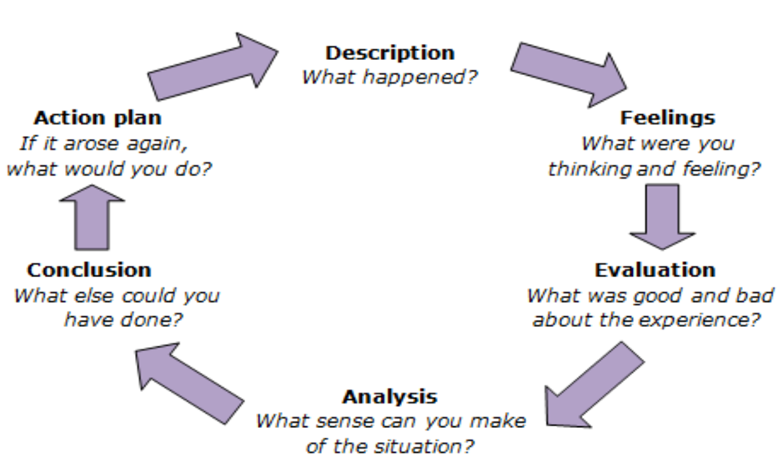

Reflection.

During the usual session on Wednesday, we were surprised by the unexpected arrive of international students, coming from different parts in China. They arrived in the University from 2-3 days, and our project has been advised from the International Support Office. They were young people between 18 and 21 we presumed, all males with one older figure who was the teacher or responsible for the group. Later on, two young girls joined us, timidly. They were from China as well, and they found our project thanks the ISO. Me and a colleague were playing cards game with the boys, when we saw the young girls arrive. As I saw them like lost and timid, I immediately try to engage with them, offering a hot beverage and painting with them. Everything went smoothly, sharing myself between the card games on one table, and an informal chat to keep the girls involved. When the moment of saying bye arrived, I spontaneously tried to ensure that everybody felt welcomed, with the positive aim to see all, again, in the following session. As I perceived shyness from the two girls, I maybe wrongly, offered myself as a support around the campus. The meaning of the ‘offer’, was to help them knowing the surrounding, and giving them a person, they could trust and rely on, even just to contact for attending the following session.
My action was spontaneously driven, by positive feelings. Saying this, I meant no harm. What I felt, was a projection of what were my fears at that age, about being shy, misunderstood and not welcomed. So, I spontaneously acted like a sort of saviour, crossing every boundary, putting a risk myself and the young people I tried to help and support. The aim was exclusively to ‘save’ them, from exclusion.
During the self-analysis, a bad aspect of the experience was the amount of possible risks I lived, the possible negative outcomes and consequences. A good aspect was the discovery of my passion for this profession. It is possible to argue that, acknowledging my constant need to improve, my principles are strong and prioritize the young people.
This experience can be evaluated as one more reason to learn, how to not project myself, in other people. With the aim, to safeguard them and myself.
I personally wanted to do more, like helping them giving my personal contacts and show them the campus and around. I felt the desperate need to be helpful, as soon as I recognised a small sign of shyness. Doing this, I exposed them and myself, risking my professionality. Even if they looked to appreciate my behaviour, I am aware that was not the best option. Instead of that, I could have simply reminded them the next session, hoping for them to come back.
In the eventuality that a similar situation may happen again, I am aware of the tools I have to tackle and welcome shyness, without forcing any additional feeling. Simply making the session memorable, will positively reminding young people, they were welcomed and there always will be, a safe place.

-------------------------------------------------------------------
PowerPoint Presentation: Notes & Key Points.

- Keep the Presentation short, and clear.
- The Presentation should be neat, tidy and professionally looking.
- 10 minutes Presentation: - 2/3 minutes for the description. – 2/3 minutes for the review, using theories to justify my words. – 4/5 minutes on the main part, the evaluation of possible learning for future practice.
- No pictures are needed, main focus on what explained verbally.
- To justify my words, acknowledge concepts learnt from my reading.

Important: Mention authors or theorists, during the Presentation to help the understanding.

