1902559- Bettina Silsby
Leading and Managing Change

University of Wales, Trinity Saint David
3/18/2022

Audi as Hybrid and Electric cars
Executive Summary

Table of content

Table of Contents
1.0 Introduction 3
2.0 Main Body 4
2.1 Background of Audi………………………………..……………………………………………………………………….4
2.2 Implementing Changes …………………………………………………………………………………………………..5
2.3 Changing Models…………………………………………………………………………………………………………….7
2.4 Leadership – Management of Complex Areas …………………………………………………………………9
2.5 Culture………………….………………………………………………………………………………………………………10
2.6 Change Agents ………….……………………………………………………………………….……………………….11
Conclusion …………………………………………………………………………………………………………………………………12
Recommendation…………………………..………………………………………………………………………………………….12
Reference list……………………………………………………………………………………………………………………………..14
Appendices………………………………………………………………………………………………………………………………..16

- Introduction
This report has been put together upon the request to analyse Audi changing management through look at internal and external factors that have been impacted the organisation. This report has been requested by Brynach Heffernan Manager Director of Audi on 10th of January 2022 and It has been completed by Bettina Silsby a Change Manager Director of Audi on the 19th of March 2022.
The purpose of this report is to understand the last two years challenges due to internal and external impact on the organisation, understanding all the changes that Audi leadership and management implemented to resolve those issues, analysing working culture through Handy and Hofstede Culture models, and looking at the implementation of change agents on the internal and external level. To adapt changes at any organisation it is very important to involve stakeholders in the right stage, the best way to understand all the steps and carry out a successful change at any organisation is using changing models, Audi must recognise the importance of implementing changing models when is conducting any changes and must involve change agent. This report will critically discuss Lewin and Kubler Ross change management models, and it will be analysing the involvement of change agent for the electric/hybrid car manufacturing. The report will draw out a conclusion and will make a recommendation to help resolve issues and to help achieve a success outcome.
To create this report and have critical view on the all-organisation primary and secondary sours have been analysed, for example Articles, Journals, websites, and Books.

- Main Body

  - Background of Audi

Audi was technically founded in 1885 when the Wanderer Company was established, later becoming a branch of Audi, but as we now know it launched their first car in 1910 and was the first type of Audi Type A Sport-Phaeton. Sales grew strongly during the 2000s and this continued into this decade. Audi saw record sales in May 2011 and produce vehicles in seven countries across the world. Audi lunch they first hybrid car in very early years the first hybrid model was the 100 Avant quattro Duo of was manufactured in 1989 (OSV, 2022)
According to the online Car Sell Statistic website (2022) Audi market share between 2016-2020 had a range between 3.1 and 9.8 percent, meaning it consistently controlled a relatively high portion of the UK car market. Audi had the fifth biggest market share in the UK market in December. Audi have announced a total revenue of £50.29 billion worldwide, while the total market revenue amounted to £1.2 trillion in 2020. According to Deslauriers (2022) The electric car revenue AUDI AG is continuing its transformation into a provider of sustainable premium mobility and claims to be by some distance the biggest maker of electric vehicles. The Audi e-tron model registered a significant increase in demand last year, with growth of 79.5 percent (47,324 cars) compared with the previous year. With breaking in the electric car market Audi find another big competitor the modern American electric car company Tesla. According to Reed (2020) Tesla an electric vehicle manufacturer and clean energy company founded in San Carlos, California in 2003 by American entrepreneurs Martin Eberhard and Marc Tarpenning. The company is named after Serbian inventor Nikola Tesla. Tesla is the world's leading electric vehicle manufacturer, and, as of the end of 2021, Tesla's cumulative global sales totalled 2.3 million units.

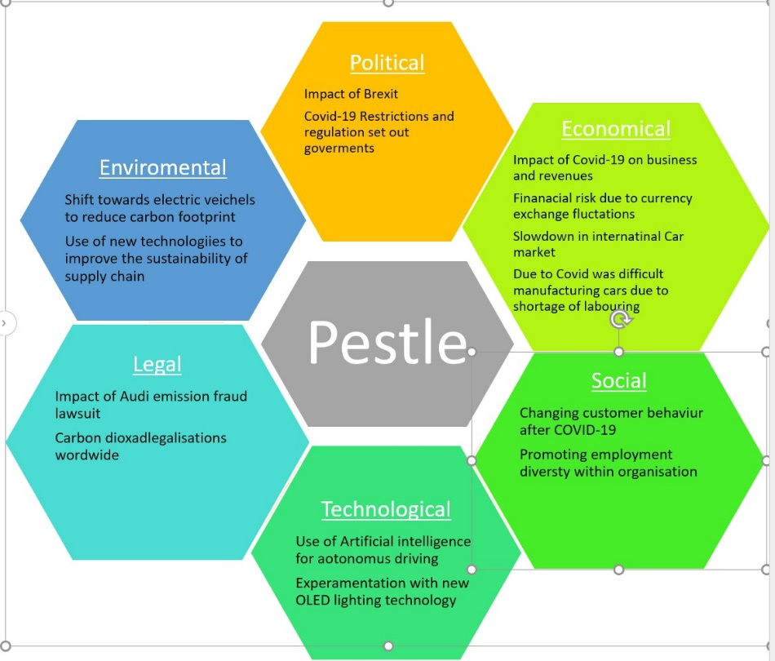
  - Implementing changes
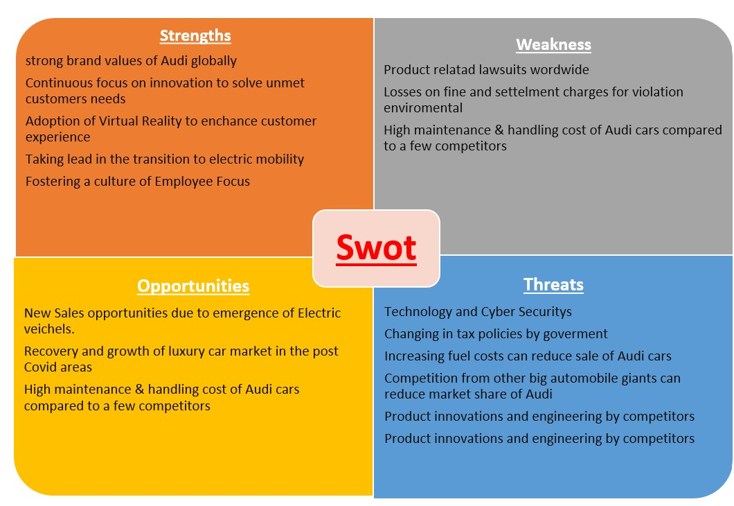
According to Thompson (2018) In simple terms, business change is the act of moving the company from where it is now to where it wants to be. Change can be happened from impact of positive or negative factors. Mccullough (2022) stated Change encourages innovation, develops skills, develops staff, and leads to better business opportunities, and improves staff morale. Changes can help organisation in many ways not only help with profit margin but have positive effects on working culture. Also, in businesses each day can bring different challenges that leaders must resolve. Undertaking regular PESTLE analysis can help understand external factors, that is have impact on the organisation and the Swot analysis can help see what internal factors the company to help support all the stage of in change. In the last two years many external factors have been impacted organisation due to Brexit, Covid-19, and Climate change problems. The firs diagram showing the full PESTLE analysis that have effect currently on Audi. Economical and Environment factors need to be resolving urgently through the great opportunity that technological factor can offer for the company. Audi have had early developments on electric car manufacturing according to Audi.com (2022). It was great opportunity to put more invest and labouring to answer Covid-19 impacts and Climate change regulations. Market Line Report (2020) showing sales have been driven by large amount of favourable polices introduced in recent years which have increased the demand for purchasing electric or hybrid vehicles. According to MarketLine report (2020) the EU is aiming to reduce 40% of emission by 2030 and planning to implement tighter regulation to encourage consumers to purchase hybrid and electric cars. Hence only way to be answer the external impacts and stay on the top of the market for Audi (2019) have announced it will become a provider of holistic CO2-neutral premium mobility, with the aim of assuming a leading role among its competitors. The manufacturer is therefore accelerating its electrification roadmap and company-wide decarbonization. By 2025, the vehicle fleet’s CO2 footprint is to be reduced as a first step by 30 percent over its entire lifecycle compared with 2015. In the future, return on investment as a key financial steering parameter will also reflect the CO2 performance of the Four Rings and is to rise to more than 21 percent through sustainable management. (Neckarsulm, 2019) The SWOT analysis showing on the second diagram explain that Audi have a strong brand value on global scales, Audi also have a strong working culture, and the employees are showing trust and loyalty to the organisation. Therefore, Audi already on stable base to implantation successful changes. Audi should take consideration all the threat that is relevant to the electric car innovation and manufacturing process. The new record increase in global gas price will leading to increasing 54% of electric prise in UK market and will affect other countries. (Ofgem.gov.uk, 2022) Hence Audi need it calculate higher manufacturing cost and the consumer will have less money to spend on car, where electric car already considered one the high-end price cars. The other major investment next to manufacturing electric cars will be building enough car charging points on the countries there Audi present on the market to help encourage consumers to buy electric car.

  - Changing models
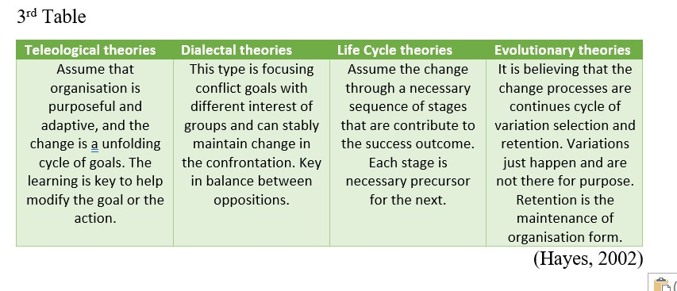
Organizational change has been a persistent topic of discussion in the field of organizational behaviour and organizational effectiveness for many decades (Nadler 1995)
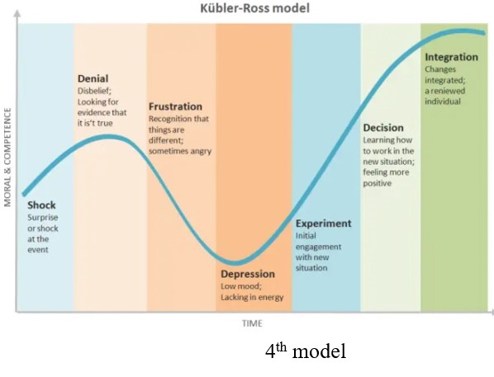
Hayes (2002) have stated that effective leaders are those who set a direction for changes and influence others to achieve goals that improve internal and external alignments. To be able to direct changes leaders at any organisation must have good afford to implement any of the change management models. The first step is identifying the changing model that is most applicant to the nature of changes. Hayes (2002) led to four type of changes- teleological, dialectical, life cycle and evolutionary theories as the third table is explaining the difference between the theory types. Lewin (1951) created a free step changing model. Lewin argued that the state of no change does not refer a situation in which everything is stationary. (Hayes, 2002) The change can link to behaviour of people at the organisation that is act as a force and pushing for and resisting change. Lewin suggested that the successful change require three-step – 1st unfreeze the organisation from its present state, 2nd make a desired type of change and 3rd refreeze the organisation in the new desire state (Crolley, 2021). This model fit in the teleological and dialectical theories how the third table explaining above. Crolley (2022) have stated this model is very simple and easy to understand, it is uses clear concepts and illustrations that make change management easy to understand. However, it can be argued that the Kurt Lewin change theory may be somewhat outdated since it was developed in 1947 well before technology became such a central part of today’s workplaces. The online article Start-up Talky (Admin, 2011) have argued Lewin change model is requires a lot of time to freeze and settle down with the new changes. As the changes continue to take place in a challenging environment, the organization may not have the time to get used to the modifications.
The other changing model that is originally was developed to help people in grief is Kubler Ross (1969) Coping cycle model. This model looking at 5 stages of emotion as the fourth model showing. According to Belyh (2022) The Kubler-Ross Model also holds true when it comes to business, work, or employment. Every organization needs to bring about changes in its management and policies. But besides the improvement of systems, there must be a change in the people or employees as well. If even in bringing about several changes in the systems and processes, the employees of any organisation must be persisting the old ways, otherwise all the investment will go waste. This is the main reason why it is important for the employees too to adapt and change accordingly. Only when the workforce of an organization makes personal changes, or transitions can the company move ahead and reap the benefits. Also, according to Mindtools (2022) with knowledge of the Change Curve, organisations can plan how to minimize the negative impact of the change and help people adapt to it more quickly. Tahir (2019) have criticized this model for being relevant to situation and to culture and it is not applicable to all situation in the entire change process.
Chairman of the Board of Management of Audi Markus Duesmann (2022) have stated Audi has enormous potential. The flexibility and adaptability of people at Audi over the course of the pandemic it was genuinely impressive. Audi power is the people that works for organisation. For Audi is very important to help each employee in the adaptational and changing process. Audi have published interviews employees that is showing sings Audi have implemented Kubler Ross model to help for employees in the changing process. Audi (2022) have asked employment in deferent sectors inside the organisation to talk about the changing process. The employees explained the first shock was working from home and same to be unrealistic is happened in one minute to the other. In the adaptation was issues around technical support and it was causing frustration at employees. Audi have created the z20guides, this is a very modern form of cooperation to support employees. Almost 300 people throughout the whole Audi Group act as daily helpers, assisting each colleague with queries and problems, regardless of hierarchies and hurdles. To give further support Audi have digital.shift’ and ‘digital.future’ initiatives. The six to 18-month qualification programs are intended to build up IT skills in the company in order to strengthen strategic areas of future focus and support the digital transformation. Audi employees are approached specifically and prepared to take over an activity in the Audi IT Department. (Audi, 2022) Audi have offered many ways to help in the adaptational to new situation for all employees instead of choosing Lewin freezing model that is helped to form a strong culture that is have full trust in the organisation.

  - Leadership – Management

Gill (2002) argues that change is requires effective leadership to be successfully introduced and sustained. Combining an understanding and translation of vision, values and strategy coupled with inspiration is argued by Gill (2002) to promote a more sustainable change approach within the firm. Therefore, Audi management board have understood is not enough to switching its product range to electric vehicles. Other powerful levers are a comprehensive range of charging options and the type of electricity that e-vehicles can “fill up with” at charging points. Fossil fuels are still used to some extent to generate this electricity. (Audi, 2020) To create this change Audi had to involve everyone in this process as is very complex change, not only coming out with a new type of vehicle but change the manufacturing process and create charging point to consumers able to use the new car. According to Urlick (2020) the HR of director at Audi the brand is positioning itself for the future, with courage and determination, with the willingness to change and with a clear awareness of its own DNA. This requires unconventional measures and a workforce that is open to new ways of thinking and working. Hence Audi have involving employees and stake holders to the changing process and is made the company agile. The organisation structure is a Management Matrix/Structure that consists of many layers across various business functions and geographical prominence. According to Audi (2022) The corporate management of Audi AG draws on its expertise and leadership to promote the interests of more than 80,000 employees, the Audi shareholders, and the Audi customers around the globe. The managers of Audi AG form the basis for responsible corporate management. All the evidence showing that the organisation leadership style is a transformational leadership style. The transformational leadership style is a style, which epitomizes passion and inspires positive changes across the organisation. Both process and people driven, transformational leaders relate to the need to understand employees within the organisation. Moving towards a more personalised form of leadership, this leadership style has been positively related to effective and sustainable approaches to change within the organisation. (Avolio & Yammarino, 2013). Steers (2012) is argued that there is a need to adopt a situational based approach to leadership to assume the flexibility and adaptability required to support change within the organisation. Hence the previous research showing int this report Audi management have support it the employees with the Z20 Guidance, digital shift and Audi have offered trainee programs, vocational training to the company’s areas of future focus. Audi focus was making employees fit for the future through individual and tailor-made development paths and in so doing shape the transformation of Audi’s personnel. (Audi, 2022)
  - Culture
Organisation culture refers to the study of employee behaviours, decision making, perceptions and their responses within the organisation. Culture is the main factor that determines whether a company succeed and grow in today's highly competitive landscape. Having a tangible and excellent organisation culture allows employees to perform at their best level, which thrusts the company towards their corporate objectives (Management Study Guide, 2015).
The hardest part of a business transformation is changing the organisational culture – the mindset and instincts of the people in the organisation. An existing culture is based on shared philosophies, ideologies, values, assumptions, beliefs, and attitudes. Transforming, sustaining, and allowing for evolution of a culture is a complex process requiring a clearly articulated strategic aim, underpinning objectives and long-term programme coordination and mobilisation of resources. Audi have understood in the value of culture as seen in the first diagram one of the most important strengths behind of the organisation is the culture. According to Audi (2020) the organisation has considered Audi own leadership behaviour in depth since 2013 and drew up the Audi leadership principles with the involvement of managers, employees, and the Works Council. These were gradually implemented in the HR tools. Participants have studied those principles in depth in a series of workshops. After anchoring the new leadership at all divisions and at the international sites in 2016, Audi has established an organisational unit for Leadership and Collaborative Culture since 2017. According to Audi (2022) when pandemic hit it was a big shock but was clear it is not going a way so the culture must adapt.
Charles Handy (1996) popularised a framework which links categorisations of organisational culture to evidence in the form of organisational structure. Handy believed that there are four main types of organisational culture which can be identified by the extent to which an organisation is both formalised and centralised. The four types of culture he identified were: Power Culture, Role Culture, Task Culture, Personal Culture. (Management Study 2022) The Power and the Role of culture is the most applicant to Audi. At Audi leadership have Matrix structure that is not one person making a decision must all the department will be involved in the decision regarding to the changes. At the Role of culture Audi offer great training programs, vocational training to make employees fit for the future through individual and tailor-made development paths. (Dr Thomas Hasenbank, 2022) Audi build the company on the working culture and the organisation understand the way to success happy, loyal employees. According to Daniela Hubert (2020) The cohesion between Audi employees has been noticeable everywhere and many exciting digital initiatives have emerged during the pandemic. Together with appreciation and trust, this is the basis of a positive team culture.

  - Change Agents

According to Pratt (2018) in business, a change agent is an individual who promotes and supports a new way of doing something within the company, whether it's the use of a new process, the adoption of a new management structure or the transformation of an old business model to a new one. When the change agent, is internal to the organization then he/she is usually the employee such as a manager, senior executive, leader, HR professional or any other person from the staff who has mastered in behavioural sciences and intervention technology of organization development. (Business Jargon, 2016) A change agent can also be someone outside the organization; an external change agent is often a consultant hired to help with a change effort. According to Audi (2020) digital era and data offers to the companies enormous added value, the organisation uses this potential to make decisions based on data, establish new digital business models and improve core processes. In other words, Audi have developed inside the company a division that is looking and analysing date regarding to any changes. According to Audi (2022) Increasing digitalisation means the Data Team, must react flexibly to changes. The team can map end-to-end chains and provide analysis insights and answers in agile way. This requires a high level of in-house development and a profound knowledge of all data domains. Based on this, Audi implement entire products in our own development teams. At the same time, embeds data awareness in Audi corporate culture. Audi been a multi organisation and it has been representing in many different countries, the organisation has found it more beneficial to use only internal change agent from different part of the organisation. To manufacturing electric cars and answer for a climate change problem, Audi had to implement change not only in the organisation but in the all-supplier chain. Audi (2022) have stated the supply chain at Audi is subject to constant change and is also highly complex because of the large number of processing steps and materials involved. Therefore, the organisation does not have much time to use external change agents, it is more beneficial to the organisation to form an agile and resilient working culture, that can be take changes easily and adapt well to that. According to Business Jargons (2018) Change agents aim at making changes in the existing processes or culture of the organisation that sticks. And to do so, change agents focus on the matters relating to organisational effectiveness, innovation, and advancement. Audi have implemented that with supporting employees with offering many of trainings and have Audi learning Academy and always in the main fucus the happy working culture.
- . Conclusion
Audi have been on market since 1885, still today one of the leading car manufacturing organisations. Audi offering many new innovations and the organisation have understand to protecting our planet is the most important task for today’s business. Therefore, Audi have worked out a matrix structure leadership and the agile strong working culture and developed high-tech digital system. The award for that one of the biggest strengths that the organisation can have, an employee force that have all the faith and trust in leaders and changing management process. Audi leaders do not have to work hard to convince stakeholders about any changes, as the data analytics team can show the accurate reports of the consumers’ needs and product success.

- Recommendation
The report has highlighted few areas that Audi must address in the process of implementing changes. The findings of the report have showed the sudden price rise off electric and gas price changes and have not enough charging point in the country. That can lead to higher cost of manufacturing process and will increases the selling price of the already very high electric/hybrid vehicles, and consumer will have to pay more to charge up the car. Also, the fact is not enough charging point in the country will accusing consumer lost. If the company have been considered using external change agents, the not enough changing point will be highlighted for the management board and could be resolved in earlier stage. Also, external change agents could be have raised a concern the very high price that Audi asking for the electric/hybrid vehicles, Audi have stated the importance of sustainability, yet very limited people have the finance in the word wide scale to able to own an electric car.

- Reference list

References
Admin, 2011. Lewin’s Change Management Model. [Online]
Available at: https://startuptalky.com/lewins-change-management-model/
[Accessed 22 02 2022].
Audi, 2022. To us sustanabelity is responsibility. [Online]
Available at: https://www.audi.com/en/company/sustainability/core-topics/value-creation-and-production/supply-chain-responsibility.html
[Accessed 05 03 2022].
B. J. Avolio, F. J. Y., 2013. Transformational and Charismatic Leadership: The Road Ahead. Volume 5.
Belyh, A., 2022. Understanding the Kubler-Ross Change Curve. [Online]
Available at: https://www.cleverism.com/understanding-kubler-ross-change-curve/
[Accessed 02 02 2022].
Best-Selling-Cars.com, 2022. Car Sale Statistics. [Online]
Available at: https://www.best-selling-cars.com/brands/2020-full-year-global-audi-sales-worldwide/
[Accessed 12 02 2022].
Burtz, N., 2022. The journey towards a data-driven company. [Online]
Available at: https://www.audi.com/en/career/professionals/it-at-audi.html
[Accessed 05 03 2022].
Business, J., 2016. Change Agent. [Online]
Available at: https://businessjargons.com/change-agent.html
[Accessed 05 03 2022].
Crolley, O. A. a. F., 2021. Kurt Lewin Change Model | Pros & Cons | What You Need to Know. [Online]
Available at: https://www.airiodion.com/kurt-lewin-change-model/
[Accessed 22 2 2022].
D. Nadler, E. W., 1995. Discontinuos Change. San Fransisco: Jossey Bass.
D. Nadler, R. S. a. E. W., 1995. Discontinous Change. San Fransisco: Jossey-Bass.
Deslaurires, M., 2022. Audi 2022 Lineup: Models And Changes Overview. [Online]
Available at: https://motorillustrated.com/audi-2022-lineup-models-and-changes-overview/92252/
[Accessed 12 02 2022].
Dr Thomas Hasenbank, 2022. Audi insight ride: changing the work culture. [Online]
Available at: https://www.audi.com/en/career/working-world/insight-ride-transformation.html
[Accessed 03 03 2022].
Duesmann, M., 2022. High-level meeting – how Audi is shaping the future. [Online]
Available at: https://www.audi.com/en/company/report-2020/members-of-the-board.html
[Accessed 22 02 2022].
Grill, R., 2002. Change management–or change leadership?. Journal of change management, , 3(4), pp. Journal of change management, .
Guide, M. a. S., 2015. Importance of Organization Culture.. [Online]
Available at: ttps://www.managementstudyguide.com/importance-of-organization-culture.htm
[Accessed 22 02 2022].
Hayes, J., 2002. The Theory and Practice of Change Management. 4th ed. New York: Palgrave Macmillan.
Lewin, K., 1951. Fieald Theory in Social Science. Now York: Harper & Row.
Mccollough, K., 2022. Why it’s important to adapt to change in the workplace. [Online]
Available at: https://www.karenmccullough.com/change-in-the-workplace-a-guide-for-companies/
[Accessed 19 February 2022].
Neckarsulm, 2019. “Consistently Audi”: Board of Management presents corporate realignment to shareholders. [Online]
Available at: https://www.volkswagenag.com/en/news/2019/05/Audi_consistently_Audi.html
[Accessed 22 02 2022].
Ofgem, 2022. Price cap to increase by £693 from Apri. [Online]
Available at: https://www.ofgem.gov.uk/publications/price-cap-increase-ps693-april
[Accessed 13 02 2022].
OSV.Uk, n.d. A brief history of Audi. [Online]
Available at: https://www.osv.ltd.uk/brief-history-of-audi/
[Accessed 12 02 2022].
Pratt, M. K., 2018. change agent (agent of change). [Online]
Available at: https://www.techtarget.com/searchcio/definition/change-agent
[Accessed 05 03 2022].
R. M. Steers, C. S.-R. L. N., 2012. Leadership in a global context: New directions in research and theory development.. Journal of World Business,, 47(4), pp. 479-482.
Tahir, U., 2019. Kulber Ross Changing curve Model. [Online]
Available at: https://changemanagementinsight.com/kubler-ross-change-curve-model/
[Accessed 22 02 2022].
Thompson, J., 2018. The Definition for a Business Change. [Online]
Available at: https://bizfluent.com/facts-7214659-definition-business-change.html
[Accessed 2022 02 21].

6.0. Appendices

