INTRODUCTION

The two previous chapters of this dissertation was able to complete two individual goals respective of each individual chapter. The literature review chapter of this dissertation was able to explain the premise and objective of the dissertation through use of gathered sources and material to outline the ethical and medical implications of taser deployment. The methodology chapter outlined how the research was going to be conducted through use of questionnaires sampled by active police officers and members of the public to gain a non-biased response of the topic area.

This chapter is designed to analyse the results gathered from the questionnaires as a means of answering the topic question and will do so by breaking the questionnaires down into separate themes.

MAIN BODY

As mentioned previously, the analysis of these questionnaires will be broken down into individual themes which are “whether the participant is an active member of the police force or a member of the public”, “for taser deployment” and “against taser deployment”. Though these themes appear to be simplistic in nature, this gives the reader an insight into the participants views of taser deployment whilst allowing a clear and simple pathway through the analysis process.

Theme 1 – Participants who are police officers/participants who are members of the public

This theme is very simple however is incredibly important as the influence of participants being active police officers or members of the public is resonated throughout the rest of the questionnaire. By asking this very simple question, the possibility of there being an unfair bias towards the use of taser deployment is negated as the questionnaire had been evenly distributed between both active police officers and members of the public. It is found that people can become biased by factors such as pre-existing beliefs, attitude and working environments (Chien et al, 2014) and with this it is reasonable to assume that police officers who have experience with taser deployment may instinctively have a bias towards taser deployment.

In the contrary, those who are not police officers may not have any prior experience of using a taser and as such may display a dismissive or negative view towards the use of taser which may in turn effect the results of the questionnaire.
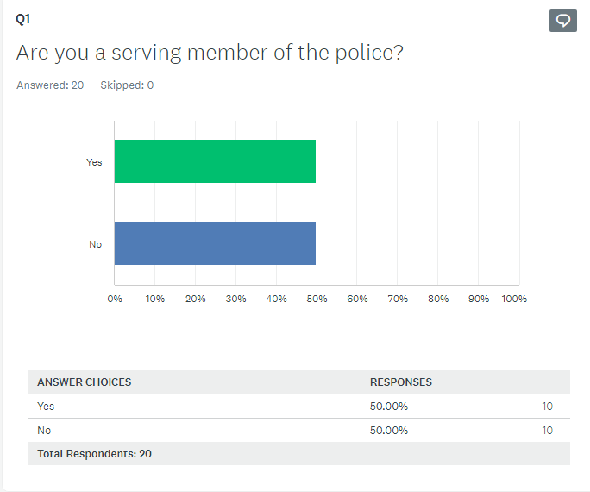

Theme 2 – For the use of taser

After establishing that the sample group for the questionnaire was equally split between active police officers and members of the public, a sequence of questions was asked surrounding the use of taser by police officers and the answers between the questions varied greatly. Questions 2 and 3 asked participants if they thought police officers should carry/use tasers and whether participants thought taser use is a reasonable use of force respectively. Both questions were answered identically with a staggering 95% of participants saying “yes” to the questions asked. These results show that regardless of bias, most participants are in favour of taser use regarding the context of these questions.
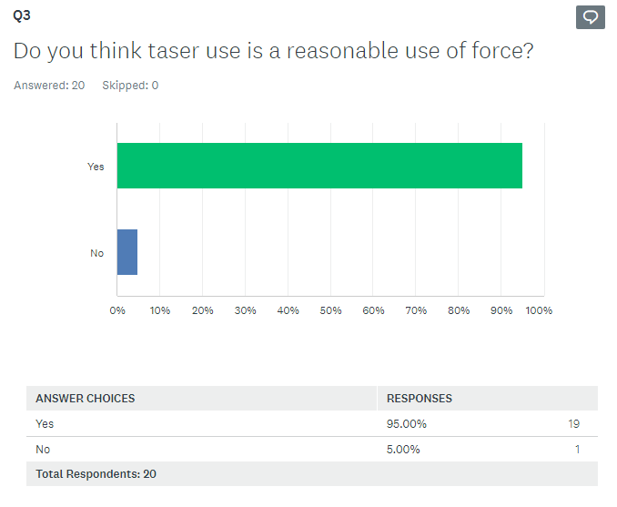
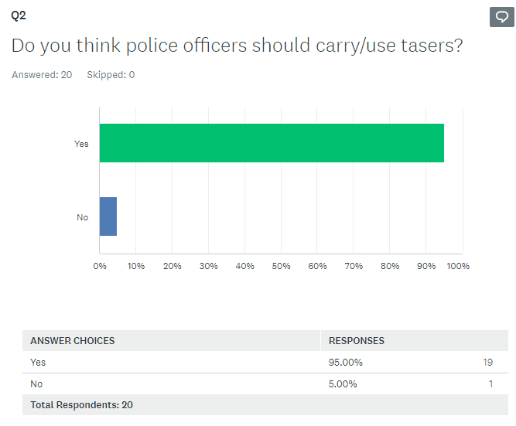

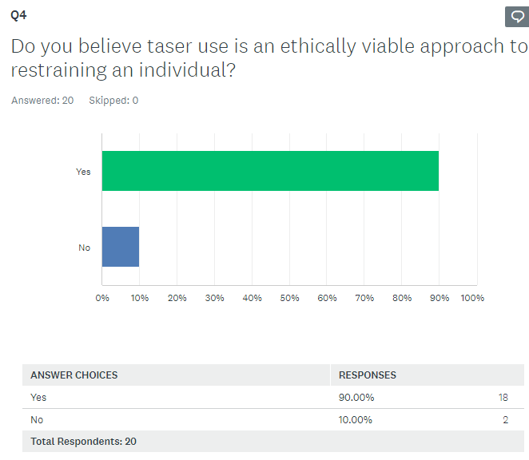
Questions 4 and 5 begins to narrow into the core topic as they ask, “do you believe taser use is an ethically viable approach to restraining and individual” and “are there better alternatives to a taser” respectively. These questions were asked as a means of tying in with the main research that was obtained during the literature review section and to allow participant to think and reflect upon the ethics of taser use. Question 4 had 90% of participants agree with taser use being an ethically viable approach to restrain an individual however question 5 had 55% of participants disagree with there being a better alternative to taser use.
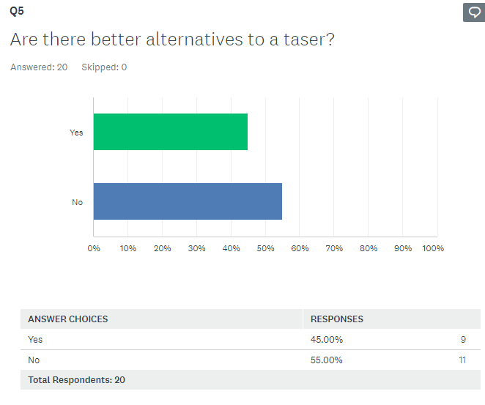

The contrasts between both questions highlights mixture of emotions as with question 4, most participants vote in favour of taser use, however 45% of participants consider there to be a better alternative to taser. As illustrated in the literature review, a survey conducted by the National Police Chief Council found that all of force used across 18 participating forces in 2017, taser use only scored a 9% injury rate which is lower than the likes of police dog and irritant spray causing a 30% and 17% injury rate respectively (National Police Chief Council, 2017). With this information in mind, it is reasonable to suggest that taser use is both an ethically viable tool and likely one of the most proficient.

Question 8 delves deeper into the ethical use of taser by asking participants “do you think race and ethnicity have an impact on taser use” to which 90% of participants answered no, believing that race and ethnicity did not have an impact on taser use. This is reflective of a study that was conducted in 2021 that shows of 108 cases whereby tasers were deployed on 94 individuals, only 22% of individuals were black whilst 71% were white. This shows that racial bias does not have a significance in taser deployment.
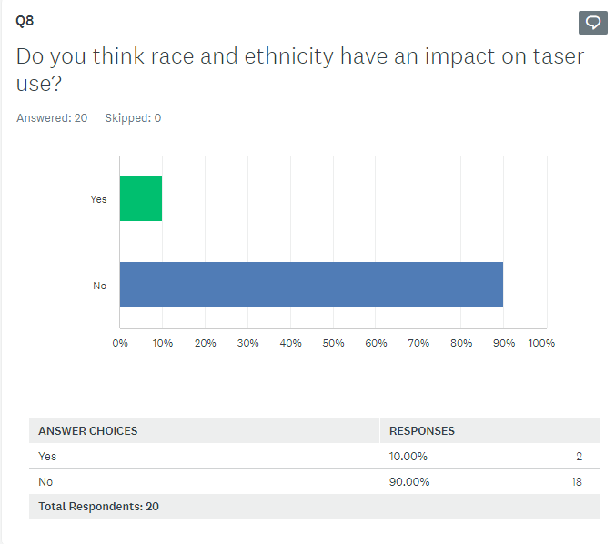

Theme 3 – Against the use of taser

Of the 9 questions that were asked to participants, only 1 question had greater number of people answering in a manner that can be considered “against” the use of taser and that question was “are you aware of any health implications surrounding taser use” to which 70% of participants said that they were awaer of the health implications surrounding taser use. Though this does not directly suggest that the participants are against taser use, any health implications caused by taser use can induce a negative bias towards taser use.

This is reflective of a survey conducted by the National Police Chief Council in 2016 which shows that of 948 of recorded incidents whereby tasers had been fired, a total of 159 cases resulted in the subject attending hospital (National Police Chief Council, 2016).
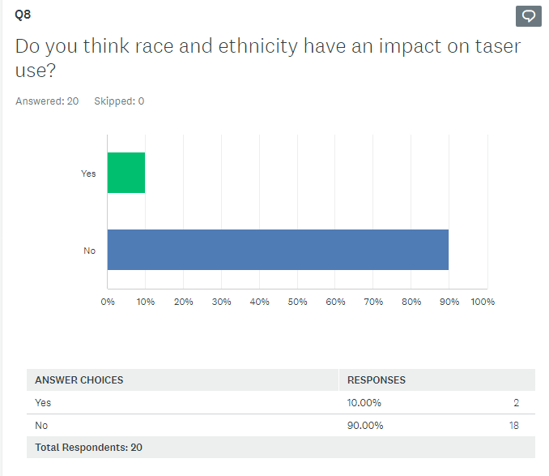

CONCLUSION

This chapter has been successful in analysing the results of the questionnaires that been completed among participants that highlights their views of taser deployments in relation to ethical and health implications. With this analysed data, links to source material gathered during the literature review was also compared to answer the question of ethical and health implications of taser use.

Bibliography

Yi-Wen Chien et al (2014), The Flexible Correction Model: Bias Correction Guided by Naïve Theories of Bias. Available at: https://doi.org/10.1111/spc3.12105

