What important political and social transformations were brought about by the French Revolution, and what was the cultural impact of these transformations?

The French Revolution of 1789 was the beginning of change in France, Europe and indeed the rest of the world. For this essay I will concentrate on the elements I have most enjoyed namely the art, costume and the introduction of the chosen instrument of revolutionary vengeance the guillotine (1792).

To discuss the political and social transformations brought about by the French Revolution we must first gain an understanding of some of the causes of the Revolution, there were three main contributing factors. France was suffering from crises on three fronts, Social Crisis, Economic Crisis and Political crisis.
During the 18th Century a time known as the Ancien Regime French society was divided into three groups or estates as they were referred too, the clergy, the nobles and the common people. The first estate was home to the clergy; they occupied the top position in society and enjoyed many privileges, one of the main ones being exempt from paying any taxes to the monarchy though having the power to levy a ten percent tax known as a tithe on the common people of the third estate. The second estate consisted of the nobility, including members of the royal family though not the King, they too were exempt from tax but also collected from the third estate. The third estate housed the remaining 96% of the population of France from peasant farmers through to the Bourgeoisie-the wealthy business class, they had none of the privileges the other two estates enjoyed causing the common people to become rebellious.

The economic crisis was triggered by several contributing factors, King Louis XVI (1754-1793) was seeking revenge for his grandfather’s defeats, he accumulated war debts from America’s War of Independence in the region of 1500 000 000 livre, he was also known for his extravagant spending habits. He and his wife Marie Antoinette (1755-1793) enjoyed a luxurious existence; she enjoyed staging plays, spending money on fashion and gambling. As the expenses accumulated she adopted the name Madame Deficit. France was nearing bankruptcy and this economic instability formed one of the most important causes of the French Revolution.

Many claim that King Louis XVI abused his powers in more ways than just those of the economic crisis; another cause for the French Revolution was politics. France at the time was a complete monarchy giving the King complete control over everything and everyone. People were angry with the state of the country, the laws that were being introduced, lower classes having no privileges or control over their lives, being taxed according to social class. The privilege of voting and freedom of speech dependent on status. The inequality at the time was another contributor for the revolution. People wanted their voices heard they wanted equality and change.
To look at art first The French Revolution (1789-1799) was flanked by two artistic styles, Rococo and Neo-classicism. The name Rococo comes from French rocaille, meaning rock work, based on forms of sea shells and coral. Rococo style originated in 18th century Paris and later spread to sculpture, theatre design and music. The style is typically characterised by elaborate ornamentation, depicting scenes of love and nature and an abundance of pastel tones. The frivolity of rococo art, its emphasis on decoration was inseparably linked with the ancient regime which was nearing its final phase. ‘The Swing’(1767) by Jean-Honre Fragonard (1732-1806) one of Fragonard’s most delightful and famous painting depicts a girl playfully kicking her slipper into the air, enjoying light hearted entertainment, a yapping dog tries to alert its owner, while cupid stands with his finger to his lip being drawn into the intrigue.

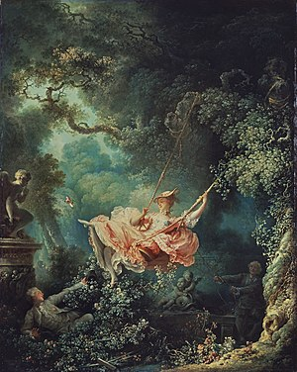
The Swing (1767) Jean-Honre Fragonard (1732-1806)
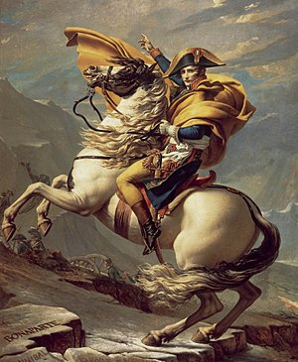
Hints of a revolution lead to the rejection of all the playfulness and whimsy rococo style and leads to the return of a more classical style known as neo-classicism. Neo classicism was a child of the Age of Reason (The Enlightenment). Characterised by clarity of form, shallow space and sober colours. There was a preference for the severity, the heroism and the moral strictures; it signified moderation and rational thinking. If we look at the painting Napoleon crossing the Alps (1801) by Jacques Louis- David (1748-1825) arguably the most successful portrait of Napoleon Bonaparte ever made. Is it art? Or propaganda? There were five versions of this equestrian portrait made it depicts Napoleon astride a wild eyed rearing Arabian stallion on a snow covered mountainside. The background is obscured by rocks; French troops hauling a canon can be seen along with the tri colour French flag. Napoleon’s name is carved into the rocks alongside the names Hannibal and Charlemagne who also lead their troops over the Alps. Napoleon and his horse dominate the scene; he is pictured as the archetypal classical hero. David suggests that this man whose achievements will be celebrated for centuries can do anything.

Napoleon crossing the Alps (1801) Jacques Louis-David (1748-1825)
A similar contrast can be seen if we compare the clothing and costumes of pre Revolution France to those of post Revolution France. The French Revolution really brought about the old cliché “clothes make a man”. Fashion became a political statement, if we look at the portrait of King Louis XVI (1779) by Antoine-Francois Callet (1741-1823). The flamboyant style, lace cuffs and knee breeches, ruffles and frills alongside the high heels and large wigs were typical aristocratic symbols of the Macaroni Style. Lavish and extravagant garments.
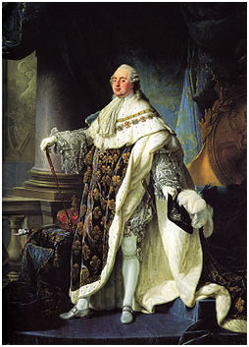
King Louis XVI (1779) by Antoine-Francois Callet (1741-1823).
The spread of democratic ideals meant a shift away from this to welcome darker clothes, ankle length trousers or Sans Culottes meaning “without breeches” unlike the flamboyant pantaloons favoured by the nobility and bourgeoisie. The bonnet rouge and triple coloured cockade became a quasi-uniform of the revolution. The phrase Sans Culottes was in common use to describe the people of the third estate, urban workers, artisans and small businessmen and especially any supporters of the revolution.

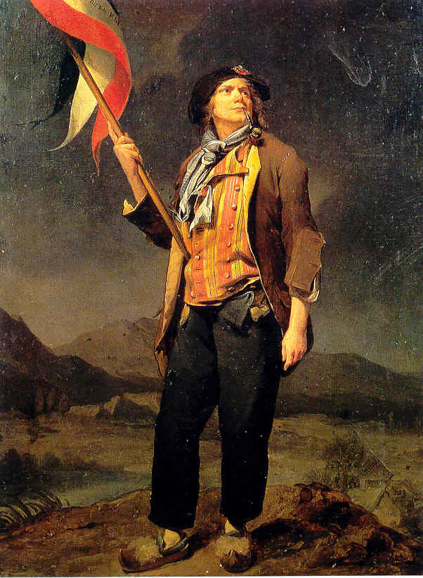
Portrait of a Sans-Culotte (1792) Louis-Leopold Boilly (1761-1845)

Bibliography
William Doyle, The French Revolution A Very Short Introduction (Oxford: Oxford University Press, 2001), p. 1.
Oxford Art Online, Neo-classicism and the French Revolution (2018) <http://www.oxfordartonline.com/page/neo-classicism-and-the-french-revolution/neoclassicism-and-the-french-revolution#> [accessed 11 November 2018].
Tate Gallery, rococo (2018) <www.tate.org.uk/art/art-terms/r/rococo> [accessed 11 November 2018].
National Gallery of Victoria, Napoleon Revolution to Empire (2012) <www.ngv.vic.gov.au> [accessed 12 November 2018].
Andrew Graham Dixon, Artists Their lives and works (London: Cobalt it, 2017), p. 183.
'The French Revolution, dir. by (History Channel HD, 2015).
Eric Hobsbawn, The age of Revolution (London: Penguine , 1962).
Allan Forrest, The French Revolution (Oxford: Blackwell Publishers, 1995), p. 13-78.
William Doyle , The Oxford History of the French Revolution, second edn (Oxford: Oxford University Press, 2002).
John Berger, Ways of Seeing (London: Penguin Group, 1972).

William Doyle, The French Revolution A Very Short Introduction (Oxford: Oxford University Press, 2001), p. 1.
'The French Revolution, dir. by (History Channel HD, 2015).
'The French Revolution, dir. by (History Channel HD, 2015).
Oxford Art Online, Neo-classicism and the French Revolution(2018) <http://www.oxfordartonline.com/page/neo-classicism-and-the-french-revolution/neoclassicism-and-the-french-revolution#> [accessed 11 November 2018].
Tate Gallery, rococo (2018) <www.tate.org.uk/art/art-terms/r/rococo> [accessed 11 November 2018].
National Gallery of Victoria, Napoleon Revolution to Empire (2012) <www.ngv.vic.gov.au> [accessed 12 November 2018].
Andrew Graham Dixon, Artists Their lives and works (London: Cobalt it, 2017), p. 183.

