Archive Project – 1927
PRINCIPAL’S REPORT
During the course of this year 36 new students were enrolled in the College. This is a somewhat smaller number than the previous year when 46 new students enrolled but that number too was smaller than the year prior which had counted 49 students. As such, the number of students currently in residence is a 125, a record by no means but quite satisfactory as this is as many as can be comfortably accommodated. It should also be noted that of the 36, 10 were previously attendees of Saint David’s College School.
For those of you who are not aware, St. David’s College School prepares for St. David’s College and through affiliation, for Oxford and Cambridge. It also prepares them for the Matriculation examinations of the University of London and the University of Wales and entrance to the army, civil service, banks and higher branches of Trade in general.
In this last year some seven Scholarships were available to students of the College. These were the “W. Dillwyn Llewelyn” Memorial Scholarship, awarding £50; three “Griffiths”, awarding £30 to selected sons of Clergy from the diocese of St. David’s; the Bates Prize of £13 for the best candidate in the entrance examination who is native of the principality, and has been 2 years at a secondary school; the “Edmwnd Prys” for knowledge of the Welsh Prayer Book and Metrical Psalms, awarding £8; and finally £30 for the student chosen, after examination, to act as organist.
Of course, the most notable event in the College’s calendar this last year was the Centenary celebrations on 11th October. The centenary recognized was that of the admittance of the first students to the College in 1827. Celebrations were held throughout the day, starting with services of Holy Communion at the College Chapel in both Welsh and English, at 7 and 8 a.m. respectively. These were followed at 10 a.m. by Matins in the Chapel, before a procession to the Parish Church at 11 a.m. Therein was held a service of Holy Communion at which the Archbishop of Wales delivered the Sermon.
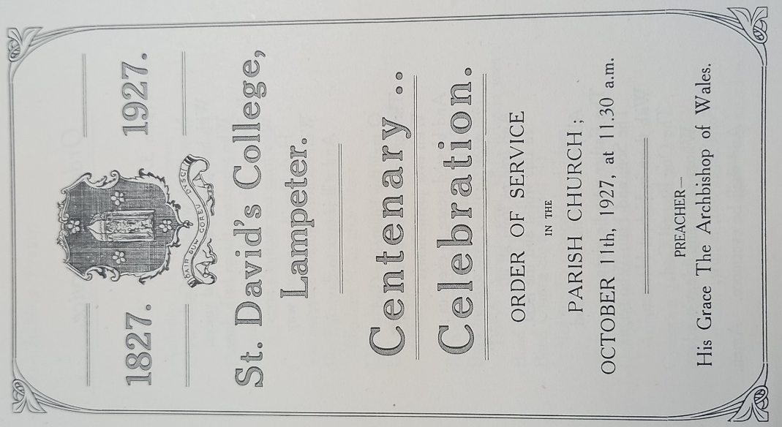 Fig. i.
Recalling to ourselves that this College is not only a Christian institution but also a place of learning, degrees were conferred upon graduates at 12.45 p.m. in the Victoria Hall. Attendees then processed back to the campus for a 1.30 p.m. Luncheon in a Marquee set out on the green between the Old and Canterbury buildings. Special thanks here are owed to R. Bolland and Sons, Limited of Chester, who catered effectively for over 400 people, and who were so prompt and helpful in both in suggesting and in response to the Centenary plans. It is unlikely that any student here now remembers, but some staff may recall it was this company who so effectively organized the catering for the college’s 75th anniversary in 1902 and were in fact pleased to be remembered. In truth both Mr. Davies, our Bursar, and I were more impressed with R. Bolland and Sons than with the alternative tender by Owen’s Caterers & Confectioners of Aberystwyth. I was also impressed by R. Bolland’s General Manager’s willingness to travel to Lampeter in order to meet with Mr. Davies and discuss menus and other arrangements.
The day’s celebrations were brought to a satisfactory conclusion with a 4.30 p.m. tea in the Hall at the College. Regretfully, in the end our Centenary celebrations were not broadcast on BBC despite my asking. To the BBC’s credit, I received correspondence from Broadcasting House to say that this was because of the celebration’s timing, which would interfere with their regularly scheduled School Transmissions. Far be it for an educational institution such as ours to deprive others of learning!
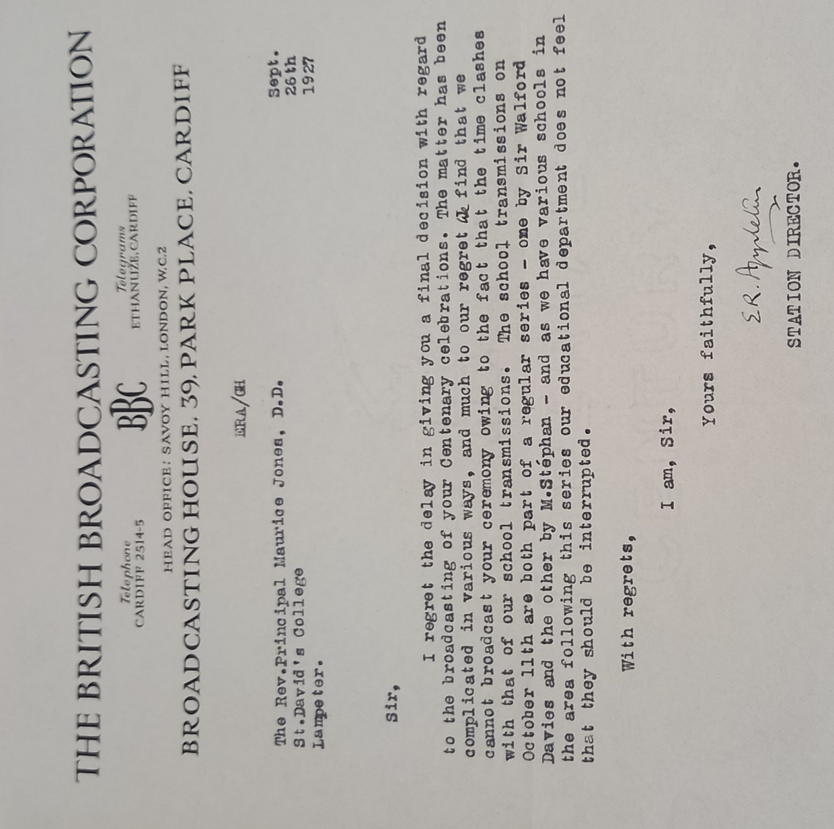 Fig. ii.

Also in the spirit of the centenary, the College had the honour of a hymn being composed for us by Lewis Davies. It is entitled ‘In Trailing Rose of Tamarisk’ and dedicated to all prior principles of the College. This hymn also recalls the College motto; in Welsh: Goreu Arf Arf Dysg; in English: ‘the best weapon, the weapon of learning.’
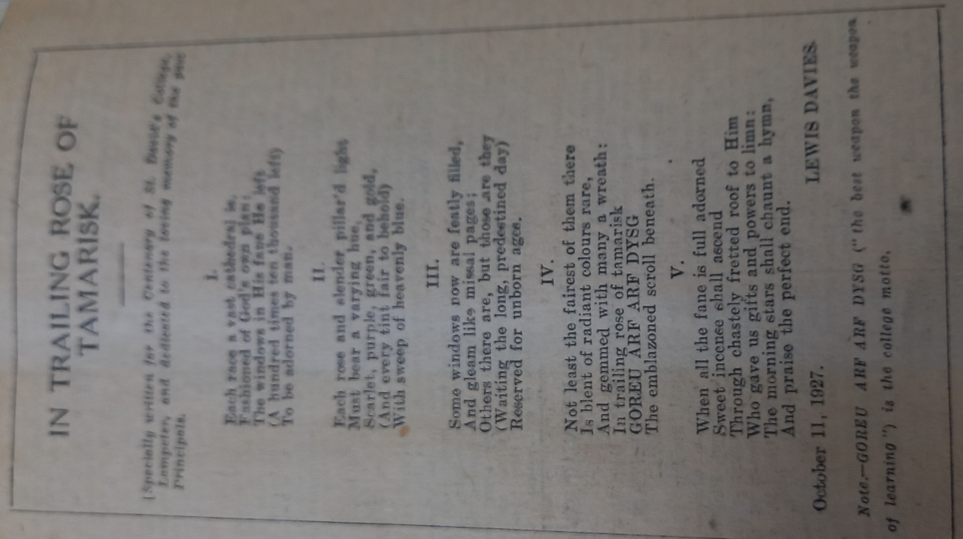 Fig. iii.
Correspondence was also sent to me in September by a Miss Sybil E. G. Stevens, great, great niece of Bishop Burgess - our founder. This correspondence was concerning the silver trowel used by Bishop Burgess to lay the foundation stone of the College. In particular, Miss Stevens offered this trowel as a gift to the College having read that we were due to celebrate our Centenary. Miss Stevens was also so kind as to send me a copy of the wording engraved on this silver trowel. It reads:
“This trowel was used by the Right Reverend Thomas Burgess D.D., F.R.S., F.A.S., P.R.S.L., and Lord Bishop of St. David’s, in laying the first stone of St. David’s College at Lampeter, 12th August, 1822 – Rev.^{d} Charles Philipps, B.D. officiating on The occasion. C. R. Crockwell Esq., Architect. W. Daniel Mainwaring., Mason.”
This gift of silver trowel has of course been accepted by the College and we await receipt of this wonderful piece of history.
Further correspondence has found my desk from our northern neighbor, the University College of Wales in Aberystwyth - in this case from two fronts. The one sent by the Secretary to their Court of Governors as he had been asked to convey the following resolution to our College:
“That the Court of Governors of the University College of Wales sends its cordial greetings to the Council, Staff and Students of St. David’s College, Lampeter, on the occasion of the Centenary Celebrations of the College, places on record its appreciation of and gratitude for the great services rendered by the College and conveys its warmest wishes for continued success and prosperity.”
The second was from their Students’ Representative Council, on behalf of the students of the University College of Wales Aberystwyth. They wished to extend their very heartiest congratulations on the celebration of our 1st Centenary and trust that the close association our two colleges have enjoyed will continue.
In light of one hundred years of this College’s existence, we saw fit to institute a “Centenary Fund” - an appeal for £40,000. This was for two purposes. The first is that it will enable Wales, and the Welsh church, to express their appreciation and gratitude to the services rendered by this College for the last 96 years in a tangible form. In addition, it would provide for the College to continue this work in a secure financial position, without the previous worries caused by a lack of adequate funds. As to the services provided by the College, at the last ordination held in Wales 26 of 39 priests and deacons, i.e. 75%, were graduates or licentiates of Lampeter. It is also my great joy to recall several letters I received in support of the Centenary Fund. Notably from the Archbishop of Canterbury, the Archbishop of Wales and some 6 other Bishops. We may also say that our present King himself has subscribed to this fund, showing his own practical interest in our academic endeavours.
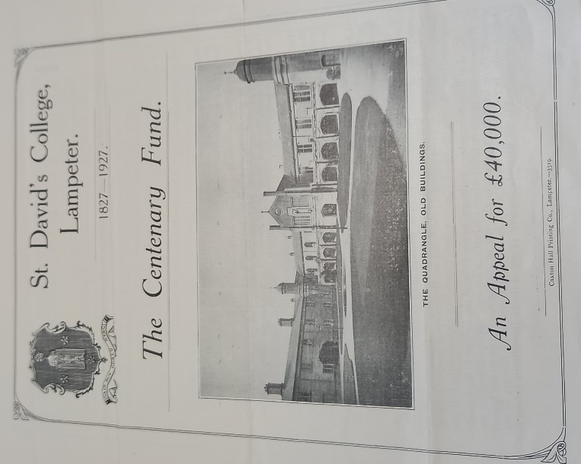 Fig. iv.
As to examinations this year, distinct congratulations must be given to Mr. H. A. Parry and Mr. Vivian Thomas, both of whom achieved class 3 diplomas in Theology.
As always the Sporting life of the College throughout this year has been most satisfactory, with every win and loss our teams have displayed themselves excellently – on and off the field. Owing to the continued interest in sporting activities, fixtures are being prepared for the upcoming season with Football, both Rugby and Association, conducting their traditional matches of the seniors against the freshmen in October. Hockey fixtures will be starting in January while Cricket is yet to be organized
It is also satisfactory to report that there have been no major disciplinary incidents to report upon this year. However, this should be accredited to the character of our current student body rather than any action by the College.
Finally, it has been my pleasure to introduce two new members into the College Faculty this year: Mr. E. R. Brooke and Mr. H. A. Harris. Mr. Brooke holds a B.A. from Magdalene College, Cambridge, and will be lecturing in Classics and History. Mr. Harris meanwhile read his B.A. at Jesus College, Oxford, and will be lecturing in English. It is my fervent hope that these two will be a fine addition to the College both as lecturers and men; and that they will find their time in Lampeter rewarding and enjoyable in equal measure.

Appendices
List of Illustrations
- Centenary Celebration Order of Service in the Parish Church, October 11th 1927 at 11.30 a.m., from: RBLA UA/D/96 Papers and correspondence concerning the College Centenary and the Centenary Fund, 1927
- Letter from the BBC Station Director to Principal Maurice Jones concerning broadcast of the Centenary Celebrations, from: RBLA UA/D/96 Papers and correspondence concerning the College Centenary and the Centenary Fund, 1927
- Davies, Lewis, ‘In Trailing Rose of Tamarisk’ published in the Times newspaper 11th October 1927, from: RBLA UA/X/132/12 Scrapbook of Newspaper Cuttings, 1909-29
- The Centenary Fund: an appeal for £40,000, pamphlet from: RBLA UA/D/96 Papers and correspondence concerning the College Centenary and the Centenary Fund, 1927
Bibliography
Roderick Bowen Library and Archives: University Archive UA/A/18 Tutors’ Register, 1899-1959
Roderick Bowen Library and Archives: University Archive UA/BUR/13 Stipend Book, 1894-1927
Roderick Bowen Library and Archives: University Archive UA/CM/1 Notes on Burgess Hall, result lists and ordination lists, 1927-62
Roderick Bowen Library and Archives: University Archive UA/CP/42 College memoranda (bound vol.), 1925-33
Roderick Bowen Library and Archives: University Archive UA/D/96 Papers and correspondence concerning the College Centenary and the Centenary Fund, 1927. Menus, seating plans, tickets, invitations, order of service at St Peter’s Church, guest list, correspondence with the catering company, donation of Bishop Burgess’ trowel by his great, great nephew and nieces. Also includes menu and toast list and seating plan for the 75th Anniversary, October 2nd, 1902.(1 bdle)
Roderick Bowen Library and Archives: University Archive UA/SM/12 Students' Handbook, 1919-24, 1927-42, 1947-50, Rugby Fixtures, 1949-50, Athletics Sports Programme, 1885 (27 items)
Roderick Bowen Library and Archives: University Archive UA/X/132/12 Scrapbook of Newspaper Cuttings, 1909-29
Webliography
British Pathé, (20/10/2020), The Archbishop of Canterbury attends centenary celebrations at St. David's College (1927), available at: https://www.youtube.com/watch?v=Vq3q-CQGVw8; [accessed 12/10/2023]

Roderick Bowen Library and Archives: University Archive UA/A/18 Tutors’ Register, 1899-1959
Roderick Bowen Library and Archives: University Archive UA/D/96 Papers and correspondence concerning the College Centenary and the Centenary Fund, 1927. Menus, seating plans, tickets, invitations, order of service at St Peter’s Church, guest list, correspondence with the catering company, donation of Bishop Burgess’ trowel by his great, great nephew and nieces. Also includes menu and toast list and seating plan for the 75th Anniversary, October 2nd, 1902.(1 bdle)
RBLA UA/A/18 Tutors’ Register, 1899-1959
Roderick Bowen Library and Archives: University Archive UA/CP/42 College memoranda (bound vol.), 1925-33
RBLA UA/D/96 Papers and correspondence concerning the College Centenary and the Centenary Fund, 1927
RBLA UA/D/96 Papers and correspondence concerning the College Centenary and the Centenary Fund, 1927
RBLA UA/D/96 Papers and correspondence concerning the College Centenary and the Centenary Fund, 1927
RBLA UA/D/96 Papers and correspondence concerning the College Centenary and the Centenary Fund, 1927
RBLA UA/D/96 Papers and correspondence concerning the College Centenary and the Centenary Fund, 1927
RBLA UA/D/96 Papers and correspondence concerning the College Centenary and the Centenary Fund, 1927
RBLA UA/D/96 Papers and correspondence concerning the College Centenary and the Centenary Fund, 1927
Roderick Bowen Library and Archives: University Archive UA/X/132/12 Scrapbook of Newspaper Cuttings, 1909-29
RBLA UA/X/132/12 Scrapbook of Newspaper Cuttings, 1909-29
RBLA UA/D/96 Papers and correspondence concerning the College Centenary and the Centenary Fund, 1927
RBLA UA/D/96 Papers and correspondence concerning the College Centenary and the Centenary Fund, 1927
RBLA UA/D/96 Papers and correspondence concerning the College Centenary and the Centenary Fund, 1927
RBLA UA/D/96 Papers and correspondence concerning the College Centenary and the Centenary Fund, 1927
RBLA UA/D/96 Papers and correspondence concerning the College Centenary and the Centenary Fund, 1927
RBLA UA/D/96 Papers and correspondence concerning the College Centenary and the Centenary Fund, 1927
RBLA UA/D/96 Papers and correspondence concerning the College Centenary and the Centenary Fund, 1927
RBLA UA/D/96 Papers and correspondence concerning the College Centenary and the Centenary Fund, 1927
RBLA UA/D/96 Papers and correspondence concerning the College Centenary and the Centenary Fund, 1927
RBLA UA/D/96 Papers and correspondence concerning the College Centenary and the Centenary Fund, 1927
Roderick Bowen Library and Archives: University Archive UA/CM/1 Notes on Burgess Hall, result lists and ordination lists, 1927-62
Roderick Bowen Library and Archives: University Archive UA/SM/12 Students' Handbook, 1919-24, 1927-42, 1947-50, Rugby Fixtures, 1949-50, Athletics Sports Programme, 1885 (27 items)
RBLA UA/SM/12 Students' Handbook, 1919-24, 1927-42, 1947-50, Rugby Fixtures, 1949-50, Athletics Sports Programme, 1885 (27 items)
RBLA UA/CP/42 College memoranda (bound vol.), 1925-33
RBLA UA/CP/42 College memoranda (bound vol.), 1925-33

