Construction Materials

Material Science and Building Services
ACBA4006

Kerri Leigh Farmer
2100037

Investigate and evaluate the characteristics and properties of construction materials.

TITLE

Hilton Garden Inn Snowdonia and Cardigan Care Centre

Index

- Introduction Pg. 4
- Social and Environmental Impact Consideration Pg. 5
- Framing Materials Pg. 8
- Summary Pg. 12
- References Pg. 13

- Introduction
Analysing steel and concrete framed buildings for contrast and comparisons, I have chosen the steel frame constructed Hilton Garden Inn in Snowdonia and the reinforced concrete framed Cardigan Care Centre in Cardigan, both these buildings were chosen based on the purpose and location in comparison. Cardigan Care Centre had to be a complete demolition project and rebuild, where the considerations were in the purpose of the building, where social, and community-based needs were a major factor. Whereas Hilton Garden Inn Snowdonia, timeframe, speed, cost, and environmental impact was what influenced the framing material. Interestingly Hilton Garden Inn was originally designed to be a concrete structure.
Both framing methods have various advantages and disadvantages depending on the use of the building, location and other materials used in conjunction with the framing to achieve certain requirements, which will be looked at in depth from the original design plan, function, purpose, and construction methods used.
The impact of climate and environmental conditions each building, and location faced. As well as the production process of the materials used and the impact this had on the environment and ease of construction of both steel and concrete framed buildings and the total life cycle of the buildings.

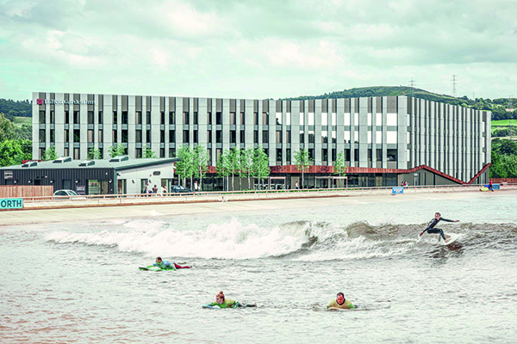
Hilton Garden Inn Snowdonia
Premier Construction News (2020)
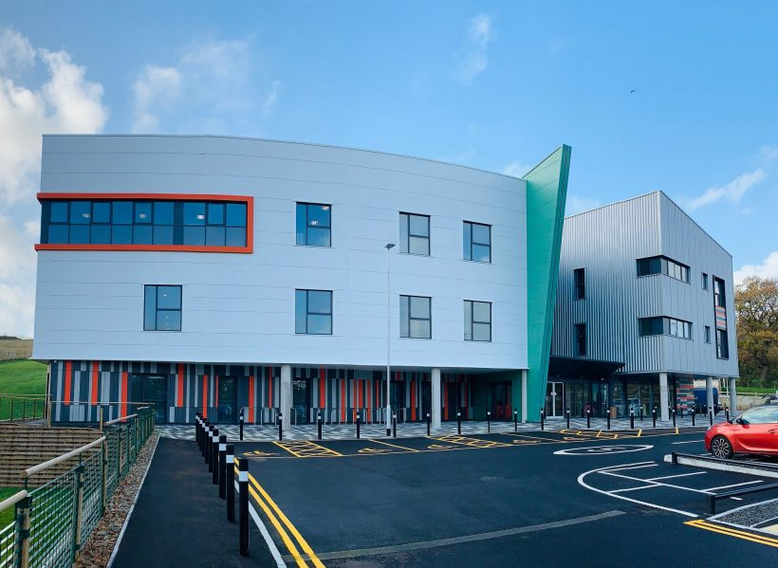
Cardigan Care Centre
Cardigan Health Centre (2021)
2. Social and Environmental Impact Consideration
When we compare the social and environmental impact on the two sites and builds, the requirements vary due to the use and location of each site. The Cardigan Care Centre replaced an old hospital building that was run down although effort was made to maintain the building, it was not possible and wouldn’t be sustainable in the long run. Due to the use and purpose of the building being a hospital to serve the surrounding community there was more consideration paid towards social and heritage implications of the new Hospital being built. When we look at the Hilton Garden Inn Snowdonia, more attention needed to be paid to environmental impacts on the construction process as well as the sustainability of the site. Tourism is great for the economy but can have a negative impact on the environment if it is not controlled and regulated correctly by following the correct regulations with regards to the actual build and construction as well as long term sustainability by ensuring there is little future negative impact on the existing building in relation to the environment and elements.
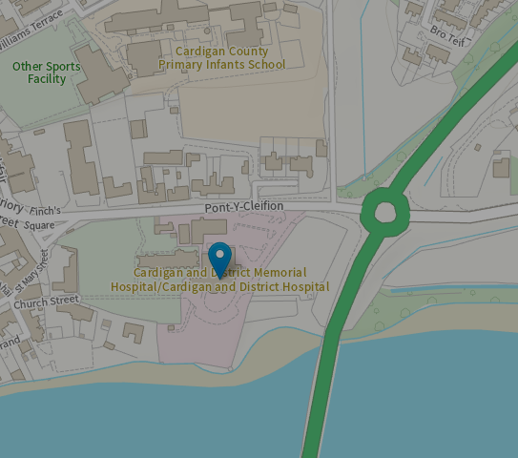

site of Cardigan Health Care Centre
https://coflein.gov.uk/en/site/35163/
The site where the Cardigan Care Centre was built, original building dated back to the 19th Century. It was then converted into the Memorial Hospital in 1927, due to the age and build it was however not fit for purpose, which caused a huge backlog and negative impact on the actual function of the hospital. Therefore, a new modern and fit for purpose hospital/care centre needed to be built in its place.
The NHS full business study on the current site and building describes the run-down condition of the current Memorial hospital:
The physical condition of the site has deteriorated through age despite general maintenance and other building and engineering upgrades. Despite the efforts of staff who maintain a high level of service, it can be concluded that the current space and functional constraints do not support the standards expected of a modern health care facility.
(Full Business Case Cardigan Integrated Care Centre pp. 39)
The original hospital was not a listed building, and therefor focus was on protecting any conservation area and heritage that may surround the proposed build of the new Cardigan Health Care Centre.
Preserve or enhance the character or appearance of conservation areas, whilst the same time helping them remain vibrant and prosperous.
Preserve the special interest of sites on the register of historic parks and gardens; and protect areas on the register of historic landscapes in Wales.
(Holland Heritage Heritage Impact Statement May 2021 pp. 64)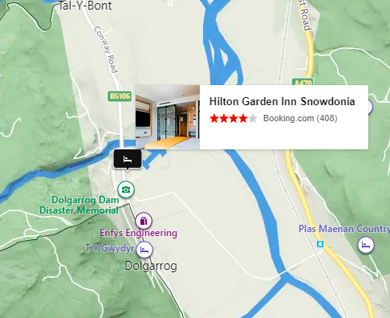
site of Hilton Garden Inn, Snowdonia
https://www.bing.com/maps
The location of Hilton Garden Inn Snowdonia in North Wales surrounded by mountains and forests, meant special consideration needed to take place regarding the environment, durability and adaption during the construction process and once completed. The design was to build it to match the angular landscapes surrounding Hilton Garden Inn Snowdonia and industrial materials to match the history of the site.
“The design is striking with a strong, angular design which reflects and represents the surrounding mountainous landscape but built-in high quality industrial materials which responds to the past uses of the site.” (Pezzoni Architecture)
During the construction process, the entire build had to adhere to BREEAM measures, this was put in place to ensure that there was minimal impact on the environment during the construction of the Hilton Garden Inn Snowdonia. The hotel makes use of a few measures to ensure environmental sustainability is met from the day construction started and into the life of the building, these included an innovative waste-water management system, FSC approved timber and photovoltaic roof panels. The restaurant and bar at the hotel also use locally sourced products for supplies to support and help sustain the local businesses and environment.
“The BREEAM rating measures design impact and carbon emissions, design durability and resilience, adaption to climate change, and ecological value and biodiversity protection.”
(Premier Construction News 2020)
Concrete has been the material most used in the past for construction and building framing, steel framing has increased in choice for framing and construction due to its flexibility and speed at which it can be constructed.
Green Spec (n.d)
Both have various impacts on the environment with cement production being between 4 – 5 % of the total of the earth’s Co₂ emissions with iron and steel production producing 3%.
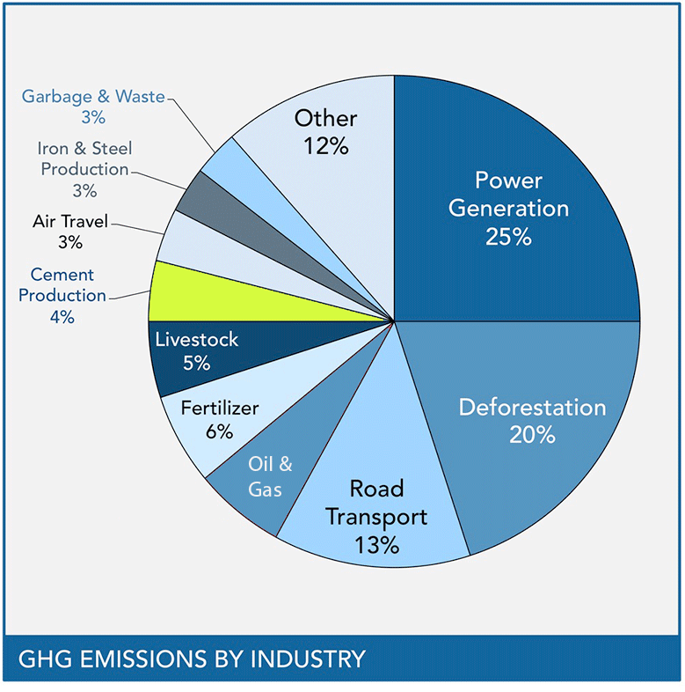
Emissions by industry (Green Spec, n.d)
https://www.greenspec.co.uk/building-design/environmental-impacts-of-concrete/
Concrete is not the most environmentally friendly framing material available, cement production being the main cause of carbon emissions. Cement is created by burning Limestone and other materials in a kiln, with this and the chemical reaction, it is this that creates the Co2 emission.
(Ramsden, 2020)
The environmental impact on steel production occurs mainly form the coking and ironmaking. Steel emissions include, wastewater, hazardous wastes as well as solid wastes.
(Anon., n.d)

3. Framing Materials
Considering the previous issues with the memorial hospital with regards to upkeep and maintenance that couldn’t be kept up to standard, regardless of the amount of engineering and works that took place to get the previous building to standard and fit for purpose it was nearly impossible and was not financially viable for the future of the building. Therefore, a full business plan survey took place to put in place the feasibility and viability of building a new concrete framed state of the art fit for purpose Cardigan Care Centre. Taking this all into consideration the choice to use Concrete as framing structure for the new build as concrete tends to have fewer operating costs and maintenance requirements throughout the lifecycle of the building, was the best solution and choice for the new care centre. The building was framed with reinforced concrete over 2 storeys with 2 lift cores and 2 stair cores, the duration for the concrete framing took 20 weeks to complete.
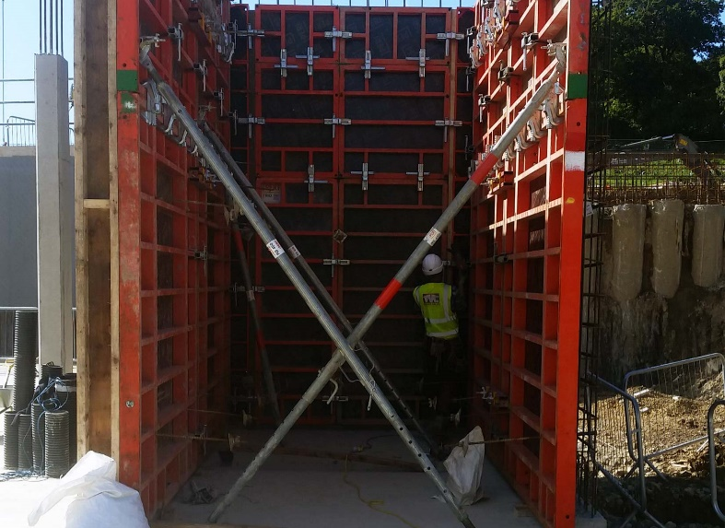
Cardigan Care Centre
Thames Valley Construction (2018)
Using concrete meant that there could be monetary saving with fire protection as concrete does not always need extra fire protection also saving time and money for any ongoing maintenance that may have been required for fire protection and steel framing.
With the correct air sealing design and built-up insulation, concrete buildings can withstand cooler climates such as the cold and wet climate Cardigan experiences. Low maintenance and high flexibility meant it could be poured into any shape or design with ease, speed, and efficiency for the construction phase. Concrete is naturally water-resistant, with the correct nominal cover over the reinforcing bars, the concrete building will sustain the impact of cold and wet climates. BS 8500:2019 Annex A gives the guidance and specifications for nominal cover for reinforced concrete and selected exposure classes
Concrete doesn’t burn, rust, or rot. It is resistant to fire, wind, water, vibrations, and earthquakes, keeping people safer and reducing costs. In the aftermath of extreme weather events, concrete structures have proven to be the most resilient.
(Rediscover Concrete)
Concrete has high vibration control compared to using steel framed buildings which would need extra cost and consideration to reduce the vibration within the built environment.
Concrete can be produced to specification with exact quantities need for a specific building this can help reduce waste and pollution with concrete from demolitions recycled and used as aggregate for other uses. Concrete can be made with several waste materials from steel and other manufacturing plants such as power plants. Materials needed to produce cement and concrete is readily available in Wales UK. Modern technologies and additives to the concrete mix to suit weather conditions and climate exposure, the concrete mix can be produced stronger and resistant to various climate exposure. Due to the abundance of Limestone and quarries in the United Kingdom, concrete’s carbon footprint can be regulated and controlled and monitored, the distance concrete needs to travel to the site will also be substantially reduced, compared to most steel constructed framing.
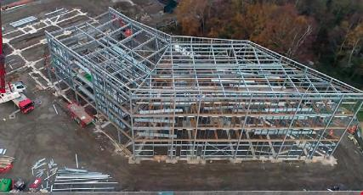
Hilton Garden Inn, Snowdonia
NSC (2020, p.16)
According to NSC (2020, pp. 16 -17) the Hilton Garden Inn, Snowdonia was originally designed with a cast-in-situ concrete frame, it was later changed to a steel frame design due to the speed of construction with steel. The hotel is a 4 storey with 106 rooms, the frame was erected with a five-week program, in 2 phases with the first handover of steel after 8 days of working.
Prefabrication of steel off-site means a reduction in waste; all steel is recycled therefore making it a very sustainable material to use in construction. Steel can maintain its strength while also being versatile in shape, however, any errors with the fabrication can take time to correct on-site, whereas with the concrete framing any errors can be quickly adjusted on-site before concrete pouring.
Building owners value the flexibility of steel buildings, and the value benefits they provide, such as the light, open, airy spaces that can be created, making it ideal for modernisation, reconfiguring, extending or adapting with minimal disruption, and without costly and sometimes harmful demolition and redevelopment. Even without these benefits, steel is often the first choice on the basis of cost alone.
(Steel Construction, n.d)
The flexibility of steel in Modern buildings means it can be easily adapted for future uses and refurbishments increasing the lifespan of the building. Due to steel framing being significantly lighter than a concrete frame, there is less impact on the environment with foundation piling requirements.
The framing material of a structure creates the largest portion of the carbon footprint of the life cycle of the building.
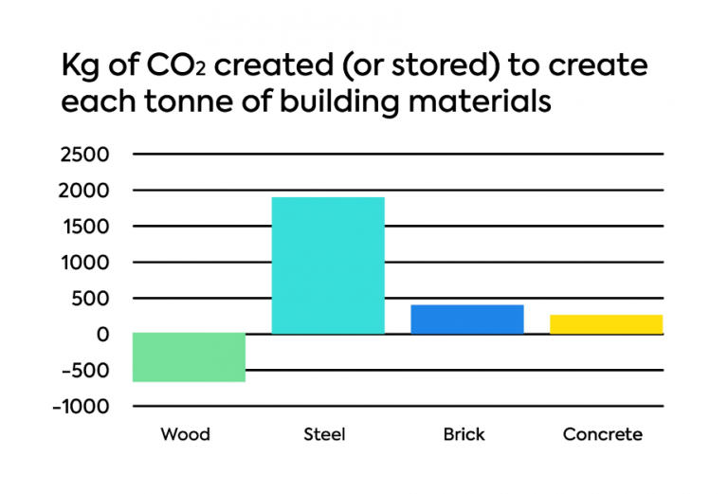
Graph illustrating the amount of Co₂ created for each tonne of building material
Citu (n.d)

There are many advantages and disadvantages for both steel and concrete construction, as they both meet all the requirements for contractors, with all factors such as, location, purpose, time frames, and costs considered will determine your choice of framing material.
Advantages of concrete | - Durable  - Low maintenance  - Energy efficient  - Cost effective  - 100% Recyclable  - Locally available  - Production can assist in waste reduction  - Quieter building
Disadvantages of concrete | - Low tensile strength  - Curing time  - Formwork required  - Shrinking
Advantages of steel | - Reduced weight  - Speed of construction  - Adaptability  - Architectural expression  - High quality control on prefabrication  - Safety factor in constructing
Disadvantages of steel | - High maintenance cost  - Corrosion  - Cost to fireproof/Soundproof

4. Summary
In summary steel and concrete framing, both have a high carbon footprint, during the initial production of each material but yield very different properties within the life of the building and the sustainability of the building and the building material. Steel can be recycled continuously and doesn’t lose any of its properties in strength and durability, steel is also more widely recycled than concrete once it comes out of a demolished building. Concrete can be recycled and is crushed and used as an aggregate in concrete production. Concrete has good thermal properties, while steel can allow modern specious areas allowing a lot of natural light to enter. Steel will need layers and extra fire resistance applied to ensure safety and energy efficiency is met.
Steel is at full strength immediately on completion of it being erected, whereas concrete has a setting and curing time that will need to be met before achieving full strength for the specific application. Concrete will also need to be tested over 28 days to ensure full compressive strength is achieved.
Both steel and concrete buildings are durable and give excellent climatic resistance. Modern buildings, take careful consideration into the design, cost, time, and energy efficiency of a project from the start of construction to completion and after. Whether concrete or steel is used in the framing of the build, both have excellent properties to give the building strength, durability, sustainability, and ease of assembly. There are strict regulations and procedures in place that are to be followed to ensure as little impact as possible on the environment.

5. References
Anon, n.d Green Spec
Available at: https://www.greenspec.co.uk/building-design/steel-products-and-environmental-impact/#:~:text=Steel%20production%20has%20a%20number,from%20coking%20and%20iron%2Dmaking
(Accessed: 8 December 2021)
Cardigan Health Centre (2021) Cardigan Health Centre
Available at: https://www.cardiganhealthcentre.com/2021/07/15/part-time-receptionist-opportunity-2-posts-cyfle-i-dderbynwr-aig-rhan-amser-2-swydd/
(Accessed: 29 October 2021)
Citu (n.d) What is the carbon footprint of a house
Available at: https://citu.co.uk/citu-live/what-is-the-carbon-footprint-of-a-house
(Accessed: 5 November 2021)
Green Spec (n.d) Green Spec
Available at: https://www.greenspec.co.uk/building-design/environmental-impacts-of-concrete/
(Accessed: 5 November 2021)
Holland Heritage (2021) Ceredigion Online
Available at: https://ceredigion-online.tascomi.com/planning/?fa=downloadDocument&id=38849&public_record_id=59417
(Accessed: 29 October 2021)
Hywel Dda University (n.d) Health Board Wales NHS
Available at: http://www.wales.nhs.uk/sitesplus/documents/862/Item8iFullBusinessCaseCardiganIntegratedCareCentre.pdf
(Accessed: 29 October 2021)
Microsoft (2021) Bing Maps
Available at: https://www.bing.com/maps
(Accessed: 29 October 2021)
NSC (2020) ‘Hotel Accommodates Steel’ New Steel Construction, March 202 Vol 28 No 3, pp. 16 -17
Available at: https://www.newsteelconstruction.com/wp/wp-content/uploads/digi/NSC_Mar20digi/pubData/source/NSC_Mar20digi.pdf#page=16
(Accessed: 5 November 2021)
Pezzoni Architecture (n.d) Pezzoni Architecture
Available at: https://www.pozzoni.co.uk/projects/hilton-garden-inn
(Accessed: 2 November 2021)
Premier Construction News (n.d) Premier Construction News
Available at: https://premierconstructionnews.com/2020/12/08/hilton-garden-inn-snowdonia/
(Accessed: 2 November 2021)
Ramsden, K, 2020 PSCI Princeton Edu
Available at: https://psci.princeton.edu/tips/2020/11/3/cement-and-concrete-the-environmental-impact
(Accessed: 8 December 2021)
Rediscover Concrete (n.d) Rediscover Concrete
Available at: http://rediscoverconcrete.com/en/sustainability/a-better-building-material/the-benefits-of-concrete.html
(Accessed: 2 November 2021)
Roma Publications (2020) Premier Construction News
Available at: https://premierconstructionnews.com/2020/12/08/hilton-garden-inn-snowdonia/
(Accessed: 29 October 2021)
Royal Commission on the Ancient and Historical Monuments of Wales (n.d) Coflein Gov
Available at: https://coflein.gov.uk/en/site/35163/
(Accessed: 29 October 2021)
Thames Valley Construction (n.d) Thames Valley Construction
Available at: https://thamesvalleyconstruction.com/portfolio_page/cardigan-care-centre/
(Accessed: 2 November 2021)
The Free Encyclopedia for UK Steel Construction (n.d) Steel Construction
Available at: https://www.steelconstruction.info/The_case_for_steel
(Accessed: 5 November 2021)

