

Entitled
Business Report – Comparison of Two Hospitality Organisations

Module
BMIH5007 – Financial Management for the Hotel Industry

Lecturer
Tristan Hawkins

Name
Muhammad Abid Mahmood

Student Number
2128264

Executive Summary

The current proposal incorporates the view to comparative analysis and in-depth study between two prominent players in hospitality, namely ‘Shangri-La’ group of hotels and the ‘Premier Inn’ chain of hotels, whilst the objective of this financial business report seeks to evaluate between their fiscal performance impacting key areas of revenue trends involved and factors driving their revenue growth or decline given to their respective approach to the financial management of the organisation, as critical insights of these two highly successful hotelier organisations from opposite sides of the world have compared

Table of Contents

Cover Page………………………………………………………………………………….…1
Executive Summary…………………………………………………………………………..2
Table of Contents……………………………………………………………………………..3
Introduction 4
Total Revenue Analysis……………………………………………………………………....5
Market Positioning 9
Growth Potential 10
Financial Commitment to Corporate Social Responsibility (CSR) 12
Recommendations 14
Conclusion 15
References 16

Introduction

Hoteliers operate in a highly competitive market catering to different consumer segments, which makes effective financial management essential for success. This report critically analyses the comparison drawn between two key competitors of the industry (namely) ‘Shangri-La Hotel Group’ and ‘Premier Inn’ of the hotel chain, whilst focusing on financial decisions made in total revenue generation, market positioning, growth potential and Corporate Social Responsibility (CSR) efforts (Chen, 2023). The aim is to provide a comprehensive understanding to each of the organisation’s financial standing and solvency by trade and affluence, whilst reviewing how they manage resources to remain in the competition given to respective market segments, that is to say luxury for Shangri-La and budget for Premier Inn, as the implications elicit their future growth and sustainability in what is a dynamic, global market.

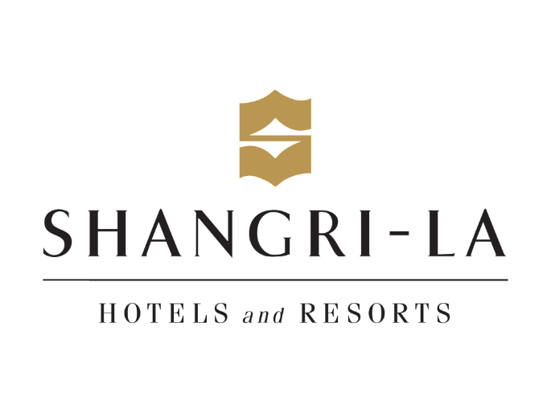

Figure 1 Shangri-La Hotels (Khassawneh et al., 2024)

Total Revenue Analysis

It will be appreciated this group of hotels generates revenue from diversified services such as room division, food and beverages, health and spa services, banqueting and event management services, amongst others. According to the recent figures released for the year ended 2023, the company generated revenues equal to approximately £2.3bn, which places it at 95% of the pre-pandemic positions (Dutta et al., 2024). A big improvement led to this recovery in travelling desires in its core markets, notably mainland China, where the company experienced a revenue growth rate of 63.6%, as well as Hong Kong, which experienced a growth rate of 94.2% (Khan and Wahab, 2024). New RevPARs within these regions reached £88, a 69% increase, meaning that the company has benefited massively from hikes in room rates and occupancy levels. These included lifting restrictions on international travel to the company’s subtitles by boosting business and leisure travels, which included business and leisure travels by mainland Chinese tourists. Mainland China continues to be Shangri-La’s biggest market, with £575m generated in 2023 due to policy changes, especially the increased mobility of domestic tourists (Khassawneh et al., 2024). Other highlights were the increasing revenue contribution from Hong Kong since restrictions on travel were eased and buoyant demand for luxury hotel services. The luxury status of Shangri-La also provided the company with the right to command high rates for its services, which in turn induced high operations costs. The services offered by the company and the desirable quality of the items in the properties require a considerable amount of expenditure on human resources and physical assets. Although the company has achieved rising revenues, its costs are still relatively high, causing pressure on its operating margins; though, in 2023, it achieved great Efficient Operating Business Income or a so-called EBITDA margin of 31.5% (Kim, 2024).

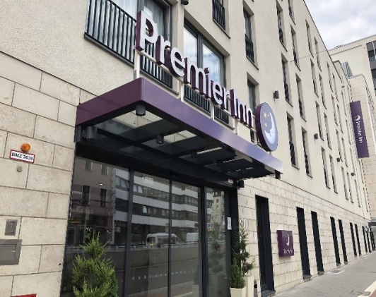

Figure 2 Premier Inn (Leoni and Moretti, 2024)

Premier Inn, a part of Whitbread PLC is in the budget hotels subsegment specialise mostly in the United Kingdom. The largest revenue generator is their accommodation. However, food and beverages generated from hotel restaurants also contribute to revenues, whilst in 2023 their report highlighted on continued rejuvenation of travel with increased domestic tourism and a resurgence in business travel (Lee et al., 2024). This ideal model of operations worked for Premier Inn, since the chain could offer basic services at lower prices and still record upward growth in sales, even as operating costs escalated. Their revenue growth pattern may be described as moderate but quite steady, which is the result of the company’s firm position in the British market of budgeting hotels. The company’s success in attracting cost-conscious clientele, including families and businesspersons, has helped maintain its operating capability.

Although Premier Inn’s revenues are a fraction of Shangri-La, it generated healthy margins due to a lower cost structure (Leoni and Moretti, 2024). Premier Inn’s cost structure is rather modest, and there is not much of an aim to provide many luxurious services, which is a great advantage in its operation. One of the most important things to consider when comparing these two hotel chains is their revenue structure. The additional revenue for Shangri-La also comes from other service offerings. For example, spa and wellness, events, and food services successfully capture high-end market demand, but the company has high operating expenses (Lin & Sakamoto, 2024).

The luxury market is also affected more by the economic shift that can result in uncertainties, which a Shangri-La may find challenging in sustaining such growth. While Whitbread operates a diverse portfolio of brands, each with a different service proposition, owning three brands across two businesses with differentiated service propositions is effective when one operates at a lower cost base than the other: Premier Inn can rely on a far simpler service proposition than Pizza Hut and effectively compete on price. However, this simple structure reduces the potential of expanding the revenue stream any further to the Shangri-La level, especially not forgetting that luxury brands have a higher propensity in the international markets.

Market Positioning

Shangri-La, as going to be discussed in detail, is strategic in the luxury market, focusing on the target demographic of HNWI and ensuring it provides high-end services across certain global locations. The luxury and personalised services the company offers have enabled it to set very high price levels. It majors in the Asia, Europe and North America regions and is expected to recover in 2023 due to the influx of international and business travelers (Majeed et al., 2022).

The strategic positioning of Shangri-La is supported by the impressive RevPAR, which is way beyond what most industry competitors with a focus on low-cost business models can achieve.
Finally, Premier Inn was recognised as a firm targeting economy-class guests who are price-sensitive travellers, families, and business people seeking cheap accommodation. Also, its market niche has effectively targeted the UK market, capturing a large chunk of domestic traffic with constant demands during the high travelling season. Here, the image comes from the positioning strategy adopted by Premier Inn, which seeks to provide cheap and quality services to its customers; this has made it gain many loyal customers despite threats from other companies within the same industry (Manoharan et al., 2024).

Analysing the absolute data further shows that it benefits Shangri-La to be in a high-price category since its market positioning allows it to control prices. Still, it puts it at risk from shifts in the economic cycle and volatility of the market (Nazarian et al., 2024). Another advantage of Premier Inn is that its customer base is less likely to be affected by the downturn than holidaymakers. Still, on the downside, they are struggling to make a mark in the highly competitive budget segment of the hotel business.

Growth Potential

Altogether, the outcome of Shangri-La Hotels indicates a good prospect for growth, particularly in expansionist strategies for new growth markets in Asia and the Middle East. These areas have increasing disposable per capita income and demand for better quality accommodation, known as upscale hotels. The different business plan deliveries include acquiring investment projects to create new objects or develop existing ones to enhance the offer for the guests and consolidate the company’s position on the market.

However, potential threats exist that currently affect the Shangri-La Hotel. These are geopolitical risks, economic risks, and competitive risks (Peng et al., 2024). However, these challenges should be addressed if the organisation perseveres with the rising trend on the growth curve.

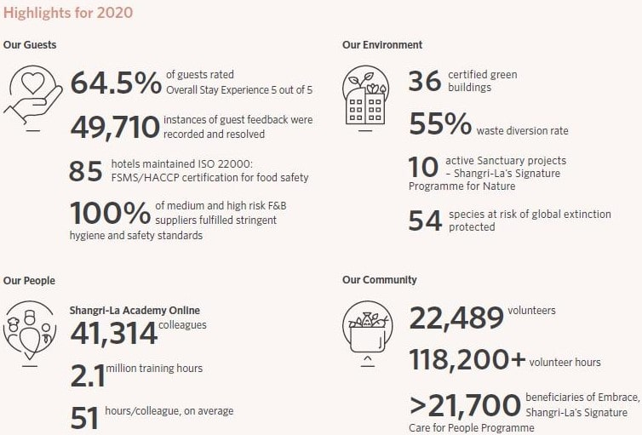

Figure 3 Shangri-La Hotel growth analysis (Peng et al., 2024)

Here, too, growth plans are well defined by Premier Inn; however, the group is noticing a rise in the coverage area but is only focused on the UK and the global markets. Another reason pointing to the fact that the environment for the growth of this concept is very favourable is that there is always a constant demand for such budget hotels in the urban territory. Nonetheless, threats such as enhanced market competition, rising operating costs and tough regulations greatly threaten Premier Inn’s expansion strategies.
An evaluation of the growth plan demonstrates that although the luxury market segment will allow Shangri-La to benefit from the possibility of large top-line growth, the firm is exposed to market fluctuations. The eight adaptation techniques chosen for Premier Inn are not very revolutionary, and there are some limitations to the chain’s expansion within the given market type.

Financial Commitment to Corporate Social Responsibility (CSR)

While the strategies for CSR at the two organisations are not spelt out, the amount of expenditure committed to CSR varies depending on the company’s business model. As a luxury hotel company, Shanghai has a broader CSR plan. There are effective practices of sustainable development in which the company has specialised in utilising energy and waste and engaging its communities (PJ et al., 2023). For instance, the company has implemented energy-saving projects and water usage initiatives in its hotels and resorts, decreased food wastage, and promoted the diversified cause of the communities (Suder et al., 2024). In 2023, the CSR expense of Shangri-La was also higher due to the overall company’s annual mission, which aimed at the improvement of its environmental obligations and the modern development of luxurious branding since sustainability became highly important for the luxury travel market.

To some extent, this strategic financial investment in CSR is consistent with Shangri-La’s luxury target market, in which customers demand environmentally and socially responsible products. The sustainable activities have improved the company’s brand reputation and loyalty, thus increasing the corporation’s chances of attracting guests with keen environmental consciousness. Sustainability is not an add-on for Shangri-La; through investments, they incorporate the brand's essence into the company’s vision.

Whitbread’s budget hotel – Premier Inn, is another example of the least enthusiastic attitude towards CSR. In fiscal areas, and despite some progress in some fields, including reducing carbon impact or improving energy efficiency, its financial engagement with the latter is more restrained (Ratna et al., 2024). This aligns with its strategic goal of keeping out costs as one of its key dimensions of strategic operations. Future sustainability issues may be reasonably well addressed through Premier Inn’s fairly comprehensive, if not highly daunting, CSR status that appears to combat current sustainability issues. The company has promised to reduce carbon emissions by half by 2030 (Ru and Jantan, 2023). It has employed strategies for curtailing wastage and energy conservation but lacks the financial muscle to support most of its CSR interventions.

While both firms have adopted CSR strategies, a notable difference is what these strategies have done to their positioning in the market. CSR initiatives across the Shangri-La group are comprehensive and form a significant aspect of the appeal of luxury travelling services to those seeking environmentally friendly and sustainable travel (Ru & Jantan, 2023). CSR can also provide a significant competitive advantage in the expanding luxury hotel marketplace as consumers appear more likely to choose a hotel with a compelling CSR approach.

Premier Inn has been less ambitious in its CSR investments because it is a budget hotel chain. Therefore, it has been able to concentrate on operations while neglecting the opportunity to serve the growing market of environmentally friendly hospitality services (Ru & Jantan, 2023). In this aspect, Shangri-La has been active in forwarding its CSR, making it ready for future differentiation; Premier Inn, by contrast, may extend its CSR to provide differentiation to survive in the constantly evolving market.

Recommendations

To further enhance its revenues, Shangri-La Hotels should consider the launch of products such as branded merchandise that would appeal to the selected market and special experiences that are advantageous for the targeted market. The above strategy would help wean off the traditional hospitality services, building the overall robustness of revenues while engaging the customers more. In general, it is proposed that Premier Inn Hotels continue spending money on technology to enhance its operation and amenities for its guests. As a result, Premier Inn can make more effective strategic decisions using data analysis and gain a greater sense of market orientation, which is critical for survival in an intensely competitive low-cost hotel market. This would further entrench it in the marketplace.

Aspect | Shangri-La Hotels | Premier Inn Hotels
Total Revenue | High due to luxury services | Steady from room bookings and F&B sales
Market Position | Luxury segment, affluent clientele | Budget segment, family and business focus
Growth Potential | Expanding in emerging markets | Growing within the UK, facing saturation
Financial Commitment to CSR | Significant investments in sustainability | Moderate CSR focus, cost management

Conclusion

The two giants in the hospitality industry, Shangri-La Hotels and Premier Inn Hotels have taken their strategic directions and come up with unique financial management. Shangri-La outperforms in areas like upper shelf positioning and development opportunities in the luxury segment. On the other hand, Premier Inn offers easy access to affordable hospitality to cost-sensitive travellers. Concisely, this paper stresses the role of and relevance of efficient knowledge concerning financial management principles in the hospitality industry, as well as the importance of efficient decision-making that derives from detailed financial analysis. As a result of the hotel's case investigation, this report provides a basis for the future identification and analysis of financial management principles within the sphere and reveals the challenges of effective financial management in the rapidly developing market.

References
Chen, Z. (2023). Beyond reality: Examining the opportunities and challenges of cross-border integration between metaverse and hospitality industries. Journal of Hospitality Marketing and Management, 32(7), 967-980.
Dutta, D., Vedak, C., and Joseph, V. (2024). New hire performance: identifying critical traits for the hospitality industry. Tourism Review, 79(1), 69-84.
Khan, S., and Wahab, A. (2024). Engaging customers through satisfaction: does social media marketing and perceived innovativeness really matter? A time-lagged study in the hospitality industry. Journal of Hospitality and Tourism Insights, 7(4), 2347-2366.
Khassawneh, O., Mohammad, T., Bouchon, F., and Behery, M. (2024). Eco-innovation and customer satisfaction in the hospitality industry in Dubai: the role of green leadership. Journal of Human Resources in Hospitality and Tourism, 23(3), 413-438.
Kim, J. J. (2024). Brand portfolio extension of international hotel chains: a perspective on consumer confusion and consumer decision-making process. International Journal of Contemporary Hospitality Management.
Lee, S., Song, H. J., Yoon, H., Kim, C. S., and Ham, S. (2024). Resilience of the hospitality industry during crises: A comparison between the 2008 financial crisis and COVID-19. International Journal of Hospitality Management, 116, 103622.
Leoni, V., and Moretti, A. (2024). Customer satisfaction during COVID-19 phases: the case of the Venetian hospitality system. Current Issues in Tourism, 27(3), 396-412.
Lin, I., and Sakamoto, C. (2024). The Outrigger Hotels and Resorts Brand Portfolio and Brand Extension. Journal of Hospitality and Tourism Cases, 21649987241259258.
Majeed, M., Asare, C., Fatawu, A., and Abubakari, A. (2022). An analysis of the effects of customer satisfaction and engagement on social media on repurchase intention in the hospitality industry. Cogent Business and Management, 9(1), 2028331.
Manoharan, A., Hutchinson, C., Treuren, G. J., and Madera, J. M. (2024). Disability employment in the hospitality industry: a systematic literature review. Cornell Hospitality Quarterly, 65(3), 362-377.
Nazarian, A., Shabankareh, M., Ranjbaran, A., Sadeghilar, N., and Atkinson, P. (2024). Determinants of intention to revisit in hospitality industry: A cross-cultural study based on globe project. Journal of International Consumer Marketing, 36(1), 62-79.
Peng, X., Zhu, J., Lee, S., Zhou, D., Song, W., and Ying, T. (2024). Digital transformation in the hospitality industry: A bibliometric review from 2000 to 2023. International Journal of Hospitality Management, 120, 103761.
PJ, S., Singh, K., Kokkranikal, J., Bharadwaj, R., Rai, S., and Antony, J. (2023). Service quality and customer satisfaction in hospitality, leisure, sport and tourism: An assessment of research in web of science. Journal of Quality Assurance in Hospitality and Tourism, 24(1), 24-50.
Ratna, S., Saide, S., Putri, A. M., Indrajit, R. E., and Muwardi, D. (2024). Digital transformation in tourism and hospitality industry: a literature review of blockchain, financial technology, and knowledge management. EuroMed Journal of Business, 19(1), 84-112.
Ru, D., and Jantan, A. H. B. (2023). The intervening role of customer loyalty and self-efficacy on the relationship between customer satisfaction, customer trust, customer commitment, customer value and customer citizenship behaviour in the hospitality industry in Guangdong, China. Journal of International Business and Management, 6(1), 1-12.
Suder, M., Duda, J., Kusa, R., and Mora-Cruz, A. (2024). At the crossroad of digital and tourism entrepreneurship: the mediating effect of digitalisation in the hospitality industry. European Journal of Innovation Management, 27(4), 1057-1081.
Tanveer, M. I., Yusliza, M. Y., and Fawehinmi, O. (2024). Green HRM and hospitality industry: challenges and barriers in adopting environmentally friendly practices. Journal of Hospitality and Tourism Insights, 7(1), 121-141.

