

Student name: Ionut Claudiu Ungureanu
Student number: 2323114
Programme: BA (Hons) Developing Leadership and Management
Module: People Management
Module code: BMSW5010
Title: People Management at BrightWave Services Ltd
Lecturer: Rebecca Francis Davies
Word count: 2000 words
Submission deadline: 12th December 2025 at 23:59

Executive Summary
BrightWave Services Ltd is a South Wales-based medium-sized management company. This overall writing states the importance of managerial capability through applying HR thesaurus, proposes evidence and self-improvement and assesses the organisational culture. This organisation focused on developing its organisational culture by providing task-driven insights to stress and develop efficiency. Roles & Skills Required by Managers to Manage Performance are effectively managing performance through planning, leading, facilitating, organising, and controlling. With the help of different theoretical aspects and frameworks, this report covers the crucial role of the manager at BrightWave and the impact on employee management. It also states the reasons why organisational culture causes HR problems. At last, it gives some crucial recommendations for developing employee performance and strengthening organisational success.

Table of Contents
Introduction 4
Current Situation & People Management Problems of BrightWave 4
Roles & Skills Required by Managers to Manage Performance 5
Application & Critical Evaluation of People-Management Theories 7
Impact of Organisational Culture on Employee Management 9
Recommendations 11
Conclusion 12
Reference 13

Lists of Figures
Figure 1: Company Logo 4
Figure 2: Management skills 6
Figure 3: Herzberg Two-Factor Theory 8
Figure 4: Schein’s Three-Level Model 10

Introduction
BrightWave Services Ltd is a medium-sized management company based in South Wales. This company employs around 350 staff across three important business divisions, including workplace support, cleaning service and building effective maintenance. According to Meli (2013), this organisation has followed a flat structure with a senior manager at the head office in Swansea and the services of frontline managers for effectively supervising teams across dispersed sites. This company makes use of the lines as a reliable and cost-effective provider.
This report states the importance of managerial capability through applying HR thesaurus, proposes evidence and self-improvement and assesses the organisational culture. The importance of retention primarily encompasses both employee retention and contract retention. These are crucial business strategies that fundamentally impact organisational stability, productivity and overall efficiency. The main purpose of this report is to evaluate the role and skills of managers at BrightWave Services. This report also examines the organisational culture at BrightWave by applying theories and models.


Figure 1: Company Logo
(Source: Contacts, 2025)

Current Situation & People Management Problems of BrightWave
BrightWave is focused on developing its organisational culture through providing task-driven insights to stress and develop efficiency of the company's market to their clients as reliable and cost-effective providers (Brightwave, 2025). Current challenges of this company and its management procedure include performance management gaps, managerial skill gaps, organisational culture, turnover has reached 28%, and external pressures that have enhanced the risk of losing contracts.
High turnover: High employee turnover develops disruptive issues that directly enhance financial burdens. Employees often feel undervalued and lack opportunities for growth or have poor relationships with their direct managers.
Low recognition & progression Cost: Another significant issue faced by BrightWave is low recognition and progression cost. Modern workers particularly develop progression costs and create limited development opportunities.
Low engagement and rigid thinking: BrightWave's face turnover rate has reached 28%, which has particularly enhanced limited progression, rigid thinking, poor communication with managers, and not feeling valued by managers.
Poor managerial skill: According to Bukh and Svanholt (2020), the middle managers are focused on cost control, scheduling, and compliance reporting. This company has faced increasingly inconsistent service. Poor management skills lead to high turnover and low engagement.
Underperformance tolerated: Underperformance allows this company to avoid performance conversations. BrightWave faces Underperformance for creating resentment among higher-performing employees. Poor performance creates an inequitable work environment, which can lead to a general decline in overall team accountability and productivity.
Gap of performance management: BrightWave fails to effectively provide feedback promptly and does not align with the employees' need for future growth, continuous development, and agile goal adjustments.

Roles & Skills Required by Managers to Manage Performance
In the view of Hughes and Terrell (2011), to manage efficient performance, managers act as strategists, coaches, and key essential skills like clear communication, strategic thinking and emotional intelligence. Key roles of managers to effectively manage performance include leading, planning, facilitating, organising, and controlling. Effective managers should compare these skills to BrightWave’s current situational reality.
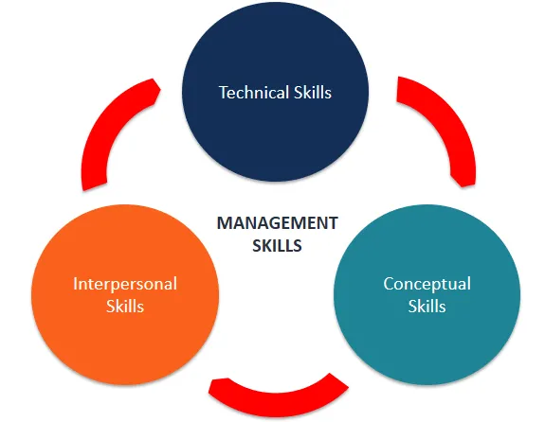

Figure 2: Management skills
(Source: Corporatefinanceinstitute, 2025)
Skills required: The crucial skills required for a manager to effectively manage the organisational performances include the ability to resolve conflicts, skills of performance review, giving constructive feedback and having the ability to mentor and coach with strong communication and motivation. It is also helpful to set a SMART objective trust to help evaluate the performance management within BrightWave Service Ltd. in the view of Pastila (2024), through developing emotional intelligence, strategic thinking, data literacy, critical thinking, and problem solving are other important skills for managers at BrightWave.
Performance management theory for evaluation:
Armstrong’s Cycle: The performance management has primarily evolved from annual review-based systems to a more dynamic and continuous process. The Armstrong Handbook cycle also emphasised the shift toward developmental feedback that focuses on competencies and real-time assessments (Issuu, 2025). This cycle boosts the organisation through developing people's skills and efforts. It also emphasises shared understanding, celebrity and interaction between employees and managers.
SMART goal setting: Setting SMART goals is also a performance management theory that guides the development of a manager's performance. This is also an individual's goal with the company's objectives through providing a clear direction towards future goals. The SMART objective ensures evaluation and alignment with future direction and monitoring overall progress, motivating and developing styles to build a foundation of trust and continuous dialogue.
CIPD managerial capability frameworks: According to Armstrong (2022), the CIPD’s approach helps to boost the managerial capability and performance management that is rooted in an evidence-based model. This effectively integrated various psychological and motivational theories, and leveraged the goal-setting theory, Strengths-Based Approach and Expectancy Theory.
Critical depth:
Emotional intelligence, giving constructive feedback, coaching & mentoring, conflict resolution and Communication & motivation are essential for any modern organisation such as BrightWave (Yuldasheva, 2024). These help top site employee development and enhance experience with developing a positive relationship and achieve better success within the organisation. Due to a lack of these skills, BrightWave faces current challenges, which significantly slow down the organisation's future success. Performance management gap, gap of managerial skills and pressures from externals hinder the employee well-being and sustainable employment.

Application & Critical Evaluation of People-Management Theories
Motivation & Engagement
Herzberg Two-Factor Theory: Herzberg's theory suggested that the two important factors include hygiene factors like policy, pay and conditions (Ybañez, 2024). These are driving satisfaction and better performance. This theory also helps managers to maintain the hygiene needs of employees. BrightWave faces significant issues due to its low recognition and high progression cost. A lack of recognition fails to maintain the hygiene needs of employees and leads to no job satisfaction. Managers have to fix hygiene losses through policy and salary to stop employee complaints and use various motivators to foster employee satisfaction.
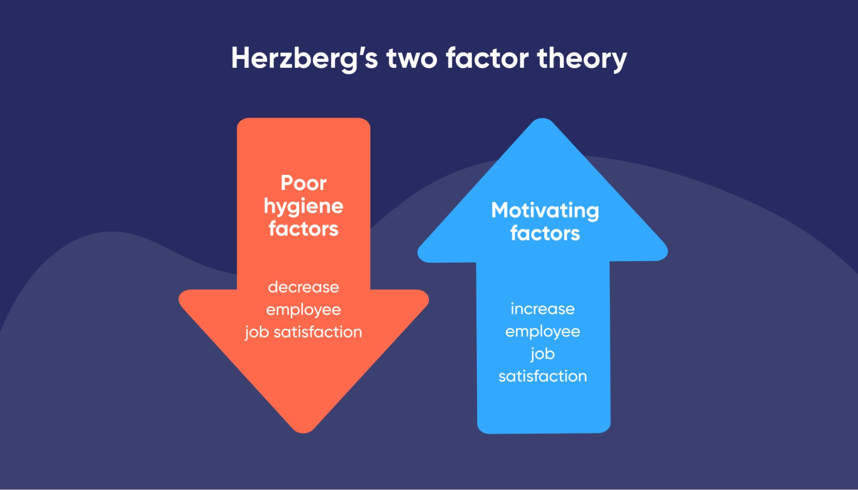

Figure 3: Herzberg Two-Factor Theory
(Source: Bluedonkey, 2025)
Leadership & Management
Transformational vs Transactional leadership
 | Transformational | Transactional
Application | Fostering employee commitment, change management and developing leaders to develop innovations. | Develop routine tasks, clear structure, ensure critical management and achieve organisational short-term goals.
Pros | Encouraging creativity boosts morale and builds strong relationships. | Clear expectations, efficient and motivated by tangible reward.
Cons | Risk for burnout, demanding and relies on the leader's charisma. | Offer little intrinsic motivation, limited clarity and do not focus on personnel growth.
Transformational leadership can help managers at BrightWave to inspire new changes, intrinsic motivation and foster innovation by focusing on the future empowerment and growth opportunities, while Transactional leadership should help this service company to ensure employee stability and focus on short-term goals (Jaqua and Jaqua, 2021).
Performance Management
GROW coaching model: The GROW coaching model is a four-stage model, including Goal, Reality, Options, and Will, with a structured framework that is widely used to guide individuals towards effectively achieving specific objectives through encouraging self-awareness, self-directed actions, and responsibility (Knowles, 2022). BrightWave faced significant changes related to performance management approaches. This model offered the organisation a powerful and structured framework to address these issues and foster employee accountability and engagement. GROW models offer various significant advantages for BrightWave’s performance management transformations.
Learning & Development
Kolb Learning Cycle: According to Morris (2020), Kolb Learning Cycle mainly explains how people effectively learned through concrete experience, abstract conceptualisation and reflective observation. This learning cycle has four important steps: concrete experience, Reflective observation, abstract conceptualisation and active experimentation. These are to develop manager leadership techniques at BrightWave. The application of Kolb Experiential Learning Cycle at BrightWave offers a holistic and potent framework for effectively managing complex performance in people. This model also provides a robust structure for organisations as well as individuals' continuous improvement. Thai theoretical assumptions can require a careful implementation with an adaptable mindset.

Impact of Organisational Culture on Employee Management
Organisational culture significantly impacts an individual's management through shaping employee engagement, retention, performance and overall experience. Key impacts of organisational culture on people management are employee engagement, fostering a positive culture, attracting, performance management and enhancing change management.
Schein’s Three-Level Model
Edgar Schein’s Three-Level Model is significant for effectively analysing various cultural impacts on people's management (Eskandari et al., 2025). This theory talks about the visible elements such as dress codes, ritual office design, espoused values like HR policies, employee consistency and basic underlying assumptions like human nature, powers and relationships. These play a significant role in dealing with BrightWave rigid & low innovations. Through applying this theory, BrightWave influences HR practice and deals with skill gaps.
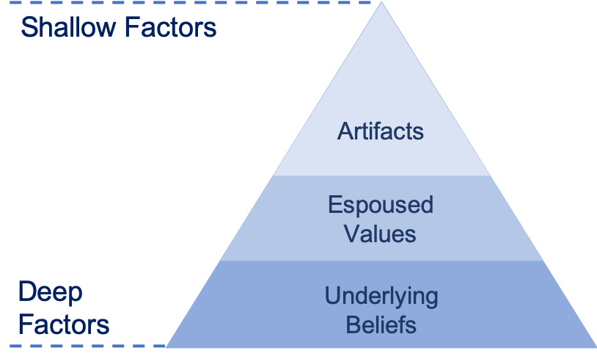

Figure 4: Schein’s Three-Level Model
(Source: Carrier, 2025)
Handy Cultural Types
Charles Handy’s model effectively categorises organisational culture like power, role, tasks and people, which helps to explain how organisational culture shows management and behaviour through focusing on power, tasks, roles and people. Understanding these four important types helps managers tailor core strategies for retention. Motivation and better performance. This also ensures the customer supports the organisational strategic goals.
Deal & Kennedy
According to Akpa et al., (2021), the cultural theory of Deal & Kennedy helps to analyse behaviour patterns through effectively linking organisational culture with people management. This theory focuses on people management skills like clear rewards, longer-term focus, high-risk environments and gathering employee positions for boosting bearer performance. Applying this culture theory through four types, BrightWave can manage volatility, maintain hog morale, team, and carefully allocate resources.
culture causes the HR problems:
An organisational culture fails to prioritise its employees' performance management, which causes a lack of recognition, low empowerment and a focus on people. Lack of recognition causes employee turnover, and that creates service inconsistency. Lack of efficient organisational culture creates low employment, which develops weak innovation and poor engagement of employees (Aman, 2019). Extreme focuses on tasks over people, ignores employee well-being and future progression, which are courses cultivated by difficulties and various HR problems.

Recommendations
A. Develop Managerial Capability
Developing managerial capability mainly requires comprehensive and multifaceted approaches that combine supportive mechanisms with practical applications (Motamedimoghadam, et al., 2025). By fostering employees, skill training and mandatory leadership, the managerial capabilities are boosted. Through introducing GROW or coaching farmwork, it will help managers at BrightWave to solve critical problems and provide significant advice. The coaching framework emphasises powerful questioning and active listening, providing in-depth training. BrightWave should also focus on creating peer support, manager forums that help to create a psychologically safe work environment for managers to share their unique experiences, practices and challenges. It also fosters a culture of continuous learning.
B. Strengthen Performance Management Systems
To strengthen the performance management system of BrightWave, it should help to develop quarterly review cycles, set efficient SMART objectives and introduce the culture through training. Significantly shifting food from a single annual review to a quarterly review allows timely feedback and offers course corrections and enhances employee engagement. By setting a clear and strategic goal for business success, the SMART firm contributed to organisational strategic success. Through aligning KPI to SMART objectives to adjust rebuke review, systems foster collaborative work and set a high level of operational growth (Linkedin, 2025). A healthy and efficient feedback culture is essential for operations and supported leadership models.
C. Improve Engagement & Retention
Through implementing structured programs for career development and recognition, recognition schemes like giving employees a monthly reward improve customer satisfaction rate and reduce turnover by 10 to 15 % within 1 year. Opportunity to develop career pathways through various organisations' internal progression programmes, develop employee trust & loyalty, and promote internal mobility. The buddy system for newly joined employees and a structured induction provide social support and give informal guidance to new joiners.
D. Culture Change Strategy
According to Azevedo et al., (2021), organisational cultural change is a multifaceted and complex journey through introducing employee voice channels like focus groups and surveys, focusing on employee wellbeing and giving them the flexibility to develop innovative ideas. These recommendations and strategies are to embed the desired behaviours and develop employee mindsets within the BrightWave service Ltd in a specific period of time. These strategies help to develop a better organisational culture and enhance employee satisfaction through managing the survey scores from employees, which increase every year.

Conclusion
It is concluded that BrightWave Services Ltd has followed a flat structure, and it has employed around 350 staff across three important business divisions. The current challenges faced by their company include a managerial skill gap, organisational culture, turnover has reached 28%, and external pressures and so on. To manage and deal with these changes, managers play a significant role, such as developing emotional intelligence, enhanced strategic thinking, data literacy and expanding critical thinking and problem solving are other important skills at BrightWave. The theoretical implications make a significant impact on this organisation and develop an understanding of the importance of leadership and feedback. A healthy and efficient feedback culture is essential for operations and supported leadership models. The various recommendations based on evidence of this organisation include improving employee engagement, athlete management system, and developing managerial capabilities.

Reference
Akpa, V.O., Asikhia, O.U. and Nneji, N.E., (2021). Organizational culture and organizational performance: A review of literature. International journal of advances in engineering and management, 3(1), pp.361-372. https://www.researchgate.net/profile/Professor-Asikhia/publication/356105838_Organizational_Culture_and_Organizational_Performance_A_Review_of_Literature/links/618bed3907be5f31b762d272/Organizational-Culture-and-Organizational-Performance-A-Review-of-Literature.pdf
Aman, M.K., (2019). The effect of employee engagement and organization culture on company innovation capability. International Journal of Contemporary Accounting, 1(1), pp.13-22. https://www.e-journal.trisakti.ac.id/index.php/ijca/article/view/5182
Armstrong, M., (2022). Armstrong's handbook of performance management: An evidence-based guide to performance leadership. Kogan Page Publishers.
Azevedo, M.C.D., Schlosser, F. and McPhee, D., (2021). Building organizational innovation through HRM, employee voice and engagement. Personnel Review, 50(2), pp.751-769. https://www.emerald.com/pr/article-abstract/50/2/751/325902/Building-organizational-innovation-through-HRM?redirectedFrom=fulltext
Bluedonkey, (2025) Herzberg Two-Factor Theory and #1 lead generation marketing Blue Donkey - Intelligent Telemarketing. Available at: https://www.bluedonkey.co.uk/herzberg-two-factor-theory-lead-generation/ (Accessed: 10 December 2025).
Brightwave, (2025) Research agents for professionals Brightwave. Available at: https://www.brightwave.io/ (Accessed: 10 December 2025).
Bukh, P.N. and Svanholt, A.K., (2020). Empowering middle managers in social services using management control systems. Journal of Public Budgeting, Accounting & Financial Management, 32(2), pp.267-289. https://www.emerald.com/jpbafm/article-abstract/32/2/267/237022/Empowering-middle-managers-in-social-services?redirectedFrom=fulltext
Carrier, J. (2025) Edgar Schein’s organisational culture triangle: A simple summary - peopleshift %, PeopleShift. Available at: https://people-shift.com/articles/edgar-scheins-culture-triangle/ (Accessed: 10 December 2025).
Contacts:, M. (2025) Brightwave and Quartr partner to streamline research and help investment teams boost deal coverage, Global Press Release & Newswire Distribution Services. Available at: https://www.businesswire.com/news/home/20250211425728/en/Brightwave-and-Quartr-Partner-to-Streamline-Research-and-Help-Investment-Teams-Boost-Deal-Coverage (Accessed: 10 December 2025).
Corporatefinanceinstitute, (2025) Management skills Corporate Finance Institute. Available at: https://corporatefinanceinstitute.com/resources/management/management-skills/ (Accessed: 10 December 2025).
Eskandari, D., Haghparast Ghomesheh, A., Jabbari, M., Gholami, A. and Ahmadi, O., (2025). Development of a New Index to Assessing the Safety Culture Based on the Edgar Schein Model (Audit Approach). The Scientific World Journal, 2025(1), p.3166187. https://onlinelibrary.wiley.com/doi/full/10.1155/tswj/3166187
Hughes, M. and Terrell, J.B., (2011). Emotional intelligence in action: Training and coaching activities for leaders, managers, and teams. John Wiley & Sons.
Issuu, (2025) Armstrongs Handbook of Performance Management an evidence based guide to delivering high performance by Angie.butler943 - Issuu. Available at: https://issuu.com/angie.butler943/docs/armstrongs-handbook-of-performance-management-an-e (Accessed: 10 December 2025).
Jaqua, E. and Jaqua, T., (2021). Transactional leadership. American Journal of Biomedical Science and Research, 14(5), pp.399-400. https://www.researchgate.net/profile/Ecler-Jaqua-2/publication/360288883_Transactional_Leadership/links/63a0bbf240358f78eb018ac0/Transactional-Leadership.pdf
Knowles, S., (2022). Coaching for Learning and Growth. In Positive Psychology Coaching (pp. 127-137). Cham: Springer International Publishing. https://link.springer.com/chapter/10.1007/978-3-030-88995-1_10
Linkedin, (2025), How to align Kpis with business objectives LinkedIn. Available at: https://www.linkedin.com/top-content/business-strategy/aligning-operations-with-business-goals/how-to-align-kpis-with-business-objectives/#:~:text=Summary,areas%20for%20improvement%20across%20departments. (Accessed: 10 December 2025).
Meli, M., (2013). Craft beer in Japan: The essential guide. Bright Wave Media, Inc..
Morris, T.H., (2020). Experiential learning–a systematic review and revision of Kolb’s model. Interactive learning environments, 28(8), pp.1064-1077. https://www.tandfonline.com/doi/abs/10.1080/10494820.2019.1570279
Motamedimoghadam, M., Mira da Silva, M. and Amaral, M., (2025). Organizational capabilities for digital innovation: a systematic literature review. European Journal of Innovation Management, 28(7), pp.3024-3048. https://www.emerald.com/ejim/article-abstract/28/7/3024/1250115/Organizational-capabilities-for-digital-innovation?redirectedFrom=PDF
Pastila, A., (2024). Development of an emotionally intelligent leadership concept. https://www.theseus.fi/handle/10024/850646
Ybañez, R., (2024). Application of Herzberg's two-factor theory: Motivational factors and hygiene factors in the financial industry. Journal of Interdisciplinary Perspectives, 2(4), pp.92-101. https://jippublication.com/index.php/jip/article/view/576
Yuldasheva, K.K., (2024). The impact of emotional intelligence on the effectiveness of key decision-making by leaders. Spanish Journal of Innovation and Integrity, 36, pp.86-92. https://www.sjii.es/index.php/journal/article/view/16

