Effective Team -working and Communication
BMSW4009_CARD 1000 words – actual 1142
Luiza Costache (2222612)
6-16-2023

Table of Contents
Terms of Reference 1
Procedure 2
Introduction 3
Main findings 4
Effective communication in the workplace 4
Berol’s Model 5
Shannon-Weaver Model 6
Schramm's Model 7
Workplace communication issue example 8
Conclusion 9
Reference list: 10

Terms of Reference

James Squire-Wood, a lecturer at the University of Wales Trinity Saint David, has requested for a report on workplace communication. The report is due on June 16, 2023. The goal of the report is to provide understanding on effective workplace communication by exploring its key elements, assessing communication models, and sharing personal experiences with communication challenges at work.

Procedure

I used the reading list provided by my lecturers on Moodle, an online learning platform, to gather information for this report. The reading list gave me a good understanding of the subject. Additionally, I conducted my own research by exploring relevant databases and academic journals to find additional sources. This helped me explore specific topics of interest and gain a deeper understanding of the subject.

Introduction

This report examines three crucial aspects of workplace communication: clarity, empathy, openness, and adaptability. It will also explore three communication models: Berlo, Shannon-Weaver, and Schramm. Finally, it will share a personal experience with a communication challenge at work to show how communication issues can arise in real-life situations and offer solutions to overcome them. Overall, this report aims to enhance understanding of why effective communication is crucial in the workplace and provide practical tips for improving it.

Main findings

Effective communication in the workplace

To communicate effectively in the workplace, it is important to use clear language, listen attentively, and treat others with respect (CIPD, 2022). Here are some key things to keep in mind:
- Use straightforward language: Avoid employing technical phrases or sophisticated words that people might not understand. If necessary, use examples or images to illustrate your idea.
- Listen carefully: Pay attention to what others are saying without interrupting them. Demonstrate your understanding by nodding or asking questions. Try to see things from their perspective.
- Engage in two-way communication: Encourage open conversations and value different ideas. Communication involves both speaking and listening, so seek out feedback and be open to it.
- Be aware of your nonverbal signals: Communication is not just about words. Your body language, tone of speech, and gestures can all reflect how interested or engaged you are.
- Be polite and respectful: Use kind words and a friendly tone with your colleagues. Avoid making offensive jokes or negative comments. Foster an inclusive and welcoming environment.
- Adapt to others: People communicate differently, so be flexible and adjust your style accordingly. This can help you build better connections and ensure that your message is understood.
- Give and receive feedback: Constructive feedback is essential for improving communication. Focus on actions rather than criticism when providing feedback to others and be open to receiving feedback yourself.
- Use technology wisely: Email and video calls can be helpful communication tools, but face-to-face conversations are often more effective. Use the right tool for the situation.
- Clarify goals: When communicating with others, make sure everyone knows the purpose and goals of the conversation. Be clear about what you want to achieve and what actions are required.
- Follow up: Communication is an ongoing process. Check back later to ensure that everything is understood and progressing as planned. Regularly touch base with your team and address any questions or concerns (Valentine Belonwu, 2013).

Understanding the communication process and how information is transferred between people is made easier with the help of communication models. I will provide a critical evaluation of Berol's model, the Shannon-Weaver model, and Schramm's model.

Berol’s Model

David Berol’s communication model identifies five key components: sender, message, channel, receiver, and feedback (Communication Theory, 2014). However, it falls short in capturing the complexities of real-life communication. This model assumes a linear and one-way flow, which is not always the case. Additionally, it oversimplifies interpersonal communication by neglecting important factors such as emotions, context, and culture. Lastly, this model doesn't account for barriers or noise that can impede effective communication.



Shannon-Weaver Model

The Shannon-Weaver Model explains how information is transmitted through a sender, channel, and receiver (Lyon, 2017). It considers noise as any disruption during communication. It is useful in understanding technical aspects, but oversimplifies communication by overlooking context, meaning, and feedback. It portrays the receiver as passive, ignoring their active role in interpreting and participating in the communication.

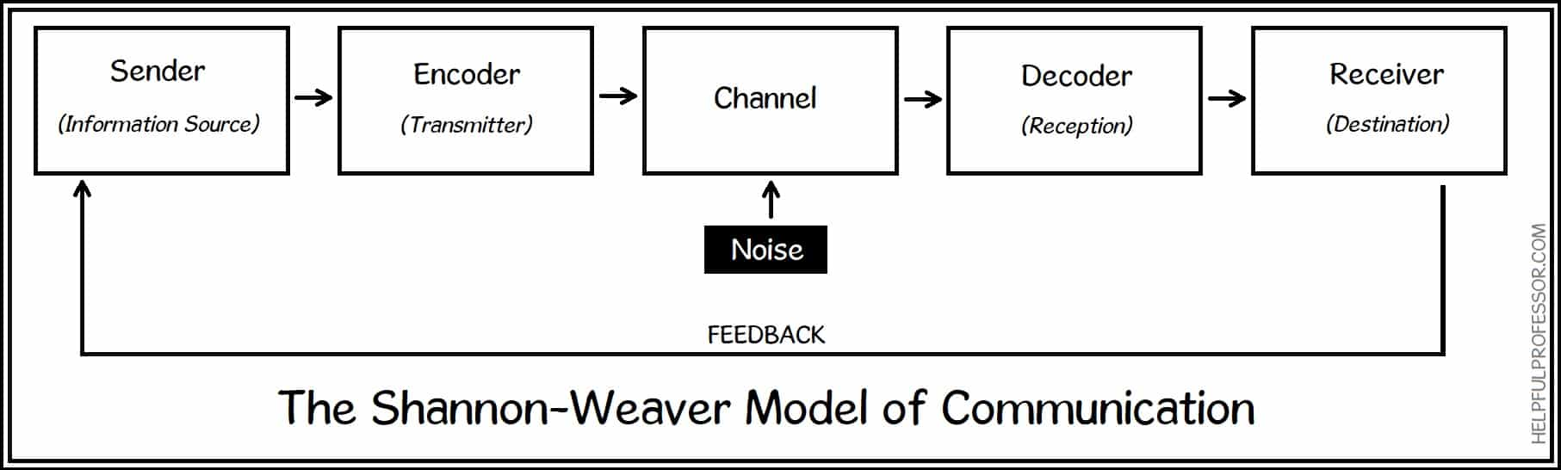

Shannon, in his famous article titled “A Mathematical Theory of Communication” where he outlined the theory, explained what the goal of his model was:
The fundamental problem of communication is that of reproducing a message sent from one point, either exactly or approximately, to another point” (Shannon, 1948,).

Schramm's Model

Communication is a dynamic process that involves both the sender and receiver. Schramm's model highlights the importance of feedback and interaction between the two parties, and recognizes that individual interpretations, cultural backgrounds, and shared experiences influence the communication process (Drew, 2020). However, this linear model oversimplifies communication and does not fully capture its complexity in real-life scenarios. While models can provide helpful frameworks for understanding communication, it's important to recognize their limitations and the need for a more nuanced and contextualized understanding. Effective communication requires practice, but it can greatly improve work environments and relationships with others.

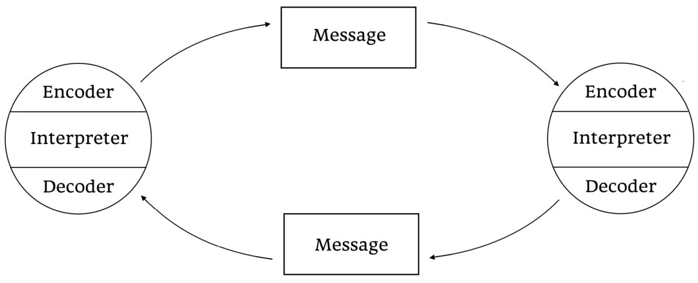

Workplace communication issue example

As a shift manager at McDonald's, I experienced a critical communication breakdown when the previous shift manager failed to communicate the stock shortage. This could have resulted in operational chaos and customer dissatisfaction.
Once I became aware of the problem, I promptly notified my team and delegated specific tasks to address it efficiently. Additionally, I kept the business manager informed of the situation and the steps I was taking to resolve it. To prevent similar issues from happening in the future, I took a proactive approach and established a checklist to minimise miscommunication. I made it mandatory for shift managers to provide a comprehensive report on stock levels at the end of each shift. This measure significantly improved communication and prevented any future shortages.
The experience taught me the importance of proper handover and standard operating procedures for communication during shift changes, as well as the need for open communication channels to share important information.
Effective communication is essential for any workplace, and organisations can improve their operations by understanding and implementing key elements of effective communication and employing suitable communication models. Experiences like the stock shortage issue emphasize the importance of communication and protocols to ensure critical information is relayed to the relevant personnel.

Conclusion

In conclusion, effective communication is crucial for a successful workplace. Clear language, active listening, respect, awareness of nonverbal cues, adaptability, feedback, appropriate technology use, goal clarification, and consistent follow-up are all important for strong communication. Understanding communication models like Berlo's, Shannon-Weaver, and Schramm's is also valuable. My experience shows the importance of seamless communication during transitions like shift changes. Adopting these essential communication elements and creating standardized protocols can improve team dynamics and achieve operational excellence. Careful and attentive communication is necessary to ensure everyone is informed and ready to tackle challenges together.

Reference list:

Chris Drew (2019). 4 Key Principles | Osgood-Schramm Model of Communication (2020). [online] Helpful Professor. Available at: https://helpfulprofessor.com/osgood-schramm/ [Accessed 2023].
CIPD (2022). CIPD | Employee communication. [online] CIPD. Available at: https://www.cipd.org/uk/knowledge/factsheets/employee-communication/ [Accessed 2023].
Communication Theory (2014). BERLO’S SMCR MODEL OF COMMUNICATION. [online] Communication Theory. Available at: https://www.communicationtheory.org/berlos-smcr-model-of-communication/.
Drew, C. (2020). All 8 Models of Communication, Explained! (2020). [online] Helpful Professor. Available at: https://helpfulprofessor.com/communication-models/ [Accessed 2023].
ETV, M.E. (2019). Osgood Schramm Communication Model. [online] www.youtube.com. Available at: https://www.youtube.com/watch?v=GQu2D7020Sc [Accessed 2023].
Jenkinson, P. (2013). Communication Models: Basic SMCR Model. YouTube. Available at: https://www.youtube.com/watch?v=yUGW2d6nXe0 [Accessed 2023].
Kaur, S. (2015). Communication Skills | PDF | Interpersonal Relationships | Emotions. [online] Scribd. Available at: https://www.scribd.com/document/255097236/Communication-Skills [Accessed 10 Jun. 2023].
Keyton, J. (2011). Communication and organizational culture: a key to understanding work experience. Los Angeles; London; New Delhi: Sage Publications.
Lyon, A. (2017). Transmission Model of Communication: Shannon and Weaver. YouTube. Available at: https://www.youtube.com/watch?v=OY1JsGFZprc [Accessed 2023].
Shannon, C.E. (1948). A Mathematical Theory of Communication. Bell System Technical Journal, [online] 27(4), pp.623–656. doi: https://doi.org/10.1002/j.1538-7305.1948.tb00917.x.
Valentine Belonwu (2013). 20 Ways to Communicate Effectively with Your Team. [online] Small Business Trends. Available at: https://smallbiztrends.com/2013/11/20-ways-to-communicate-effectively-in-the-workplace.html [Accessed 2023].

