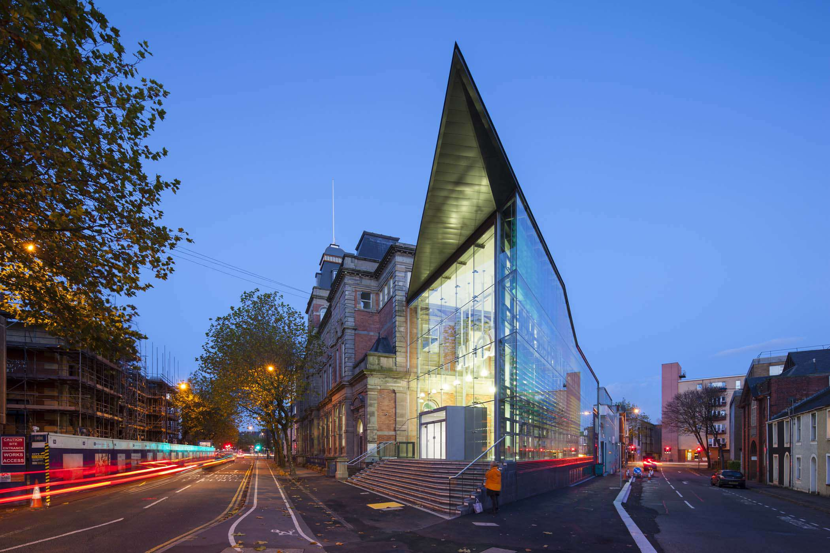  ACBA 6009 Advanced construction technology | Abstract  Retrofitting modern construction technology into a grade 2 listed building.  Goodrum, Joseph (J)

Contents
Introduction. 2
Building overview 2
Alex building existing technology 3
Alex building proposed technology 5
Conclusion 8
Appendices 10
References 12

Introduction.

This report examines how modern construction technology can be incorporated into buildings and explains how the Alex Building, Swansea, SA1, could be retrofitted with modern technology to improve the performance of the building and facilities management during operation. It also evaluates how these technologies could improve the building’s performance in terms of maintenance and repair of the asset.

Building overview

The construction of the Alex Building was completed in 1887, as confirmed in Appendices A and B. The building was constructed over demolished residential dwellings and was originally designed for use as a library. Figure 1 below shows the original building sometime after completion.

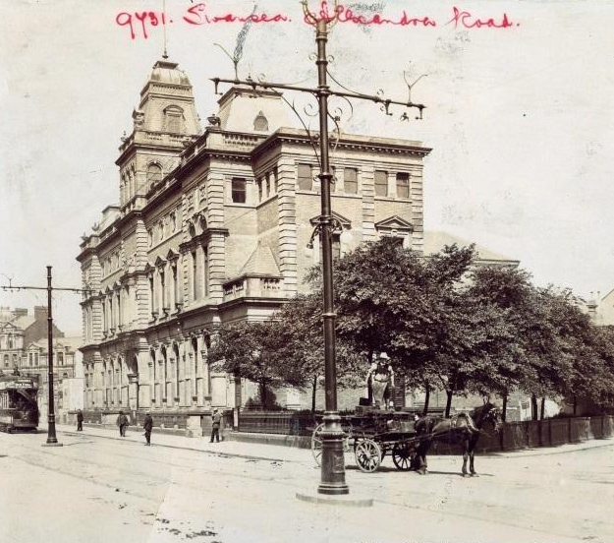
Figure 1 Screenshot of original Alex Building image from (Swansea Council, 2022).

The building’s use was changed from a library into an academic institution, with the project completed in 2014. The change of use included a refurbishment of the original building, retaining original features, along with the addition of a contemporary extension, shown in Figure 2 below. The project specification included the addition of a PV array on the original building, an audio-visual installation, and a Building Management System (BMS) linked to automatic windows to manage thermal comfort within the new contemporary extension. The extension also features a stack-effect passive ventilation strategy.

Figure 2. Screenshot of Alex Building and contemporary extension from (Powell Dobson Architects, 2024).

Alex building existing technology

The use of the Alex Building has changed several times since it was first constructed in 1887. Its original intended purpose was as a library; however, although it has been an arts facility for a long period, the nature of arts education has evolved over the decades and, as such, the building’s use has also changed. The building now has an array of different technologies installed within the substructure and superstructure.

The substructure has been repurposed for use as workshops and as the plant room that controls the building. The workshops feature industrial technologies such as painting and blasting booths, while the plant room contains the Building Management System (BMS), which controls the heating system, domestic hot water (DHW), and ventilation via air handling units (AHUs). The plant room also contains a traditional gas-fired boiler heating system and air handling systems for use in the workshops. Figure 3 below shows the BMS currently fitted and in operation.
At the time of the field visit, it was noted that many features of the BMS were either faulty or turned off, with only the three boilers, 50% of the heating pumps, and the AHUs being controlled by the BMS.

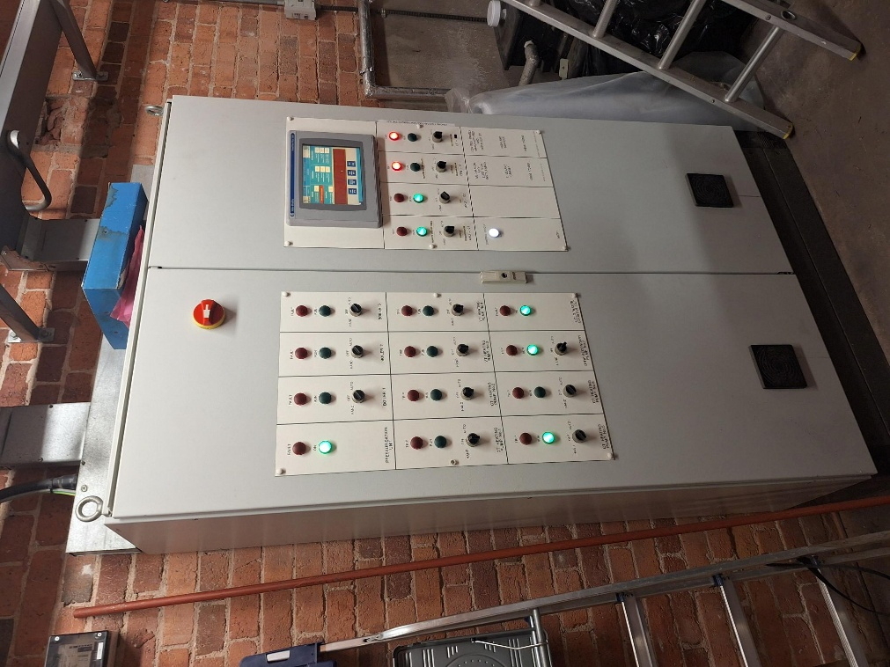
Figure 3. Alex building BMS system in operation.

The above-grade structure accommodates a mixed use, including an auditorium and teaching spaces, with the addition of the new glass façade structure housing the entrance and reception areas. Figure 4 below shows the interior of the new glass façade extension.
This extension features passive ventilation design elements, using a double-skin glass façade on the south elevation with internal brise-soleil to regulate solar gains because of the large, glazed façade.
At the time of the visit to the building, it was noted that the occupants had bypassed these design strategies by opening internal windows and installing active ventilation into the reception area due to the regular thermal overheating of the new glass façade extension. The rooms in the original part of the building featured occupancy sensors that are used to gather data on how much the building is utilised.

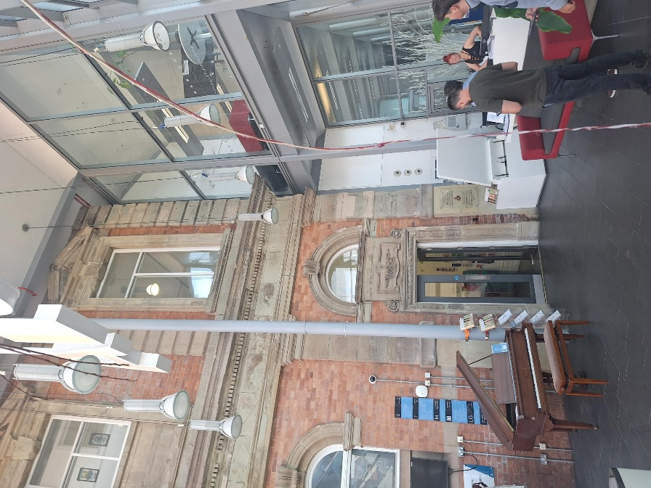
Figure 4. glass façade extension interior.

Alex building proposed technology

From the information gathered during the desktop survey and site visit to the Alex Building, it is evident that facilities management of the building is challenging. Several issues have been highlighted, including the costs and conservation restrictions associated with the building being Grade II listed, the high operating and maintenance costs of a 139-year-old building, the potential underutilisation of the building and the university’s wider assets, and the challenges presented by adapting the original building design for modern operations.
Although originally developed for new-build construction processes, Building Information Modelling (BIM) could be adopted for legacy asset management and, in theory, has the potential to assist in alleviating some of the challenges listed above.
The BIM work process for new construction involves collecting and storing asset information from project creation to completion, creating increasing levels of information and detail as the project progresses through the construction project stages. Information on the materials used to construct the building and supporting documentation of these materials like quality documents, drawings & vendor information are retained within a data-rich federated model of the asset to be used throughout the building’s lifecycle and can be combined with a computer-aided facilities management system (CAFM) maintenance plans for the materials and equipment used in the building. This information and detail can be used by the asset owner during the construction, operation and demolition of the building by providing accurate details on the building itself and how to operate and maintain it.

Historic England, the governing body that advises on the planning and protection of England’s historic assets, including listed buildings similar to the Alex Building, has documented how BIM can be utilised to manage historic assets. It notes that the BIM process can be used as an effective asset management tool, creating a centralised data repository that enhances collaboration across the asset’s stakeholders and improves productivity and efficiency within management teams. Historic England further proposes that the adoption of BIM leads to better decision making for the conservation and preservation of legacy assets by gathering data, supporting condition monitoring, and prioritising the maintenance of assets accordingly (Historic England, 2017; Historic England, 2019).
The case study, Inclusion of Heritage in Asset Management Plans, by Historic England demonstrates how assets should be managed in relation to the benefits associated with the BIM process mentioned above, and how historic assets can be mismanaged without proper categorisation, prioritisation, and objectives. UWTSD operates multiple buildings across the city of Swansea of different ages and uses, with a need for maintenance of both the installed educational technology and the assets themselves. These require differing construction technologies and approaches based on the age and classification of each building (Historic England and NPS Group, 2015).
The Historic England (2015) papers and case study highlight that, although there are multiple advantages to the adoption of BIM, there are also several challenges in retrospectively creating this process. Creating a BIM model for listed buildings, such as the Alex Building, can be expensive and time-consuming, particularly when accommodating gaps in knowledge regarding the building’s make-up and history, or when trying to digitise early existing records which may require further assessment work.
During operation, there would be a requirement to record and archive data to build a picture of the overall building, accommodating any maintenance activities or changes from its current form. This would take time to document accurately for future use and maintain the records in the future as the asset has consecutive maintenance and new learning technologies installed.

Traditionally, record keeping for legacy assets such as the Alex Building can vary, with some records being better than others. This can lead to issues when maintenance is required due to a lack of information on the building’s make-up, services and any modifications to the building itself.
The adoption of a BIM process can help to centralise the information retained throughout the building’s lifecycle to date, including drawings of the building itself, details of any retrofitted technology, maintenance records, operational manuals, and annual maintenance plans (AMPs). This could be combined with digital information through the formation of a digital twin of the existing building, creating a graphical representation of the building and its installed services and technologies.
KTH Royal Institute of Technology, Sweden, completed a study on the creation of a digital twin for existing university buildings, which is comparable to both the use of the Alex Building and the retrofitting of technology into an existing building.
The study investigated how the digital twin could help both the facilities management team (FMT) and the occupants of the building by creating a digital twin through scanning the existing structure and developing a data-rich model for the FM team to use. It also incorporated an internal navigation and booking system into the digital twin to assist occupants in navigating the building and booking rooms for use. This data could then be analysed to maximise the efficiency of the building in terms of optimising indoor space usage.
Table 1 below shows the hardware that was installed in the building and the data it collected for analysis (Bäcklund, Lundqvist and Molinari, 2024).

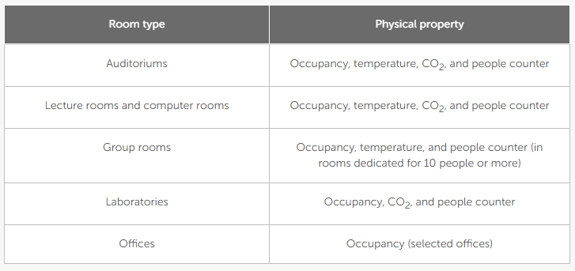
Table 1. case study room data.

Pang et al. (2023) and Bäcklund, Lundqvist and Molinari (2024) demonstrate the benefits of linking a range of sensors to building management systems to create a smart building.
A smart building uses a range of different sensors and systems to consciously monitor and control the building changing the buildings performance in relation to the information received from the sensors and systems. The buildings performance can be tailored to adjusted for comfort to the users of the building in terms of air quality, temperature and humidity, or adjusted for performance looking at energy efficiency. Smart buildings can also be equipped with sensors to identify defects and issues with the building itself helping to rectify them before they become a bigger problem.

The Alex Building already has occupancy sensors installed, which could be used to make informed choices about how the building is used and operated. This information could also be incorporated into a BMS that uses the data to make informed decisions on which rooms should receive heating or ventilation, and which do not require these services, depending on current occupancy status, thereby increasing the efficiency of the building. During the site visit, it was observed that the top-floor hallway of the building was noticeably warm when compared with the workshops on the same floor. A smart building would be able to detect this and minimise heating in this space or potentially distribute the heat through a mechanical ventilation with heat recovery (MVHR) system to heat other cooler spaces within the building.
During the Alex Building site visit, it was observed that the building is in a state of disrepair in several areas, mostly due to moisture ingress, with the current FM team raising concerns over the internal gutters, which block and cause damp issues within the fabric of the building. The building design itself also poses a problem for the FM teams, with little or no consideration given to the care and preservation of the building under occupancy, including poorly designed access or no access at all to some of the most vulnerable elements of the building, such as the cupola and turrets.
Going beyond the already installed occupancy sensors, smart buildings can incorporate a range of different technologies to improve performance and assist with maintenance activities. Retrofitting additional sensors, such as moisture sensors, could assist in eliminating the need to access vulnerable and difficult-to-reach parts of the building. These sensors could provide real-time condition monitoring of the asset, flag issues with the building superstructure early, and help identify and prioritise maintenance activities to repair defects before they cause significant damage to the structure, thereby reducing the overall maintenance costs for the building. Historic England (2025) implies that being able to assess the condition of the building fabric is an important factor in diagnosing faults and understanding building risks.

The addition of photovoltaic (PV) sensors to the existing PV array and, in turn, the BMS or digital twin could help the FM team to assess the current performance of the system and determine whether the array has any defective components or reduced output. This gathered data, much like the previous examples, can provide the information required to develop action plans to replace defective components or clean the array to restore performance. This would, in turn, maximise operational energy production and help the building remain as efficient as possible (Ansari et al., 2021).

Although the Alex Building could be retrofitted to become a smart building, a key barrier is the practical effort required to install, commission, operate, and maintain smart technologies, particularly where existing building systems are complex or outdated, as with the potential systems currently installed in the Alex Building (Baharetha et al., 2024).
Due to the building being an academic institution, there would likely be a requirement for a business case to be developed to justify the initial investment in the technology, including return on investment calculations. Securing initial agreement for funding can also pose a challenge when compared with a new development designed to accommodate these technologies from the outset. The knowledge required to operate and repair these systems can also prove challenging, with a need for this knowledge to be documented and shared with the operators and users of the building. There would be a requirement for continuous staff training on how to use the systems and for the creation of operation and maintenance manuals (O&M) to explain how to operate and maintain the technologies. It is highly likely that, in the event of failure of smart technology components, the FM team would be unable to repair the defective item or items without specialist service providers. These providers may not be able to attend immediately, meaning the building and linked services, such as room booking capability, may not function until repairs are completed. This could create potentially dangerous environments for building users (Sabit and Tun, 2024).

Conclusion
The Alex building being a grade 2 listed building presents unique challenges in the ongoing operation and maintenance of the building with high challenging maintenance costs and trying to use the building outside of the intended design. This presents challenges to incorporating modern technology, that are commonly found in new build modern construction, into the fabric of the listed building. However, the incorporation of these technologies also presents certain opportunities to operate the building more effectively and efficiently helping to preserve such buildings for future generations and make the operation of them more sustainable.
The existing retrofitted technologies, BMS and occupancy sensors, are either defective or their full potential are not currently being achieved. This draws the conclusion that any installed technology requires the appropriate levels of maintenance, training and funding of these systems to maintain the performance of the building leading to potentially higher operating costs. The improved performance benefits of such systems must be carefully weighted against the upfront installation costs and the ongoing operation of these systems. As with all retrofit construction projects a whole building approach should be undertaken with a view to improving the performance of the whole building rather than looking at elements in isolation as altering the performance of one element can lead to affecting the performance of other elements within the building envelope. With the building already being used far from the original intended purpose this can also compound any efforts to install and operate modern systems and technologies, careful consideration needs to be paid to maintaining the buildings original character and period features when installing technologies and upgrading the building performance.

Appendices

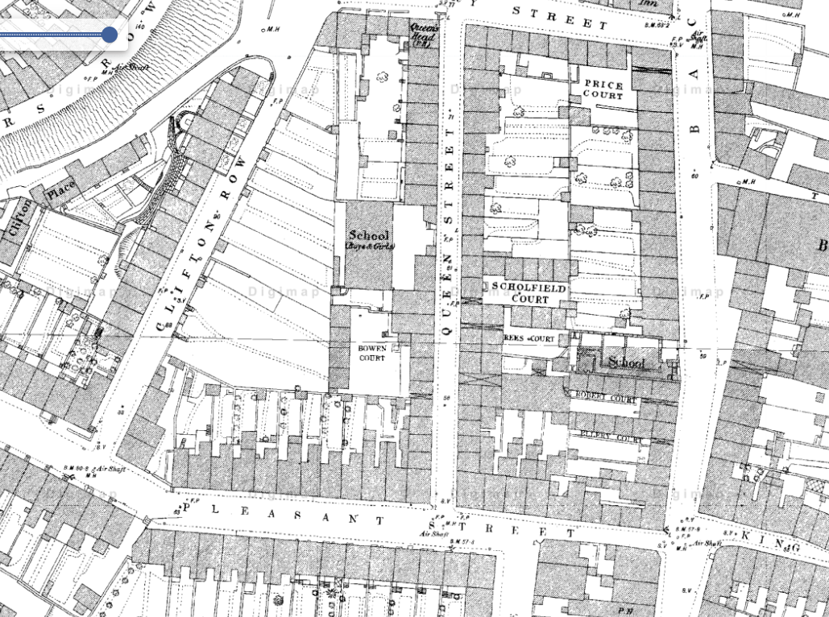

Appendix A (EDINA Digimap, 2026a).

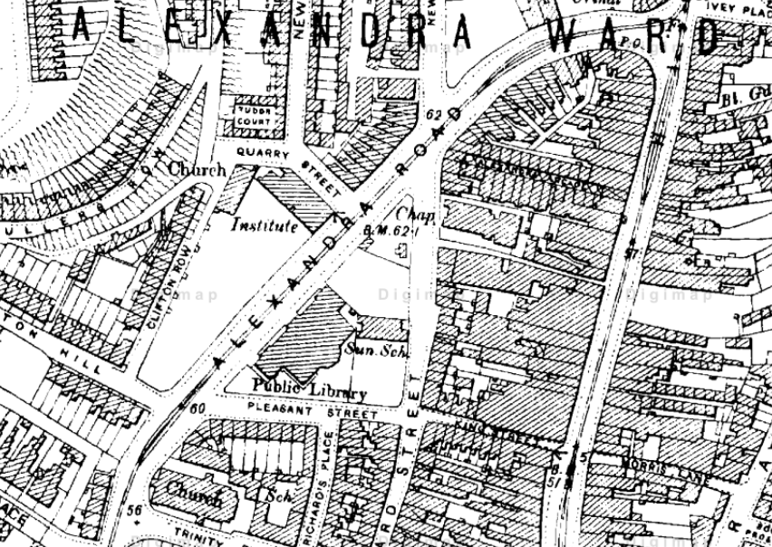
Appendix B (EDINA Digimap, 2026b).

References

Ansari, S., Ayob, A., Lipu, M.S.H., Saad, M.H.M. and Hussain, A. (2021) ‘A review of monitoring technologies for solar PV systems using data processing modules and transmission protocols: progress, challenges and prospects’, Sustainability, 13(15), 8120. Available at: https://doi.org/10.3390/su13158120 (Accessed: 25 June 2026).

Bäcklund, K., Lundqvist, P. and Molinari, M. (2024) ‘Showcasing a digital twin for higher educational buildings: developing the concept toward human centricity’, Frontiers in Built Environment, 10, article 1347451. Available at: https://doi.org/10.3389/fbuil.2024.1347451 (Accessed: 19 June 2026).

Baharetha, S., Soliman, A.M., Hassanain, M.A., Alshibani, A. and Ezz, M.S. (2024) ‘Assessment of the challenges influencing the adoption of smart building technologies’, Frontiers in Built Environment, 9, article 1334005. Available at: https://doi.org/10.3389/fbuil.2023.1334005 (Accessed: 26 June 2026).

BSI (2021) Little book of BIM: 2021 edition. London: British Standards Institution. Available at: https://www.bsigroup.com/globalassets/localfiles/en-ae/bim/little-book-of-bim-2021/bsi-be-little-book-of-bim-2021-edition.pdf (Accessed: 19 June 2026).

EDINA Digimap (2026a) Historic Roam map screenshot [screenshot]. Available at: https://digimap.edina.ac.uk/roam/map/historic (Accessed: 6 July 2026).

EDINA Digimap (2026b) Historic Roam map screenshot [screenshot]. Available at: https://digimap.edina.ac.uk/roam/map/historic (Accessed: 6 July 2026).

Historic England (2017) BIM for Heritage: Developing a Historic Building Information Model. Available at: BIM for Heritage: Developing a Historic Building Information Model (Accessed: 25 June 2026).

Historic England (2019) BIM for Heritage: Developing the Asset Information Model. Available at: BIM for Heritage - Developing the Asset Information Model | Historic England (Accessed: 25 June 2026).

Historic England (2025) Care of Buildings. Available at: https://historicengland.org.uk/research/current/conservation-research/care-of-buildings/ (Accessed: 25 June 2026).

Historic England and NPS Group (2015) Inclusion of Heritage in Asset Management Plans: Stage 2 – Case Study Report. Available at: Inclusion of Heritage in Asset Management Plans - Stage 2 - Case Study Report | Historic England (Accessed: 25 June 2026).

Pang, Z., O’Neill, Z., Chen, Y., Zhang, J., Cheng, H. and Dong, B. (2023) ‘Cost-effectiveness and decarbonization potential of occupancy-based HVAC controls in commercial buildings’, Applied Energy. Available at: https://www.sciencedirect.com/science/article/abs/pii/S0306261923009583 (Accessed: 25 June 2026).

Powell Dobson Architects (2024) Oakleigh House [online image]. Available at: https://www.powelldobson.com/projects/oakleigh-house/ (Accessed: 26 June 2026).

Sabit, H. and Tun, T. (2024) ‘IoT integration of failsafe smart building management system’, IoT, 5(4), pp. 801–815. Available at: https://doi.org/10.3390/iot5040036 (Accessed: 30 June 2026).

Swansea Council (2022) Flagship buildings where the slums used to be [online image]. Available at: https://www.swansea.gov.uk/article/7856/Flagship-buildings-where-the-slums-used-to-be (Accessed: 26 June 2026).

