Global Business Environment

Student ID | 2124047
Student Name | Zlatko Nalbanski

Table of Contents
Task 1 3
Introduction to the international business environment 3
Introduction of the selected country 3
Applying business environment theories 3
PESTLE 3
Porter’s five forces 6
Opportunities of Sainsbury’s in Bangladesh 10
Challenges of Sainsbury’s in Bangladesh 11
Business Strategy 13
Cultural Sensitivity 14
Different barriers experienced by foreign businesses in Bangladesh 14
Recommendation 15
Conclusion 15
Task 2 17
Introduction 17
Key opportunities present in Bangladesh during the plan to set up the factory of Sainsbury's 17
Challenges faced by Bangladesh while planning to set up the factory of Sainsbury's 18
The exploitation of opportunities and challenges by Sainsbury's 19
Recommendations for overcoming the challenges 20
Conclusion 20
References 22
Appendix 26

Task 1

Introduction to the international business environment
Globalisation has become necessary in modern times for businesses to expand and capture the international market. Reaching out to international markets helps a company increase their market dominance and revenue generation. This report observes the company Sainsbury’s, the second-largest UK-based supermarket chain and its efforts at globalisation. The company is looking to expand to Bangladesh to capture the international market and increase its revenue and public reach. In this report, the different challenges and opportunities, the barriers the company will face in the selected country and the different theories of business environment are all used to analyse the selected country and observe how the company can expand optimally.

Introduction of the selected country
Bangladesh is one of the most densely populated countries in the world. Previously it was part of India but in 1971 it became the independent country of Bangladesh, with its capital at Dhaka. It is predominantly a Muslim country and Islamic laws prevail in the country. The government system is a parliamentary democracy. Bangladesh has a traditional economic system in which the allocation of available resources is made on the basis of inheritance and primitive methods. Bangladesh is a member of the Asia-Pacific Trade Agreement (APTA) and the South Asian Association for Regional Cooperation (SAARC).

Applying business environment theories

PESTLE
Factors | Elements | Impact on Sainsbury’s
Political | The political stability index of Bangladesh is -0.97 points (The Global Economy, 2021). The country also observes many political parties with different ideologies and a power struggle between Awami League and Bangladesh National Party is observed. | In terms of political stability in Bangladesh, Sainsbury observes that due to Bangladesh’s political instability, operating under strict political conditions can become an issue. Bangladesh is a follower of the free market economy hence this can positively encourage Sainsbury’s expansion (Abdin, 2016).
Economic | Consumer Price Index CPI in Bangladesh increased to 334.89 points in October from 331.88 points in September of 2022 (Trading Economics, 2022). | Bangladesh depends a lot on remittances for its GDP and thus its economy is not properly stable. Moreover, their economy still depends on traditional agriculture. This along with the increasing consumer price index can be challenging for the expansion of Sainsbury’s. Bangladesh’s garment industry accounts for a total of 83% of the total export earnings of the country (Alamgir and Banerjee, 2019). Bangladesh also observes a high amount of labour force. These can be beneficial for the company's expansion.
Social | GDP Per Capita income in Bangladesh has been 2503 in 2021 (The world bank, 2021). | The population of Bangladesh makes up about 2.11% of the world’s total population. The current population of the country is observed to be 168,795,835 as of December 2022 (Worldometer, 2022). A high population growth rate is also observed in the country. These factors can be very helpful for the company to find a huge market and also to find employees in Bangladesh.
Technological | In terms of technological development, Bangladesh observes its innovation index to be 20.2 out of 100 (Global Economy, 2021). | Bangladesh observes a low rate of innovation index. As it is still a developing country technical innovation is lower compared to other countries. While this can be a challenge for the expansion, it can be easily addressed as Bangladesh has started to realise the importance of technological advancements and is motivating the youth to innovate new technologies.
Environmental | In order to protect the environment, the Bangladesh government imposed the Environment Conservation Act in 1995 (Globalrec, 2020). | Sainsbury's has been identified as an ethical organisation which tends to fulfil its corporate social responsibility on a large scale. Thus, following the act, the organisation might be able to be more ethical, which can be considered an opportunity.
Legal | The judicial system of Bangladesh observes a mix of both English and Mughal practices. | This system can be problematic for Sainsbury as it would have to maintain legal regulations according to Islamic laws which are followed in the country.

Porter’s five forces
Porter’s five forces | Impact | Justification
Rivalry among existing competitors | High | The supermarket industry in Bangladesh observes a large number of companies which have established successful supermarket chains in Bangladesh. The top supermarket chains in Bangladesh are Shwapo, Agora, Meena Bazar and Unimart. Shwapno has more than 130 outlets across the whole country. The company has become a leader in distribution in Bangladesh. Considering the same, it can be considered a weakness for Sainsbury’s.
Substitute Products and Services | Medium | In the case of substitute products and services, the different supermarkets in Bangladesh sell mostly the same products hence customers can find substitute products from the competitors. However, as Sailsbury’s is a premium brand it can keep a collection of international products in its new stores in Bangladesh to attract a wider range of customers. Hence the impact is observed to be medium.
The threat of New Entrants | Low | The supermarket industry in Bangladesh is generally dominated by a few brands and entering such a market requires huge amounts of capital and time. As Sainsbury’s is an international brand it can allocate more funds for its expansion. Considering the low GDP of Bangladesh, new competitors cannot rise in the country and will not be able to compete with Sailsbury.
Bargaining power of consumers | Moderate | The number of similar organisations providing the same services in Bangladesh is large. Hence, consumers' bargaining power and the ability to choose any organisation for meeting their needs are there. Additionally, Sainsbury has been in the business and become a leading organisation as well, therefore consumers from Bangladesh might choose Sainsbury over any other companies due to their attraction to an international brand. Hence, this force is impacting the brand moderately, which is another strength.
Bargaining power of suppliers | Low | There are a large number of suppliers in Bangladesh. Supermarkets in Bangladesh also import many products from India and other neighbouring countries. It is also important to consider that Sainsbury is an international brand which will import many products from the UK and other international markets hence the impact of the bargaining power of suppliers is low.

Opportunities of Sainsbury’s in Bangladesh
In order to successfully expand the business in Bangladesh, Sainsbury’s needs to understand the opportunities that the country may provide to the business stakeholders of Sainsbury’s. The following discussion is going elaborate on the business opportunities that Sainsbury’s will have in Bangladesh.
Digital Business Capacity
Ever since the pandemic hit the country Bangladesh, it has seen a downturn in the economy as most of the countries in the world experienced. The business environment in the country experienced some positive changes during 2021 as the Covid-19 restrictions were eased in the country. In the year 2021, the country’s sole requirement was to recover front the Covid-19 effect. The reason why the country has given immense opportunities for businesses to grow in the country is that it has the capacity to grow its digital business space and financial services in the country (Khan et al., 2021). For example, in a survey conducted by Al-Zaman (2020), it was found that 67% of the respondents agreed on the fact that the country’s digital capacity is going to grow immensely in the next 10 years. Despite the global economic risk factors, the country seemed to have the capacity to incorporate digital systems in the business environment significantly.
Supermarket Competitive Advantage
Even though the local people in Bangladesh choose to purchase fresh items every day from local shops and from traditional markets, the purchasing power of Bangladesh’s middle, upper-middle, and elite-class people is significantly rising as the companies are seeing immense demand and footfalls in the retail grocery stores in the cities. As a result, a super shop or supermarket concept in Bangladesh or in Dhaka is not a new concept in the market. After the Covid-19 pandemic, Bangladesh has seen major growth in supermarket expansion as the demand for supermarkets or super shops has been growing exponentially (Islam, 2021).
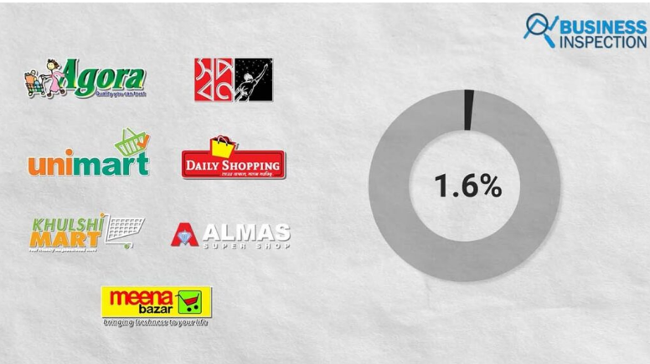
Figure 1: Super Markets in Bangladesh and their contribution to the economy in 2020
Source: (Islam, 2021)
For example, Mr Sabbir Hasan, the executive director of ACI logistics of the company Shwapno has seen almost 131 crores BDT of sales which is equivalent to almost 1.3 Billion GBP is 2020. According to the executive director is almost 50% greater that the average sales of commodities from the local super shops in Bangladesh. A company called Unimart also say a sales growth of 40% every month since March 2020. Thus the concept of supermarkets has been growing in the market exponentially (Islam, 2021).
Thus, from the analysis of the opportunities above, it can be understood that the company is going to have a competitive advantage along with the capacity of digital business in the urban markets of Bangladesh.

Challenges of Sainsbury’s in Bangladesh
There are a number of challenges that the company will have to face during the business expansion. The following discussion is going to highlight the probable challenges that are going to be standing as barriers to business in Bangladesh.
Intermediaries Profit Sharing
According to the business profitability sharing is concerned there are some undeniable challenges in Bangladesh. For example, the super shops have two different types of values chains system; direct resourcing and indirect resourcing. From indirect resourcing, the companies typically have 8 different intermediaries that also include customers and the producers of the commodities. In this case, the company has to share almost 0 to 12 per cent of profit with those intermediaries. On the contrary, companies also need to share their profit with 5 different intermediaries in direct resourcing. The companies usually share almost 12-18 per cent of their profit with those stakeholders. The supermarkets thus need to release a large portion to those intermediaries which is considered to be a critical challenge for retailers in the country (Varga and Rosca, 2019).
Logistical Issues
As far as the logistical infrastructure of Bangladesh is concerned, there are a number of limitations in the country that may affect the business negatively. The company s primary challenge will be to transport items that are supposed to be transported through a cold-storage system. In this case, most of the companies need to reach vendors that belong to unclean wholesale markets which are considered to be unhygienic for most consumers. The companies need to take responsibility to complete cleaning and transporting those items and bringing them to the supermarket, which is going to increase the operating cost of the company immensely (Bishwajit et al., 2017).
Considering these challenges, it is evidence that Sainsbury’s is going to face some serious issues in terms of establishing their supermarket business in the cities of Bangladesh, some of those challenges being logistical challenges and intermediary challenges.
Corporate Governance
Corporate Governance Theories
There are numerous Corporate Governance Theories that can be explained here ins the assignment for a better understanding of what Sainsbury is going to undertake in a market like Bangladesh. The following issue is going to consist of those theories that are going to be detrimental to considering a retailer in Bangladesh.
The following theories are considered to be the theories of Corporate Governance
- Agency theory: In this theory, the principle of the company is to hire agents to perform the business work.
- Stewardship Theory: Stewardship theory states that stewards or executives of the company work for the shareholders to protect capital and make profits.
- Resource dependency theory: This theory generally focuses on the board of directors in providing access to important resources that are required to run the business (Madhani, 2017).
- Stakeholder theory: The stakeholder theory incorporates accountability management towards a broad range of stakeholders. Usually, retailers use this Corporate governance theory for business practice.
- Transaction Cost Theory: According to this theory, the company creates contractual transactions with the internal stakeholders of the company.
- Political Theory: Political theory brings a developing approach to the companies through a voting system among shareholders (Turnbull, 2019).
Among these theories Stakeholder theories, it can be understood that stakeholder theory is going to be feasible for Sainsbury’s as they will be able to include many stakeholders into their company as they are retailers.
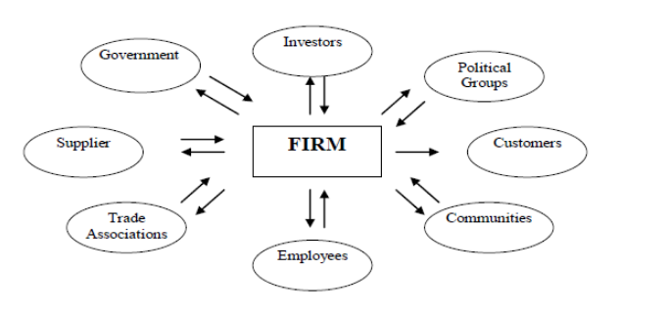
Figure 2: Illustration of Stakeholder Theory mapping
Source: (papertyari, 2021)
According to this theory, Sainsbury’s is going to have different stakeholders that will contribute to the company to operate in the market as the company can enter the market as a single entity in the first place and then they can provide business opportunities for business franchises.

Business Strategy
The business strategy of Sainsbury’s can be of different types. The business can expand by creating strategic partnerships with any existing supermarket companies in the UK. Apart from that, the company can enter the market by being a Wholly-Owned Subsidiary (Healey, 2017). They can expand their business by exporting and licensing as well.
In terms of Sainsbury’s, since the retailer is supposedly one of the most reputed business organisations in the UK, the company should be able to reach the Bangladesh market by direct investment. The company should be able to incorporate different Foreign direct strategies for business expansion.

Cultural Sensitivity
Bangladesh is a hierarchical society in which citizens are respected based on their occupation, financial stability, age and position. Older people are generally viewed as wise people and they are respected accordingly. Bangladesh has a rich literature background and the educational qualification in the cities of Bangladesh is quite high. The majority of Bangladesh citizens are Muslim and they are also driven towards pre-Islamic folk traditions in the rural areas of Bangladesh. Eid is considered to be the main festival of the country. During those festivals, the consumption of commodities is generally higher than usual (Parvin et al., 2022).

Different barriers experienced by foreign businesses in Bangladesh
Since Bangladesh is a middle-income country, it is important for the organisation to acknowledge the fact that internationalisation is considered to be one of the most critical aspects for businesses in the country. There are almost 39 barriers that are mentioned in the study (Tumpa et al., 2019). Among those barriers, the top 5 barriers that are experienced by almost every foreign business in Bangladesh are the-
i) Political Instability
ii) Tax and Tariff related issues
iii) Lack of working capital
iv) Insufficient marketing research resources and instrument
v) Lack of Brand recognition.
The primary target for Sainsbury’s should be to strategically tackle these issues so that the company can protect their capital effectively.
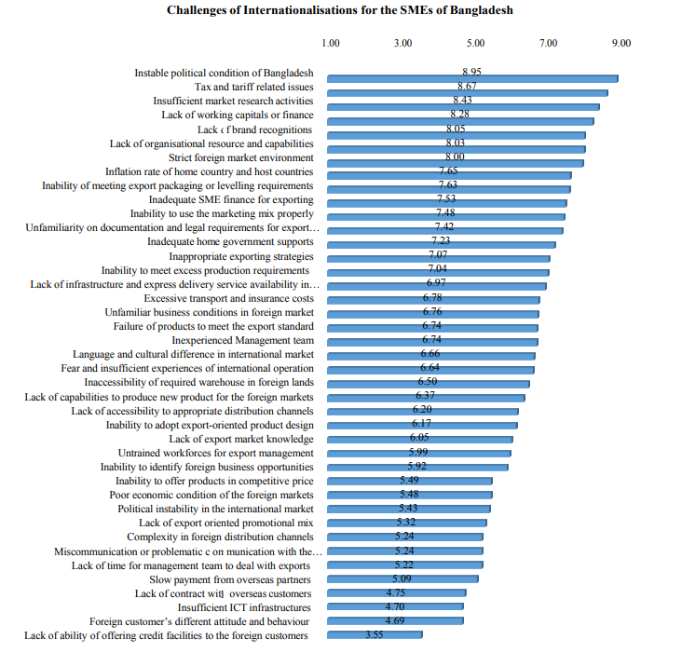
Figure 3: Top barriers to Internnationalsation in Bangladesh
Source: (Biswas et al., 2017).

Recommendation
From the analysis above, it can be recommended to Sainsbury’s that the company has to set a product cost strategy strategically so that their profit sharing with intermediaries does not affect their profitability. On the contrary, the company also has to consider the competitive pricing strategy in the market so that they gain a competitive advantage in the country. As it is mentioned in the study by Salmon and Tordjman (2020) standardisation of prices is important in global strategy. As mentioned later, the company should be able to incorporate foreign direct investment in order to expand its business in Bangladesh. The company needs to understand that they have to involve stakeholder corporate governance theory in its organisational structure and business structure.

Conclusion
The report here explains how a company based in the UK, can expand in a non-European developing country like Bangladesh. As can be seen in the report, Bangladesh is completely different in terms of political, social, economic, technological, legal and environmental factors of the business environment. The country has a lot of challenges and opportunities that the business can face during its initial operations. However, considering some of the strategies mentioned in the report, Sainsbury’s has the capacity to enter the market with the available resources.

Task 2

Introduction
- As opined by Sharma et al. (2020), International Business Environment (IBE) is the market horizon where most international brands are managing their businesses.
- International Business Environment plays an important role in case of developing the economic stability of a country (Merga and Haji, 2019).
- This report focuses on developing an understanding of different multidimensional risks along with different exploitation opportunities incorporated by Sainsbury's.
- The report can help to understand the competencies of the international market for the development of the business.
International Business Environment (IBE) is the market horizon where most international brands are managing their businesses. It plays an important role in case of developing the economic stability of a country. The international business environment has various positive aspects along with different issues as well. Moreover, it plays a significant role in technological upliftment along with potential infrastructure for the business and increases the opportunity for the businesses as well. This report focuses on developing an understanding of different multidimensional risks along with different exploitation opportunities incorporated by Sainsbury's. It can help to understand the competencies of the international market for the development of the business.

Key opportunities present in Bangladesh during the plan to set up the factory of Sainsbury's
- Expansion of Sainsbury’s business within Bangladesh helps to assess the great opportunity of increasing the potential of the business within the competitive market.
- According to Hossain et al. (2022), the phrase pandemic mainly increases the use of digital platforms within Bangladesh in the case of managing their businesses.
- Covid plays an important role in the case of transitioning the business along with increasing the opportunities of the business as well.
- In the year 2021, Bangladesh explores the opportunities of the digital market to improve the economic condition of the country.
- Digital marketing opportunities are going to rise in the next 10 years within the competitive market of Bangladesh (Rana et al., 2020).
- Bangladesh successfully incorporated digitalisation into the business atmosphere.
- The demand for purchasing fresh food items along with comfortable and effective product delivery increasing in Bangladesh (Saad, 2020).
- Increasing demand can help to increase the competitive advantage of the company.
In context with the expansion of Sainsbury’s business within Bangladesh help to assess the great opportunity of increasing the potential of the business within the competitive market. Moreover, it helps the company to increase its digital presence along with the potential of delivering competent businesses within the competitive market of the country. According to Hossain et al. (2022), the phrase pandemic mainly increases the use of digital platforms within Bangladesh in the case of managing their businesses. Henceforth, it can be stated that Covid plays an important role in the case of transitioning the business along with increasing the opportunities of the business as well.
In the year 2021, Bangladesh explores the opportunities of the digital market to improve the economic condition of the country. It also has been observed that digital marketing opportunities are going to rise in the next 10 years within the competitive market of Bangladesh (Rana et al., 2020). It can help Sainsbury’s to expand its businesses within the market horizon of Bangladesh. Even after having various potential risks for developing the marketing management process through digitalisation, Bangladesh successfully incorporated digitalisation into the business atmosphere. It also can help the company like Sainsbury’s to enhance their market opportunities. The demands for purchasing fresh food items along with comfortable and effective product delivery increasing among the middle, upper-middle and elite-class people of the Bangladesh (Saad, 2020) It can help the supermarket to get immense popularity and scope for increasing its business opportunities within the market of Bangladesh. It also can help to increase the competitive advantage of the company to increase its potential and business opportunity in the competitive market of Bangladesh.

Challenges faced by Bangladesh while planning to set up the factory of Sainsbury's
- Sustainable business opportunity for intermediary profit, Bangladesh is facing different issues due to two different value chain systems within the country.
- Various companies need to share 5% of their profit percentage through direct sourcing of the business (Sari and Sedana, 2020).
- It creates a potential barrier to the path of development of the company.
- There also can be some potential political risks during the management of the business in Bangladesh.
- It can help to increase the potential of the customers through management of the supermarket business in the country horizon of Bangladesh.
- The logistic infrastructure of Bangladesh is also one of the reasons behind the potential challenges faced by an emerging business in the country (Azizuddin et al., 2021).
- As opined by Basheer et al., (2019), logistic management plays a significant role in the case of managing the supply chain process of companies.
- Sainbury’s will face various potential issues due to poor transportation availability along with the movability of the products as well.
In the case of delivering a sustainable business opportunity for intermediary profit, Bangladesh is facing different issues due to two different value chain systems within the country. Indirect resourcing, as well as direct resourcing, can help the organisation to increase the potential of the business to deliver sustainable services and product management facilities as well. Moreover, various companies need to share 5% of their profit percentage through direct sourcing of the business (Sari and Sedana, 2020). It creates a potential barrier to the path of development of the company. It also can affect the profitability of the company through various potential measures to sustain in the competitive market.
There also can be some potential political risks during the management of the business in Bangladesh. It can help to increase the potential of the customers through management of the supermarket business in the country horizon of Bangladesh. Moreover, the logistic infrastructure of Bangladesh is also one of the reasons behind the potential challenges faced by an emerging business in the country. As opined by Basheer et al., (2019), logistic management plays a significant role in the case of managing the supply chain process of companies. Sainbury’s will face various potential issues due to poor transportation availability along with the movability of the products as well. Henceforth, it can be stated that the potential of Sainbury’s to manage its business with effective management techniques will not be successful. Poor logistic management processes will be one of the big challenges for the company in Bangladesh.

The exploitation of opportunities and challenges by Sainsbury's
- The business strategy of Sainsbury’s can be of different types.
- The business can expand by creating strategic partnerships with any existing supermarket companies in the UK.
- The company can enter the market by being a Wholly-Owned Subsidiary (Healey, 2017).
- In terms of Sainsbury’s, since the retailer is supposedly one of the most reputed business organisations in the UK.
The business strategy of Sainsbury’s can be of different types. The business can expand by creating strategic partnerships with any existing supermarket companies in the UK. Apart from that, the company can enter the market by being a Wholly-Owned Subsidiary (Healey, 2017). They can expand their business by exporting and licensing as well. In terms of Sainsbury’s, since the retailer is supposedly one of the most reputed business organisations in the UK, the company should be able to reach the Bangladesh market by direct investment.
The company should be able to incorporate different Foreign direct strategies for business expansion. Bangladesh is a hierarchical society in which citizens are respected based on their occupation, financial stability, age and position. Older people are generally viewed as wise people and they are respected accordingly. Bangladesh has a rich literature background and the educational qualification in the cities of Bangladesh is quite high (Parvin et al., 2022). The majority of Bangladesh citizens are Muslim and they are also driven towards pre-Islamic folk traditions in the rural areas of Bangladesh. Eid is considered to be the main festival of the country. During those festivals, the consumption of commodities is generally higher than usual.

Recommendations for overcoming the challenges
- Sainsbury’s can set a product cost strategy strategically so that its profit sharing with intermediaries does not affect its profitability.
- On the contrary, the company also have to to consider the competitive pricing strategy in the market so that they gain a competitive advantage in the country.
- As it is mentioned in the study by Salmon and Tordjman (2020) standardisation of prices is important in global strategy. The company can increase its opportunities through different pricing techniques.
- As mentioned later, the company should be able to incorporate foreign direct investment in order to expand its business in Bangladesh.
- The company needs to understand that they have to involve stakeholder corporate governance theory in its organisational structure and business structure.

Conclusion
From the above-conducted study, it can be concluded that the report helps to understand a company based in the UK, can expand in a non-European developing country like Bangladesh. As can be seen in the report, Bangladesh is completely different in terms of political, social, economic, technological, legal and environmental factors of the business environment. The country has a lot of challenges and opportunities that the business can face during its initial operations. However, considering some of the strategies mentioned in the report, Sainsbury’s has the capacity to enter the market with the available resources.

References
Abdin, M.D., 2016. The nature and evolution of capitalism in Bangladesh. Abdin, MJ (2016). The Nature and Evolution of Capitalism in Bangladesh,“The Nature and Evolution of Capitalism in All World.
Alamgir, F. and Banerjee, S.B., 2019. Contested compliance regimes in global production networks: Insights from the Bangladesh garment industry. Human Relations, 72(2), pp.272-297.
Al-Zaman, M.S., 2020. Digitalization and transformation of teaching and learning in Bangladesh. In Challenges and Opportunities in Global Approaches to Education (pp. 56-77). IGI Global.
Azizuddin, M., Shamsuzzoha, A. and Piya, S., 2021. Influence of circular economy phenomenon to fulfil global sustainable development goal: Perspective from Bangladesh. Sustainability, 13(20), p.11455.
Basheer, M., Siam, M., Awn, A. and Hassan, S., 2019. Exploring the role of TQM and supply chain practices for firm supply performance in the presence of information technology capabilities and supply chain technology adoption: A case of textile firms in Pakistan. Uncertain Supply Chain Management, 7(2), pp.275-288.
Bishwajit, G., Tang, S., Yaya, S., Ide, S., Fu, H., Wang, M., He, Z., Da, F. and Feng, Z., 2017. Factors associated with male involvement in reproductive care in Bangladesh. BMC Public Health, 17(1), pp.1-8.
Biswas, S., Khan, A. and Biswas, S.K., 2017. Challenges of Internationalisation for the SMEs of Bangladesh. The International Journal Of Business & Management, 5(7), pp.2321-8916.
Globalrec, 2020.The Bangladesh Environment Conservation Act, 1995 [online] Available at: <http://globalrec.org/wp-content/uploads/2014/03/Bangladesh-Environment-Conservation-Act-1995.pdf> [Accessed 14 December, 2022]
Healey, N.M., 2017. Beyond ‘export education’: aspiring to put students at the heart of a university’s internationalisation strategy. Perspectives: Policy and Practice in Higher Education, 21(4), pp.119-128.
Hossain, A., Hasan, S., Begum, S. and Sarker, M.A.H., 2022. Consumers' Online Buying Behaviour during COVID-19 Pandemic Using Structural Equation Modeling. Transnational Marketing Journal, 10(2), pp.311-334.
Islam, K.W. 2021 Supershop industry in Bangladesh : A sector with huge potential, Business Inspection BD. businessinspection.com.bd. Available at: https://businessinspection.com.bd/supershop-industry-in-bangladesh/ (Accessed: December 14, 2022).
Khan, M.M.R. and Al Amin, M.M.H., 2021. A study on digital transformation in the healthcare sector of Bangladesh: Current scenario and the future roadmap. Journal of Governance and Accountability Studies, 1(2), pp.163-176.
Madhani, P.M., 2017. Diverse roles of corporate board: Review of various corporate governance theories. The IUP Journal of Corporate Governance, 16(2), pp.7-28.
Merga, B. and Haji, J., 2019. Economic importance of chickpea: Production, value, and world trade. Cogent Food & Agriculture, 5(1), p.1615718.
papertyari 2021 Theories of corporate governance: Agency, stewardship ETC, Paper Tyari. papertyari.com. Available at: https://www.papertyari.com/general-awareness/management/theories-corporate-governance-agency-stewardship-etc/ (Accessed: December 14, 2022).
Parvin, A., Hakim, S.S. and Islam, M.A., 2022. Policy, design, and way of life in resettlement projects: The case of Ashrayan, Bangladesh. International Journal of Disaster Risk Reduction, p.103073.
Rana, M.S., Rahman, M.K., Islam, M.F. and Hassan, A., 2020. Globalization effects on tourism marketing in Bangladesh. In Tourism marketing in Bangladesh (pp. 157-171). Routledge.
Saad, A.T., 2020. Factors affecting online food delivery service in Bangladesh: an empirical study. British Food Journal.
Salmon, W.J. and Tordjman, A., 2020. The internationalisation of retailing. The Retailing Reader, p.364.
Salmon, W.J. and Tordjman, A., 2020. The internationalisation of retailing. The Retailing Reader, p.364.
Sari, I.A.G.D.M. and Sedana, I.B.P., 2020. Profitability and liquidity on firm value and capital structure as intervening variable. International research journal of management, IT and Social Sciences, 7(1), pp.116-127.
Sharma, P., Leung, T.Y., Kingshott, R.P., Davcik, N.S. and Cardinali, S., 2020. Managing uncertainty during a global pandemic: An international business perspective. Journal of business research, 116, pp.188-192.
The global economy, 2021.Bangladesh: Innovation Index [online] Available at: <https://www.theglobaleconomy.com/Bangladesh/GII_Index/#:~:text=Innovations%20index%20(0%2D100)&text=The%20latest%20value%20from%202021,to%20compare%20trends%20over%20time.&text=Investments%3A%20buy%2C%20sell%20or%20hold%3F/> [Accessed 14 December, 2022]
The global economy, 2021.Bangladesh: Political stability [online] Available at: <https://www.theglobaleconomy.com/Bangladesh/wb_political_stability/> [Accessed 14 December, 2022]
The World Bank, 2021.GDP per Capita- Bangladesh [online] Available at: <https://data.worldbank.org/indicator/NY.GDP.PCAP.CD?locations=BD> [Accessed 14 December, 2022]
Trading Economics, 2022.Bangladesh Consumer Price Index [online] Available at: <https://tradingeconomics.com/bangladesh/consumer-price-index-cpi#:~:text=Consumer%20Price%20Index%20CPI%20in%20Bangladesh%20averaged%20147.78%20points%20from,points%20in%20July%20of%201993> [Accessed 14 December, 2022]
Tumpa, T.J., Ali, S.M., Rahman, M.H., Paul, S.K., Chowdhury, P. and Khan, S.A.R., 2019. Barriers to green supply chain management: An emerging economy context. Journal of Cleaner Production, 236, p.117617.
Turnbull, S., 2019. Corporate governance: Its scope, concerns and theories. In Corporate governance (pp. 415-440). Gower.
Varga, V. and Rosca, E., 2019. Driving impact through base of the pyramid distribution models: The role of intermediary organizations. International Journal of Physical Distribution & Logistics Management.
Worldometer, 2022.Bangladesh Population [online] Available at: <https://www.worldometers.info/world-population/bangladesh-population/> [Accessed 14 December, 2022]

Appendix


