

LEVEL 5

SEMESTER 1 & 2

MODULE CODE: SHSS5084
Expedition Skills

aSSESSMENT TYPE: Project
Assessment/Component: 2
COMPONENT WEIGHTING: 70%
WORD COUNT: 5,000 WORDS
MODULE TUTOR: DENISE LEONARD

Expedition Portfolio

Produce a detailed log of the planning for your expedition. This will include comprehensive risk assessments, route plans, emergency procedures, transport arrangements, medical forms, pre-expedition training/ preparation and any other relevant details. Further information related to this assessment can be found on Moodle under Expedition Portfolio Resources as well as on-going tutorial support.

SUBMISSION DETAILS:

Deadline:
Date: 7th February 2020
Time: 3.00pm
Portal: Turnitin

School of Sport, Health & Outdoor Education

Assessment Feedback Sheet

Student No./Name:
Module: SHSS5084
Module Code: Expedition Skills

Personal Evaluation – to support your academic progress please complete the section below BEFORE submitting your work.
What do you consider to be the best aspects of this work? |  |  | Planning the route
Which aspects do you consider could have been improved in this piece of work? |  |  | Research
What have you found most satisfying whilst undertaking this submission? |  |  | Researching the history of the areas
ASSESSMENT CRITERIA | Learning  Outcomes |  | GRADE
ASSESSMENT CRITERIA |  |  | Poor  0 – 25% | Unsatisfactory  26-39% |  | Satisfactory  40 – 49% | Good  50 – 59% | Very Good  60 – 69% | Excellent  70 – 85% |  | Exceptional  86– 100% | %
Produce a well presented and comprehensive expedition planning log with logical format and clarity of purpose | 1,2,4,6 |  |  |  |  |  |  |  |  |  |  | 80%
Use of appropriate reference material | 6 |  |  |  |  |  |  |  |  |  |  | 20%
It is expected that students will present work that is proof read, correctly referenced and adheres to the Assessment Checklist. Therefore a range of 0 – 10 marks will be deducted for non-completion of any of the points on the checklist below.
TUTOR COMMENTS:

Submission date:  via Turnitin |  | Return date:  (at least within 4 weeks) |  |  | Tutor: Denise Leonard |  |  |  |  | Mark:

Assignment Checklist

- Please complete the Personal Evaluation section of the Assessment Feedback sheet, add your name and details, and paste the whole of this assignment document into the front of your assignment

- Submission is a single word file, clearly labelled with your name and module code
- Font style - Times New Roman, size -12 for text and 14 for headings
- Ink colour – black only
- Line spacing – 1.5 line spacing and 2cm- 2.5cm page margins
- Quotations more than three lines to be indented 1 line spacing
- One line space between paragraphs, paragraphs must be left aligned
- Pagination (your assignment should have page numbers)
- All tables and figures are internally referenced and have a title
- Word count checked and written at end of text (before references and any appendix)
- Assignment is within 10% of the word limit (excluding references and any appendices)
- All references in the text are included in the reference list
- Correct referencing following the Harvard style, as described in the Palgrave study skills book ‘Cite them Right’.
- Correct spelling using UK English
- Correct use of punctuation
- Grammar and syntax correct- double check anything that has a green line under it
- I have read my assignment out loud to myself and it makes sense and is easy to read
- Somebody else has read my work and it makes sense to him or her!
- I have checked and I have not plagiarised
Failure to follow these guidelines will cost you marks!
SHSS5084 EXPEDITION SKILLS

Name of Expedition Leader: Georgina Ireland

Your Expedition Planning Log is not just a series of lists related to routes, dates and equipment etc. but instead, is a detailed account of your planning process that identifies the range of choices you have considered, as well as the rationales that have informed your decision making.

The titles overleaf form a fundamental matrix on which to base your log. In order for your expedition to be signed off, each title needs to be addressed to a satisfactory level, as deemed by a member of module staff.

Failure to address all of the titles overleaf to a satisfactory level will result in the expedition being cancelled or deferred until the appropriate planning and preparation has been undertaken.

Statement of Expedition Readiness

I agree that all the titles noted overleaf have been completed and that my expedition is ready to proceed. I also agree to undertake my expedition in accordance with any specific safety conditions noted by the module tutor.

Expedition Leader
Signature: G.Ireland Date: 11/02/2020

Expedition Approval

To the best of my knowledge all the necessary safety checks noted overleaf have been completed and the expedition is ready to proceed.
Specific safety conditions governing the undertaking of the expedition are noted below:
1.
2.
3.
4.
5.

Module Staff
Signature: Date:
CONTENTS
Expedition Overview ……………………… |  | p.6
Aim & Objectives …………………………. |  | p.6
Expedition Leader Profile ………………. |  | p.6
Competencies / Qualifications …………… |  | p.7
Expedition Assistant Leader Profile …………… |  | p.7
Expedition Team Profiles …………………………… |  | p.7
Expedition Support Person ………………. |  | p.8
First Aid Provisions ……………………… |  | p.8
Medical Declaration Forms ……………… |  | p.8
Assumption of Risk Forms ……………… |  | p.8
Behavioural Expectations ………………………. |  | p.9
Individual Kit List ………………………. |  | p.9
Group Kit List …………………………. |  | p.9
Equipment Request Form ………………. |  | p.9
Preparatory Training Undertaken ………… |  | p.10
Reconnaissance of Expedition Route ……… |  | p.10
Campsites …………………………………. |  | p.10
Route Cards ………………………………. |  | p.11
Escape Routes ……………………………………………. |  | p.11
Contingency Planning ……………………… |  | p.11
Weather Forecast Sources …………………………. |  | p.11
Contact with Landowners ………………. |  | p.12
Generic Risk Assessments …………………. |  | p.12
Site Specific Risk Assessment …………………… |  | p.12
Roadworthiness of Vehicles ………………………. |  | p.12
Drivers Licences …………………………………………. |  | p.13
Drivers Insurance …………………………. |  | p.13
Important Contact Details ………………………… |  | p.13
Accident Emergency Procedures ………. |  | p.14
Expedition Contact Details ………………. |  | p.14

References ………………………………. p.14
Appendix ………………………………. p.15 – p.51

Expedition Overview
The expedition is a walking expedition in the Peak District, England. The first day will start on the 4th May which will be spent driving up to the Midlands to stay at in Barton-under-Needwood for the night, this is so we are well rested and are fed properly after the long drive before starting the expedition the following day. The next day we will set off from Barton-under-Needwood and drive up to the Ladybower Reservoir which is the start our walk (Sk858 205). We will spend around 20 minutes at the reservoir talking about the history of the site. The reservoir has historical importance because it was were bomber planes practiced the bombing runs for when they went over to Germany as they closely resembled the dams in Germany (Dambusters.org.uk, 2020) we will then walk an easy route 8.5km to Greenacres campsite (S33 7ZH - SK 141 859), Edale where we will spend the night. Day 2 is the hardest day of the expedition as it will be uphill for a lot of it and will be a walk of 16.82km up to the peak of Kinder Scout (SK090 883) returning via Jacobs Ladder (SK082 868) before spending the night at Coopers Campsite, Edale (S33 7ZD - SK 121 858). The 3rd day will be an easier walk than the 2nd day and will cover of 9.09km stopping at places of interest such as the Blue John Cavern before ending at Castleton where we will meet our support person who will take us back to Barton-under-Needwood where we will spend the night before travelling back to Carmarthen the next day.

Aims and Objectives
The main aims of this expedition are to take welsh students to the English countryside to teach them about history and geological aspects of this area of the peak district. To achieve this aim and objectives I have researched the history of the area as well as interesting facts about the geological aspects and I will share this information with the students as we progress on the expedition, stopping at relevant places that we pass and allowing them time to look around, there is also the possibility of looking around the Blue John Cavern if the students are interested. The Blue John Carven is a place of both geological and historical interest as it is the only place in the world that Blue John has been found ‘The worlds only known deposits of this extremely rare and beautiful stone have been found in Castleton to date’ (Bluejohn-cavern.co.uk, 2020). I will also be explaining to them the history of the Ladybower reservoir as it was an important part of WW2 the ‘dam was used by the Lancaster Bomber Pilots to practice the bombing runs and target practice…..[the] reason for this dam being used is its close resemblance to the German dams.’ (Dambusters.org.uk, 2020). The Ladybower Reservoir is also a place of interest because during dry spells the water level can ‘drop that much that the remains of the lost village of Derwent reappear,’ (Dambusters.org.uk, 2020).

Expedition Leader Profile
I will be the leader on this expedition, my name is Georgina Ireland and I am 21 years old. I am originally from the Midlands and that is why my expedition is in the Peak District as it is an area that I am comfortable to walk and lead a group in. I currently hold no leader qualifications however I have experience hiking through hills because of university and scouts so I feel competent at reading maps and navigating around the land. I also have experience in water environments as well as my British Canoeing Sea Kayaking Discovery Award which will help when we are near the reservoir and rivers in case someone falls into the water.

Competencies / Qualifications
Although I do not have any qualifications relating to hiking itself, I have my first aid in the outdoors qualification (Appendix 18), I received this qualification in my first year of university and it lasts three years, so I am still able to provide first aid on the expedition should it be necessary. I also have my British Canoeing Sea Kayaking Discovery award and I was working towards my FSRT in my first year of university which will be useful as we are walking by water for some of the expedition and will allow me to be able to perform a rescue should it be needed. Although I have no official qualification for hiking, I believe I am a competent hiker and even though I do not have my lowland leader qualification I believe that I am competent enough at map reading and navigation to be at this level, I also think that I am familiar and unconsciously competent with the route to direct more of my attention on to managing the group. ‘spare attention which can be focused on group members and adapting appropriate leadership approaches’ (appendix 14 Lowland leader skill check list )

Expedition Assistant Leader Profile
I have chosen Rhodri Richards as my expedition assistant leader because he has 3 years’ experience in working in outdoor centres which means he is has experience in leading a group of people. He also has a variation of water sport qualifications such as a level 1 paddle sports instructor, 2 star in all crafts (i.e. kayak, canoe, SOP etc.) this could be useful because some of the expedition is by a reservoir and rivers, so having someone with these qualifications is useful in case someone falls in to the water, then we will be able to affectively rescue the person. Rhodri has 2 first aid qualifications and a health and safety qualification meaning that if a situation occurs, I will have a second opinion with assessing the risks, as well as someone else to help attend to any possible injuries that could occur. Rhodri also has experience of hiking through university which I am happy with his ability to map read. I have confidence in him to be my assistant leader for this expedition.

Expedition Team Profile
Including myself there will be four people taking part in this expedition. I have asked three Welsh students to participate in the expedition, in order to fulfil my aims for the expedition of taking Welsh students to the English countryside, I will teach them some aspects of the history of the area. I have asked Cerian Edwards, Mathew Chicken and Rhodri Richards to participate in the expedition because I know that we can work well as a group, and none of them should struggle with the suggested route. I asked Mathew as I know he is a confident in hiking and he won’t struggle with the route I have selected for the expedition. He is happy to help at the camping site with tents and equipment as he has experience of camping from his time in the army. Matthew has expressed an interested to visit the English countryside to see the difference in terrain. I have asked Cerian because although she is not the most confident map reader or hiker, she is interested in the geological and historical aspects of this expedition and if she is up to it, we can also use this expedition to help her practice her map reading skills. I have also asked Rhodri to participate in the expedition and be my assistant leader because of the qualifications he has (see above) but also because he hasn’t been to England much and wants to explore the culture and history.

Expedition Support Person
I have decided to ask Sam Ireland to be my expedition support person, I have chosen her because she lives locally to where my expedition takes place and she also has a knowledge of the area we are walking in. I have also chosen her because she is an Explorer scout leader and has a good knowledge of maps and is confident at map reading and walking in the Peak District and will be able to help if we need it. I have asked her to be my support person during the expedition as she knows the location well and is available to drop us off at the start point and pick us up from the final finishing point at the end of the expedition and if needs be, available if anything should happen.

First Aid Provisions
Whilst on the expedition I will request each participant to carry their own personal first aid kit with any personal medication that they may need for the time that we are away, I will also carry a Group first aid kit (Appendix 10) with me that will contain items such as bandages, plasters, tweezers, cleaning wipes and cotton tape. I will carry items that can have multiple uses in order to lessen the amount I have to carry but also still be able to deal with a range of accidents. ‘do as much as you can with as little as possible and consider improvising where necessary.’ (Wills, 2013). I know that every team member has a first aid certificate and are able to provide first aid care, as we all participated in the same first aid course and passed, a copy of my first aid certificate is in appendix 18.

Medical Declaration Forms
The students that come on the expedition will need to complete a medical declaration form (Appendix 4). This is so I know if any of the students have any medical issues that I need to be aware of and therefore if I need to adjust my route in order to compensate for those medical issues. For example, if a student had asthma, I would need to add more breaks into my route plan mainly for the second day in order to give them enough time to catch their breath and have some water and ensure they are okay to continue. ‘The ideal speed for any party is one that allows for conversation to be conducted without struggling for breath.’ (Long, 2003, p.117).

Assumption of Risk Form
The students will need to sign an assumption of risk form (Appendix 2) to show that they understand the risks that come with taking part in the expedition. Expeditions have an assumption of risk form so that the students understand and recognise that there are certain risks that come with completing the expedition and that it is their responsibility to act responsibly whilst out on the expedition because they are all over 18 and are representing the university. The assumption of risk form is in place to protect the expedition leader as they can not control all outcomes or hazards of the expeditions.

Behavioural Expectations
Whilst out on my expedition there will be certain behavioural expectations for the group both whilst walking and in the campsites. Before leaving for the expedition I will discuss with the group how I expect them to behave, respecting the environment we travel through and following a leave no trace policy ‘nothing is left and everything is carried out. There is no reason for leaving any litter’ (Cunningham and Fyffe, 2007). They will also be expected to be polite at the campsites and respect the other people that may be there by keeping he noise down in the evenings

Individual Kit List
The students will have to carry their own kit whilst they are walking, so I will provide a kit list of the personal equipment that they will need during the expedition (Appendix 8). They will need kit such as waterproof coats and trousers with them and easily accessible so that they do not get too wet if it rains, they will need these even if the weather is predicted to be dry. They will also need walking boots or walking shoes in order to protect their feet whilst they are walking and have a good grip as well as keeping their feet dry (Hazzard, 2020). As well as their kit they will also need to carry enough food for the three days we are out as we will be cooking our own meals whilst on the expedition. ‘A balance should be sought between simple sugars, which are rapidly broken down to provide energy quickly and starchy foods that provide slow-burning fuel.’ (Long, 2003, p.57). I have recommended to the group to bring ration packs (which can be bought from Cotswolds) as they are easy to cook and carry instead of carrying ingredients, they are also good because they have various meals for breakfast, lunch, dinner and desert.

Group Kit List
There will also be group kit that will need to be taken with us (Appendix 9), such as group shelters, stoves and pans etc. this will be divided between the group to make it more equal for all group members. It will also allow us to take what we need because we have more space between everyone to share the equipment, instead of one person having to limit what they take in order to fit all the group kit into their bag as well as their own personal kit. Equipment such as tents will be divided between pairs as there are two boys and two girls in the group, the girls will share one tent and the boys will share the other. ‘A group leader should work on the assumption that at least one member of their party will forget or lose… thus spares for the group or family members should be carried’ (Long, 2003, p.57).

Equipment Request Form
I will need to borrow some equipment, such as stoves and group shelters from the university. In order to do this, I will need to fill in an equipment request form (Appendix 6). This form is required, so that both myself and the university can keep track of what equipment I have taken out of stores, and when it is due to be returned at the end of the expedition. It is also needed, so I know everything has been returned and in the same condition we took it out in, this also allows myself and the university to know if anything is missing.

Preparatory Training Undertaken
The route chosen for the expedition should not be above any of the group members ability as day one and three are relatively easy and although day two is harder we have the time to take it slow, take breaks as and when they are needed, because of this no official training is needed for the students participating in the expedition. However, through university, we all completed a range of different hikes that gradually got harder and more difficult. Which has allowed me to see how the others coped with that terrain and gave me an idea of how they would cope with the route I have chosen for my expedition.

Reconnaissance of Expedition Route
Although I have some knowledge of the area, where my expedition is taking place. I recently went and did the main parts of the route to double check that the paths were still there, and accessible. Which will allow me to be a bit more confident of the route, so I can focus more on the group whilst on the expedition than on the navigation. However, closer to the date of the expedition, I will have to travel back up to the Peak District and walk to the top of Kinder Scout in order to check, what the ground is likely to be like, for when we complete the expeditions. As one of the geological features, that I want to show the group, is that fact that the ground at the top of Kinder Scout can change from soft boggy land, to dry and cracked if it is very warm for a period of time, this is because it is a Peat bog. Before completing the expedition, I will have to check what the ground is like in order to decide whether to avoid the peak of Kinder Scout or if it is okay to walk across or walk around the edge of the top. I will also make this decision again on the day of the expedition.

Campsites
In the Peak District you are not allowed to wild camp on any of the land, without first obtaining a permit, however the area I would want to camp in are owned by the Peak District National Park and they say ‘We do not allow wild camping on any land that we own’ (Peak District National Park, 2020). Due to this we will have to stay on campsites during the expedition. On day one we will be finishing at Greenacres Campsite, Edale. We will be staying there for 1 night and it will cost £7 each. On day two we will be staying at Coopers Campsite which will cost £6 each for the night.

Greenacres Campsite Coopers Campsite
Nether Booth Edale
Edale Hope Valley
S33 7ZH S33 7ZD

Route Cards
I have made a route card for each day of the expedition (Appendix 13) I will use these to keep on top of where we are and how long it should take to get to the next check point. ‘route cards area an excellent planning format and are particularly useful for inexperienced leaders developing the ability to plan a day from the map.’ (Long, 2003, p.119) the route cards will allow me to keep track on if we are sticking to the timings or if I need to take more control and get us to pick up speed and reach the campsite in time. I can also put the bearings I need on the route cards this means that I can set up the compass quickly rather than trying to take a bearing of the map, this can be helpful if the conditions are wet and windy. As well as carrying at least one copy of the route cards with me I will also give a copy to my support person so that they know the route I plan on taking and where I should be throughout the expedition, this makes it easier for them to know where I am should an incident occur. Route cards are important because should an incident arise, details of where we are can be given to the emergency services which will make it easier for them to find us.

Escape Routes
It is important to have escape routes in place in case of an emergency because then there are already set evacuation points that both the team and the support person know about meaning that there is less confusion when trying to meet up with the support person. In the event of using the escape route, I will have the grid reference of the end point which I can pass on to the emergency services if necessary. Throughout the expedition I have identified several possible escape routes in case we need to leave the expedition due to an accident or illness etc.

Contingency Planning
Throughout the expedition there may be situations that cannot be avoided, because of this I have put a few contingency routes in place during my expedition where we can continue to the next check point, via a different route, meaning that we don’t have to endanger ourselves but we also don’t have to miss out on completing the expedition. I have put in contingency plans in where there may be a problem with the route, for example if the top of kinder scout is too damp to cross then I know that there is another path that skirts around the edge of the peak and joins the path we would have ended up on originally. ‘Having a plan B, in case of a range of eventualities, may allow you to enter the recovery phase following an incident, rather than moving directly to abandonment or escape.’ (Hodgson and Berry, 2011). For day 2 it is almost a circular route, because of this I can change the direction of the walk if necessary, for example if the weather is supposed to be wet towards the end of the day then I can decide to walk up Jacobs Ladder in the morning to avoid slips and trips that may occur if we walked down during the rain.

Weather Forecast Sources
I will need to keep an eye on the weather in that area leading up to the expedition to know what the ground is likely to be like when we go, I will also need to check the weather as we leave for the expedition as well as during the expedition, making sure there are no major changes to the weather. Long (2003, p.98) states that ‘the weather has a profound effect on the walking environment … knowing what the weather might do for the duration of … [the] expedition is an essential part of the planning process’. I will use the met office website - https://www.metoffice.gov.uk/weather/forecast/gcqxwejpn#?nearestTo=Edale&date=2020-02-13 - to check the weather before going on the expedition and before setting off on the expedition, whilst on the expedition I will then use the met office app to keep track of the weather as the expedition goes on. When checking the weather forecast, I will be looking for the wind speed, temperature, wind direction, chance of precipitation and the visibility.

Contact with Landowners
As my expedition does not pass through any private land because we are sticking to footpaths and open access areas I do not need to contact any landowners, however, we are still expected to treat the land with respect and follow the country code by fastening any gate we pass through and keeping to the public footpaths across farmland as well as leaving any livestock, crops and machinery (Long, 2003). I will need to contact the campsites in order to book a pitch for the nights we are staying. I will also need to confirm with Sam Ireland that we are allowed to stay the night before and after the expedition.

Generic Risk Assessment
I have completed a generic risk assessment for the expedition (Appendix 11). ‘Risk management is the process of making informed decisions about the things that can harm people in order to minimise their potential and to balance them against the outcome’ (Long, 2003, p.128). I have made a risk assessment to show that I have assessed the risks that may arise on the expedition and made the decision that the risks do not out way the positive outcomes that come with completing the expedition. As part of my risk assessment I will make sure the group know that when they are cooking, they have to be at least one and a half meters away from the tents as to prevent any chance of a fire.

Site Specific Risk Assessment
I have completed a site-specific risk assessment for the expedition (Appendix 12). ‘Site-specific hazards may not be apparent on a map or at initial briefings and may only be discernible upon arrival.’ (Long, 2003, p.129) I completed the site specific risk assessment after doing my reconnaissance of the route, however depending on any damage done by weather condition between then and when the expedition takes place the risks may change, because of this I will all complete a dynamic risk assessment whilst the expedition is on-going. ‘On-going assessment is vital for successful risk management’ (Long, 2003, p.129)

Roadworthiness of Vehicles
I will be transporting the group from Carmarthen to Barton-under-Needwood, to do this we will be travelling in my car. For a copy of my cars MOT see Appendix 15. Although my MOT runs out before we go on the expedition, I have already booked it in to be redone so the MOT will still be up to date.

Drivers Licence
There is a copy of my drivers’ licence in Appendix 16. I will be driving the group to the Barton under Needwood as I am very familiar with the route and am used to driving for that amount of time (4 hours).

Drivers Insurance
There is a copy of my car insurance in Appendix 17.

Important Contact Details
The important contact details include the tutors at the university as well as the emergency services.
Emergency services: 999 (Then ask for the appropriate service)

UNIVERSITY:
Cynefin: 01267 225122

Denise Leonard
Denise.leonard@uwtsd.ac.uk
Tel: 07979 835785

Jon Haylock:
Tel: 07979 695733
Email: j.haylock@uwtsd.ac.uk

Tom Moore
Tel: 01267 226 616
Mob: 07794 445 535
Email: t.moore@uwtsd.ac.uk

Graham Harvey:
Tel: 07896 431200
Email: G.Harvey@uwtsd.ac.uk

Support Person: Sam Ireland
Tel: 07864 681199
Mob: 07864 681199
Email: Samantha.ireland0@gmail.com

In case Sam cannot be reached on either of these numbers try:
Neil Ireland
Tell: 07841 976130
Email: neil.ireland0@gmail.com

Accident Emergency Procedures
If an accident should happen, depending on the seriousness of the incident my first course of action will be to call my support person and try to get to a point that we can meet them. If it is a more serious incident or cannot reach my support person, I will call mountain rescue via 999. After the incident has occurred, I will have to fill in an accident report from (Appendix 1). In case there is an accident that requires medical attention but is not serious enough for the emergency services to get involved, all emergency contact details for local hospitals / doctors are listed in appendix 5.

Expedition Contact Details
In case anyone needs to contact the team whilst we are on expedition, the expedition team’s contact details are in Appendix 7. This includes my own details as well as each of the team members and the support persons contact details. I will also make sure each team member has a copy of these numbers whilst on the expedition in case we end up getting split up whilst walking.

Word count: 4656

References
Bluejohn-cavern.co.uk. (2020). history. [online] Available at: https://www.bluejohn-cavern.co.uk/history [Accessed 11 Feb. 2020].

Cunningham, A. and Fyffe, A. (2007). Winter skills. [Capil Curig]: Mountain Leader Training UK,

Dambusters.org.uk. (2020). Derwent Valley Museum | The Dambusters. [online] Available at: http://www.dambusters.org.uk/reccomendations/derwent-valley-museum/ [Accessed 11 Feb. 2020].

Hazzard, C. (2020). Do I Need Hiking Boots? (2020) - HikingGuy.com. [online] HikingGuy.com. Available at: https://hikingguy.com/how-to-hike/do-i-need-hiking-boots/ [Accessed 11 Feb. 2020].

Long, S. (2003). Hill walking. [Capel Curig]: Mountain Leader Training UK .

Peak District National Park. (2020). Camping: Peak District National Park. [online] Available at: https://www.peakdistrict.gov.uk/visiting/getactive/camping [Accessed 11 Feb. 2020].

Wills, K. (2013). Outdoor first aid. Gwynedd: Pesda Press.

Appendix

Appendix 1: SHSS5084 EXPEDITION LEADERSHIP
Accident Report Form

This form must be completed and sent to the module coordinator as soon as possible after an accident. If operating in a remote area it must be sent within 24 hours of returning to the expeditions operating base.

A verbal notification and a brief account of circumstances of the incident must be phoned through to the module coordinator as soon as possible after the accident.

Expedition Leader:

Second in Charge:

Date of Accident:

Place of Accident:

Name of Casualty

or Casualties:

Circumstances leading up to the accident including details of the route being followed or activity being undertaken, the weather, conditions underfoot, etc:

Description of the accident:

Description of the injuries sustained by the casualty(s):

Details of actions taken to treat the casualty(s):

Details of actions taken to safeguard the rest of the group:

Recommended actions to be taken by Expedition Leader to prevent a similar case recurring:

Details of any witnesses to the accident include on a separate sheet a written statement from the witness if possible:

Name:

Address:

Post Code: Tel:

Name:

Address:

Post Code: Tel:

Name:

Address:

Post Code: Tel:

Details of police officer or other relevant authorities informed:

Name:

Status/authority:

Address:

Post Code: Tel:

Name:

Status/authority:

Address:

Post Code: Tel:

Please return this form to:

Tom Moore
University of Wales Trinity Saint David
School of Sport, Health & Outdoor Education
Carmarthen, UK
SA31 3EP
Tel: 01267 226 616
Mob: 07794 445 535
Email: t.moore@uwtsd.ac.uk

Appendix 2:
SHSS5084 EXPEDITION LEADERSHIP
ASSUMPTION OF RISK FORM
(Please read this document carefully)

Expedition’s that are run as part of module SHSS5084 Expedition Leadership inherent in the Outdoor Adventure Education programme at the University of Wales: Trinity Saint David, can take place both at day and night and in different environments, which might be considered remote or hostile, often without easy access to advanced medical or other facilities.

I (full name) ________________________________________ ____________
acknowledge and accept that participation in an expedition of this nature entails both known and unanticipated risks, which could result in damage to my property, physical or emotional injury, paralysis or death. I understand that such risks cannot be eliminated without jeopardising the fundamental qualities of the expedition. By participating in this expedition, I accept these risks and take responsibility for my own actions and involvement.

I accept the fact that I have a personal duty and responsibility to learn and to follow safety guidelines and procedures established by the expedition leaders:
Expedition Leader: _____________________________________________________
Assistant Leader: _____________________________________________________

I undertake to inform those named above, at any point during the expedition process, should I not understand what is expected of me or should I not wish to further participate in the expedition. However, due to the venues being used, I understand that it might not always be possible to simply stop or withdraw immediately from the expedition.

I am physically and mentally fit to participate in this expedition. I have completed a medical form that is accurate and true. I agree to notify the expedition leaders of any changes to my health or fitness. If I become ill or injured, I give my consent for first aid to be administered and for provision of other medical treatment or rescue services as required.

Signed: ________________________________ Date: _____________________

Appendix 3: SHSS5084 EXPEDITION LEADERSHIP
Expedition Contract

I Georgina Ireland will run my expedition between the dates of 4th May – 9th May .
I will at all times, conduct myself as professionally as possible, adhering to the University’s Code of Conduct, and only operate within the agreed parameters of my signed-off expedition, as outlined below.

I will be running an expedition by foot / bike

The aims and objectives of my expedition are:
To take welsh students to the English countryside to teach them some of the history and geological aspects of some of the peak district

The venues I have chosen to use are:
Day 1: 114 main street Barton -under – Needwood DE13 8AB
Day 2: Greenacres campsite, Edale
Day 3: Coopers Campsite, Edale
Day 4: 114 main street Barton -under – Needwood DE13 8AB

My appointed assistant leader is:
Rhodri Richards

The members of my expedition group are:
1: Cerian Edwards
2: Mathew Chicken
3: Rhodri Richards

I have checked the abilities of all expedition group members and deem them able to partake in the expedition.
I have collected relevant and up-to-date medical details from each expedition group member and am aware of any condition that may affect their ability during the expedition.

In signing this document, I agree to everything listed overleaf. I understand that I must adhere to all the documents and risk assessments I have submitted for which my expedition has been signed off.

Expedition Leader Module Staff

Name: Georgina Ireland Name: Tom Moore

Signed: G.Ireland Signed:
Date: 12/02/2020 Date:

Appendix 4:
SHSS5084 EXPEDITION LEADERSHIP
MEDICAL DECLARATION FORM

Please complete this form as accurately and truthfully as possible. The information you disclose will be confidential and will only be used to help the expedition leaders respond to an injury or illness.

Name: _____________________________________________ D.O.B.:______________________

Address: ________________________________________________________________________

________________________________________________________________________________

Mobile Number: __________________________________________________________________

Next of Kin/Guardian Name: ________________________________________________________

Next of Kin/Guardian Contact Number: ________________________________________________

If you answer yes to any of the following questions, please give brief details in the space provided.

1. Do you currently suffer from any physical or psychological medical conditions/ailments?
________________________________________________________________________________

2. Are you currently taking any form of medication?
________________________________________________________________________________

3. Do you have any form of allergy?
________________________________________________________________________________

4. Do you currently have any injuries or ailments?
________________________________________________________________________________

5. Do you have history of any physical or psychological medical conditions, injuries or ailments that may affect your participation in any aspect of the programme?
________________________________________________________________________________

If you have answered yes to any of the questions above, please use the space provided on the back of this sheet to give further details, and ensure you discuss this with the expedition leaders.

I declare that the information on this form is as accurate and truthful as possible.
I acknowledge it is my responsibility to keep expedition leaders informed of any information stated here in, or changes to this information, that may affect my participation in the expedition.

Signature: _________________________ Date: __________________

Please use the space provided below to expand on any of the information you have given overleaf.

Appendix 5:
SHSS5084 EXPEDITION LEADERSHIP
Accident and Emergency Procedures

Accident and Emergency Procedures relate to the need to deal with any event throughout the duration of your expedition, in which a physical injury occurs to any expedition team member.

You are expected to deal with accidents, to the best of your abilities, and within the recommendations and remit of your first aid qualification. Where recruitment of further assistance (Emergency Services) is essential, you are required to inform a member of module staff, as soon as possible.

If it is necessary to send an expedition member to hospital, you must ensure that at least one other member accompanies the injured party.

To facilitate the processes outlined above, it is essential you complete the following, specific to your expedition:

Emergency Information:

Local Hospital:
Name: Cavendish Hospital
Address: Manchester Road, Buxton, Derbyshire, SK17 6TE
Tel:01298 212800
A&E: Yes

Local GP Service:
Name: Dr T J Adler – Evelyn Medical Centre
Address: Marsh Ave, Hope Valley S33 6RJ
Tel:01433 621557

Local Dentist:
Name: Hope Dental
Address: Eccles CI, Hope Valley, S33 6RG
Tel: 01433 620468

Media Guidance
If at any point during your expedition, the media approaches you, please adopt a “No Comment” response and refer them to a member of module staff.

Appendix 6:
SHSS5084 EXPEDITION LEADERSHIP
Equipment Request Form

Name: Georgina Ireland

Dates of Expedition: 4th may – 9th may

Date of collection: 1st may

Date of Return:9th may

Item/s | Serviceable check or | Date of Return

Tent x2
Stove x2
Pans x2
Sleeping Bags x2

I have checked and agree that all the equipment is complete and serviceable.

Signature: G.Ireland

Date:

Appendix 7:
SHSS5084 EXPEDITION LEADERSHIP
Expedition Team Contact Details

Expedition Leader:
Name: Georgina Ireland Number: 07826516249

Expedition Assistant Leader:
Name: Rhodri Richards Number: 07984063226

Expedition Support Person:
Name: Sam Ireland Number: 07864681199

Expedition Team Member:
Name: Cerian Edwards Number: 07393430901

Expedition Team Member:
Name: Mathew Chicken Number: 07951721805

Expedition Date: 4th May – 9th May
Venue: Edale, Peak District

Campsite 1 Date: Greenacres Campsite,
Location: Edale, Peak District

Campsite 2 Date: Coopers Campsite
Location: Edale, Peak District

Appendix 8:
INDIVIDUAL KIT LIST
Items in Italics are optional
- Rucksack
- Waterproof Jacket
- Waterproof Trousers
- Torch (plus spare battery’s)
- Walking Boots
- Gaiters
- Water Bottle
- Whistle
- Hat/Gloves
- Food
- Spare Food
- Personal First Aid Kit
- Sleeping Bag
- Insulation Mat
- Cutlery
- Bowl
- Spare clothes
- Sunglasses / Sun cream
- Mobile Phone (Turned off and in bag)

Appendix 9:
Group Kit List

- Group First Aid Kit
- Group Shelter
- Spare Map & Compass
- Spare Clothes
- Penknife
- Spare Hat / Gloves
- Spare Food
- Stove x 2
- Pan Set x 2
- Small repair kit
- Tent x 2
- Gas
- Lighter / Matches
- Water Container

Appendix 10:
Group First Aid Kit
- Individually wrapped sterile plasters x 6
- wound dressings (various sizes)
- Triangular bandages x 2
- Safety pins x 2
- Individually wrapped moist cleaning wipes
- Disposable latex gloves x 2 pairs
- Cling film
- Blister dressings
- Penknife with tweezers
- Clothing Scissors
- Wide stripe of cotton tape
- Waterproof paper and pencil
- Heavy duty duck-tape
- Crepe Bandage
- Emergency contact card

Appendix 11: Generic Risk Assessment



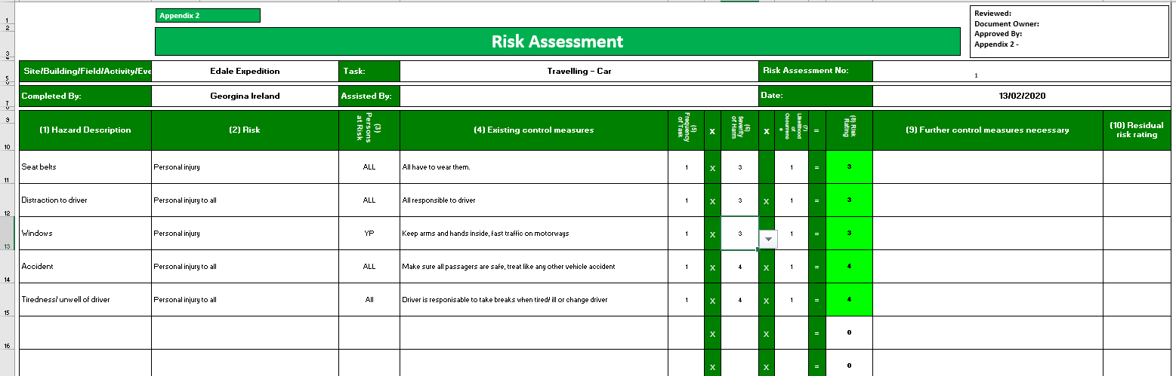

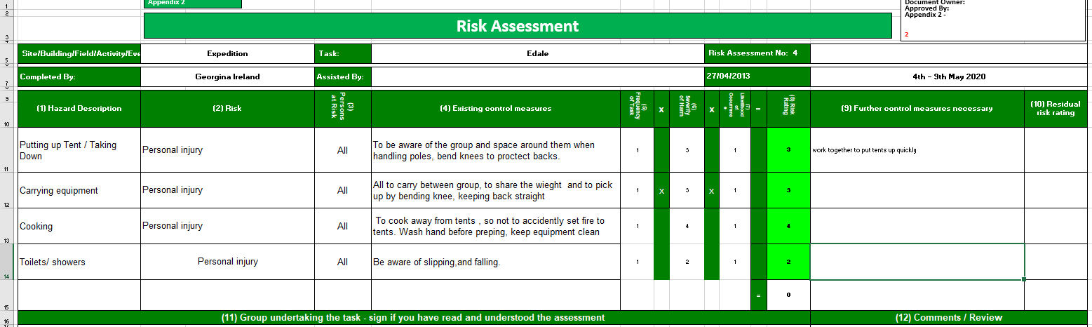

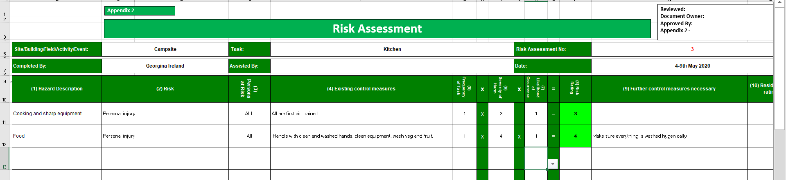
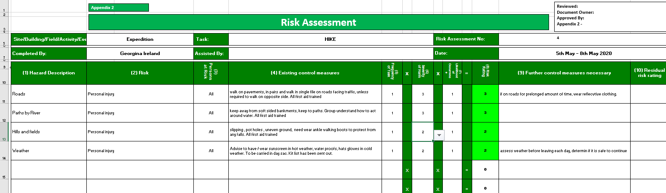

Appendix 12: Site- Specific Risk Assessments - Day 1

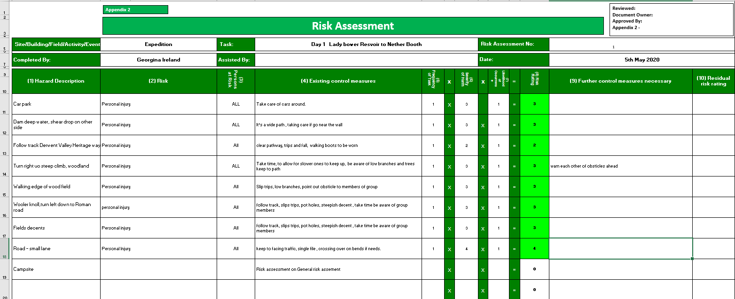
Day 2

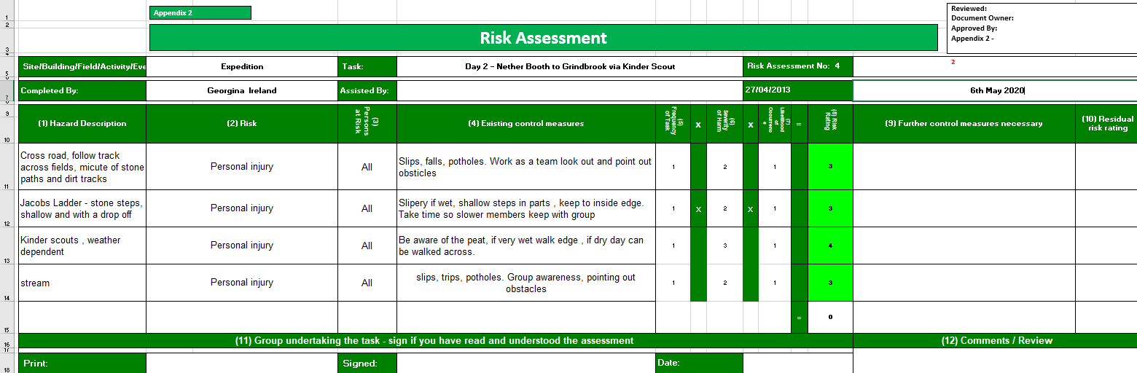
Day 3

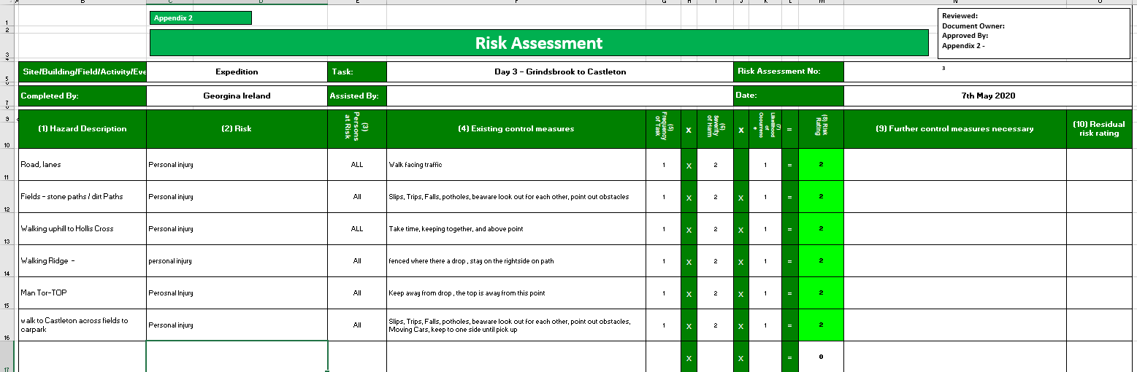

Appendix 13: Route Cards
Whole expedition route-

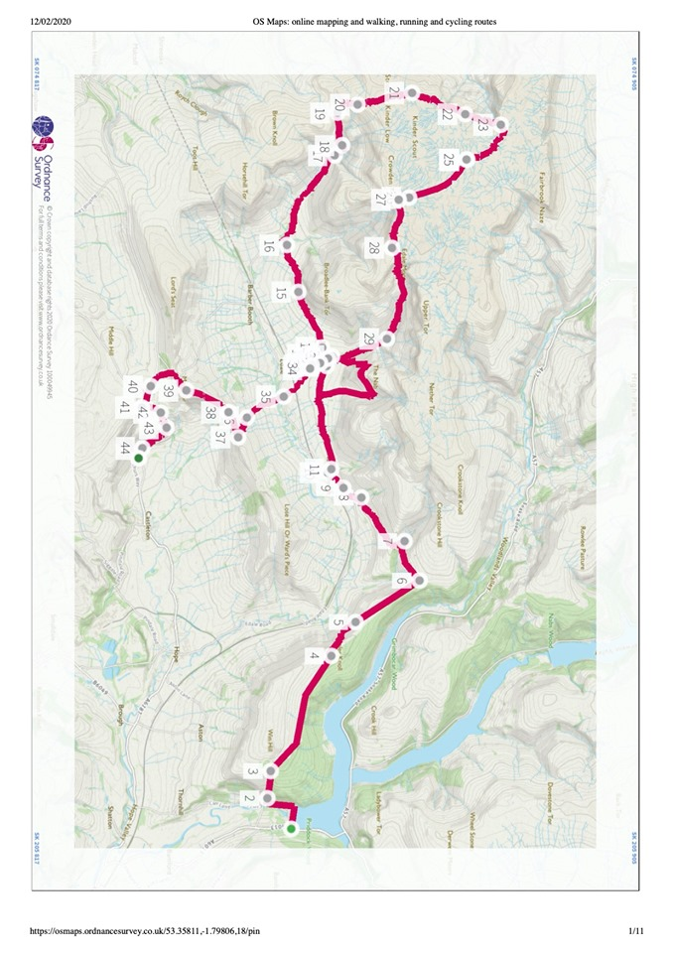

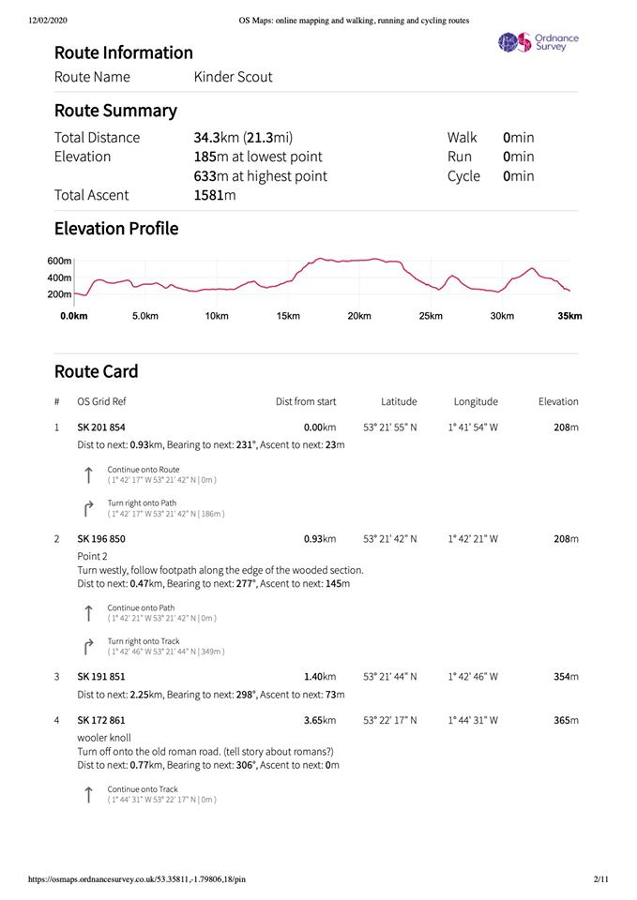

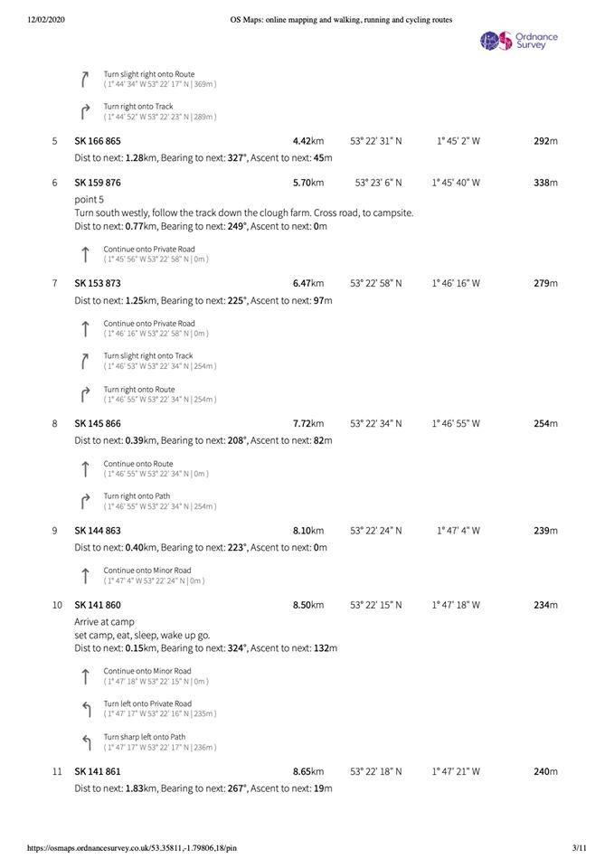

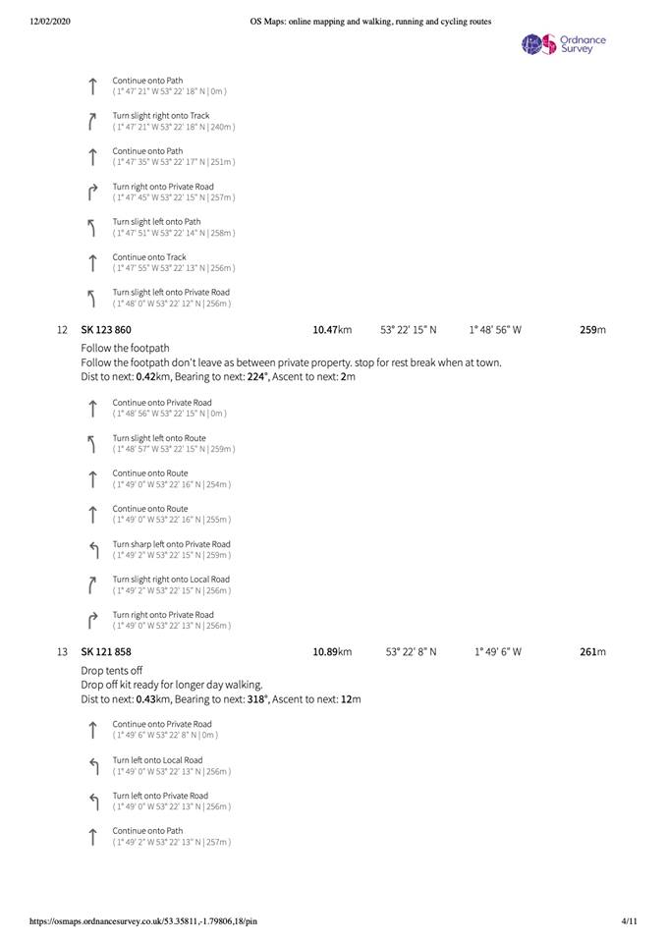

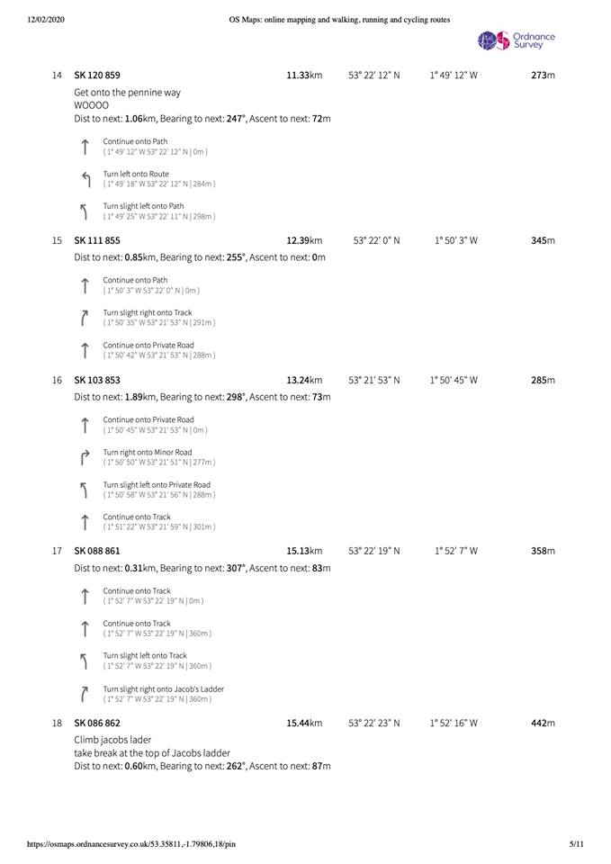

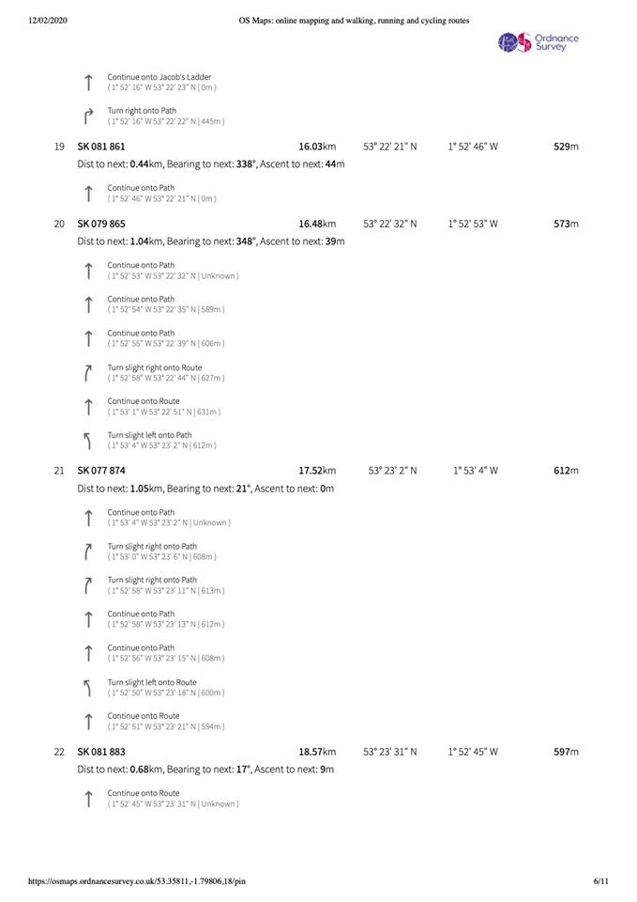

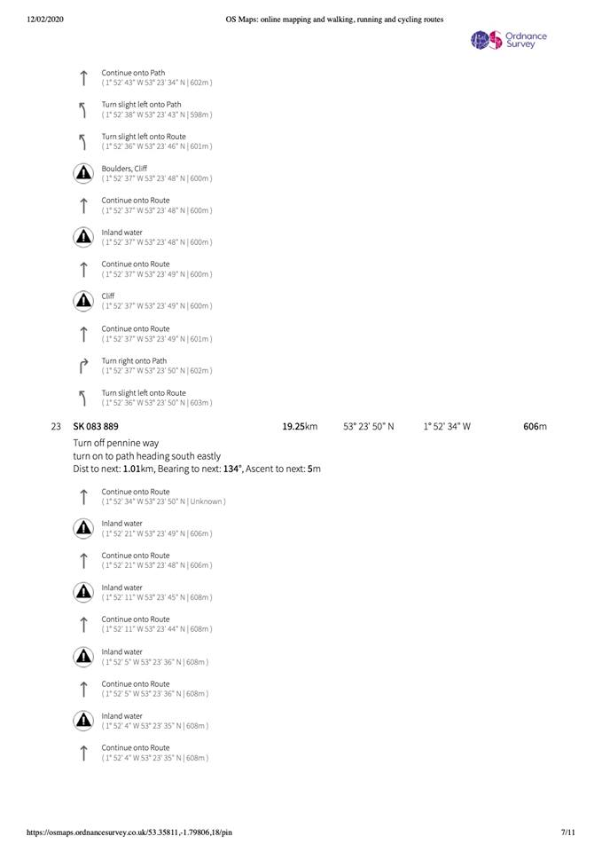

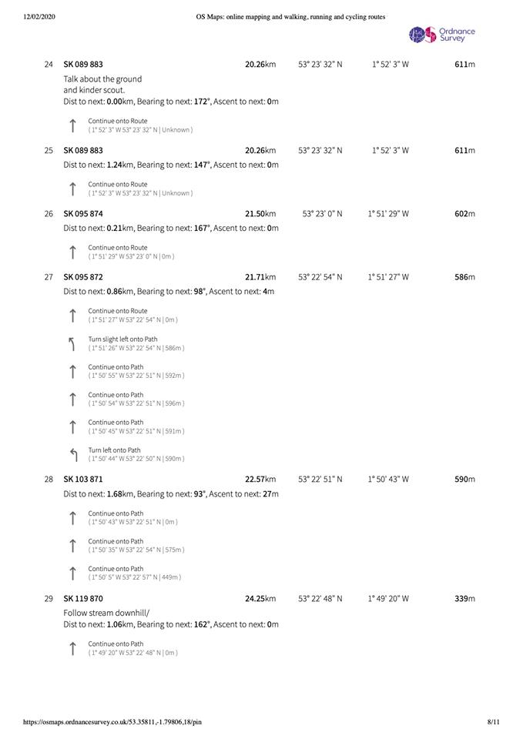

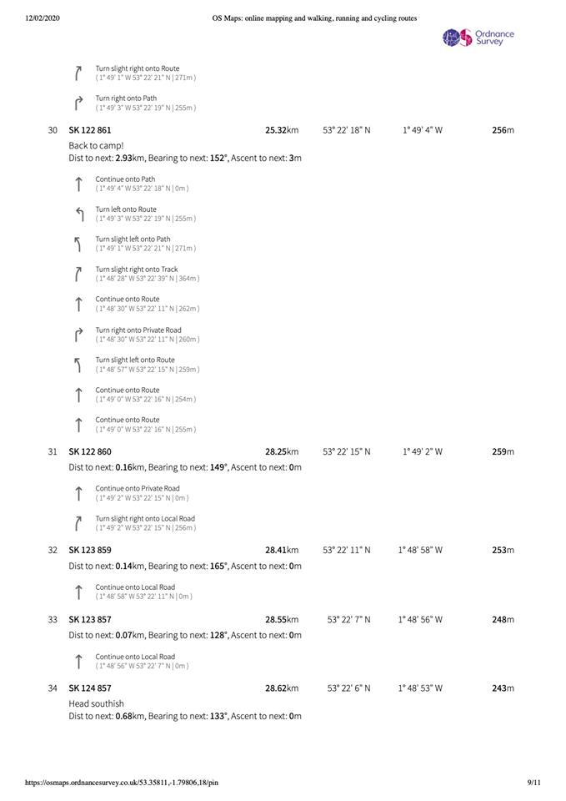

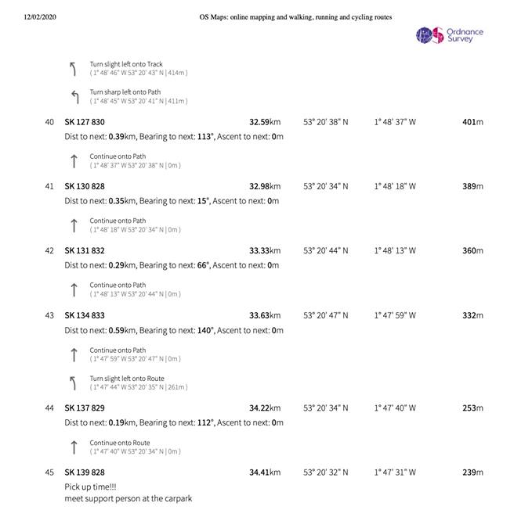

Appendix 14: Lowland leader skills checklist

Lowland Leader Award

Skills Checklist

Introduction
This skills checklist is designed to enable you, as a Lowland Leader candidate, to both record what you have covered as your training progresses e.g. as a technical diary and, at the close of your course, reflect on the syllabus topics covered during your Lowland Leader training allowing you to rate yourself using the ‘learning stage’ described below.
It is hoped that this process will then assist you in completing your Action Plan (which you can share and discuss with your course director at your end of course debrief) which will guide you in consolidating and developing your experience and skills post training and pre-assessment.
When reflecting you might find it useful to refer back to the Lowland Leader Candidate Handbook. In addition the MTUK publication – “Hill Walking” – details many of the techniques that might be used by a Lowland Leader and will be useful for refreshing your memory of specific techniques or skills covered at training.

How to appraise yourself
The syllabus is broken down into headings. Against each competency you can give yourself a ‘learning stage’ number – each number 1-3 corresponds with a description as detailed below. Learning stage 3 would very broadly equate with the degree of competency you’d expect from a qualified and experienced Lowland Leader.

Learning stage descriptions
Cognitive or understanding phase (Learning stage 1)
In the first stage of learning performances are inconsistent and success is not guaranteed. Performing the skill requires all of the candidate’s attention and so they rely on the trainer for cues. This is a process of trial and error. Correct performances must be reinforced through external feedback.

Associative or verbal motor phase (Learning stage 2)
Performances are becoming more consistent as knowledge and skills are being formed. While the simpler parts of the performance now look fluent and are well learned, the more complex elements require most of the candidate’s spare attention. The candidate is starting to get a sense of internal 'kinaesthetic' and ‘cognitive’ feedback when they perform or apply a skill well. They are starting to detect and correct their own errors.

Autonomous or motor phase (Learning stage 3)
In the final stage of learning, performances have become consistent, fluid and ‘unconsciously competent’. The knowledge and skills involved are well learned and stored in the long-term memory. There is now spare attention which can be focused on group members and adapting appropriate leadership approaches and techniques as applied to situations. To retain the new skill at this level, it must be regularly practiced to reinforce the motor and cognitive programmes.
The leader of walking groups needs a wide range of skills and knowledge in order to operate effectively. Not only is it necessary to be able to perform each element in isolation but it is also vital that leaders can combine several skills at any one time. For example, they may need to manage the group and navigate at the same time.
1. Leadership Skills and Group Management  The leader should be aware of: | LEARNING STAGE |  | NOTES
a. their responsibilities to the group and individuals within it, parents/guardians, employing authorities, other outdoor users and the general public, including the choosing of venues and planning and recording of routes.
b. current legislation that relates to the care of groups under their charge, including legislation relating to the care of young people and vulnerable adults.
c. specific responsibilities to choose appropriate objectives, to complete detailed preparations and ensure that the group is adequately equipped and briefed for the activity.
d. the health and fitness benefits of walking, and be able to explain them to a group.
e. communication strategies whilst leading groups.
f. group management strategies and the need to adapt to differing groups and situations.
g. the variety of barriers to participation, including mental and physical disability, ethnicity, fitness/health and be aware of the impact of various medical conditions.
h. the progress of those under their charge and motivate them towards further participation where appropriate.
i. national walking initiatives.
2. Walking Skills |  | LEARNING STAGE |  | NOTES
a Demonstrate an appropriate level of personal fitness
b Set a sensible pace for the group, understand how to conserve energy and demonstrate balance and co-ordination
c. Identify potential hazards and manage risk
3. Planning a Walk
Adequate planning of a walk is crucial to the enjoyment and safety of the participants and the confidence of the leader. It can vary from a few minutes thought to a pen and paper exercise. When planning a walk, a leader should consider the group’s abilities, the terrain to be covered, the weather forecast and the plan for any potential emergencies.
 |  | LEARNING STAGE |  | NOTES
a. Understand the scope of the Lowland Leader Award scheme and plan walks that lie within this terrain.
b. Know where to find information to assist with the planning of walks
c. Understand what is required to plan and successfully lead a walk
d. Understand common health problems and disabilities and the impact they may have on the walk
f. Weather forecasts – sources, interpretation and assessing impact on planned walks and equipment requirements
e. Understand why and when group and personal insurance is necessary
g. Be able to identify significant risks and appropriate methods to manage risk, both in the planning stage and during the journey
h. Demonstrate awareness of any policies and guidance for the planning and recording of walks that differing organisations might require.

4. Basic Mapwork and Route Finding Skills
The ability to efficiently navigate along a planned walk is a fundamental skill for any walk leader; indeed without that skill very little can be accomplished. Candidates should be able to:
 | LEARNING STAGE | NOTES
a. Use a variety of commonly used maps and understand the use of scales and symbols.
b. Understand and use the information given on maps with regard to rights of way and access to land
c. Understand how to find uphill and downhill sections using contours and printed heights and identify major land features
d. Understand and provide six figure grid references
e. Find which direction to walk in by orientating the map either in relation to surrounding features or with a compass.
f. Use the compass to determine the direction of a path or feature
g. Find out how far apart two points are on the map and calculate how long it will take to walk between them
h. Understand ‘tick off’ and ‘catching’ features and how to use them to aid route finding.
i. Recognise linear features such as walls and streams on a map.
j. Identify position on the map.
k. Navigate competently (using the above skills) in poor visibility due to weather conditions or darkness.
l. Understand the benefits and limitations of using handheld GPS devices.
5. Equipment  Leaders should be familiar with, and able to advise participants on: | LEARNING STAGE | NOTES
a. Suitable personal clothing and equipment

b. Additional equipment carried by the leader
c. Appropriate food and liquids to carry
d. Use of walking poles
e. Appropriate maps and compasses
6. Hazards and Emergency Procedures
Leaders should be familiar with strategies for managing groups when encountering the following hazards:
 | LEARNING STAGE | NOTES
- Badly eroded trails, uneven and wet sections
- A variety of man-made features e.g. stiles, stepped decking, steps etc
- Animals; both livestock and wild
- Roads and traffic
- Other users and their needs e.g. runners, bikers and horses
- Working environments e.g. farmyards, quarries, forestry operations
- Water features such as rivers or lakes
- Poor visibility
- What to do if the path becomes indistinct and /or signs are missing
- Weather conditions
6. Hazards and Emergency Procedures cont/
The leader should be able to: | LEARNING STAGE | NOTES
a. Select an appropriate first aid kit and additional group equipment

b. Deal with common injuries and medical problems
c. Manage self and group in a variety of different weather conditions including heat, cold, rain and high wind.
d. Take appropriate action in the event of an incident or accident including knowing how to get appropriate assistance
e. Plan and follow ‘escape routes’, using appropriate navigational techniques, to nearby assistance.
f. Manage a group to perform a small scale search for a missing person
7. Environmental Awareness, Conservation, Access and Land Ownership

Access considerations  Leaders should understand and be familiar with the following: | LEARNING STAGE | NOTES
a. their responsibility to minimise impact on the environment and applicable national codes (such as the Country Code).
b. current applicable legislation concerning access to the countryside including the law relating to rights of way and access to land and, the nature of specially designated areas and limitations on their use
c. how and where to get information about access to the countryside e.g. from appropriate guidebooks and maps, Mountaineering Council sources, local and National Access Forums and from the various countryside agencies and local authorities.

7. Environmental Awareness, Conservation, Access and Land Ownership cont/

Environmental Awareness  Leaders should seek to develop and extend their: | LEARNING STAGE | NOTES
• Knowledge of countryside flora and fauna

• Knowledge of local history, place names, etc.
• Understanding of how walking can impact on the environment and other people
• Awareness of conservation programmes such as ‘Leave No Trace’ and apply those principles in order to minimize the impact of their activities


Lowland Walking Leader ACTION PLAN

What is the timescale for doing your assessment?
How many Quality Days (QD) – that meet ALL of the QD criteria in the Lowland Leader handbook – have you logged?
List three syllabus areas that you feel/think particularly confident or practised in.
List three syllabus areas that you feel/think require further practice.
What opportunities can you foresee for gaining experience to develop your Lowland Leader skillset?
Given your answers to the above briefly outline your way forward for becoming a Lowland Leader?
Appendix
Assessment requirements
Prior to assessment all candidates must have completed an absolute minimum of 20 logged walks in lowland countryside. Duplicated walks must not be counted in this total and walks should encompass a breadth of different lowland terrains i.e. coast, forest, farmland.

Experience gained in other mountain activities is useful, but not a pre-requisite. Some non–UK/ Ireland experience may be included, but should be in terrain and conditions that are similar to those in the UK/Ireland and must be unguided. Normally any overseas days would be considered as additional experience and should not form a substantial part of the required total.

Complete an appropriate first aid course.

Terrain Definition for Lowland Leader Award

The Lowland Leader Award is designed to train and assess the skills and knowledge required to operate as a leader of walking parties in rural countryside and forest following paths and tracks. Walks must follow paths or tracks that are clearly marked on a map and normally visible on the ground. There will always be situations where crop growth, ploughing or simply heavy leaf fall might obscure a path temporarily, however entry and exit points to such areas will normally be easy to locate. Routes should not require navigation across untracked areas. The navigational demands of routes should be such that the use of the map alone would normally suffice with the compass simply being needed to orientate the map or indicate path direction.

There should be no requirement to cross any hazardous terrain such as very steep slopes or cliffs although it must be recognised that some paths in appropriate lowland terrain may be steep and broken.

The terrain should be fairly close to access points so that the leader can easily cut short a walk or gain help. As a general rule no point on planned walks should be more than around 3km from an access point such as a car park, lay-by or populated area where assistance or evacuation would be available.

Any ‘escape routes’ from the planned walk should also be through terrain that lies within the scope of the Lowland Leader Award. A long route that ran 3 km away from, and parallel to, a road but which had a high moorland ridge between it and that road could therefore fall outside the scope.

Walks should at all times use bridges or other recognised water crossing points such as steppingstones or fords when needing to cross any stream that could constitute a hazard to the party.

Walks must only take place in summer conditions (ie when there is no unavoidable snow or ice on any part of the route). It should be noted that such conditions may well be found at any time of the year; the Lowland Leader should operate according to the conditions underfoot rather than the season.

Appendix 15: MOT
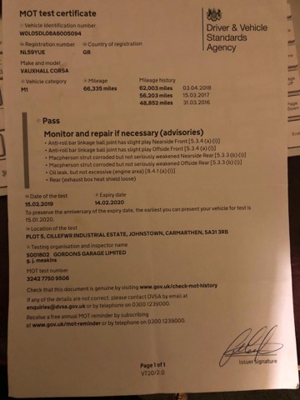

@@

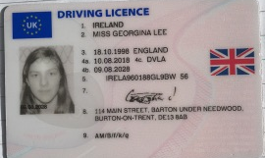
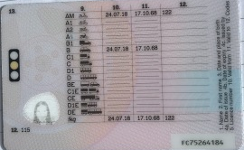
Appendix 16: Drivers licence

Appendix 17: Drivers Insurance

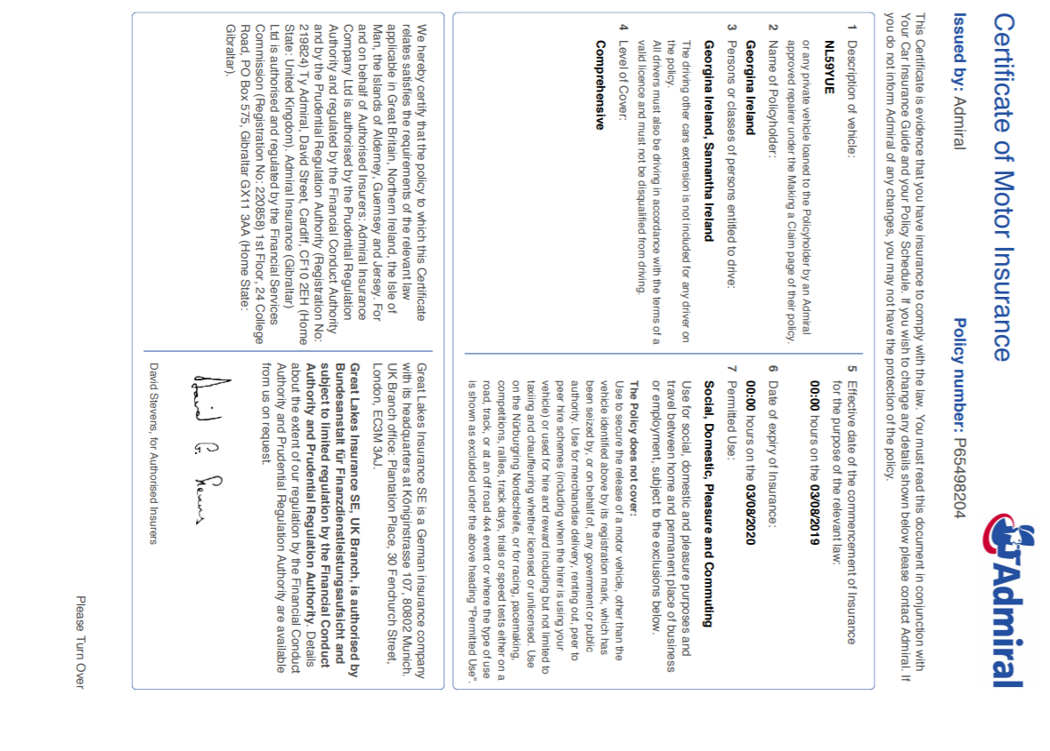

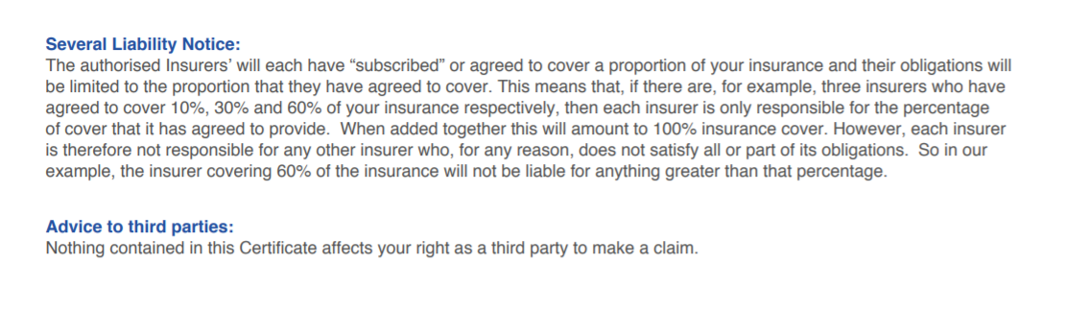

Appendix 18:



