

Module: Developing Relationships and Workplace Achievements
Module No: BMSW5102_LON_A1
Lecturer: Molly Jack
Student Name: Maria Sabrina Belcianu
Student Number: 1914905

Table of Contents
Slide 1: Training and Development Needs for an HR Officer 3
Slide 2: Introduction 3
Slide 3: Appropriate Knowledge Required by HR Professionals 4
Slide 4: Appropriate Skills and Behaviors Required by HR Professionals 5
Slide 5: An HR Officer Responsibilities 6
Slide 6: Personal Skills Audit: Information Technology 7
Slide 7: Personal Skills Audit: Communication Skills 7
Slide 8: Personal Skills Audit: Problem Solving Skills and Supervisory Management 8
Slide 9: Potential Benefits to the Organization of Developing me as an HR Officer 8
Slide 10: Conclusion 9
References 10

Slide 1: Training and Development Needs for an HR Officer
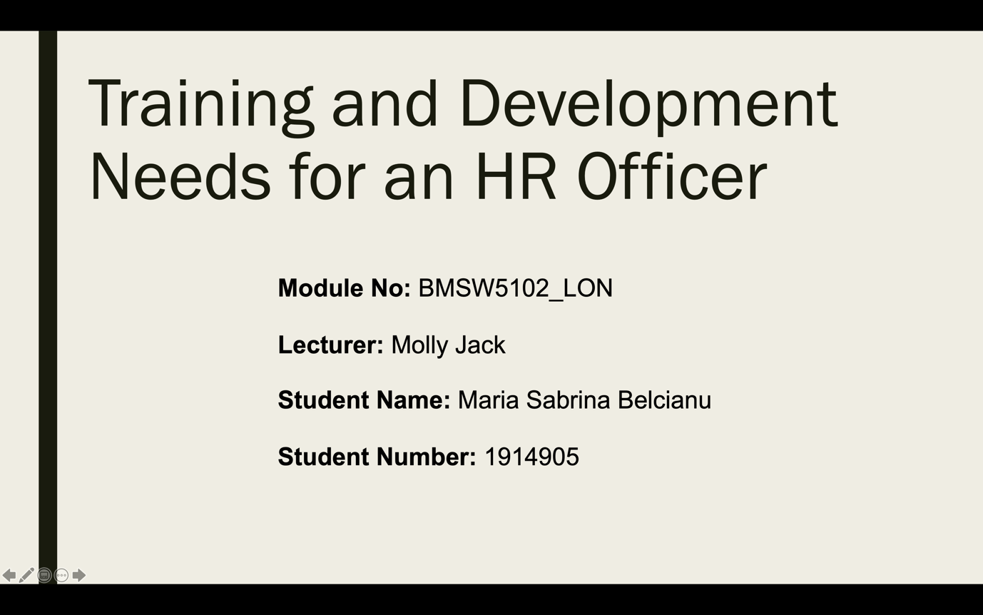

Slide 2: Introduction
BAT or British American Tobacco PLC is the supplier of nicotine and tobacco products and the world’s largest tobacco manufacturer, under the tobacco industry in United Kingdom. BAT is a British Multinational company and was founded in 1902. BAT offers variety of brands and is operating more than 180 countries in the world. BAT owns some local brands which are State Express 555, Stradbroke, HB, Alas etc. Many controversies have arises against BAT because BAT ignores the risk of cancer in cigarettes, it also ignores smoking bans, marketing practices etc.

Slide 3: Appropriate Knowledge Required by HR Professionals

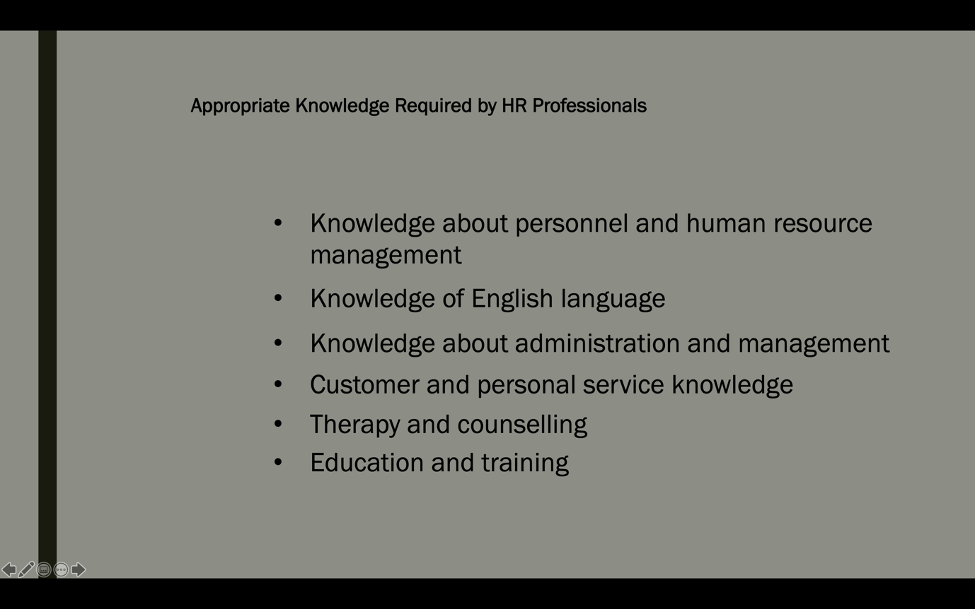
HR professionals should have knowledge about personnel recruitment, selection, employment, process, policies and procedures about human resources (Kehoe, 2017). As English is an international language used by people all over the world’s HR professionals should have appropriate knowledge of correct spelling, grammar, speaking or writing etc. HR professionals are the mid-level manager, they have the authority over several employees. So, they should have knowledge of strategic process management, how to allocate resources, leadership techniques, coordinating peoples etc. They should have knowledge of identifying customers’ needs and satisfaction to increase their performance. HR managers have the responsibilities of motivating employees, so they should have counselling knowledge and how to give therapy (Michael, 2019). This knowledge includes process, procedures of giving treatments, influencing abilities of mental guidance. Sometimes HR manager need to train employees on the job, so they should have knowledge about education and training system. As an HR professional, every manager in British American Tobacco should have the above knowledge.

Slide 4: Skills and Behaviors Required by HR Professionals
Human resources professionals are the mentor of employees, so they should actively listen to their employees, what they want to say or what they expect. Managers also need speaking skills as they need to give motivation to their employees. Coordination refers to take policies into actions by employees (Chams, 2019). HR Managers should have coordination skills. They also need critical thinking ability to find out the best way of achieving strategic goals, to find out the opportunities and strengths. As, they are the supervisor of their employees, they should have negotiation and persuasion skills. To make judgement and to make decision HR professionals should have critical thinking abilities. Time management skill is also required to achieve organizational goals within a specific time and make profit. HR manager should be well-behave. They should have the ability if analysing operating needs and requirements. To be an HR officer in British American Tobacco PLC, an individual should have the above skills and behaviours.

Slide 5: An HR Officer Responsibilities
There are several responsibilities of an HR officer. As an HR officer, an individual recruit and select right person for the right job. HR officers provide relevant guidance to her/his employees to improve performance or to meet strategic goals (Macke, 2019). As officers are the supervisor, they have to develop pay scales and give compensation to their employees. Resolving disputes is also a responsibility of an HR officer. HR officer should actively implement human resource policies and then manage employees to implement those policies (Hewett, 2018).

Slide 6: Personal Skills Audit: Information Technology
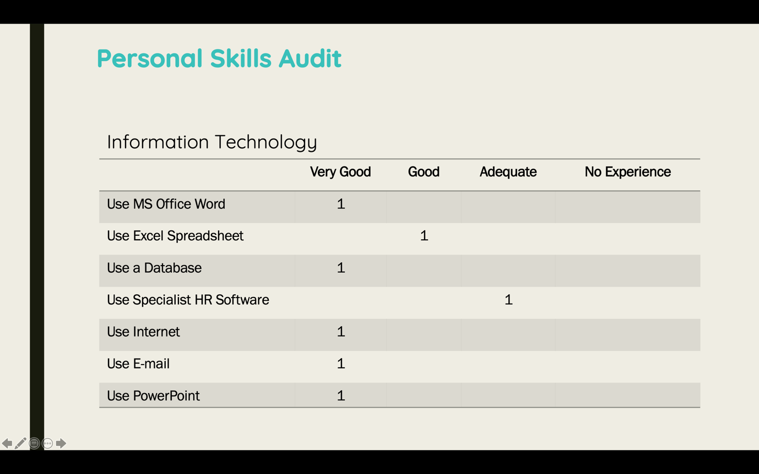
As I had to make several reports, presentation, excel sheet for academic purposes, I have gathered knowledge about Microsoft office word, excel spreadsheet, MS PowerPoint etc. I am very good at those information technologies. I have worked for data entry for freelancing, so I have a very good knowledge about database management. Today is the world of technology, so as a human in this era I am good at using internet and e-mail, but I have a limited knowledge in specialized HR software.

Slide 7: Personal Skills Audit: Communication Skills
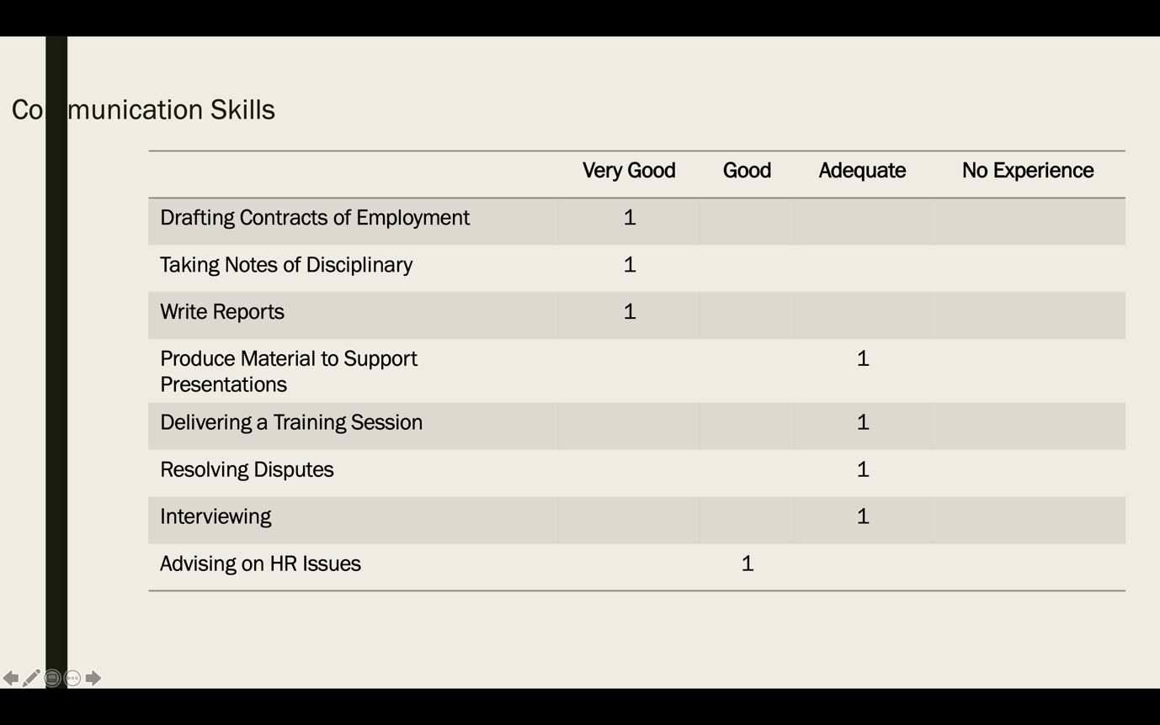
I have a very good knowledge of drafting contracts of employment, taking notes of disciplinary, writing reports as I have worked as an intern in HR department. I have an adequate knowledge in resolving disputes, interviewing, delivering training session. And have a good knowledge in advising HR issues.

Slide 8: Personal Skills Audit: Problem Solving Skills and Supervisory Management

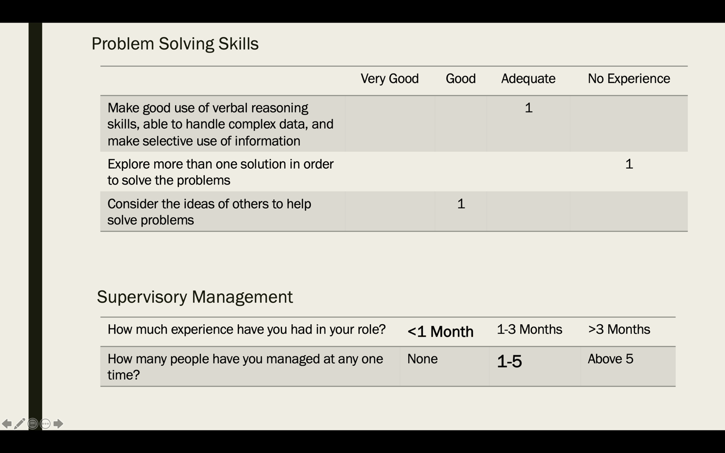

I am good at gathering ideas of others for solving a particular problem, but I have no experience in investigating more than one answer to help fixing problems. I have an adequate knowledge of creating good use of verbal reasoning, able to handle complex data. I have an experience of less than 1 month in that role and I have manager 1-5 people at one time.

Slide 9:Benefits to the Organization of Developing me as an HR Officer
There are several potential benefits to the organization in they employ me as an HR Officer. Such as, I have the ability of managing staffs effectively and I have the potential to manage HR department towards achieving strategic goals. I may ensure employee performance by giving incentives to them. I can manage contracts through negotiation and paying salaries perfectly to the employees. I am good at conducting disciplinary actions. These are the reason why an organization can hire me as an HR officer.

Slide 10: Conclusion
Training and developing needs should be identified to improve performance of and HR Professional. If he/she have the appropriate abilities or skills required for that job, then he/she can actively manage employees and the department toward achieving strategic or organizational goals.

References
Chams, N., 2019. On the importance of sustainable human resource management for the adoption of sustainable development goals. Resources, Conservation and Recycling.
Hewett, R., 2018. Attribution theories in human resource management research: A review and research agenda. The International Journal of Human Resource Management.
Kehoe, J., 2017. Human resource management and unit performance in knowledge-intensive work. Journal of Applied Psychology, Volume 102, p. 1222.
Macke,D., 2019. Systematic literature review on sustainable human resource management. Journal of cleaner production, pp. 806--815.
Michael, A., 2019. A handbook of human resource management practice. s.l.:bookboon. com.

