MODULE CODE: LCMB7024
MODULE: MARKETING MANAGEMENT
ASSIGNMENT TITLE: MARKETING ENVIRONMENT ANALYSIS
STUDENT NAME: Nicolae Mihai
STUDENT ID: 2124103@student.uwtsd.ac.uk
Teacher: Taonga Kaonga Sobere-Sinthers

Table of Contents
Introduction 1
Task 1: Macro-Marketing Environment Impact Analysis 1
Role of Macro-Environment in Strategic Management 1
Actor 1: Economic Factors 2
Actor 2: Social Factors 4
Analysis of Competitive Positioning 6
Task 2: Comparative Evaluation of Strategic Responses 6
Evaluation of Porter’s Generic Strategies 6
Application of Ansoff’s Growth Matrix 8
Sustaining Competitive Advantage 10
Conclusion 11
References 12
Task 1 12
Task 2 14

Introduction
The UK grocery retailing market is now marked by stiff price battles and structural change out of the old-fashioned "Big Four" supermarkets to the value-based retailers (Kantar, 2026). The limited assortment discount sector within this landscape is the driver of market growth. The present report dwells on Aldi UK as the pioneering organisation, which has initiated the strict hard discount model in the UK in 1990. It is combined with Lidl GB, the follower organisation (market entry 1994), which followed a comparable model but has since been transformed into a soft discounter with specific operational shades. The purpose of the report is to critically examine how the determinants of the competitive positioning of these two firms, as largely, influenced by the macro-environmental factors, specifically, Economic and Social, and to assess the efficacy of the strategy employed by these firms in preventing stagnation in the turbulence of the mid-2020s.

Task 1: Macro-Marketing Environment Impact Analysis

Role of Macro-Environment in Strategic Management
Strategic marketing management requires a prerequisite of scanning the macro-environment since organisations do not exist in a vacuum; they are directly integrated into a larger framework outlined by the PESTLE framework (Political, Economic, Social, Technological, Legal, and Environmental) (Eierle et al., 2022). In the case of UK discounters, this external scanning is critical since the business models of the companies do not offer much room to make mistakes, in case external shocks take place. According to theoretical views, the capability of the firm to match its internal resources with these external realities is what makes or breaks the firm. Almost by tracking macro-actors like shift in inflation rates or changes in consumer ethical norms the retailers such as Aldi and Lidl can be proactive in making a shift to more predictive strategies rather than reactionary ones. Inability to scan successfully exposes a company to the risk of strategic drift whereby the value proposition of a company is no longer relevant because the external world is evolving, a situation that has befallen past mid-market retailers that had not considered the emergence of the discount model (Hardcastle, 2024).

Actor 1: Economic Factors
A continuous and enduring "Cost-of-Living Crisis" has radically transformed the economic environment in the UK grocery industry in the mid-2020s. This was a turbulent time of unrelentingly high food inflation and real wages that failed to grow, and formed an economic duality defining consumer behaviour anew. On the one hand, this volatility provided an enormous opportunity of the trade-down, because financial need compelled households to reconsider their expenditure patterns (Snipp, 2025). With the constrained disposable incomes, the social stigma that had always accompanied the act of shopping in discounted stores virtually disappeared. This cultural change also compelled even the middle-income segments to give up on high-end retailers such as Waitrose or the mid-market market leaders such as Sainsbury to find more value. As a result, this economic force served as a potent recruitment tool to both Aldi and Lidl, as they seized the opportunity to boost their market share because of the influx of new customers to the point where their combined market share would reach 19.2% by 2025 (Cawthray, 2025). But this was not a completely favourable climate; the very inflationary forces that accelerated the customers to the door were threatening the very same operation models of the discounters. Rising power prices and high levels of supply chain fluctuation were a threat to the already minuscule margins, enabling such discounters to exist, as they struggled to keep delivering their promises of low prices at the same time their own input prices were skyrocketing.
To counter these pressures, the comparative strategic effects on the two companies indicated different structural differences in how they dealt with the crisis. Aldi, keeping strictly to its position as the first to adopt the hard-discount model, redoubled its effort on a strategy of homicidal operational efficiency as a way of covering up these escalating costs. With a firm commitment to keeping its overheads to a minimum by strictly adhering to a fixed number of Stock Keeping Units (SKUs), about 2,000, and avoiding the administrative baggage of a loyalty scheme or a multi-buy offer, Aldi was in a position to reduce its overheads (Brand Nudge, 2025). This economic uniformity gave them a cushion through which they could take on board supplier price increases without entirely transferring it to the consumer and retain their price leadership. By contrast, the Lidl model had greater overhead pressures because of its follower evolution that supports a slightly larger range of about 2,500 SKUs and has operationally complex, energy-intensive in-store bakeries (Webb, 2024). Lidl was thus forced to increasingly use its Lidl Plus app to provide a more digital-only discounted offer as a way of covering up the required price increases, where Aldi could afford to use a transparent, unchanging shelf price.
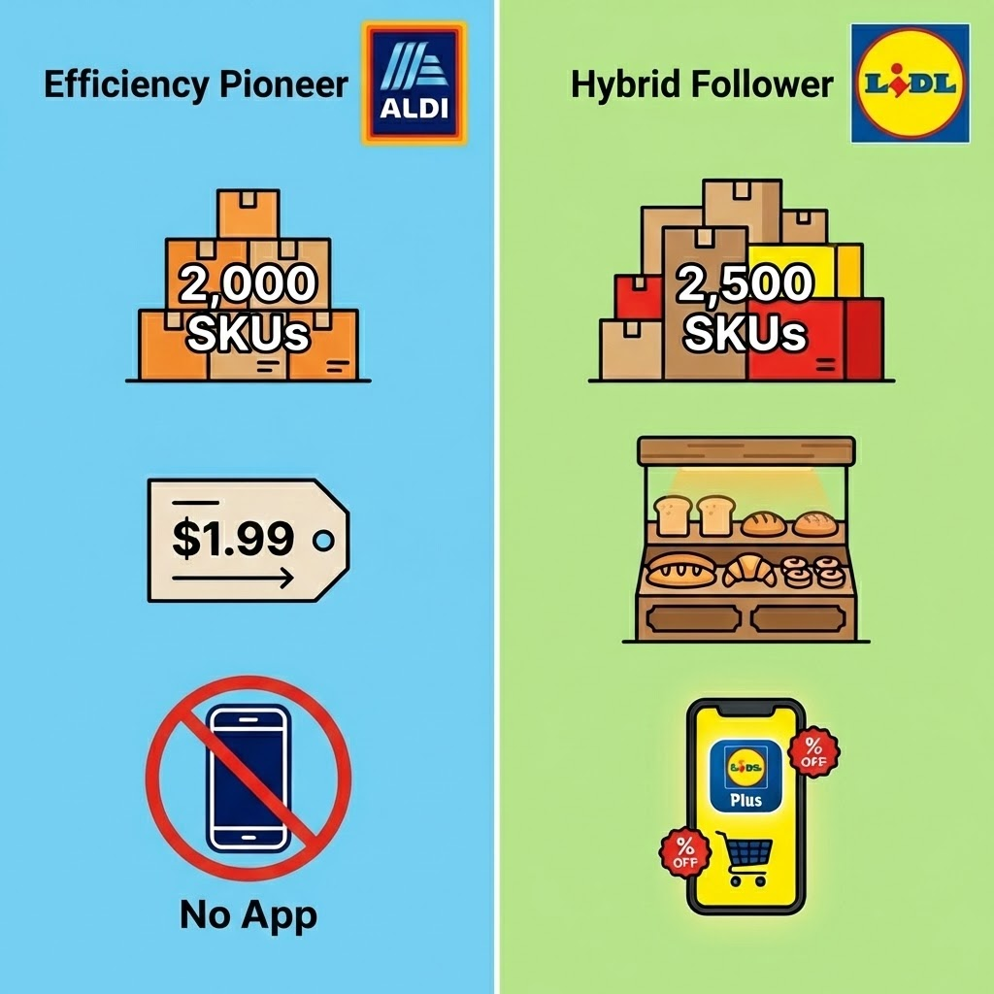
Figure 1: Strategy Comparison
(Source: Learner)
The ensuing competitive stand point has seen the discounters become a decisive winner at the cost of the traditional Big Four. This advantageous economic situation enabled Aldi to establish itself as the fourth-largest supermarket in the UK, essentially entrenching a new generation of shoppers who at first moved because of financial necessity but stayed because of the perceived value creation (Shadbolt, 2019). According to industry data provided by Kantar (2026), the difference in price between the discounters and the traditional supermarkets was the most significant factor behind footfall during the crisis. The inability of Aldi to water down its lean model saw it emerge victorious on its own grounds on lean price trust between shoppers and Aldi, who believed that they would always get the best price without having to use a coupon. In the meantime, Lidl leveraged the crisis to position itself as an alternative in the form of a full-shop, stealing bigger basket shares of Tesco by demonstrating that even in the middle of a recession, a dining-out shopping experience could include fresh bakery products and branded delicacies.

Actor 2: Social Factors
The second macro-factor that is critical in the industry is a radical social change to conscious consumerism coupled with growing need of digital convenience. Consumers in this new world have left behind the concept of value being merely a ratio of low price and are now seeking value with values where the company displaying the values must demonstrate ethical behaviour to its customers (Lightspeed Commerce Inc, 2025). This transformation incorporates an obvious social craving toward green sourcing, animal welfare excellence, and overt encouragement of British farming- regions of where discounters were traditionally seen as feeble and commonly related to poor-quality, imported products (Ward, 2024). At the same time, retail experience has shifted, since retailing gamification using mobile applications has become a social convention. Younger audiences and especially Gen Z and Millennials have become accustomed to personalised online experiences and interactive benefits over consumers merely being offered low prices (Popova, 2025).
Comparative analysis points towards the evident divergence in the manner in which the two companies have managed these social changes. Aldi, as the unwavering innovator, paid a lot of attention to the concept of "Provenance" as the way to orient its brand to the traditional social values of Britain. They intensively promoted their own brand range, the Specially Selected premium category, and introduced high-profile promotional campaigns that promised 100% British Beef and strong advocacy of British farmers (Speare-Cole, 2025). This was an important strategic action to neutralise the social risk posed by shopping in a discounter to form a permission structure enabling wealthy shoppers to trade down without being socially embarrassed. On the other hand, Lidl conformed to the speeding up social trend of "Digital Engagement." Lidl Plus is an app created not only to serve as a savings mechanism, but as a social interactions platform with interactive functionality such as scratch cards and partner offers, including cinema tickets (Cristea, 2020). This strategy goes directly to the social identity of the smart shopper, and it manages to make the brand more contemporary, younger, and increasingly technologically connected than Aldi with its more traditional and app-free strategy.
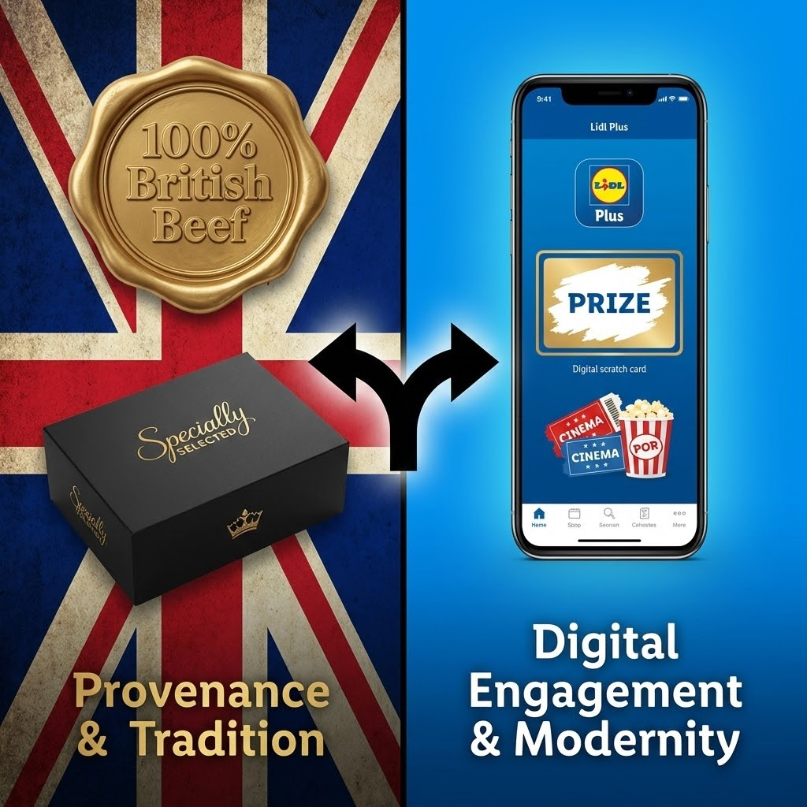
Figure 2: Strategic Divergence of UK Discounters
(Source: Learner)
These social changes have completely changed the perception of competition of the whole discount industry. The discounters are not considered as the sellers of poor quality goods, but the places of smart quality. Aldi has been able to establish itself as the winner of the British consumer, and the company has earned widespread brand loyalty due to its operational reliability and its unwavering refusal to employ any gimmicky data collection methods (Houlton, 2025). However, Lidl has positioned itself distinctly as the "modern discounter" by leveraging its app infrastructure to mediate the divide between a traditional discounter and a mainstream supermarket shopping experience (Mukherjee, 2025). As Aldi is winning the trust/simplicity front among traditionalists, Lidl is winning the social relevance front among younger tech-savvy families where the app-based loyalty experience has become a valuable, integrated component of the current shopping ritual.

Analysis of Competitive Positioning
Competitive positioning in the UK discounter market has been radically divided and this has provided a clear strategic distance between the innovator and the imitator. Aldi has established itself as the unchallenged Cost Leader, using its innovative lean operational process to take the lead in the struggle over the rational, price-sensitive consumer (Penhaligon, 2025). It has positioned itself with the strict consistency, simplicity and unswerving adherence to the lowest shelf price, which has served to shield its fundamental value proposition against the economic turbulence of the Cost-of-Living crisis. Subsequently, Lidl has managed to establish a distinct "Hybrid" niche that incorporates hard discount prices and supermarket-type differentiation. Combining the social aspects (the data-driven Lidl Plus loyalty application) with the experience (in-store bakeries), Lidl targets a segment of people who value the price and do not sacrifice on the convenience or choice of the modern world (Aissa, 2025). Therefore, the two companies are no longer mere duplicates that fight over the same coin; they have practically divided the market. Aldi focuses the high-volume mission of its main shop on economic trust, whereas Lidl gains increasing shares of the mission of lifestyle and top-up based on social relevance. This split suggests that Aldi still plays the structural role of guardian of the discount format, but Lidl has become its main innovator, making it able to go beyond its perception of being cheap enough to challenge the Big Four on quality in addition to price.

Task 2: Comparative Evaluation of Strategic Responses

Evaluation of Porter’s Generic Strategies
The reason why Porters framework has been selected in this case is that it is a good way of identifying how two companies within the same low price industry can overcome direct cannibalism. It emphasises that they are both the same in that they are both discounters but Aldi follows pure efficiency (Cost Leadership) whereas Lidl follows an elegant combination of value and added features (Differentiation) (Dixit, 2024).
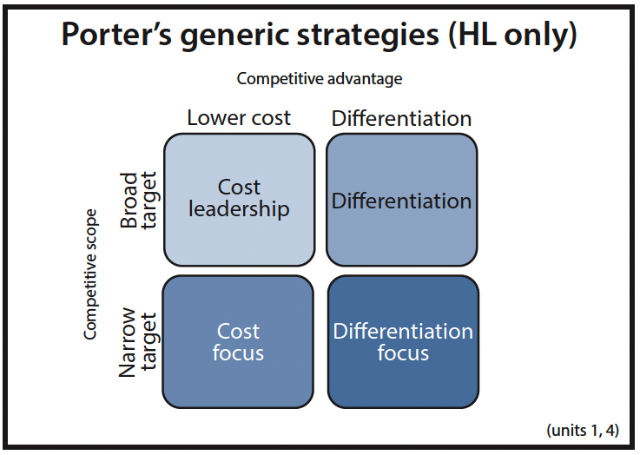
Figure 3: Porter’s Generic Framework
(Source: Dixit, 2024)
Strategic Element | Aldi (Pioneer) Response | Lidl (Follower) Response
Generic Strategy | Cost Leadership | Cost Focus with Differentiation (Hybrid)
Core Focus | Keeping their operational base as low as possible to finance the lowest prices on the shelf (McMillen, 2024). | The low prices cost and supermarket characteristics (Bakeries, branded goods).
Implementation | SKU restriction (2,000 items) is strict. 90% Private Label. No loyalty data costs. Pre-done packages to save on labour. | Expanding slightly (2,500 items). Lidl Plus Data-driven targeting app. Increased margins in non-food aisle of Lidl in the middle.
Evidence of Success | Always named the Cheapest Supermarket in the UK by Simmonds (2025). Great confidence in Everyday Low Prices (EDLP). | "Lidl Plus" user base grew 34% in 2024. More robust focus on families who desire a one-stop shopping experience which incorporates brands (Lidl.co.uk, 2025).
Table 1: Evaluation by Porter’s framework
(Source: Learner)
The latest industry data provided by Houlton (2025) indicate that Aldi has a somewhat stronger Cost Leadership in its pure market share (10.8% compared to Lidl 8.3%). During a severe Cost-of-Living crisis, the straightforwardness of the Aldi what you see is what you pay philosophy reaches on a greater scale than the Lidl deals through apps that need consumers to be on the hunt. But the hybrid model that Lidl is following is creating greater growth in the basket size since customers are purchasing higher-margin non-food products, indicating that it has a higher potential to be profitable in the long term though the overall market share is slightly reduced.

Application of Ansoff’s Growth Matrix
In order to dissect the targeted growth vectors, Ansoff Matrix is employed. It assists in recognising the fact that Aldi is expanding by selling more of the same to new individuals, and Lidl by selling new things to the same individuals (Zugay and Zakaria, 2023).
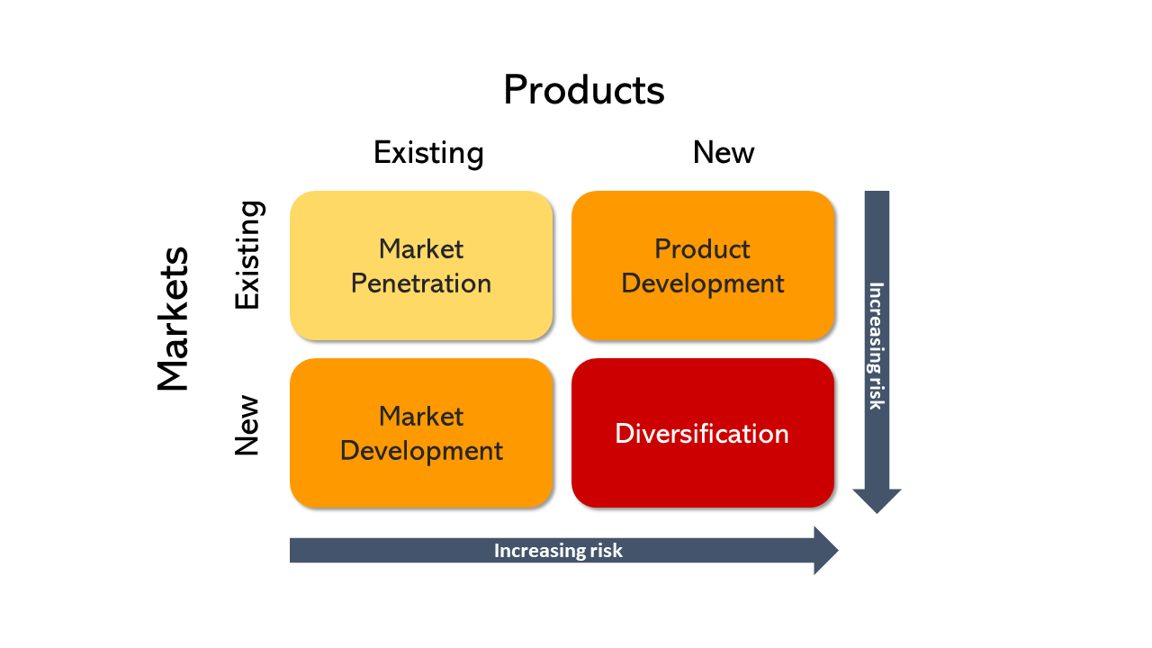
Figure 4: Ansoff Framework
(Source: Zugay and Zakaria, 2023)
Growth Vector | Aldi (Pioneer) Response | Lidl (Follower) Response
Market Penetration | Through Forceful Geographical Expansion. Aiming at 1,500 stores in the UK (at the moment 1,050). They are under-represented in London/South East where the big investment is made (ESM Magazine, 2025). | Digital Penetration. Utilising Lidl Plus to enhance the number of visits by the existing shoppers. The same week return visits are stimulated by the use of coupons.
Product Development | Premiumization. Diversification of "Specially Selected" range (sales increased 12% Xmas 2024). Introducing the presence of plant-based ranges so that vegans do not revert to Tesco. | Non-Food Innovation. Themed (DIY, ski-wear) aisle is turned so that food shoppers can purchase high-margin items in the middle of Lidl. Expansion of new vegan range Vemondo.
Evidence of Success | Increased store traffic in new areas of catchment. The fastest growing tier is Special Selected, which is capturing Waitrose. | Middle of Lidl creates viral social media marketing (e.g. sneakers made under the Lidl brand). Large percentage of app users becoming weekly shoppers (Schwab, 2020).
Table 2: Evaluation by the Ansoff framework
(Source: Learner)
Lidl exhibits greater originality in its implementation of growth strategies. Although Aldi engages in the conventional, linear route of physical store expansion (the classic, highly-known scale-up strategy, Pioneer), Lidl has innovated Product Development (the well-known Middle of Lidl) and digital penetration to expand without having to open stores at the same maniacal pace (Fouad, 2023). Lidl is more inventive as its strategy focuses on transforming a grocery store into a treasure hunt experience, whereas Aldi is an extremely powerful, yet, standard, reiteration of their current strategy.

Sustaining Competitive Advantage
The strategic strength of the response at Aldi is that it reduces economic risks given that it maintains the lowest base of costs that enables it to always win the price war. The complexity is resisted by them, which guarantees survival in the long term. Nevertheless, Lidl reaction is more effective in counteracting the social risk of not being relevant (Petropoulos et al., 2025). Lidl creates a defensive moat, which interprets non-food items as a treasure hunt, and this use of digital loyalty and treasure hunt, which avoids customer boredom (among the major threats of the limited-assortment model), ensues. Finally, Aldi safeguards the margin whereas Lidl safeguards relevance.

Conclusion
Therefore, two opposite directions have been predetermined by the macro-environment the economic squeeze compelled Aldi to refine its own "Cost Leadership" model to safeguard prices, whereas social trends activated Lidl to become a Hybrid digital-first company. The final decision goes in favour of Aldi in terms of structural advantage as compared to Lidl in terms of potential in the future. Aldi has been the structural leader of the industry; it has a lean operating model that is recession-resistant and cost-efficient in a low-margin industry. Lidl has however managed to differentiate itself. By transforming into a smart shopping cart instead of a hard discounter, Lidl has hedged itself against a future in which the economy will recover, and shoppers will judge based on experience rather than pure price. The future trend of the UK discount retail market would favour Aldi as the major retailer of routine grocery shopping, and Lidl as the major retailer of supplementary and discretionary shopping, which has a practical division of the market between the two companies.

References

Task 1
Aissa, B. (2025). How the cheapest supermarket, Lidl, became a €125 billion empire: a lesson for successful…. [online] Medium. Available at: https://medium.com/quill-and-ink/how-the-cheapest-supermarket-lidl-became-a-125-billion-empire-a-lesson-for-successful-251d2e1ee18a [Accessed 31 Jan. 2026].
Brand Nudge (2025). How Aldi and Lidl changed the price game (and what it means for the rest of the market) – Brand Nudge. [online] Brand Nudge. Available at: https://brandnudge.com/insights/from-disruptors-to-dominators/ [Accessed 31 Jan. 2026].
Cawthray, B. (2025). Aldi UK and Lidl GB gained a combined 0.8% share of the GB grocery market in the 12 weeks to 18 May 2025. [online] Linkedin.com. Available at: https://www.linkedin.com/posts/benjamin-cawthray-87a9a815_grocerymarketshare-activity-7333446208796942336-Kdfj [Accessed 31 Jan. 2026].
Cristea, M.-A. (2020). Lidl launches Lidl Plus mobile app, a digital customer loyalty program that offers extra shopping benefits - Business Review. [online] Business Review. Available at: https://business-review.eu/business/retail/lidl-launches-lidl-plus-mobile-app-a-digital-customer-loyalty-program-that-offers-extra-shopping-benefits-213691 [Accessed 31 Jan. 2026].
Eierle, B., Hartlieb, S., Hay, D.C., Niemi, L. and Ojala, H. (2022). External factors and the pricing of audit services: A systematic review of the archival literature using a PESTLE analysis. Auditing: A Journal of Practice & Theory, 41(3), pp.95–119.
Hardcastle, K. (2024). The Battle For Middle Ground: Standing Out In Retail’s Crowded Arena. Forbes. [online] 13 Jul. Available at: https://www.forbes.com/sites/katehardcastle/2024/07/13/the-battle-for-middle-ground-standing-out-in-retails-crowded-arena/ [Accessed 31 Jan. 2026].
Houlton, C. (2025). Data: Aldi market share at highest rate yet. [online] Grocery Gazette - Latest Grocery Industry News. Available at: https://www.grocerygazette.co.uk/2025/04/01/aldi-market-share-sales-2/ [Accessed 31 Jan. 2026].
Kantar (2026). Promotions, premium own label and no alcohol options: inside Britain’s £13.8bn Christmas grocery shop. [online] Available at: https://www.kantar.com/uki/inspiration/fmcg/2026-wp-promo-premium-own-label-and-no-alcohol-options-inside-britains-13-8-bn-xmas-grocery-shop [Accessed 31 Jan. 2026].
Lightspeed Commerce Inc (2025). Consumers Embrace ‘Valuespending’: Intentionality and Brand Values Now Central to Purchasing Decisions. [online] Prnewswire.com. Available at: https://www.prnewswire.com/news-releases/consumers-embrace-valuespending-intentionality-and-brand-values-now-central-to-purchasing-decisions-302482718.html [Accessed 31 Jan. 2026].
Mukherjee, U. (2025). Lidl’s new service to let Plus members reserve in-store launch items. [online] Retail Insight Network. Available at: https://www.retail-insight-network.com/news/lidls-new-service-plus-members/ [Accessed 31 Jan. 2026].
Penhaligon, B. (2025). LOYALTY PRICES UNABLE TO BEAT ALDI PRICES FOR A WHOLE YEAR – PROVEN BY WHICH? INDEPENDENT RESEARCH. [online] ALDI UK Press Office. Available at: https://www.aldipresscentre.co.uk/product-news/loyalty-prices-unable-to-beat-aldi-prices-for-a-whole-year-proven-by-which-independent-research/ [Accessed 31 Jan. 2026].
Popova, N. (2025). Gamified Loyalty: Underrated Today but Poised for Future Growth. [online] Euromonitor. Available at: https://www.euromonitor.com/article/gamified-loyalty-underrated-today-but-poised-for-future-growth [Accessed 31 Jan. 2026].
Shadbolt, P. (2019). How the discounters are beating the supermarkets. BBC News. [online] 22 Sep. Available at: https://www.bbc.com/news/business-34315643 [Accessed 31 Jan. 2026].
Snipp (2025). How Inflation is Reshaping Grocery Shopping in 2025. [online] Snipp.com. Available at: https://www.snipp.com/blog/inflation-reshaping-grocery-shopping-survey [Accessed 31 Jan. 2026].
Speare-Cole, R. (2025). Supermarkets pledge to keep sourcing meat from British farms after US trade deal. [online] Yahoo Finance. Available at: https://uk.finance.yahoo.com/news/supermarkets-pledge-keep-sourcing-meat-144343594.html [Accessed 31 Jan. 2026].
Ward, R. (2024). Consumer Attitudes Towards Sustainable Retail Practices - Tribe Connect. [online] Tribe Connect. Available at: https://tribeconnect.io/consumer-attitudes-towards-sustainable-retail-practices/ [Accessed 31 Jan. 2026].
Webb, C. (2024). Aldi vs Lidl: which is the better discount supermarket? [online] Which? Available at: https://www.which.co.uk/news/article/aldi-vs-lidl-which-is-the-best-discount-supermarket-a50gb6E8BsMT [Accessed 31 Jan. 2026].

Task 2
Dixit, A.S., (2024). Exploring HR practitioner’s perspective on linking of employer branding and porter’s generic strategies: an alignment of business and HR strategy. International Journal of Organizational Analysis, 32(6), pp.1060–1072.
ESM Magazine. (2025). Aldi UK Commits £1.6 billion To Ramp Up Store Expansion | ESM Magazine. [online] Available at: https://www.esmmagazine.com/retail/aldi-uk-commits-1-6-billion-to-ramp-up-store-expansion-296165/ [Accessed 31 Jan. 2026].
Fouad, A. (2023). Master the Game of Retail — P2: The Winning Strategies of Lidl, and Aldi. [online] Medium. Available at: https://ahfouad.medium.com/master-the-game-of-retail-p2-the-winning-strategies-of-lidl-and-aldi-a279947b084d [Accessed 31 Jan. 2026].
Houlton, C. (2025). Data: Aldi market share at highest rate yet. [online] Grocery Gazette – Latest Grocery Industry News. Available at: https://www.grocerygazette.co.uk/2025/04/01/aldi-market-share-sales-2/ [Accessed 31 Jan. 2026].
Lidl.co.uk. (2025). LIDL GB TO TRIAL CLICK, RESERVE & COLLECT VIA THE LIDL PLUS APP – Lidl Great Britain. [online] Available at: https://corporate.lidl.co.uk/media-centre/pressreleases/2025/lidl-to-trial-click-reserve-collect-via-lidl-plus [Accessed 31 Jan. 2026].
McMillen, J. (2024). The Price Of Aldi’s Expansion? It Could Be Cheaper Groceries. [online] Forbes. Available at: https://www.forbes.com/sites/jennmcmillen/2024/04/11/the-price-of-aldis-expansion-it-could-be-cheaper-groceries/ [Accessed 31 Jan. 2026].
Petropoulos, F., Akkermans, H., Aksin, O.Z., Ali, I., Babai, M.Z., Barbosa-Povoa, A., Battaïa, O., Besiou, M., Boysen, N., Brammer, S., Brandon-Jones, A., Briskorn, D., Browning, T.R., Buijs, P., Centobelli, P., Chiarini, A., Cousins, P., Cudney, E.A., Davies, A. and Day, S.J. (2025). Operations & supply chain management: principles and practice. International Journal of Production Research, pp.1–184. doi:10.1080/00207543.2025.2555531.
Schwab, P.-N. (2020). Lidl Sneakers: analysis of a marketing phenomenon. [online] Market Research Consulting. Available at: https://www.intotheminds.com/blog/en/lidl-sneakers-analysis-marketing-phenomenon/ [Accessed 31 Jan. 2026].
Simmonds, E. (2025). Lidl beats Aldi to cheapest supermarket title again. [online] Which? Available at: https://www.which.co.uk/news/article/cheapest-supermarket-of-the-month-ag3nQ4J0v6ht [Accessed 31 Jan. 2026].
Zugay, B. and Zakaria, R., (2023). Ansoff matrix. SAGE Publications, Inc.

