ACCOUNTING FUNDAMENTALS
Table of Contents

Introduction 3
Task 1 3
Question 1 3
(a) Description and computation of journal entries 3
(b) Description and computation of trial balance 6
(c) Description and the analysis of profit and loss as well as balance sheet 7
2. Relevance of financial statement to its users 10
Conclusion 11
References 12

Introduction
The term accounting fundamental leads to guide the process of various accounting policies and procedures and it leads to the layout of the income statement, balance sheet, and cash flow statement. It helps to demonstrate the preparation of financial statements from scratch and it is essential for analyzing the performance of the business of Michael.

Task 1

Question 1

(a) Description and computation of journal entries
The term journal entry is defined as a record of transactions regarding the business in the accounts of books of a particular business. It is a documented entry that consists of corrected data regarding the information which has been created in the description below of every transaction. The term journal entry is the first step for the accounting cycle as it provides detailed information regarding the business that has to be attached under every transaction. As most of the businesses use a double-entry accounting system which impacts on two accounts which is credit and debits it therefore both the account has to be shown simultaneously. The journal entry has an equal amount of debit and credit. The recordings of transactions that occurred show the specific amount as it affects whether the transaction used whether double-entry accounting system (Heng, 2019, p.622). The entry is required both great as well as the debit side to complete every entry for increase or decrease in inventory or the account payable. The term annual increases the foundation of the financial report as it is significant in providing information that has been used by other auditors to analyze the happening of events in the financial transaction and take me up at some business in future.
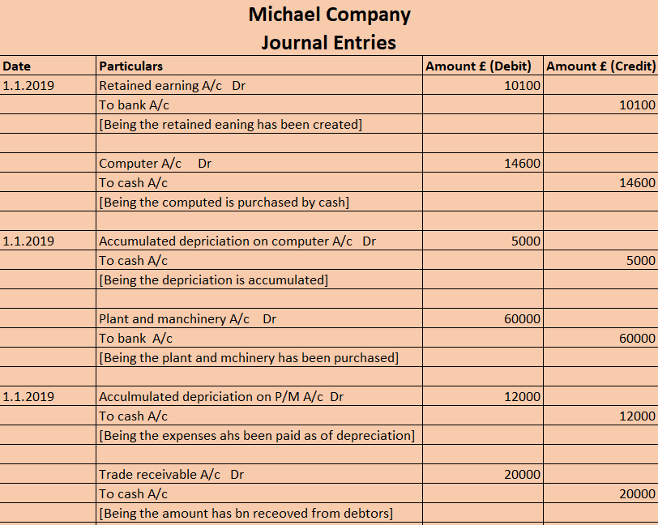
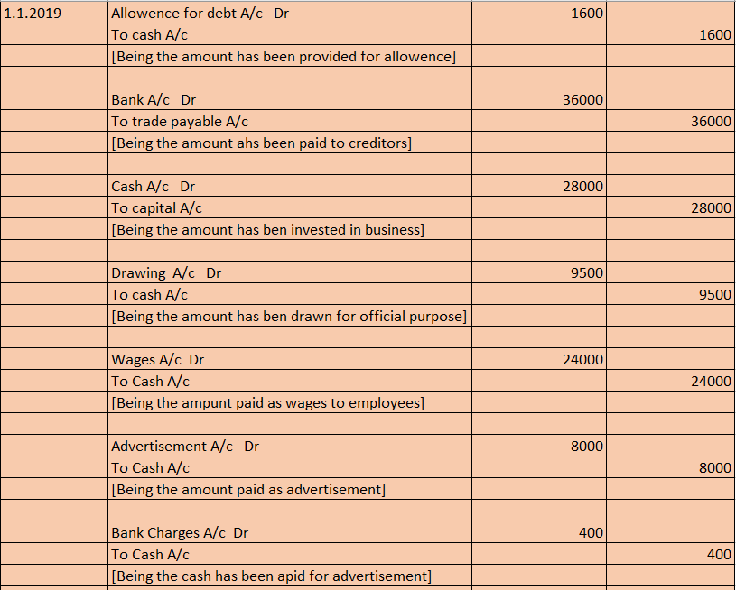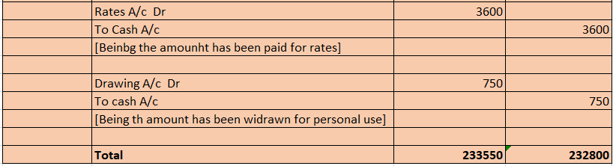
Figure 1: presentation of Journal entries
(Source: Self-created)
In the above figure, the journal entries have been shown and it leads to identifying the transactions. The retained earnings have the amount of £10100. The payment has been done by the bank account of the same amount in the business on the date of 1.1.2019. The company named Michael had purchased computers by providing cash which amounted to £14600. The computer generally involves the accumulated depreciation of the amount of £5000 and it had been paid by cash. The plant and machinery have been purchased and it has been debited in the amount of £60000 and it has done the payment through the bank. The trade receivable amounts to £20000 by the cash accounts. The allowance is the debt that has been paid with cash and it amounts to £1600. The drawing amounts to £9500 which has been used for official purposes. The drawing which amounts to £750 which has been used by the owner for its personal use. The total amount of the journal ledger in both the debtor and well as the credit side amounts to £233550.

(b) Description and computation of trial balance
The concept of trial violence is defined as the bookkeeping of a worksheet in which the balances of all ledgers are compiled into David and credit accounts for analyzing the total amount of the business. The organization prepares the trial balance periodically to analyze the performance of the company. The general purpose of production regarding the balance in a trial form is to ensure that all the entries in the organization are presented in its bookkeeping system and following the accounting policies and procedures (Car and Tanczer, 2018, p.441). The preparation of trial balance to detect any mathematical error which can occur in the form of a double-entry accounting system. If the debit balance equals credit balance, then the ledger has followed the accounting policies and procedures. If it doesn't match then there must be some mathematical error that has to be removed. The trial balance includes debits in credit amount regarding the transaction of business for a certain period and it involves assets, liabilities, expenses, and revenues of the business.
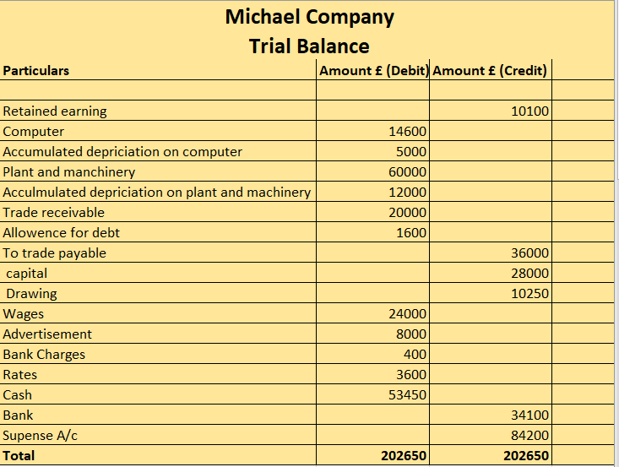
Figure 2: Presentation of Trial balance
(Source: Self-created)
In the above figure, the amount of trial balance amounts to £202650. The retained earning has bn credit which amounts to £10100. The trade payable amounts to £36000 and it has been credited. The capital amounts to £28000 which has been credited and the drawings have also been credited and it amounts to £10250. The suspense accounts which have been created and amounts to £84200. The other expenses have been debited and its total amounts to £202650.

(c) Description and the analysis of profit and loss as well as balance sheet
The term profit and loss are a statement of a financial part that leads to summaries the cost, revenue, and expenses that have been incurred in the specific period for analyzing the performance of the organization. Profit and loss are a form of statement which records information for analyzing the ability of the organization to generate the profit for increasing the earning revenues and decreasing the cost (Axtell et al. 2017, p.40). The statement refers to various losses and profits which helps to analyze the operation of the business from the statement of profit and loss is the one part of the financial statement which has been used by the public to solve the issues quarterly or annually along with the balance sheet as well as the statement of cash. It is significant to compare the statement for different accounting periods by changing operating cost, revenues and it helps to analyze the net earnings of the organization during the period.
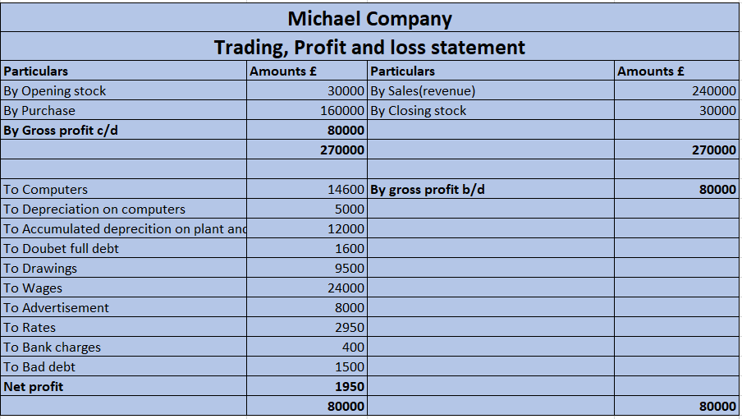
Figure 3: Presentation of Trial balance
(Source: Self-created)
The term balance sheet in the financial statement records the company's liabilities, shareholders, equities, and it is involved in the business for various activities. It provides a basic competition read regarding the returns which have been evaluated with the help of capital structure (Kristandl and Quinn, 2018, p.221). It is a statement that involves the finance part and provides a snapshot of the company regarding various mornings and investments by the shareholders. It is important as it provides various information which is based on the income statement and helps to conduct this cash flow for analyzing the financial ratios.
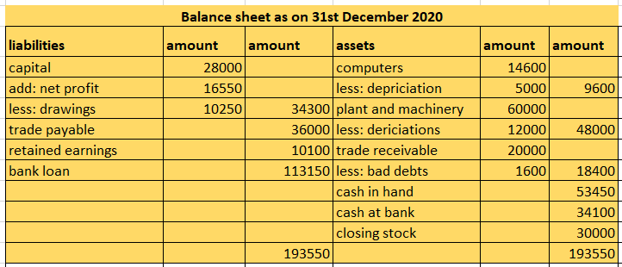
Figure 4: Presentation of balance sheet
(Source: Self-created)
There are certain items that have been presented in the balance sheet that will help the business to reflect the final position of both Assets and liability. The financial position of the business has been conducted for the year ended 31st December 2020 and for the business of Michael company. According to the balance sheet, it can be identified the business is having a capital balance of £28000 Pounds at the end of the year. The value of net profit has been added with the value of capital and the final balance has been deducted with the value of drawings. Thus, The total value of capital is evaluated at £34600 at the end of the year. The amount of trade payable at the end of the year is obtained to be at £36000. The value of retained earnings was evaluated in the balance sheet at £10100.
There are certain assets that were computed for the business at the year ended 31st December 2020. The final balance of the computer after deducting the value of depreciation was obtained to be at £9600. The value of plant and machinery at the end of the year was evaluated at £60000 and the value of depreciation was £12000. Thus, the final book value of the plant and machinery at the end of the year was evaluated at £48000. The final balance of trade is available that is going to be received by the business is £20000. However, the business is going to face a bad debt of £1600, thus, the amount of trade receivable to be received by the business at the end of the year is £18400. The amount of cash in hand was recognized at £53450 and the value of cash on the Bank was £34100. The business is having the value of closing stock that was recognized at £30000. Thus, the total amount of both asset and liability at the end of the year is £1935550

2. Relevance of financial statement to its users
Financial statements are considered to be the important aspects of every company that allows them to identify their performance made during a year. Furthermore, the importance of financial statements is to provide a quick overview of the financial entries conducted by the business to achieve profit. There are many users of financial statements that have been identified as such as investors, shareholders, creditors, and even governments (Osadchy et al. 2018, p.25). However, the internal users are the employees, managers, and rest of the members. The financial statements are prepared in the year ending by a business that allows them to evaluate their revenue, expenses, and movement of Assets and liabilities.
There are three types of financial statements that are conducted by a business and are important for its users. These financial statements are the income statement, balance sheet and the last one is the cash flow statement. The income statement is important for the users to understand the profit earned by the business after conducting their sales during a year. Additionally, this book is important to understand the expenses made by a business to conduct sales effectively. However, the balance sheet is used by a business to evaluate their final position of Assets and liabilities during a year.
There are certain purposes for evaluating the financial statement. It is used to understand the financial information of an entity. There are certain external users of the financial statement process, the government, and investors. These books are also important to help the users of financial statements along with the potential investors to understand the health of a business (Pelekh et al. 2020, p.197). The government used the financial statement to understand the taxes in process of the business after conducting their sales. The statement is used to provide adequate information about the preparation of tax during a specific period of time. The characteristics of a financial statement are that it can easily be compared and can easily be understood. Furthermore, it reflects accuracy and is simple to evaluate.
The financial accounting is analyzed by its user to understand whether the business is maintaining its operations on track. Additionally, this statement is used to get a quick snapshot of financial health during a year. On the other hand, the investor uses this financial statement to understand whether the company has the ability to generate income on the investment or not. These statements are also used by internal members such as employees and managers to understand the profitability index of the business conducted during the year (Nurdiniah and Pradika, 2017, p.25). The main function of preparing financial statements is to make decisions for the business that will help them to achieve their set goals easily. There are two bases of accounting that are prepared by a business during the year such as cash accounting and the other one is accurate accounting.
A financial statement is a way of collecting and representing financial information in such a way that it will help the business to understand their transactions and to evaluate their profit or losses. The main purpose of conducting financial statements is to understand the result of the operations and the movement of cash during the year. This statement is also used by the suppliers or vendors of a business. The suppliers try to understand the ability to repay the leftover balance of the creditor by a business. They try to evaluate the creditor turnover period to understand the ability of business in terms of creditability.
There are three main users of accounting information that use the data to understand the performance of the business during the year. These users are the internal members, the external members, and the Government of the country. The internal members use the financial statement to make useful decisions. Furthermore, they try to shape the business with the help of their decisions conducted after analyzing the books of accounts (Begolli, 2020, p.181). They also use the financial statement to make future expansions. On the other hand, external users such as customers, creditors, and union employees use the financial statement to understand the health of a business.

Conclusion
The concept of accounting fundamentals leads to contract the format of income statement and the balance sheet by defining various financial statements regarding the payables and receivables of the business. It has been concluded that the business has to construct the statement of cash flow in the course of accounting which outlines the inflow and outflow of cash and analyzes the difference between profits and expenses.

References
Axtell, J., Smith, L.M. and Tervo, W., 2017. The advent of accounting in business governance: from ancient scribes to modern practitioners. International Journal of Business Governance and Ethics, 12(1), pp.21-46.
Begolli, E., 2020. FINANCIAL STATEMENTS, AUDIT AND LEGAL FRAMEWORK IN THE COMPANY. Knowledge-International Journal, 40(1), pp.181-186.
Carr, M. and Tanczer, L.M., 2018. UK cybersecurity industrial policy: An analysis of drivers, market failures and interventions. Journal of Cyber Policy, 3(3), pp.430-444.
Heng, T.T., 2019. Understanding the heterogeneity of international students’ experiences: A case study of Chinese international students in US universities. Journal of Studies in International Education, 23(5), pp.607-623.
Kristandl, G. and Quinn, M., 2018. Internal accounting practices at Whitbread & Company, c. 1890–1925. Accounting History, 23(1-2), pp.206-230.
Nurdiniah, D. and Pradika, E., 2017. Effect of good corporate governance, KAP reputation, its size and leverage on integrity of financial statements. International Journal of Economics and Financial Issues, 7(4).
Osadchy, E.A., Akhmetshin, E.M., Amirova, E.F., Bochkareva, T.N., Gazizyanova, Y. and Yumashev, A.V., 2018. Financial statements of a company as an information base for decision-making in a transforming economy.
Pelekh, U., Khocha, N. and Holovchak, H., 2020. Financial statements as a management tool. Management Science Letters, 10(1), pp.197-208.

