

Task 1 – Reading Task Template
Upload your photo of your A3 in-class notes here:
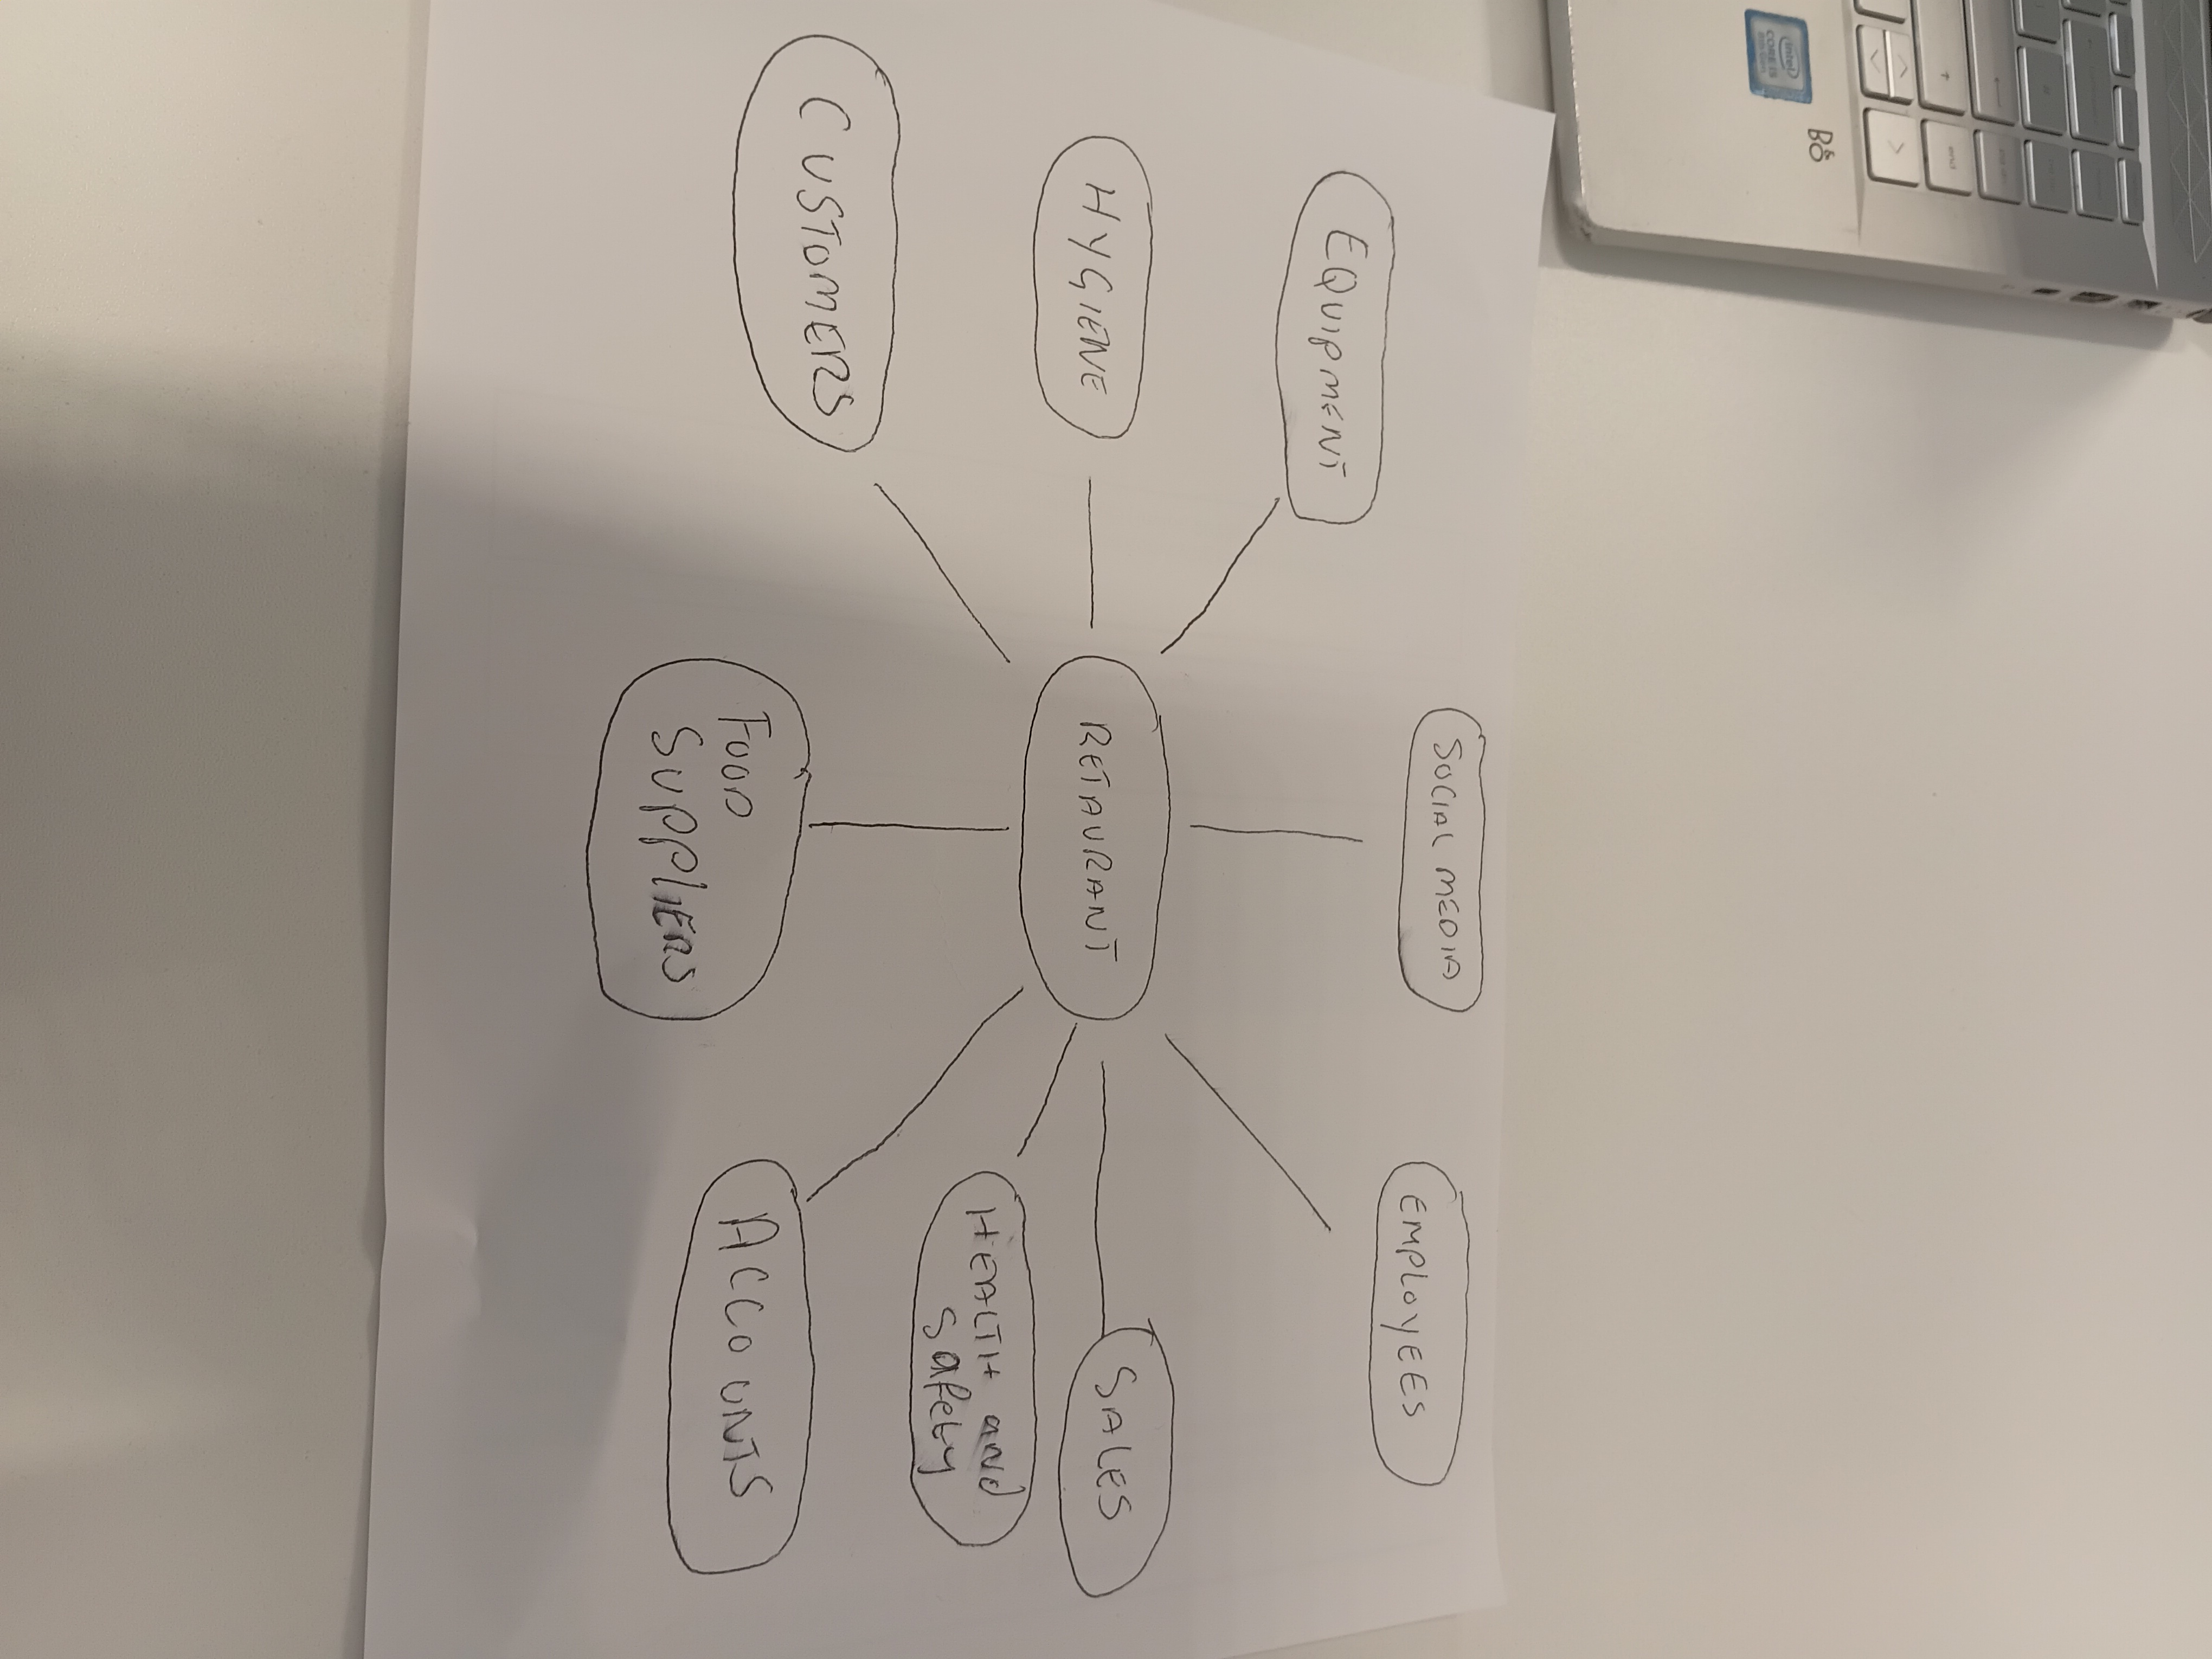

1. Answer these questions using the sentence starters below
a. What is the main idea of the text?
The main idea is a start up to a restaurant.
b. What are two key points?
One key point is number of staff which I will require.
Another key point is were are we going to get equipment and machinery.
c. What part of the text did you find most important? Why?
The most important part was health and safety and hygiene.
d. Was anything unclear or difficult to understand?
I was not sure to upload the image.
e. How did your group help you understand the text better?
My group helped me by making me understand how to make better decitions.
3. One sentence reflection
Question: What did you find challenging about this task?
The hardest part was uploading and understanding.

