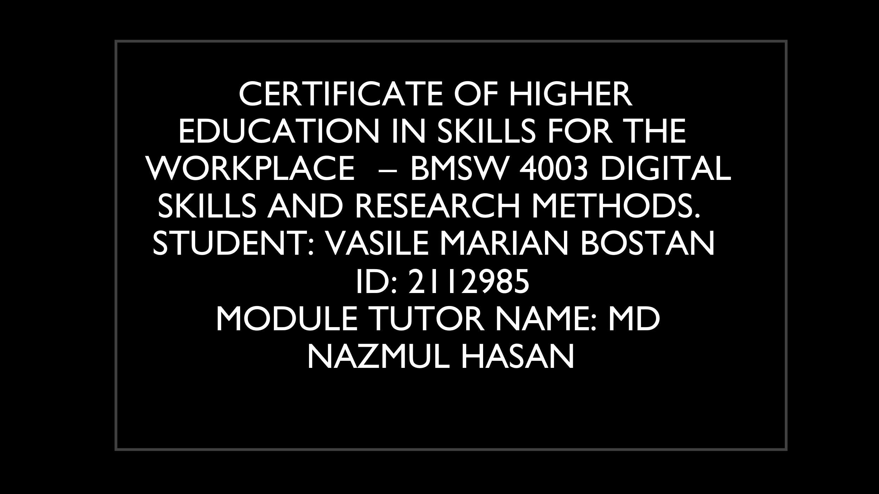
Greetings Everyone! Happy to have you all here,
I am Vasile Marian Bostan currently studying at the University of Wales at Trinity Saint David. This is the course of Digital skills & research methods which means that several students will be evaluated on the basis of their grit score and the relation between this score and success level at academics is studied. This presentation is related to the research of Angela Ducker on the estimation of grit and its impact on the academics of a student. I, preferably, went through the book that she wrote about her research & experience in 2018. While reading her book (Duckworth, 2018) , I took a deep dive into her experience & research on GRIT score. To verify that her research is actually of importance and academics of people can be measured by their grit score, I adopted a similar experiment, where I conducted a survey and asked my fellows to participate in it. The outcome of this experiment was to be verified by the research of Angela.
For this, I used MS platform’s tool to create a survey. In this survey, I straightforwardly asked only two questions i.e., their grit score and their academic performance. For the confirmation of obtained results, I made use of DIKW principle. Based on 4 letters, DIKW (Francisco, 2019) occurs in four stages which are the obtaining of raw, scattered data, giving their scattered data a shape of information, which is then transformed into knowledge and utilization of that knowledge in the procedure can lead to wisdom which is the last stage of this principle.

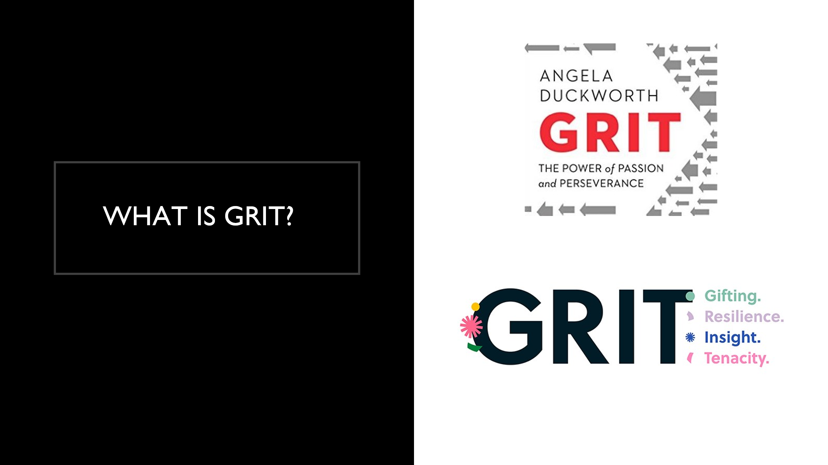
As everything requires background knowledge for the better understanding, therefore it is essential to look at the origin of Grit and how the term was coined. As the first person to do research on grit was Angela Duckworth who also coined this term to teach the role of passion and perseverance. She used to be a teacher at grade 7th, she taught mathematics and observed that the best kids in class are not the smartest, she knew there was involvement of foundational skills and therefore she left the profession of teaching to better understand these skills. (Brahmachary, 2019)After becoming a researcher of psychologist, she better understood the skills of passion and perseverance.
Through her research, she claimed that the significant predicator of success is grit i.e., the skills of passion and perseverance. Grit is the enthusiastic force which pushes people towards achieving goals. She conducted her research on thousands of people and concluded that grit is more proficient factor in achieving success in comparison to insights and intelligence. Girt forces a person to arduously work towards her dreams and goals and overall, all obstacles that might come in between. Grit keeps one going even after disappointments. Among those thousand people she surveyed were the military cadets who she evaluated based on survey result, she found out that the peers having a higher score in grit were less likely to drop out compared to ones who had less score in grit. Her theory of grit got abundant attention only after her TED Talk in 2013.
I also conducted this survey to confirm if grit decides one’s future and if it comes out to be true, the question emerges why don’t everyone develop grit and become successful? And how it can be developed. (Duckworth, 2018) As per Dan Chambliss, conformity can help developing grit in people as when one is surrounded by a person having high grit score, he is likely to become grittier. Angela, however, is of view that idea of growth mindset determines whether grit is to be developed in an individual or not.
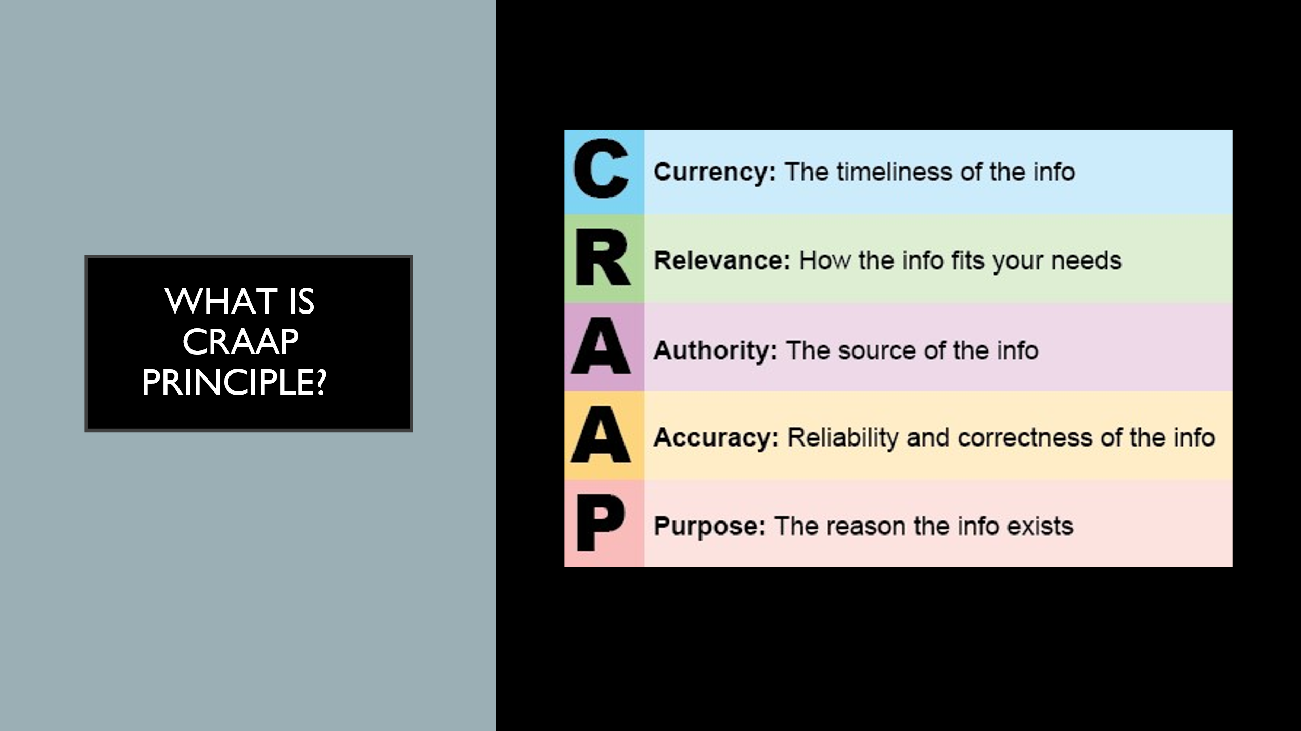
When I conducted CRAAP analysis of her research, I agreed with her concept of grit. Because for a theory to be authentic, craap evaluates it based on its currency and relevance meaning if it is relevant in today’s world, accuracy, authority, and purpose. Luckily, I found out that she justifies all requirements that are needed to become an authentic source, regarding the currency and relevance, she introduced her idea in a TED Talk in 2013 (Francisco, 2019) and later wrote a book on grit in 2016, this shows that it is still relevant in today’s world as it is only five years old, her up-to-date theory discusses intangible characteristics i.e., passion & perseverance. To quantify her findings, she even conducted the interviews and surveys of successful and famous people to see if same pattern was observed in all, she created a grit survey on her website which helped her get accurate results of thousands of people, the survey had different questions with options ranging from 1 to 5, the 1 is least likely and 5 is most likely to. (Duckworth, 2018) Initially she was a teacher and later mastered the research in psychology, her theory along with the confirmation and citations of her work prove that her work is authentic and that she did not impose her decisions of grit on anyone. She just observed a pattern and conducted various surveys and interviews to verify that the observed pattern is correct.
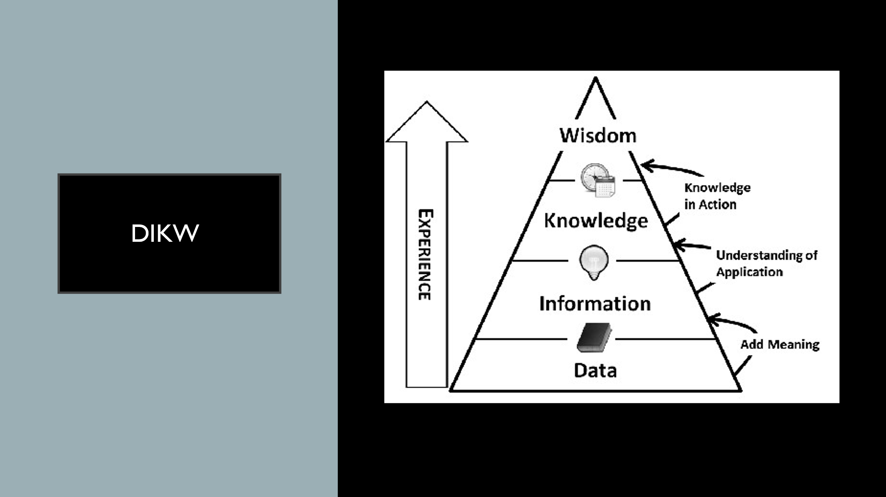
As I had to make use od DIKW principle to confirm the analysis obtained through the experiment conducted, therefore I used the principle and it helped me in my research evaluation. The initial step of this principle as displayed on slide is the obtaining of scattered and raw data. The data can be available in the form of facts, figures, etc., This data is then transformed into information because a scattered data is of no use. The information is related to the data about a particular incident which in this case clearly was grit score and its impact on academics. The information is then transformed into knowledge as it is famously known, knowledge is power hence this is a mandatory step. (Brahmachary, 2019)The step might take time in its transformation but if left as it is, the information is becoming useless. The data obtained is compared with secondary data before it can be transformed into knowledge through process of information. Once the knowledge is obtained, the last and pertinent step and feature of this triangle is reached which is, wisdom. It is the reflection of knowledge obtained so far and helps in the critical judgement.
If the principle of DIKW was not used, the scattered data would have been of no use, DIKW (Brahmachary, 2019) made data understandable. This transformation makes the skills of decision making and strategic decisions easier at executive stage. It is also used to maintain an integrity and confidentiality of information inside an enterprise. This further ensures that data is not used for illegal purposes and that company abides by its policies. Therefore, it can be easily be used for the evaluation of grit which further finds out the alliance of people in their academics.

Initial step of my experiment involved the sending of my survey to my fellows and colleagues so that scattered data can be obtained. For the creation of this survey, I relied on MS platforms. The survey contained only two questions and therefore I was expective 2 sets of quantitative data for this survey which can easily be transferred to excel so that the second stage of DIKW principle i.e., the transformation into information takes place. (Brahmachary, 2019) The primary data shows the answers obtained by fellows on the form. The first question in my survey was related to the grit test score, to answer this question, my fellows had to refer to the website of Angela where she has uploaded this survey test, the fellows had to take that test and write their obtained score here. The second question that I added in my survey was related to academic level based on the requirements of UK Government. For this, I shared with them a pdf file having the details of UK govt. requirements regarding academics, the fellows were asked to refer to the chart before answering this question.
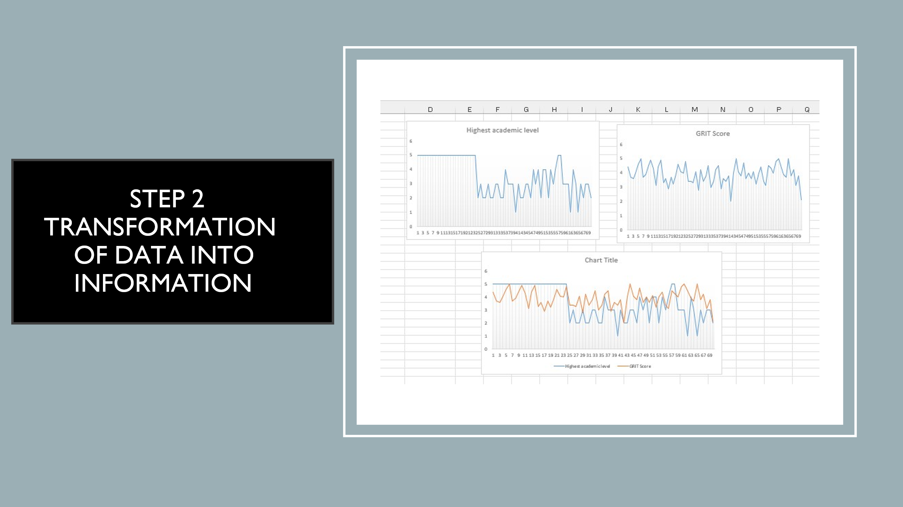
The next stage of DIKW is the transformation of scattered data into information. It was time to transform the discreet and scattered data obtained into information because data without information is not comprehendible, hence this pertinent is performed which gives structure to our data and aids in the decision-making skills of an individual. For this transformation, I exported the survey containing rough data from MS platform to excel and generated a table at first, this table contained the average grit obtained vs the academic level. however, the analysis could not be performed well merely on the basis of this table therefore I used right tools from excel and further transformed this information from table into a graph. The information in the form of graph clearly demonstrated & visualized the results. I could clearly see a collaboration of research conducted by me and research done by Angela. The trend in the graph clearly showed that the academic achievements were influenced by grit because fellows with a higher grit achieved high in academics as well. Although, similar results were found by me, but it is not as efficient as that of Angela because I conducted the survey on only 71 of my fellows but she had surveyed thousands of people from military campaigns, teaching profession, students, and others.
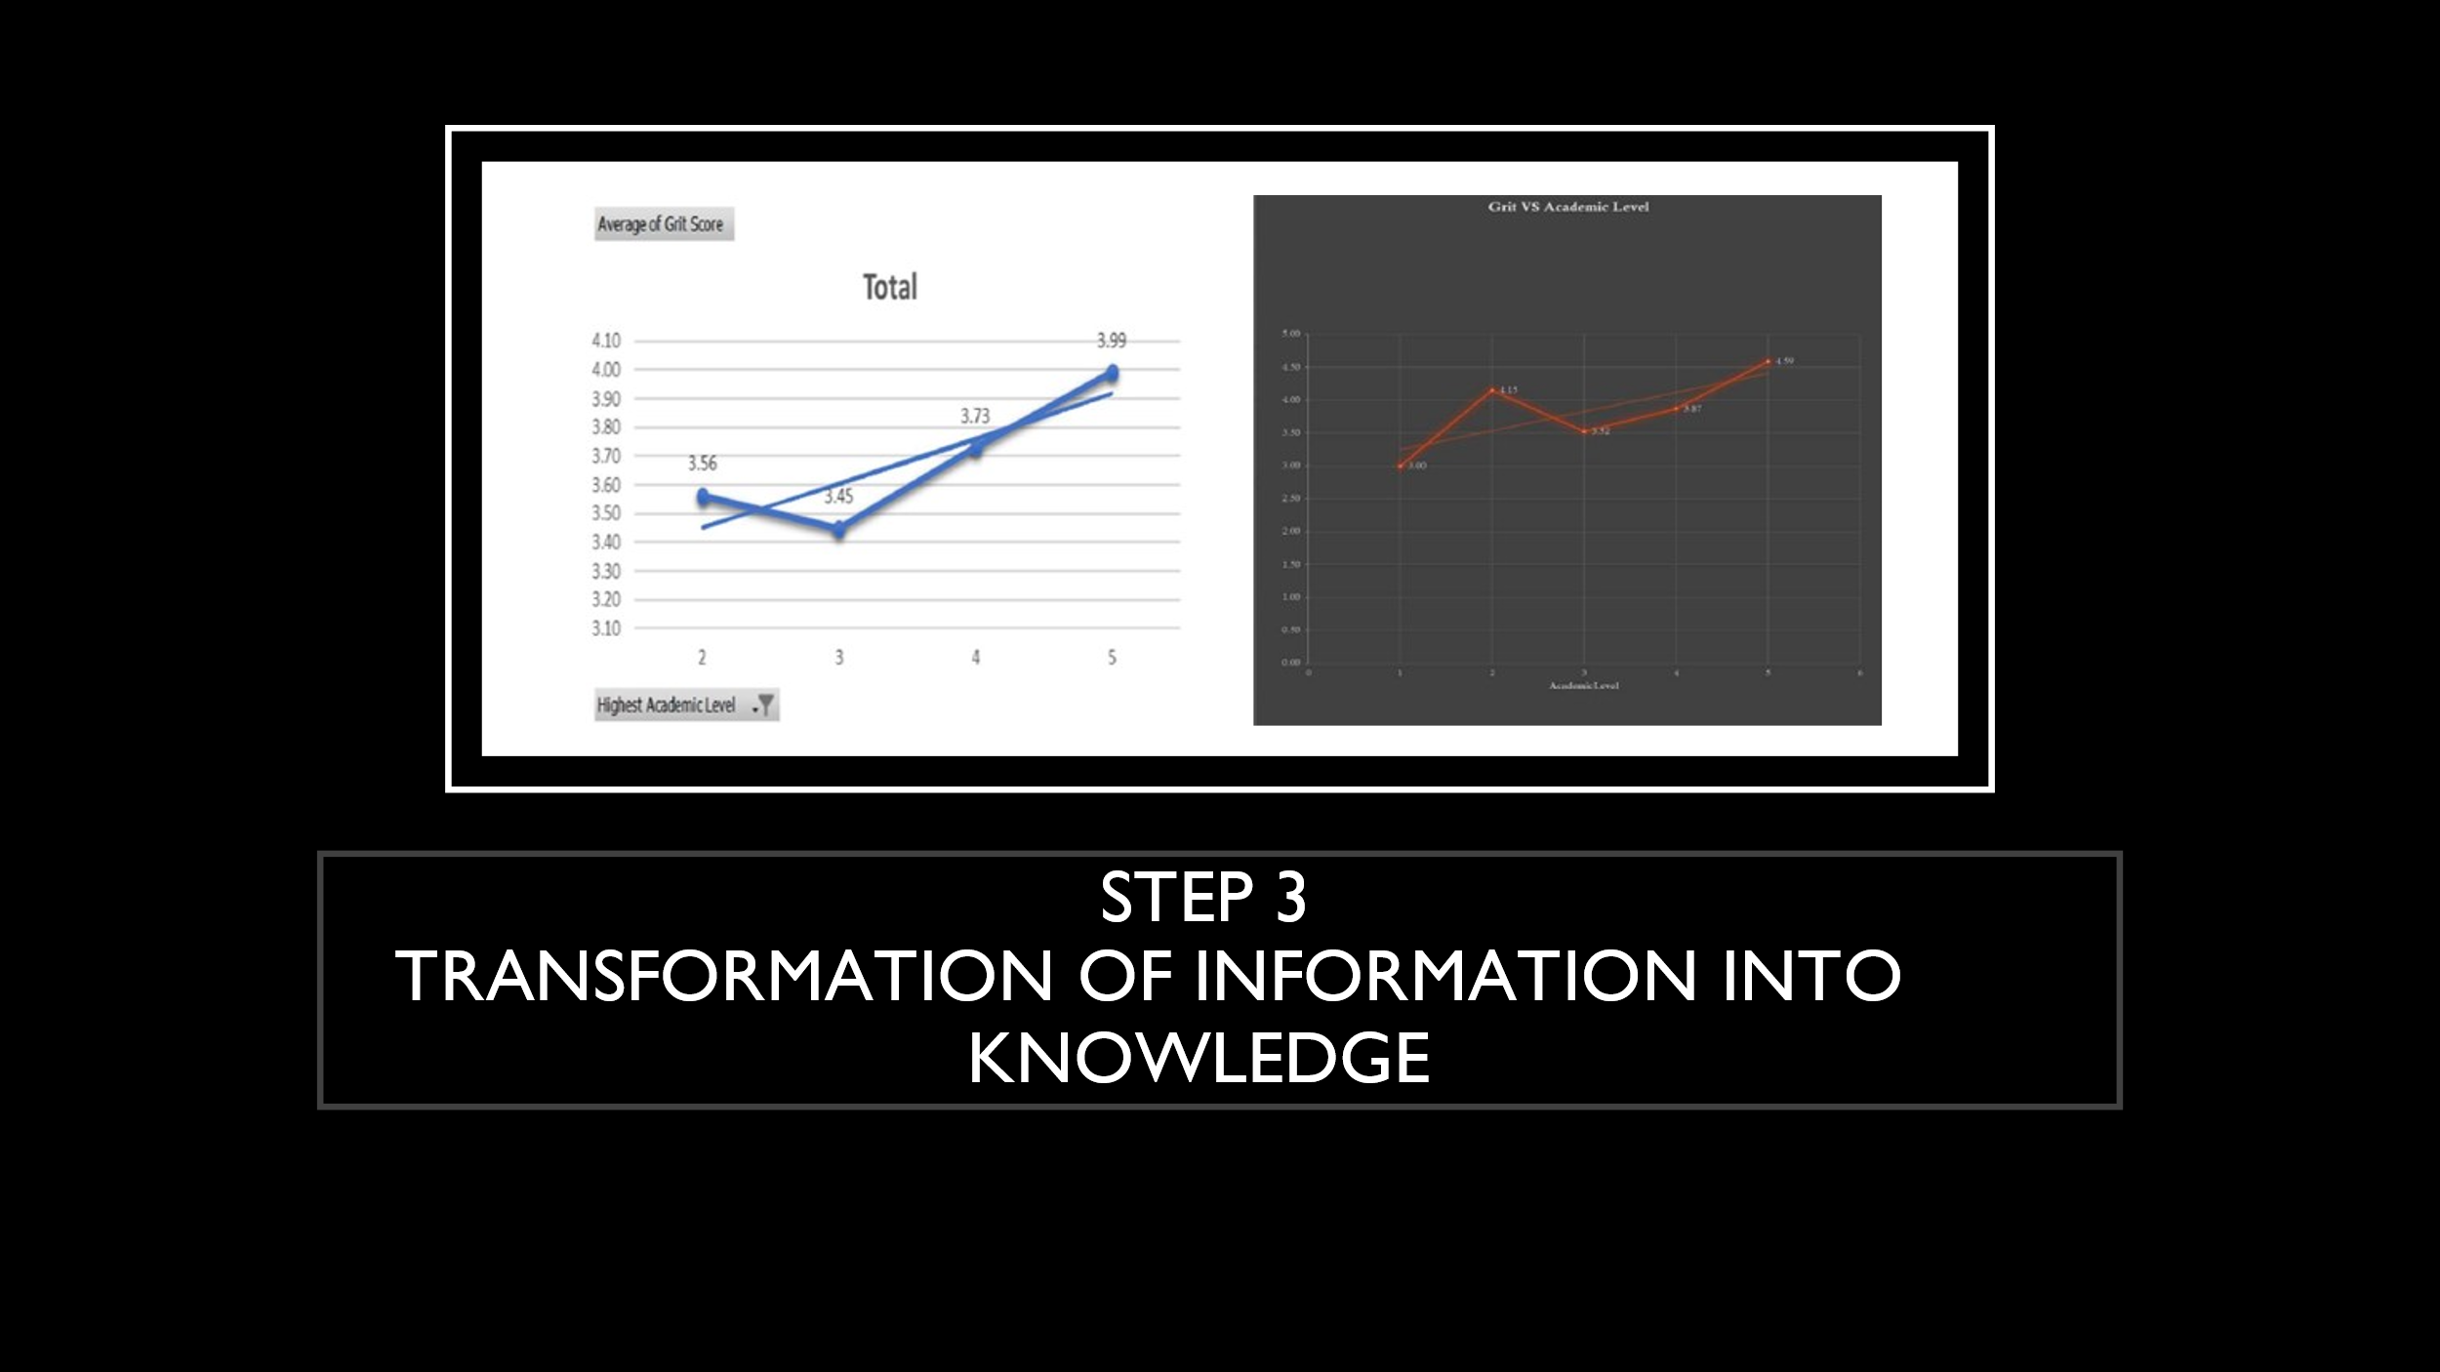
The next step once the data has been disciplined into information is the transforming of information into knowledge. The primary information (data obtained) is further transformed into secondary information however, this transformation did not show a convincing response as there was a lacking response on surveys yet, the secondary data comply with primary information. For this process, I followed the Moodle of same research conducted in 2020 by UWTSC where they exported the data from excel containing secondary information and transformed them in the same manner.
The trend line shows a higher grit score in comparison to academic level as can be observed going up on primary as well as secondary data. (Duckworth, 2018)But the grit level is higher for second level compared to the other two hence it can be analyzed and concluded that the variance occurs due to age as people get older, their grit is more likely to increase correspondingly, they should also have high achievements in academics. After the collection and evaluation of data, the graphs were shown, and it was easily understood that why some people had higher grit score while others did not have scored high.

The final stage is that of wisdom which occurs due to extrapolation of knowledge. The step is involved with the examination of results and the analysis of prior three steps of DIKW principle and is then utilized for the assessment of human programming such as morals, ethics, etc. Therefore, the process of wisdom is considered as the one in which one decides a fine line between good & bad, negative & positive or any other important decision in life.
At this last stage of DIKW principle, the knowledge obtained so far is reflected and is applied in real life. This is the topmost level of the triangle observed before. It focuses on the instincts of a human about getting something, translating, and receiving of information via other activities however this process requires a deep dive & reflection of knowledge so that wisdom can be inculcated in one’s life.
It can clearly be demonstrated by the research conducted by Angela on grit, she did the research on thousands of candidates, and all were free to participate, she did not force anyone to participate or provide certain results. Through this evaluation, she concluded her research saying that it is grit that decides the higher achievements in academics, same results were obtained by me in my small experiment hence, her theory is proven right. However, the curious question of development of grit in one’s nature still exists, and it is essential to address this question. Carol Dweck (Dweck, 2006) has come up with an idea of growth mindset which Angela believes is a way for the development of grit in one’s nature.
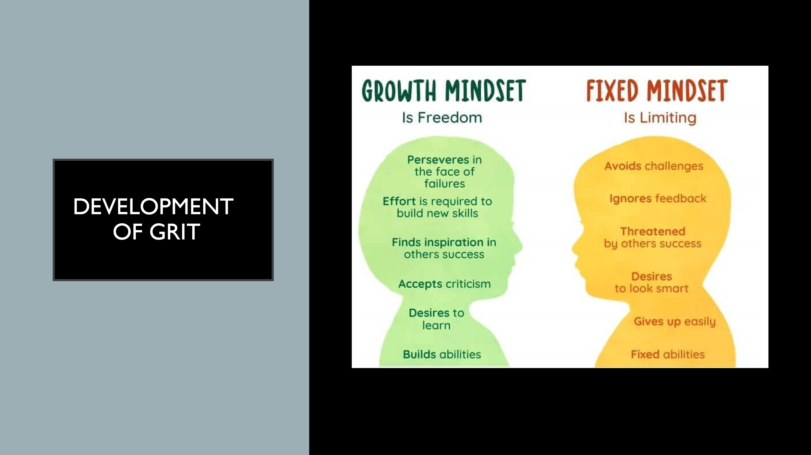
Carol Dweck has produced idea of growth mindset which is the intellectual ability of people to adapt themselves with time. She gave two mindsets in her book; growth mindset & fixed mindset, according to her, the people with a growth mindset consider themselves smarter and they put efforts in their shortcomings to overcome their fault and become more talented, they have a clear control on themselves and do not stop on a failure. On the other hand, the people with a fixed mindset do not reflect on their failure, they focus on the aspects that went wrong and find ways to make them right, they do not think to adapt. (Dweck, 2006)
Carol demonstrates that there should be an understanding related to failure that it is not the end of the road but a road to a new journey, journey that leads to success therefore, on failure, one needs to reflect on his faults and adapt to improve.



Brahmachary, A. (2019). DIKW Model: Explaining the DIKW Pyramid or DIKW Hierarchy.
Duckworth, A. (2018). Grit: The Power of Passion and Perseverance.
Dweck, C. (2006). Mindset: The New Psychology of Success.
Francisco, K. A. (2019). The Research Behind the TED Talk: Angela Duckworth on Grit.

