1808070
Samantha Williamson
BMSK4003
Digital Skills and Research Methods
Anupam Mazumdar

Contents page

Summary p. 3

Introduction p. 4

What is modern technology and how can it be used effectively in the workplace p. 5- 6

Exploring social media as a marketing tool in a work setting p. 7- 8

How social media is used to gather information in the workplace p. 9

Conclusion p. 10

Creating an online presence p. 11- 12

References p. 13- 14

Bibliography p.15- 16

‘Write a report of 2,000 words, which evaluates the effectiveness of the use of modern technologies within the workplace and explore social media as a tool for marketing, information gathering and communication within the workplace, creating their own professional online presence to illustrate and evidence this research’.

Summary

In this essay I will discuss how modern technology is used within the workplace. This report will also describe how social media platforms are used to communicate within the work place. This report also aims to address how social media can become a tool for marketing and information gathering in a work setting. By creating my own personal online presence, I will be able to show evidence of how social media is used.

Introduction

Technology has made great developments over time, so much, that the average 21st century person somewhat relies on it, in everyday life. In order to be able to use technology as an advantage and properly utilise its advancements, one must keep up to date as it continues to evolve. Modern technology can be used to make the workplace more efficient. As much as the workplace needs modern technology in a lot of ways to operate, the popularity and influence stems from social culture and structures. The possibilities modern technology offers are so many, that often, conventional items such as calendar’s, GPS, address books, and even cameras can all be found on a small smart phone (Maund, 2017 p. 108).

What is modern technology and how can it be used effectively in the workplace

Before the days of modern technology without internet and smartphones, people used to communicate through fax machines and listen to news on radio broadcasts (Pioneercomms.co.uk, 2018). The advancements in technology mean today we have much quicker ways to communicate interpersonally and professionally (Maund, 2017 p. 108- 109).

Modern technologies are available today in way of electronic and digital devices and services. A general advancements modern technology offers is the ability to complete everyday tasks much faster. For example, having a smartphone which uses 4G enables a person to wirelessly send information in a matter of minutes, the current problem being with an excess of users crowding the network. Technology has advanced within the workplace smart phones, broadband and 5G network are just a few to name.
5G network is a modern way to deliver wireless connections. You can use 5G network to connect any device which requires the use of the internet. This will allow the device to send, receive and download information at a faster and more efficient pace. 5G will also allow for information of a greater capacity, to be sent and delivered through a wireless internet connection. The performance of the 5G network is beneficial and effective to many work company’s and sectors. For example, in a healthcare setting, private, important and sensitive information needs to be stored, sent and received constantly. It’s said that 1.1million freed up GP hours will be available once the 5G network is in full operation (Wired.co.uk, 2019).

Almost all companies use technology to perform even the smallest of tasks. The time saved in comparison to manually doing a task is changed dramatically by the use of modern technology at work. A device such as a computer, social media networks and virtual organising software allow information and jobs to be completed fast and securely (Ramey, 2013).

Technology can be used effectively in the workplace to communicate. A smart phone for example, could offer applications to schedule, time and organise meetings in the workplace. Time spent to structure and organise meetings are eradicated. Scheduling and organisation programs via modern communication technology, can allow for employee updates, regardless of whether your physically at work. Instant messaging saves time in the workplace. The use of e-mails or text messages saves time when communicating, through the ability of addressing more than one person (Ramey, 2013).

Technology in the workplace also saves time. A spreadsheet for example uses modern technology to calculate sums. This leaves little room for error. Elevators have the ability to transport people and items around a building within seconds. Today we live in a world where its only getting bigger and so are the buildings. An elevator is an example of how modern technology can benefit a company by saving time. Another way technology can be used effectively in the workplace could be through its developments of satnav and GPRS. Satnav’s can plan a journey and even make a driver aware of traffic alerts, allowing transport journeys to be completed quicker (Ramey, 2013).

Modern technology has the ability to get rid of the restrictions time and space has on many jobs in the workplace. Modern technology has the ability to share data in real-time. There are also many other modern technologies that work effectively in the work place. The use of electronic ID cards at work for example, gives a person access around the building without the need of manually typing in a code. Electronic ID cards promote effective use of modern technology in the workplace. A meeting conducted virtually is another example of effective modern technology. Virtual communication technology allows all participants to be involved, without physically have to be there (Ramey, 2013).

Exploring social media as a marketing tool in a work setting

Social media by definition, according to Cambridge Business English Dictionary, is a noun and represents-
“forms of media that allow people to communicate and share information using the internet or mobile phones:
Blogs, podcasts and other forms of social media are creating new opportunities for entrepreneurs to reach the public” (Dictionary, 2018).

This means social media has the ability to identify a group of people through communicating. Social media can also be described as internet related programs and apps. Understanding the importance of viewing social media programs and apps (platforms), as a multi-way communication option is important in relation to this report. This will allow the reader to understand how social media is used to communicate within the workplace. Humans have always communicated in some way, well before the age of technology. Employers can use social media programs and apps to voice their opinions, vent, advise, and confirm options. This gives social media platforms the ability to shape the ways employees communicate (Unerman and Baskin, 2012).
P 40- 44

The use of social media’s marketing ability keeps in-line with its effectiveness to conduct elements of customer service. In the workplace, through-out many sectors having a strong, reliable and trustworthy customer service base is key to the successfulness of a business. There is a huge impact, social media platforms have on customer satisfaction. Some companies have the ability to contact their customers through social media platforms such as Facebook (Betancourt, 2010). Before the age of social media customers had little opportunity to voice their opinions on products and services provided by a company.
Social media platforms give customers, through its ability to communicate, the option to be involved and heard. Customers can experience a company better suited to their preferences, in real-time, due to social media platforms (Unerman and Baskin, 2012 p. 40- 44).

In the workplace social media platforms can be used to respond to their customers wants and needs quickly. Social media is used as a communicator through every channel and platform it has. The phrase ‘the customer is always right’ can be supported by a company’s skilful use of social media platforms. By using social media platforms companies can assess and reach conclusion on company matters much quicker than before. There are pro’s and con’s to using social media as a marketing tool in the workplace. As communication can be done quickly through social media platforms in the workplace, companies are able to keep up with the demand of their customers. This also means that if a company neglects to effectively use social media as a marketing tool it may lose customers. Additionally, modern technology has become part of everyday life and so if companies fail to engage their customers, by using relevant and popular social media platforms as a marketing tool, they could lose reputability (Unerman and Baskin, 2012 p. 40- 44). The recognition of social media platforms being used to communicate, challenges people to acknowledge its many marketing capabilities.

Nike is a prime example of how the effective use of social media platforms can be used as a marketing tool. Being the largest sports brand in the world, Nike uses social media platforms such as Facebook and Instagram as one of their key marketing tools. By dedicating specific social media platforms to individual sports, like football, Nike encourages their customers to associate their brand with the sport. Nike promote and advertise their brand through various social media platforms. By having many customers and followers, on many different social media platforms, Nike has the opportunity of attracting and keeping their customers up to date with their brand. Intentionally, Nike benefits from increased sales from marketing their brand on various social media platforms (Cole, 2018).

How social media is used to gather information in the workplace

When it comes to social media platforms being used to gather information, Facebook and LinkedIn can be used as examples. Due to Facebook and LinkedIn being public social media platforms, companies are free to collect any information and data they want. (Betancourt, 2010)

LinkedIn is a social media platform which allows professionals to connect with one another and be more efficient and productive (Linkedin.com, 2018). LinkedIn offers an economic opportunity for professionals to network, learn, swap ideas and locate future work opportunities.

lnkedIn is a social media platform which is more effective in a work setting when its customers provide it will additional information. LinkedIn uses information it gathers to provide a more efficient service. This tells the reader that by gathering information via social media platforms such as LinkedIn, information gathering is necessary for the service to work productively. Data on LinkedIn and Twitter is collected the moment a user registers, this is a form of data collecting and allows for faster information gathering. This shows the speed in which the data is collected and can be used to benefit a workplace. LinkedIn uses affiliate services to improve its functionality, for example, Outlook. Address books can be synced to LinkedIn from Outlook and is an example of effective information gathering (Linkedin.com, 2018).

Twitter is a social media platform used to show current news, economic updates and communicate through broadcasts. The aim of Twitter is that the information displayed finds an appropriate audience and is either found useful or exciting. Twitter can be used in the workplace to virtually communicate and collect information (Gil, 2018). An example of where Twitter can be used in a work setting is its ability to give alerts and headlines on company progress and important updates.
Information gathered by Twitter is used in the workplace in instances such as E-mails. E-mails allow a workplace to communicate effectively. Emergency broadcasts use the information gathered and stored by Twitter to alert a wide audience. This can be effectively used in a workplace to update employees quickly and all at once (Twitter.com, 2018).

Conclusion

To conclude modern technology has assisted the workplace in being more efficient. Social media is used as a popular marketing tool as it allows companies to advance with the times. Companies gather information to make it easier for them to communicate and provides efficient services. In the workplace social media platforms are used to communicate, to update employee’s and deal with some public enquiries. Although modern technology is used constantly within the workplace, its advancements require employers to stay regularly updated.

Creating an online presence

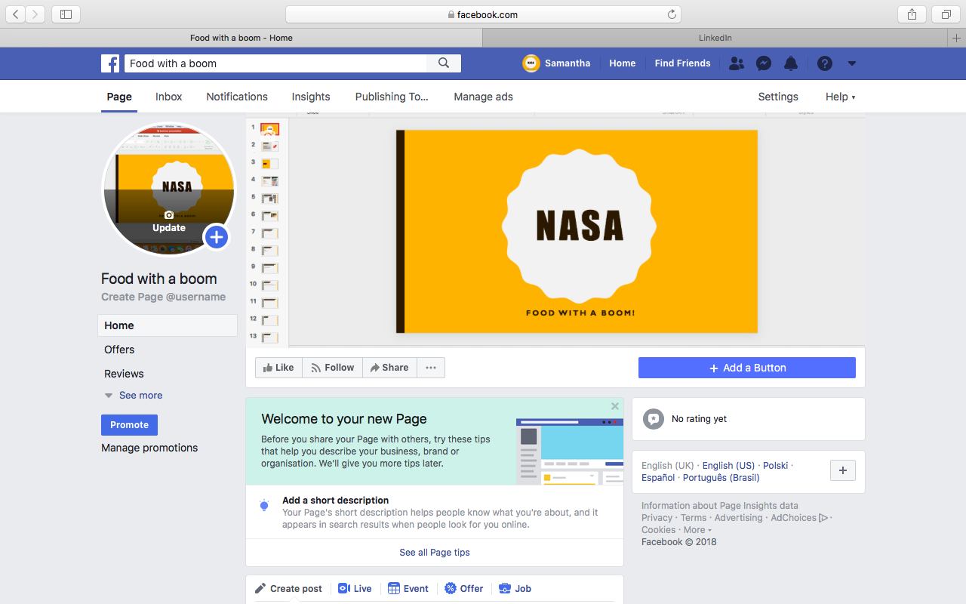
(Facebook, 2019) (https://www.facebook.com/?react=AQCWgpNhuMUf4O8N)

This is my Facebook business page where you can communicate with me, explore my business and see all relevant information.

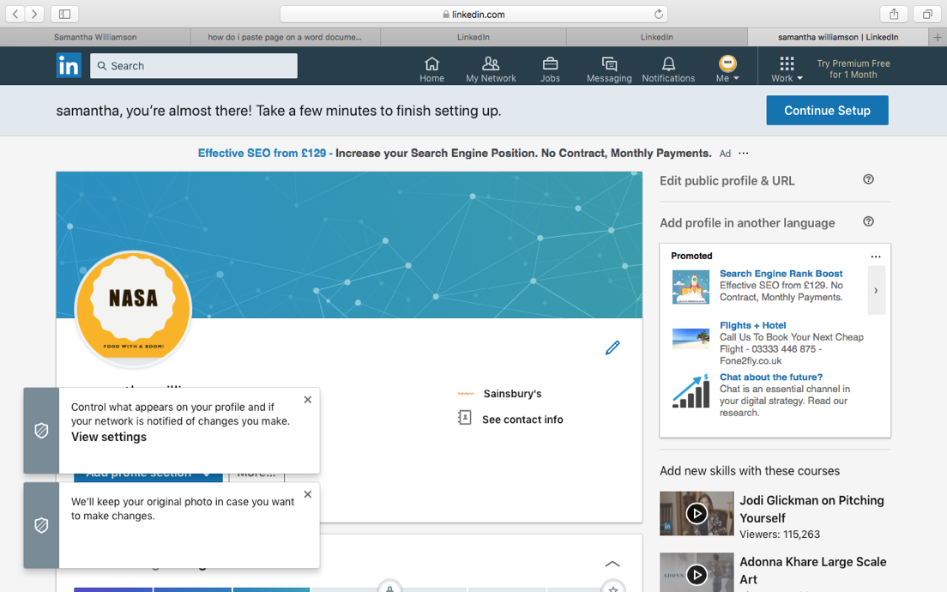
(Linkedin.com, 2018) (https://www.linkedin.com/feed/)

This is my LinkedIn page where you can find out all relevant information about me and my professional experience and wants.

Reference list
- Maund, A. (2017). Certificate in higher education. London: SAGE Publications, p. 108.
- Pioneercomms.co.uk. (2018). History of Communication. [online] Available at: https://www.pioneercomms.co.uk/history-of-communication/#1919-1925 [Accessed 27 Dec. 2018].
- Maund, A. (2017). Certificate in higher education. London: SAGE Publications, p. 108- 109
- Wired.co.uk. (2019). What is 5G and when will it come to the UK?. [online] Available at: https://www.wired.co.uk/article/what-is-5g-launch-date-mobile-networks-uk [Accessed 17 Dec. 2018].
- Ramey, K. (2013). The Advantages and Disadvantages of Technology in the Workplace - Use of Technology. [online] Use of Technology. Available at: https://www.useoftechnology.com/technology-workplace-2/ [Accessed 27 Dec. 2018].
- Ramey, K. (2013). The Advantages and Disadvantages of Technology in the Workplace - Use of Technology. [online] Use of Technology. Available at: https://www.useoftechnology.com/technology-workplace-2/ [Accessed 27 Dec. 2018].
- Ramey, K. (2013). The Advantages and Disadvantages of Technology in the Workplace - Use of Technology. [online] Use of Technology. Available at: https://www.useoftechnology.com/technology-workplace-2/ [Accessed 27 Dec. 2018].
- Ramey, K. (2013). The Advantages and Disadvantages of Technology in the Workplace - Use of Technology. [online] Use of Technology. Available at: https://www.useoftechnology.com/technology-workplace-2/ [Accessed 27 Dec. 2018].
- Dictionary, S. (2018). SOCIAL MEDIA | meaning in the Cambridge English Dictionary. [online] Dictionary.cambridge.org. Available at: https://dictionary.cambridge.org/dictionary/english/social-media [Accessed 28 Dec. 2018].
- Unerman, S. and Baskin, J. (2012). Tell the truth. Dallas, Texas: BenBella Books, p. 40 -44.
- Betancourt, L. (2010). How Companies Are Using Your Social Media Data. [online] Mashable. Available at: https://mashable.com/2010/03/02/data-mining-social-media/?europe=true [Accessed 16 Nov. 2018].
- Unerman, S. and Baskin, J. (2012). Tell the truth. Dallas, Texas: BenBella Books, p. 40 -44.
- Unerman, S. and Baskin, J. (2012). Tell the truth. Dallas, Texas: BenBella Books, p. 40 -44.
- Cole, S. (2018). How Nike uses Facebook and Instagram – Econsultancy. [online] Econsultancy. Available at: https://econsultancy.com/how-nike-uses-facebook-instagram/ [Accessed 18 Nov. 2018].
- Betancourt, L. (2010). How Companies Are Using Your Social Media Data. [online] Mashable. Available at: https://mashable.com/2010/03/02/data-mining-social-media/?europe=true [Accessed 16 Nov. 2018].
- Linkedin.com. (2018). LinkedIn. [online] Available at: https://www.linkedin.com/feed/ [Accessed 17 Nov. 2018].
- Linkedin.com. (2018). Privacy Policy | LinkedIn. [online] Available at: https://www.linkedin.com/legal/privacy-policy?trk=uno-reg-guest-home-privacy-policy [Accessed 26 Nov. 2018].
- Gil, P. (2018). What Exactly Is 'Twitter'? What Is 'Tweeting'?. [online] Lifewire. Available at: https://www.lifewire.com/what-exactly-is-twitter-2483331 [Accessed 26 Nov. 2018].
- Twitter.com. (2018). Privacy Policy. [online] Available at: https://twitter.com/en/privacy [Accessed 28 Dec. 2018].
- Facebook. (2018). Facebook – log in or sign up. [online] Available at: https://www.facebook.com/?react=AQCWgpNhuMUf4O8N [Accessed 13 Nov. 2018].
- Linkedin.com. (2018). LinkedIn. [online] Available at: https://www.linkedin.com/feed/ [Accessed 17 Nov. 2018].

Bibliography
- Betancourt, L. (2010). How Companies Are Using Your Social Media Data. [online] Mashable. Available at: https://mashable.com/2010/03/02/data-mining-social-media/?europe=true [Accessed 16 Nov. 2018].
- Cole, S. (2018). How Nike uses Facebook and Instagram – Econsultancy. [online] Econsultancy. Available at: https://econsultancy.com/how-nike-uses-facebook-instagram/ [Accessed 18 Nov. 2018].
- Dictionary, S. (2018). SOCIAL MEDIA | meaning in the Cambridge English Dictionary. [online] Dictionary.cambridge.org. Available at: https://dictionary.cambridge.org/dictionary/english/social-media [Accessed 28 Dec. 2018].
- Facebook. (2018). Facebook – log in or sign up. [online] Available at: https://www.facebook.com/?react=AQCWgpNhuMUf4O8N [Accessed 13 Nov. 2018].
- Gil, P. (2018). What Exactly Is 'Twitter'? What Is 'Tweeting'?. [online] Lifewire. Available at: https://www.lifewire.com/what-exactly-is-twitter-2483331 [Accessed 26 Nov. 2018].
- Linkedin.com. (2018). LinkedIn. [online] Available at: https://www.linkedin.com/feed/ [Accessed 17 Nov. 2018].
- Linkedin.com. (2018). Privacy Policy | LinkedIn. [online] Available at: https://www.linkedin.com/legal/privacy-policy?trk=uno-reg-guest-home-privacy-policy [Accessed 26 Nov. 2018].
- Maund, A. (2017). Certificate in higher education. London: SAGE Publications, p. 108.
- Pioneercomms.co.uk. (2018). History of Communication. [online] Available at: https://www.pioneercomms.co.uk/history-of-communication/#1919-1925 [Accessed 27 Dec. 2018].
- Ramey, K. (2013). The Advantages and Disadvantages of Technology in the Workplace - Use of Technology. [online] Use of Technology. Available at: https://www.useoftechnology.com/technology-workplace-2/ [Accessed 27 Dec. 2018].
- Team, T. (2017). Modern Technology Definition and Everything you Need to Know. [online] Techquintal.com. Available at: https://www.reflektive.com/blog/advantages-new-technology-workplace/ [Accessed 17 Dec. 2018].
- Twitter.com. (2018). Privacy Policy. [online] Available at: https://twitter.com/en/privacy [Accessed 28 Dec. 2018].
- Unerman, S. and Baskin, J. (2012). Tell the truth. Dallas, Texas: BenBella Books, p. 40 -44
- Wired.co.uk. (2019). What is 5G and when will it come to the UK?. [online] Available at: https://www.wired.co.uk/article/what-is-5g-launch-date-mobile-networks-uk [Accessed 17 Dec. 2018].
- Wray, S. (2018). What Is 5G and when will it arrive in the UK?. [online] 5g.co.uk. Available at: https://5g.co.uk/guides/what-is-5g/ [Accessed 16 Dec. 2018].

