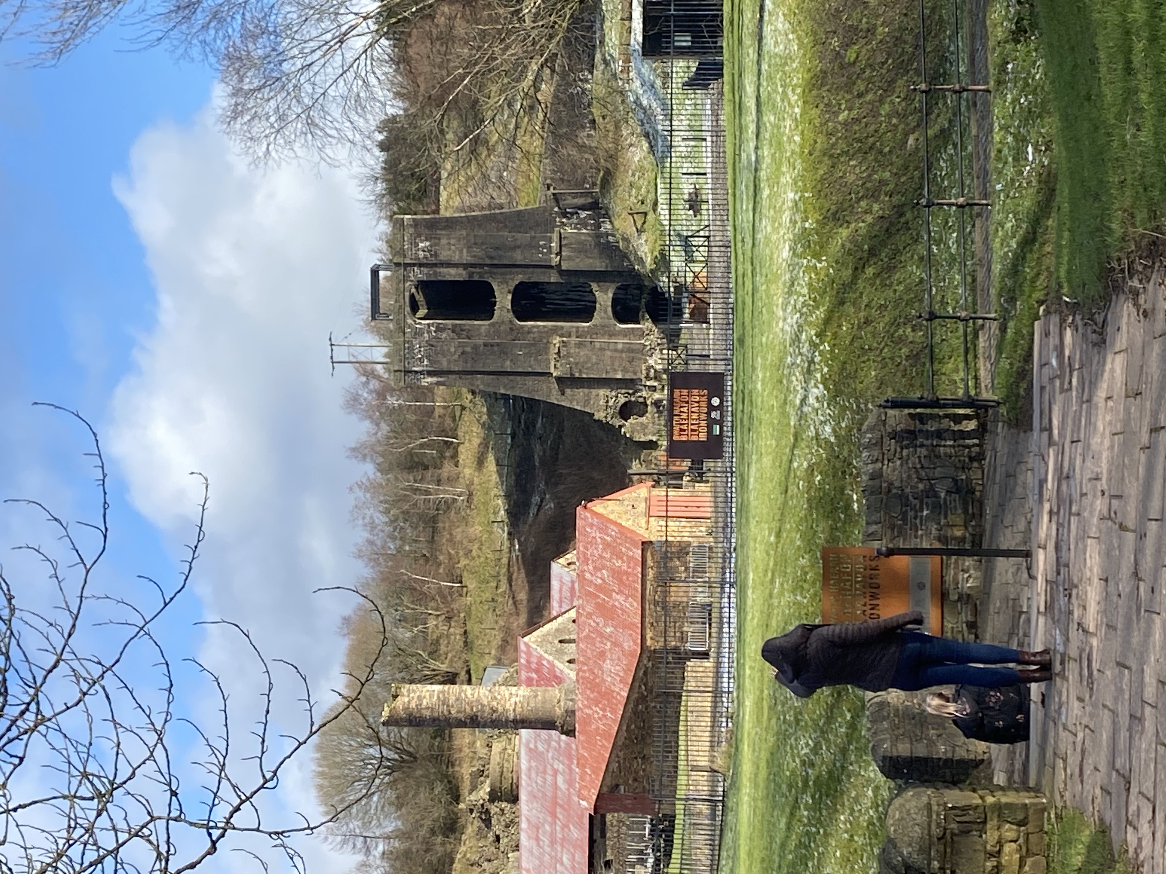  distinctiveness & regeneration  Tutor: Anthony Burnes | James Dexter (1907923)

Introduction

Discussed in this report will be the information that I have gained of Blaenafon and the industrial revolution. Blaenafon was a significant place that helped fuel the revolution in many ways and had led to impacts globally.

Industrial revolution

The industrial revolution began during the 18-19th century, during this period of time there was a shift in the rate of manufacturing products through the power of steam, this enabled areas that were mainly agricultural as well as rural to turn into large urban and industrialised areas ( A&E television, 2019). Steam engines changed the way products were manufactured meaning that items that would originally be done hand could now be done much quicker and more efficiently by these machines improving the production rate. The main source of fuel for these machines were coal. Transportation was another breakthrough that was led by steam engines allowing parts of the country to gain resource’s and trade. The rise of these industries drew people away from rural areas and as the population grew towns and cities formed.

Coal, Iron & Lime
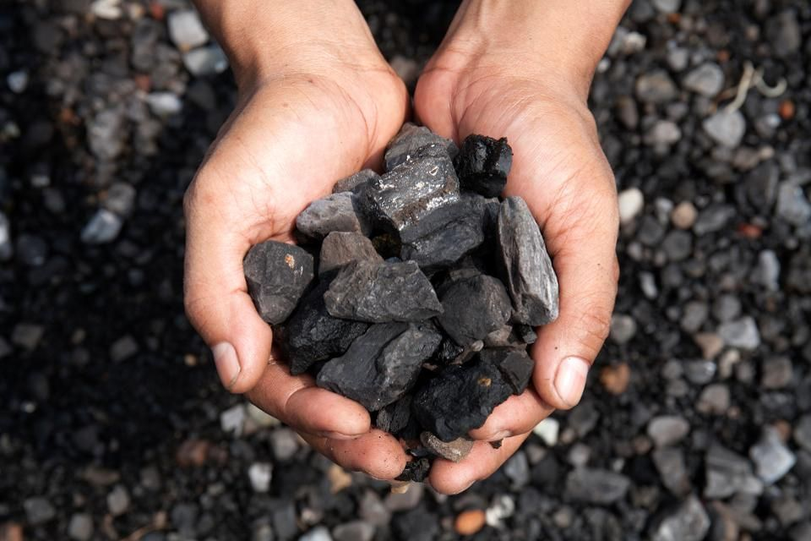
Coal is known as a fossil fuel that is made up of prehistoric vegetation remain that used to be found in peat bogs and swamps. The energy released from the coal is from the vegetation storing energy from the sun (world coal association, 2019). Coal being the fossil fuel that powered these large steam machines would become more in demand, along with this iron was able to be formed through a certain process to build these machines and transportation.
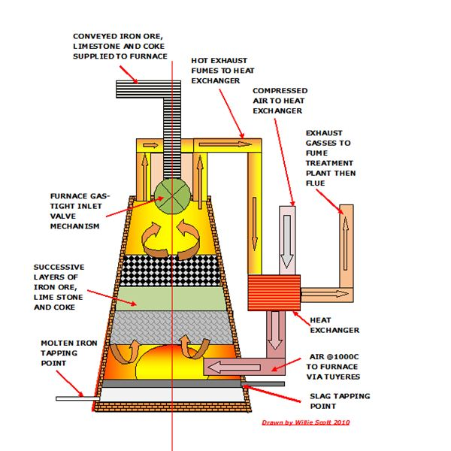

Iron played an important part in the industrial revolution as it was common element found and also one of the more versatile and strongest but also being low in price to produce. Steel can be made from iron which creats a much stronger material also used for a wide range of uses (Woodford, 2019).

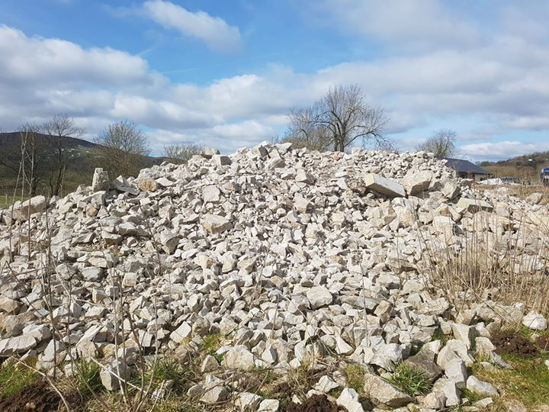
Limestone is a sedimentary rock used in the blast furnace to remove any impurities when making iron. During the process the slag floats to the top so it can be easily removed (BBC, 2020). Limestone is an important ingredient to making as pure as possible meaning iron created will be stronger.

Blaenafon
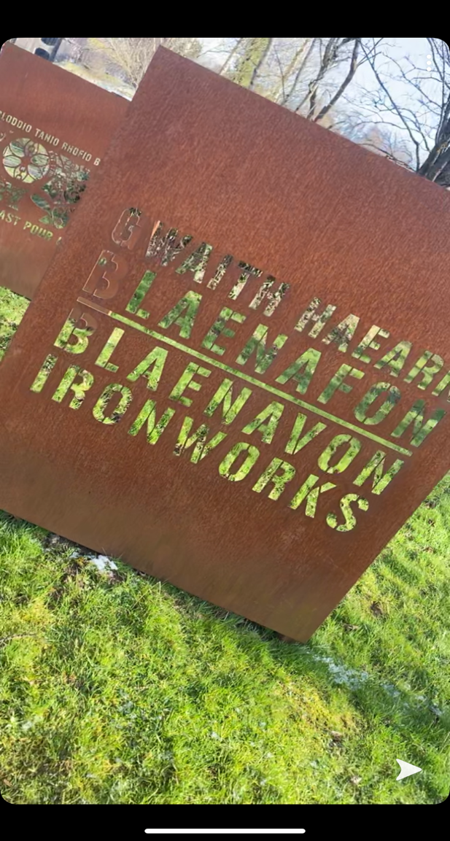

Blaenafon is a world heritage site that once used to be a very important town during the industrial revolution as due to its location and close areas around. It was a prime place for natural resources such as coal, iron and limestone. Blaenafon ironworks was open in 1789 as an project with high hopes built by three entrepreneurs that came together to make the Hill and Company for a large amount at the time. During that period these new works would be considered a technological wonder and very advanced for extracting iron from ore (Britain express, 2020).

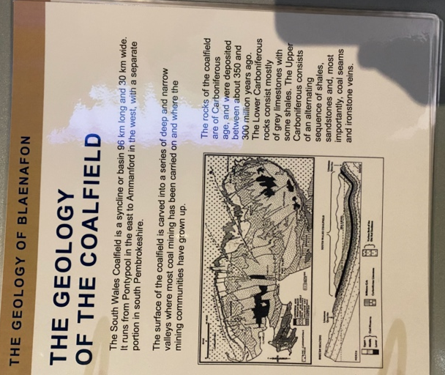
The pictures show the geology of Blaenafon and the ease of access to these natural resources and the techniques they used to gain this.
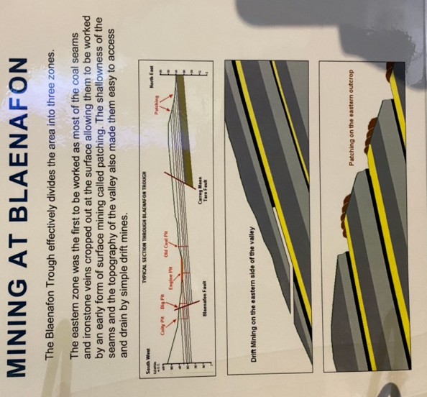
The coal in the area was of very high quality as it would give great seam raising power. Having iron available was also a positive for the revolution as it was another key part in making pure iron and steel. These materials produced would be used to make tools. As mentioned, limestone is a rock that removes the impurities during the smelting process. This was discovered by Sidney Gilchrist Thomas he was the person who transformed the worlds steel industry with this method to remove phosphorus from iron ore (cadw, 2020).

Coal mines limestone quarries iron forges brick roads and tramroads were created. Blaenafon was the first place in Wales to have a multi-furnace ironworks. 5,400 tons of iron per year was being produced in the ironworks and due to this, houses had to be built to accommodate the high number of workers. With natural materials being so close by production would be very high and with all that was produced it would need to be transported to other parts of the UK and the world with the growth rate of the industry, this helped fuel the transportation of products by using railways that were produced from iron and steel made in the ironworks.

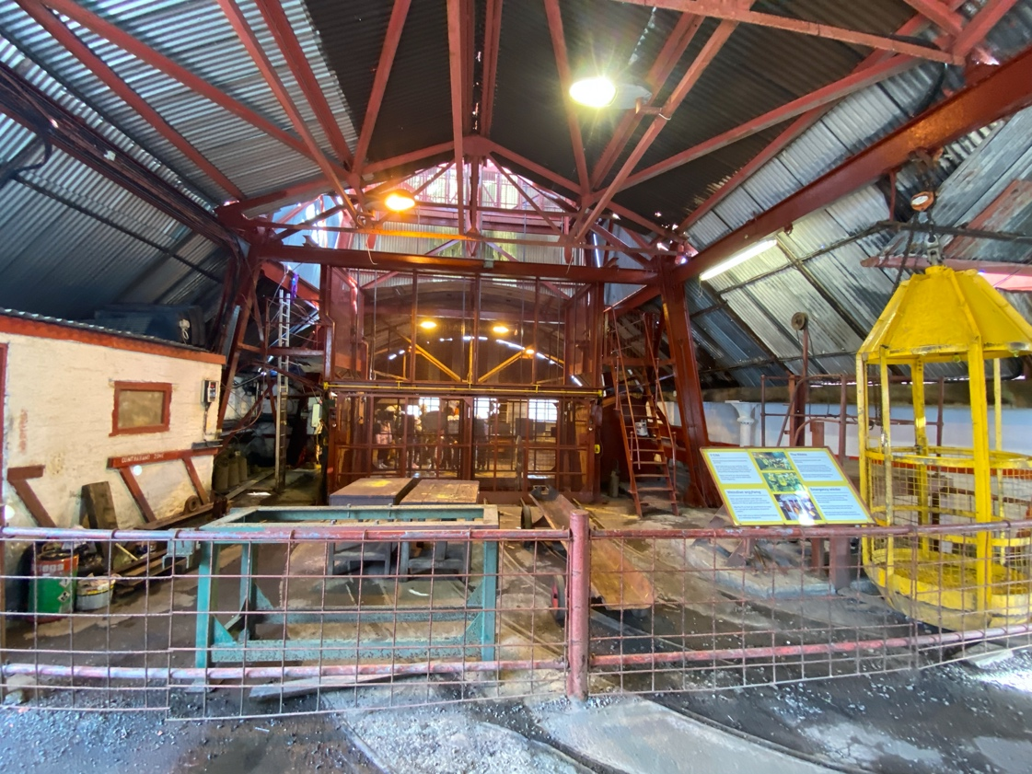
This information that I have gained has given a good insight to how much of a role that Blaenafon had in the industrial revolution just due to its location it was able to become a working town in such a rural area. To have these materials really did help fuel the revolution and with all their technologies it has been shown in history. During these periods so much had changed, and they had coped with the pressure provided. Visiting The Big Pit gave a sense of how much of a scale this operation was on and it’s amazing to think what was achieved.

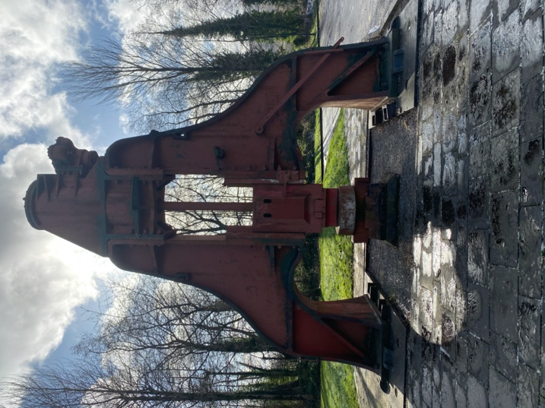

References

A&E television, History, updated 2019, retrieved from: https://www.history.com/topics/industrial-revolution/industrial-revolution

The world coal association, 2019, retrieved from : https://www.worldcoal.org/coal/what-coal

Coal picture, Brian Murray, coal for thee, but not for me, Forbes, 23,10,2018 retrieved from: https://www.forbes.com/sites/brianmurray1/2018/10/23/coal-for-thee-but-not-for-me/#48dbcff51098

Iron picture, Brighten hub engineering, iron ore smelting process, visited 2020, retrieved from: https://www.brighthubengineering.com/manufacturing-technology/66220-metallurgy-modern-methods-of-iron-ore-smelting/

BBC, Limestone, BBC retrieved from: https://www.bbc.co.uk/bitesize/guides/z6gqmsg/revision/3

Limestone picture, Our welsh limestone sourced here in North Wales ideal for walling projects, Finesse Masonry, 20/03/2018 retrieved from: https://www.finessemasonry.co.uk/stone-mason/our-welsh-limestone-sourced-right-here-in-northwales-ideal-for-walling-projects/

Cadw, Blaenavon ironworks, Cadw, retrieved from: https://cadw.gov.wales/visit/places-to-visit/blaenavon-ironworks

