Katy Marie Hughes
1713165
Work Based Research Project
BMPF6010
Sarah Loxdale
Lowri Harris

Project Title : To critically evaluate the impact of the Early Literacy Intervention Programme (ELIP) on learners with outcome B-E on the Dyslexia Screener.

The Context
Craig-Yr-Hesg Primary School situated in Glyncoch forms part of the Fern Federation. The school consists of 178 pupils.

At Craig-Yr-Hesg Primary school 34% of pupils reside on the additional learning needs register and 37% of children are eligible for free school meals. This is higher than the Welsh average of 17%.

The Justification
The researcher currently has responsibility for leading support for children with additional learning needs (ALN) in year 3 at Craig-Yr-Hesg Primary School. As part of this role the researcher runs daily Early Literacy Intervention Programme sessions for 40 minutes a day with a targeted group of children who have been identified as struggling with their reading and writing, achieving lower results than their peers or results expected for their age. This group of children have also scored results ranging from B-E on the Dyslexia Screener.
The Welsh Government has recently changed their approach to supporting children who have difficulty learning.

“The Welsh Government has passed
new legislation, called the Additional Learning Needs (Wales) Act 2018, and Additional Learning Needs (ALN) Code 2021, which will replace all of the existing legislation and guidance about special educational needs.
The main changes include:
- bringing together all existing systems into a new, single system for ALN
- being more learner-centred
- providing learners with the same rights and entitlements whatever their age or setting
- being a fair and transparent system for all
The Welsh Government hope that these changes will mean that children and their parents and young people will:
- get the support they need earlier
- be more involved in making decisions about their lives and the support they need
- be able to find information more easily than before
- be supported if they disagree with decisions
- be able to appeal decisions to the education tribunal”
(snapCymru. The Special Educational Needs System is changing)

I believe the intervention will help in ensuring the children in my setting ‘ get the support they need earlier’ and also ‘being more learner centred’.
Interventions have been proven to work in primary and secondary schools in many places. One intervention used widely across RCT and many other areas is ‘catch up literacy’. This intervention is proof that the impact of interventions are invaluable in a child's learning.

“Catch Up® Literacy helps struggling learners achieve more than double the progress of typically developing learners
Learners (aged 6 - 14) who received Catch Up® Literacy support for an average of 7 months achieved an average Reading Age gain of about 19 months. The Reading Age ratio gain* was 2.74 and the Reading Age gain per total hour of intervention was 2.39 months. (Data for 3,134 learners from 27 local authorities, 2010. As reported in 'Early intervention to prevent long-term literacy difficulties: the case of Catch Up® Literacy'.)

Learners in Years 7 - 10 who received Catch Up® Literacy support for an average period of 8.3 months made average Reading Age gains of 16.7 months - a mean ratio gain of 2.01. (As reported in 'Catch Up® in Secondary Schools'.)

* A ratio gain of 2 or more is considered 'good impact' (Brooks, 2004)

Catch Up® Literacy is twice as effective as other individual literacy support
Learners who received Catch Up® Literacy support made double the Reading Age gain of a control group of children who received individual literacy support for the same amount of time. Data for 85 learners from the City of Nottingham local authority, 2010.

The impact of Catch Up® Literacy is long lasting
92% of children who received Catch Up® Literacy support at age seven continue to be able to participate fully in the curriculum, along with their peers, at age fourteen. Data for 247 children from two local authorities, 2003 and 2010.

Catch Up® Literacy has impact beyond reading
After receiving Catch Up® Literacy, learners:

- became more self-confident and motivated in class
- felt more confident to write independently
- displayed a much improved attitude towards English
- displayed a much improved attitude to other subjects in the curriculum”
- (Catch up, 2023)

The intended impact
This project is designed to understand the impact the Early Literacy Intervention Programme can have on children who are struggling with their reading and writing skills, who have also scored a B-E on the Dyslexia Screener.

I have previously provided a group with a numeracy intervention in which all pupils made progress and one pupil in particular went above all his other peers and made progress that took him above his outcome level for his age. I was also able to see the impact the intervention had on the children's confidence and their enthusiasm to learn more.

If the outcome of this project proves to be beneficial to these pupils, the intervention will be rolled out to pupils across the Fern Federation and more staff will be trained to deliver the programme.

The outlined intention
This project will focus on 6 participants from year 3 who have mild to moderate signs of dyslexia and are struggling with their reading and writing skills. Each participant will receive daily 40-minute ELIP sessions over a period of 3 weeks. These sessions will take place at Craig-Yr-Hesg Primary School.

The project will use a mixed methodology incorporating quantitative and qualitative data. Each participant will take part in a structured interview containing questions produced by the researcher. This longitudinal study will enable me to observe how the variables have changed over time.

A Salford Sentence Reading Test and a Schonell Spelling Assessment will also be carried out with each participant prior to the project starting, then taken again at the end of the project to obtain results of any progression made. The same will be done using the ELIP assessment.

These assessments will provide a baseline as well as a measure of improvement of each individual's personal experience of reading and writing. The use of the assessment scoring and semi-structured interview means the results recorded are as accurate as possible and the quantitative data collated through the assessment can be confirmed in a qualitative way.

The ethics and insider research
Work based research can be very beneficial to an organisation as it can help develop and grow the organisation's staff and find solutions to the organisation’s difficulties that have been highlighted. An insider would have greater access to people, places, data, and materials within the research setting. They would already have relationships with others in the setting which would be an advantage to gain trust and get the most accurate responses. manage their dual roles and responsibilities. This may also cause issues for the researcher as both their
colleagues and the organisation must have confidence that the researcher has the ability to remain impartial and have no predisposed bias.

“The main benefit of being an insider within research is that the researcher is familiar with the group’s language or norms (Brannick & Coghlan, 2007). They may have already built up rapport with their participants, and are able to identify the honesty of their participants while knowing which topics may not be appropriate for elaboration (Brannick & Coghlan, 2007; Hockey as cited in Hellawell, 2006). This familiarity may lead to the researcher having better access to participants and being more accepted by the participants (Berger, 2013; Corbin Dwyer & Buckle, 2009).
When the researcher is considered an insider, participants may be more confident in the researcher’s ability to represent their story (Berger, 2013). Therefore, the participants may be more willing to share, and provide richer data (Berger, 2013). Insider research can also be personally beneficial as the researcher not only contributes knowledge to the field but may be able to apply what they have learned to their own lives (Corbin Dwyer & Buckle, 2009)”
(Examining the implications of insider-outsider positioning)

According to Gray (2013, p. 68), ethics has to do with ‘the appropriateness of the researcher’s behaviour in relation to the subjects of the research, or those who are affected by it’ and by ensuring that the study was conducted in a ‘responsible and morally defensible way’. Grey continues that ethics can be understood by looking at the English translations of the word; that is ethics as ‘custom’ and ethics as ‘character’. Custom refers to the rules which are imposed on researchers by their institution or professional body or regulatory organisation; while
character refers to ‘the personal identity of the researcher as a social agent formed through the reflexivity of the researcher’ (Williams, 2009, p. 119).
Each participant in my research will be informed of the research procedures in advance and written consent will be obtained from each. They will be told about their right to withdraw and also the option of omitting questions they do not wish to answer. I will tell participants that their data will be treated with full confidentiality and that, if published, it will not be identifiable as theirs.

The expected learning outcomes
To analyse and critically evaluate the impact of ELIP on learners with ALN and help them by providing them with strategies to become more confident in themselves with their reading and writing skills.

Introduction
Craig-Yr-Hesg Primary school is part of the Fern Federation in Glyncoch and consists of 178 pupils. 34% of these pupils reside on the Additional Learning Needs (ALN) register. Glyncoch is a small neighbourhood that tends to have higher proportions of lone parent households than others in Wales, slightly lower proportions of homeowners and higher levels of social rented homes. There also tends to be fewer people in work and in full time employment than the welsh average. (Understanding Welsh Places,2023)

During March 2023 alone, 18 crimes were reported in Glyncoch. Violence and sexual offences - 12, Anti-Social Behaviour - 3, Public Order - 2, Drugs - 1. (South Wales Police,2023). The researcher currently works and lives in Glyncoch and can clarify a number of these crimes were committed by past pupils who happen to have been struggling at school themselves and are now unemployed.

The Justification
The researcher currently has responsibility for leading support for pupils with additional learning needs in year 3 at Craig-Yr-Hesg Primary School. As part of this role the researcher delivers an Early Literacy Intervention Programme (ELIP) for 40 minutes a day, five days a week, to a group of targeted learners who have been identified as struggling with their reading and writing skills and also have scored results B-E on a dyslexia screener.

The intended impact
This project is intended to understand the impact the Early Literacy Intervention Programme can have on learners who are struggling with their reading and writing skills who have also scored B-E on a dyslexia screener. If this project proves to be beneficial to these learners, the intervention will be rolled out to learners across the Fern Federation to improve more learners' reading and writing skills and also their personal feelings towards their reading and writing ability.

Deborah Stipek and Sarah Miles at the Stanford School of Education discovered in a 2006 study that
“relatively low literacy achievement in 1st grade predicted relatively high aggressive behaviour in 3rd grade … [and] low literacy achievement in 3rd grade similarly predicted high aggressive behaviour in 5th grade.”The theory was that as students became more discouraged with school, they acted out more often. These issues are magnified over time, resulting in adults that are more likely to end up with lower earning potential (75% of unemployed adults have low literacy) and a higher risk of ending up incarcerated (70% of those incarcerated have low literacy rates).Fortunately, early intervention can help students avoid these problems. Catching this shift in behaviour early provides teachers, and other students, a much more conducive learning environment.”
(Improving Literacy Improves Behaviour, 2017)

“Illiteracy is a threat to the teacher’s classroom as much as it is to the student’s future. Students who struggle to read, act out during class in a variety of ways. Their outbursts cover the full range of emotions, from anger and lashing out to comedic interludes to gain attention. By the time they reach third grade, they possess a basic understanding of the fact that they are behind their peers. This can lead to the negative emotions that cause them to act out during class, doing whatever they can to distract from time spent having to learn. Students that have a hard time learning become averse to going to school and using that time productively”
(Improving Literacy Improves Behaviour, 2017)
This behaviour had been recognised by myself personally in class and I am confident that the Early Literacy Intervention Programme can help build solutions for this.
The expected learning outcomes
To analyse and critically evaluate the impact of ELIP on learners with additional learning needs and help them with strategies to become more confident in themselves with their reading and writing skills.

Literature Review
Being able to read and write has an important impact on a child’s experience right throughout life. When a child cannot read or write they are at risk of “school dropout, attempted suicide, incarceration, anxiety, depression, and low self-concept. It is therefore important to identify and treat poor readers as early as we possibly can”. (Genevieve McArthur & Anne Castles, 2017)

There are many reasons why children may struggle with reading and writing but one that most people are aware of and would think of when experiencing difficulties with reading and writing is dyslexia.
“In the United States, National Institute of Neurological Disorders and Stroke (NIH) research has shown that dyslexia affects 20%, or 1 in every 5 people”. (dyslexia help, debunking the myths about dyslexia)
Similarly, Katherine Martinelli states that “It is estimated that as many as one in five kids has dyslexia, and that 80 to 90 percent of kids with learning disorders have it”. (Martinelli, 2023)

I work in two classes this year, year 4/5 and year 5/6. Both classes have 33 children each and in year 4/5 there are 7 children with dyslexia and year 5/6 has 6 children with it. This information along with both sources' other findings such as many children going undiagnosed or only 1 in 10 children qualifying for an individual education plan that will help them to get the support they need in reading is very alarming. I have witnessed myself children's struggles being incorrectly attributed to intelligence or level of effort and these children are then left without any interventions and added pressure in lessons. They are often told they need to try harder or complete the work again because their teacher knows they can do better as their belief is that the child is just making careless mistakes due to lack of effort.

“Difficulties faced when presenting with dyslexia involves the ability to recognise and manipulate words or breaking them down into manageable syllables which helps the process of decoding which helps children read and spell words more accurately and fluently. They may compensate by memorising words, but they’ll have trouble recognising new words and may be slow in retrieving even familiar ones.”

(Understanding dyslexia, 2023, page 1)

These are the same skills as those needed for reading and writing successfully which is why people with dyslexia find these tasks so difficult.

As Katherine Martinelli explains, dyslexia is not a reflection of a child’s intelligence but is defined as a gap between a student's ability and achievement. She explains that some youngsters with dyslexia are able to keep up with their peers with extra effort at least for the first few years but when they need to be able to read quickly and fluently in order to keep up with their work, they run into difficulties.

The British Dyslexia Association (BDA) also states that “some also have strengths in other areas, such as design, problem solving, creative skills, interactive skills and oral skills”. (BDA, 2010) I fully agree with these statements as in my setting we have a number of learners with dyslexia and each one is very intelligent and has strengths in certain areas. One child is above his expected age for maths and displays excellent problem-solving skills, while another little girl’s design skills and oral skills when talking about her designs are incredible.

Katherine Martinelli from the Child Mind Institute says that “with help and strategies for compensating for their weakness in decoding, students with dyslexia can learn to read and thrive academically” and an article from The Yale Centre for Dyslexia and Creativity (2022) states that “Many dyslexic students perform very well in school. These students are usually highly motivated and work very hard. In many cases they have been identified early and have received evidence-based interventions and accommodation”.

I believe early identification is key in helping children overcome their struggles in reading and writing. This was also supported by a study published by the Journal of education psychology. They found that students at risk of reading disabilities who received intervention in the first and second grade made nearly twice that of children who did not receive intervention until the third grade. (The University of Texas Permian Basin n.d. The importance of early detection of dyslexia). We have a number of children who were identified as dyslexic in year 2 and have received interventions such as one to one literacy sessions and extra reading lessons and accommodations such as overlays, work printed on green paper, sat in a certain area of the classroom, extra time to complete work and other support someone with dyslexia would be expected to receive. Most of these children are now succeeding extremely well and one little girl is producing work that would never show she has dyslexia. On the other hand, there is a little boy who has always struggled, but the viewpoint of the teacher is that he rushes work and doesn’t focus so this little boy has never received any interventions or accommodations and still to this day, makes the same mistakes he has always made, even when being made to re do the work. Thankfully, after a lot of persuasion, this child is now due to start receiving support and the outcome of this will be very interesting.

Being in my role the past 14 years has shown good and bad practice in relation to children struggling with their education in all areas. Years ago, they were deemed as unable to read and write and left as just that. No support was ever provided, and they were the ones left behind with the excuse they had learning difficulties. These are the same children I see around the local area on this day without a job, some with criminal records and a lot of them struggling with substance misuse.

More recently, children are getting recognised as struggling but in my experience, a lot of the time they are tested for things such as dyslexia and then the support needed does not follow as it should. Quite often teaching assistants are trained in different interventions for children with difficulties and they provide these very well, outside of the mainstream class, but, when children are in class for the rest of the time, the teachers are not aware of how to support the child and quite often just one hour of interventions is not enough. I think very highly of interventions and have seen the success in using many, but as Jules Daulby says,

“Teaching children to read and write is important, yet if school segregates students with literacy difficulties too often, this will disempower them”. (Daulby, 2020)
Daulby claims that too much time spent out of mainstream lessons can cause a child to ‘feel less part of the school community’ and ‘lose any belief they had in their abilities’. From my own personal experience in my setting, this has never shown in any of the children that have been taken out of a mainstream lesson to receive a literacy intervention. The children have always made comments on how they are able to do a certain piece of work in class because they were taught a certain strategy whilst ‘doing fun games in starbooks’. The children also ask on a very regular basis when they can next come to these lessons and always leave with their confidence highly improved. This is evident by the comments they make, such as, “nobody can ever trick me anymore because I know how to read and write everything”, and “I am such a good reader now, I couldn’t read before but now I can read everything”. This is also evident when communicating with class teachers and they comment on the difference in the child’s improved confidence in their independent writing or when a teacher brings a children's book to me for me to see that they have applied what they were taught at an intervention lesson into their literacy lesson.

A lot of interventions used previously in many schools have proven to have a positive impact and improve children’s reading and writing age quite dramatically. This is shown in the information provided below.

Catch up Literacy Intervention
Catch Up Literacy is a one-to-one literacy intervention for children aged 6-14. This intervention consists of 15 minutes, structured sessions, twice a week. Test results have shown that it has made a significant difference in literacy skills for the majority of primary pupils who have received it. A key factor in its success appears to be that it is practical and inexpensive to implement in a variety of school contexts.
A study carried out on year 3 children with low attainment for 10 weeks showed that they made substantial progress.

Read Write Inc Intervention
Read Write Inc. Phonics is a synthetic phonics-based reading, writing and spelling programme. In order to read with fluency and understanding children need to be accurate and speedy word readers. The children read and write for an hour each day, grouped according to their reading level. Progress is carefully monitored – some children will be fast-tracked; others need one-to-one tuition daily to ensure they keep up with their peers.

This intervention is for ALN children in years 4-6. The test results showed the pupils made useful progress in reading accuracy and comprehension. ￼
“The Education Endowment Foundation (EEF) published an independent evaluation of Read Write Inc in which 66 schools were offered the Read Write Inc intervention and 65 schools were not. The evaluation found that children in the schools who were offered the Read Write Inc Intervention made, on average, one month's additional progress in reading compared to those in the control group”.
(Education Endowment Foundation, October 2022)
This intervention was used at Whitstable Junior school who state,

“Read Write Inc can support all children to make progress and it is particularly suited to supporting those children with dyslexic tendencies. It is a recommended resource by the British Dyslexia Association”.
(Whitstable Junior School, Phonics: Read Write Inc and Fresh Start)

Reading Recovery
Reading Recovery identifies children who are having difficulties in acquiring literacy skills at an early stage of their school life and aims to provide help before problems become entrenched. Children receive lessons for up to 20 weeks and they are 30 minutes, daily.

The definitive account of this study is Hurry and Sylva (2007). The progress made by a group of children receiving RR was compared with that made by two comparison groups, one in the same schools as the RR children, the other in different schools. Between pre and post-test the RR group made significantly greater progress than both comparison groups in reading accuracy and reading comprehension.

At a one-year follow-up, the RR children were no longer ahead of, but had still made significantly better progress than, the between-schools comparison group on both aspects, but had no longer made significantly better progress than the within schools comparison group.

(Gregg Brooks (2016) What works for children and young people with literacy difficulties).

This evidence is something I have seen myself with children and interventions. They make great progress throughout the intervention but they struggle to retain the information and apply it in a classroom setting when the intervention is completed, and they are back in class completing mainstream lessons.

As shown from these results in various interventions, they can have a positive impact on children’s learning and to ensure children are not missing out in other lessons, an article from the headteacher update, by Sarah Alston, has a very good view to consider. “To avoid impacting on other learning, interventions often take place at “non-learning” times – lunchtime, register time, assembly, before or after school – or during “less academic” lessons, often anything that is not English/literacy or maths/numeracy”. Sarah Alston (2022) Outventions: when interventions turn into exclusion.

Although there are many literacy intervention programmes available to schools, with evidence based results showing they can have a positive impact for struggling readers, the ELIP programme I will be using has not been highlighted by any other schools and I am interested to see if this specific intervention can provide as much of an impact for learners with dyslexia as the previous interventions mentioned.

Methodology

Introduction
Children currently struggling with their reading and writing who have Additional Learning Needs (ALN) are left behind due to the lack of staff knowledge and understanding and also resources available on how to help them develop. This programme will be delivered to six children with mild to severe signs (A-E) of dyslexia to see if it has a positive impact for them. The researcher currently has responsibility for facilitating support for pupils with additional learning needs (ALN) in a year 3 class at Craig-Yr-Hesg Primary school. As part of this role, the researcher currently delivers daily sessions of an Early Literacy Intervention Programme (ELIP) with a number of pupils who have been identified as struggling with their reading and writing skills and have also obtained results B-E on a dyslexia screener. I want to ensure every learner in our setting is receiving the best possible learning experience, making as much progress as possible and also that they are happy and confident while doing so. I believe this research will provide myself and my setting with the
knowledge and understanding of how we can provide these better outcomes for our learners with ALN. I have been providing this intervention for a short while to a number of learners and have been able to see the positive impact it has made. I know from my experience that it is an early, timely and effective intervention that provides assessments, planning and monitoring for the learners who receive it, but currently there is no formal experience to support or challenge this view. My research will provide an unbiased viewpoint into what is being offered in my school and what impact it is having on children with ALN.

Methodology
In the case of my study, the purpose is to gain an insight on how interventions can help children who struggle in literacy. Namely children who struggle with dyslexia.
Qualitative, quantitative or mixed methods can be used to carry out research for studies. There are also two forms of data in which information can be collected, these are primary and secondary. Quantitative research involves collecting data and numbers. Quantitative research has its limitations, such as, quantitative experiments do not take place in natural settings. In addition, they do not allow participants to explain their choices or the meaning of the questions they may have for those participants (Carr, 1994). And also, large sample sizes are needed for more accurate analysis. Small-scale quantitative studies may be less reliable because of the low quantity of data (Denscombe, 2010). This also affects the ability to generalise study findings to wider populations.

The advantages of quantitative research is,

“it is useful for testing and validating already constructed theories. Quantitative data is based on measured values and can be checked by others because numerical data is less open to ambiguities of interpretation, hypotheses can also be tested because of statistical analysis”.
(Saul Mcleod, Qualitative Vs Quantitative Research Methods & Data Analysis, 2023)

Qualitative research involves collecting and analysing non numerical data and this can be used to understand opinions and experiences.

Qualitative research has its limitations with things such as time and cost. The time required for data collection, analysis and interpretation is lengthy. Analysis of qualitative data is difficult, and expert knowledge of an area is necessary to interpret qualitative data
.
(Saul Mcleod, Qualitative Vs Quantitative Research Methods & Data Analysis,18th December 2023)

I chose this method of data collection as I wanted to see if there was a link between the child’s confidence/attitude towards reading and writing and their progress. I am extremely confident in my knowledge of the Early Literacy Intervention Programme due to the high intensity training I have received on this topic and I also know each child very well due to working with them for the past few years. For these reasons I am confident in my ability to be able to analyse and interpret the data collected from both sources.
The mixed methods approach involves carrying out more than one method and provides a variety of results. For the purpose of this research, I will be using mixed methods as I aim to discover if and how the learners' attitudes towards reading and writing change throughout the intervention and also the test scores to determine if there has been any progress made to their reading and writing skills after the intervention. Using the mixed methods approach allows me to gain both these results.
Research Methods
This project will use a mixed methodology incorporating quantitative and qualitative data. In total there will be 6 participants who I currently teach in my class. Each
participant is in year 3 and has mild to moderate signs of dyslexia. (Appendix 1) This is shown as a B, C D or E result from the dyslexia screener. Each child will receive daily, 30-minute ELIP sessions.

Semi-structured Interviews - Each participant will take part in a structured interview containing questions produced by myself. (Appendix 2) This will enable me to understand how each participant feels about their reading and writing skills. The same questions will then be asked at the end of the programme to help understand if the participant’s self-esteem has improved with regard to their reading and writing skills. This longitudinal study will enable me to observe how the variables have changed over time. I currently do this as my job role with the children I provide ELIP to now and most participants show improved self-esteem.

Reading and comprehension skills assessment - This will be carried out on each participant prior to the programme starting using the Salford Sentence Reading Test. (Appendix 3) The Salford Sentence Reading Test is a measure of sentence reading to inform teaching and learning strategies. The sentences are carefully graded and cover different levels of difficulty. The test provides three parallel forms and gives standardised scores as well as reading ages. It also includes an optional measure of reading comprehension. This will give scores for each participant which can be retaken at the end of the programme to determine if the participants’ reading age has improved.

Schonell Spelling Assessment - This will be carried out with each participant prior to the programme starting. (Appendix 4) The Schonell Spelling test assesses students' dictated spelling. The students are provided with an individual word, followed by a sentence using that word. This will give a spelling age for each participant which will again be retaken at the end of the programme to see any progression.

ELIP assessments - These will also be taken prior to the programme starting. This involves a number of short assessments which produce scores for each participant. For these assessments there is a letter identification test, word reading test, vocabulary test, running record test, hearing and recording sounds in words test and a concept about print test. These assessments provide in depth information allowing you to see exactly where the participant is needing their skills developed. This
assessment provides tracking throughout and is able to be updated at the end of the programme. (Appendix 5)

The assessments listed above will provide a baseline as well as a measurement of improvement of each individual’s personal experience of reading and writing. The use of the assessment scoring and semi-structured interview means the results recorded are as accurate as possible. This will enable me to truly reflect on the impact the Early Literacy Intervention Programme has on learners with ALN.

Ethical Considerations
All participants involved in this study will be children from the year 3 class at Craig Yr Hesg Primary School. They will be informed of the research that will be carried out before any consent is signed, along with their parents/guardians.

The right to withdraw will be given to all the participants that take place in my study. They will also be informed throughout my research that they are able to withdraw at any time. If a person does decide to withdraw from the study, all the research that was recently gathered will also be withdrawn.

Throughout this research, the participants will be referred to as child A,B,C etc, to protect their identity. All work will be proofread to ensure there is no identification of a child and all evidence of work will also be proofread to ensure no identification of a child IDgiven away.

If any participants show any signs of emotional distress, the questions will be stopped, and emotional support will be given by myself.

Parents will be invited to attend the interviews and if a parent does not attend, a member of staff from my setting can be present while they take place.

Findings

Child A - Dyslexia outcome - B Few signs of dyslexia
Child B - Dyslexia outcome - C Mild dyslexia
Child C - Dyslexia outcome - C mild dyslexia
Child D - Dyslexia outcome - D moderate dyslexia
Child E - Dyslexia outcome - D moderate dyslexia
Child F - Dyslexia outcome - E severe dyslexia

One thing I would like to highlight before discussing the results is that throughout the intervention, the words used in the assessment are not taught as a specific focus throughout the lessons, so, any words learned by the children were through general reading and strategies taught. The words do appear in the books and there is a lot of repetition of the words but the children are not taught the assessment words specifically. I believe it is important that this is highlighted to show the true reflection of improvement in each child and that the assessment criteria was not the focus of lessons as this could give a false reading of true improvement if children were only taught what was needed to improve assessment results. Similarly, although some children may only show minimal improvement on the words in the assessment scores, this isn’t to say these are the only words they have gained knowledge of from receiving the intervention.
After all tests and interviews were conducted, I was able to organise the data in a structured way which made it more manageable to analyse.
My aim for this research was to find out if the use of interventions, namely the Early Literacy Intervention Programme (ELIP) could provide a positive impact on children who had dyslexia test results ranging from B-E and who were performing below their age in reading and spelling.
The first method of data collection was interviews with the participants. These were carried out to understand each child’s personal feelings towards reading and writing and hopefully achieve a true reflection of their confidence in regards to them both. I believe if a child feels confident in their abilities, they will put more effort into the task and achieve better outcomes. This is also highlighted in an article by Rea Gill in NCFE.

‘Studies have shown that learners with higher confidence are more willing to learn, challenge themselves, and have better resilience in the face of difficult transitions like changing schools’
(Rea Gill, why building confidence can benefit learners and help them to achieve)

Improvement in attitude/confidence towards reading and writing.

Unsurprisingly, most children showed very little confidence in their ability with regard to reading and writing in the interviews conducted before the intervention took place. Although I knew the children had little confidence in their reading and writing skills, I found it interesting how much they opened up about this in a one to one situation. In a classroom setting, these children have never openly said they can’t do these things. They will sit and not complete work, copy their friends work or display disruptive behaviour as a way to get out of completing the work. From them opening up, I was able to provide reassurance and understand more how I can help them in sessions. When in a classroom setting with 30 other children, myself and other teachers will often just say ‘ you can do it’ in a reassuring way and be called to the next child within seconds. I felt this really enabled me to get to know the children’s fears and difficulties on a deeper level and in turn provide much more tailored support to each child.

“Reading is really hard nothing makes sense”

“Nope, it is even harder than reading”
(Child D)

“I like looking at pictures and making stories up because I can’t read words”

“ I can’t write but I like drawing pictures”
(Child E)

“ I don’t read because I can’t read but I like books so my mam and dad read them to me”

“I write stories but nobody can read them because I can't write words either”
( Child F)

Child A and child C loved reading. Child B made an interesting statement,

“I don’t like reading, it isn’t hard I just think it’s boring”
( Child B )

Although my first instinct on hearing this was that the child was worried about feeling silly if they admitted to finding something hard, they then admitted to finding writing difficult and I believed this child was just genuinely not interested in reading.

“I prefer it to reading but I don’t really like it because writing is actually hard”
( Child B)

After all test scores were analysed, child B was revealed as making the most improvement in their reading and writing scores. I now believe this was due to the confidence they already possessed and the confidence gained through the intervention giving them a love of reading they never felt before.

“I love reading because you showed me and now I can do it and it doesn’t take me ages to read it all”
(Child B )

Something that I came across from speaking to the children was the theme of them liking to write ‘news’ or ‘ words they already knew’.

“I like writing sentences I already know. If I write new things I can’t remember what I was going to say”
( Child C)

“Some words are hard and some are easy if they are words I write all the time. New words are quite hard though”
( child B)

This coincided with past literature from an article I came across in ‘understanding dyslexia’ where is was said;

“Difficulties faced when presenting with dyslexia involves the ability to recognise and manipulate words or breaking them down into manageable syllables which helps the process of decoding which helps children read and spell words more accurately and fluently. They may compensate by memorising words, but they’ll have trouble recognising new words and may be slow in retrieving even familiar ones.” (Understanding dyslexia, 2023, page 1)

The Early Literacy intervention Programme is a very fun, hands-on programme and children rarely realise they are learning or doing work when taking part. They always ask when they can come out next and are very enthusiastic when taking part in the sessions. It provides children with numerous strategies in order for them to be able to try reading and spelling words they may not have tried before. This was proved consistently throughout the interviews with children after the interventions had taken place. From saying they just skip words, guess or don’t read them, children were able to tell of the strategies they now use that were taught in the intervention.

“I try and sound it out but sometimes it’s too hard, so I use the pictures to help me”
( Child E )

“I sound out the letters to build up the words”
( Child D)
“I can say my sounds now so I can try and read the words if I say all my sounds and put them together really fast”
( child F)

“some high frequency words are still hard to spell but I use my word mat and I can find them on there and copy them until I just remember how to write them without looking”
( child A)

I think the results here are very important as it proves that children can succeed with a variety of strategies being put in place that may not necessarily be put in place in a mainstream classroom. This is also in line with a statement made by Katherine Martinelli in her article on the child mind institute website called ‘understanding dyslexia’.

“with help and strategies for compensating for their weakness in decoding, students with dyslexia can learn to read and thrive academically”
(Katherine Martinelli, Understanding dyslexia)

The focused interventions provide a chance to spend more quality time with the children struggling and finding out what works best for them. Strategies used in the intervention have now been put in place in the classroom and teachers are aware of the support each individual needs. This has made a real difference to the words the children can read and spell, or the effort they put into reading and spelling words and this is shown in their reading and spelling assessments later on.

I think the overall results from the interviews are very positive in showing that all children felt like they ‘liked’ or ‘loved’ reading by the end of the intervention. This shows the confidence it can provide for individuals and regardless of their test results, confidence is very important in how they learn further in the future. With a newfound confidence, I am sure they will go on to learn more in time.

Teacher questionnaire
Two members of staff were asked to answer the questions due to them being the staff of the children involved in the interventions this time round. The questions asked were;
- Do you feel interventions make an impact on a child's progress in the
classroom?
- How do you feel about children missing lessons to attend the interventions?
- Is there anything else you would like to add about interventions?

Both teachers felt that interventions had a positive impact on a child's development in the classroom with teacher A stating, “I always see a difference in the children who are taken for interventions” She also states that it varies from child to child but there is always a “positive difference”. (teacher A)
Teacher B held the same view and explained that “they do progress very well” but stated that “some take longer than others”. Something extra that teacher B commented on was the children’s confidence. “One thing I see in all children who go out for intervention is a change in their confidence”. (Teacher B)

“Teaching children to read and write is important, yet if school segregates students with literacy difficulties too often, this will disempower them” (Daulby, 2018).

Daulby’s view on this was quite the opposite to how teachers at my setting viewed children leaving lessons for interventions, as is illustrated by the comment below by Teacher A.

“My children attend interventions through group guided reading (GGR) time which is very beneficial to me and the children as they are unable to access the group guided reading”.
(Teacher A)

“The children are now taken at a time where they get more from the intervention than what they would from the lesson I am teaching”
(Teacher B)
I believe this is because in my setting we have put a lot of time and effort into making arrangements to ensure every child is given the best possible opportunity and as many opportunities as possible. Children used to be taken as and when and quite often it became clear that children were missing important literacy lessons or maths lessons, in which they were able to succeed as well as their peers did. This meant children were leaving important lessons and the intervention was being replaced rather than extra support and also that they were out of lessons at times when their confidence could have been built as they were able to complete the same work as their peers. If this was still happening, I would be more inclined to agree with Daulby myself. It not only impacts the children when this happens but also the teachers.

“They used to be taken in the mornings when we had literacy, and I did not agree with this as the intervention is supposed to be extra support and not replace literacy lessons. It also put a lot of pressure on myself and the children to try and catch up on the work they had missed”
(Teacher A)

“This used to be a big issue as I had to catch them up on the work they had missed or give them my whole attention when they got back to ensure they had caught up to the rest of the class. This was difficult with 33 other children in the class”
(Teacher B)

This is also supported by Sarah Aston, (2022)

“To avoid impacting on other learning, interventions often take place at “non-learning” times – lunchtime, register time, assembly, before or after school – or during “less academic” lessons, often anything that is not English/literacy or maths/numeracy”.

(Sarah Alston (2022) Outventions: when interventions turn into exclusion)

Another theme that occurred from both teachers was the children who were actually being chosen for interventions and the staff member who takes the interventions are all of importance in ensuring the best outcomes for the children.

“I think as a school we need a criteria for which children receive interventions. I have children going out for interventions because they have an individual education plan (IEP) but they don’t struggle in the subject they are being taken for. I then have children who desperately need the intervention and they can’t go because the spaces have been taken”
(Teacher A)

“I feel as though as a school, we put some children down for interventions which they do not really need. We then rush the interventions to try and fit all groups in. It’s as though it is done to tick boxes. For example, we have children who need support with socialising, but they are on a literacy intervention rather than ‘relationship based play’ intervention”
(Teacher B)

I agree with this fully. I see children struggling in lessons who I know I could really help and would really benefit from the intervention but unfortunately, there is no space for them due to children who are on an Individual Education Plan and are put into interventions to tick boxes and say they are receiving support regardless of it not being the support they need. This is highlighted in the sessions when they are correcting the other children, laughing at them for getting something wrong and leaving the session with no new knowledge due to already knowing everything at the level I am teaching. This has in the past caused one child to not want to come to the session due to being laughed at.
Teacher A also spoke of the importance of the member of staff undertaking the intervention. They said;

“Another thing I think is important, the teaching assistant from each class should be providing the intervention. They know the children better so understand what they need in order to succeed back in the classroom. It also makes communication between staff easier so that everyone is aware of the child’s targets and can work together to ensure there are opportunities and encouragement to achieve them both in interventions and in mainstream lessons”
(Teacher A)

Providing interventions myself, I feel strongly about this statement being correct. I have worked with children from other classes and find it very difficult to ensure progress is kept in mainstream lessons as well as the intervention sessions. When working with children from the classes I am TA of, I am able to see the children’s books to identify areas of improvement needed, attend lessons and reinforce what we have practise in the interventions and also communicate clearly and more often with the class teacher to ensure they are aware of what the child can do, what resources they may need for support in the lesson and quite often what vocabulary to use with the children to ensure they understand what is expected of them. I have been in lessons where a child has said their work is finished and it is definitely not at the standard, I know they can achieve. Being able to remind them of spelling words they have practised and strategies they can use, has enabled the child to go back through their work and produce a much better piece. With the children also aware I look over their classroom work, they are very excited to apply what they have learnt in the intervention into their books and then come and show me the work.

Being able to hear the teachers' views in regards to interventions has been extremely helpful with going forward. This enables us as a school to understand what works well and what doesn’t. We can now ensure what works well is upkept and any difficulties highlighted can be worked on to provide better outcomes.

Schonell Spelling Assessment
Each child was tested before and after the intervention was delivered. The words in this test are not words worked on specifically throughout the intervention. They start off with basic CVC words and progress to harder words including double letters, diagraphs and high frequency words as the test goes on.
From this test I was able to see exactly where each child was struggling with regards to their spelling. For example, one child (child F) was only writing the beginning sound for each word and child D wrote every word as two letters, completely leaving the medial sound out of every word. When speaking with child D, they were aware that there were three sounds in the words they were asked to spell but told me how they could work out what the sound was. Child F was completely unaware that there were more than one sound in the word and believed they were writing the word by writing the first sound they heard. This enabled me to see that the child had no concept of letters and words and I was able to make this the first step of learning for them in the intervention sessions. Here are the test results for each child and the difficulty they were facing that came to light after analysing each child's result.

Child A - Was able to spell 12 words correctly before the intervention sessions. Confident with cvc words but struggled with double letters, digraphs and high frequency words. After working on this throughout the intervention, child A could then spell 18 words. Improvement was made mostly on high frequency words but no improvement was made on words containing double letters.

Child B - Was able to spell 11 words correctly before the intervention sessions. Confident with cvc words but struggled with double letters and high frequency words. After the intervention, child B could spell 22 words. Improvement in spelling was made in both areas of double letters in words and high frequency words. This child also made a very good attempt at sounding out the words they were unsure of although spelt wrong.

Child C - was able to spell 7 words correctly before intervention sessions. This child’s results showed they were not persistent with medial sounds in words and also double letters in words. This enabled me to start teaching them from the stage of medial sounds in words. After the intervention, child C was able to spell 11 words. They became confident with medial sounds in words but unfortunately, we did not get round to rules and strategies for words with double letters so there was no improvement regarding this.

Child D - wasn’t able to spell any words correctly before the intervention started. Left out every medial sound in every word. After the intervention and working on medial sounds, child D was able to spell 11 words. All cvc words were spelled correctly but they were unable to spell anything beyond these.

Child E - was able to spell 6 words correctly before intervention. They showed inconsistencies with cvc words in general. Often leaving medial and end sounds out of the words. We concentrated on cvc words throughout the intervention and the child became confident in spelling them and also had a very good go at sounding out and spelling the other words further down the test by using their new knowledge of spelling cvc words. They were able to spell 11 words from the test after the intervention.

Child F - wasn’t able to spell any words before the intervention sessions. They wrote either one or two letters for the words given but they were not the correct letters. We started the sessions working on beginning sounds in words which is the very first step in spelling words. This child progressed quickly throughout the sessions and we were able to move on further from beginning sounds and ended the intervention with working on cvc words. At the end of the intervention, child F was able to spell 10 words on the test. These were all cvc words with just one cvc word missing the medial sound.

I feel this was one of the most useful tests carried out as they were easily analysed and things were able to be put in place for each individual's need and stage. When a teacher is looking through a child's book, picking out patterns in their spelling mistakes is not as easy, if they are writing a story, it wouldn’t consist of all cvc words or high frequency words. Although spelling strategies are taught in phonics lessons, the ones being taught are way beyond the level of these children. No year 3 teacher would be teaching beginning sounds or cvc words in their phonics so these children very rarely get the opportunity to be taught exactly what they need unless it is through an intervention.

Surprisingly, child F improved most with their spelling on this test. Child F has severe dyslexia and spelling is known to be the most difficult for children and adults with this.

Spelling is one of the biggest, and most widely experienced difficulties for the dyslexic child and adult. Most dyslexic people can learn to read well with the right support, however, spelling appears to be a difficulty that persists throughout life.
(How can I support my child? British Dyslexia Association)

Throughout the intervention the child was shown different strategies to enable them to spell cvc words, although in previous literature it has stated that dyslexic learners need strategies in place to support learning

“Although spelling is likely to be something that a dyslexic person always finds challenging, there are strategies that parents and teachers can put in place to support learning”
(British Dyslexia Association)

I did not expect this child to make more progress than others due to the fact they have the most severe dyslexia.

Even though the score gains may seem minimal, these are only the words from the tests. From speaking with the teachers of these children, they have confirmed that there is an improvement in each child’s spelling when it comes to writing in their literacy or news books.

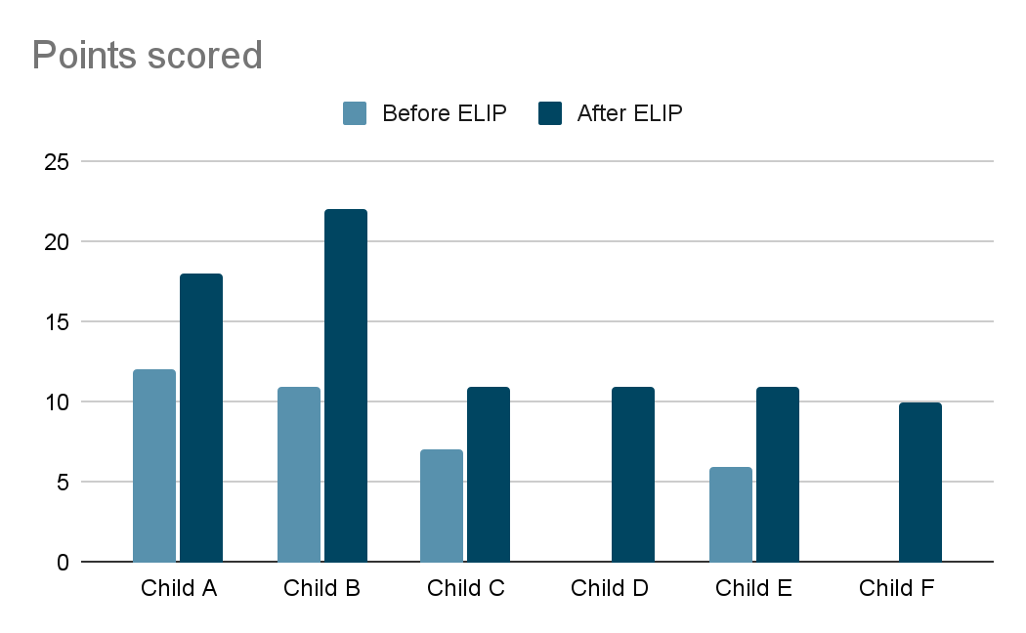
Salford Reading Test Results

The Salford reading test starts at a reading age of 4 years 5 months. To get this score a child must read 17 words. Anything below this counts as ‘no score’. A child is allowed to carry on reading until they make their sixth error on the bold words. Words that are not in bold do not count as part of their score. Just to give a bit of context as to what the child has to read to gain a score of 4 years 5 months, the bold words up to this stage are; the, dog, sat, up, come, and, play, ball, she, loves, bike, across, park, like, make, things, school. As the test goes on, the words become progressively harder.
The results for the children receiving intervention are as follows;

Child A - 7 years 5 months old. A reading age of 4 years 6 months and made their sixth error on 19 words before the intervention took place. After intervention the child made their sixth error on 41 words and scored a reading age of 6 years 2 months.

Child B - 8 years 2 months old. Child B did not score on the reading test and made their sixth error on 7 words. After the intervention the child made their sixth error on 35 words and had a reading age of 5 years 6 months.

Child C - 7 years 11 months old. Child C did not score on the reading test before intervention and made their sixth error on word 13 of the test. After intervention child C made their sixth error on 23 words and had a reading age of 4 years 10 months.

Child D - 8 years 4 months old. Child D did not score on the reading test before intervention. They made their sixth error on 6 words. After the intervention they made their sixth error on 15 words and had a reading age of 4 years 6 months.

Child E - 7 years 5 months old. Child E did not score on the reading test before intervention and made their sixth error on 8 words. After the intervention they made their sixth error on the sixteenth word and missed out on a reading score of 4 years 5 months by one word.

Child F - 7 years 9 months old. Child F did not score on the reading test before intervention and made their sixth error on the sixth word meaning they didn’t read any words correctly. After the intervention they still had no score but made their sixth error on the twelfth word and read seven words correctly from the test.

These results again show minimal progress. I believe personally that this text does not give a true reflection of a child’s reading ability. I feel the words are very difficult to achieve at the age the children are expected to be able to read them. For a child to be able to finish this test they must be able to read words such as contemporary, government, prestigious and orchestra. It may be due to the area I work in but these words are not even in the children’s vocabulary for them to recognise them and with the length of the word, most children would not attempt to sound them out. The test was used in this instance due to it being the schools tool for testing children's reading abilities. It is also used largely by other schools.
Previous literature of the Salford reading test goes against my beliefs about it and I struggled to find any negative criticism about it when looking into it. There was one con pointed out by the National Deaf Children’s Society which was “it only measures sentence reading”, but this was alongside many pros which also included that it is recommended by the Department for Education Catch Up Programme”.
(National Deaf Children’s Society)

Catch Up Literacy is a programme which provides literacy interventions for struggling readers and it is even recommended by these and has been for 20 years.

“As part of the Catch Up Literacy package we encourage schools to use standardised test scores to help them in identifying which pupils need additional one-to-one support and we recommend the ‘Salford Test’ in particular, now named Salford Sentence Reading and Comprehension Test (SSRCT)”.
(Hodder Education, Salford sentence and reading comprehension test| recommended by catch up for over 20 years)
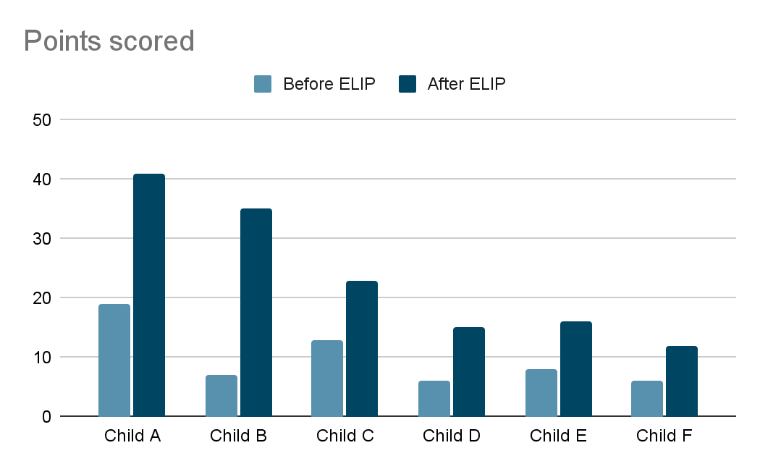
Although my views on this are not shared, I know that the children who have taken the test and carried out the intervention are able to read. Every child now reads books even if it is at a lower level than expected for their age.

Early Literacy Intervention Programme
The Early Literacy Intervention Programme consists of five different tests. Each one tests the child’s ability in different areas all linked to reading and writing. Below I will discuss each test and the results of each test individually.
Letter identification test
This tests the children’s knowledge on their letter recognition. It allows the children to give their answer as the alphabetical name or the sound or a word beginning with that sound and it is scored out of 54 as it also involves capital letters. All children by year 3 should know all their sounds but out of the six children tested, only three of them knew all 54 sounds at the beginning of the intervention.
Child A only knew 48 sounds. They were confusing b and d, n and u, Q and o and l and 1. With these confusions I was able to apply my knowledge of dyslexia and try the child with a coloured overlay. This helps the child see letters and words more clearly and in this case it corrects the confusion between Q and o, and l and 1. B and d, and n and u took more work and a longer period of time to correct but, through the intervention this was worked on and the child recognised all 54 letters by the end.
Child E knew 46 sounds and was also confusing common letters associated with dyslexia. Again, a coloured overlay was supplied and the corrections were successful with this.
Child F only knew 15 sounds. They were able to give words as answers for some of the sounds they couldn’t name. For example, they gave the word fish for the letter F. for a lot of letters they either gave no response or an incorrect response. This letter identification became a big part of this child’s intervention time as it was impossible to move them on with reading or spelling when they were unable to identify so many letters. With a lot of focus on letter identification, they were able to identify all sounds by the end of the intervention.
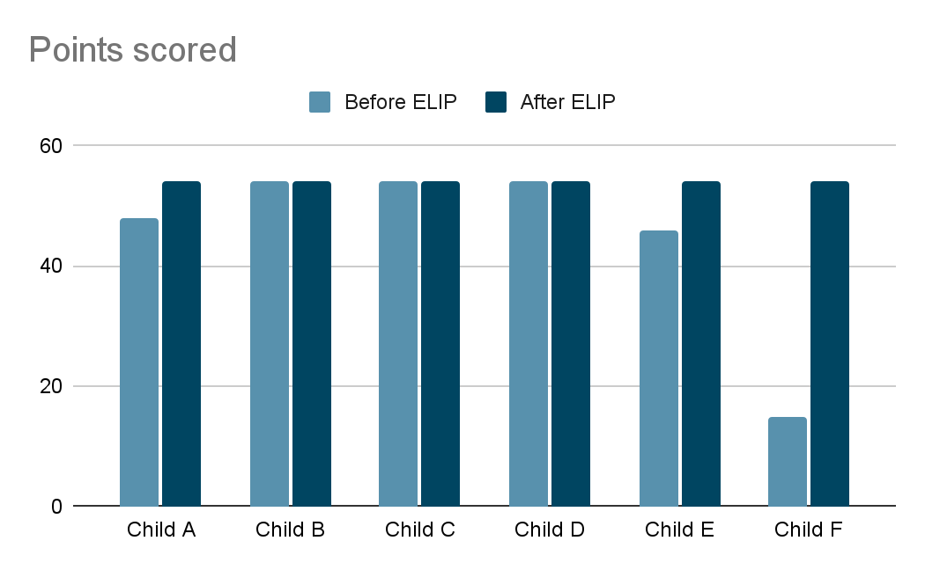
Duncan Word Test
This test looks at the children’s knowledge of high frequency words. There are two separate lists to choose from and work through for this test and there are 23 words in each list. These words are not taught specifically as a focus throughout the intervention, they are in the books we read and are picked up through repetition and the fact the children have to point to each word as they read the book. The results of this were as follows;
Child A - from 12 to 23
Child B - from 12 to 23
Child C - from 10 to 22
Child D - from 4 to 21
Child E - from 6 to 19
Child F - from 0 to 12.
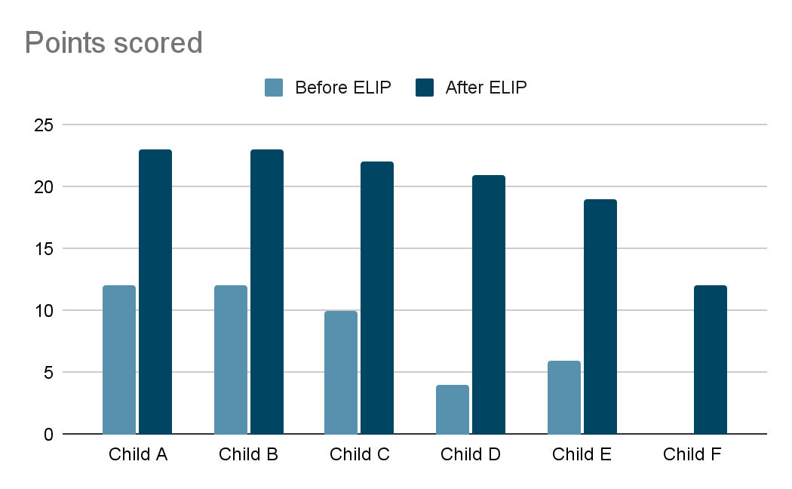
All children improved on this test with two of them getting the highest score possible. I am confident that with the progress of the other children already made, they could also reach the maximum score with more time on the Early Literacy Intervention Programme.
A study suggested that children need 10-15 repetitions of a word to learn it.
Basically, these studies suggest that the number of repetitions needed to learn a word is about 10-15 times, with lots of variation--among kids and words. For example, poor readers may require 12-25 reps to “learn” a word, while better readers may get away with only 8-12 (Lemoine, Levy, & Hutchison, 1993).
(Shanahan on literacy, How many times should they copy the spelling words?)
With this information, I think it’s important to acknowledge just how much the children have achieved by learning this many new words in this short amount of time.
Hearing and recording sounds in words (dictation task)
This part of the test involves the test giver reading a few sentences to each child individually whilst they write down each word. It gives a good indication of what sounds the child hears when writing and includes a few high frequency words to gain an understanding of their knowledge of these as well. It is marked out of 37 and each correct sound is worth one mark which means children don’t necessarily need to be able to spell words with ‘magic e’ as it's focused on the sounds they hear when sounding out the word. I think this is a very good test for lower ability children as it enables the recorder to see exactly what is missing from a child’s first stages of writing and gives a good indication of what needs to be worked on to help the child progress further.
Child A improved 7 marks on this test, taking them to the maximum marks possible. They were able to spell all words in the test correctly including words such as home, take and have which would have been recognised and remembered from reading the books as no sessions were focused on ‘magic e’. This shows that a child’s knowledge can really improve from reading. Child B also had the same results as child A but there was also a noticeable difference in their formation of the letters b and d which were used correctly at the end of the intervention after mixing them up for most of the sessions in the intervention.
Child C started with a score of 26 and it was clear to see they were struggling with sounding out any unfamiliar words and words with more than three sounds. This was worked on in sessions and the child produced a score of 35 at the end of the intervention and showed a much better understanding of sounds in each word.
Child D scored 22 in the first test and progressed to 34 by the end. It was clear from their first test that they were struggling with medial sounds in words so we were able to work on this in our sessions.
Child E scored 16 on the first set of testing and it was very clear they required support with medial sounds and high frequency words. They also only used 2 letters in each word regardless of what word was dictated. This gave a clear indication of the support this child needed to progress with their writing and after only a few sessions they improved dramatically with their writing. Their last test score was 33.
Child F scored 0 on the first test, they wrote some letters but those letters did not correspond to the spoken words. Their formation of letters was also very concerning. This child spent a lot of time completing letter formation and beginning sounds in words as a first step and also a lot of talking about letters and words and how letters make up the word. After a lot of work they were able to write the correct sounds and also write the first and final sound in each word. They were still unable to get the medial sound of words but with more time and this planned as a next step I am confident they will achieve this. Their last test score was 18.
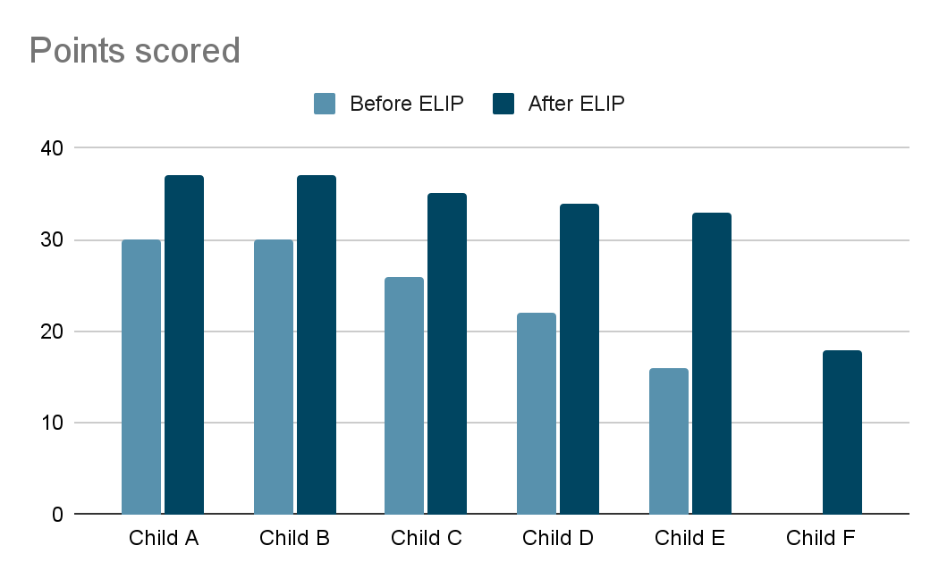
I think this test is a very good way of getting a baseline for children and highlighting exactly what part of their writing needs to be improved. From this the child is able to be taught directly and systematically which has been proven to gain better reading skills which in turn will provide better spelling skills.
“The National Reading Panel (2000) conducted a meta-analysis to review and evaluate research on the effectiveness of various approaches for teaching children to read. Their findings showed that students who received systematic and explicit phonics instruction were better readers at the end of instruction than students who received non-systematic or no phonics instruction” (Ehri, 2006; Armbruster, Lehr, and Osborn, 2001).
(Read Naturally, Phonics )
Vocabulary Test
The writing vocabulary test gives you an indication of a child’s vocabulary range. There is no specific score to reach for this test. The child is given ten minutes to write as many words as they can. If a child is struggling the test record is able to provide prompts such as, ‘Can you think of any rhyming words?’ ‘What about the high frequency words we practise?’ In my experience these are the words children write most on this test even without the prompting. The words are only marked correct if the spelling of the word is all correct.
According to families online, a child’s vocabulary by age 5 is critical to their development and a lower ability child should know about 3,000 words by age 7 and acquire 1 new word a day.
- “The extent of a child’s vocabulary at age five is so critical to the development of their perceiving, thinking, and understanding that it is used as a measure of these cognitive skills.”
- “The top quarter of pupils know about 7,100 words by age seven, and add about three new ones each day. The bottom quarter have fewer than half as many words at that age – about 3,000; they acquire only about one word a day, so the gap continues to widen.”
- (Families, How many words does your 7 year old know?)
The six children’s results were;
Child A - 13 before, 17 after
Child B - 11 before, 24 after
Child C - 9 before, 16 after
Child D - 3 before, 11 after,
Child E - 5 before, 12 after
Child F - 1 before, 6 after
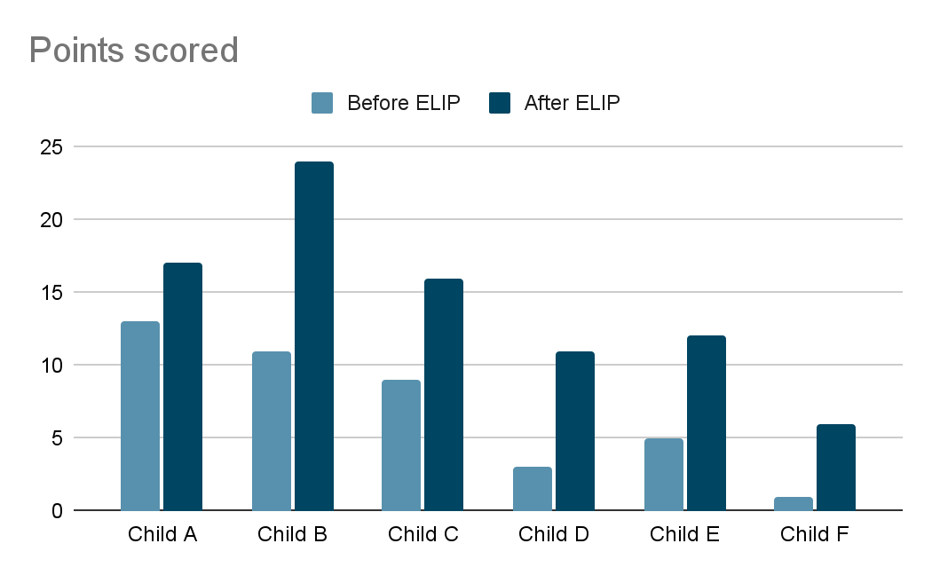
These results would mean these children are way below their expected age level. Although we know they are below, I believe this test does not give a true reflection of their vocabulary. The children wrote these words down and if they were able to speak the words, I am confident they would have achieved a lot more. This is evident just from daily conversations with the children. There are many factors to consider here such as a child’s confidence, their ability to spell and the 10 minute time frame. I would like to retake this test with the children speaking their words to get a true reflection of their vocabulary range.
Although the children showed only a few extra marks on these tests, I believe it is important to highlight that each child used mainly completely new words in their second test compared to what they did in the first. For example, child C went from 9 words to 16 but only 3 of them were used in their previous test, meaning, they had acquired 16 new words. This was the case with most children. Another thing I would like to highlight is that although these words are taught in phonics, phonics is only 15 minutes a day and once a word has been taught in that day, it’s hardly ever repeated. This means the children get one chance at remembering it as focus learning and for these lower ability children, this just isn’t enough. They need more time to learn new things and this is why interventions are so important for them. As already stated, a child needs to see a word 10 - 15 times before it becomes embedded in their memory so one phonics lesson focused on a specific word or spelling is going to be extremely difficult for a child with learning difficulties.

Concepts about print test
This test allows you to understand a child's concept about books and reading in general. It involves specific questions about books which can really make you understand where a child’s misconceptions are and gives you the opportunity to correct these to improve their reading ability. A lot of the time you are able to pinpoint one small misconception which enables the child to progress very well when it has been corrected. This is scored out of 24 and asks questions such as; where is the front of the book? Which way do we read? What is the meaning of a full stop?
The children’s test results were;
Child A - 17 before, 21 after
Child B - 16 before, 21 after
Child C - 17 before, 19 after
Child D - 13 before, 19 after
Child E - 17 before, 18 after
Child F - 8 before, 16 after
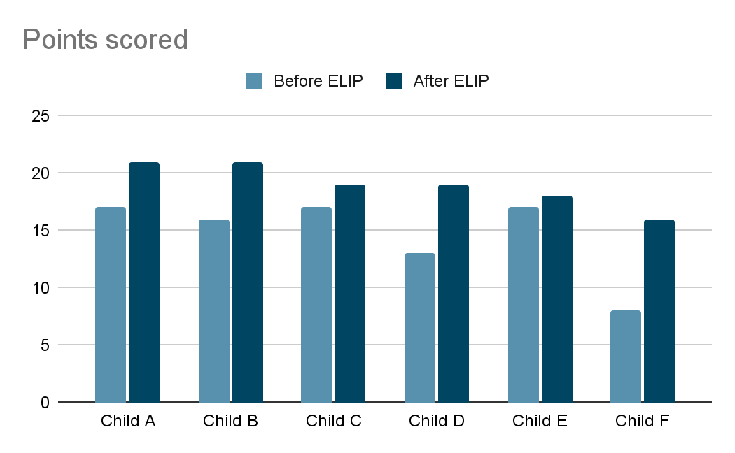
From this I was able to see most children were struggling with changes in words. This pointed to the fact they needed more time playing around with words and activities where they needed to pay more attention to words and sentences. They needed their confidence built in this area and after this being provided in sessions through games, they were able to recognise these happening on the test the second time round. Child A showed they could not do word matching and didn't know the difference between words and letters. Again, this was worked on throughout the sessions by using various games and it improved the child's knowledge of books very, very well. All children are now more confident with books and pay more attention to details when reading. The one-to-one word matching by pointing has also helped child A recognise more words through visual recognition.

Conclusion

The research conducted drew together many findings. It was clear that the Early Literacy Intervention Programme (ELIP) made a positive impact on each individual's self-esteem and confidence as well as their achievements and progress in their reading and writing skills. Every child made progress and some progress made that are not as obvious in the test results were things such as their letters that were formed backwards are now formed correctly and their handwriting being much neater. For me this shows that the strategies used throughout the intervention worked and with the improved confidence, the children are taking more responsibility and pride in their work.

The ELIP sessions provided the children with an opportunity to learn in a small group with peers experiencing the same difficulties which allowed them to speak openly about their struggles and in turn, they were able to be taught exactly the skill they were lacking. In class, the child would not openly speak of their struggles and the one-to-one teaching would not be provided. Their work would be marked wrong and told to self correct with no input on how to achieve the skill needed. This ELIP intervention then led to high levels of engagement and better self-esteem.

In contrast, the findings were able to reveal that there were many perceived challenges of using ELIP. As staff highlighted, the interventions need to be consistent, and the children need to be taken at the correct time to ensure they are not missing out on other important teaching opportunities. The teachers also felt the TA of the class should be the person to take the intervention to ensure good communication between staff and the reinforcement back in lessons. This challenge could be overcome by ensuring a suitable timetable, staff holding weekly progress meetings and the TA being allocated more time in class to reinforce the previous week's targets and support the teacher with dyslexia strategies. I also believe it
should be a whole school approach where teachers and TA’s are all trained in ELIP and dyslexia.

Overall, this research aimed to explore the impact ELIP has on learners with dyslexia. It is clear there are more benefits than challenges that offer children opportunities to develop their reading and writing skills through more focused sessions and personal strategies. What works for one child may not work for another and this intervention allows the opportunity to make the learning more personal for each individual. Continuous evaluation needs to take place to ensure good practice within the interventions being provided and the support the children receive when they are back learning in the classroom full time.

While conducting this research, it was clear to see there were some limitations. The sample that was used was a small sample, so only a few opinions and answers were gathered. With this in mind, for future research, a larger sample could be used to gather more reliable data. More time would be needed so more data could be carried out on a larger scale. Follow up observations will also be useful to ensure the children continue to make progress when their intervention period has ended. Nevertheless, this research gathered from 6 children and 2 staff members was able to provide me with current data of the benefits and challenges in using ELIP for learners struggling with dyslexia and causing them to be below their reading and spelling age. With more time, I believe these children will progress even further and catch up more to their reading ages as it is clear to see from this short period of intervention that it did in fact make a difference to the child’s learning, both academically and emotionally.

Reference List

(PDF) Insider Research: Ethics, professionalism and positionality (2019) Insider Research: Ethics, Professionalism and Positionality. Available at: https://www.researchgate.net/publication/333775938_Insider_Research_Ethics_Professionalism_and_Positionality (Accessed: 02 March 2024).
Admin, K. (2017) Improving literacy improves behavior, Kids Read Now. Available at: https://kidsreadnow.org/improving-literacy-improves-behavior/ (Accessed: 05 March 2023).
Alston, S. (2023) Outventions: When interventions turn into exclusion, Headteacher Update. Available at: https://www.headteacher-update.com/content/best-practice/outventions-when-interventions-turn-into-exclusion/#:~:text=Avoiding%20impact%20on%20lessons&text=While%20accepting%20that%20a%20withdrawal,importance%20of%20the%20wider%20curriculum. (Accessed: 02 June 2023).
‌Association, B.D. (n.d.). Spelling. [online] British Dyslexia Association. Available at: https://www.bdadyslexia.org.uk/advice/children/how-can-i-support-my-child/spelling. (Accessed: February 2023)
British Dyslexia Association, B. (ed.) (2010) What is dyslexia?, British Dyslexia Association. Available at: https://www.bdadyslexia.org.uk/dyslexia/about-dyslexia/what-is-dyslexia#:~:text=Dyslexia%20is%20a%20learning%20difficulty%20that%20primarily%20affects%20the%20skills,memory%20and%20verbal%20processing%20speed. (Accessed: 05 March 2023).
Brooks, G. (2016) What works for children and young people with literacy ..., Interventions for literacy. Available at: http://www.interventionsforliteracy.org.uk/wp-content/uploads/2017/11/What-Works-5th-edition-Rev-Oct-2016.pdf (Accessed: 02 March 2023).
CarnegieUK (2019) Welcome to understanding welsh places, Understanding Welsh Places. Available at: http://www.understandingwelshplaces.wales/en/home/ (Accessed: 05 March 2023).
Catch Up (ed.) (no date) Catch up literacy intervention, What is Catch Up Literacy? Available at: https://www.catchup.org/interventions/literacy.php (Accessed: 08 June 2023).
child mind institue (2023) Understanding dyslexia, understanding dyslexia. Available at: https://childmind.org/article/understanding-dyslexia/ (Accessed: 09 February 2023).
Daulby, J. (2020) A culture of success for DYSLEXICS • Sen Magazine, SEN Magazine. Available at: https://senmagazine.co.uk/content/specific-needs/dyslexia-spld/7658/a-culture-of-success-for-dyslexics/ (Accessed: 10 February 2023).
EEF (2022) EEF publishes independent evaluation of read, write, inc.. phonics and..., EEF. Available at: https://educationendowmentfoundation.org.uk/news/eef-publishes-independent-evaluation-of-read-write-inc-phonics-and-fresh-start (Accessed: 07 March 2023).
‌Gill, R. (2022). Why building confidence can benefit learners and help them to achieve. [online] Why building confidence can benefit learners and help them to achieve | NCFE. Available at: https://www.ncfe.org.uk/all-articles/confidence-benefits-learners/. (Accessed: 15 January 2024)
How Many Times Should They Copy the Spelling Words? | Shanahan on Literacy | Shanahan on Literacy. [online] Available at: https://www.shanahanonliteracy.com/blog/how-many-times-should-they-copy-the-spelling-words [Accessed: 05 January 2024].
Kent, S. (no date) Phonics: Read write inc. and fresh start, Whitstable Junior School. Available at: https://www.whitstable-junior.kent.sch.uk/page/?title=Phonics%3A%2BRead%2BWrite%2BInc.%2Band%2BFresh%2BStart&pid=34#:~:text=Read%20Write%20Inc%20can%20support,by%20the (Accessed: 02 March 2023).
Martinelli, K. (2017). Understanding Dyslexia. [online] Child Mind Institute. Available at: https://childmind.org/article/understanding-dyslexia/. (Accessed: March 2023).
McArthur, G. and Castles, A. (2017) Helping children with reading difficulties: Some things we have learned so far, Nature News. Available at: https://www.nature.com/articles/s41539-017-0008-3 (Accessed: 09 February 2023).
McLeod, S. (2023). Qualitative Vs Quantitative Research Methods & Data Analysis. [online] Simply Psychology. Available at: https://www.simplypsychology.org/qualitative-quantitative.html. (Accessed: February 2023)

online.utpb.edu. (2020). The Importance of Early Detection of Dyslexia | UT Permian Basin Online. [online] Available at: https://online.utpb.edu/about-us/articles/education/the-importance-of-early-detection-of-dyslexia/#:~:text=The%20importance%20of%20early%20detection%20of%20learning%20disabilities%20like%20dyslexia. (Accessed: 05 March 2023).

Read Naturally (2013). What Is Phonics, Explicit Phonics Instruction :: Read Naturally, Inc. [online] Readnaturally.com. Available at: https://www.readnaturally.com/research/5-components-of-reading/phonics. (Accessed: 05 January 2024).
‌Rising Stars. (n.d.). Salford Sentence Reading and Comprehension Test | Recommended by Catch Up for over 20 years. [online] Available at: https://www.risingstars-uk.com/blog/august-2022-(1)/salford-sentence-reading-and-comprehension-test-e#:~:text=As%20part%20of%20the%20Catch [Accessed 5 January. 2024].
Snap Cymru (ed.) (2022) New Aln System, Snap Cymru. Available at: https://www.snapcymru.org/get-support/new-aln-system/ (Accessed: 07 June 2023).
South Wales Police (no date) Police details for South Wales Police (glyncoch neighbourhood), Police Details for South Wales Police (Glyncoch Neighbourhood). Available at: https://streetguide.co.uk/police/south-wales/glyncoch (Accessed: 05 March 2023).
W., H. (2019) Examining the implications of insider-outsider Positioning • Heather A. Woods, Examining the implications of insider-outsider positioning. . Available at: https://heatherawoods.ca/research/examining-the-implications-of-insider-outsider-positioning/ (Accessed: 28 May 2023).
www.familiesonline.co.uk. (n.d.). How many words does your 7 year old know? [online] Available at: https://www.familiesonline.co.uk/local/north-manchester/in-the-know/how-many-words-does-your-7-year-old-know#:~:text=The%20extent%20of%20a%20child%27s [Accessed 8 February. 2024].

www.ndcs.org.uk. (n.d.). Salford Sentence Reading Test | Reading assessments. [online] Available at: https://www.ndcs.org.uk/information-and-support/professionals/assessments/literacy/reading-assessments/salford-test/ [Accessed 16 January. 2024].
‌Yale Dyslexia. (2017). Yale Dyslexia. [online] Available at: https://dyslexia.yale.edu/. (Accessed: February 2023).

