



Dale Monks
Module: Material Science and Building Services
Module code: ACBA4006
Student ID : 2114358

Contents

Steel framed building – The Empire State building, New York, USA 2
Concrete framed building – Pentagon, Virginia, USA. 5
Compare and Contrast 9
Conclusion 13
List of Figures 14
List of Tables 15
Bibliography 16

Module: Material Science and Building Services
Module code: ACBA4006

Steel framed building – The Empire State building, New York, USA

Built in 1931, the founder John Jacob Raskob commissioned architects Shrieve, Lamb and Herman, who would see the building reach a height of 381m, sat on a concrete base. The builders Stylet Brothers and Ikan Company were appointed to complete the construction within 18 months and at a cost of 50 million dollars.
Thanks to the gift of the Statue of Liberty which has a steel skeleton design, designed by Gustave Eiffel in 1886, Eiffels skeleton design has been considered as a technology transfer to the United States.
The geology for the site was classed as almost earthquake proof, and ideal for skyscrapers, due to its bedrock with a history of few and very weak tremors, as described by (Anderson, 2015)
The build would see some unusual approaches to construction arrangements e.g. the plant/machinery and tools would be bought rather than the conventionally leased items, providing time and reliability benefits. Tools would be resold upon completion to reclaim costs. Another key efficiency included in the design was the expansion of the railway line, which avoided unnecessary obstruction through building material being stacked up in the streets.
60,000 tonnes of steel were required with exact number of matching rivets, produced off site in Pittsburgh. (The Empire State Building, an Engineering Miracle, 2007) describes how each steel girder would be stamped with an index number which indicated the delivery date and where it was to be installed. Only 80 hours after being cast the sections for the steel skeleton had reached their destination on Fifth Avenue.
For the Façade, marble and concrete was used with over 30,000 square meters of high-quality marble ordered from Europe.
Using a steel skeleton construction, it can be said that the higher they are the more stable their walls are, but for the Empire State Building the supporting walls would have to be very thick. A steel skeleton however transfers the weight not to the walls but to the foundations, the facade is merely attached to the skeleton like a curtain. The advantages, relatively low weight so that such constructions guarantee extremely high stability to be erected quickly. Parts are prefabricated to size by the steel works and simply riveted together on site. The weight of the Empire State Building is borne by a total of 210 pillars.
Despite their size, steel structural components have a tolerance of less than half a millimetre, this precision also enables intermediate elements to be prefabricated and installed in the shell construction later.
With a skilled workforce of 3,000 people, non-existent health and safety laws, or even any form of fall arrest, there were 5 fatalities. Nothing better pictures this sight than this icon photograph Figure 1 from 1932 (a year after the Empire State was completed) picturing 11 steel workers eating their lunch at the construction of the Rockefeller Centre with no fall arrest.
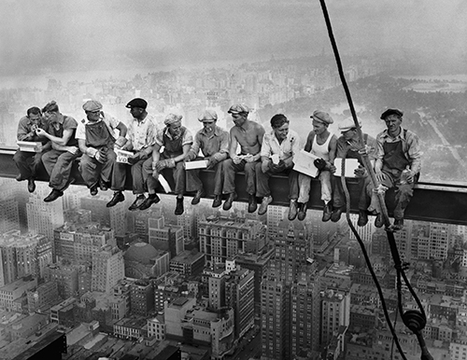
Figure 1 - Lunch atop a Skyscraper. (Ebbets, 1932)
Manhattan being what is now considered as an Island of Skyscrapers (Mackay, 2012), steel frames are considered the standard building material, and the benefits at the time of construction may not have included its re-sale value during a demolition stage or its potential ability to be reused/recycled. The benefits of using steel apposed to concrete meant that the project would be completed faster and cheaper than initially thought, thanks to the speed in which the steel could be produced and delivered. The result, an 18-month project completed in just 13 months with a 50 million dollar budget final accounted at 41 million, a nine million dollar saving, partly due to the huge unemployment and cheap labour following the black Friday stock market crash.
The skyscraper utilising its upward footprint meant that it lead the way for later buildings to maximise the space for people, employment, residential properties (apartments). Although with any city population increase, overcrowding, lack of affordable housing has created a very densely populated Manhattan, where air quality is considered to be poor. There is an argument when compared to other cities, Manhattan boasts an efficient underground service to its neighbour boroughs off setting pollution from cars/busses.
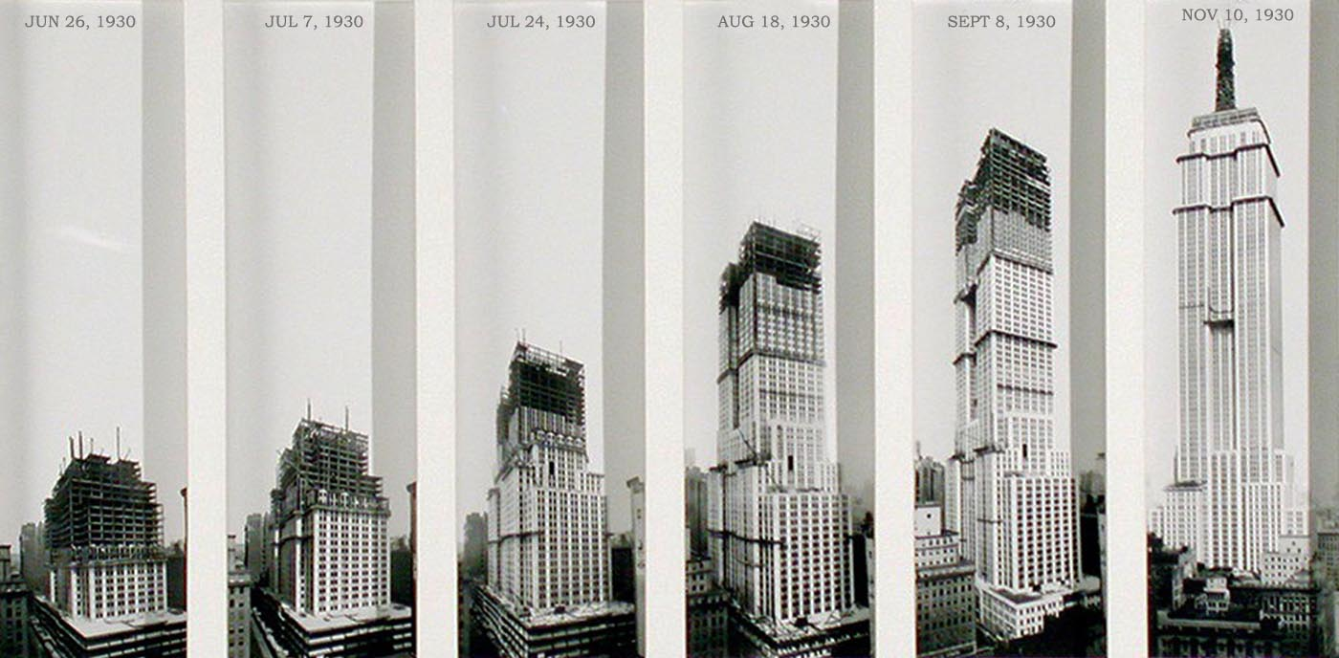
Figure 2 - Empire State Construction Phases. (Coneybeare, 2018)

Concrete framed building – Pentagon, Virginia, USA.

The Pentagon started construction on September 11th, 1941, 60 years before the devasting terrorist attack on the same date 60 years later.
The buildings proposed location was surrounded by 5 roads, and this give birth to the Pentagon design. President Roosevelt felt it would restrict the view from the Arlington Centre of Washington DC, and was relocated.
With just over 6,500,000 square foot of office space, it has three times the floor space of the Empire State Building. The location for this enormous footprint was mostly a swampy wasteland whose only structure was a small, abandoned Washington-Hoover Airport, perhaps showing some signs of sustainability, even during war time?
The buildings architect, George E. Bergstrom and the prime contractor John T. McShain Company of Philadelphia lead with a concrete framed design, and concrete was chosen as it would be more fire-resistant and steel was being conserved to build War vehicles. Steel reinforcement would be required but scaled back to bare minimum e.g. Internal ramps were constructed of mainly concrete, to negate the need for a metal/steel elevator, with the exterior walls reinforced with concrete to provide stability and defence.
Due to its unique shape the centre is a 30 square metre open courtyard, which provides natural light into each of the segments.
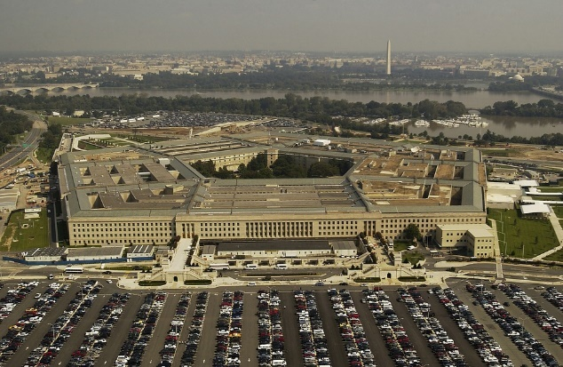
Figure 3 - Modern day Pentagon
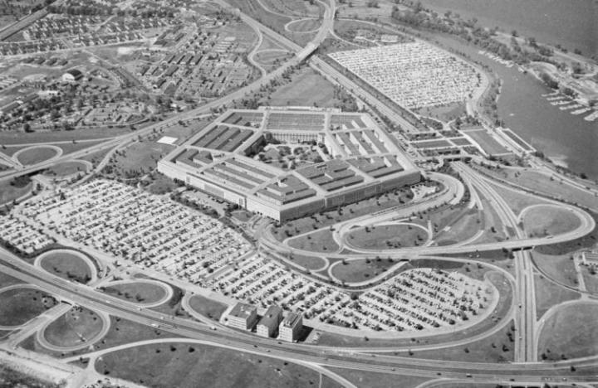
Figure 4 - Pentagon operable in 1944
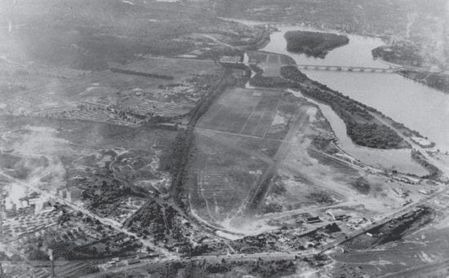
Figure 5 - Photo of the land before the Pentagon was built
Figures 3,4 & 5. (ZIMMERMAN, 2018)
Around 13,000 workers were involved in its construction, in April 1942, just eight months after the breaking ground, the first two sections were complete, and staff moved in. In January 1943 the building was complete and noted in (Defense, U.S. Department of, 1944) that during congress the War Department reported expenditures of $63 million, and later revising this calculation to above $80 Million.
Fire protection was at the heart of construction, key walls being masonry, like the basement walls, where vehicles and storage rooms were located. These areas would also be divided into fire areas by further concrete walls, reinforced and connected with double automatic fire doors. This design was extended to all key areas within the building. (Gurney, 1964).
The builders were frugal in their choice of materials, by using the nearby Potomac River. This would reduce the cost incurred from importing the materials and speed up the build. They dredged 680,000 tons of sand and gravel (creating the Boundary Channel and Pentagon Lagoon - as seen in Figure 6) before starting the process of creating the concrete on site. 435,000 yards of concrete was required due to the sedimentary foundation soils, so the foundation was erected on top of 41,000 concrete pilings, which conserved enough steel to build a gun ship. To protect the vista of neighbouring Arlington National Cemetery, the Pentagon’s height was strictly limited to 24 metres.
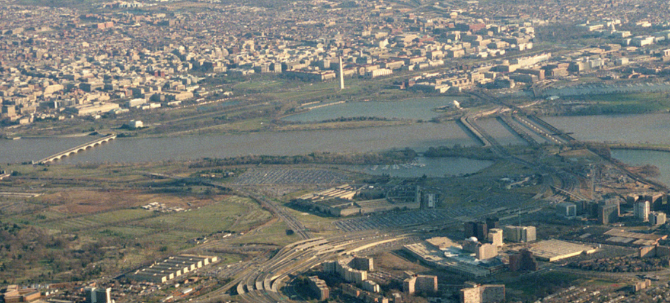

Figure 6 - Pentagon. (Archives, 1991)
Although the dredging of the river would have provided cost and time benefits, the negatives are highly notable impacting marine organisms negatively through entrainment, habitat degradation, noise, remobilization of contaminants, sedimentation, and increases in suspended sediment concentrations.
A rotary kiln would have been on site, allowing Portland cement to be produced quickly. With the natural resources already dredged, they would be crushed and added to the rotary Kiln, and produced into blocks and a cement mixture/mortar. Air agents/ad mixtures/accelerants would be added to increase the hardening time. Using a reinforced mesh steel throughout the external main walls to provide further structural support and defence. The mixture of the concrete would vary depending on which part of the building was being erected. The concrete pilings would have also been reinforced with steel providing corrosive protection from sulphur found in the spoil.
As the Pentagon Reservation began to develop in the 1940s surfaces that were once permeable were replaced with impermeable surfaces. The Pentagon Reservation has 79 acres of green space but often these areas are neither sufficiently vegetated, nor are they vegetated with sustainable plants. The Pentagon Reservation has a significant amount of impervious surface area, primarily from paved parking lots. It has required many updates to alleviate issues around surface water flooding and drainage in its external areas. In more recent years a focus of wellbeing and biodiversity has encourage the planting of trees, greener landscaping, and protection of the marine life in the Potomac River via an Environmental Assessment. (AECOM, 2015).
The initial completion time was 7 years, but the war soon expedited the schedule by vastly increasing the workforce. The buildings life cycle has been constantly upgraded and amended to adjust for the modern threats to security, reducing its carbon footprint, and focus on making the building more inhabitable for employees/visitors especially at the memorial site. With its national heritage status and involvement in 9/11, it’s likely the building will never be reused or demolished and will continue to be adapted to suit modern day purposes. If, however the building was demolished then the concrete would be unsuitable for reuse and would need to be re-purposed as landfill or crushed to make aggregate for perhaps inclusion in new concrete.
By comparison the Empire State’s mass steel skeleton could be recycled back into the steel making process or if structural sound, repurposed on another building, or sold for scrap. The cement façade would have similar issues to that of the Pentagon, and the cost of deconstructing the Empire State in modern Manhattan, would likely make for an expensive project.
Despite the Pentagon being built at speed, consideration for the site, ecology and materials was clearly taken into account, as demonstrated in the above. The social sustainability could be measured in the ongoing integral work the staff at the pentagon do to protect its citizens, It was noted after the terrorist attack that the large concrete walls, although badly damaged were integral into protecting the structure and occupants. The two-year project to repair said damages was completed with every contractor refusing any overtime payments. It seems fair to conclude that this building provides a feeling of national pride and maybe has a social/heritage value, as in 1992 the Pentagon was designated as a National Historic Landmark.

Compare and Contrast

The concrete frame of the Pentagon when construction started in Sept 1941 would have been subjected to seasonal weather. As seen in Figure 6, the frame would require some form of protection. The weather in Virginia, USA, is largely unchanged today and therefore it seems appropriate to conclude that the materials selected, and construction methods chosen were suitable considering the buildings good condition today and following relatively minor damage from the terrorist attack in 2011.
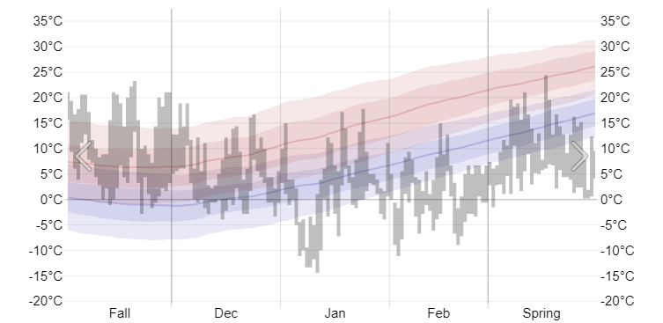
Figure 7 - Virginia Temperature History - Winter of 1941. (Weather Spark, 1941)
Whilst the concrete frame was being erected it would have been prudent to use admixtures – air entraining agents to speed up the hardening process and reduce the risk of frost damage and the freeze thaw cycle, seeing as ground was broke in September. The voids within the concrete mix would the trap and freeze the water within the voids, giving room for expansion. This would also give a high level of workability, much needed in a project of this speed and size.
Accelerators would have been ideally used to cast the framework in cold weather to generate the heat for a quicker hardening process.
Large parts of the Pentagon have been built with reinforced concrete, to protect the structure from damage and to support the weight. Using reinforced concrete would also allow for future expansion with its “energy-absorbing capacity incorporated in the future into the designs of buildings and other structures in which resistance to progressive collapse is deemed important.” (Mlakar, 2003).
The Pentagon’s outer finish was mostly concrete and limestone. It could be argued that Limestone was chose to match the aesthetic of many neo classical style buildings and features of the area, one being, The University of Virginia.
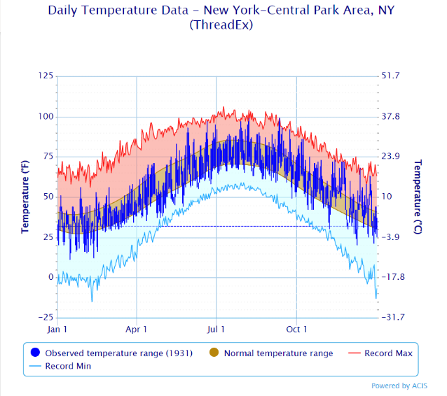
By comparison the steel frame of the Empire State, would have started its first phase in the spring where temperatures would have been mild, (Figure 8) and with typical dry seasonal weather the steel would have been unlikely to have suffered from corrosion.

Figure 8 - Temperatures in Manhattan 1931. (Regional Climate Centers and NCEI, 1931)
Steel being prefabricated off site in Pittsburgh and delivered via train when required, prevented steel sitting on site and corroding. Once the steel was installed the remaining building was wrapped in its concrete/marble façade almost as quickly as seen in Figure 2. Doing this would make it extremely fireproof, so much so, that when a plane crashed into the building during construction, destroying 5 floors, it only took 2 weeks to repair the damage and continue building. The fire caused from the high-octane aviation fuel, had burnt out by the time the firefighters reached the 79th floor. (Dunn, 2017). By modern standards to prevent climatic corrosion the steel could have been painted with rust inhibiting material e.g. zinc or aluminium, or use a corrosion resistant steel. To improve fire safety and provide resistance to heat the following are also preferable - cement based spray, intumescent coating, masonry, plaster or gypsum plaster board.
The environmental effects of the steel production would not have been felt in Manhattan, although Pittsburgh was ripe with abundant natural resources, such as “wood, coal, limestone and sand, along with flax and cotton” (DIETRICH II WILLIAM. S, 2008)
Mills of all kinds, mixed with a vast railroad/shipping network, the Pittsburgh’s air would be black by 9am, taking its toll on the environment. With iron ore, limestone, coke and a forested mountain range for wood, the blast furnaces would be working 24/7. Mining these materials locally would cause long term health issues, back breaking labour, and a densely populated city due to the vast employment opportunities.
Cast iron would be produced from the blast furnace, high in carbon, sulphur and phosphorous. Reducing these levels in cast iron requires the adding of manganese (improves corrosion resistance), chromium, nickel or vanadium (assist raising yield strength) (BSI, 2019). For structural steel to be at its toughest and more ductile carbon needs to be as low as 0.2% - 0.25%.
Bi products from the process being slag and molten iron. Molten iron then goes on to be further treated to become molten steel, before being shaped/rolled/poured into the designed final shape. Scrap metal can be produced from most parts of this process which can be readded to the beginning of the steel production process into the coke ovens to reduce wastage.
A notable biproduct from the iron works was the early invention of Tarmacadam, by Edgar Hooley in 1901. Noticing a smooth surface outside the iron works caused by a spill of tar and slag, this surface traps dust and later became vastly produced as Tarmacadam (BBC, 2009)
As dust and sulphur poured out of the steel works at Pittsburgh, combined with overcrowding living conditions, leading to poor health, a change was required. After the second World War, an era of Pittsburgh Renaissance began, adding smoke-controlled legislation and parks and offices. Many of the head offices were beginning to leave, moving towards the boom of automobile and light goods manufactures to reduce cost for production/transport of light sheet steel. What followed was 116 day strikes, redundancy and vast unemployment, again further changing the economic, environment and social factors of the city.

Table 1 – Frame Comparisons
Comparisons of the frame types are generally understood as per below:
Groups | Pro’s | Steel | Concrete | Con’s | Steel | Concrete
Aesthetics and Prestige |  | - More freedom for expression  - Column free clear spans  - Elegant simplicity | - Concrete can be coloured for designed finish/effect. |  | - Some steel can discolour from original and become unsightly.  - If small corrosion occurs, it can lead to an unpleasing look. | - Salt deposits may form on the surface (efflorescence), becoming unsightly.
Economy |  | - Lower foundation costs due to excellent  - strength to weight ratio  - Lower site costs during construction  - Durability, long life, calculated maintenance  - Short construction period. | - Uses low-cost materials  - Low labour cost and requires less skilled/specialised workers.  - Low maintenance cost. |  | - High up-front cost  - Transporting steel can be costly if heavy  - Requires highly skilled workers  - Higher maintenance costs | - Long process of installation, with curing time.  - Limited options to recycle, mainly used as aggregates.
Flexibility |  | - Environment  - Technical Performance  - Safety  - No limits for architectural design. | - Concrete structures are very resistant against compression, effectively.  - Mouldable  - Can be reinforced with Steel bars for tensile strength. |  | - Lower fire resistance  - Susceptible to fatigue when exposed to changing loads | - Brittle when strength is exceeded  - Requires formwork  - Can crack due to shrinkage and moisture expansion.
Adaptability |  | - Can easily be modified  - Re-usable  - Can totally be recycled.  - High dimensional accuracy therefore reduces the need for rectification. | - Can be manufactured to the desired length  - Prestressed concrete allowed smaller cross section and lighter structures.  - Fire and weather resistance. |  | - Susceptible to corrosion and requires frequent treatments.  - Susceptible to brittle fracture when its ductility is lost. | - Low tensile strength  - Requires bulky structure  - Sustained loads cause permanent deformation (creep).
Pace |  | - Smaller foundations save construction time  - Prefabricated elements are ready for erection upon arrival at site. | - Quick and easy to move on site |  | - Transport times can be long if not sourcing steel locally. | - Long curing time (28 days).
Quality Assured |  | - Steel is subject to document quality control procedures during manufacturing and rolling. | - Intensive process, well documented. Vital when creating different mix’s |  |  | - Demands strict quality control which can be a lengthy process, bespoke to the mix.

Conclusion

Previously noting that the Empire State withstood a plane crash, there has been many investigations as to how the Worlds Trade Centre (WTC) collapsed upon similar circumstances. It was believed that the steel skeleton would withstand such a blow. Investigations have highlighted that the modern aviation fuel kerosene burns at a higher temperature and at an increased speed which contributed, although Deputy Chief Vincent Dunn ret. Reported (Dunn, 2017) that the Empire State’s structure was load bearing, with the façade attached, but a change in skyscrapers design years later saw the load bearing skeleton moved to the outside, and therefore having less protection. With 1930’s steel being solid girders and beams, the WTC has tubular steel bearing walls, which provide less strength
Steel, Concrete and other types of frames have been invented and developed to meet the needs of humans, and further be aesthetically pleasing. Both frame types have a role to play in the environment they are placed, and the required use of the building. With a relative comparison seen in figure 9. With the Empire State, being built on an overcrowded island, where space is expensive, the birth of the skyscraper seems to be the required answer, and using steel allowed these structures to be erected quickly. By contrast the Pentagon was built at a lower level, keeping the surrounding views unrestricted, but with a requirement to be built as thick impenetrable fortress and extremely fire resistant. This brief suited the use of reinforced concrete.

List of Figures

Figure 1 - Lunch atop a Skyscraper. (Ebbets, 1932) 3
Figure 2 - Empire State Construction Phases. (Coneybeare, 2018) 4
Figure 3 - Modern day Pentagon 5
Figure 4 - Pentagon operable in 1944 6
Figure 5 - Photo of the land before the Pentagon was built 6
Figure 6 – Pentagon. (Archives, 1991) 7
Figure 7 - Virginia Temperature History - Winter of 1941. (Weather Spark, 1941) 9
Figure 8 - Temperatures in Manhattan 1931. (Regional Climate Centers and NCEI, 1931) 10

List of Tables

Table 1 – Frame Comparisons 12

Bibliography
AECOM, 2015. Rentagon Reservation Master Plan Update, Washington DC: Shalom Baranes Associates.
Anderson, M., 2015. The EPA Blog. [Online]
Available at: https://blog.epa.gov/2015/07/14/the-manhattan-skyline-why-are-there-no-tall-skyscrapers-between-midtown-and-downtown/
[Accessed 1 11 2021].
Archives, T. U. N., 1991. U.S. National Archives & DVIDS. [Online]
Available at: https://nara.getarchive.net/media/an-aerial-view-of-arlington-virginia-with-the-potomac-river-and-washington-a9c2ce
[Accessed 24 11 2021].
BBC, 2009. BBC Nottingham. [Online]
Available at: https://www.bbc.co.uk/nottingham/content/articles/2009/07/03/edgar_hooley_tarmac_feature.shtml
[Accessed 24 11 2021].
BSI, 2019. Modiranahan. [Online]
Available at: https://www.modiranahan.com/uploads/pdf/BS_EN_10025_2_2019.pdf
[Accessed 24 11 2021].
Coneybeare, M., 2018. Viewing NYC. [Online]
Available at: https://viewing.nyc/vintage-photographs-from-1930-show-progression-of-empire-state-building-construction/
[Accessed 20 11 2021].
Defense, U.S. Department of, 1944. greatbuildings.com. [Online]
Available at: http://www.greatbuildings.com/buildings/The_pentagon.html
[Accessed 24 11 2021].
DIETRICH II WILLIAM. S, 2008. Pittsburgh Qauterly - A Very Short History of Pittsburgh. [Online]
Available at: https://pittsburghquarterly.com/articles/a-very-brief-history-of-pittsburgh/
[Accessed 24 11 2021].
Dunn, V., 2017. https://vincentdunn.com/. 1 ed. New York: FDNY FIRE ZONE.
Ebbets, C. C., 1932. Lunch atop a Skyscraper. [Art] (Rockefeller Center).
Gurney, G., 1964. The Pentagon - A Pictorial Story. 1 ed. Crown Publishers: New York.
Mackay, D. A., 2012. The Building of Manhattan. 1 ed. New York, USA: Courier Corporation.
Mlakar, P. &. D. D. &. H. J. &. H. G. &. P. L. &. S. M., 2003. Research Gate. [Online]
Available at: https://www.researchgate.net/publication/269079714_Findings_and_Recommendations_from_the_Pentagon_Crash/citation/download
[Accessed 24 11 2021].
Regional Climate Centers and NCEI, 1931. National Weather Service. [Online]
Available at: https://www.weather.gov/wrh/Climate?wfo=okx
[Accessed 24 11 2021].
The Empire State Building, an Engineering Miracle. 2007. [Film] Directed by Marco Theurkauf. United States of America: Inter/Aktion.
Weather Spark, 1941. Weather Spark. [Online]
Available at: https://weatherspark.com/h/s/20970/1941/3/Historical-Weather-Winter-1941-in-McLean-Virginia-United-States#Figures-Temperature
[Accessed 24 11 2021].
ZIMMERMAN, D. J., 2018. The Pentagon: Building An Icon. Pentagon: 75 Years – The Building. The People. The Institution. 1943 – 2018, 3 Jan, pp. 35 - 41.

