2023506
David Cornelius
Networking & Cybersecurity Essentials

BSC-PT Computing (Computer Networks & Cybersecurity)

10th July 2021

Contents
List of Figures/ Tables 4
Abstract 5
Introduction 6
Task 1 7
Possible Security Breach 1: Man in the Middle Attack 7
Possible Security Breach 2: Phishing 7
Possible Security Breach 3: Sniffing 7
Possible Security Breach 4: Drive by Attack 7
Possible Security Breach 5: Internal Actors 7
Possible Security Breach 6: Disgruntled Employees 7
Task 2 9
Threats 9
What is a Threat? 9
Types of Threats 9
Vulnerabilities 10
What? 10
Why? 10
How? 10
Attacks 11
What? 11
Why? 11
How? 11
.meds file format attack 12
What it is? 12
How it affects the operation? 12
Is there any possible methods to recover? 12
Task 3 13
Logical Topology 14
Physical Topology 15
Implemented Topology 16
Network Credentials 16
Task 4 17
Guidelines for responsible Digital Use (Staff) 17
Guidelines for responsible Digital Use (Customer WIFI) 17
Conclusion 18
References 19

List of Figures/ Tables
Fig. 1 - Cisco, “Introduction to Packet Tracer Cert" [Online] - Accessed July 2021
Fig. 2 - Credly, “Introduction to Packet Tracer Badge" [Online] - Available: https://www.credly.com/badges/48c7dc16-3b00-4d41-9299-9710aacc9d5a/public_url
Fig. 3 – Logical Topology

Fig. 4 – Physical Topology

Fig. 5 – Implemented Topology Inc Security

Abstract
The following report is an analysis of the underlying and ongoing security issues that are present within Popeyes retail showroom. The aim of the report will be to educate and outline basic information related to cyber security and networking with the purpose of providing actionable long term cybersecurity solutions.

From initial analysis, there several underlying security issues that will need to be addressed. First and foremost the .meds infection which has limited access to the business infrastructure.
Network infrastructure is also lacking and needs to be addressed especially regarding the free WIFI being provided. Further to the above, there are no company guidelines enforcing correct and responsible digital use leading to poor understanding and education.

The first issue to be addressed is the .meds infection. We can look to eliminate the effect of the infection by using a robust anti malware tool. Once the infection has been managed, we can look to make use of company backups to restore as much data as possible. Following on from a rebuilding of the company’s business systems, the next step would be to address to the network infrastructure and implement a) security and b) better suited devices. This has been demonstrated in the final report below. Finally, we would look to provide a complete and digestible digital usage education in the form of company and customer guidelines which will be applied when using the network.

Implementation of the proposed solution above would result in a robust and secured network infrastructure. Long term education for staff and customers would reduce t chance of being exposed to threats in the future.

In conclusion, Popeyes retail showroom is currently facing several difficulties in cybersecurity and networking. However, with simple and clearly defined solutions, we will be able to restore the business to full working order with limited downtime. By implementing our advised approach, you will be able to rest easy knowing that your business will be safe from any future concerns in this area.

Introduction
The following report seeks to illustrate and explain the findings of analysis and investigation into why POPEYES RETAIL SHOWROOM is currently the subject of a cyberattack. How that cyberattack impact can be reversed and all possible future solutions that can be implemented to avoid a repeat occurrence.

The report will first analyse ways in which the company may have been breached. This is with a view to educate the owner in what is possible and why it needs to be protected against.

Next, education will be provided to give a better understanding of what these breaches are and how they are usually carried out. Knowledge provided will be comprised of threats, vulnerabilities, attacks and lastly what exactly is the .meds infection and what the consequences may be.

Following on from education, we look at practical solutions in the form of network topology and how the infrastructure can be addressed. By documenting the current network topology in the form of physical and logical representations, we can then provide a long-term solution that is suitable for the network. This will include recommendations for network and security configurations considering the requirements of the network.

Lastly, the report concludes with recommendations and guidelines for staff members and customers who are using the WIFI. The guidelines seek to cover a range of appropriate digital use and best practices for security with a long-term aim of reducing the likelihood of accidental misuse.

Task 1

Possible Security Breach 1: Man in the Middle Attack
With no investment in additional networking or security infrastructure the business applications and any data passed through the network were available to anyone. As no security was in place there would be no requirement to breach the network and any data that a "Malicious Actor" wanted to obtain would be free game. This could be email addresses, personal information to use in social engineering. Alternatively, with no additional security or infrastructure. Malicious files could be injected into the network for use in later attacks.

Possible Security Breach 2: Phishing
In the above scenario, it was stated that Jack was employed by Bluto. Jack could have used insider knowledge of POPEYES business to configure relevant phishing attacks that would have a high probability of success. By faking relevant emails or texts to POPEYE with the aim of gaining valuable information to be later used in breaching the network [1].

Possible Security Breach 3: Sniffing
In the above scenario, it was stated that the WIFI network was extended to include the new coffee shop. In this scenario the network is unsecured so we can quite easily just "Sniff" the network. Information gained while "Sniffing" the network could be used as preparation for "Social Engineering Attack" [2]. This information could then be used to gain physical access to the network or for furthermore directed phishing or baiting attacks.

Possible Security Breach 4: Drive by Attack
In the above scenario, it was stated that the WIFI network was extended to include the new coffee shop. Drive by Attack could be used to distribute a "Hostile Link" to everyone attached to the network. As this now includes the Coffee Shop. The likelihood of the attack being successful increases with a broader and less informed user base. Again, as everyone is connected to one network. As soon as a coffeeshop user device is infected with the payload it would rapidly spread throughout other connected network devices.

Possible Security Breach 5: Internal Actors
In the above scenario, it was stated that all Sales Execs were given full access to the business applications. Previous employee Jack being newly employed by Bluto still had contact with a Sales Executive who he convinced to upload ransomware to the network under the promise of employment with BLUTO when POPEYES business fails. Internal Actor purposely installs "Infected Software" onto a Showroom machine and with the lack of security or network infrastructure there is no measures in place to mitigate the spread. This ultimately results in all the Network Devices being encrypted with the MEDS ransomware.

Possible Security Breach 6: Disgruntled Employees
In the above scenario, it was stated that Jack lost his job in Popeyes attempts to further maximise revenue. This led Jack to be bitter towards Popeye and his new success. Jack was employed by Bluto and promised an immediate promotion if he helped to bring down POPEYES business. With Jack's knowledge of the internal structure of the business and how it operates. Jack can pass the knowledge onto Alice to identify areas of the business which are easily penetrated, and which areas of the business may impact POPEYEs business the most.

Task 2

Threats

What is a Threat?
A cybersecurity threat is the malicious act or intention of an individual or organization attempting to gain access to a network or system by employing a multitude of tactics or techniques [3] to corrupt or steal the confidential information within.

Types of Threats

Malware -

Malicious Software which can include anything from a worm to ransomware [4]. Usually distributed by a link which is clicked or a self-installing email attachment.

Phishing

Sending fraudulent communications with the intention of deceiving the receiver into thinking its legitimate.

Man in the Middle

When a Hostile Attacker inserts themselves between the network and a receiving device. A common target of this attack is public Wi-Fi

DDOS

Flooding a server or network with unusual levels of traffic with the intention of exhausting bandwidth [4].

SQL Injection

Inserting malicious code into a server using SQL with the intention of revealing or corrupting information [5].

Zero Day

An attempt to take advantage of a known vulnerability before patching [5].

Vulnerabilities

What?
A weakness within a system or process that can be exploited by a hostile actor

Why?
Vulnerabilities in computing are usually a simple case of Human Error. As computing becomes more complex the opportunity for error increases. These could be because of poor design choices or mistakes made during roll out. Vulnerabilities are actively pursued by Hostile Actors who seek to take advantage of them before they are public knowledge [6].

How?
An example of how vulnerabilities may be used is Zero Day Attacks. These are when Hostile Actors seek to take advantage of knowledge which is not public to breach a system before it can be patched [7] .
System features may also be used has vulnerabilities when they do something the original designer did not intend.

Attacks

What?
An attack in cybersecurity is an attempt to alter, expose, corrupt, destroy, steal or leverage information which has value to an organization through unauthorized access to a system or network [8] .

Why?
Most of the times hackers will try to infiltrate a network for financial gain. Whether this is stealing information to sell or holding information in an encrypted state for ransom. Alternative motivations to financial gain which are commonly seen are: Hacktivism, Espionage or just an intellectual challenge [9].

How?
Attacks generally happen in two forms

Targeted –

Threat actors are specifically aiming to breach security for a predefined purpose. Spear-Phishing may be used in targeted attacks, leveraging researched information to craft emails to specific people [9].

Untargeted

This can be when threat actors are just looking to compromise as many devices as possible with no specific target in mind. Vulnerabilities are generally used in this case which help to avoid detection. Again, phishing is a good example whereby a random mail list is retrieved and used to cast a wide net and see what comes back [9].

Alternatively, another common source of cyber-attacks is internal threats. Which could include
- Misplacing or accidentally leaving information in public
- No IT policies within company leading to poor cyber hygiene.
- Ex-employees looking to take advantage of insider knowledge
- Malicious employees who are compromised.

.meds file format attack

What it is?
.meds is a ransomware belonging to the Djvu ransomware family. It is primarily designed to encrypt critical files and force the victim to pay for decryption tools or keys [10]

How it affects the operation?
When infected .meds works by encrypting the most common file types using AES encryption. First a copy of the file is created to avoid any write errors next once encrypted the encryption key is sent to the attackers where it is held for ransom [10].

Encrypted files now show a new file type .meds - for example a locked doc may look like " importantDocument.doc.meds ".

A ransom note in the form of a _readme.txt is provided along with each encrypted directory instructing the user to purchase decryptions tools.

Generally, Encrypted files are inaccessible until decrypted. However, .meds only encrypts the first 150kb of each file. So there is a possibility of saving larger files [10].

Being a variant of STOP ransomware .meds also seeks to remove any backups on the machine making it harder to remove. This however is not always successful

Is there any possible methods to recover?
.meds ransomware creates a copy of the file before encrypting. This does leave a small opportunity for File Recovery using in built tools [10].
However, generally If the computer was connected to the internet when the attack took place. It can be nearly impossible for files to retrieved. The most effective scenario in this instance would be rely on backups, although these may have already been compromised.

You can remove the virus by using a anti malware tool. However, this will just prevent future files from being encrypted

Task 3

Fig 1 – Cisco cert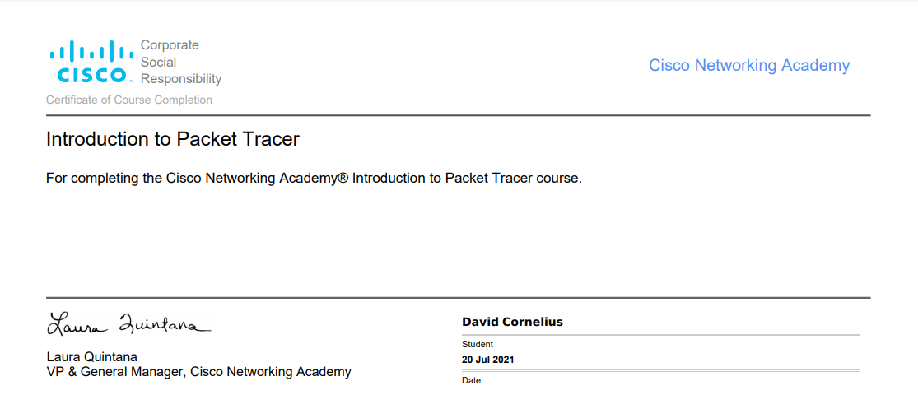

Fig 2 – Credly Badge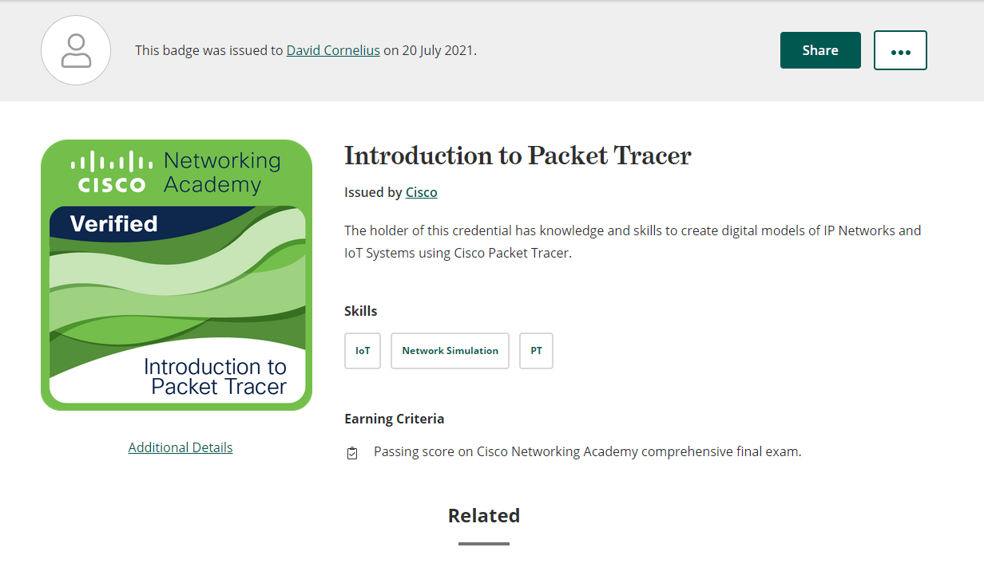
https://www.credly.com/badges/48c7dc16-3b00-4d41-9299-9710aacc9d5a/public_url

Logical Topology
Fig 3 – Logical Topology
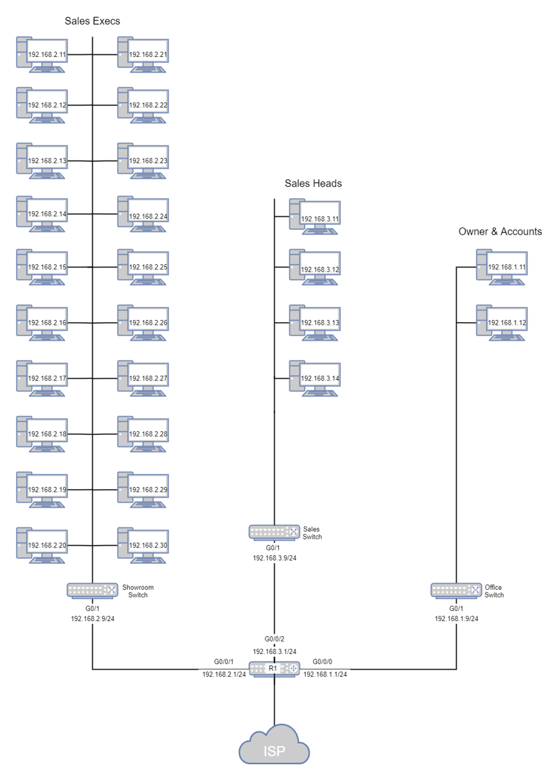

Physical Topology
Fig 4 – Physical Topology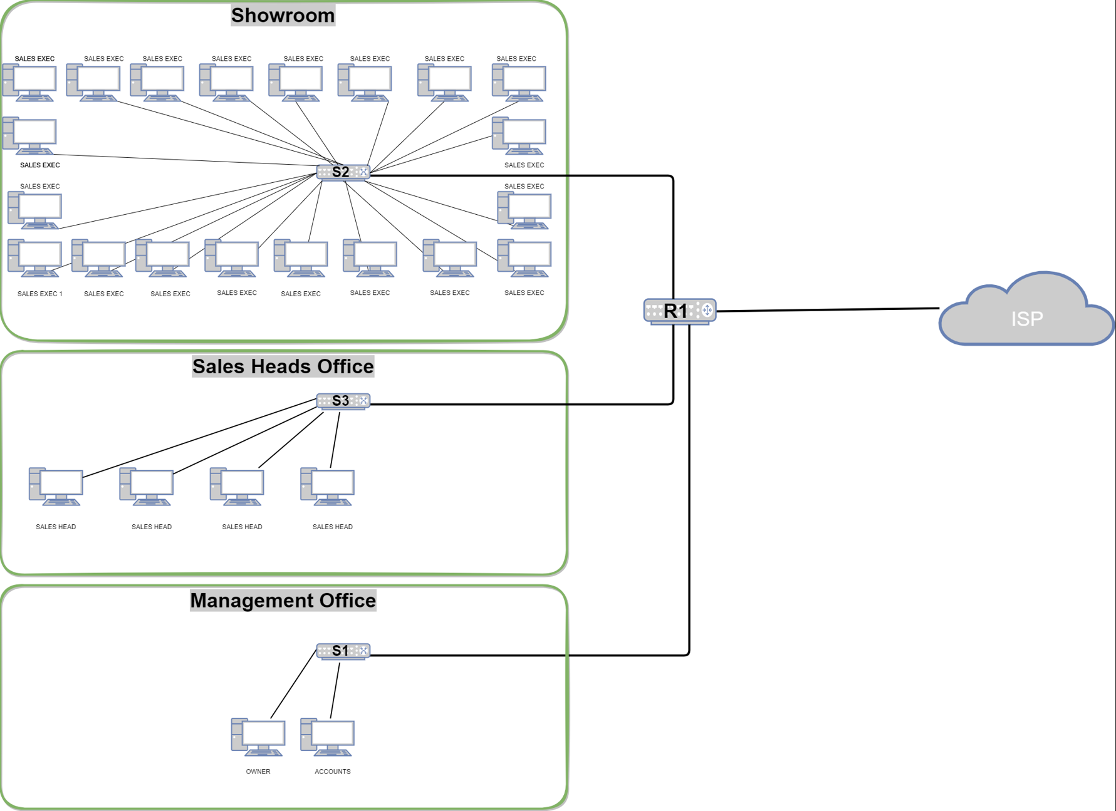

Implemented Topology
Topology implemented based on the end of the scenario including proposed security configuration for robust network infrastructure and wireless access. PKT File has been attached separately.
Owner
Marketing Office
Accounts
Wireless Access for customers
20 Sales Execs (Assumed computers are shared)

Network Credentials
R1 Passwords:  Secret: xtr1317xtr  User exec: pfj6429pfj  Line: k19trs74 | Switch:  Secret: jax539rs  User exec: vvb262cbr  Line: 7rt53rda | Coffee Shop:  Admin: js677AEZh2bLGQnH | WPA:  Safehouseharmlessprank

Fig 5 – Implemented Topology Inc security
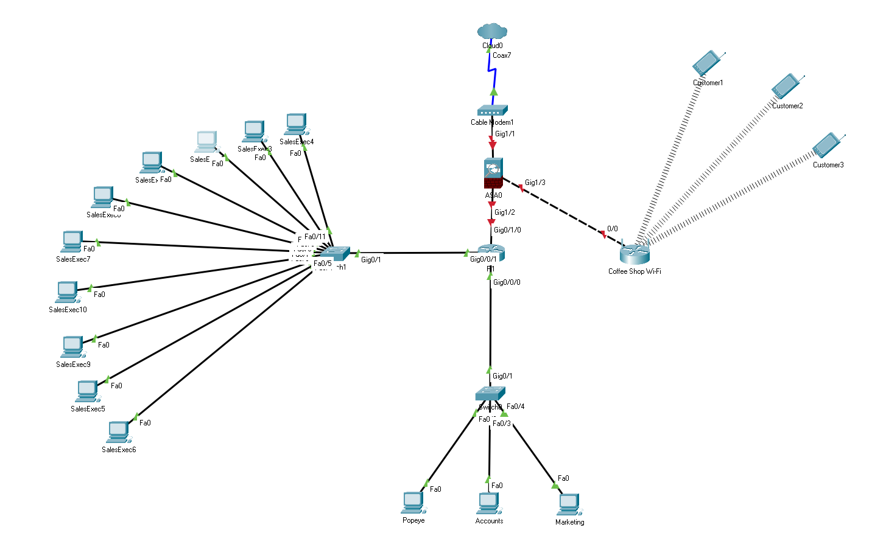

Task 4

Guidelines for responsible Digital Use (Staff)

- Do not leave business devices unlocked and unattended.

- All business devices should be secured with an adequately complex password

- Passwords should not be written down

- Be aware of your surroundings when accessing sensitive company information.

- Devices should not be used for any content outside of work-related content.

- Illegal streaming, Gambling and Adult content is strictly prohibited.

- Phishing scams are common. Always remain vigilant and check the sender’s address. Refrain from opening emails from unknown senders.

- Any additional software required should be installed by a senior member of staff.

- Email should only be used for business purposes.

- Access to certain apps is restricted. If you have access to things, you shouldn’t notify a senior member of staff immediately

Guidelines for responsible Digital Use (Customer WIFI)

- Devices using public WIFI should have appropriate security software
- Not everything you see online is what it seems. Be careful when clicking on unfamiliar links

- While using Public WIFI it is advised not to log into online banking or other websites with highly sensitive information

- Downloading of illegal content is strictly prohibited

- Be aware of shoulder surfing. Always remain vigilant.

- Illegal streaming, Gambling and Adult content is strictly prohibited.

- Phishing is used to steal your data through email. Don’t open emails from anybody unless you are 100% sure.

- Clicking on popups should be avoided in most cases

- When using the internet if you are not sure. Use a search engine and seek advice

- Do not share personal information electronically with people you do not know and on websites you do not trust

Conclusion
In conclusion, there are number of security issues which needs to be addressed with the utmost importance.
The first and most pressing issue is the complimentary Wi-Fi. My immediate recommendation would be to segregate the networks and provide a single use network for Customers. This keeps your business applications protected and is just generally best practice. There are multiple ways to achieve this, however my proposed solution would be the installation of a “Wireless Router”. This would connect to your existing infrastructure at minimal cost and instantly provide you with an additional layer of security. This ultimately limits your exposure to what happens on the complimentary Wi-Fi and is highly recommended.
Next, as we have limited the ability for the complimentary Wi-Fi to compromise the network. Moving fowrad would be a recommendation of purchasing a firewall. A firewall will stop any outside threat at source. This combined with a segregated network will heavily increase your overall security.
With a firewall in place, we would look to remove the .meds infection using anti malware software. Following on from the removal of the infection, all devices will be restored using available backups which were not comprised in the attack. Once system functionality is restored. All users will be issued new credentials and briefed with our outlined “Staff Guidelines”.

From following the approach outlined above we can restore your business to full working order with a limited downtime. While providing you robust and long-term solutions to combat any cybersecurity threats in the future.
References
[1] Phishing.org (). Phishing | What Is Phishing? Available: https://www.phishing.org/what-is-phishing [Accessed Jul 21, 2021].
[2] Avast (). What is a Sniffer, and How Can I Protect Against Sniffing? Available: https://www.avast.com/c-sniffer [Accessed Jul 21, 2021].
[3] M. Humayun et al, "Cyber Security Threats and Vulnerabilities: A Systematic Mapping Study," Arabian Journal for Science and Engineering (2011), vol. 45, (4), pp. 3171-3189, 2020. . DOI: 10.1007/s13369-019-04319-2.
[4] IT Governance (). Types of Cyber Threat in 2021 | IT Governance UK. Available: https://itgovernance.co.uk/cyber-threats [Accessed Jul 21, 2021].
[5] Cisco (). Cyber Attack - What Are Common Cyberthreats? Available: https://www.cisco.com/c/en_uk/products/security/common-cyberattacks.html [Accessed Jul 21, 2021].
[6] Rapid7 (). Vulnerabilities | What is a Security Vulnerability? Available: https://www.rapid7.com/fundamentals/vulnerabilities-exploits-threats/ [Accessed Jul 21, 2021].
[7] Kaspersky (-06-17T17:24:38Z). What is a Zero-day Attack? - Definition and Explanation. Available: https://www.kaspersky.co.uk/resource-center/definitions/zero-day-exploit [Accessed Jul 21, 2021].
[8] IBM (-11-27). Cyber Attacks Explained. Available: https://www.ibm.com/uk-en/services/business-continuity/cyber-attack [Accessed Jul 21, 2021].
[9] SearchSecurity (). What is a Cyber Attack? Definition, Types and Examples. Available: https://searchsecurity.techtarget.com/definition/cyber-attack [Accessed Jul 21, 2021].
[10] G. LLC. (). MEDS Ransomware (STOP/Djvu) - What is it? Keep Your Privacy Well. Available: https://gridinsoft.com [Accessed Jul 21, 2021].

