MARKETING FUNDAMENTALS

Table of Contents
Introduction 2
Task 1A: 3
Processes and stages of marketing 3
Situational analysis 4
Strategy 8
Role of the marketing mix 8
Role of marketing in creating value for customers 10
Impact of Stakeholder engagement on the marketing activities 12
Task 1B: 15
Definition 15
Communication Model 15
Integrated Marketing Communication 15
Utilisation of combination of promotion strategies used by ADIDAS 16
Conclusion and Recommendations 16
Reference List 18

Introduction
Marketing could be defined as the process of producing products that directly or indirectly meets the customers’ needs and satisfaction. This would help in gaining the organization with a position in the competitive environment of the location. The study has been conducted based on the various aspects of marketing and its application including the influence as well as the challenges that organisations face while executing its business.
Company Background
ADIDAS is an organisation in Germany that deals with various items including fashion and sporting products for the customers. The organisation has been providing services to the residents of Germany using their branches in the form of supermarkets. The company has an approximate of 1324 outlets all over the world. Their own manufacturing firm produces most of their items that are under their business environment. The organization has been operating its business for 70 years. (adidas.de, 2019)

Task 1A:

Processes and stages of marketing
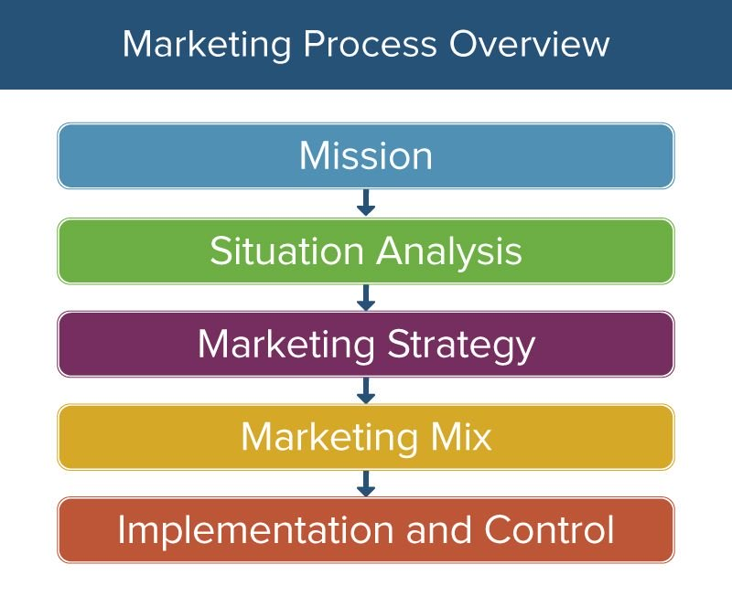
Figure 1: Stages of marketing process
(Source: Influenced by Armstrong et al. 2018)
Mission
The company, ADIDAS aims to gain the world’s largest producer of sporting goods industry.
Situational Analysis
Situational analysis is an effective manner in which the present position held by the organisation in the market can be identified. It further helps in identifying the impact of external as well as internal factors on the productivity of an organisation. ADIDAS has a favourable position in the market due to its strong brand image.
Strategy
The stage of strategy involves the development of an effective marketing strategy after the analysis of the external and internal situation of an organisation. ADIDAS would develop an effective strategy for its marketing functions after conducting a research on the market and its present scenario.
Implementation
This stage is associated with the implementation of the developed marketing strategy by the company. ADIDAS would be required to efficiently manage the process of implementing the strategy in order to receive the desired outcomes.
Control
The stage associated with the control of the process of implementation ensures that there are no challenges faced during this process. ADIDAS would be required to control the quality of the process of implementation in order to achieve its determined objectives of marketing.
Objectives
- To innovate their products using innovative manufacturing procedures
- To provide customers with improved quality of products to match their use and needs.
- To develop consistency in delivering products to retain their position in the competitive market
- To provide diversity using social and environmental responsibilities

Situational analysis
Macro Environment (PESTLE)
Political | - Being a company of global distribution ADIDAS have to abide by the rules that are set up by different countries  - Utilization of the political forces as a method of intervention
Economical | - Currency fluctuations due to diversification of business  - An inflation rate of 1.1% and a GDP rate of 0.1% affect business operations (destatis.de, 2019).
Social | - The growth rate of the population of the country increases opportunities in business  - Increase in the educational background of the individuals improve marketing performance
Technological | - Introduction of modern technologies help in efficient promotion and production facilities  - Through digital platforms, it has become a cost-effective method for the advertisement of products for business organisations
Legal | - Trading issues of import exports  - Several rules and regulations of the government guidelines prevent the manufacturing methods of certain goods.
Environmental | - Emission of harmful gasses during the manufacture of selective products affect the environment of the locality drastically  - Use of chemical ingredients in the manufacturing processes makes the products non-environment friendly
Table 1: PESTLE Analysis
(Source: Influenced by Widya Yudha et al. 2018)
Analysis
Based on the macro factors, it could be understood that the organisation faces various restrictions for the execution of its business operation worldwide. According to Santos (2017), the involvement of different governments in different countries limits their business expansion globally. The involvement of technology has led the organization to improve its manufacturing processes using sustainable methods. Legal guidelines by the government of Germany also provide various limitations to the business operation of ADIDAS. The increase of the educational background of various individuals of the localities provides the company with the benefits of recruiting efficient employees within their environment.
Porter’s 5 Forces
- Competitive Rivalry
ADIDAS needs to identify its competitors as well as their strengths. In this way, the company would be able to develop efficient strategies that would enable the competitiveness of the marketing execution. Generally, Nike is considered as a side by side competitor of ADIDAS.
- Supplier power
The productivity of ADIDAS depends upon their supplier strengths. The quality of the raw materials that are supplied by the suppliers provides the company to obtain manufacturing procedures that initiate productivity.
- Buyer Power
The revenue growth of the company’s performance deliberately depends upon the power of the customers that the organization holds. ADIDAS targets customers that would effectively retain for a lifetime. These customers are provided with special offers since the capacity of the items that they buy are huge with respect to other regular customers.
- Threat of Substitution
ADIDAS must retain its position in the competitive market situation in order to be a preferable choice for the consumers. Customers often refer to the companies that provide products that eventually meet their needs. In this way, the customers choose a company for buying their actual needs.
- Threat of new entry
ADIDAS is suggested to develop strategies that would prevent other companies to obtain a sustainable position in the market. This may lead to their customers to substitute their choice over other companies rather than ADIDAS.
SWOT Analysis
Strengths  - Powerful Branding of the company  - Huge customer base with feedback programmes | Weaknesses  - Limited productivity due to outsourced manufacturing  - Response to the changes in the marketing environment is very weak
Opportunities  - Business execution through online platforms would eventually increase the expansion of the business environment  - Production of items smart materials would engage more customers through a wider range | Threats  - Competition in the manufacturing industry is the highest when compared to other industries  - The increase in the technologies would allow competitors to strengthen their positions and hence would be challenging for ADIDAS to cope up with the competitive levels
Table 2: SWOT Analysis
(Source: Influenced by Bull et al. 2016)
Analysis
ADIDAS has an effective background of their production activities that would provide them with an upper hand in the competitive market. With the involvement of various legal aspects, the company is unable to expand its business which becomes a weakness of the company. This weakness would be overcome if the company plans to execute its business through social media and other internet-based online shopping portals. The opportunities that the company would be obtaining could help in the overcoming of the threats and thus develop a sustainable nature of their business (Kotler et al. 2017).
Advantages and disadvantages of SWOT analysis
By adequately conducting a SWOT analysis, an organisation is able to successfully identify the areas of issues. According to Kotler et al. (2017) this is effective for conducting a multi-level analysis of the organisation and its operations.
However, the disadvantages of conducting this form of analysis are its ambiguous nature. According to Gürel and Tat (2017), “SWOT analysis” provides a subjective analysis of the performance of the organisation. This analysis may not provide accurate perspectives of the actual performance of the organisation. The cost effective nature and ease of conducting this type of analysis makes it a successful tool.

Strategy
STP
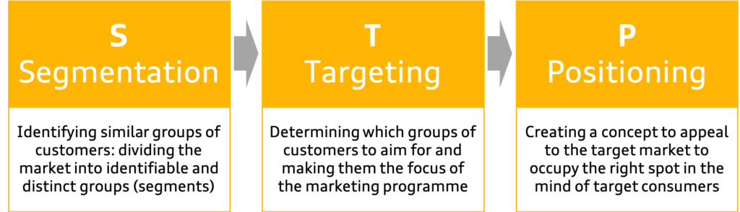
Figure 2: STP model
(Source: Influenced by Camilleri, 2018)
The segmentation strategy used by ADIDAS is determined by the demographic along with social factors of its consumers. Furthermore, the organisation focuses on meeting the needs of a wide range of demographics. The key target of ADIDAS is the youth with its major focus on adults between the age group of 13-40 years who belong to upper middle class and luxury class of consumers (Adidas.de, 2019). It has also been identified that the ADIDAS is positioned as a brand with a distinctive image which provides high quality of products to its consumers. Furthermore, the brand has been successful in maintaining its positive brand image.

Role of the marketing mix
Marketing Mix 4P’s
Marketing mix of a company helps in the analysis of the strategies that they adopt to deliver their services to their customers. In this section, the study would be dealing with the marketing 4ps that ADIDAS applies in order to incorporate their business tactics.
Product | ADIDAS values their Sportive products over other products since the sporting market is one of the essential ones for the customer's it obtains the position of a regular use basis. Therefore, customers’ would expect ADIDAS to provide them with high-quality products for their daily use. Since the company deals with sporting products, it is their responsibility to monitor the reactions of the customer after the usage of the products and hence take measures on improving their quality as well as supplies.
Price | The pricing of a product for the manufacturing industry of Germany is a very essential and crucial factor. Because of the presence of various competitive companies for ADIDAS, it is the responsibility of the company to provide the customer with high-quality products with the maintenance of its values. Therefore, keeping the balance of the quality of product the company must deliver affordability in the pricing of their product.
Place | The placement of stores and supermarkets is a necessary criterion for a successful business executive in the sportswear industry of Germany. Therefore, ADIDAS must develop several stores near areas where there would be gaining a huge mass of customers. For instance, if ADIDAS develops a supermarket near a rural location then it would be irrelevant to expect a huge mass of customers. Hence, the place of marketing for ADIDAS in global urban areas helps to gain a competitive advantage in business.
Promotion | The use of Facebook in Germany has been observed to be at a very high rate than any other countries. With the help of this platform, ADIDAS is required to promote their products through social media, such as Facebook, or any other similar platforms such that their product would be advertised through a vast location. In this way, the company would not only be able to gain a mass of customers but also gain a competitive advantage over others.
Table 3: 4P’s of Marketing mix
(Source: Influenced by Thieu et al. 2017)
Comparison between the macro environments with Porter’s 5 forces
Based on the various aspects that have been studied from the porter's five forces and the macro environment of the company’s location, it could be concluded that the company meets various challenges that restrict them from evaluating their business. In other words, as exclaimed by Ahmad (2018), the political forces of the macro-environment prevent the business from expanding globally.

Role of marketing in creating value for customers
Social Marketing concept
The social marketing concept focuses on identifying the social position held by an organisation. As identified from the above analysis of the marketing mix utilised by ADIDAS, the social position held by the organisation is significantly positive. This has helped the company to develop a positive as well as strong image for itself in the prevalent market. Furthermore, this marketing concept aims to determine the requirements and considerations made by a company for the long term benefit of the society. ADIDAS conducts its operations in a sustainable manner and has a high sense of social responsibility.
Advantages of branding
The rise in market competition has made marketing a significantly crucial part of creating a unique presence in the market. According to Dumitriu et al. (2015), effective branding ensures that an organisation is able to hold a significant position in a saturated market. Moreover, it facilitates the development of credibility for the brand and creating a unique identity which customers associate it with. ADIDAS has been able to develop an effective and unique image for its brand which is popular and holds a significantly high amount of equity in the market.
Ansoff matrix Strategies
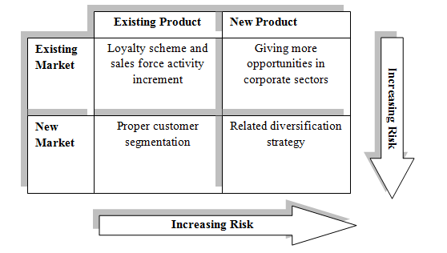
Figure 1: Ansoff matrix
(Source: Created by author)
ADIDAS develops Ansoff matrix to develop their strategy in obtaining a competitive position in the market. With the help of this matrix, it could be understood that the risk management of ADIDAS’s business execution could be efficiently
Relationship marketing
Companies that deal with customer satisfaction needs are required to consider them as the core of their business functionality. Therefore, as concluded by Zhang et al. (2016), the performance of the organisation deliberately depends upon how the organisation facilitates their customers. In the case of ADIDAS, it has been reported that the company provides a loyal relationship with its customers by delivering high-quality products at a lower price. In this way, the company is able to maintain a sustainable position in the market. With the help of relationship marketing, the company is able to directly focus on managing its customers through strong relationships. As opined by Sheth (2017), relationship marketing is facilitated by communicating with the customers and enquires about their reactions and feedback about the product that they buy from that company. The relationship marketing strategy provides ADIDAS with the upper hand of developing a relationship with the suppliers as well as the customer. Internal as well as the external environment of the markets are drastically affected by the relationship that the company possess (Baines et al. 2014).

Impact of Stakeholder engagement on the marketing activities
Definition
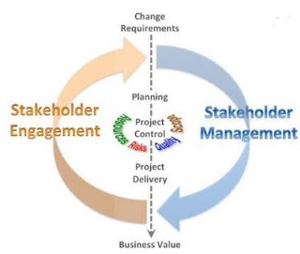
Figure 2: Stakeholder engagement
(Source: apm.org.uk, 2019)
Stakeholders could be considered as the participants of a business organization that directly or indirectly affects the execution of the business. According to Lim and Greenwood (2017), the engagement of stakeholders in the marketing environment of an organisation effectively changes its performance level from a lower position to a higher one.
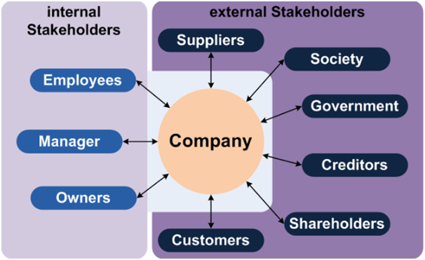
Figure 3: Identification of stakeholders
(Source: finance-ni.gov.uk, 2019)
Internal Stakeholders
The internal stakeholders of ADIDAS could be identified as the following.
Stakeholders | Roles
Employees | ADIDAS provides its employees with suitable training such that they are capable of maintaining sustainable manufacturing processes.
Managers | The manager of ADIDAS provides adequate leadership to the employees working under him to operate their business processes.
Owners | The owners of ADIDAS are the shareholders whose investments are used for the manufacturing processes of the organisation's productions.
Table 4: Internal stakeholders
(Source: Influenced by Brunton et al. 2017)
External Stakeholders
The external stakeholders of ADIDAS could be identified as the following.
Stakeholders | Roles
Suppliers | The involvement of suppliers help in the production procedure in an enhanced way
Society | ADIDAS’s way of marketing is directly affected by the societal changes that occur within their marketing environment
Government | The involvement of various governmental organisations helps in usage of the legal practices of the marketing tactics for ADIDAS
Customers | Customers play the major role of the stakeholders the whole business of ADIDAS depends on the reactions and involvement of customers.
Table 5: External stakeholders
(Source: Influenced by Cardwell et al. 2017)
Impacts on marketing activities
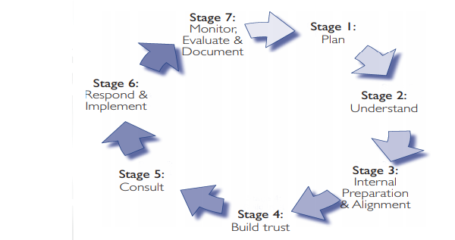
Figure 4: Impacts of stakeholders
(Source: finance-ni.gov.uk, 2019)
The involvement of stakeholders within a business environment facilitates various processes that undergo the decision making phase. As influenced by Barrett et al. (2016), with the engagement of decisions from a vast source of stakeholders, it becomes possible for a company to develop chances of threats and opportunities that the company would be able to tackle during its operations. ADIDAS includes its stakeholders on decision-making sessions such that there would be able to develop relevant knowledge about the changes that they need to incorporate in order to continue their business. For instance, the reactions of the customers are to be considered as major informative data because it defines the quality of the services that the company provides.

Task 1B:

Definition
In order to incorporate an effective business operation, it is important to generate a communication medium such that all the participants of the business would be able to communicate with each other. Therefore, it can be stated that communication is a tool that is essential for an organisation to achieve success by an organisation.

Communication Model
The development of a communication model is necessary as it facilitates the communication between the employees and the higher executives of a business organisation.
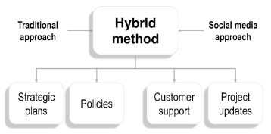
Figure 5: Communication model
(Source: Influenced by Barnlund, 2017)
A communication model could be classified into three categories based on its application. In the case of ADIDAS, the communication model that is being used by them is the interactive model. As stated by Assadi et al. (2016), with the help of this model, there exists a bidirectional communication mechanism through which the business executives are able to instruct the employees, as well as the employees, could place their queries to be resolved by the authorities. In this way, effective communication is maintained between them.

Integrated Marketing Communication
The communication model that the company, ADIDAS uses for its communicating medium is incorporated with the integrated marketing communication. According to Finne and Grönroos (2017), the concept of integrated marketing communication state that the communication mechanisms that are applied by the company are clearly linked with one another. In other words, the links between the communicating entities provide relevant information about the structural and functional units of the company. This enhances the production procedures as well as the delivery of services and goods to the customer (Blythe, 2014). The introduction of various video graphic promotional methods has enhanced the marketing communication in an integrated way. With the implication of blog posts by various organisations helped in providing relevant information about the products to the customers.

Utilisation of combination of promotion strategies used by ADIDAS
ADIDAS uses social media as the basis of promotional constraint to deliver information about the products they manufacture and launch. Through the help of this technology, the company is able to extend its business through various nations all over the world. The positive impacts of this mechanism provide the company to attract a mass of customers towards their product hence developing a sustainable market position globally. Apart from social media, ADIDAS uses advertising as an effective promotional process for reaching a wide demographic of consumers. Through the use of both social media and traditional forms of promotion, ADIDAS is able to increase the awareness associated with the brand and reach a wider number of consumers in the global market.

Strengths and weaknesses of the promotional strategy
The key strengths that ADIDAS has due to the use of an integrated promotional strategy are that it is able to gain access to a wider demographic of consumers at an international scale. According to Keller (2016), use of a combination of promotional strategies ensures that the brand is able to establish its presence in the market and generate awareness about the products sold by them.
However, the drawbacks of using social media as a promotional tool for ADIADAS is that it cannot control the type of comments that are posted by the consumers. The use of traditional advertising forms as promotional means is expensive and does not provide two way communications with consumers. Through the effective use of social media, ADIDAS would be able to communicate with its consumers and increase their engagement and satisfaction levels.

Conclusion and Recommendations
Based on the various aspects that have been reflected through this study, it could be concluded that ADIDAS adopts several strategies that help them to manage their business operation and retain their customer’s trust. Marketing could be considered as a business that lets both sides satisfaction including the organisation as well as the addressed individuals that is the customer. Therefore it could be stated that marketing is a buyer-seller perspective process that involves production of sportswear that an organization provides to retain and strive the lifetime loyalty of customers. Therefore, it is necessary to develop a bonding between the customers and other stakeholders of the company to obtain a sustainable position in the marketing environment. ADIDAS is recommended to obtain a database from the stakeholders including the customers well as the suppliers such that their sustainability of the business is maintained along with revenue growth.

Reference List
Adidas.de (2019). CYBER WOCHE – BIS ZU 65 % RABATT. Available at: https://www.adidas.de/ [Accessed on 13.11.2019]
Ahmad, N., (2018). The Internet, Social Media, and Knowledge Production and Development of Political Marketing. In Social Media Marketing: Breakthroughs in Research and Practice (pp. 1465-1496). IGI Global.
Apm.org.uk (2019). What is stakeholder engagement?. Available at: https://www.apm.org.uk/resources/find-a-resource/stakeholder-engagement/ [Accessed on: 15.11.2019]
Armstrong, G.M., Kotler, P., Harker, M.J. and Brennan, R., (2018). Marketing: an introduction. Eds. 2. London: Pearson UK.
Assadi, S., Khanna, S., Li, Y. and Yaroslavtsev, G., (2016). Maximum matchings in dynamic graph streams and the simultaneous communication model. In Proceedings of the twenty-seventh annual ACM-SIAM symposium on Discrete algorithms (pp. 1345-1364). Society for Industrial and Applied Mathematics.
Baines, P., Fill C., Page, K., (2014) Marketing, Oxford, 2nd edition
Barnlund, D.C., (2017). A transactional model of communication. In Communication theory (pp. 47-57). Routledge.
Barrett, M., Oborn, E. and Orlikowski, W., (2016). Creating value in online communities: The sociomaterial configuring of strategy, platform, and stakeholder engagement. Information Systems Research, 27(4), pp.704-723.
Blythe, J., (2014), Principles and Practice of Marketing, 3rd edition, Sage
Brunton, M., Eweje, G. and Taskin, N., (2017). Communicating corporate social responsibility to internal stakeholders: Walking the walk or just talking the talk?. Business Strategy and the Environment, 26(1), pp.31-48.
Bull, J.W., Jobstvogt, N., Böhnke-Henrichs, A., Mascarenhas, A., Sitas, N., Baulcomb, C., Lambini, C.K., Rawlins, M., Baral, H., Zähringer, J. and Carter-Silk, E., (2016). Strengths, Weaknesses, Opportunities and Threats: A SWOT analysis of the ecosystem services framework. Ecosystem services, 17, pp.99-111.
Camilleri, M.A., (2018). Market segmentation, targeting and positioning. In Travel Marketing, tourism( economics and the airline product. Eds. 4. Cham: Springer.
Cardwell, L.A., Williams, S. and Pyle, A., (2017). Corporate public relations dynamics: Internal vs. external stakeholders and the role of the practitioner. Public Relations Review, 43(1), pp.152-162.
Destatis.de (2019). Our topics. Available at: https://www.destatis.de/EN/Home/_node.html [Accessed on 14.11.2019]
Dumitriu, D., Voicu, P., Mihai, P. and Ioanid, A., (2015). Competitive marketing advantages in online businesses. In International Conference on Management and Industrial Engineering. Eds. 7. Bucharest: Niculescu Publishing House.
Finance-ni.gov.uk (2019). Stakeholder engagement within a programme or project. Available at: https://www.finance-ni.gov.uk/articles/programme-and-project-stakeholders [Accessed on 13.11.2019]
finance-ni.gov.uk (2019). Stakeholder engagement within a programme or project Available at: https://www.finance-ni.gov.uk/articles/programme-and-project-stakeholders [Accessed on 16.11.2019]
Finne, Å. and Grönroos, C., (2017). Communication-in-use: customer-integrated marketing communication. European Journal of Marketing, 51(3), pp.445-463.
Gürel, E. and Tat, M., (2017). SWOT analysis: A theoretical review. Journal of International Social Research, 10(51), pp. 45-76.
Keller, K.L., (2016). Unlocking the power of integrated marketing communications: how integrated is your IMC program?. Journal of Advertising, 45(3), pp.286-301.
Kotler P, Armstrong G, Harris, L, Piercy, N., (2017), Principles of Marketing, 7th Edition, Pearson
Lim, J.S. and Greenwood, C.A., (2017). Communicating corporate social responsibility (CSR): Stakeholder responsiveness and engagement strategy to achieve CSR goals. Public Relations Review, 43(4), pp.768-776.
Santos, D.F., (2017). Adidas Group: equity valuation thesis (Doctoral dissertation).
Sheth, J., 2017. Revitalizing relationship marketing. Journal of Services Marketing, 31(1), pp.6-10.
Thieu, B.T., Hieu, N.T.M., Le Huyen, N.T., Binh, P.C. and Hoang, N.V., (2017). Linkages between Marketing Mix Components and Customer Satisfaction: An analysis on Google in Hanoi, Vietnam. Journal of Economics & Business Research, 23(1).
Widya Yudha, S., Tjahjono, B. and Kolios, A., (2018). A PESTLE policy mapping and stakeholder analysis of Indonesia’s fossil fuel energy industry. Energies, 11(5), p.1272.
Zhang, J.Z., Watson Iv, G.F., Palmatier, R.W. and Dant, R.P., (2016). Dynamic relationship marketing. Journal of Marketing, 80(5), pp.53-75.

