4/24/2026
University of Wales Trinity Saint David
London campus
Module Name: Scripting and Programming Concepts
Module Code: ACCA 5036

Student Name: Higor Scaffi Dutra do Nascimento
Student ID: 2413595

Lecturer’s Name: Koushik Modak

SPC Assignment on
Student Equipment Booking System
Code Link: https://github.com/hscaffi/Assigment1_ID2413595.git

Table of Contents
Introduction 2
Main Body 3
1. Analysis 3
Data Structures 4
Summary 5
Summary 5
2. Software Design and Development 6
Design: 6
Figure 1: Student Equipment Booking System Flowchart 7
Implementation Decisions 9
Source Code 10
3. Testing and Debugging Report 11
a) Importance of Testing 11
b) Types of Errors 12
c) Test Cases 12
4. Evaluation 14
Conclusion 16
References 17
Appendices 18

Introduction
Bright Minds Academy currently manages classroom equipment bookings using a manual paper-based system. This approach often leads to issues such as double bookings, missing records, and difficulty tracking equipment availability. As the number of students and tutors increases, the system becomes inefficient and prone to human error. Additionally, searching through paper records is time-consuming and unreliable, making it difficult for staff to quickly check equipment availability.
To improve this process, a Student Equipment Booking System has been developed using Python. This system replaces the manual method with a digital solution that allows users to view equipment, add new items, record bookings, and search booking records. By automating these tasks, the system reduces errors and improves efficiency.
Python was chosen for this project because of its simplicity and powerful built-in data structures, such as lists and dictionaries, which allow efficient data management without requiring a database [4]. The system was developed following structured software engineering principles, including analysis, design, implementation, testing, and evaluation. According to Sommerville, structured development ensures that software systems are reliable and meet user requirements [1].
Overall, the Student Equipment Booking System provides a practical and efficient solution, improving organisation and reducing errors in equipment management.

Main Body
- Analysis
• Requirements Analysis

The purpose of this system is to provide a simple and efficient way for Bright Minds Academy to manage equipment bookings. The system must meet several functional and non-functional requirements in order to operate effectively.

Functional Requirements
- Add new equipment: Staff members must be able to input new items such as laptops or projectors into the system. This ensures that the system can be updated when new equipment is purchased.
- Record bookings: Staff must be able to assign a piece of equipment to a student for a specific date. This is one of the most important features, as it replaces the manual booking process currently used by the academy.
- View booking records: Users must be able to see all bookings stored in the system. This allows staff to check which equipment is already booked and avoid scheduling conflicts.
- Search bookings: The system allows users to search using either a student name or equipment name. This improves efficiency by making it easier to find specific records.
- The system also allows users to view, search, and remove equipment. These features ensure that the equipment list remains accurate and up to date.

Non-Functional Requirements
In addition to functionality, the system must meet several quality criteria:
- Reliability: The system must be reliable, meaning that it should store booking data accurately and consistently. This is achieved through validation checks that prevent incorrect data entry, such as empty inputs or invalid dates.
- Usability: Another requirement is usability. The system uses a menu-driven interface that allows users to easily select options. This ensures that staff members without advanced technical knowledge can use the system effectively.

- Performance: The system must also provide good performance. Since it is a small-scale application using lists and dictionaries, operations such as searching and displaying records are completed quickly.
- Maintainable: The system must also be maintainable. The program is divided into functions, making it easier to update or expand in the future. Modular programming improves readability and simplifies debugging.

Data Structures
The system uses multiple data structures to store information. A dictionary is used to store student data, where each student is associated with a unique ID. Another dictionary is used to store book data. A list is used to store all equipment items, including laptops, books, tablets, projectors, and accessories.
Booking records are stored as dictionaries inside a list. Each booking contains a student name, equipment name, and booking date. This structure allows flexible data storage and easy searching.
According to the Python Software Foundation, lists and dictionaries are commonly used for storing and managing collections of data in Python [3][4].

Summary
Abstraction is used to simplify the problem by focusing only on essential elements. The system includes students, equipment, and bookings. Other features such as authentication are not included.
Decomposition is used to break the system into smaller parts. These include functions for viewing data, adding equipment, recording bookings, and searching.
This approach improves clarity and organisation.

Summary
The analysis stage identifies the main requirements of the system and defines how the problem will be solved. The Student Equipment Booking System provides a structured solution that improves efficiency, reduces errors, and replaces the manual booking process. The system demonstrates the use of Python data structures, modular programming, and validation techniques, which align with standard software engineering practices [2].

2. Software Design and Development
Design: The design of the Student Equipment Booking System focuses on simplicity, clarity, and functionality. The system follows a menu-driven structure, which allows users to interact with the program through clearly defined options. This type of design is particularly suitable for small-scale applications because it provides an organised and user-friendly interface.
The system operates using a continuous loop, which ensures that the program does not terminate after a single operation. Instead, the user is returned to the main menu after completing each task. This design improves usability because it allows multiple actions to be performed without restarting the program.
The overall structure of the system can be divided into three main components:
- Input Handling – where the user selects options and enters data
- Processing Logic – where the system performs operations such as searching or validating data
- Output Display – where results are shown to the user
This structured approach ensures that the system behaves predictably and is easy to understand.
    - Flowcharts: The flowchart represents the logical flow of the program from start to finish. It begins with the Start symbol, followed by the display of the menu. The user is then prompted to enter a choice.
    - A decision node is used to check whether the input is valid. If the input is invalid, an error message is displayed, and the system returns to the menu. If the input is valid, the system follows the corresponding branch based on the selected option.
    - Each branch represents a specific function, such as viewing equipment or recording a booking. After completing the selected task, the system loops back to the main menu. This loop continues until the user selects the exit option, at which point the program terminates.
    - Flowcharts are useful because they provide a visual representation of program logic. According to Ian Sommerville, visual models such as flowcharts help developers understand and communicate system behaviour more effectively [1].

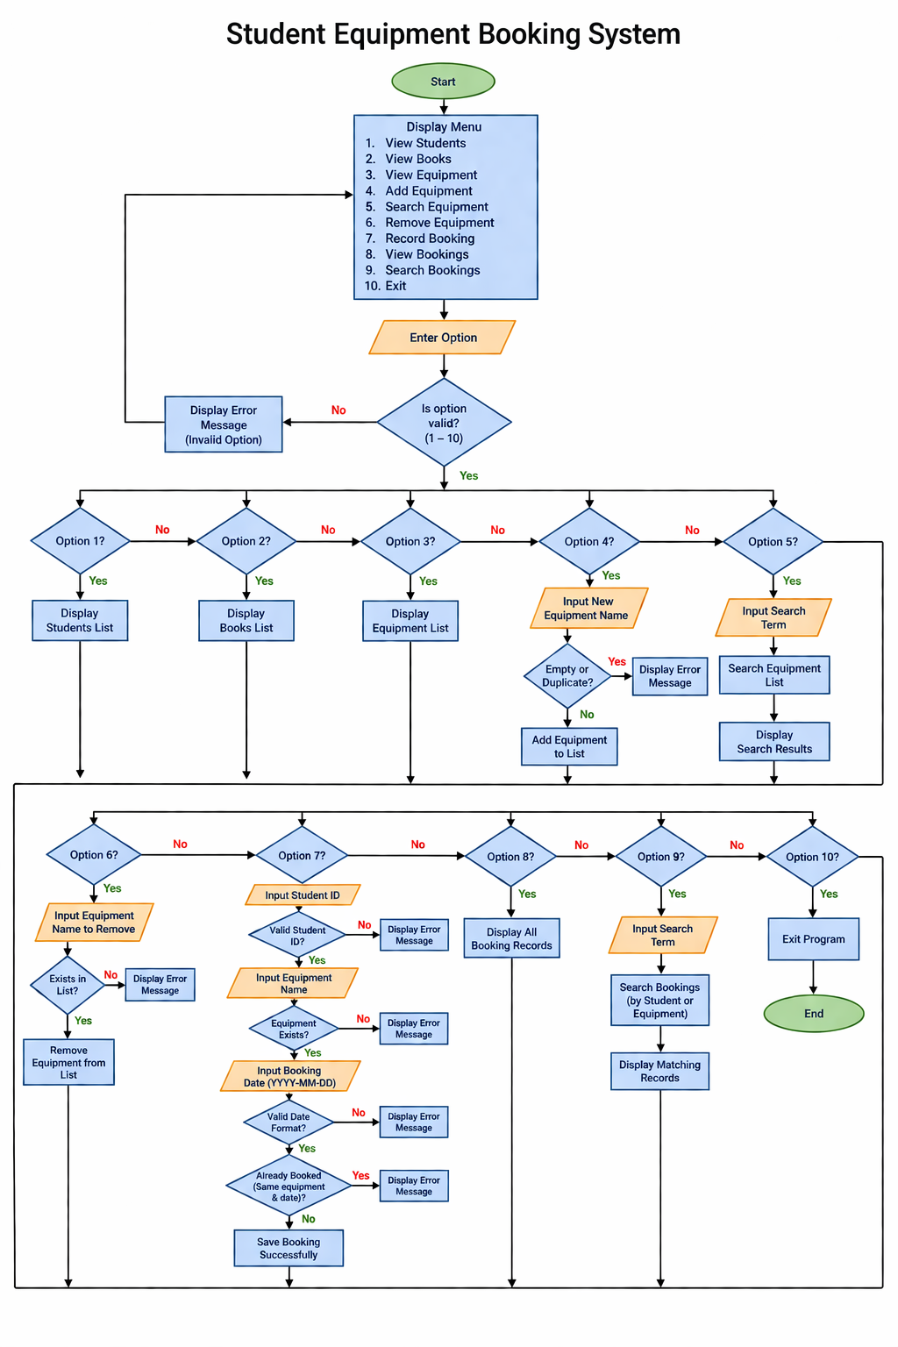
Figure 1: Student Equipment Booking System Flowchart
- Pseudo-code: Pseudocode is used to represent the logic of the system in a simplified, human-readable format. It helps bridge the gap between the design and implementation stages.

BEGIN
DISPLAY menu
REPEAT
INPUT user choice
IF choice = 1
DISPLAY students
ELSE IF choice = 2
DISPLAY books
ELSE IF choice = 3
DISPLAY equipment
ELSE IF choice = 4
INPUT new equipment
IF empty OR duplicate
DISPLAY error
ELSE
ADD equipment
ELSE IF choice = 5
INPUT search term
DISPLAY matching equipment
ELSE IF choice = 6
INPUT equipment
IF exists
REMOVE equipment
ELSE
DISPLAY error
ELSE IF choice = 7
INPUT student ID
VALIDATE ID
INPUT equipment
INPUT date
VALIDATE date
CHECK duplicate booking
SAVE booking
ELSE IF choice = 8
DISPLAY bookings
ELSE IF choice = 9
SEARCH bookings
ELSE IF choice = 10
EXIT
UNTIL exit
END

Implementation Decisions
- Data Structures: The system uses different data structures to manage information effectively. A dictionary is used to store student data, where each student is linked to a unique ID. Another dictionary is used for storing book data. A list is used for storing equipment items, and a list of dictionaries is used to store booking records.
- This approach allows structured storage while maintaining flexibility. Lists are suitable for storing collections of items, while dictionaries allow quick access to data using keys. According to the Python Software Foundation, dictionaries are efficient for storing structured data, while lists are useful for ordered collections [4].
- Variables
- The main variables used in the system include:
- students_dict → stores student information
- books_dict → stores book information
- equipment_list → stores all equipment
- bookings → stores booking records
- student_id → identifies selected student
- equipment_name → stores equipment input
- booking_date → stores booking date
- These variables are clearly named to improve readability.

- Programming Constructs: The system uses several programming constructs to control program behaviour.
- Selection statements such as if and elif are used to handle menu options. These allow the program to perform different actions based on user input.
- Loops are used to keep the system running continuously. The while loop ensures that the user can perform multiple operations without restarting the program.
- Functions are used to organise the code into smaller, reusable components. This improves readability and reduces repetition.
- Validation checks are implemented to ensure that user input is correct. For example, the system checks whether a student ID is valid and whether a booking date is correctly formatted.
- According to Roger S. Pressman, modular programming improves maintainability and simplifies debugging [2].

- Python Modules and Libraries: The system uses the built-in datetime module to validate booking dates. This module ensures that dates follow the correct format (YYYY-MM-DD). If the date is invalid, the system displays an error message.
- Using built-in modules simplifies development and improves reliability. The Python documentation confirms that the datetime module is commonly used for date validation and manipulation [5].

Source Code
The source code of the system is structured using functions. Each function performs a specific task, such as displaying equipment or recording bookings. This modular approach makes the code easier to understand and maintain.
The system includes validation to prevent errors. For example, it checks for duplicate equipment entries and prevents double bookings. These features improve reliability and ensure that the system behaves correctly.
The code also uses clear variable names and consistent formatting. This improves readability and makes it easier for other developers to understand the program.

3. Testing and Debugging Report

a) Importance of Testing
Testing is a critical stage in software development because it ensures that the system operates correctly and meets the intended requirements. Without proper testing, errors may remain undetected, which can lead to system failures, incorrect outputs, or poor user experience. In the context of the Student Equipment Booking System, testing is particularly important because the system handles user input and booking data that must remain accurate and consistent.
Testing helps verify that all functionalities, such as adding equipment, searching items, and recording bookings, work as expected. It also ensures that validation rules are correctly implemented. For example, the system must prevent duplicate bookings and reject invalid inputs such as incorrect dates or empty fields. By testing these scenarios, the reliability of the system is improved.
Another important benefit of testing is that it helps identify defects early in the development process. Fixing errors at an early stage is more efficient than addressing them after the system has been fully developed. According to software engineering research, testing plays a key role in improving software quality and reducing the risk of failure [6].
In this project, testing was carried out using different scenarios, including both valid and invalid inputs. This ensures that the system behaves correctly under normal conditions and handles errors appropriately.

b) Types of Errors
During the development of the system, different types of programming errors may occur. Understanding these errors is important for effective debugging and improving system performance.
Syntax errors occur when the code does not follow the rules of the programming language. For example, missing brackets, incorrect indentation, or typing mistakes can cause syntax errors. These errors are usually detected by the Python interpreter before the program runs, making them easier to fix.
Runtime errors occur while the program is executing. These errors happen when the system encounters unexpected input or conditions during operation. For example, entering a non-numeric value where a number is expected may cause the program to fail. Runtime errors can be prevented by implementing validation and error-handling techniques.
Logical errors are more difficult to identify because the program runs without crashing but produces incorrect results. For example, allowing a booking to be recorded even when the equipment is already booked for the same date would be a logical error. These errors require careful testing and analysis to detect.
Debugging is the process of identifying and fixing these errors. In this project, debugging was performed by testing different scenarios, analysing outputs, and correcting the logic where necessary. This helped ensure that the system produces accurate results and behaves as expected.

c) Test Cases
The following test cases were designed to verify that the system functions correctly and handles different types of input. These tests include both normal scenarios and edge cases to ensure that the system is reliable.

Test ID | Description | Input | Expected
T1 | View equipment | Option 3 | List displayed
T2 | Add equipment | New item | Added successfully
T3 | Duplicate equipment | Existing item | Error shown
T4 | Search equipment | “Laptop” | Results displayed
T5 | Remove equipment | “Mouse 1”
  Removed
T6 | Record booking | Valid input | Booking saved
T7 |  | Same equipment/date | Error shown
  Double booking
T8 | Invalid student ID | Wrong ID
  Error
T9 |  | Student format | Error
  Invalid date
T10 | Search booking | Student name | Record displayed
(Screenshots of the testes shown in the appendices at the end.)

4. Evaluation
• Challenges Faced: During the development of the Student Equipment Booking System, several challenges were encountered. One of the main difficulties was designing a system that remained simple while still including all the required functionality. Since the assignment required the use of lists and dictionaries instead of a database, it was necessary to carefully plan how data would be stored and managed. Initially, organising bookings in a clear and structured way was challenging, especially when trying to link student information with equipment and booking dates.
Another significant challenge was implementing effective validation. Ensuring that users could not enter incorrect or incomplete data required multiple checks throughout the program. For example, the system needed to verify that student IDs were valid, equipment existed in the list, and booking dates followed the correct format. Additionally, preventing double bookings required comparing existing records to new inputs, which increased the complexity of the logic.
Handling user input errors was also a challenge. Since the program relies on user interaction, it was important to ensure that invalid inputs, such as empty values or incorrect menu selections, did not cause the system to crash. This required the use of conditional statements and error messages to guide the user.
Another challenge was structuring the program using functions. Breaking the system into smaller parts required careful planning to ensure that each function performed a specific task without overlapping responsibilities. This was important for maintaining clarity and readability in the code.
These challenges were addressed through testing and debugging. By running multiple test cases and analysing the results, it was possible to identify errors and improve the system. This process helped ensure that the final program was stable and met the required functionality.
• Future Improvements: Although the current system meets the basic requirements, there are several ways in which it could be improved in the future. One major improvement would be the addition of a graphical user interface (GUI). The current system uses a text-based menu, which may not be user-friendly for all staff members. A GUI would provide buttons, forms, and visual elements that make the system easier to use.
Another improvement would be the use of a database. Currently, all data is stored in memory, which means that information is lost when the program is closed. By integrating a database such as MySQL or SQLite, the system could store data permanently, allowing users to access previous bookings at any time.
The system could also be expanded to include user authentication. This would allow different staff members to log in with unique accounts, improving security and accountability. Access levels could be introduced to restrict certain actions to authorised users only.
Additional features could include editing and deleting bookings. At present, once a booking is recorded, it cannot be modified. Allowing users to update or cancel bookings would improve flexibility.
Another possible improvement is the introduction of automated notifications. For example, the system could alert users when equipment is frequently booked or when availability is limited. This would help staff manage resources more effectively.
Overall, these improvements would enhance the functionality, usability, and scalability of the system, making it more suitable for real-world applications.

• Self-Reflection: This project has significantly improved my understanding of programming and software development. One of the most important skills I developed was the ability to break down a problem into smaller, manageable parts. By using decomposition, I was able to design functions that handled specific tasks, making the program more organised and easier to develop.
I also gained practical experience in using Python data structures such as lists and dictionaries. Before this project, I had a basic understanding of these concepts but applying them in a real system helped me understand how they can be used to store and manage data effectively. I learned how dictionaries can be used to represent structured data, while lists can be used to store collections of items.
Another important area of learning was input validation. I realised that user input cannot be trusted and must always be checked. Implementing validation helped me understand how to prevent errors and improve system reliability. This is an important concept in real-world software development.
The project also improved my debugging skills. When errors occurred, I had to carefully analyse the code to identify the cause and fix the issue. This process required patience and logical thinking, which are essential skills for a programmer.
Additionally, I learned the importance of writing clear and readable code. Using meaningful variable names and organising the program into functions made the code easier to understand and maintain.
Overall, this project helped me grow as a developer by improving both my technical skills and problem-solving abilities. It also gave me a better understanding of how software systems are designed and implemented.

Conclusion
The Student Equipment Booking System provides a practical and effective solution to the problems identified in the Bright Minds Academy scenario. The original manual booking system was inefficient and prone to errors, particularly when managing multiple pieces of equipment and users. By developing a computer-based system, these issues have been significantly reduced.
The system successfully implements key features such as viewing equipment, adding and removing items, recording bookings, and searching records. These features allow staff to manage equipment more efficiently and ensure that resources are allocated correctly. The inclusion of validation checks improves reliability by preventing incorrect data entry and reducing the risk of double bookings.
The use of Python as the programming language proved to be an appropriate choice for this project. Its simple syntax and built-in data structures allowed the system to be developed efficiently without unnecessary complexity. Lists and dictionaries were used effectively to store and manage data, demonstrating a clear understanding of programming concepts.
The project also highlights the importance of following a structured software development process. By progressing through stages such as analysis, design, implementation, testing, and evaluation, it was possible to develop a system that meets user requirements and functions correctly.
Although the system is relatively simple, it provides a strong foundation for further development. With additional features such as a graphical interface, database integration, and user authentication, the system could be expanded into a more advanced application.
In conclusion, the Student Equipment Booking System demonstrates how programming can be used to solve real-world problems. It improves efficiency, reduces errors, and provides a structured approach to managing equipment bookings. The project also reflects the learning and development of programming skills throughout the course.

References
[1] I. Sommerville, Software Engineering, 10th ed. Harlow, U.K.: Pearson, 2016.
[2] R. S. Pressman and B. R. Maxim, Software Engineering: A Practitioner’s Approach, 9th ed. New York, NY, USA: McGraw-Hill, 2020.
[3] Python Software Foundation, “The Python Tutorial,” Python Documentation.
[4] Python Software Foundation, “Data Structures,” Python Documentation.
[5] Python Software Foundation, “datetime — Basic date and time types,” Python Documentation.
[6] D. Gelperin and W. C. Hetzel, “The growth of software testing,” Communications of the ACM, 1988.
Appendices
Each test case was designed to evaluate a specific function of the system. Test case T1 ensures that the equipment list is displayed correctly, confirming that the data is stored and accessed properly. Test cases T2 and T3 verify that the system correctly handles adding new equipment and prevents duplicate entries, which is important for maintaining data integrity.
Test case T4 checks the search functionality, ensuring that the system can locate equipment based on user input. Test case T5 verifies that equipment can be removed successfully, confirming that the system updates the list correctly.
Test cases T6 and T7 focus on the booking functionality. T6 ensures that valid bookings are recorded, while T7 verifies that the system prevents double bookings. This is a key requirement of the system, as it avoids conflicts in equipment usage.
Test cases T8 and T9 evaluate validation. T8 checks whether the system correctly handles invalid student IDs, while T9 ensures that incorrect date formats are rejected. These tests confirm that the system can handle user input errors effectively.
Finally, test case T10 verifies that the booking search function works correctly, allowing users to retrieve records based on student names.
Overall, the testing process demonstrates that the system performs reliably under both normal and incorrect conditions. Validation and error handling ensure that the system maintains accurate data and provides appropriate feedback to users.

T1: View Equipment
This test shows that the system successfully displays all available equipment stored in the list.
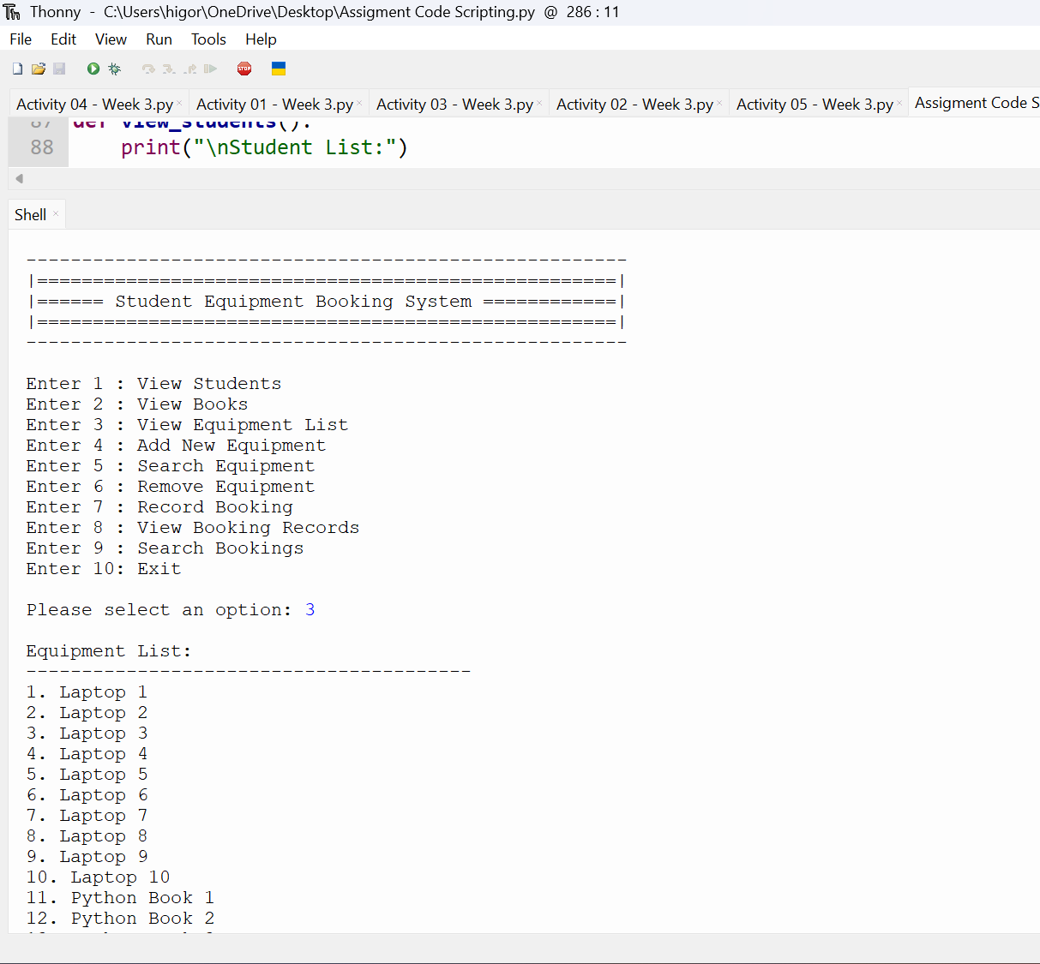
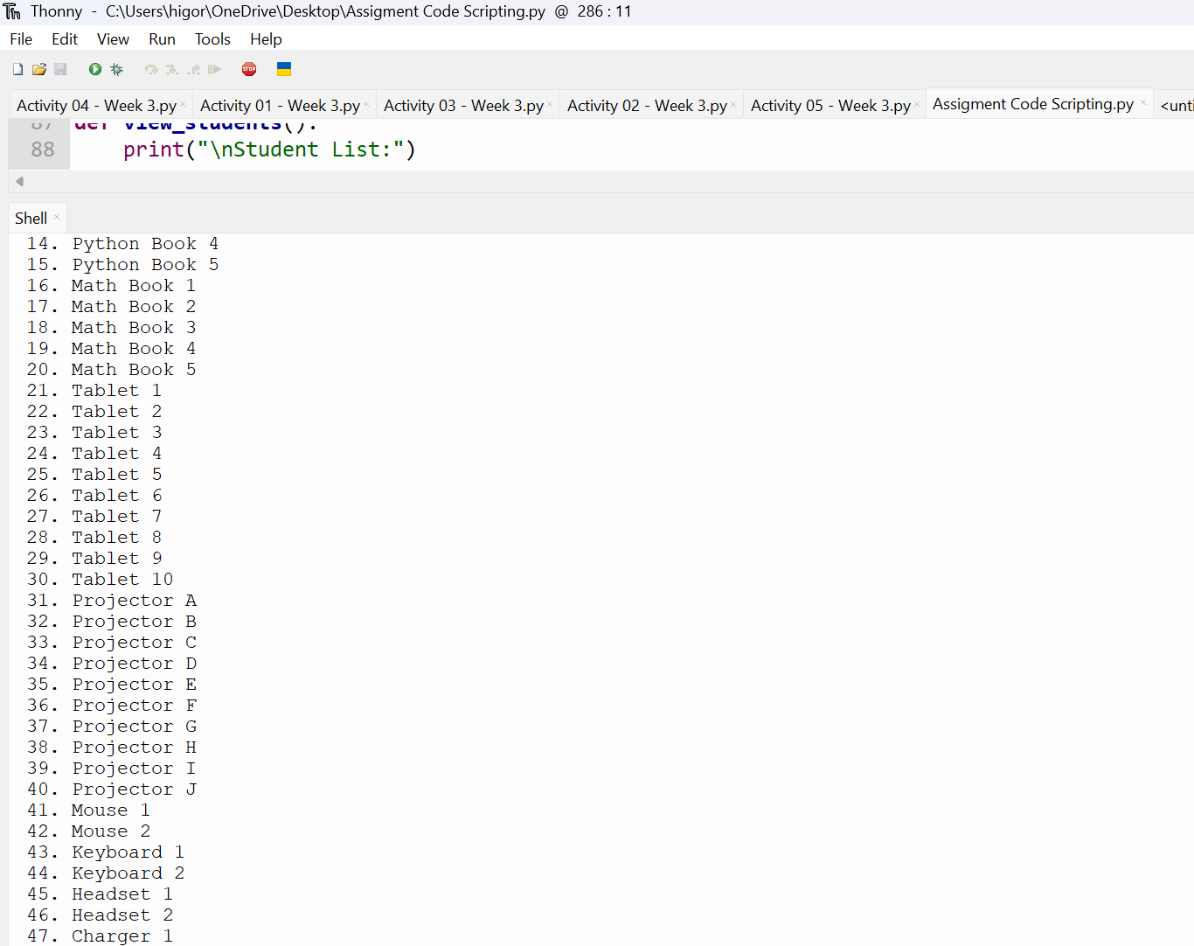
Figure 2.

Figure 3.
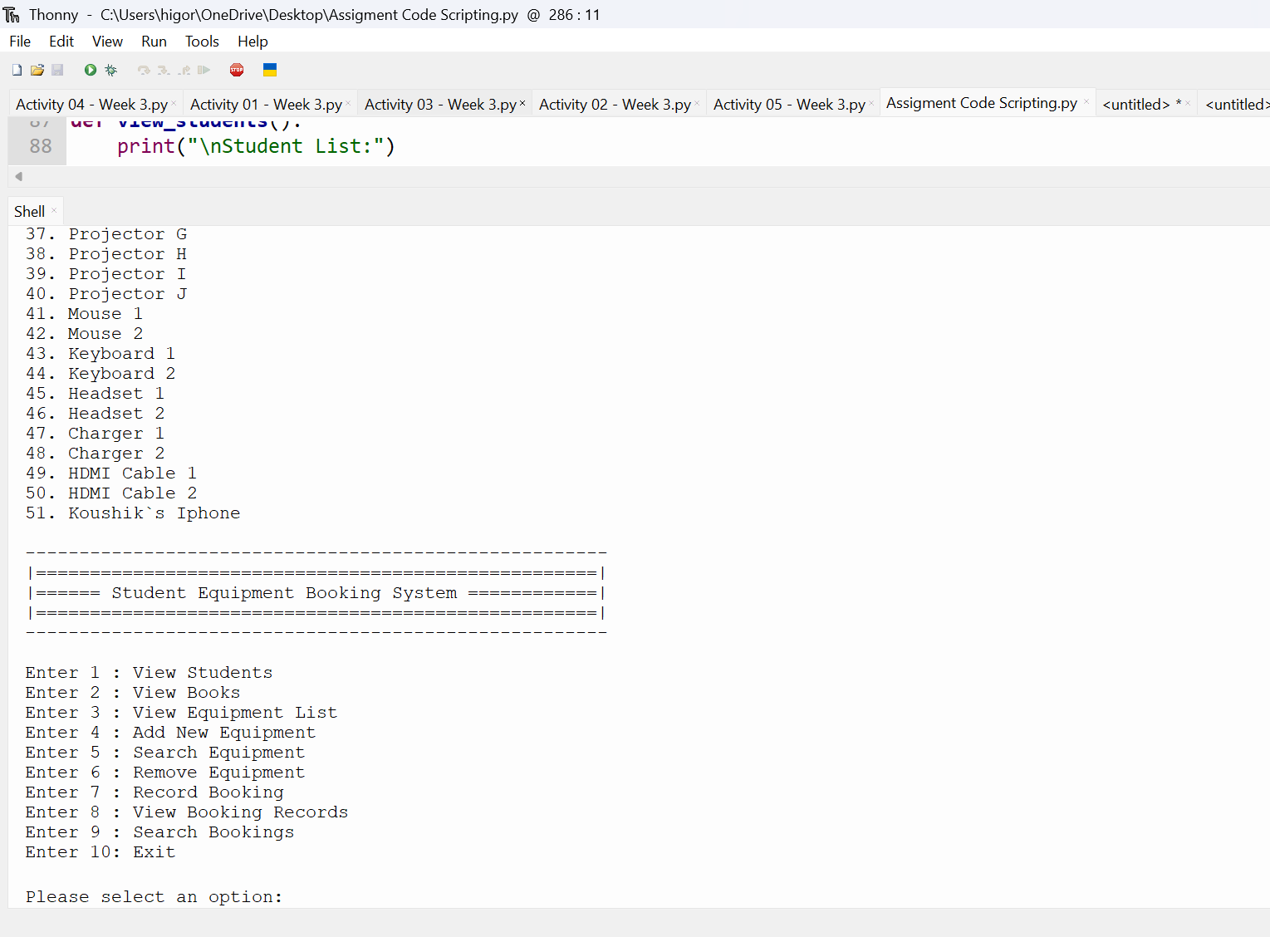
Figure 4.
T2: Add Equipment
This test confirms that a new equipment item can be added correctly to the system.
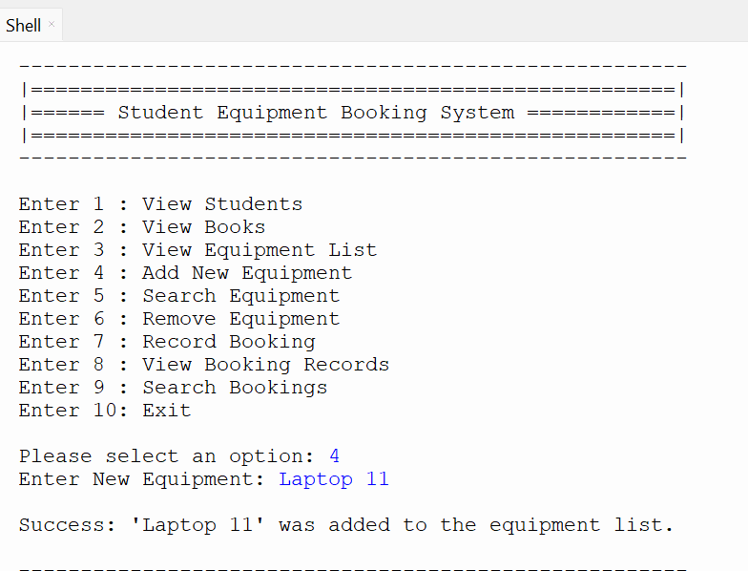

Figure 5.

T3: Duplicate Equipment
This test demonstrates that the system prevents duplicate equipment from being added, ensuring data accuracy.
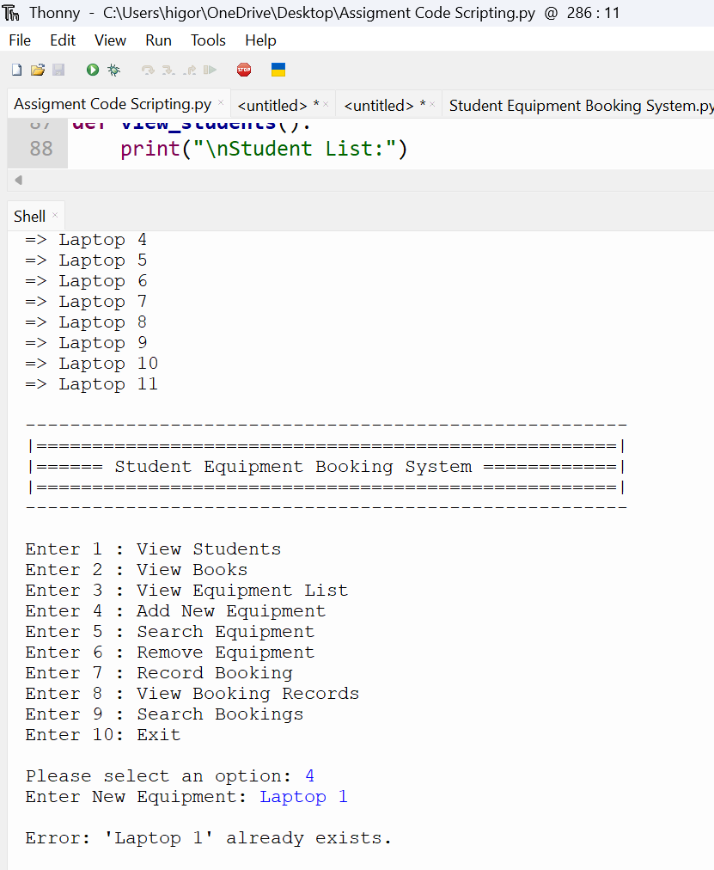

Figure 6.

T4: Duplicate Equipment
This test verifies that the search function correctly displays matching equipment based on user input.
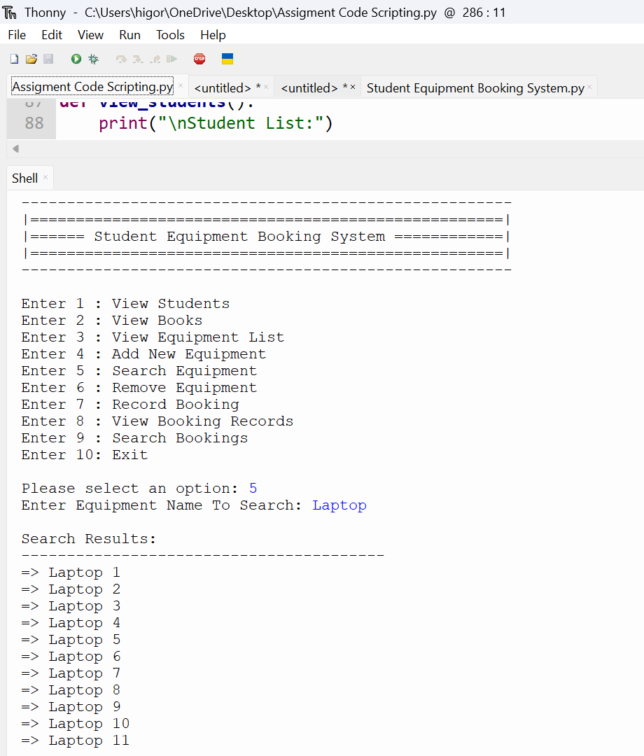
Figure 7.

T5: Remove Equipment
This test confirms that an equipment item can be successfully removed from the system.
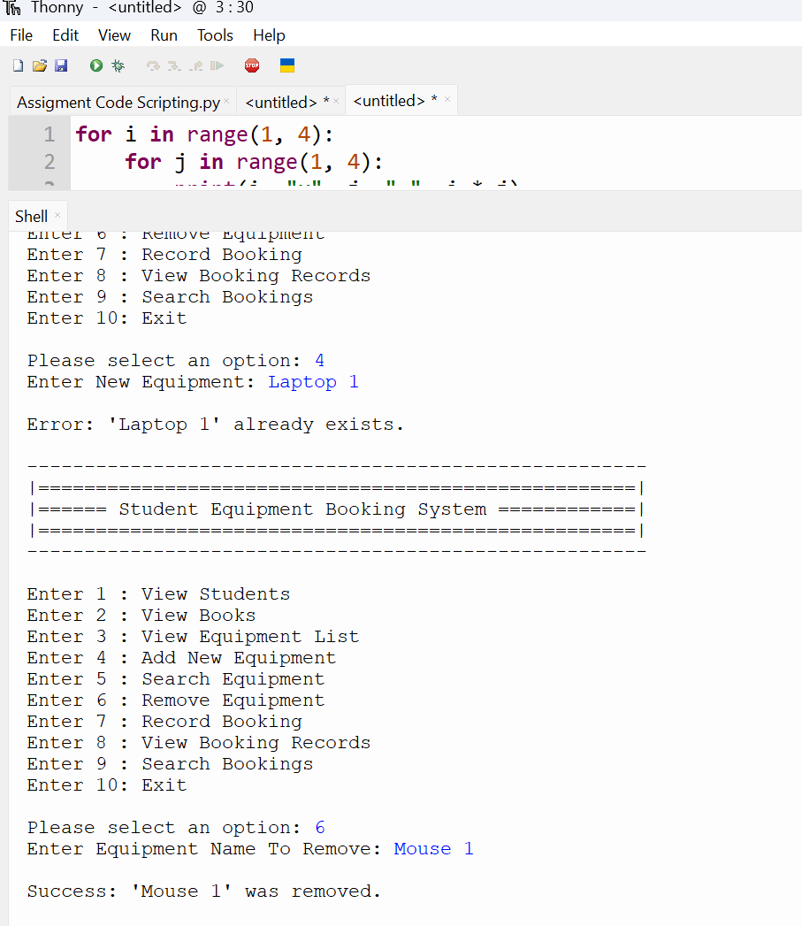
Figure 8.

T6: Record Booking
This test shows that a valid booking is recorded successfully with correct student, equipment, and date.
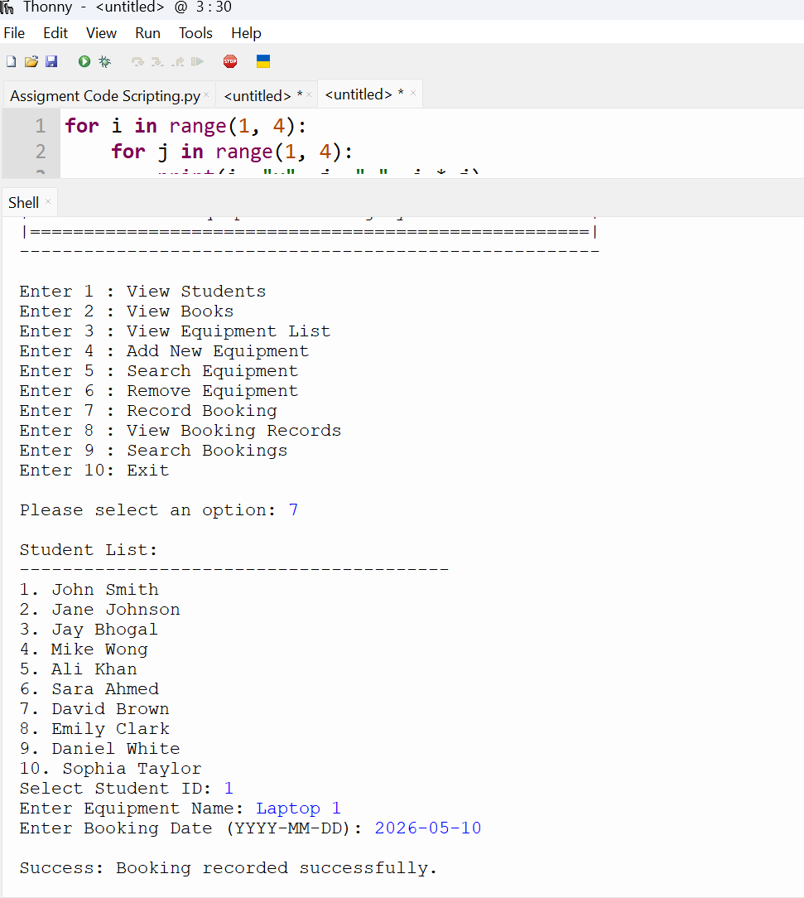
Figure 9.

T7: Double Booking
This test demonstrates that the system prevents duplicate bookings for the same equipment and date.
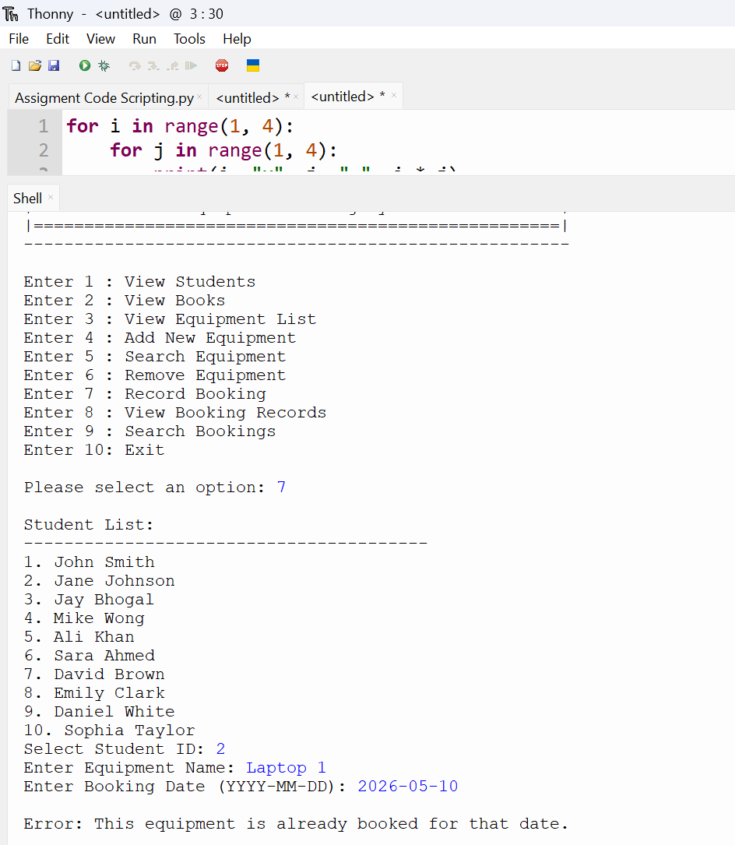
Figure 10.

T8: Invalid Student ID
This test confirms that the system detects and rejects an invalid student ID.
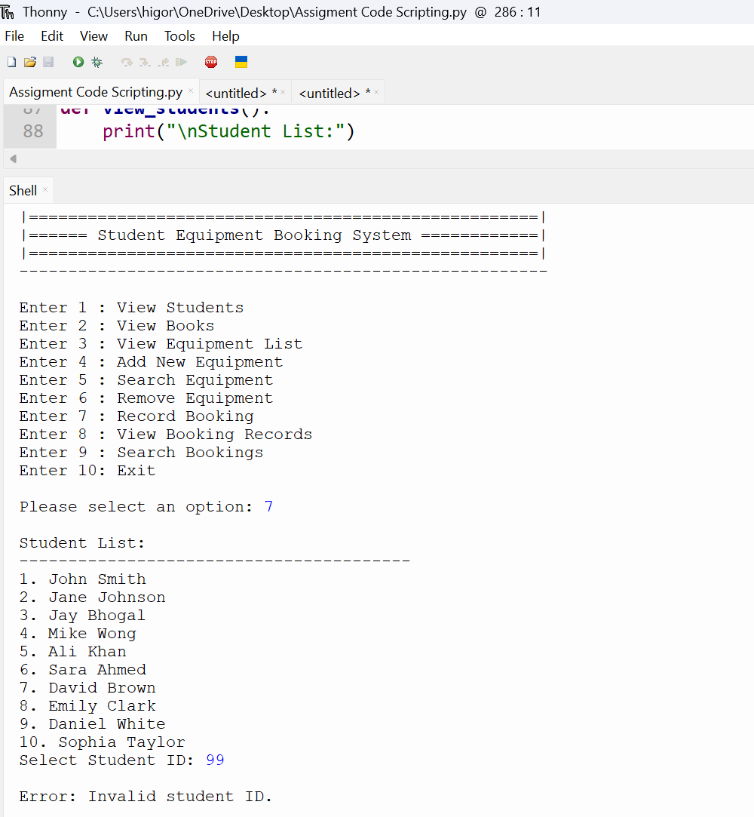
Figure 11.

T9: Invalid Date
This test verifies that the system rejects incorrect date formats and ensures proper validation.
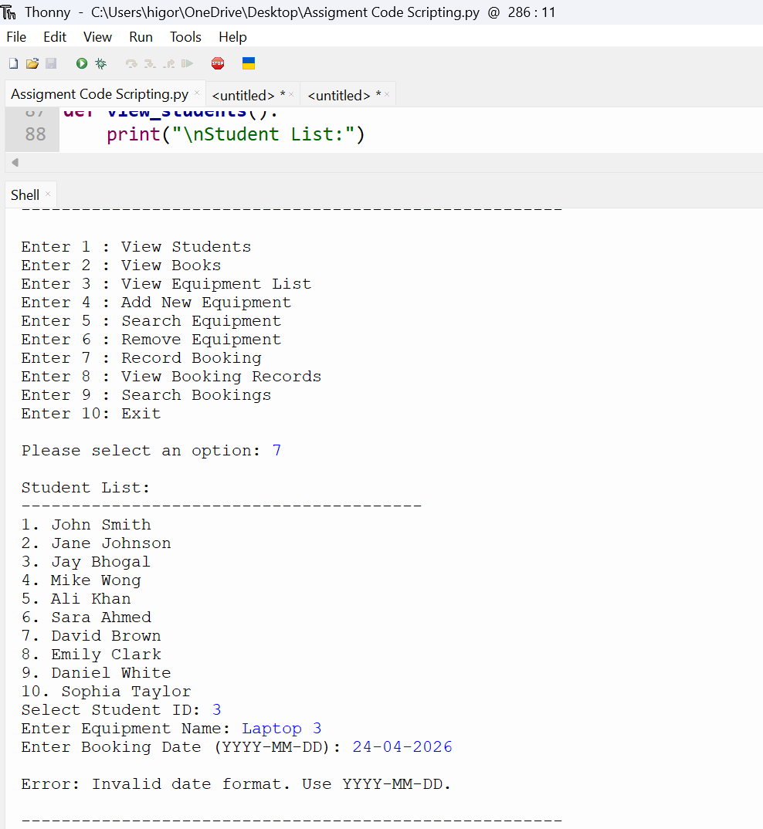
Figure 12.

T10: Search Booking
This test shows that the system correctly retrieves booking records based on search input.
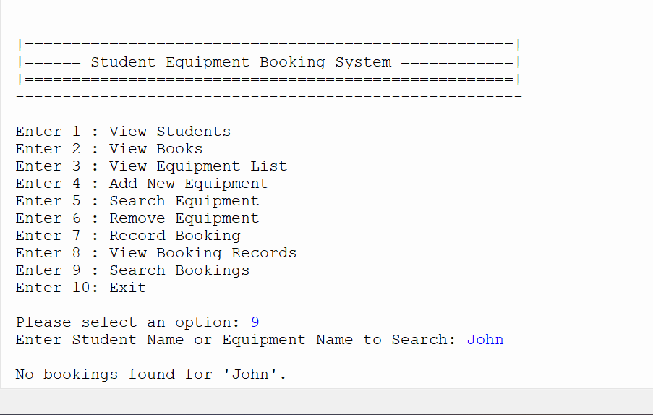
Figure 13.

Debugging Tests:
Syntax Error
This screenshot demonstrates a syntax error where a colon (:) was missing after the function definition. Syntax errors occur when code does not follow Python’s rules. The issue was resolved by adding the colon, ensuring the program could execute successfully.
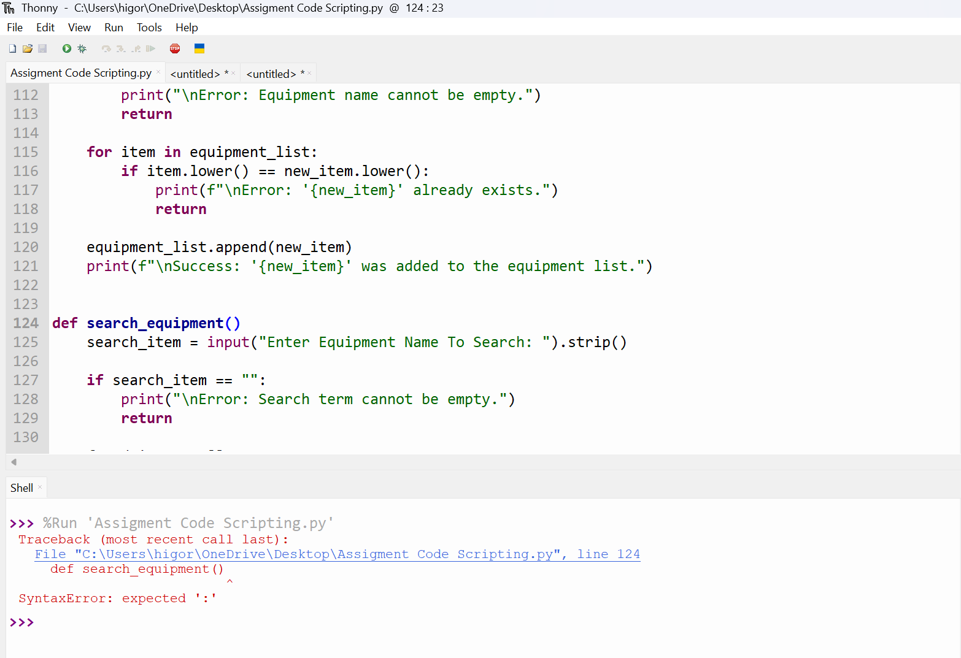
Figure 14.

KeyboardInterrupt
This screenshot shows a validation and runtime scenario where the system correctly prevents a double booking by displaying an error message when the same equipment is booked for the same date. After this, a KeyboardInterrupt occurs because the program execution was manually stopped while waiting for user input. This is not a system error but happens when the user interrupts the program (e.g., pressing the stop button). The system itself is functioning correctly as it successfully handled the booking validation before the interruption.
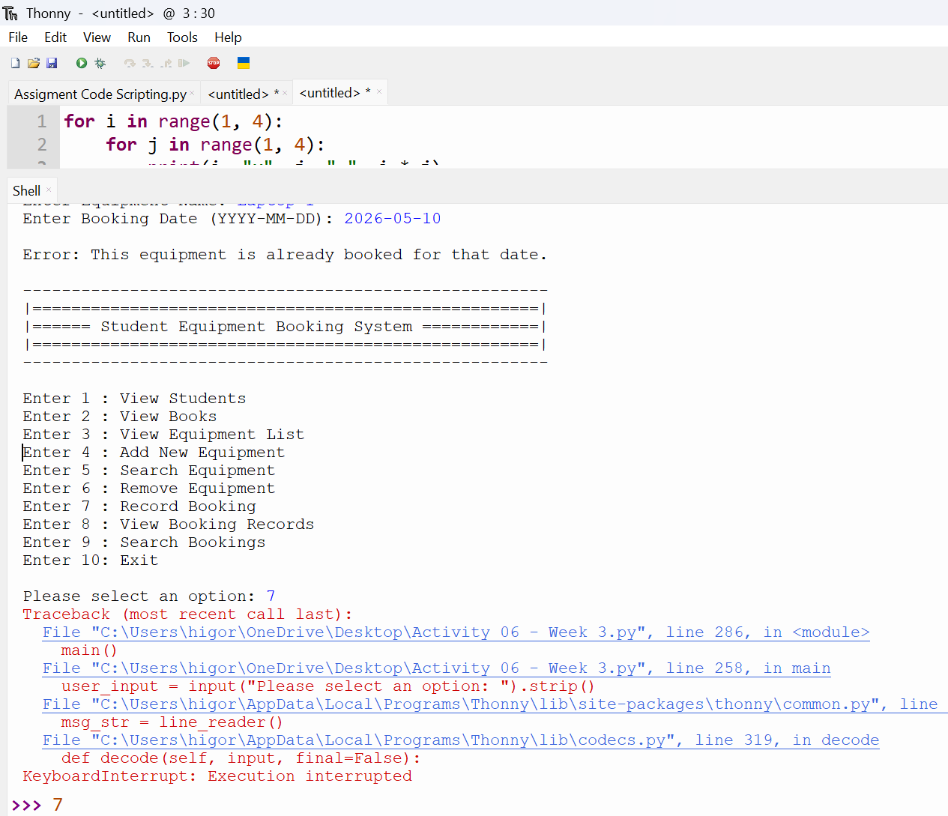
Figure 15.

