
Group Project improving quality and control
Gabriel Phillips

May 19, 2023
University of Wales Trinity Saint David

Executive Summary
This report aims to analyse and reflect on a project undertaken to enhance the quality of products manufactured at Harris Pye. The project involved the implementation of a new procedure utilising DMADV methodologies, as well as adjustments to existing procedures that did not meet the required standards using DMAIC methodologies. The outcome of the project has led to substantial modifications in the manufacturing and monitoring procedures within the company.

Table of Contents

Executive Summary 1
List of Figures 3
Introduction 4
Main Findings 5
Root Cause Analysis – CEX Pumps 5
Root Cause Analysis – CVI Skids 7
Summary of Root Cause Analysis 9
Resolving the Root Causes 9
Insufficient equipment for monitoring tolerances during the manufacturing process 9
Inadequate planning resulted in tolerances going unnoticed (root cause 3) 13
Results Analysis 15
Conclusion 18
Bibliography 21
Appendix 22

List of Figures
- Figure 1 – Ishikawa Analysis of CEX Pumps
- Figure 2 – Upper Column Isometric View
- Figure 3 – Detail of Upper Column showing Linear and Geometric Tolerances.
- Figure 4 – Ishikawa Analysis of CVI Skids
- Figure 5 – CVI Suction Pipe detail of linear and geometric tolerances.
- Figure 6 – CVI Suction Pipe Isometric View
- Figure 7 – Manchester Metrology Faro Arm Offers
- Figure 8 – Fusion Faro Arm Performance Spec Sheet (Faro 2013)
- Figure 9 – Harris Pye Inspection Report Format
- Figure 10 – CVI Suction and Discharge Jig Drawing
- Figure 11 – CVI Suction and Discharge on Jig
- Figure 12 – Horizontal Borer Inspection
- Figure 13 – Horizontal Borer
- Figure 14 - CVI Discharge 2 before repair.
- Figure 15 - CVI Discharge 2 after repair.
- Figure 16 - Upper Column 1 - Perpendicularity, Parallelism and Concentricity measurements.
- Figure 17 - Completed Upper and Lower Column - As the columns are internal, they are not painted.
- Figure 18 - Completed CEX Pump Head
- Figure 19 - CVI Set 1 Completed
- Figure 20 - CEX Embedded Plate Undergoing Faro Final Inspection

Introduction
As the world progresses, the quality and complexity of products in industries such as oil, gas, marine, and energy continually evolve. In order to remain competitive and meet the changing demands, Harris Pye needs to adapt and align with the advancements in the industry. After undertaking a recent project for a major nuclear power plant, which involved the production of 6 25-tonne pumps (CEX Pumps) and 8 10-tonne skids (CVI Skids), Harris Pye confronted the sobering realisation that their manufacturing quality fell short of expectations. CEX pumps consisted of 10 parts, 7 of which Harris Pye are contracted to produce. CVI skids consisted of 15 parts, 4 of which Harris Pye were to produce. Due to the critical nature of the products application, attaining the required tolerances holds paramount importance, and therefore, it is imperative to establish a new quality procedure to guarantee their achievement.
A 3rd party inspector brought the quality issues to the attention of management, both engineers and the QA team offered their recommendations for enhancing the quality system. The primary suggestion involved integrating Coordinate Measuring Machines (CMM) into our existing quality procedures. To address the identified challenges, Sony Philip (QA) and Gabriel Phillips (Project Engineer) were tasked with the responsibility of analysing, conducting research, and devising effective plan. Management allocated a budget of £20,000 for the project, which presented challenges when considering the integration of Coordinate Measuring Machines (CMM), as the cost of brand-new machines alone can exceed £90,000.
Six Sigma methodologies, specifically DMAIC (Define, Measure, Analyse, Improve, Control) and DMADV (Define, Measure, Analyse, Design, Verify) will be utilised to drive the enhancement of quality standards and processes. Root cause analysis (Ishikawa Diagram) will be applied to identify the underlying causes of quality issues, allowing for the implementation of corrective measures. In order to develop the new procedure, the procurement of additional equipment becomes necessary as the current equipment does not meet the required standards. The quality assurance (QA) team and workshop project engineers have the responsibility of conducting research and devising a comprehensive plan to develop an effective solution within a timescale and budget. Following the successful restructuring of the quality system, the outcome should be improved product quality, heightened customer satisfaction, enhanced operational efficiency, and increased competitiveness in the market.

Main Findings

Out of the scopes of work handled by Harris Pye, the CEX pumps and CVI skids exhibit the tightest tolerances. They will serve as benchmarks for the standards that the company needs to adhere to and strive towards. Components within these scopes are:

Analysis of the processes in place will be using Six Sigma methodologies DMAIC or DMADV. When encountering complex problems with high associated risks, the DMAIC approach will be applied to address and improve the relevant processes. DMAIC is the preferred method in such cases due to its effectiveness in tackling intricate issues and mitigating potential risks (Berardinelli 2012). In situations where the implementation of a new process is required, the DMADV methodology will be utilised. Unlike the improvement focused DMAIC approach, DMADV incorporates a distinct design phase, making it the appropriate method for introducing and developing new processes (Selvi, Majumdar 2014). Ishikawa diagrams will be applied for conducting root cause analysis, as their design encourages comprehensive exploration of all potential causes contributing to a problem (Lilliana 2016). The utilisation of Ishikawa diagrams allows for a systematic approach to identify and analyse the various factors that could be influencing the issue at hand.

Root Cause Analysis – CEX Pumps
The 1st CEX product manufactured by Harris Pye was upper column 1 – it was observed to be 4mm out on concentricity from bore to bore via an inspection by a 3rd party inspector using a faro arm, the column was finished machined and the tolerance was 0.05mm as shown in figure 3.
Ishikawa Analysis
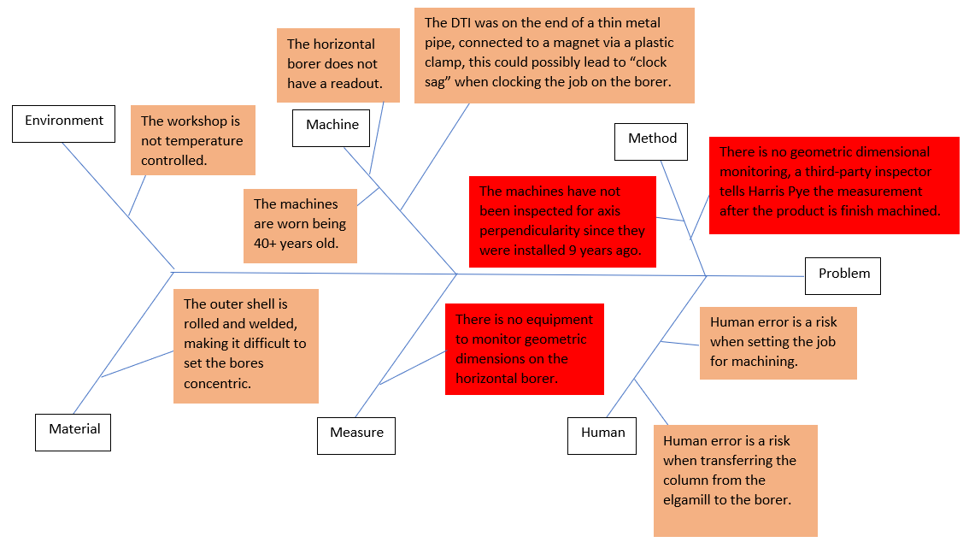
Figure 1 - Ishikawa Analysis of CEX Pumps
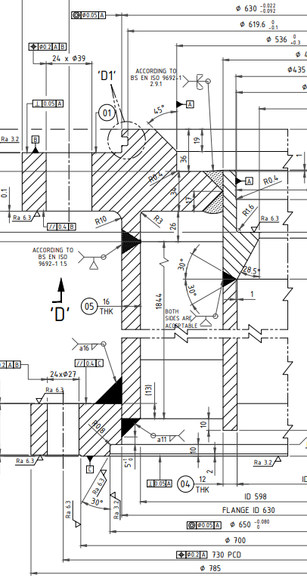
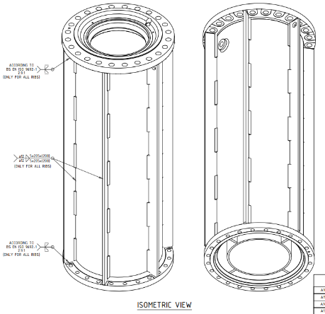
Upon investigating the manufacturing procedure, several potential areas of concern were identified. The columns undergo a step-by-step process of machining and fabrication, with interlinked stages. It was determined that the final machining step should be the stage where the concentricity is brought within tolerance. Prior to this, the columns are rough machined for fabrication with green on each bore, allowing for movement during alignment in the final machining phase. During the final machining process, the bores are inspected using a CNC Elgamill, which employs DTIs (Dial Test Indicators) to precisely determine the relative positions of the bores. Subsequently, the columns are moved to a horizontal borer for diameter machining. However, the horizontal borer lacks a readout, so the column is inspected on the Elgamill, and annotated for manual clocking on the borer. The clocking-in process involves aligning and positioning the columns according to the specifications indicated on the Elgamill. The primary issue of concern revolved around the inability to accurately measure the geometric measurements between the bores. The machinists had to heavily rely on the assumption that their machines were precisely square and level, which posed a significant risk. The items highlighted in red indicate the most likely factors to affect quality.
Figure 2 - Upper Column Isometric View

Figure 3 – Detail of Upper Column showing Linear and Geometric Tolerances.

Root Cause Analysis – CVI Skids
The CVI skids presented a different challenge compared to the CEX pumps, as they comprised high-tolerance pipe spools and vessels with linear and geometric tolerances of +/- 0.5mm. Given the design specifications, most of the CVI parts were procured as standard flanges, pipes, elbows, and tees. Fabrication of the CVI skids relied on conventional techniques, such as tape measures and squares. However, upon completion, a third-party inspector conducted an inspection and identified multiple instances where geometric and linear dimensions deviated from the specified tolerances. Examples of the tolerances are should in figure 6.
Ishikawa Analysis
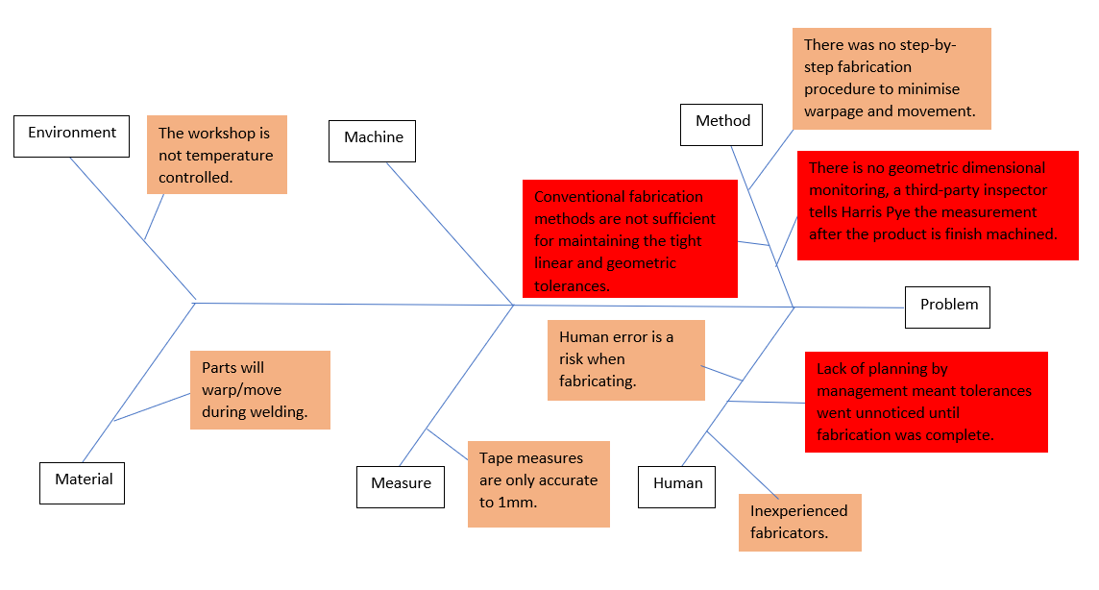
Figure 4 - Ishikawa Analysis of CVI Skids
During the evaluation of the CVI manufacturing procedure, three key issues were discovered. Firstly, inadequate planning by management resulted in fabricators being assigned the task of fabrication without a proper manufacturing plan. This lack of systematic approach and consideration for the tight linear and geometric tolerances greatly increased the risk of dimensional deviations and compromised the overall quality of the CVI skids. Secondly, a common problem with the manufacturing of CEX and CVI was identified. The absence of geometric dimensional monitoring prevented the assessment of whether the perpendicularity and parallel dimensions fell within the specified tolerances. These combined factors hindered the ability to ensure we produced the products to the specified tolerances. An example of the tolerances Harris Pye had to achieve is shown in figure 5.

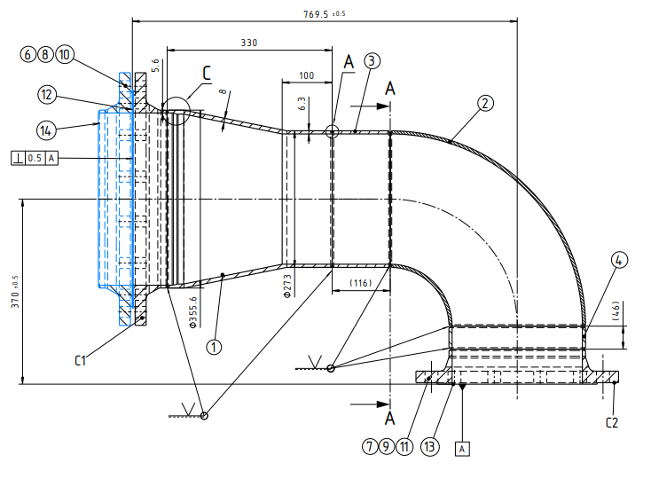
Figure 5 - CVI Suction Pipe detail of linear and geometric tolerances.
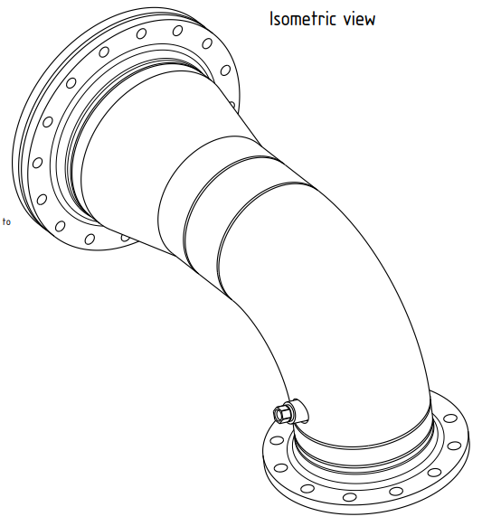
Figure 6 – CVI Suction Pipe Isometric View

Summary of Root Cause Analysis
The primary causes for the problems during the manufacturing of the highlighted products can be mainly attributed to:
- Insufficient equipment for monitoring geometric tolerances during the manufacturing process.
- Limited knowledge regarding the accuracy and capabilities of the machines.
- Inadequate planning resulted in tolerances going unnoticed and unaddressed.
- The utilisation of conventional fabrication methods for products that have high tolerances.

Resolving the Root Causes

Insufficient equipment for monitoring geometric tolerances during the manufacturing process (root cause 1)

This was a common issue impacting both CVI and CEX. Given that these tolerances are specified by the clients, it is crucial to continuously monitor them throughout the manufacturing process, rather than solely at the end, to ensure compliance with their requirements. Implementing comprehensive monitoring procedures will be essential in meeting the specified tolerances and satisfying client expectations. Methods available for improving our monitoring capabilities are:
- Using DTIs (Dial Test Indicators) and centre finders as inspection tools with the assistance of readouts on the CNC Elgamill.
Advantages
- Cheap: Cost effective solution as we already have the machines.
Disadvantages
- Time and Resources: When the machine is utilised for inspection purposes, it is not engaged in machining activities, as it is not the primary function of the machine, despite its capability to do so.
- Human error: The inspection process involving DTIs relies on human visual inspection, which introduces the possibility of human error.
- Failed in current procedure: In the case of the CEX column, this method was implemented during inspection for final machining, resulting in a concentricity measurement that deviated by 4mm from the specified tolerance.
- Harris Pye are unable to verify the precision and accuracy of the machine.

- Subcontracting to a company with the expertise and resources to conduct inspections on our behalf and designing a reporting system for their findings to inform our subsequent actions.
Advantages
- Expertise: The subcontracted company should ensure a high level of accuracy and reliability in their assessments as it will be their service.
- Advanced Equipment: Inspection companies often have access to state-of-the-art inspection equipment and technologies that will probably surpass any CMM we are able to procure due to our budget.
- Time and Resource Savings: Outsourcing the inspection function allows us to focus on our core competencies, there is no need to train any of our personnel.
- Reporting and Documentation: Working with a subcontracted company that provides detailed and standardised reports ensures clear documentation of inspection results.
Disadvantages
- Cost: Hiring an inspection company will incur additional costs compared to conducting inspections in-house. The fees charged by the subcontracted company need to be factored into the overall project budget. Given the nature of the products and the frequent need for inspections, the expenses will continue to escalate since we are repeatedly incurring costs for a service instead of making a single payment for a product and training.
- Delays: In order to minimise costs, individual inspections may be suspended since it is not cost-effective to pay travel costs or a day rate for a 20-minute inspection. However, this approach may lead to project delays as we wait to complete enough parts for bulk inspection.
- Dependency: Relying on an external company for inspections means being dependent on their availability and responsiveness. Poor performance and communication issues from the subcontracted company may impact project timelines. (Mehmet, Demir et al. 2001)
- Loss of Control: Outsourcing inspections relinquishes direct control over the process. Decision-making and quality control may become more challenging as we are relying on a third party to provide accurate and reliable results.
- Communication: Misunderstandings in communication may lead to incorrect interpretations of inspection requirements.

- Purchasing a CMM and providing training to personnel for programming and operation. Additionally, developing our own quality procedures and report format to align with the requirements of our clients.
Advantages
  - Cost-effective: By investing in a CMM and training personnel internally, the long-term costs can be significantly reduced compared to relying on external inspection services.
  - Improved efficiency: Having a CMM on-site allows for immediate and convenient access to inspection capabilities. There is no need to wait for external service providers, resulting in faster turnaround times for inspections.
  - Control: With in-house personnel trained to operate and program the CMM, there is greater control over the entire inspection process.
  - Flexibility: In-house training enables personnel to tailor the CMM operation and programming to the specific needs of the company and its products (Optimus Learning 2013). This flexibility allows for more precise and targeted inspections, leading to better quality control. Some CMM can also be used to inspect the machines for the geometric relationships between the beds and the spindles/chucks.
  - Company Development: Developing internal expertise through training ensures that the knowledge and skills related to CMM operation and programming are retained within the organisation. This helps build institutional knowledge and reduces dependence on external resources.
  - Timely decision-making: With in-house inspection capabilities, immediate access to inspection results and reports allows for faster decision-making and problem-solving (Rapid Direct 2021).
  - Long-term asset: Acquiring a CMM and training personnel establishes a long-term asset for the company (Galin, Avrahami 2006). The CMM can be utilised for future projects and in house maintenance, providing ongoing value and cost savings.
Disadvantages
- High initial investment: Acquiring a CMM involves significant upfront costs, including the purchase price of the machine, software, and training expenses. Finding a reliable CMM with software and training for under £20,000 will be challenging.
- Ongoing maintenance and calibration: CMMs require maintenance and calibration to ensure accurate and reliable measurements. These activities can incur additional costs and require specialised expertise or external support.
- Need for skilled operators: Operating a CMM effectively requires trained personnel who are knowledgeable in programming, operating, and interpreting the results. Training skilled operators requires additional expenses and time, cutting corners on training can lead to inefficient procedures and mistakes (Mian, Al-Ahmari 2014).
- Technology advancements: The field of metrology and inspection technology is continuously evolving (Mian, Al-Ahmari 2014). Investing in a CMM means committing to a particular technology at a given time. Over time, newer and more advanced measurement technologies may emerge, potentially making the purchased CMM outdated or less competitive.

Both option 2 and option 3 offer advantages to the company. Option 2 provides cost savings initially and helps streamline the workload, enabling Harris Pye to concentrate on its core competencies. On the other hand, option 3 presents a significant asset that could enhance the company's in-house manufacturing capabilities. It not only enables the monitoring of products but also facilitates the monitoring of our own machines, effectively achieving two objectives simultaneously. Both options offer distinct benefits to the company. Both options will be pursued, with option 3 being the preferred objective. The primary concern regarding of option 3 is the budgetary aspect, therefore, option 2 will be considered as a viable alternative if option 3 proves to be unachievable.

Procurement of Assets
Specification
  - Price – Training, Software and Equipment must all be obtained within a budget of £20,000.
  - Type – The machine must be portable, narrowing the options down to articulated arms, laser trackers and optical CMMs (Capture3D 2022).
  - Size – 3m/10ft minimum measurement capabilities, but the bigger the better.
  - Measurements – Software and equipment must be capable of measuring all linear and geometric measurements.
  - Accuracy – The desired level of accuracy should align with the tightest tolerances specified in our drawings, which include GD/T parallelism of 0.02mm and a linear tolerance of 0.08mm.
Upon contacting multiple companies for the acquisition of a portable CMM, it became evident that our budget would not accommodate the purchase of a new one. Leica presented a quotation of £114,000 for a laser tracker, which encompassed training and software costs. They also offered alternative models at lower price points, although with a slight decrease in accuracy. Unfortunately, all their options exceeded our budget. Faro provided quotes starting from £55,000 for their articulated arms. We also explored the possibility of acquiring a brand called PMT, which offered articulated arms that met our specifications. However, their best price amounted to £30,000. Manchester Metrology had pre-owned Faro arms available for purchase that aligned with our budget. It is worth noting that their original offerings did not include software and training, and some units lacked a warranty.
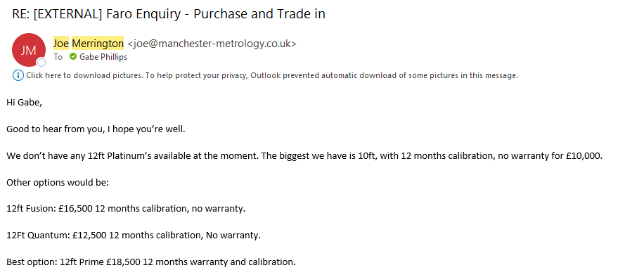
Figure 7 - Manchester Metrology Faro Arm Offers
Unfortunately, none of the faro arms met the ideal level of accuracy. However, Harris Pye’s engineering team and QA acknowledged proceeded with negotiations despite this limitation, as the capabilities offered by the faro arm far exceeded our current capabilities as a company. Following negotiations with Manchester Metrology, an agreement was reached, resulting in a bulk deal that included, a 2-day training course for three individuals, a 12ft 7-axis Fusion Faro arm and CAM2 measurement software for a total cost of £20,000. CAM2 software is a 3D measurement system designed specifically for Faro (Faro 2022), it is capable of all GD/T measurements as well as linear dimensions.

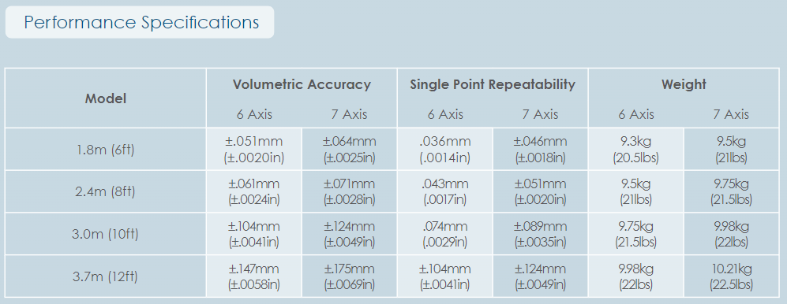
Figure 8 - Fusion Faro Arm Performance Spec Sheet (Faro 2013)

Three project engineers from Harris Pye, Gabriel Phillips, Martyn Hipkin, and John Thomas, were enrolled on the training course. Given the budget constraints, the duration of the training course was relatively short, covering the fundamentals of operating and programming the arm. However, the training provided the engineers with the necessary foundation to explore and acquire further knowledge. Tutorial videos available on YouTube supplemented their learning, and in case of any technical queries, Harris Pye had the option to seek assistance from Manchester Metrology.
The implementation of the faro arm into Harris Pye’s quality control system should significantly reduce if not completely eradicate products being produced out of tolerance. The faro arm can also be used as a monitoring tool for our own machines (root cause 2), inspecting the chucks for perpendicularity or parallelism with respect to the machine beds allowing the engineers to address two route causes simultaneously.
Furthermore, a report structure was designed by QA to effectively convey the information from inspections. The clients expressed their satisfaction with the design. The structure consisted of the standard reports produced by CAM2, along with the table shown in figure 9.
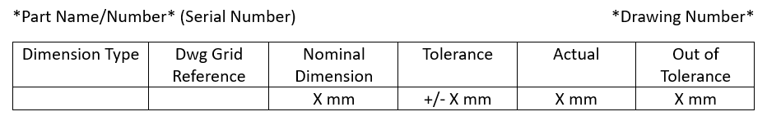
Figure 9 - Harris Pye Inspection Report Format
The procedure for inspections was simplistic but accurate, the procedure was to follow the drawing for all information, as that was the specification of the product. Datums in inspections must be the same datums as the drawings, all geometric and critical (tight tolerance) measurements of the product must be inspected via faro arm, if the measurements were standard fabrication tolerances, they could be inspected using standard calibrated equipment such as a measuring tape or vernier calliper.

Inadequate planning resulted in tolerances going unnoticed (root cause 3)
CVI encountered difficulties with fabrications being out of tolerances, which is suspected to be a result of lacking a proper fabrication plan. To address this issue, a well-executed plan, combined with the newly acquired Faro arm, is expected to rectify the poor product quality. The CVI Suction pipe spools were identified as being out of tolerance, requiring the repair of all 8 spools. It was determined that the most effective approach would be to fabricate a jig using CNCs and the Faro arm.
Jigs are useful tools when a manufacturer is looking to increase accuracy: Jigs provide precise and consistent positioning of components, ensuring that they are aligned correctly during the fabrication process (Marshall 2010). Improve time efficiency; jigs enable faster and more efficient fabrication by eliminating the need for manual measurements and adjustments (Pandit 2017). Improve quality; with jigs, there is a reduced risk of human error during fabrication (Xometry 2022). The consistent positioning and alignment provided by jigs result in improved quality and consistency of the fabricated parts. Cost effective: by ensuring accurate alignment and minimizing errors, jigs help reduce material waste and rework (Xometry 2022). Scalability: jigs can be designed to accommodate various sizes and shapes of components. This allows for scalability in production, as the same jig can be used for multiple projects with similar requirements (Xometry 2022).
Harris Pye's Project Engineers developed a jig, designed to oversee the fabrication of both the suction and discharge pipe. Figure 10 shows the design, which includes pins and bolt holes for hole orientation and secure clamping. A test was additionally performed to evaluate the shrinkage of the welds. This involved replicating the welding procedure on discarded sections of the pipes and measuring the resulting shrinkage. The test results revealed an average shrinkage range of 2.8mm to 3.2mm after the welding process. To ensure optimal dimensions and account for the shrinkage caused by welding, the design incorporates a +3mm allowance for all linear measurements. The jig was machined on a CNC after fabrication, the Faro arm was used for continuous monitoring.
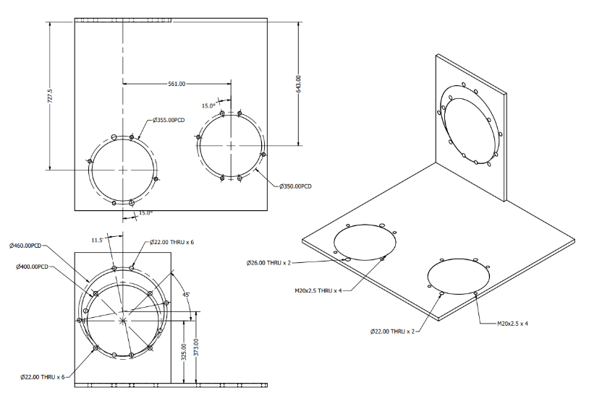
Figure 10 - CVI Suction and Discharge Jig Drawing
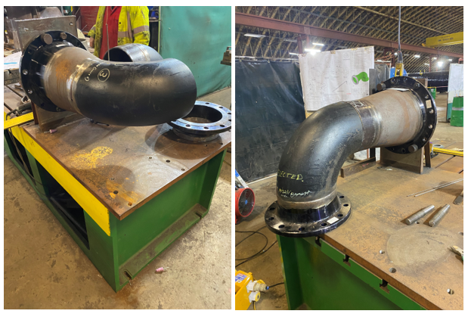
Figure 11 - CVI Suction and Discharge on Jig
Other components of CVI that also had high linear and geometric tolerances (Manifold and Separator) followed the same process to ensure design specifications are met. Implementation of jigs and CMM equipment should address the limitations of traditional fabrication techniques (root cause 4), ensuring that the products are completed according to their specifications.

Results Analysis
Following the training on the Faro arm, we proceeded with conducting comprehensive inspections across CEX and CVI. This step was essential for familiarising ourselves with the new equipment and ensuring the correctness of our procedures. By comparing our inspection results with those of the third-party inspector, we could validate the accuracy of our processes. Furthermore, this allowed the operators to become acquainted with the Faro arm and its reporting process.
In addition to inspecting CEX and CVI, we also assessed the geometric accuracy of the elgamill and horizontal borer. The elgamill demonstrated good condition overall, with the spindle having a minor deviation of 0.01mm in parallelism to the bed per 1000mm. However, the horizontal borer presented a significant issue, as it exhibited a deviation of 1.09mm per meter in perpendicularity. This finding gave Harris Pye a breakthrough on understanding why upper column 1 had such significant misalignment.
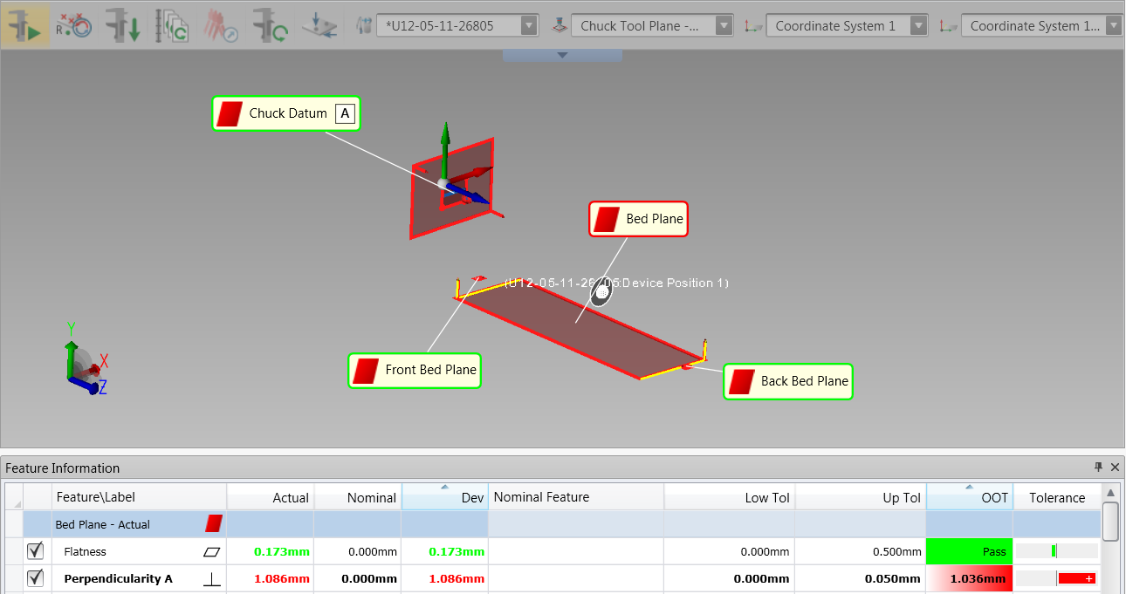
Figure 12 - Horizontal Borer Inspection
Mechanical fitters along with a Faro operator enabled Harris Pye to level the machine with ease. The chuck face was initially inspected as Datum A, while the bed was separately inspected as its own plane. The measurement of the perpendicularity between these two planes revealed a significant error. To address this issue, the bed was adjusted using jacks, and the inspection process was repeated for both planes. It was suspected that the jacks might have been affecting both the bed and the movement of the spindle column, hence the need for reinspection to ensure accurate measurements.
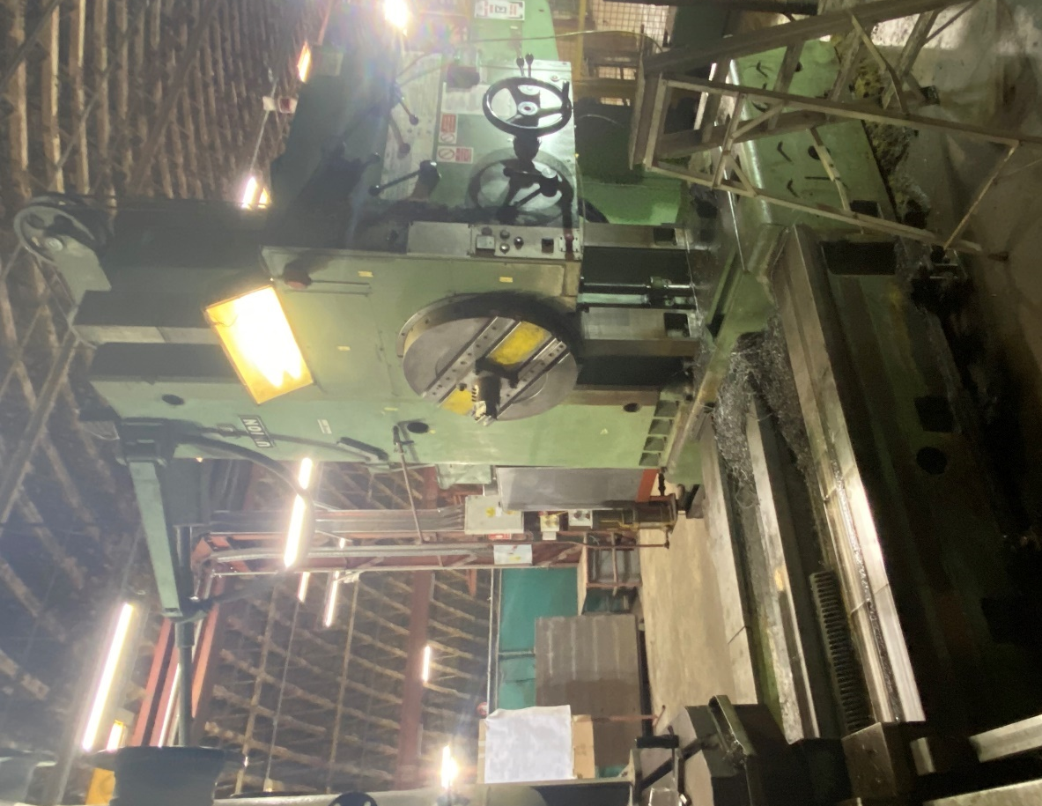
Figure 13 - Horizontal Borer
The process of using the Faro arm for levelling and inspection was simple and shimming the machine bed and was completed within a day. As a result of the adjustments made, perpendicularity ranging from 0.00mm to 0.03mm was achieved.
CVI and CEX inspections aligned with the findings of the third-party inspector, confirming the accuracy and reliability of our inspection procedures. With this validation, we moved forward with the repair process for the parts that did not meet the required tolerances. We identified areas where weld joints needed to be cut, and by utilising the fabricated jigs, we were able to ensure precise alignment and fitment. These measures enabled us to successfully achieve the necessary tolerances for the repaired parts. Figure 13 and 14 shows how the development of the procedures helped bring CVI into tolerance, the example shown is CVI discharge 2, a drawing can be found in the appendix.
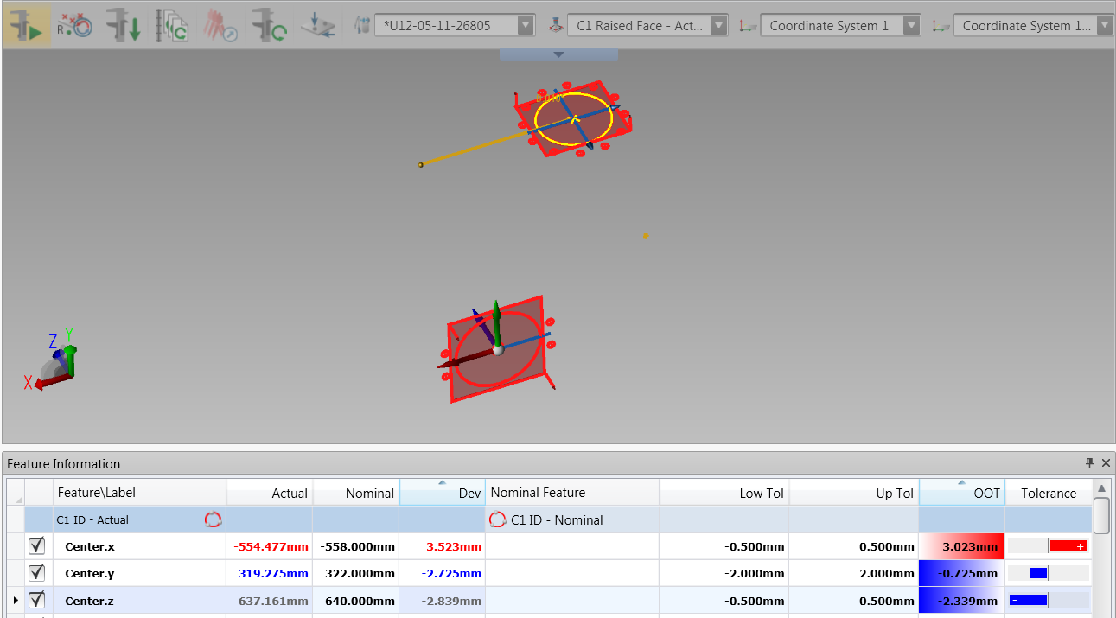
Figure 14 - CVI Discharge 2 before repair.
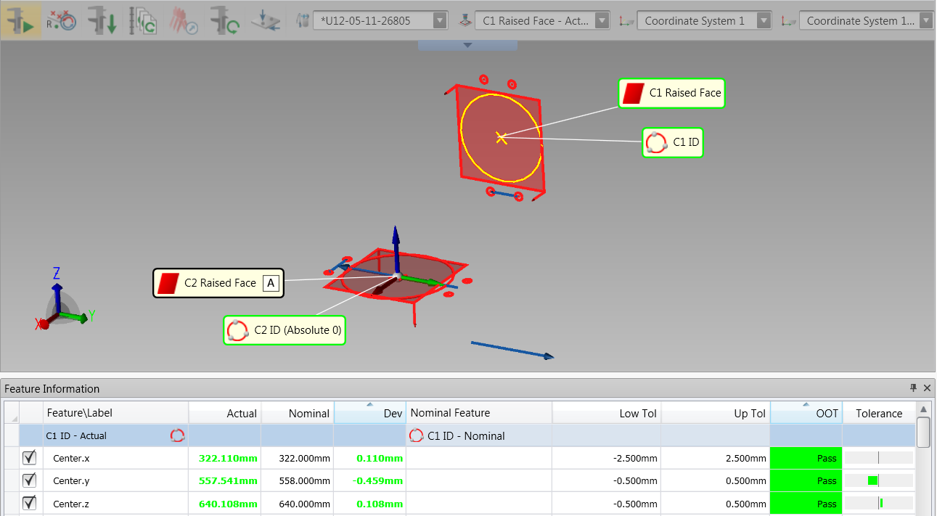
Figure 15 - CVI Discharge 2 after repair.
CVI Discharge 2 was one of the more difficult repairs as all areas were out of tolerance, so the fabrication essentially had to be restarted, achieving this difficult repair was a confirmation that the procedures and equipment in place to improve the quality of our products was working, even if some of the measurements were close to being out of tolerance. The geometric tolerance of 0.5mm perpendicularity from raised face to raised face was also achieved with a measurement of 0.03mm.
Rectifying CEX Pumps presented significant challenges as some components had tighter tolerances than the volumetric tolerance of the Faro arm, and we can only rely on its measurements to be correct and aligned with our desired results. In the case of Upper column 1, both the superior and inferior flange were removed and replaced with rough flanges through welding. The setting procedure involving the Elgamill to mark up the column's centreline for clocking in on the borer became redundant. Instead, the Faro arm was utilised as a digital readout during job setup and throughout production, eliminating problems associated with clock sag and potential human error. The results are shown below, the drawing can be found in the appendix.
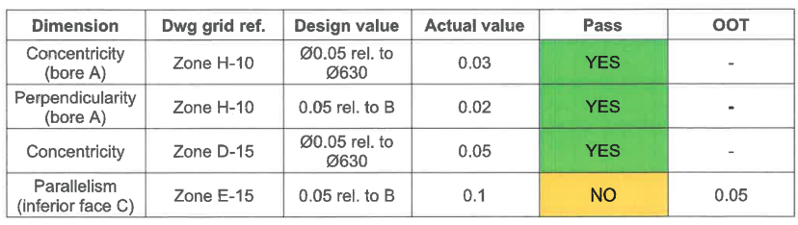
Figure 16 - Upper Column 1 - Perpendicularity, Parallelism and Concentricity measurements.
The 3rd party inspection results revealed that we were outside the tolerance limits for the parallelism measurement from face to face on one part. Although this raised concerns for future manufacturing the rest of CEX parts, it is important to note that this outcome represents a substantial improvement compared to previous results. The implementation of the Faro arm and the levelling adjustment performed on the horizontal borer contributed to this improvement. After informing the client about the results, they agreed to accept the product, but a non-conformance report (NCR) had to be raised for the out-of-tolerance GD&T dimension. Re-machining was not considered as an option because the adjustments required were very small, and the precision of the Faro arm exceeded the level needed for those adjustments. If we were to opt for re-machining, the Faro arm would not be accurate enough to ensure the desired tolerance. Therefore, it was largely a matter of chance.

Conclusion
Following the identification of the root causes behind the quality issues faced by Harris Pye, a comprehensive analysis was conducted. This analysis allowed for the development and implementation of a new Coordinate Measuring Machine (CMM) quality procedure and process. The effectiveness of this new procedure was subsequently validated through the production of products within the specified tolerance limits. This improvement process can be categorised as DMADV methodology.
Once the root causes of the out-of-tolerance CVI parts were determined, efforts were made to enhance the fabrication process through the implementation of jigs. These jigs played a crucial role in controlling the fabrication process and ensuring improved quality. This improvement initiative aligns with the DMAIC methodology, which focuses on continuous improvement. The successful completion of products within the acceptable quality standards serves as evidence of the effectiveness of these improvements.
Overall the project did help significantly improve the quality of the products we produce, allowing Harris Pye to successfully complete both CVI and CEX scopes, however there was a small recurring error where parts of CEX were slightly out of tolerance of the tightest parts, but the largest deviation was 0.05mm out of tolerance of geometric specifications. None of the jobs were rejected by the client, but by the end of the project, 5 NCRs were raised for small deviations of the products produced. The project engineers and QA at Harris Pye were commended for their results considering the constraints on the budget.
To further improve the quality control processes a few methods should provide beneficial results; a temperature-controlled environment is always useful when producing high tolerance parts (Zhang 2023) and a higher quality CMM such as the Leica AT960 that is used for high quality production parts in companies such as Redbull and BMW (Hexagon Manufacturing Intelligence 2017). To implement these would likely be at significant cost for minimal difference in results.

Recommendations for further study
This project has provided valuable skills to the project engineers at Harris Pye, enabling them to visualize jobs as if they were constructed in CAD. This visualisation capability facilitates a thorough analysis of the jobs in three dimensions, encompassing both the linear tight tolerances and the geometric tolerances. Geometric tolerances specifically refer to the interrelationships between planes and cylinders within the products. By incorporating this enhanced visualisation approach, the project engineers gain a comprehensive understanding of the job requirements, resulting in improved accuracy and adherence to tolerances. These skills will be transferable into design, QA and manufacturing roles. To progress further, it is advisable to acquire proficiency in operating CMM laser trackers. These advanced instruments possess the capability to measure significantly larger jobs, thereby expanding the abilities of Harris Pye to undertake more extensive scopes of work. By mastering the use of CMM laser trackers, Harris Pye can enhance their capacity to handle larger projects successfully.
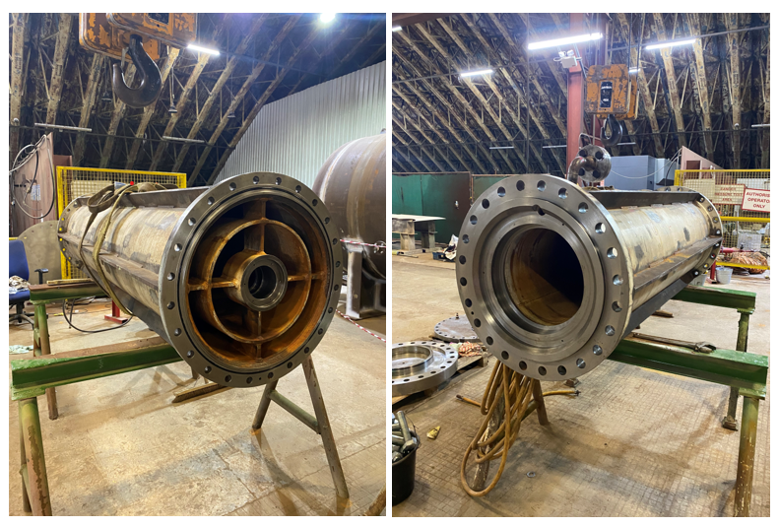
Figure 17 - Completed Upper and Lower Column - As the columns are internal, they are not painted.
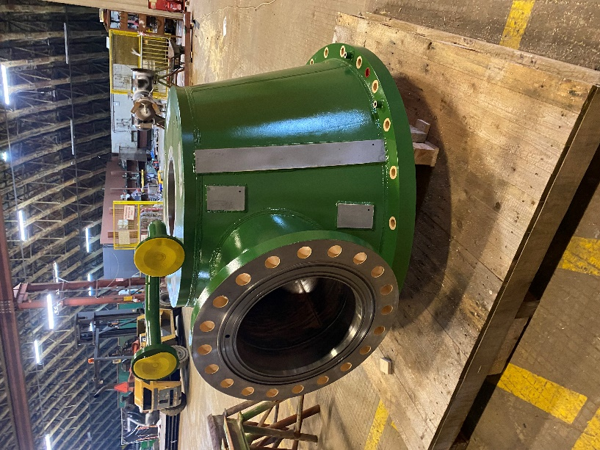
Figure 18 - Completed CEX Pump Head

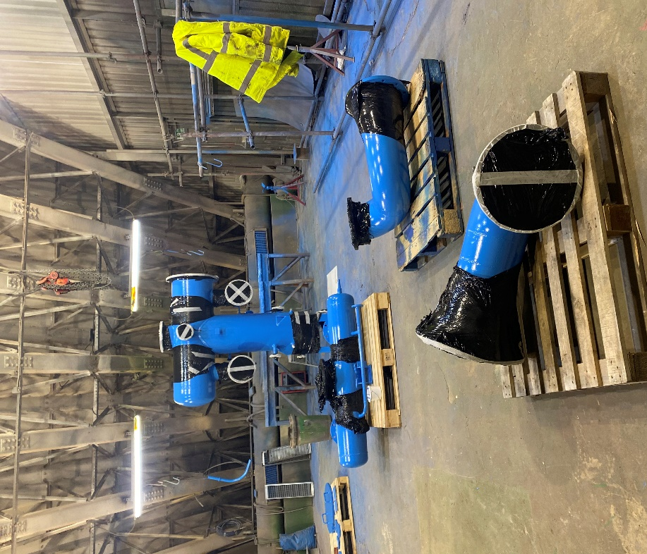
Figure 19 - CVI Set 1 Completed
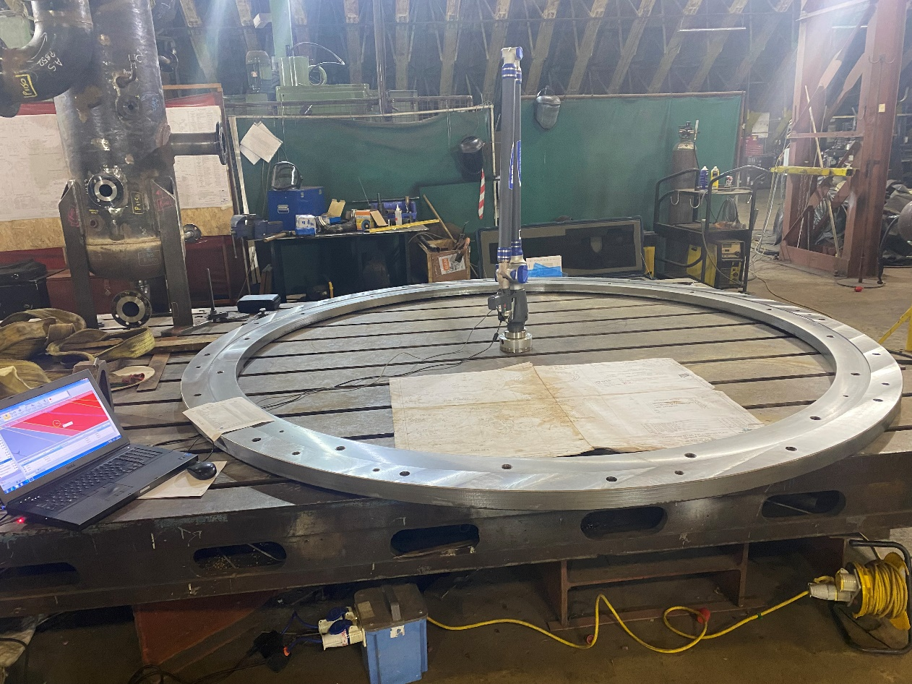
Figure 20 - CEX Embedded Plate Undergoing Faro Final Inspection

Bibliography
BERARDINELLI, C., 2012. TO DMAIC or Not to DMAIC? , pp. 72.
CAPTURE3D, February, 2022-last update, PCMM – Portable Coordinate Measuring Machines. Available: https://www.capture3d.com/knowledge-center/blog/how-to-choose-the-best-portable-cmm-for-your-application#:~:text=Portable%20CMMs%20come%20in%20two,surface%20structure%20of%20the%20part. [2023, May, 18]
FARO, 2022-last update, Faro CAM2 Software. Available: https://www.faro.com/en/Products/Software/CAM2-Software. [2023, May, 12]
FARO, 2013. Faro Fusion. , pp. 2.
GALIN, D. and AVRAHAMI, M., 2006. Are CMM Program Investments Beneficial?
Analyzing Past Studies. , pp. 1.
HEXAGON MANUFACTURING INTELLIGENCE, February, 2017-last update, Leica Absolute Tracker in the Automotive Industry. Available: https://www.youtube.com/watch?v=ygK_jWe2zOE. [2023, May, 5]
LILLIANA, L., 2016. A new model of Ishikawa diagram for quality assessment . , pp. 2.
MARSHALL, V., March, 2010-last update, Build a Jig to Improve Your Fabrications. Available: https://www.popsci.com/diy/article/2010-03/build-jig-improve-your-fabrications/. [2023, May, 17]
MEHMET, A., DEMIR, I. and GIRAN, O., 2001. Assessing the benefits of long-term relationships between contractors and
subcontractors in the UK. , pp. 1.
MIAN, S. and AL-AHMARI, A., 2014. New developments in coordinate measuring machines
for manufacturing industries. , pp. 2-5.
OPTIMUS LEARNING, June, 2013-last update, The Advantages and Disadvantages of In-House Training – An Update. Available: https://www.optimuslearningservices.com/practical-ld/the-advantages-and-disadvantages-of-in-house-training-an-update/. [2023, May, 8]
PANDIT, H., 2017. A Review Article on Jigs and Fixture. , pp. 2467-2468.
RAPID DIRECT, March, 2021-last update, What Is CMM Machine: Components, Uses, and Benefits. Available: https://www.rapiddirect.com/blog/what-is-cmm-machine/#:~:text=The%20CMM%20machine%20has%20the,errors%20in%20the%20measuring%20process. [2023, May, 7]
SELVI, K. and MAJUMDAR, R., 2014. Six Sigma- Overview of DMAIC and DMADV. , pp. 17.
XOMETRY, December, 2022-last update, What Are Jigs and Fixtures? Differences, Uses, Advantages. Available: https://www.xometry.com/resources/machining/jigs-and-fixtures/. [2023, April, 26]
ZHANG, S., April, 2023-last update, Understanding the Impact of Temperature on CNC Machining Accuracy. Available: https://www.machinemfg.com/how-does-temperature-affect-accuracy-in-cnc-machining/. [2023, May, 25]

Appendix


