Object Biographies

Objects/things are social and gain meaning through social practices; this meaning is constantly being shaped and changed through the life-use of an object and in part might be drawn from the recursive relationships between people and things.

- One way that anthropologists have thought about this process is through the metaphor of the biography of object, informed by the work of Kopytoff (1986), who argues that objects, like people, can be said to have social lives with their own distinct biography. This approach links the socialisation of an object to the concept of personhood and how within a biography it acquires distinct identities and histories over time. Moreover, there is an understanding, particularly in archaeological thought that the stages in an object’s existence, from creation (birth) through to final use, possibly destruction and discard (death) can be compared to a life history. This approach has had enormous impact on archaeological analyses of the material world (and indeed continues to do so).

- Related to object biographies is the concept of biographical or history objects (Hoskins 1998): “how things tell the stories of people’s lives”. These are personally meaningful possession, distinct from heirlooms and inalienable possessions. Their defining characteristics are that they that they share our lives with us and in so doing inform our personhood.

- Most recently archaeologists (Joyce and Gillespie 2015) have developed the notion of itinerary of object. This rejects the anthropomorphism of object biography and instead examines the spatial movement of an object through significant nodes or points in time and space. It recognises that objects have multiple meanings depending upon specific moments of their existence (time and space). This approach assumes that movement (matter flows) is a fundamental capacity of things. It captures the dynamics of an object as it moves between social contexts. It also allows us to think about the reception of ancient objects in the present as part of their life history and how this might change once it is in a museum environment for example. Two key approaches have influenced development of object itinerary:
- ANT: the idea of objects and people being related as nodes in networks
- New Materialisms and the inevitable flux and flow of matter

In your small groups I would like you to discuss the objects overleaf.
a) Consider how you might apply the notions of object biography, biographical object and object itinerary to these “things”. How useful are these concepts for exploring how objects are socialised? Does it help us further categorise objects beyond alienable/inalienable or gift/commodity?

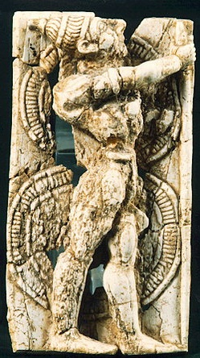
Mycenaean ivory plaque (13th century BC). Made in either Greece, Cyprus or possibly Ugarit. Found in the Artemision sanctuary on Delos (8th-7th century BC)
Amenhotep III lion hunt scarab (14th century BC) found in a Cypriot Iron Age tomb dating to 11th century BC. Wealthy tomb – in particular bronze grave goods, including three named objects (obeloi – bronze spits)
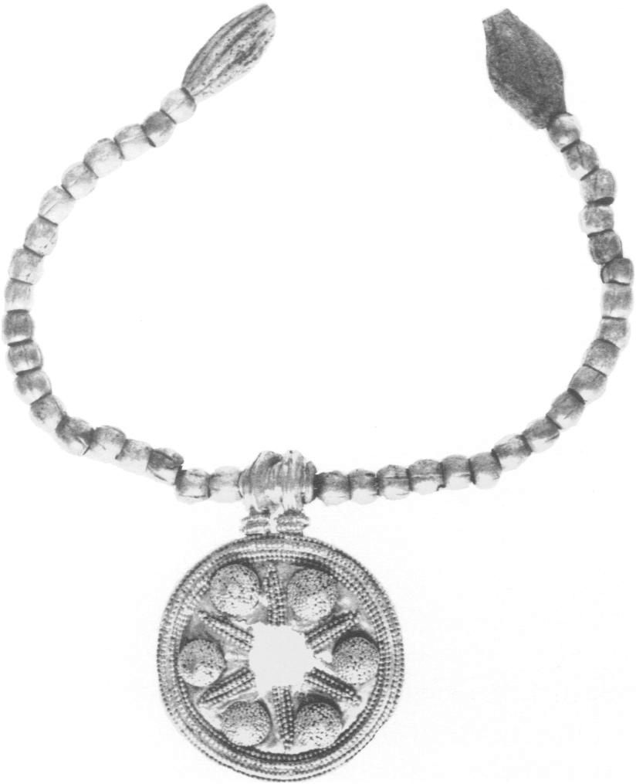
Babylonian gold pendant (c. 2000 BC) on gold and faience necklace found in Iron Age burial from Lefkandi – dating to c.950 BC. Worn by richly adorned female: gold pectoral & breast plates, numerous bronze & iron gilt pins. Cypriot? iron knife with ivory handle by her head.
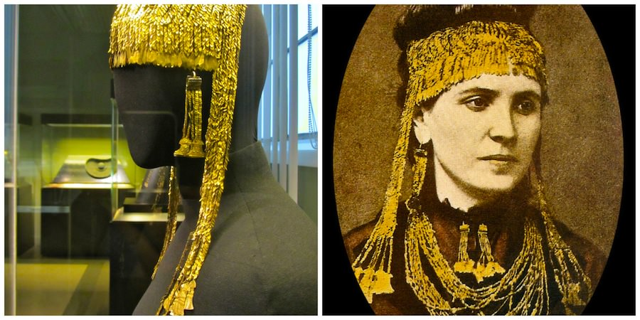
Hoard A “Priam’s treasure”: excavated by Schliemann in 1873 near the Scaean gate ▪ “Treasure of Priam’: bronze weapons, silver ingots, gold jewellery. Source of metals?
Modern history: taken to Berlin by Schliemann; looted at end of Second World War and now in Russia.
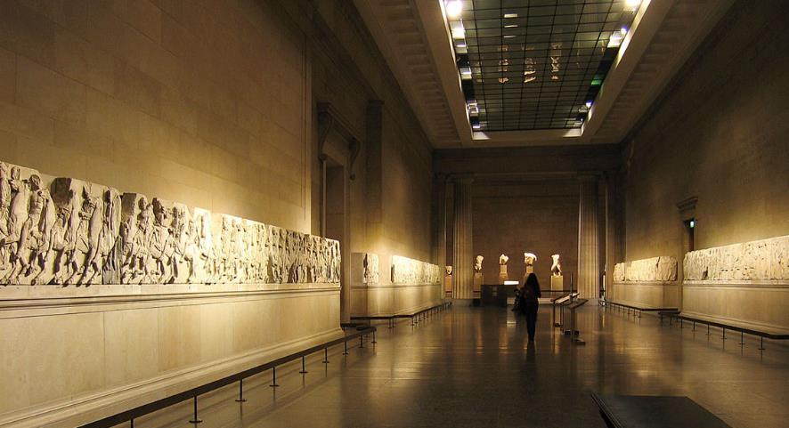
“Elgin marbles”, acquired by British Museum in early 19th century
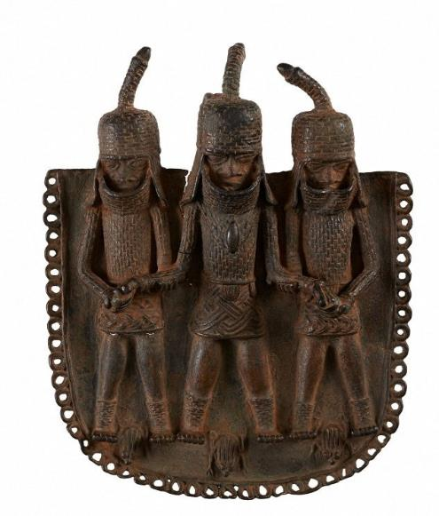
Bronze pendant looted from Benin by British soldiers in 1897: from London’s Homiman Museum and an object to be returned to Nigeria.

