E-Portfolio
Ann Benwell
2320881

Contents Page:
Task 1: 300 words written summery of the article, How does music make you feel?
Task 2: Infographic of a study skill, Time management
Task 3: Essay outline based on How does music make you feel.

Task 1:
How does music make you feel?
According to the article written by Zoe Nendick,(2022), she describes music as being a “significant” part of everyday lives. She also explains how music can be heard everywhere we go no matter the task in hand, (Nendick, 2022). Nendick, (2022) then also states how music can be a powerful object in how we portray our emotions and actions. The article questions how the different emotions in which can be portrayed from simply listening to music. Zendick, (2022) states that she studied A-level Music, which can suggest that she has previous knowledge on how interactive music can be to a person. Another factor which is considered in Nendick’s (2022) article is the possibility of an individuals culture influencing them to listen to a particular type of music. When considering that different individuals have a different emotional response to things such as music, it allows us as individuals to show and understand a person better. Nendick, (2022) focuses on a particular piece attached to a certain time period and explains how this piece impacts individual’s emotional states, (Belfi et al.,2016). Zendick, (2022) then explains how she personally has discovered that music is associated with the reward part of the brain, therefore allowing us to enjoy music. The article also states how within the last 70 years there has been more of an interest from individuals who specialise in the relationship between music and people’s emotions. Which there being such a high interest rate in music and the connection to peoples emotions this has now meant that there is “an evolving area”. Whilst suggesting that music can affect us internally the article by Nendick, (2022) also specifies how external factors can influence our emotions in regards to music. In conclusion music is everywhere, it impacts everyone in a positive and negative way.

How does music make you feel? | BPS
Nendick, Z. (2022, September 12). How does music make you feel? - The British Psychological Society.
Www.bps.org.uk. https://www.bps.org.uk/psychologist/how-does-music-make-you-feel

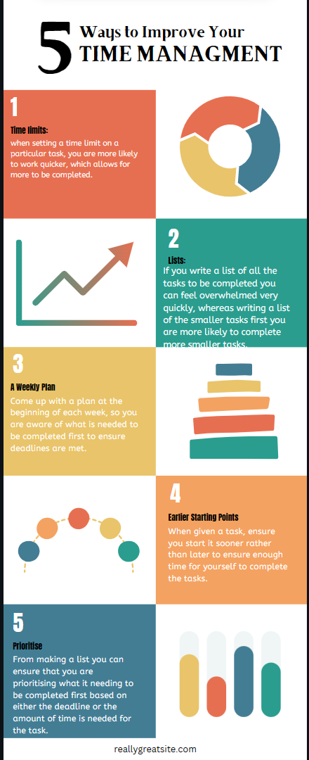
Task 2 – Infographic:

Task 3- Essay Outline

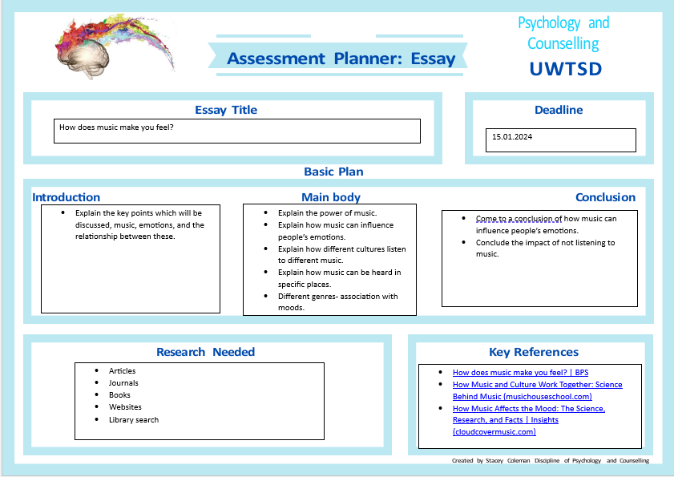

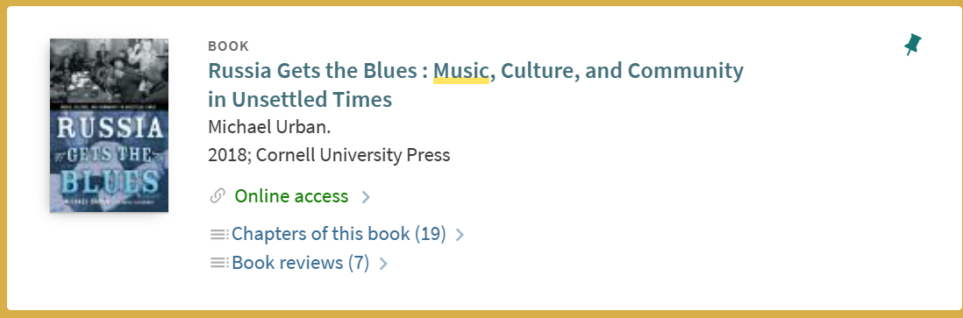

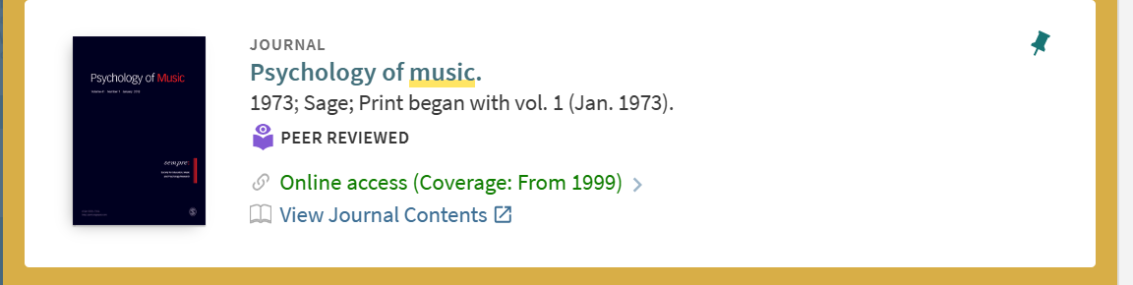
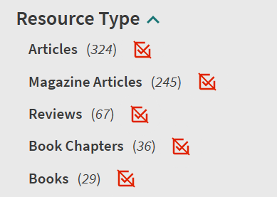
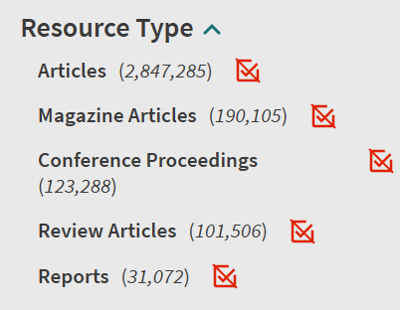

References for all tasks:
How does music make you feel? | BPS
Nendick, Z. (2022, September 12). How does music make you feel? - The British Psychological Society.
Www.bps.org.uk. https://www.bps.org.uk/psychologist/how-does-music-make-you-feel

Sage (1973). Psychology of Music.
Psychology of music. - University of Wales Trinity Saint David (uwtsd.ac.uk)
Urban, M. (2018). Russia Gets the Blues: Muic, Culture, and community in Unsettled Times, Cornell University Press
Russia Gets the Blues : Music, Culture, and Community in Unsettled Times - University of Wales Trinity Saint David (uwtsd.ac.uk)
Coursera (2023). 6 Time Management Tips to Boost Your Productivity. [online] Coursera. Available at: https://www.coursera.org/articles/time-management.

