Q1. This case study focuses on two different organisational structures: a flat, non -hierarchical structure and a hierarchical bureaucratic structure.
A non-hierarchical structure supports a horizontal hierarchy in which employees are encouraged to make decisions and share responsibilities (Slade,2018, p.18-24).
A non- hierarchical structure was appropriate under Kirsten’s ownership due to the small size of the company. With only 42 employees, Kirsten could avoid unnecessary bureaucracy and layers of hierarchy. Communication in Calmere House between Kirsten and her staff was open and direct. Employees received regular updates from Kirsten about the process and business goals which made them feel more engaged and committed to Calmere House, their residents and co-workers. This structure promoted direct communication between staff and Kirsten which allowed employees to have input into decision making and share responsibilities (Reitzig, 2022, p.80-86).
One of the disadvantages for Kirsten was management overload. She was responsible for supporting all Calmere House staff which could lead to stress or burnout. In a flat structure, there can be a confusion and uncertainty when it comes to exactly who is responsible for what and decision making or sharing responsibilities (Reitzig, 2022, p.94-95).
In hierarchical bureaucratic structures decision-making and authority are centralised. We can see clear top- down process with management levels and executive authority (Draft, 2016, p.7).
Hierarchical bureaucratic structures are suitable for larger companies, like Chaffinch Group. One advantage of the structure is the clarity of roles and responsibilities. It shows who is in charge of decisions. For employees of Chaffinch Group, it can create stability and better understanding of protocols and expectations.
When it comes to disadvantages in hierarchical bureaucratic structure employees have little decision-making power. Calmere House staff become frustrated and had lower job satisfaction under Kath’s management. Employees had to follow rules. That made them feel over-controlled, neglected or underappreciated which potentially can lower motivation. Also, this type of structure relies more on the ability of individual managers whose approach and aptitude for their role can result in inconsistency of message and objective setting (Adler, 2012, p.60-62). The need for clear policies and protocols becomes more important in such structures.
Both non-hierarchical and hierarchical structures bring advantages and disadvantages to the organisation. Flat structure encourages employees to take ownership of their work, contribute ideas and share responsibilities but can create uncertainty in decision making, which are therefore not suited to larger organisations. Hierarchical bureaucratic structure provides a system to control which help to manage larger organisations, but employee initiative and therefore individuals job satisfaction may be more limited. I believe both structures were appropriate under different ownership.
Q2. To achieve long term goals or plans, organisation need to choose the most significant strategy formulation. The most efficient organisational strategy is rational strategy formulation which involves a well thought out, clear and evidence -based method for evolving business strategy.
“Strategy is the direction and scope of an organisation over the long term, which achieves advantage through its configuration of resources within a changing environment to fulfil stakeholder expectation.” (Johnson, Scholes and Whittington, 2008).
The rational approach uses understandable, progressive system to make sensible decisions developed on evidence and justification, therefore not just based on speculation. The rational approach to strategy formulation forms a planned range of methods suited to establish logical and practical decision -making. Each step is more progressive which lead us to a clear route from evaluation to development (Johnson, Scholes and Whittington, 2017, p. 170-175).
When we are talking about Chaffinch Group customers, we need to include not only primary residents but also their family members, social workers and GP’s or even local authorities or NHS.
A SWOT analysis (Strengths, Weaknesses, Opportunities, Threats) is a practical tool that can help Chaffinch Group understand its current position and plan its strategy. Strengths, show organisations key strengths. Weaknesses, draws attention to business performance gaps. Opportunities, highlights positive development outside of organisation. Threats, shows possible danger from the external environment (Niles, 2019, p.270).
To ensure that services provided meet customer needs, Chaffinch Group could start by checking external elements like competitors, lack of workforce, government health policies, along with internal elements like staff abilities, financial consistency or residents satisfaction. Developed on these results, Chaffinch Group could create a simple plan, for instance, decreasing employee’s turnover and increasing. The management of Chaffinch Group could produce and consider a range of potential options, such as expanding employee training program or spending money on digital care technologies. Ahead of choosing the right one, every course of action would be measured for practicality, value or future assets. As soon as Chaffinch Group decided on what suited for them strategy, they will have to pursuit a plan highlighting founds, challenges and schedules. Chaffinch Goup management will have to check the process of the implementation of strategy. Pursuing this process can lead to organisational goals.

Introducing a quality circle within the care home would allow to maintain progress, promotes staff to share responsibilities and communication. Existing employees didn’t receive the support they needed and became overwhelmed with the amount of work. Unfortunately, Chaffinch Group didn’t implement residential and employee’s surveys, feedback or exit interviews. Communication with employees is the most effective approach to clarify issues and develop appropriate solutions.
In my opinion, if Chaffinch Group used a rational approach to strategy formation and ongoing feedback from the residents and employees then they could ensure that the service they provide will meet customer needs (Müller, Sankaran and Drouin, 2022, p.67-68).
Q3. Organisations are influenced by a large number of external factors, including political, economic, social, technological, legal and environmental which can be examine through PESTLE analysis (Johnson, Scholes and Whittington, 2020, p.34–41).
One external factor having a negative impact on the residential care industry is the economic crisis. The industry is facing major challenges from economic difficulty driven by the cost-of- living crisis to employment shortage. These concerns might have major impacts, not only on the quality and integrity of care being provided but also on the well-being of residents (Glasby, 2017, p.55-72).
The economic situation has increased prices of energy, food, employment as well as poor public funding, all of which has a knock-on effect to residential care.
Unsteadiness in inflation and the market, over the past few years has resulted in the increase of the cost of the food, utilities and necessary supplies for care homes. According to Care England (2024) 98% of care homes had experienced rapid increases in their running costs, especially in energy and food costs. As stated by Care Quality Communication (CQC,2023), local authorities’ payments and funding have not been matched to cover rising cost. This incompatibility between pay and expenses affected some care providers to cut the unnecessary outgoings, put a restriction to new admissions or even closing sites. It will also have an impact on investing in staff training or even potential redundancies.
Kirsten decided to sell Calmere House to larger care home company, Chaffinch Group due to lack of finance. She was aware that Calmere House was in need of refurbishment of residents’ room but also to sustain her employees with better job prospects.
According to a PESTLE analysis, this matter considers both an economic and political external factors. Politically, for example public funding and economically, with impacts from inflation and national minimum wage increases.
Conversely, one of the external factors that is currently having a positive impact on the residential care industry is technological innovation. Implementation of electronic medical records, digital care planning and remote monitoring tools have a massive impact on how care home’s function and distribute service. According to Digital Social Care (2024), ‘over 60% of adult social care providers now use digital records, which has improved data accuracy, compliance and person -cantered care’. The implementation of digital records could cause cybersecurity threats, gaps in employee competence, operational failures, escalating costs, and scepticism from service users (Currie and Guah, 2007, p.65–88).
In conclusion, at the same time as cost of living is rising, technology advance provides prospects for transformation and cost savings.
Q4. Technology has the ability to transform all our lives, and this is certainly the case for the people working and living in residential care homes. Technology has the potential of making care more exclusive, secure and productive, and can even help connect residents to their loved ones (Rivas and Wac, 2021, p.1-18).
In the care sector, technology is essential. It can allow the staff to communicate more efficiently between themselves or with healthcare professionals. Residents are able to connect to their family or friends by making video calls, which make them feel less lonely or distant (Rivas and Wac, 2021, p.95-120). With high turnover of staff in Calmere House, maybe residents wouldn’t felt so isolated if they could video call people, they are close to. Joining online activities, run centrally by Chaffinch Group, such as quizzes or virtual exercise classes would help Calmere House residence to enjoy the time they are spending there, without impact on staff resources (Rivas and Wac, 2021, p.200-230).
By using electronic systems, the Calmere House staff could share crucial information and updates about residents. Digital care plans provide up-to-date details for people operating in residential care.
Technology will allow managers and employees to have control, remain efficient and provide great care to residents. For example, digital care planning software accumulates all necessary data securely, ensuring the organisation stays compliant. Some organisations use systems which help them to manage their finances (Brown, 2022, p.25-48). It can support in controlling essential spending like food or even manage and control medical stock in correct manner. With the assistance of electronic rostering system, Calmere House could monitor the hours their employees and this would assist with resource planning. That could reduce the long hours or monitoring staff absences (Buchan, Duffield and Jordan, 2015, p.45-135).
Another great tool that could simplify their work is automated medication dispensers which help control when and what medication residents are taking (Omnicell, 2025, p.1-12).
Technology can also expose residence data to cyber threats if not managed properly. Staff can face difficulties using digital literacy causing mistakes and anxiety. High usage of technology might reduce human interaction which could have an impact on residence wellbeing. Such risks highlight the importance for steady implementation of connecting technological progress and staff training, appropriate safeguarding and governance (Rousaki and Hamblin, 2024; Garner et al., 2024).
We can confidentially say that technology has a critical part to play and a positive impact on progress in the care home sector. It can not only make communication easier for the staff but also support them. For residents, it can provide protection but also increase their well-being, welfare and happiness with the service being provided.
Q5. From the moment Chaffinch Group took over management of the small, family-run care home, Calmere House, we notice that staff and residents of the home became unhappy. Under Kirsten’s management, the care home was run in a friendly, welcoming and personable manner. This has been replaced by formal management and procedures which must be adhered to.
When talking about Social Identity Theory (Tajfel & Turner, 1979) we can see that Calmere House employees experienced an identity crisis. By being a member of small, comforting team, employees felt secure and needed through constant face to face communication with Kirsten. Now they just feel like a number in a large corporation.
Behaviours described in motivation theories can also be noticed in employees’ reactions to the takeover. Maslow’s (1943) hierarchy of needs and Herzberg (1959) two-factor theory advise that employees are motivated by acceptance, appreciation and meaningful work (Robbins & Judge, 2022, p. 198-225). Chaffinch Group manager, Kath, was giving instructions which had to be followed by her employees without discussion. Unfortunately, that has led to job dissatisfaction and demotivation.
Edgar Schein (1992) draws our attention to three levels of organisational culture: Artifacts (that can involve policies and routines); Espoused values (goals and philosophies) and basic underlying assumptions (beliefs and perceptions) (Schein, 2010, p. 23–30). We can notice that after the takeover of Calmere House, staff felt undervalued and controlled and residents noticed a loss of closeness and continuity. The basic underlying assumptions of staff towards their employer, their roles and how they were valued started to change.

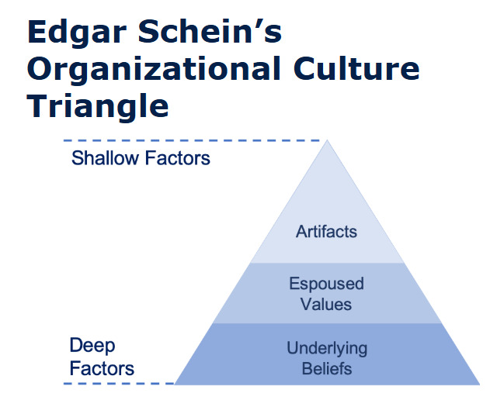

The World Of Work Project (2019).
David Rock’s SCARF model is a system to identify the factors which affect how people feel when they are in a group (Rock, 2009, pp. 152–160).

- Status: Our feeling of suitability related to others.
- Certainty: Our wish to speculate future outcomes.
- Autonomy: Our sense of control over events.
- Relatedness: Our sense of safety with others.
- Fairness: Our perception of fair exchanges between people.
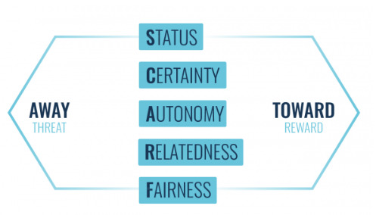
Cloke, H. (2021).
This theory demonstrates that by recognition of and application of these five modules, we can create a better environment and culture in a workplace.
All the above theories explain why Calmere House staff struggled during takeover. Employees faced uncertainty, perceived changes in status which led to job dissatisfaction. Using this framework could help the manager to provide a more gentle transition while still maintaining high quality care.
Q6. Following the takeover of Calmere House by larger organisation- Chaffinch Group, we can notice that major cultural and behavioural changes took place. We’ve noticed two significant sectors has been affected: employee selection and employee voice.
People practice has a significant impact on organisational culture due to influence on how employees behave, how they work together and how aware they are of organisational needs (Waite et al., 2022, pp. 25–30).
“Organisational culture is an important concept to the people profession. The work of HR, L&D and OD influences and is influenced by organisational culture because, at its heart, every organisation is made up of human relationships and human interactions.” CIPD (2024).
In Calmere House, the selection process previously was based on personal values, consideration and how the new employee will fit to the home’s family -like values. Chaffinch Group manager, Kath would use Agency’s to support with her requirements, with little thought to the above. According to Schein’s model of organisational culture (2010), culture is formed by similar principals and shared beliefs (Schein, 2010, p. 21–25). When selecting new employees, Chaffinch Group prioritised qualifications and experience and not particular values. We’ve noticed the cultural focus changed from “caring” to more effectiveness and greater performance. This led long-time serving employees to feel unappreciated which brought a lack of motivation and less emotional engagement in their work with residents.
One of the positive impacts Chaffinch Group could have on Calmere House is implementing structures and procedures which lead to professionally supported environment (Taylor and Woodhams, 2022, p. 58-63).
Organisational behaviour is also strongly impacted by the changes to employee voice. Staff regular catch-ups through quality circles, meetings or feedbacks will allow employees to develop openness. They’ll feel more valued which will positively impact their quality of work (Morrison, 2014, p.1-18).
Organisations that implement quality circles usually starts with set ideas such as decreasing medication errors, enhancing patient comfort and safety, or correcting mealtime experience. A foundation to achieve success in the organisation is to make sure employees voice is important and that any modifications have a positive impact on residents’ day-to-day lives (Boxall, Purcell and Wright, 2007, p.350-355).
Q7. The progression from a small owner-managed care home to incorporation within a larger care home organisation means that there will be an important change in culture, operational practice and governance. These changes need to be structured and have combined approach to make sure that employees, residents and families feel secure in their new settings. (Kotter, 2012, p.1-30).

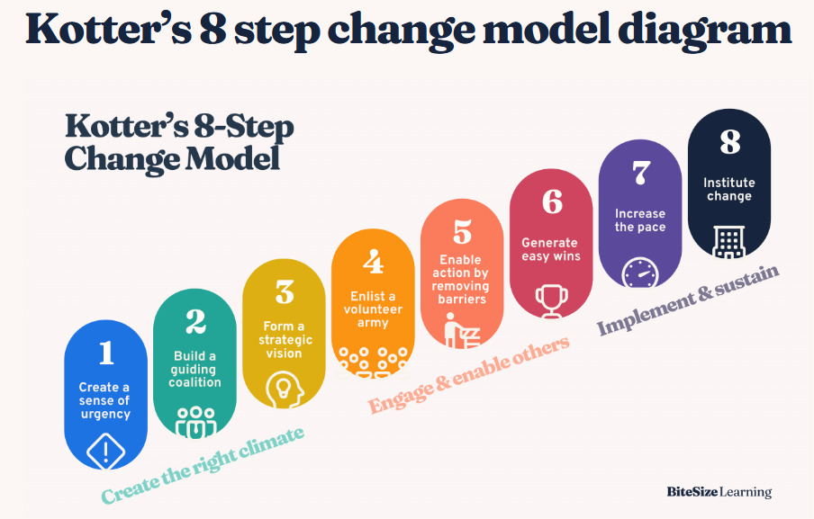
Kotter’s eight-step module is created to help implement changes successfully.

BiteSize Learning (2024).
Chaffinch Group could have develop a regulation by introducing accomplished employee of the existing team in management discussion. Forums, surveys or quality circles (i.e. enlisting a volunteer army) could allow the staff to strengthen the way the corporates polices and system were implemented. The staff engagement motivate responsibility to transform and contribute to clear behavioural outcomes (Kahn, 1990, pp. 692-724).
Lewin’s three -stage model features the urgency to unfreeze current practices before making amendments. Clear guidance, training and slowly applying of new digital system, safeguarding procedures and reporting instructions would assist Lewin’s ‘move’ phase. Employees should feel confident in new role to stay away from stress and completing their work without unnecessary errors. The Chaffinch Group should prepare the employees, residents and families by giving understandable details on why the transition was necessary and how the inputs and methods would be sustained while in transition process. Constant communication would support to decrease concerns and sustain trust (Burnes, 2017, p.133-145).

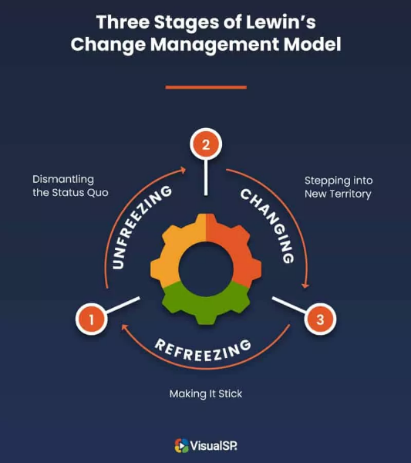
VisualSR, (2025)
Chaffinch Group could use structured evaluation process to monitor the effects of changes on organisational behaviour, employee’s confidence and residence experience. Regular feedback helps the ‘refreeze’ phase of change by analysing improvements and supporting a positive culture along with organisational goals (Burnes, 2017, p.146-150).
If Chaffinch Group had implemented a more strategic and people cantered approach using change-management theory during the take over from Calmere House, it would have helped to maintain the benefits of the existing culture at the same time as developing new policy and upgrades.
Q8. Calmere House was a small, family-run business that thrived by sense of connection and warm relationship with residents. When Chaffinch Group took over, these conditions quickly changed.
“64% of employees say their employers were not honest about the changes they would face.” (CPD Online College, 2021).
The Kubler- Ross Change Curve presents a practical system to sense how employees emotionally react to these changes. Denial, anger, bargaining, depression and acceptance are the emotional stages that employees might experience during a change in organisation (Kübler-Ross, 1969, p.34-92).
When Kirsten advised employees of the sale, they firstly experience Shock/Denial. That is the first phase felt while facing change. In many cases, employees are feeling detached with the change, they might become protective over the familiar routine or process. That may be due to uncertainty about their future position. Following interruption to the status quo, they feel and exhibit Anger and Bargaining, becoming frustrated with their losses and then attempt to discuss possibility of going back to familiar practices. Study shows that change management proves that this kind of emotional reaction are natural to staff facing change, particularly in a care environment. At this stage leaders should make the staff feel heard when raising any concerns, they should listen and observe. Leaders could also offer some personalised training to the staff which would help them to adapt to the new environment (Cameron and Green, 2020, p.120-125).
In Depression stage we can notice sense of loss. It can be a loss of the family- run culture, loss of freedom or confidence as employees need to adjust to new values, management and procedures. In this stage we can often notice discomfort, demotivation and regret. Leaders need to identify this and will profit from rewarding positive changes in behaviour. At this stage, staff may be susceptible to looking for other employment.
Eventually, staff reach the stage of Acceptance and Integration where the employees accept the change in organisation and management. Leadership should value the achievements of staff and give recognition.
The Change Curve will help management to effectively deal with the change and how it’s experienced. The stages in this model are clear and can help management to manage the staff and adapt to the new changes. During the course of denial and anger it is vital to produce simple and open information’s when concerns are being raised. In the time of bargaining and depression phase, reassurance and support need to be critical. Lastly, in time of acceptance and integration, management should highlight the achievements which make the employees feel more appreciated and involved with the organisation (Kotter, 2012, p.31-70).
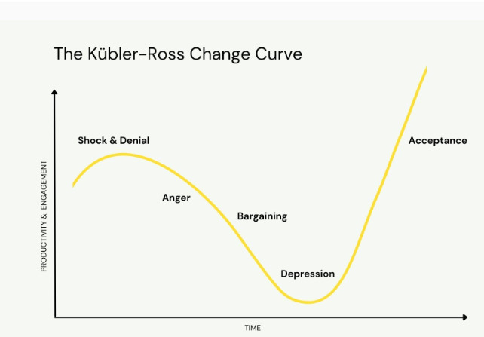

Malik, P. (2022).

Q9. Wellbeing at work has an immense effect on how employees act, function and the extent to which they are committed to work. Improving wellbeing at work relieves anxiety and promotes more effective ways of working. Stable workplaces motivate people to develop their skills and reach their potential. If the employer builds a state of fulfilment in the company, that can not only benefit the employees but also the organisation. A comprehensive wellbeing at work programme promotes employee resilience, commitment and capability, at the same time looking to reduce sickness (Robertson and Cooper, 2011, p.1-145).

“CIPD 2023 Health and wellbeing at work survey identified the top three benefits of employers increasing their focus on employee wellbeing:
- Better employee morale and engagement.
- A healthier and more inclusive culture.
- Better work-life balance.”
CIPD (2024).
One significant factor is employee workload. If uncontrolled, workloads can force avoidable stress, which may lead to working longer hours (Cooper and Dewe, 2008, p. 30-38). We can notice that when employee turnover and sickness absence increased in Calmere House. That left existing employees under pressure of covering shifts. When the workload is better managed, employees are more productive, enthusiastic and unlikely to take sicknesses leave or even leave the organisation (Cooper and Dewe, 2008, p. 90-100). Kath should introduce flexible working, shift rotations or even share her experience.
Underutilising in work might have a negative effect on employees. When staff feels unneeded in work or they haven’t got a sense of purpose that can cause demotivation or decrease in self-esteem (Furnham and Treglown, 2018, p.30-110).
Another major factor is job satisfaction. It shows how satisfied and content employee can be in their position. Emotional and mental wellbeing increases when staff feel supported, appreciated and valued (Spector, 1997, p.30-40). When Chaffinch Group took over, we could see a low job satisfaction. It was caused by lack of communication and absence of recognition which created low morale and unease among employees. Staff who feel supported also have a feeling of belonging and emotional purpose (Spector, 1997, p. 110-120). The relationship with coworkers becomes more supportive and brings compassion in caring for residents. This not only benefits employee but also care home popularity as an organisation.
It is very important that under new management Calmere House would carry on promoting a positive workplace culture by acknowledgement, productive communication and useful staff involvement. By promoting job satisfaction and engagement, managers can build strong, committed workforce that provides a stabilised, comforting place for everyone affected (Armstrong, 2020, p.950-960).

Q10. The employee lifecycle describes a course of steps that an employee experience throughout the period of time they’re with an organisation and how it influences the business overall. This framework helps HR and managers to examine the steps using data to address any gaps and promote a better employee experience at every stage reducing employee turnover (Kaufman, 2015, p. 240-250).
‘Understanding, and measuring, the employee lifecycle effectively has been known to result in a more engaged workforce and lower turnover’ Lyon, S. (2024).
The retention stage of the employee lifecycle is very important, as it is concentrating on sustaining effective employees involved, determined and dedicated to the business. A people manager is responsible for supporting clear, embracing workplace which is created by acceptance and direct conversation. They support career development possibilities, guidance and appreciation so that employee is respected and committed. Employee engagement can be strengthened by frequent feedback. Through continuous support, acceptance and appreciation, people managers create safe environment to work which helps employees to stay loyal to the company CIPD (2021, p. 19–22).
A recruitment advisor supports the retention stage by choosing suitable people. Turnover can decrease drastically if the candidates are assessed in the right way. That will include candidate’s abilities, experience and motivation to work in the care industry. Job expectations are also set during the recruitment process, which clarify any further disengagement. Recruitment advisors work closely with managers to improve recruitment methods to secure better employee and can collect feedback from recent recruit to improve onboarding practises. By giving attention to quality and knowledge, recruitment advisor creates an effectiveness and long-term engagement with organisation (Armstrong and Mitchell, 2019, p. 20-30).
An employment relation case advisor supervises and solves employee matters for example disputes, grievances, or disciplinary concerns. They create confidence and effective workplace e.g. equality and consistency of rules by implementing policies and introducing directions to managers. With honest discussion and being fair in the application of employee relations, they make employees feel appreciated and recognised which promotes long-term relationship with company (Armstrong and Mitchell, 2019, p.150).
“Organisations operate most effectively when staff turnover is low, and retention strategies help reduce the cost and impact of people leaving. HR professionals play a key role in understanding why employees leave and devising initiatives that reduce turnover and increase employee retention.”
CIPD,2025
People managers, recruitment advisors and employment relations case advisors’ roles can, if done well, build an encouraging, clear and skills developing workplace where employees feel supported, appreciated and inspired. Their joint impact benefits organisations to control consistency, increase achievements and create ongoing commitment in the company (Beardwell and Thompson, 2017, p. 550-565).
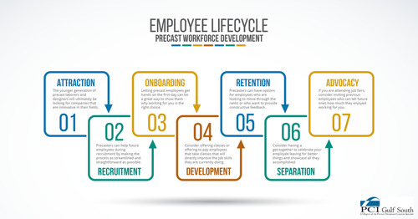
SOUTH, G. (2023).
Q11. Reaching 100% occupancy within six months by Chaffinch Group is a difficult but achievable plan if helpful people practices are deliberately applied. By implementing this method vertically with organisational aims and objectives and horizontally along HR duties, Chaffinch Group could build an ambitious team that offers excellent care, creates a favourable profile and interest new residents.
If HR wants to build and retain a reputation as a vital function, then it must embrace horizontal management strategies and build cross-functional skills (Sparrow,2015).
Vertical structure makes sure that people strategies accurately help care home’s achieving organisational goals (Holbeche, 2022, p. 47). If the target is to occupy all rooms and increase residence expectations, recruitment must concentrate on choosing caring and experience employees who express compassion and integrity. To build up care values, good service quality and resident involvement, Chaffinch Group should introduce training programmes. Performance management needs to consider connecting appraisal results to resident benefits. This will make sure that employees duties are always heading into obtaining full occupancy (Armstrong, 2021, pp. 82–90).
Horizontal strategy provides clarity and inclusion along HR practices. To create an employee ability to brings effectiveness and engagement, recruitment, reward system and development should support one each other. When recruiting, focus should be on candidate beliefs and motivation to work in care, accompanied by induction and guidelines that improve teamwork to sustain stable care culture. For the staff to deliver excellent service, appreciation and reward schemes that acknowledge great resident feedback, need to be implemented. Consistent communication, surveys and wellbeing sessions can decrease staff turnover, lift confidence which is a key to keep a balanced care performance and resident commitment. Leadership has got a very important part to play, with combining strategy with day-to-day systems (Purcell, Boxall and Wright, 2023, pp. 65–72).
‘Transformational leaders inspire followers to transcend their own self-interests for the good of the organisation’. Bass and Riggo (2006)
Mutually, vertical and horizontal strategy builds collaboration that contribute to the care home image. Staff that are qualified and committed will bring to the business steady, quality care that supports their residence and their families. Good feedback creates recommendation which allows care homes to fill the unoccupied rooms. Additionally, if the staff turnover is reduced that can help stability of care which is very important to the families (Boxall and Purcell, 2023, pp. 70–75).
Q12. When employee turnover has increased at Calmere House this could have a major impact on morale, consistence and performance in organisation. Kath should set practical ways to identify reasons why employee turnover increased. She could do that by effective discussion and engagement with employees which could help her to understand the reasons why they are leaving and prevent further resigning (Armstrong, 2020, pp. 320–328).
“The CIPD’s Resourcing and talent planning survey 2024, found that only 20% of respondents collect data on the effectiveness of retention initiatives.”
CIPD,2025
The first step she could take is to carrying exit interviews with all the staff that decided to leave Calmere House. These interviews would show her the reason why they are leaving their current position, including e.g. pay, workload or management. By investigating the issues through the interviews, she could address the frequent problems that affects turnover (Armstrong & Taylor, 2020). To receive truthful feedback, she should carry out exit interviews confidentially or anonymously.
“Recent research demonstrates that using a combination of measures can provide actionable insights. Strategic use of exit interview data can also support future retention strategies as part of a wider approach to people analytics.”
CIPD,2025
Kath could also use “stay interviews” with the employees that are currently working for her to sense what make them committed and what factors might push them to leave. By doing that, she could deal with possible issues early, which could lead to building a trust and developing job satisfaction (Taylor, 2002, pp. 55–60).
A different method for Kath, would be arranging focus groups or team discussions to promote conversation about Calmere House settings. Open sessions with the manger would allow current staff to state any concerns they’ve got. SMT coffee mornings would let employees meet senior manager and ask questions. Similarly, anonymous employee survey could provide Kath with staff point of view on work-life balance or designation (Kossivi et al.,2016).
Kath should also use regular two-way communication method. She will have to consider routine one-on-one meetings and include open-door-policies, which would help her build connections with employees and stop any problems from arising (Armstrong, 2020, pp. 145–152).
If Kath would communicate and start seeking opinion from her employees over different feedback methods that would help her to understand and identify the reason of why employee’s turnover increased. By doing that, her employees would feel appreciated and valued, which would more likely assure them to stay dedicated to Calmere House.

References:
Adler, P.S. (2012) Reinventing Hierarchy and Bureaucracy: From the Bureau to Network Organizations. Bingley: Emerald Group Publishing.
Armstrong, M. (2020) Armstrong’s Handbook of Human Resource Management Practice. 15th ed. London: Kogan Page.
Armstrong, M. (2020). A Handbook of Human Resource Management Practice. 10th ed. London: Kogan Page.
Armstrong, M. (2021) Armstrong’s Handbook of Performance Management. 6th ed. London: Kogan Page.
Armstrong, M. and Baron, A. (2002). Strategic HRM: The Key to Improved Business Performance. London: Chartered Institute of Personnel and Development.
Armstrong, M. and Taylor, S. (2023). Armstrong’s Handbook of Human Resource Management Practice. 16th ed. Kogan Page.
Athuraliya, A. (2023). Kotter’s 8 Step Change Model | A Comprehensive Step-by-Step Guide. [online] Creately Blog. Available at: https://creately.com/blog/strategy-and-planning/kotters-8-step-change-model/( Accessed 15 Oct.2025).
BBC (2024). Horizontal (flat) Structures and Hierarchical (tall) Structures - Organisational Structures - Eduqas - GCSE Business Revision - Eduqas. [online] BBC Bitesize. Available at: https://www.bbc.co.uk/bitesize/guides/zb2vvk7/revision/2 (Accessed 5 Oct. 2025).
Beardwell, J. and Thompson, A. (2017) Human Resource Management: A Contemporary Approach. 8th ed. Harlow: Pearson Education.
Bhattacharyya, D.K. (2008) Technological Change and Manpower Development. New Delhi: Excel Books.
BiteSize Learning (2024). Kotter’s 8-Step Change Model, Explained. [online] BiteSize Learning. Available at: https://www.bitesizelearning.co.uk/resources/kotters-8-step-change-model (Accessed 15 Oct. 2025).
Boxall, P., Purcell, J. and Wright, P. (eds.) (2007) The Oxford Handbook of Human Resource Management. Oxford: Oxford University Press.
Boxall, P.F. and Purcell, J. (2016). Strategy and Human Resource Management. 4th ed. London: Palgrave Macmillan.
Brooks, R. (2021). What Is Organisational Strategy and Why Does It Matter? [online] University of Lincoln. Available at: https://online.lincoln.ac.uk/what-is-organisational-strategy-and-why-does-it-matter/ (Accessed 18 Oct. 2025).
Brown, A. (2022) Digital Transformation in Health and Social Care. Abingdon: Routledge.
Buchan, J., Duffield, C. and Jordan, A. (2015) Nursing Workforce Planning and Management. London: Routledge.
Burnes, B. (2017) Managing Change. 7th ed. Harlow: Pearson Education.
Cameron, E. and Green, M. (2020) Making Sense of Change Management: A Complete Guide to the Models, Tools and Techniques of Organizational Change. 6th ed. London: Kogan Page.
Care Quality Commission (2022). Workforce - Care Quality Commission. [online] Available at: https://www.cqc.org.uk/publication/state-care-202122/workforce (Accessed 23 Sep. 2025)
Chartered Institute of Personnel and Development (CIPD) (2021) Employee Engagement: An Evidence Review. London: CIPD.
Chartered Institute of Personnel and Development (CIPD) (2024) Organisational Culture. [online] CIPD. Available at: https://www.cipd.org/uk/views-and-insights/cipd-viewpoint/organisational-culture/ (Accessed 11 Nov. 2025).
Chartered Institute of Personnel and Development (CIPD) (2024) Organisational Climate and Culture. [online] CIPD. Available at: https://www.cipd.org/uk/knowledge/factsheets/organisation-culture-change-factsheet/ (Accessed 10 Nov. 2025).
Chartered Institute of Personnel and Development (CIPD) (2025) PESTLE Analysis. [online] CIPD. Available at: https://www.cipd.org/uk/knowledge/factsheets/pestle-analysis-factsheet/ (Accessed 07 Nov. 2025).
Chartered Institute of Personnel and Development (CIPD) (2025) Wellbeing at Work. [online] CIPD. Available at: https://www.cipd.org/uk/knowledge/factsheets/well-being-factsheet/ (Accessed 08 Nov. 2025).
Cloke, H. (2021). The SCARF Model of Engagement: Dr David Rock. [online] Growth Engineering. Available at: https://www.growthengineering.co.uk/scarf-model/ (Accessed 13 Nov. 2025)
Combe, C. (2014). Introduction to Management. Oxford: Oxford University Press.
Condrey, S.E. (2005) Handbook of Human Resources Management in Government. San Francisco: Jossey-Bass, John Wiley & Sons.
Cooper, C.L. and Dewe, P. (2008) Stress Management in the Workplace. London: CIPD/Kogan Page.
CPD Online College. (2021). Managing Change in the Workplace. [online] Available at: https://cpdonline.co.uk/knowledge-base/business/managing-change (Accessed 12 Oct 2025).
Cuofano, G. (2021). Flat Organizational Structure In A Nutshell. [online] FourWeekMBA. Available at: https://fourweekmba.com/flat-organizational-structure/ (Accessed 15 Oct 2025).
Daft, R.L. (2016) Organization Theory and Design. 12th edn. Boston, MA: Cengage Learning.
Farnham, D. (2015) Human Resource Management in Context: Insights, Strategy and Solutions. 4th edn. London: Chartered Institute of Personnel and Development.
Furnham, A. and Treglown, L. (2018) Disenchantment: Managing Motivation and Demotivation at Work. London: Bloomsbury Business.
Gilmore, S. (2025). Psychoanalysis and Human Resource Management. Policy Press.
Glasby, J. (2017) Understanding Health and Social Care. 2nd edn. Bristol: Policy Press.
Government Communication Service (GCS) (2021) Using Internal Communications to Support Change. [online] Available at: https://gcs.civilservice.gov.uk/guidance/internal-communication/using-internal-communications-to-support-change/ (Accessed 17 Nov. 2025).
Holbeche, L. (2022) Aligning Human Resources and Business Strategy. 3rd edn. London: Routledge.
Hook, C. and Jenkins, A. (2019) Introducing Human Resource Management. 8th edn. Harlow: Pearson UK.
Hutchings, K., Michailova, S. and Wilkinson, A. (2024) A Guide to Key Theories for Human Resource Management Research. Cheltenham: Edward Elgar Publishing.
Information Resources Management Association (2012) Human Resources Management: Concepts, Methodologies, Tools and Applications. Vol. 3. Hershey, PA: Business Science Reference.
Johnson, G., Scholes, K. and Whittington, R. (2017) Exploring Strategy: Text and Cases. 11th edn. Harlow: Pearson Education.
Kahn, W.A. (1990) ‘Psychological conditions of personal engagement and disengagement at work’, Academy of Management Journal, 33(4).
Kaufman, B.E. (2015) Theoretical Perspectives on Work and the Employment Relationship. Champaign, IL: Industrial Relations Research Association.
King, D. and Lawley, S. (2022). Organizational Behaviour. 4th edn. Oxford: Oxford University Press.
Kotter, J.P. (2012) Leading Change. Boston, MA: Harvard Business Review Press.
Kübler-Ross, E. (1969) On Death and Dying. New York: Macmillan.
Lundy, O. and Cowling, A.G. (2020). Strategic Human Resource Management. London: Thomson Learning.
Lyon, S. (2024) What is the Employee Lifecycle? [online] People Insight. Available at: https://peopleinsight.co.uk/what-is-the-employee-lifecycle/ (Accessed 03 Nov. 2025).
Malik, P. (2022). The Kübler Ross Change Curve in the Workplace (2022) - Whatfix. [online] The Whatfix Blog | Drive Digital Adoption. Available at: https://whatfix.com/blog/kubler-ross-change-curve/ (Accessed 24 Oct 2025).
Morrison, E.W. (2014) Employee Voice and Silence in Organizational Life. Cambridge: Cambridge University Press.
Niles, N.J. (2019) Basic Concepts of Health Care Human Resource Management. Burlington, MA: Jones & Bartlett Learning.
Omnicell (2025) Guide to Implementing Automated Dispensing Cabinets in NHS Hospitals. Omnicell UK.
Patricia, Lytras, M.D., Alkhaldi, A. and Malik, S. (2025) Insights Into Digital Business, Human Resource Management, and Competitiveness. Hershey, PA: IGI Global.
Perkins, G. and Robinson, S. (2025) Strategic Learning and Development Practice. London: Kogan Page Publishers.
Potgieter, I.L. and Ferreira, N. (2022). Managing Human Resources : The New Normal. Cham: Springer.
Prosci (2024). What Is Lewin’s Change Theory? Explanation, Pros and Cons. [online] Prosci.com. Available at: https://www.prosci.com/blog/lewins-change-theory (Accessed 25 Sep 2025).
Purcell, J., Boxall, P. and Wright, P. (2023) Strategy and Human Resource Management. 4th edn. London: Routledge.
Qualtrics (2021). Understanding the 7 stages of the employee lifecycle model. [online] Qualtrics. Available at: https://www.qualtrics.com/en-gb/experience-management/employee/employee-lifecycle-model (Accessed 17 Sep. 2025).
Reed, S.M. and HR Certification Institute (2017) A Guide to the Human Resource Body of Knowledge. Hoboken, NJ: Wiley.
Reitzig, M. (2022) Get Better at Flatter: A Guide to Shaping and Leading Organizations with Less Hierarchy. Cham: Palgrave Macmillan.
Rivas, H. and Wac, K. (eds.) (2021) Digital Health: Scaling Healthcare to the World. Cham: Springer.
Robbins, S.P. and Judge, T.A. (2022) Organizational Behaviour. 19th edn. Harlow: Pearson Education.
Robertson, I. and Cooper, C.L. (2011) Wellbeing: Productivity and Happiness at Work. Basingstoke: Palgrave Macmillan.
Rock, D. (2009) David Rock on the SCARF Model. [video] YouTube. Available at: https://www.youtube.com/watch?v=5Wu33SdjeCs (Accessed 29 Sep. 2025).
Rock, D. (2009). Your Brain at Work: Strategies for Overcoming Distraction, Regaining Focus, and Working Smarter All Day Long. New York: HarperCollins.
Rousaki, A. and Hamblin, K. (2024) ‘The digitalization of social care in England and implications for older, unpaid carers: constructionist thematic analysis’, Journal of Medical Internet Research, 26, e60056. Available at: https://doi.org/10.2196/60056 (Accessed 12 Nov. 2025).
Russ-Eft, D.F. (2024). Ethics and Human Resource Development. Springer Nature.
Schein, E.H. (2010) Organizational Culture and Leadership. 4th ed. San Francisco: Jossey-Bass.
Slade, S. (2018) Going Horizontal: Creating a Non-Hierarchical Organization, One Practice at a Time. Oakland, CA: Berrett-Koehler Publishers.
Smith, P., Farmer, M. and Yellowley, W. (2013) Organizational Behaviour. London: Routledge.
Sparrow, P. (2015). Paul Sparrow: We need HR for a horizontal world - HR Magazine. [online] HR Magazine. Available at: https://www.hrmagazine.co.uk/content/features/paul-sparrow-we-need-hr-for-a-horizontal-world ( Accessed on 13 Sep 2025).
Spector, P.E. (1997) Job Satisfaction: Application, Assessment, Causes, and Consequences. Thousand Oaks, CA: Sage Publications.
Taylor, S. (2002) The Employee Retention Handbook. London: CIPD/Kogan Page.
Taylor, S. and Woodhams, C. (2022) Human Resource Management: People and Organisations. 3rd ed. London: Kogan Page.
The World Of Work Project (2019). Edgar Schein’s Culture Triangle. [online] The World of Work Project. Available at: https://worldofwork.io/2019/10/edgar-scheins-culture-triangle/ (Accessed 7 Oct 2025).
Torrington, D., Hall, L., Taylor, S. and Atkinson, C. (2020). Human Resource Management. 11th ed. New Jersey: Pearson.
Tyson, S. (2016). Essentials of Human Resource Management. London: Routledge.
Verlinden, N. (2024). Employee Life Cycle: The Ultimate Guide for HR. [online] AIHR. Available at: https://www.aihr.com/blog/employee-life-cycle/ (Accessed 13 Oct. 2025).
VQ Solutions Ltd (2025). David Rocks SCARF Theory. [online] YouTube. Available at: https://www.youtube.com/watch?v=pi-CZeRkKbA (Accessed 4 Nov. 2025).
VQ Solutions Ltd (2025). Edgar Schein’s Model of Organisational Culture Explained. [online] YouTube. Available at: https://www.youtube.com/watch?v=MKRo8n8qZi8 (Accessed 14 Nov. 2025).
Waite, K., Beevers, K., Small, N., Tomlinson, K. and Hussain, S. (2022) People Practice: A Complete Guide. London: Kogan Page.
Whatfix (2025). Kübler-Ross Change Curve, Explained: Why Employees Resist Change. [online] YouTube. Available at: https://www.youtube.com/watch?v=dhFmIlRCl9k (Accessed 20 Nov. 2025).
Wilton, N. (2022) Introduction to Human Resource Management. 5th edn. London: Sage Publications.
Zicari, A. and Gamble, T. (2025). Employee Meaning and Wellbeing. London: Routledge.

