University of Wales Trinity Saint David

Designing a Zero Trust Security Framework for a Financial Services Organisation

Synthesise a solution to a
potential real-life scenario

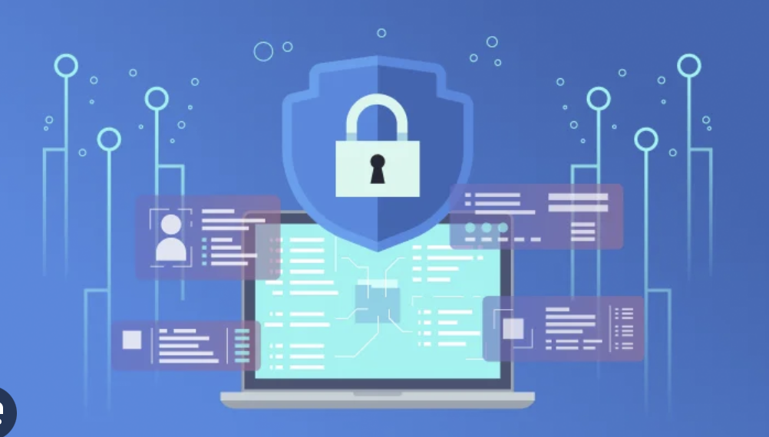

Module: “Networks and Cyber Security Essentials”
Programme: CertHE Computing Skills for Workplace

Name: Alexandr Iancovschi
Student Number: 2423378
Date: 18 December 2025

Table of Contents
Introduction 3
1. Identification of Modern Threats 3
2. Modern Security Policies Aligned with Zero Trust 5
3. Technical and Administrative Mitigation Measures 5
4. Proactive Monitoring and Incident Response 6
5. Continuous Training and Security Awareness 11
6. Mapping to NIST CSF and CIA Triad 13
Conclusion 14
References 14
Appendices 15
Appendix 1 15
Appendix 2 28

Introduction

Cybersecurity has become a critical concern for financial services organisations due to the increasing sophistication, scale, and frequency of cyber threats. Financial institutions manage highly sensitive information, including personal data, financial records, and transactional systems, making them prime targets for cybercriminals. According to industry and academic research, attacks on financial organisations are often financially motivated and designed to cause maximum operational disruption or data loss [1].

The rapid adoption of cloud computing, hybrid work models, and third-party software solutions has significantly expanded the organisational attack surface. Traditional perimeter-based security models, which rely heavily on network boundaries and implicit internal trust, are no longer sufficient in this environment. As noted by Stallings, modern networks are highly distributed, and trust assumptions based on physical or network location are increasingly ineffective [2].
This report proposes a comprehensive cybersecurity framework based on the Zero Trust security model, supported by established standards such as the NIST Cybersecurity Framework (CSF) and the CISA Known Exploited Vulnerabilities (KEV) Catalog. The objective is to design a modern, practical, and scalable security solution that mitigates current and emerging threats while promoting continuous security awareness across the organisation.

1. Identification of Modern Threats

Vigilant Trust & Asset Management (VTAM), a medium-sized financial services organisation, has recently experienced multiple cybersecurity incidents, including a sophisticated phishing attack that bypassed traditional email filtering controls and an attempted ransomware infection. These incidents highlight weaknesses in VTAM’s existing security architecture and demonstrate the need for a more adaptive and resilient security approach.

Modern cyber threats are increasingly complex, automated, and financially motivated. One of the most significant threats facing VTAM is Ransomware-as-a-Service (RaaS). RaaS enables cybercriminal groups to distribute ransomware tools to affiliates, significantly increasing the number and reach of attacks. Financial institutions are frequently targeted due to their reliance on system availability and the potential financial impact of service disruption [3].

Another growing threat is AI-powered social engineering, particularly vishing (voice phishing). Advances in artificial intelligence allow attackers to create realistic voice deepfakes that impersonate executives, financial partners, or IT support staff. These attacks exploit human trust rather than technical vulnerabilities, making them difficult to detect using traditional security tools [4].

Software supply chain attacks represent an additional critical risk. High-profile incidents, such as the MOVEit breach, demonstrate how vulnerabilities in trusted third-party software can be exploited to compromise multiple organisations simultaneously. As Stewart and Kinsey explain, modern networks depend heavily on third-party services, making supply chain security a fundamental concern rather than an isolated risk [5].

Cloud misconfigurations are another common cause of data breaches. Poorly managed access controls, exposed storage services, and inconsistent security policies across hybrid environments increase the likelihood of unauthorised access. Insider threats must also be considered, including both malicious insiders and unintentional errors caused by insufficient training or weak security awareness.

2. Modern Security Policies Aligned with Zero Trust

To address these threats, VTAM must adopt security policies aligned with the Zero Trust security model, which operates on the principle of “never trust, always verify.” Unlike traditional security models that assume internal network traffic is trustworthy, Zero Trust treats every access request as potentially hostile, regardless of its origin.

Access control policies should enforce the principle of least privilege, ensuring that users and systems only have access to resources required for their specific roles. Multi-Factor Authentication (MFA) must be mandatory for all users, particularly for privileged accounts and remote access scenarios. Research shows that MFA significantly reduces the risk of credential-based attacks, which remain one of the most common attack vectors [1].

Device trust policies should also be implemented. Devices must meet predefined security requirements, such as up-to-date patches, enabled endpoint protection, and secure configurations, before access is granted. These controls align with the Identify and Protect functions of the NIST CSF and support compliance with international standards such as ISO/IEC 27001.

3. Technical and Administrative Mitigation Measures

Effective cybersecurity requires a combination of technical and administrative controls. From a technical perspective, Endpoint Detection and Response (EDR) solutions should be deployed across all organisational devices. EDR provides continuous monitoring of endpoint activity and enables rapid isolation of compromised systems.

Network segmentation is another critical control. By separating critical systems from user networks, VTAM can limit lateral movement within the network, reducing the potential impact of a successful breach. As highlighted in Data and Computer Communications, segmentation and controlled network flows are essential components of secure network design [2].

Administrative controls are equally important. Patch management processes must prioritise vulnerabilities listed in the CISA KEV Catalog, ensuring that known exploited vulnerabilities are addressed promptly. Regular access reviews, security audits, and third-party risk assessments further reduce exposure to insider threats and supply chain risks.

4. Proactive Monitoring and Incident Response

Proactive monitoring is essential for early threat detection and effective incident response. VTAM should implement a Security Information and Event Management (SIEM) platform to centralise log collection from endpoints, servers, network devices, and cloud services. SIEM enables correlation and analysis of security events, improving visibility across the organisation.

To enhance response capabilities, Security Orchestration, Automation, and Response (SOAR) tools should be integrated with the SIEM. SOAR automates routine response actions, such as disabling compromised accounts or isolating infected devices, reducing response time and human error.

Diagram Description: SIEM–SOAR Incident Response Flow

The SIEM–SOAR incident response diagram illustrates log data flowing from multiple sources into a central SIEM system. Detected anomalies generate alerts, which are evaluated using predefined playbooks within the SOAR platform. Automated response actions are executed where appropriate, followed by analyst review and post-incident reporting.
The comprehensive 24/7 monitoring and incident response plan that incorporates SIEM (Security Information and Event Management) and SOAR (Security Orchestration, Automation, and Response), along with a clear flow diagram for visualisation.

1. Objectives
• Detect, analyse, and respond to threats in real-time.
• Ensure continuous monitoring of networks, endpoints, and cloud assets.
• Reduce dwell time of threats and minimise business impact.
• Automate repetitive response actions for efficiency.

2. Core Components

a) Data Collection & Monitoring
• Sources: Network devices, firewalls, IDS/IPS, endpoints, cloud logs, applications.
• Tools: SIEM platforms like Splunk, IBM QRadar, or Microsoft Sentinel.
• Activities:
• Aggregate logs and telemetry from all critical systems.
• Normalize and correlate events for easier analysis.
• Implement real-time alerting for suspicious activity.

b) Threat Detection
• Methods:
• Signature-based detection (known malware patterns)
• Anomaly-based detection (deviation from normal behavior)
• Threat intelligence integration (IOC feeds, MITRE ATT&CK framework)
• Tools: SIEM correlation rules, AI/ML anomaly detection, endpoint detection & response (EDR).

c) Incident Triage & Analysis
• Initial Triage: Automated classification of alerts by severity (low, medium, high, critical).
• Analyst Review: Security analysts validate incidents and prioritize responses.
• Threat Enrichment: Use threat intelligence to add context (IP reputation, geolocation, attack patterns).

d) Response & Mitigation
• Automated Actions via SOAR:
• Contain compromised endpoints
• Block malicious IPs or URLs
• Reset credentials if necessary
• Manual Actions: Escalate complex incidents to SOC or IT teams.
• Post-Incident: Perform forensic analysis and generate incident reports.

e) Continuous Improvement
• Review incident logs for trends.
• Update detection rules and response playbooks.
• Conduct regular tabletop exercises to test readiness.
3. Tools Integration

Layer | Tool / Technology | Purpose
Collection | Syslog, Cloud logs, EDR | Aggregates security data
Detection | SIEM (Splunk, Sentinel), IDS/IPS | Correlates events and alerts
Orchestration | Palo Alto Cortex XSOAR, Splunk SOAR | Automates repetitive responses
Threat Intelligence | Recorded Future, MISP | Provides actionable context
Response | EDR, Firewall, IAM | Containment and mitigation
Figure 1
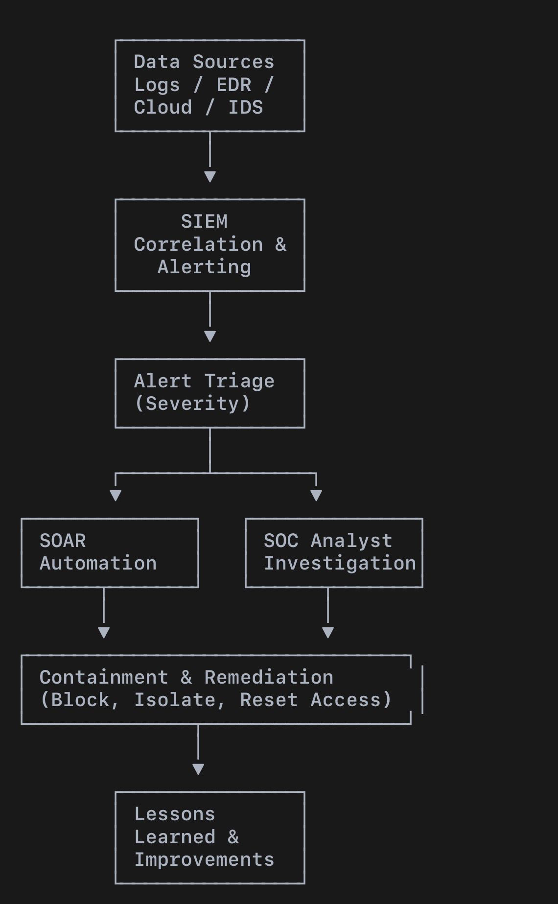
Figure 2

5. Key Notes
• Alerts should be prioritized to avoid analyst fatigue.
• SOAR enables repeatable, fast, low-risk responses, while analysts handle complex incidents.
• Integration with threat intelligence feeds ensures proactive detection.
• 24/7 coverage may involve multiple shifts in a Security Operations Center (SOC).

5. Continuous Training and Security Awareness

Human factors remain one of the most significant cybersecurity risks. VTAM must implement a continuous security awareness programme that goes beyond annual compliance training. This programme should include regular phishing and vishing simulations, role-based training for privileged users, and scenario-based exercises that reflect real-world attack techniques.

According to Austin, cybersecurity education plays a critical role in shaping organisational security culture and reducing human-related vulnerabilities [6]. Training effectiveness should be measured using metrics such as phishing simulation success rates and incident reporting frequency.
The objective of the Continuous Training and Awareness Program is to create a strong security-aware culture within the organisation. The program ensures that employees are able to recognise, avoid, and correctly report common cyber threats such as phishing, vishing, and social engineering attacks. Instead of relying on one-off training sessions, this approach focuses on continuous learning, practical simulations, and measurable improvement over time [8], [11].
1. Ongoing Attack Simulations

Phishing Simulations
Employees receive monthly simulated phishing emails designed to look like real-world threats, such as fake invoices, password reset requests, or messages from HR. The difficulty of these simulations gradually increases, moving from basic phishing attempts to more targeted spear-phishing attacks. This helps employees develop stronger detection skills over time [12]. If an employee interacts with a malicious link, immediate feedback is provided to explain the mistake and reinforce correct behaviour [10].

Vishing Simulations
Periodic vishing simulations are also conducted. These involve simulated phone calls where attackers impersonate IT support staff or senior management. This reinforces the principle of “verify before trust” and improves decision-making in realistic, high-pressure situations [9], [11].
2. Micro-Learning Training Model

This approach minimises disruption to daily work while keeping security awareness up to date. All training content is scenario-based and interactive, allowing employees to apply problem-solving and algorithmic thinking to realistic security situations rather than learning theory alone [8], [9].
3. Just-in-Time Learning

This method encourages continuous improvement and learning from mistakes without blaming individuals [10], [12].
4. Employee Engagement and Security Culture

This helps promote the idea that security is a shared responsibility across the organisation, not just the responsibility of the IT department [10], [11].
5. Management and Leadership Involvement

This demonstrates organisational commitment to security and supports the integration of security awareness into everyday business practices [11].
6. Measurement and Continuous Improvement

Key metrics such as phishing click-through rates, time taken to report incidents, repeat failure rates, and overall awareness maturity are continuously monitored. This continuous improvement process follows structured and data-driven problem-solving principles [9], [12].
This continuous and simulation-based training approach reduces human-related security risks, improves incident response times, and embeds security awareness into everyday employee behaviour. As a result, the organisation becomes more resilient and better prepared to respond to modern cyber threats, supported by computational thinking and continuous learning frameworks [8], [11].

6. Mapping to NIST CSF and CIA Triad

All recommended controls are mapped to the NIST Cybersecurity Framework core functions. Asset management and risk assessments support Identify. MFA, encryption, and segmentation support Protect. SIEM monitoring aligns with Detect. Incident response playbooks address Respond, while backups and disaster recovery planning support Recover.
The CIA Triad is used to evaluate control effectiveness. Confidentiality is ensured through strong access controls and encryption, integrity through logging and change monitoring, and availability through redundancy, backups, and ransomware recovery strategies.

Conclusion

This assessment presents a comprehensive Zero Trust security framework tailored to the needs of Vigilant Trust & Asset Management. By integrating modern threat intelligence, recognised security frameworks, and continuous training, the proposed solution enhances organisational resilience against ransomware, social engineering, supply chain attacks, and cloud-related risks.

The combination of technical controls, proactive monitoring, and security awareness initiatives ensures not only improved security posture but also long-term organisational readiness. Grounded in Zero Trust principles and aligned with NIST CSF and CISA guidance, this framework positions VTAM to effectively defend against the evolving cyber threat landscape.

References
[1] W. Stallings, Network Security Essentials: Applications and Standards, 6th ed. Harlow, UK: Pearson, 2017.
[2] W. Stallings and M. M. Mitra, Data and Computer Communications, 10th ed. Boston, MA: Pearson, 2014.
[3] J. M. Stewart and D. Kinsey, Network Security, Firewalls, and VPNs, 3rd ed. Burlington, MA: Jones & Bartlett Learning, 2021.
[4] NIST, Zero Trust Architecture (SP 800-207), 2023.
[5] CISA, Known Exploited Vulnerabilities Catalog, 2024.
[6] G. Austin, Cyber Security Education: Principles and Policies. London, UK: Routledge, 2021.
[7] ENISA, Threat Landscape for Ransomware Attacks, 2023.
[8] L. Dall’Acqua, Computational Thinking for Problem Solving and Managerial Mindset Training. Hershey, PA, USA: IGI Global, 2021. [E-book].
[9] A. Levitin and M. Levitin, Algorithmic Puzzles. Oxford, UK; New York, NY, USA: Oxford University Press, 2011. [E-book].
[10] T. Doleck, P. Bazelais, D. J. Lemay, A. Saxena, and R. B. Basnet, “Algorithmic thinking, cooperativity, creativity, critical thinking, and problem solving: Exploring the relationship between computational thinking skills and academic performance,” Journal of Computers in Education, vol. 4, no. 4, pp. 355–369, 2017.
[11] P. J. Denning and M. Tedre, “Computational thinking: A disciplinary perspective,” Informatics in Education, vol. 20, no. 3, pp. 361–390, Jul. 2021.
[12] T. Palts and M. Pedaste, “A model for developing computational thinking skills,” Informatics in Education, vol. 19, no. 1, pp. 113–128, Mar. 2020.

Appendices

Appendix 1
Board-Level Presentation

“Zero Trust Security Framework for Financial Services”, developed as a board-level briefing for Vigilant Trust & Asset Management (VTAM).
The purpose of the presentation is to communicate cybersecurity risks and strategic recommendations to senior management and non-technical stakeholders, supporting informed decision-making and alignment with business objectives.
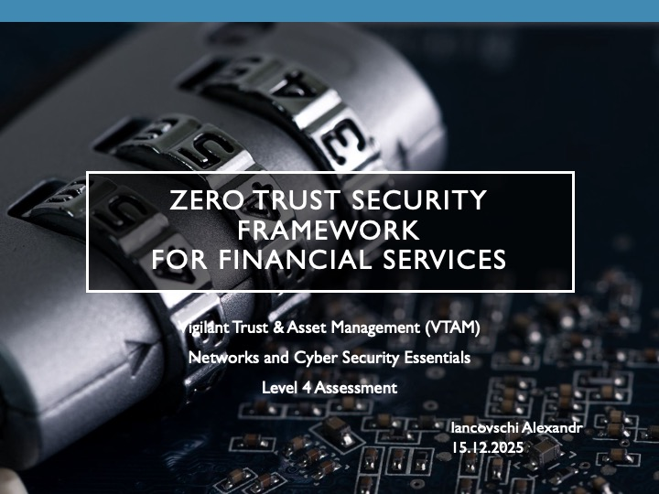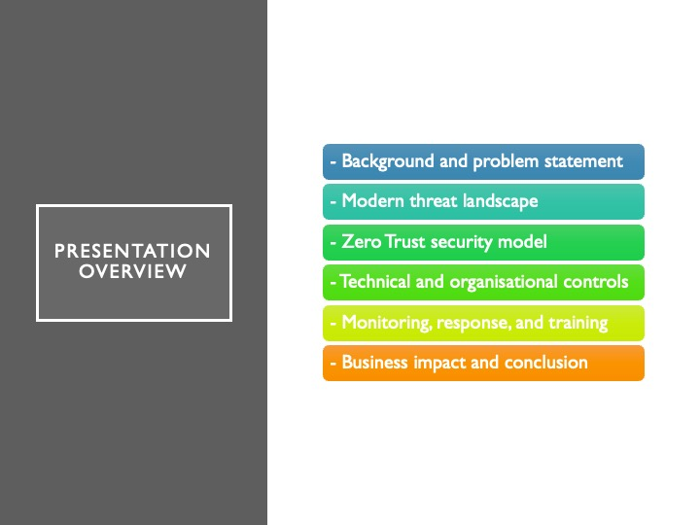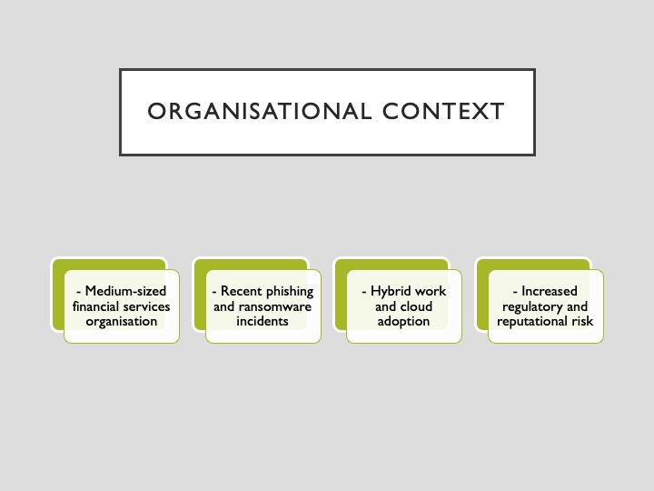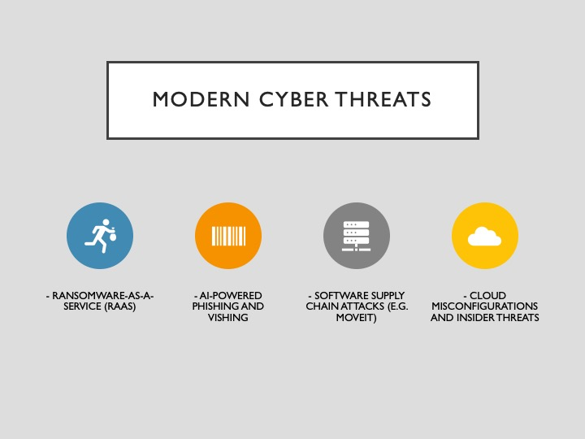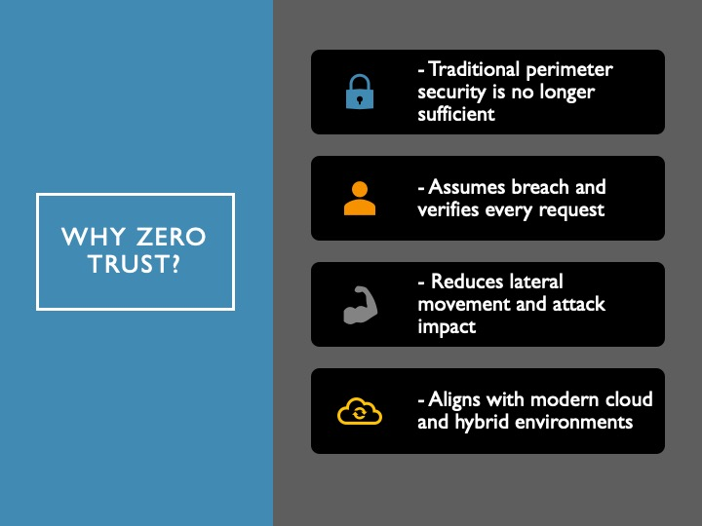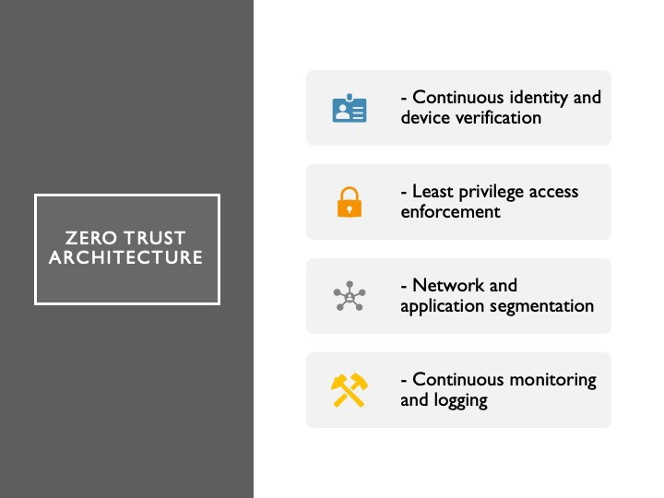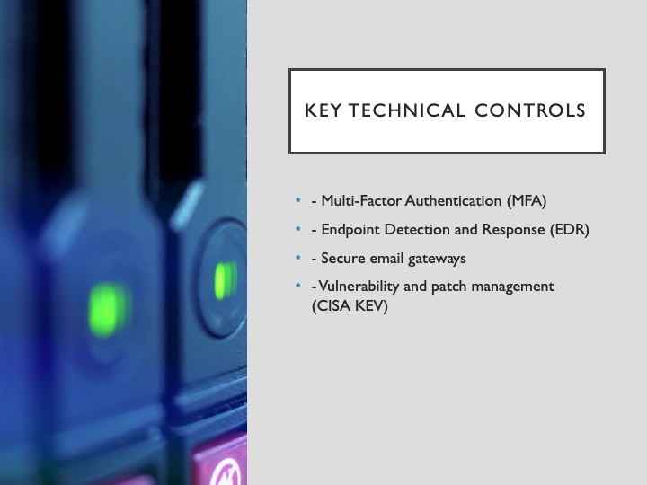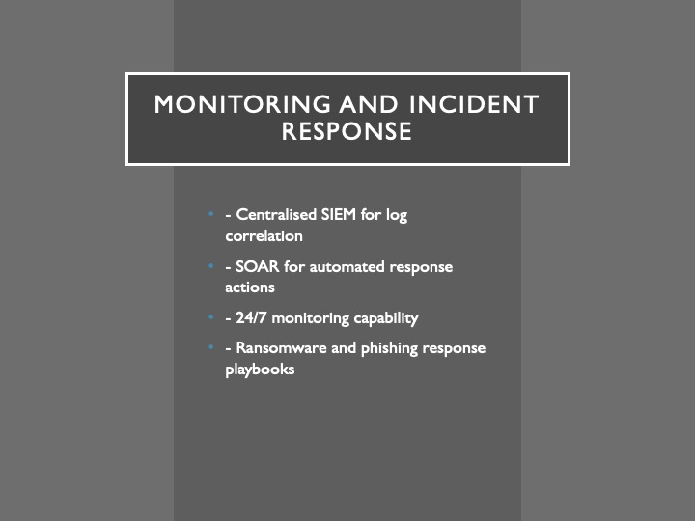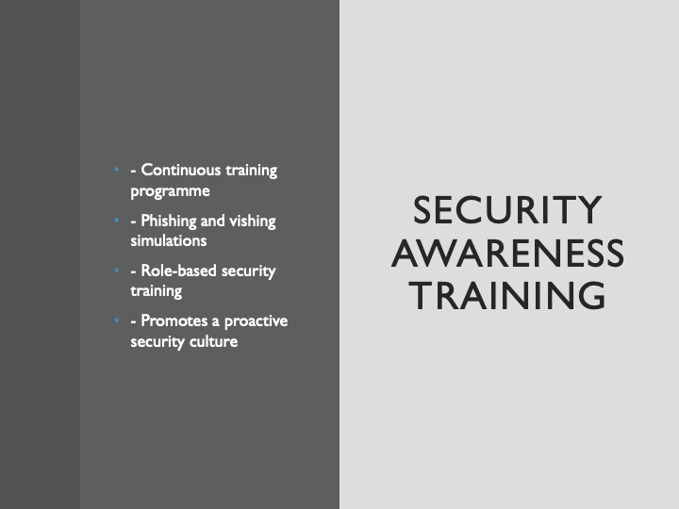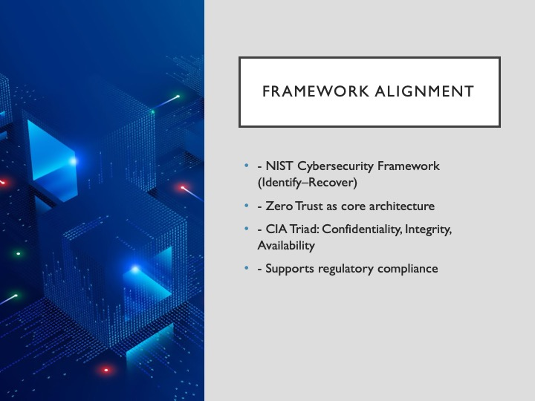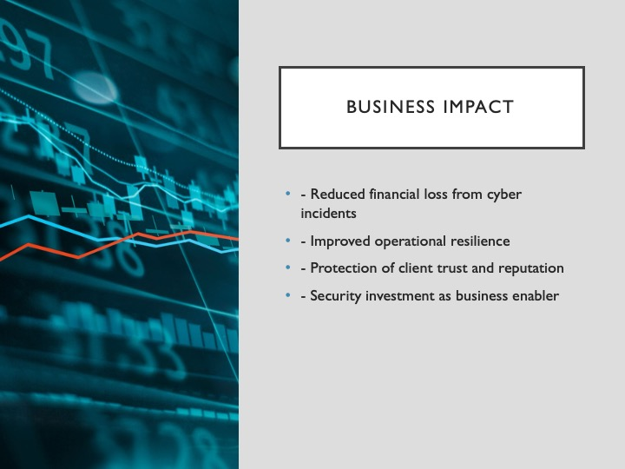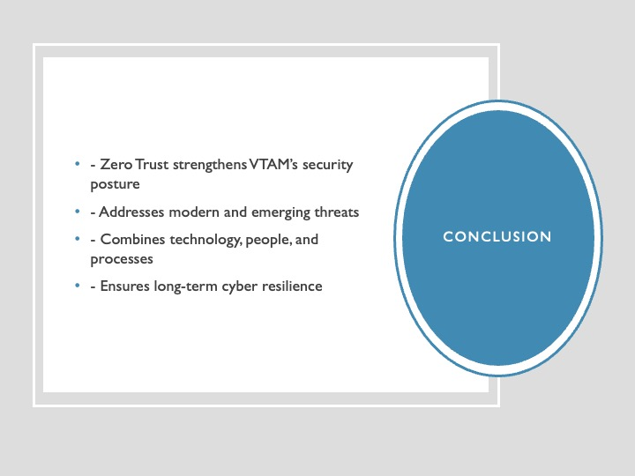

Appendix 2

Certificate : “Introduction to Cybersecurity”



