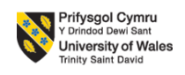
CCB4005 The Global Business Environment, May2021

The impact of pollution caused by fashion industry
Analyze of ZARA, Inditex

Module Coordinator/ Lecturer: Dr. Rexon Nting
Student: Ghiturin Adriana Mihaela
Student ID: 2018983

The fashion industry is now a global industry that has a significant impact on both our environment and people. It is dominated by fast fashion and just-in-time production, which has resulted in increased seasons and mini collections in season, resulting in new low-cost items in stores every week or even every day (Johansson, E., 2010).
According to studies, an increasing number of consumers consider the "politics behind the products" when making purchasing decisions, and that these decisions are driven by moral reasoning and pro-environmental motivation (Grappi, S., Romani, S., Barbarossa, C., 2017).
The fashion industry provides an appropriate context for analyzing consumer reactions to unethical behavior by a company, particularly when the stimuli of independent organizations concerned with changing fashion brand practices are directed at the consumer. In the vast landscape of fashion, there is a growing perception that “eco” and “ethical” fashion is not an option for conscientious shoppers (Grappi, S., Romani, S., Barbarossa, C., 2017).
The degree to which consumers perceive the brand to be responsible, accountable, and blameworthy for the toxic chemical scandal is defined as consumer evaluation of brand blame. Consumers' perceptions of and behavior toward a company involved in a product-harm crisis are influenced by their attribution of blame to the faulty company (Grappi, S., Romani, S., Barbarossa, C., 2017).
Hines and Bruce (2001) wrote that “Fast fashion is a contemporary term used by fashion retailers to acknowledge that designs move from catwalk to store in the fastest time to capture current trends in the market.” Fast fashion is also known as “MacFashion” which means fast and convenient fashion, similar to McDonalds, and is sometimes referred to as disposable fashion because it can be used cheaply and then discarded. SPA (Specialty store retailer of Private label Apparel) is a type of chain store that specializes in clothing, as well as a company that edits its own assortment using the private label. This system was inspired by GAP. Because global SPA brands use a fast fashion production system, SPA enables "fast fashion" (Jang, 2007).
Fast fashion brands such as ZARA, H&M, and UNIQLO are working toward sustainable growth by implementing environmental improvement plans and treating producer organizations well as part of their corporate social responsibility. The Inditex Group, which owns ZARA, has been attempting to improve the environment through a strategic environment improvement plan, encouraging employee participation, and aggressive investment in eco-friendly solutions. Since 2006, the internal organization and external organizations, such as the supply chain, have been engaged in environmentally friendly management, including activities such as energy conservation and recycling in their headquarters, factories, distribution chain, and stores (Jang, 2012).
Social contents are defined as the market-place of active consumer participation with a wealth of experience and knowledge about the product as a result of marketing tools such as social networking services (Jang, 2012). ZARA is actively utilizing social content based on customer participation, as well as managing a pre-response test and a style consultant.
Inditex made granular targets, such as promising to eliminating all single-use plastics from stores and sending all of the waste generated at its offices and stores for recycling or reuse. It also engaged to install recycling collection facilities in all of its shops and the clothes collected to be either donated, reused or recycled (Segran, E., 2019).
Zara obtains fabric from manufacturers with the aid of their purchasing offices in Barcelona and Hong Kong. Zara's strength and appeal to customers stems from the constant freshness of its clothing, which creates a sense of scarcity and exclusivity around the company's offerings (Jang, 2007).
Sustainable development of the company can be described as development that meets current generations' needs without jeopardizing future generations' ability to meet their own. Zara started selling stock on the Spanish stock exchange in May of 2001. This was a significant achievement for the company, as being a public company brought with it a new set of rules and regulations. The acquisition of shares by the network CCC was one of Inditex's biggest surprises. The Clean Clothes Campaign (CCC) was founded in the 1990s in response to textile worker exploitation. Zara did not take steps toward integrating a corporate social responsibility strategy until after the CCC purchased shares. The management of Inditex adopted the triple bottom-line of financial, social, and environmental efficiency (Sitaro T., 2020).
When approached with the topic of how sustainability affects his leadership at Inditex, CEO Pablo Isla replied: “every decision we make, we consider sustainability not just me personally, but also the board and all the employees. Sustainability includes the quality of our products, what they’re made from, working conditions for the people making them and the ability to recycle them”. Just 18% of bags used by all Inditex brands, including Zara, in 2018 were made of plastic. Furthermore, by 2023, the organization intends to remove all single use plastic in general. 88% of the waste produced by single use plastics is recycled or reused by the company. The management announced that they will continue to implement collection and recycling programs for all products used in package delivery and garment packaging, such as cardboard boxes, recycled plastic, alarms, and hangers, for reuse or to be submitted to a recycling program (Sitaro T., 2020).
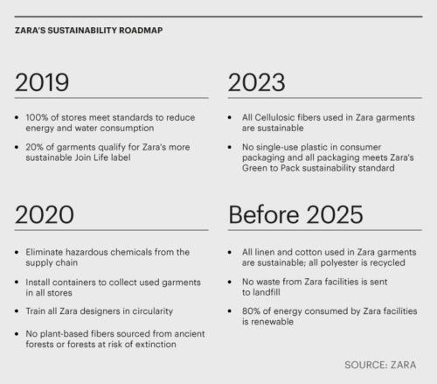
Photo 1: ZARA’s sustainability roadmap
Source: Zara Archives - Fashionismo
According to Inditex's website, 1,382 containers have been placed in the Inditex network of shops, with 2,000 street containers being placed in Spain in conjunction with Caritas, a nationwide at-home pick-up service. Containers located in Inditex's shops, offices, and logistics networks have acquired over 34,000 tons of clothing, shoes, and accessories. The completion of an entire eco-efficient store platform is the most ambitious initiative outlined by management.
SWOT Analysis for ZARA
STRENGTHS | WEAKNESSES | OPPORTUNITIES | THREATS
Has a history and determines trends | Lawsuit against Zara and negative publicity | Segmentation | Competition
Suppliers worldwide | Fast Fashion | Sustainable products | Market competitors faking their products.
Online stores | High competition | Resale market | Millennials seeking sustainable products
 | High competition in sustainable fashion | Partnerships with influencers
Table 1: SWOT Analysis
More than a third of Millennials and Gen Z, according to the Sourcing General, search for “sustainable” and “environmentally friendly” labels on clothing, so Inditex adapts to this creating eco-friendly clothes. However, Zara and all brands from Inditex are labeled as fast fashion companies, which delivers the latest trends from the runway to consumers easily and at a low cost and fast fashion is known to be as one of the main sources of pollution.
PESTEL of ZARA Company
Political | Economic | Social | Technological | Environment | Legal
European Trade Agreements | Operates in countries with low cost in labour | Good-quality product | Adopting new technologies | Creating sustainable products | Copyright issues
Brexit for UK market | Covid19 crisis | Afordable clothes | Developing E-commerce | Eco friendly laws | Being accused in a racial conflict
 |  | Setting trends | Use of Big Data | Resell trend
 |  |  | Apps and online stores
Table 2: PESTEL/PESTLE Analysis

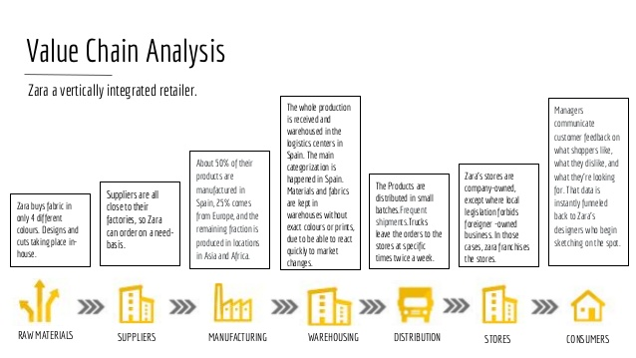
Foto 2: Zara’s Value Chain
Source: ZARA 's Business Strategy (slideshare.net)
Inditex is transforming the fashion industry by requiring other businesses to embrace aspects of the quick fashion model, even though they previously adopted a different model. The following sections are described in the table of contents of Inditex's 2018 Annual Report under the heading "Sustainable Strategy": materiality analysis, stakeholder relations, Inditex's commitment to sustainable development, and human rights promotion and respect.
Inditex developed their fourth materiality matrix in 2014, prioritizing their important issues. The 2014 matrix establishes the themes and benchmarks for the Annual Report and aligns the company's policies and activities with its stakeholders' priorities and concerns. The ongoing interaction with their stakeholders (employees, clients, non-profit organizations, companies in the communication field, and others) influences Inditex's assessments and decisions, allowing them to assess their economic, social, and environmental impacts. The reusable item-level RFID tracking system (allowing efficient inventory management, stock replenishment, security control, and better customer service) true for each garment sold in a Zara store was Inditex's best performance in 2015, which led to advancement within the ranking (Popescu, A., 2017). For Inditex, the main issues when talking about materials and creating a sustainable strategy for production in 2014 were:
- Corporate governance
- Responsible Practices and a Code of Conduct
- Corruption
- Customer relations and satisfaction
- Product quality, health and safety
- Changes in regulation
- Price volatility of raw materials
- Changes in consumption habits
- Green Design
- Energy consumption
- Water consumption
- Working conditions and human rights in the supply chain
- Health and safety in manufacturers and suppliers
- Animal welfare
- Responsible purchasing practices
- Waste management
- Recycling systems and management of the product end of life
- Protection of biodiversity
- Social action and local community development
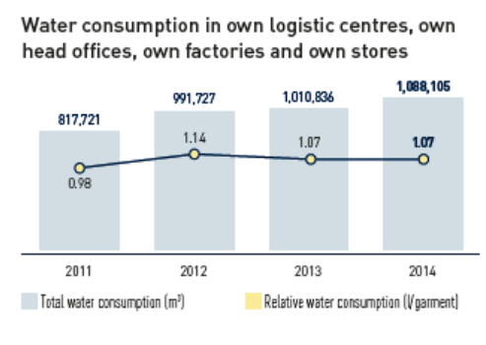
Foto 3: Water consumption for Inditex
Source: Popescu, A., 2017
More than 60% of Inditex suppliers (39.8% in India, 48.5 percent in China, and 52.5 percent in Bangladesh) adhere to the manufacturing norm for Green to Wear goods, which ensures a healthy environment in all wet processes. Inditex wanted to encourage more sustainable textiles, so they held training sessions for both designers and buyers on how to use organic and recycled textile fibers, as well as artificial textile fibers (viscose, lyocell, and modal) with consideration for the sources of those fibers (the forests from which they come should be handled sustainably) (Inditex, 2014).
Conclusions:
The success of an organization is determined by its sustainability concerns. In recent years, the fashion industry has evolved to include not only a sustainability component, but also to perform while doing so. Companies have incorporated current sustainability targets in order to create a set of criteria to use as a measuring method. Although these principles can serve as reform agents, many of the commitments made by businesses are empty. Although it is possible for a fast fashion business to become more sustainable, it is actually impossible for them to achieve 100% sustainability. Inditex-Zara demonstrates that even an organization whose business model seems to be incompatible with a sustainable business model may take steps toward a more sustainable future for all of us. It is clear that Zara takes steps towards sustainable business model because this could affect their image and, of course, their sales. People nowadays seek eco-friendly products and cruelty-free items so Zara has to adapt to this modern concern of its customers. They do focus on sustainable production, but in my opinion, they could also pay attention to other thing too except recycling, for example trying to deliver items ordered online with electrical cars or vehicles in order to reduce the pollution that they create during delivery or any other logistic activity.

References

- Christopher, M., Lowson, R., Peck, H., (2004). “Creating agile supply chains in the fashion industry”. International Journal of Retail and Distribution Management
- Crofton, O., and Dopico, L., 2005, Zara-Inditex And the Growth Of Fast Fashion, High Point University
- Grappi, S., Romani, S., Barbarossa, C., 2017, Fashion without pollution: How consumers evaluate brands after an NGO campaign aimed at reducing toxic chemicals in the fashion industry, Journal of Cleaner Production
- Inditex, 2009 - 2014 Inditex Annual Report
- Jang, J., Ko, E., and Lee, E., 2012, A Study of a Social Content Model for Sustainable Development in the Fast Fashion Industry, Journal of Global Fashion Marketing
- Johansson, E., 2010, Slow fashion – the answer for a sustainable fashion industry, Master thesis in Applied Textile Management
- Pereira, A., INDITEX A Circular Economy Business Model Case, ICEDE Group, Universidade de Santiago de Compostela (USC)
- Popescu, A., 2017, On the Sustainability of Fast Fashion Supply Chains – A Comparison Between the Sustainability of Inditex And H&M’s Supply Chains, West University of Timisoara, Romania
- Segran, E., 2019, H&M, Zara, and other fashion brands are tricking shoppers with vague sustainability claims, posted by FastCompany.com
- Sitaro T., 2020, Fast Fashion and Sustainability - The Case of Inditex-Zara, B.A. International Studies Europe Track

