


Network Security (NS)

Lab 2

Faculty of Architecture, Computing & Engineering
I.Q. Building room 205
Swansea
SA1 6ED

Introduction

The labs given within this module is geared to assist you in carrying out penetration testing on systems. In a penetration test an Ethical Hacker attempts to break into a company’s network to find vulnerability or the weakest link in the network or the network system. They are also required to analyzes the company security policy and procedures and report any vulnerability to management.

An Ethical Hacker is a person who performs most of the same activities as a hacker but with the owner of the company’s permission. The distinction is important and can mean the difference between being charged with a crime or not being charged. Ethical Hackers are usually contracted to perform penetration tests or security tests. After pre-engagement activities, penetration testers begin gathering information about their targets. Often all the information learned from a client is the list of IP addresses and/or web domains that are in scope. Penetration testers then learn as much about the client and their systems as possible, from searching for employees on social networking sites to scanning die perimeter for live systems and open ports. Taking all the information gathered into account, penetration testers study the systems to find the best routes of attack. Tins is similar to what an attacker would door what an invading army would do when trying to breach the perimeter. Then penetration testers move into vulnerability analysis, the first phase where they are actively engaging the target.

Task 1:

Pick an organization that you feel is worthy of your attention. This could be an educational institution, a commercial company. 01 perhaps a non-profit charity.

Recommended labs to assist you in footprinting;
- Basic Network Troubleshooting Using the ping utility and nslookup Tool
- People Search Using Anywho and Spokeo Online Tool
- Analyzing Domain and IP Address Queries Using SmartWhois
- Network Route Trace Using Path Analyzer Pro
- Tracing Emails Using eMailTrackerPro Tool
- Collecting Information About a target’s Website Using Firebug
- Mirroring Website Using HTTrack Web Site Copier Tool
- Extracting Company’s Data Using Web Data Extractor
- Identifying Vulnerabilities and Information Disclosures in Search Engines using Search Diggity

Lab Analysis

Analyze and document the results related to the selected organisation. Give your opinion on your target’s security posture and exposure through public and free information.

Task 2
In this lab, you will learn to Mirroring Websites Using the HTTrack Web Site Copier Tool.

Getting started, you need:
- Web Data Extractor located in the shared one drive
- You can also download the latest version of HTTrack Web Site Copier from the link http://www.httrack.com/page/2/ en/ index.html
- If you decide to download the latest version, then screenshots shown in the lab might differ
- Follow the Wizard driven installation process
- To run this tool Administrative privileges are required

Web mirroring allows you to download a website to a local directory, building recursively all directories. HTML, images, flash, videos, and other files from the server to your computer.

Lab Tasks
- After installation, launch the WinHTTrack application
- In the WinHTTrack main window, click Next to create a New Project
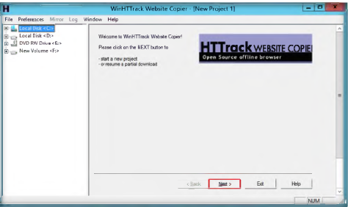

- Enter the project name in the Project name field. Select the Base path to store the copied files. Click Next.
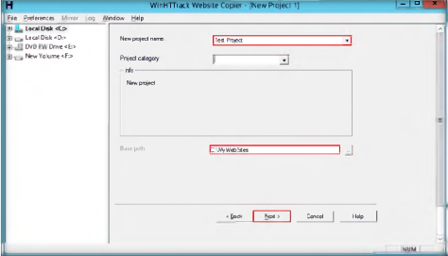

- Enter www.certifiedhacker.com under Web Addresses: (URL) and then click the Set options button

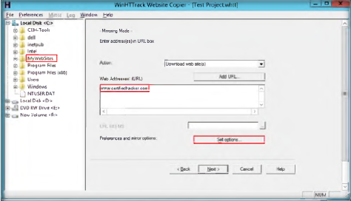

- Clicking the Set options button will launch the WinHTTrack window
- Click the Scan Rules tab and select the check boxes for the tile types as shown in the following screenshot and click OK

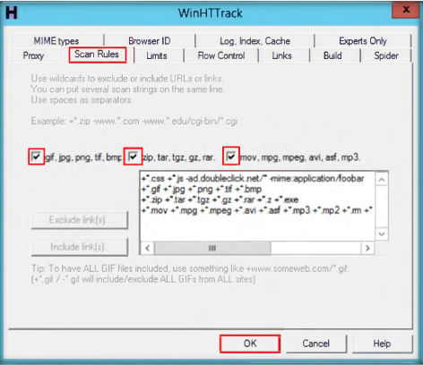

- Then, click Next
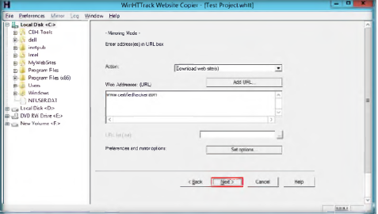

- By default, the radio button will be selected for Please adjust connection parameters if necessary, then press FINISH to launch the mirroring operation
- Click Finish to start mirroring the website

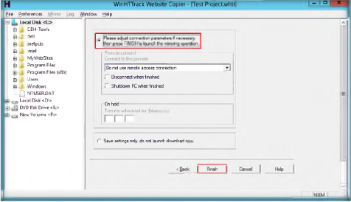

- Site mirroring progress will be displayed as in the following screenshot
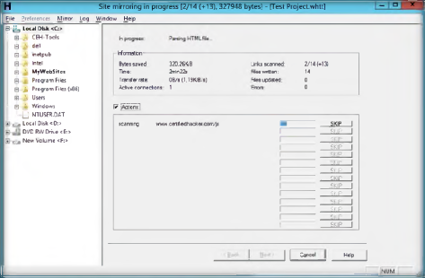

- WinHTTrack shows the message Mirroring operation complete once the site mirroring is completed. Click Browse Mirrored Website

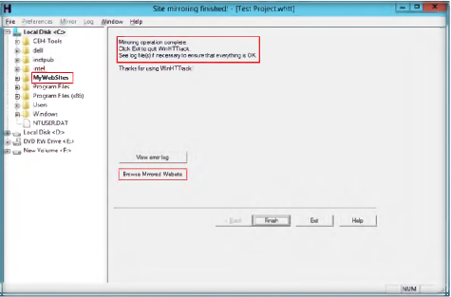

- Clicking the Browse Mirrored Website button will launch the mirrored website for www.cert1fiedhacker.com. The URL indicates that the site is located at the local machine

Note: If the web page does not open for some reasons, navigate to the directory־where you have mirrored the website and open index.html with any web browser

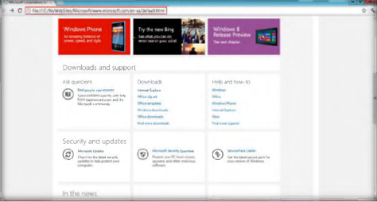

- A few websites are very large and will take a long time to mirror the complete site
- If you wish to stop the mirroring process prematurely, click Cancel in the Site mirroring progress window
- The site will work like a live hosted website.

Lab Analysis

Document the mirrored website directories, getting HTML, images, and other files.

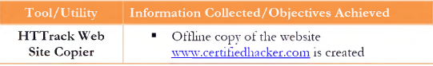

Questions:

- How do you retrieve the files that are outside the domain while mirroring a website?
- How do you download ftp files/sites?
- Can HTTrack perform form-based authentication?
- Can HTTrack execute HP-UX or ISO 9660 compatible files?
- How do you grab an email address in web pages?

Task 3
Extracting a Company’s Data Using Web Data Extractor

Web Data Extractor is used to extract targeted company(s) contact details or data such as emails; fax, phone through web for responsible b2b communication.

Lab Scenario
Attackers continuously look for the easiest method to collect information. There are many tools available with which attackers can extract a company’s database. Once they have access to the database, they can gather employees’ email addresses and phone numbers, the company’s internal URLs, etc. With the information gathered, they can send spam emails to the employees to fill their mailboxes, hack into the company’s website, and modify the internal URLs. They may also install malicious viruses to make the database inoperable.

As an expert penetration tester, you should be able to think from an attacker’s perspective and try all possible ways to gather information on organizations. You should be able to collect all the confidential information of an organization and implement security features to prevent company data leakage. In this lab, you will learn to use Web Data Extractor to extract a company’s data.

Lab Objectives
The objective of this lab is to demonstrate how to extract a company’s data using Web Data Extractor. Students will learn how to:
- Extract Meta Tag, Email, Phone/Fax from the web pages

Lab Environment

To carry out the lab you need:
- Web Data Extractor located on the shared one drive
- You can also download the latest version of Web Data Extractor from
- the link http://www.webextractor.com/download.htm
- If you decide to download the latest version, then screenshots shown in the lab might differ

Lab Tasks

- After installation, launch the Web Data Extractor application
- Web Data Extractor’s main window appears. Click New to start a new session
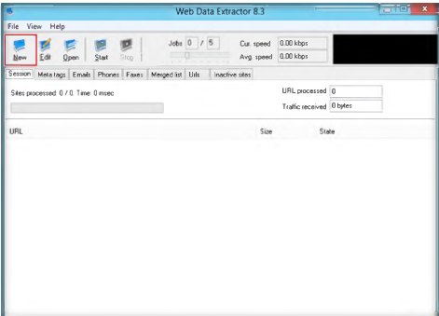

- Click New opens the Session settings window
- Type a URL rwww.cert1hedhacker.com) in the Starting URL held. Select die check boxes for all the options as shown in the screenshot and click OK

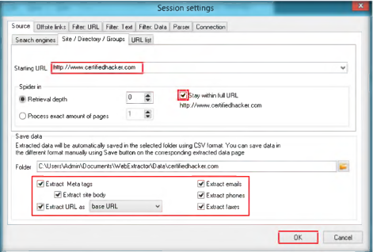

- Click Start to initiate the data extraction

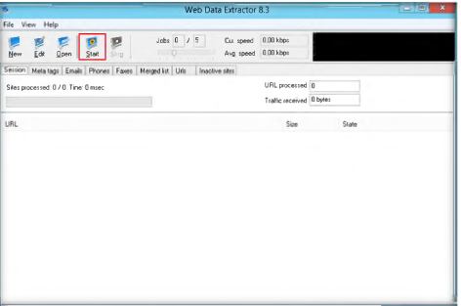

- Web Data Extractor will start collecting the information (emails, phones, faxes, etc.). Once the data extraction process is completed, an Information dialog box appears. Click OK

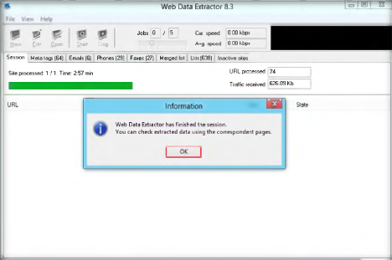

- The extracted information can be viewed by clicking the tabs

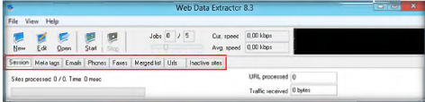

- Select the Meta tags tab to view the URL, Title, Keywords, Description. Host, Domain, and Page size information
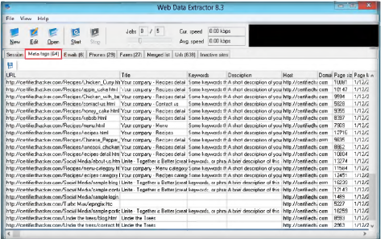

- Select Emails tab to view the Email, Name, URL, Title, Host, Keywords density, etc. information related to emails

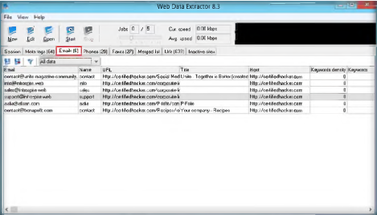

- Select the Phones tab to view the information related to phone like Phone number, Source, Tag, etc.

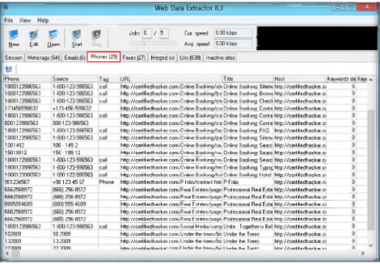

- Similarly, check for the information under Faxes, Merged list, Urls (638), Inactive sites tabs
- To save the session, go to File and click Save session

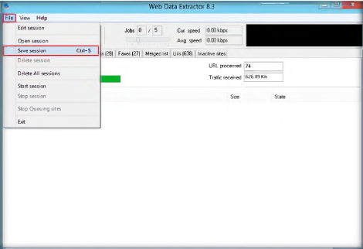

- Specify the session name in the Save session dialog box and click OK
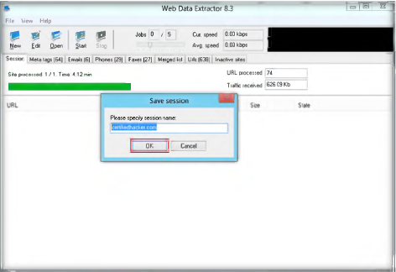

- Note the path where the session will be saved.

Lab Analysis
Document all die Meta Tags, Emails, and Phone/Fax.

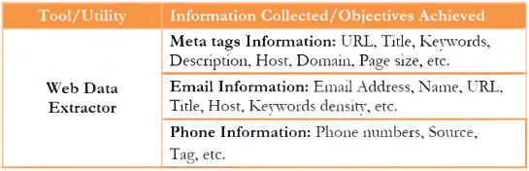

Questions:
- What does Web Data Extractor do?
- How would you resume an interrupted session in Web Data Extractor?
- Can you collect all the contact details of an organization?

Task 4
Identifying Vulnerabilities and Information Disclosures in Search Engines using Search Diggity

Search Diggity is the primary attack tool of the Google Hacking Diggity Project It is an MS Windows GUI application that serves as a front-end to the latest versions of Diggity tools: GoogleDiggity, BingDiggity, Bing LinkFromDomainDiggity, CodeSearchDiggity, DLPDiggity, FlashDiggity, MalwareDiggity, PortScan Diggity, SHODANDiggity, BingBinaryMalrareSearch, and NotlnMyBackYardDiggity.

Lab Scenario
An easy way to find vulnerabilities in websites and applications is to Google them, which is a simple method adopted by attackers. Using a Google code search, hackers can identify crucial vulnerabilities in application code strings, providing the entry point they need to break through application security.

As an expert ethical hacker, you should use the same method to identity all the vulnerabilities and patch them before an attacker identifies them to exploit vulnerabilities.

Lab Objectives
The objective of tins lab is to demonstrate how to identity vulnerabilities and information disclosures 111 search engines using Search Diggity. Students will learn how to:
- Extract Meta Tag, Email, Phone/Fax from the web pages

Lab Environment
To carry out the lab, you need:
- Search Diggity which is located on the shared one drive
- You can also download die latest version of Search Diggity from the link http://www.stachliu.com/resources / tools / google-hacking-diggitvproject/attack-tools
- If you decide to download the latest version, then screenshots shown in the lab might differ

Overview of Search Diggity
Search Diggity has a predefined query database that runs against the website to scan
the related queries.

Lab Tasks

- After installation, launch Search Diggity
- The Search Diggity main window appears with Google Diggity as the default

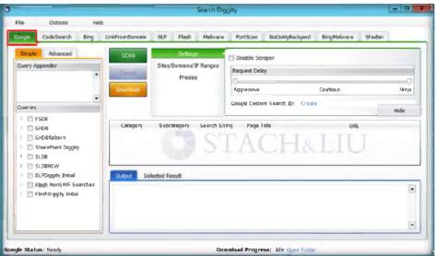

- Select Sites/Domains/IP Ranges and type the domain name in the domain field. Click Add

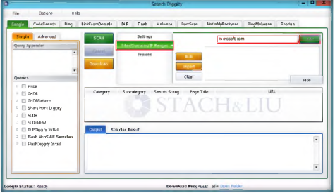

- The added domain name will be listed in the box below the Domain held

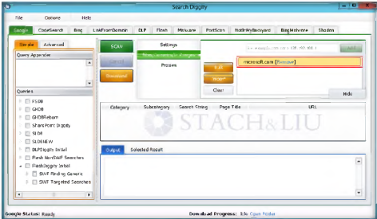

- Now, select a Query from left pane you wish to run against the website that you have added in the list and click Scan
Note: In this lab, we have selected the query SWF Finding Generic. Similarly,
you can select other queries to run against the added website

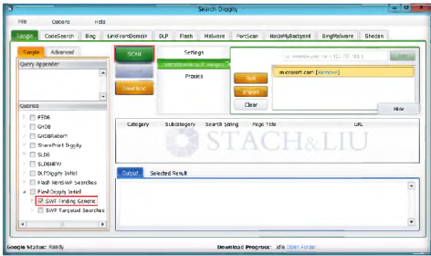

- The following screenshot shows the scanning process

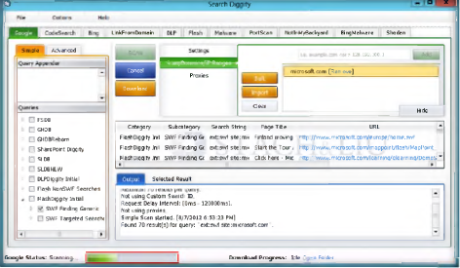

- All the URLs that contain the SWF extensions will be listed and the output will show the query results

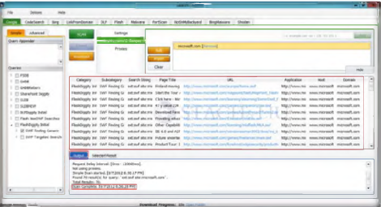

Lab Analysis

- Collect die different error messages to determine die vulnerabilities and note die
information disclosed about the website.
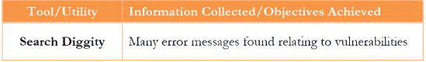

Questions
Is it possible to export the output result for Google Diggity? If yes, how?

