

BMHP5014

Changemakers: Creativity and Value Creation

Assignment Title: Component 2: Written Assignment (Report)
Student Name: Samina Shahzad
Student ID: 2328504

Contents
Poster 3
Pitch 4
Introduction 4
The current issue and need 5
The Innovation explained 6
Social Impact and Target Audience. 7
Implementation and Professional Involvement 8
Ethical Compliance, Policy and Legislation 9
Public Involvement and Advertisement 10
Conclusion 11
References 12

Poster
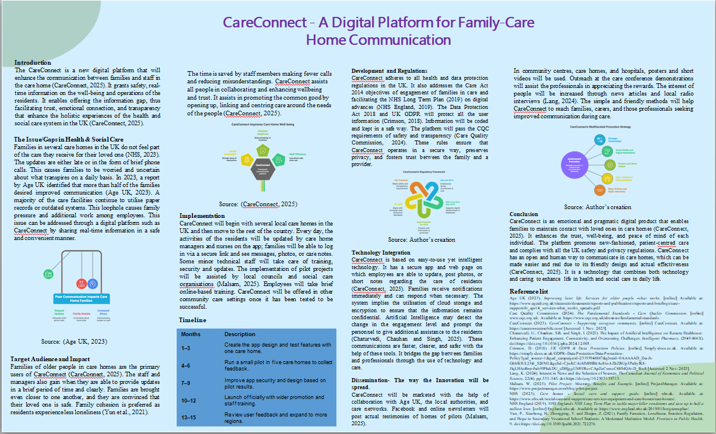

Pitch

Introduction
CareConnect is a new online application that will enhance communication between care homes and families. It provides family members with reliable real-time information on the daily well-being, activities and care of residents. There are a lot of anxious and alienated families in the care settings. CareConnect intends to address this issue by establishing trust, easing stress and helping to achieve the UK vision of more caring, person-centred, digitally connected health and social care services.

The current issue and need
Numerous families in the UK feel isolated and apart due to their loved ones in care homes. Communication is usually based on brief telephone calls or visits, which causes relatives to be anxious and not informed (de León Oliva, Rodríguez Gómez and Rodríguez Novo, 2025). According to reports by Age UK and the Care Quality Commission, a lack of communication reduces both trust and satisfaction in the care services (Age UK, 2023). Staff also consume unnecessary time in dealing with repetitive enquiries, which further stresses busy positions. Such a deficiency in open and coherent contact weakens relationships and has an impact on the emotional well-being of residents. As the UK health sector is currently moving towards digital transformation as a core policy, new tools that will bridge families, enhance transparency, and enhance person-centred care are urgently required (Department of Health and Social Care, 2022). CareConnect bridges this gap by building a safe, convenient method of updating families and professionals on real-time and significant information (CareConnect, 2025).

The Innovation explained
CareConnect is an internet-based secure platform that will fill the communication gap between care homes and families (CareConnect, 2025). A basic application and web interface allows employees to post photos, day-to-day updates and health text messages to family members. The families are in a position to see these updates in real time, and this makes them feel a part of the family and comforted. It is an encrypted technology system designed to ensure privacy and is built on NHS digital safety standards (NHS, 2024). Compared to general messaging apps, CareConnect is designed to work in social care settings, which helps build trust and adhere to the regulations. It promotes improved collaboration of the professionals, less stress on the staff and more caring and transparent care (Holosko and Taylor, 2020). By supporting the objective of digital inclusion that is part of the NHS Long Term Plan, CareConnect provides a realistic and futuristic solution to the humanisation of technology in daily care environments (NHS England, 2019).
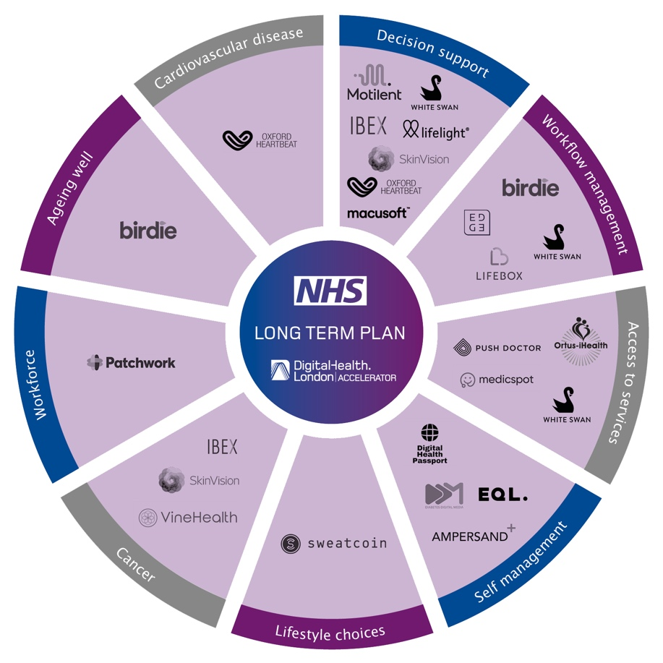
Figure: NHS Long Term Plan
Source: (NHS England, 2019)

Social Impact and Target Audience.
CareConnect serves as the main sponsor to families with older adults residing in care homes, as well as the staff and managers providing care to them. It enhances family bonds by giving real-time updates to relieve worry and create trust (CareConnect, 2025). The residents enjoy the gains of emotional support that enhances mood, well-being, and quality of life. Employees also have time to concentrate on direct care as opposed to frequent telephone calls. The community at large benefited from better relationships between families and care providers and the culture of openness and empathy. CareConnect demonstrates the principles of the social care system in the UK, which include dignity, respect and inclusion and aids in the common good, as it involves easy technology which assists in enhancing communication, minimising isolation and supporting family-based care practices across the sector (Disability Rights UK, 2025).

Implementation and Professional Involvement
The initial approach to be used in the advent of CareConnect will be pilot programmes to care homes in local authorities and later throughout the nation (Malsam, 2025). The updates and well-being information will be uploaded by care managers and nurses, and the families will have access to it through the platform in a secure way. Staff will be trained by technical support teams and made to run smoothly daily. The data protection officers, social workers, and IT developers will work together to ensure that the information is safe and accessible (Crimson, 2018). The progress and financing will be monitored by local councils and health boards so that the platform meets the quality and ethical standards. This interprofessional strategy will ensure that CareConnect is feasible, long-term, and inclusive (Bridges et al., 2021). Care homes can easily incorporate this digital solution into the current systems and enhance communication with the proper guidance and training, which does not lead to additional load but is a natural extension of daily care, which is why connecting with the family should be a natural part of the work environment (NHS, 2023).
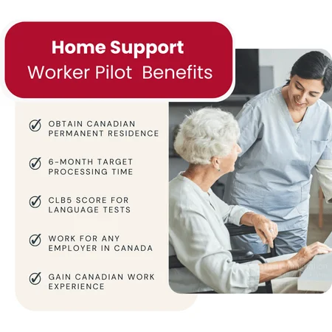
Figure: Worker Pilot Benefits
Source: (Rizlar, 2025)

Ethical Compliance, Policy and Legislation
CareConnect is completely consistent with the major UK health and social care legislation. It advocates the Care Act 2014, which facilitates wellbeing and family inclusion in care planning (Barnes et al., 2017). The platform can satisfy the requirements of the Data Protection Act 2018 and UK GDPR by ensuring that all personal data is secure and not shared (Crimson, 2018). It is also indicative of the NHS Long Term Plan (2019) vision of digital transformation in health and social care. CareConnect has its standards of safety, transparency and accountability provided by CQC (Care Quality Commission, 2024). The design is based on ethical practice, in which the dignity of the residents, their choice and consent are respected at all times. These rules and principles are the reasons why CareConnect is not only enhancing the communication but also doing it responsibly and safeguarding the users and encouraging both trust and equity in digital care development (CareConnect, 2025).

Public Involvement and Advertisement
Promotion of CareConnect will be achieved by collaborating with Age UK, NHS Digital and local care associations. The awareness campaigns will post the success stories of pilot homes on social media, community newsletters, and health forums (Climate Adapt, 2023). The ease of use of the platform will be displayed in the form of demonstrations by the people in the street at care events and family workshops. Cooperation with universities and councils will provide credibility and access to the local area (Medved, 2021). Families will be invited to become a part of the movement towards enhanced digital care and provide feedback to enhance the system. This is to ensure that CareConnect becomes an established mark of caring, cutting-edge care - a service that people endorse, practitioners believe in, and communities rejoice over as a move towards healthier and more interconnected social care throughout the UK (Holosko and Taylor, 2020).

Conclusion
CareConnect is an easy yet effective method to make contact between families, residents, and care staff. It enhances the emotional well-being, transparency, and trust in the care environments. It contributes to digital transformation objectives in the country, modernisation of social care, without leaving people behind in the process of innovation. By implementing CareConnect, the relationships, the families, and the caring environment of all the participants of the UK health and social care system will be established on a higher level.

References
Age UK (2023). Improving later life. Services for older people -what works. [online] Available at: https://www.ageuk.org.uk/siteassets/documents/reports-and-publications/reports-and-briefings/care--support/rb_apr14_services-what_works_spreads.pdf.
Barnes, D., Boland, B., Linhart, K. and Wilson, K. (2017). Personalisation and Social Care Assessment – the Care Act 2014. BJPsych Bulletin, [online] 41(3), pp.176–180. doi:https://doi.org/10.1192/pb.bp.116.053660.
Bridges, D.R., Davidson, R.A., Soule Odegard, P., Maki, I.V. and Tomkowiak, J. (2021). Interprofessional collaboration: three best practice models of interprofessional education. Medical Education Online, [online] 16(1), p.6035. doi:https://doi.org/10.3402/meo.v16i0.6035.
Care Quality Commission (2024). The Fundamental Standards - Care Quality Commission. [online] www.cqc.org.uk. Available at: https://www.cqc.org.uk/about-us/fundamental-standards.
CareConnect (2025). CareConnect - Supporting the caregiver community. [online] CareConnect. Available at: https://careconnectmobile.com/ [Accessed 1 Nov. 2025].
Chaturvedi, U., Chauhan, S.B. and Singh, I. (2025). The Impact of Artificial Intelligence on Remote Healthcare: Enhancing Patient Engagement, Connectivity, and Overcoming Challenges. Intelligent Pharmacy, (2949-866X). Doi:https://doi.org/10.1016/j.ipha.2024.12.003.
Climate Adapt (2023). Awareness campaigns for behavioural change. [online] Climate Adapt. Available at: https://climate-adapt.eea.europa.eu/en/metadata/adaptation-options/awareness-campaigns-for-behavioural-change.
Crimson, D. (2018). UK GDPR & Data Protection Policies. [online] Simply-docs.co.uk. Available at: https://simply-docs.co.uk/GDPR--Data-Protection/Data-Protection-Policy?gad_source=1&gad_campaignid=23195946867&gbraid=0AAAAAD_Zru-Jt-GhhlklUL23t6_S26NI1&gclid=CjwKCAiAlMHIBhAcEiwAZhZBUp3PuhyfK8-JIqLHAsBmv0ub9IPIukDU_cDHjggUM9JRcvCApZnCmxoC6HMQAvD_BwE [Accessed 2 Nov. 2025].
de León Oliva, B., Rodríguez Gómez, J.Á. and Rodríguez Novo, N. (2025). Difficulties in Communicating Between Nurses and Relatives of Patients Admitted to Intensive Care Units: A Scoping Review. Nursing in Critical Care, 30(5). doi:https://doi.org/10.1111/nicc.70148.
Department of Health and Social Care (2022). A Plan for Digital Health and Social Care. [online] GOV.UK. Available at: https://www.gov.uk/government/publications/a-plan-for-digital-health-and-social-care/a-plan-for-digital-health-and-social-care.
Disability Rights UK (2025). The EHRC Outlines Nine Principles for Social Care Equality | Disability Rights UK. [online] Disabilityrightsuk.org. Available at: https://www.disabilityrightsuk.org/news/ehrc-outlines-nine-principles-social-care-equality [Accessed 3 Nov. 2025].
Holosko, M.J. and Taylor, P.A. (2020). Social work practice in health care settings. Toronto: Canadian Scholars’ Press.
Lang, K. (2024). Interest in News and the Selection of Sources. The Canadian Journal of Economics and Political Science, 22(4), pp.535–545. doi:https://doi.org/10.2307/138713.
Malsam, W. (2025). Pilot Project: Meaning, Benefits and Example. [online] ProjectManager. Available at: https://www.projectmanager.com/blog/pilot-project.
Medved, P. (2021). PANDEMIJA, TELEDELO IN PREOBRAZBA PARADIGME TRAJNOSTNEGA URBANIZMA. Teorija in praksa, pp.744–761. Doi:https://doi.org/10.51936/tip.58.3.744-761.
NHS (2023). Care homes - Social care and support guide. [online] nhs.uk. Available at: https://www.nhs.uk/social-care-and-support/care-services-equipment-and-care-homes/care-homes/.
NHS (2024). Clinical safety. [online] NHS Digital. Available at: https://digital.nhs.uk/developer/guides-and-documentation/introduction-to-healthcare-technology/clinical-safety.
NHS England (2019). NHS England» NHS Long Term Plan to tackle major killer conditions and save up to half a million lives. [online] England.nhs.uk. Available at: https://www.england.nhs.uk/2019/01/long-term-plan/.
Rizlar, B. (2025). Elaar Immigration Consulting Inc. [online]. Elaar Immigration Consulting Inc. Available at: https://www.elaarimmigration.com/home-support-worker-pilot-program-canada-hswp/ [Accessed 2 Nov. 2025].
Yun, P., Xiaohong, H., Zhongping, Y. and Zhujun, Z. (2021). Family Function, Loneliness, Emotion Regulation, and Hope in Secondary Vocational School Students: A Moderated Mediation Model. Frontiers in Public Health, 9. doi:https://doi.org/10.3389/fpubh.2021.722276.

