Results chapter
4.1 Introduction
The objectives of the chapter were to evaluate the results of an online questionnaire about the use of taser and its effects on the mental approach of officers. The survey was distributed out to Gwent police officers who fit the characteristics and skill sets required to establish a balanced and fair set of results. The survey of police taser trained officers was used to gain informed opinions and experiences around the topic area.
The survey had a disclaimer at the beginning, explained what the questionnaire for and how it was completely anonymous, with no personal information being stored.
The survey had an expected time frame for completion of 2 minutes with the mean average for completing the survey at 3 minutes 18 seconds. The questionnaire had an estimated completion rate of 71% but the researcher achieved a 100% completion rate from 20 responders and was done over a 4-day period.
Each survey was sent via internal email systems with no clarification emails sent back to the researcher. This anonymous approach was designed to stay within the confines of ethics and confidentiality and served as a confirmation to the participant of its anonymity. There were several influences for the low response to email which was factored into the anticipated number of responses. These factors ranged from shift pattern and rest days, annual leave, and sick absences.
20 responses were gained over a 4-day period, with an anticipated bigger participation if there had been a wider time frame available. The online questionnaire was constructed of 8 quantitative questions and 2 Qualitative questions resulting in an 80-20 ratio.
4.2 Participants
The first question within the survey was: What is your role? The reason for this question and for being question 1 was to quickly identify the skills area of the responder and to gauge whether the relevant demographics were being represented. 80% of the responders came from frontline officers with taser skills, 10% coming from dedicated firearms officers and 10% coming from primarily office-based police constables from Criminal Investigation Department (CID).
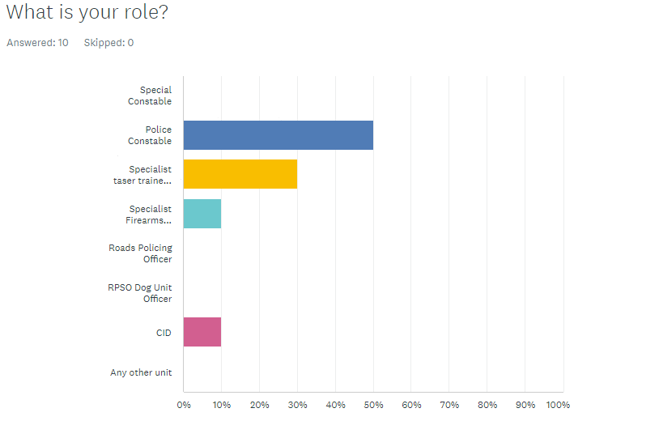

Question 2 How long have you had taser? This was used to gain a snapshot of how experienced the officers were in actual taser deployment incidents. Research has shown that a person deals with an incident that presents itself by using existing experiences gained from previous incidents in similarity (Slovic and Peters, 2023).
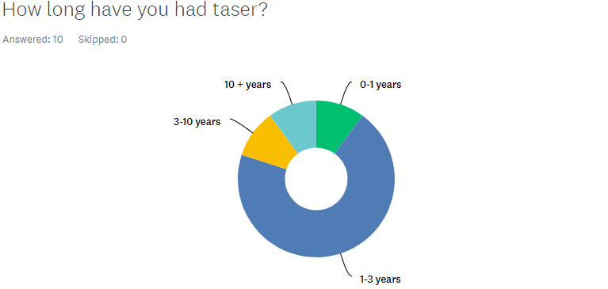
4.3 Interactions
Question 3 and 4 of the survey centred around gathering information of the duty that was being performed at the time of a recent taser incident. The questionnaire has shown a huge inconsistency in times in which officers were required to attend taser incidents. 30% of officers had encountered incidents requiring taser daily with that figure rising to 40% on a weekly occurrence. The graph also shows a swing in the other direction with 30% having infrequent needs for the taser use of force. The use of force can range from unholstering the taser, “arc” the taser, “red dotting “ and/or full deployment.
Every responder to question 3 had been involved in a taser use of force since gaining taser skilling with a full range of officer duties requiring taser being undertaken (College of Policing, 2022).
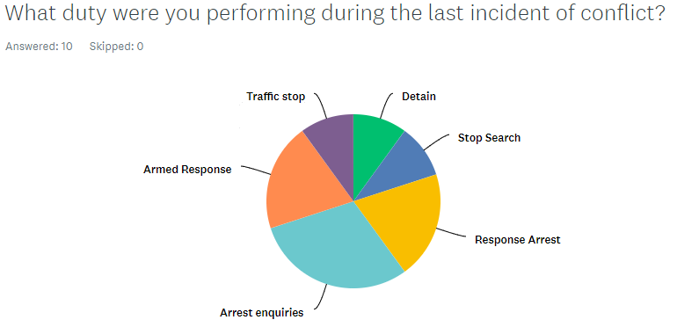

4.4 Response from officers
Question 5: Were you carrying taser at the time of a recent incident? Was used within the survey to determine whether the officer was carrying taser in an incident of conflict within a recent time prior to the questionnaire being answered. 80% of the responders confirmed they had recently been carrying taser during the deployment to an incident involving conflict. A further qualitative question could have been utilised post question 5 which would have explained the 20% non-carrying of taser.
Question 6: Did this change your approach to the subjects/ incident? Was used to determine if the lack of taser had any effect prior to the officer attending the incident. With 80% of officers declaring that it had no effect on their mindset would suggest the recruitment and training of taser officers could be deemed as a success. Another opinion born out of the result is that officers were prepared to attend a potentially dangerous incident without the protection of taser has been highlighted by the “no” answer of 80% of the responders.
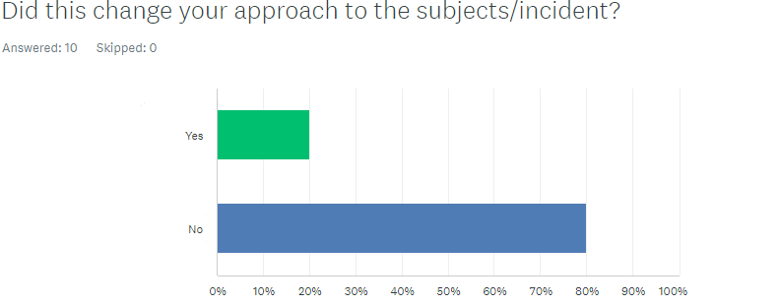

Question 7; What positive effect did taser have on your approach/actions?
The results from this question showed a combined 90% of all responders reporting a sense of control, authority, and confidence inside the incident when in possession of taser. The overwhelming majority of 60% saying they had a sense of confidence from the carrying of taser.
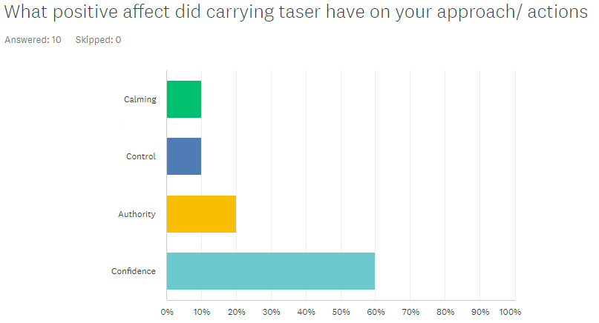
Question 8: What negative affect did carrying taser have on your mindset towards the incident/subject? 57.1% declared a change in order of tactics when dealing with the incident with the other 42.9% admitting to an over reliance of taser due to its presence. Other options available within the answers of “overconfident” and “increase in aggression” scored 0%.

4.5 effects of taser on mindset
Question 9 and 10 focused on qualitative answers (Fossey et al., 2002) and asked for free hand text explanations of officer’s mindsets pre-incident and post-incident.
Answers to the Pre-mindset of officers, centred around having confidence to deal with conflict with one answer expressing concern.
” worry and concern how it will affect the subject and if it goes wrong or receive complaints”
And another answer expressing a sense of safety due to the taser being an option.
“ I have carried Taser for over 10 years and only discharged it twice. I believe that the earlier in my career when carrying Taser it gave me much more confidence that I could deal with violent subjects especially when on route to an incident where violence is reported.”
The answers gained from the survey to the qualitative question 10, suggests an acknowledgment of the tasers presence and a reliance on the training received to stay calm and rationalise the strategy. The answer also suggests the taser becomes a secondary backup if the incident escalates.
“Again increases confidence, due to the training that complies with taser usage. Allow to you better manage conflict and allows for an additional use of force if ever required.”
and
Mid incident I am usually aware that the taser may be needed and try to be more aware of my surroundings in case the taser is needed. Howeevr, as above, I find this is not always the case when not all officers are trained in taser use, and prefer to scramble on the floor with aggressive people, instead of the calm and controlled tactical communications that come with the different levels of taser use.

4.6 Conclusion
By analysing the overall quantitative results and individual qualitative responses to the questionnaire of Officers, the researcher was able to identify a far greater determination from Frontline taser trained officers to express opinions. With 80% combined of Police constables and specialist taser officers surveyed being prepared to give feedback. This response would suggest they are the demographic which are feeling the most pressure and want to know their opinions matter (González, 2021).
With a lack of responses from other sections of the workforce the researcher could not get an accurate representation of the overall feeling by officers towards the affects on their approach to taser incidents. The responses only allowed for a generalised opinion from 4 areas of officers.
During the next chapter, a conclusion of the findings will be explored with the aim of establishing an answer to the question “Does the presence of taser affect an officers’ approach to an incident of conflict?”

Word count 1026

Reference
González, C. (2021). 5 advantages of anonymous feedback with employees. [online] Team Insights. Available at: https://teaminsights.io/en/blog/news/5-advantages-of-anonymous-feedback-with-employees/ [Accessed 27 Jan. 2023].
Slovic, P. and Peters, E. (2023). Risk Perception and Affect. Current Directions in Psychological Science, 15(6), pp.322–325. doi:10.1111/j.1467-8721.2006.00461.x.
College of Policing (2022). Police Constable - College of Policing. [online] College of Policing. Available at: https://profdev.college.police.uk/professional-profile/police-constable/ [Accessed 27 Jan. 2023].
Fossey, E., Harvey, C., Mcdermott, F. and Davidson, L. (2002). Understanding and Evaluating Qualitative research. Australian and New Zealand Journal of Psychiatry, [online] 36(6), pp.717–732. doi:https://doi.org/10.1046/j.1440-1614.2002.01100.x.

