

University of Wales Trinity Saint David
School of Engineering

Structural Integrity and Material Evaluation
Ultrasonic Attenuation Coefficient Determination and Probability of Sizing Analysis (ACEA7013)

Taylor Winter
Automotive Engineering
1901843

09/01/2023

Table of Contents
Abstract 3
Apparatus 4
1 Introduction 5
1.1 Methodology 5
2 Graphs of Raw Measurements 6
2.1.1 Investigation One 6
2.1.2 Investigation Two 7
3 Calculations 8
3.1 Investigation One 8
3.2 Investigation Two 8
3.3 Error Estimates 9
4 Results and Discussion 10
4.1 Investigation One 10
4.2 Investigation Two 11
5 Conclusion 15
6 Bibliography 16
Table of Figures 17
Table of Tables 17
Table of Equations 17
Appendix 18

Abstract
This report shows the methodology, calculations, and results of two separate investigations. The first investigation is an Ultrasonic Attenuation Coefficient Determination on a mild steel rectangular block and a brake disc. An Ultrasonic zero-degree 5MHz probe was attached to an Ultrasonic flaw detector to assess both materials. From the raw data the attenuation coefficients of both materials were calculated and compared to known data to determine the accuracy of the testing, which determined that the investigation was fairly accurate. The second investigation is a Through Wall Sizing Accuracy Analysis. This study used the raw data from a PoD study which assessed the performance of a new ultrasonic thickness gauging procedure. Each of the 10 technicians used the equipment and procedure to perform the measurements on the 21 defect measurements. Through linear regression and statistical analysis techniques, the sizing accuracy of the individual technicians was assessed. Through the study it was found that overall the equipment was not particularly accurate, however, technicians one and nine had the most accurate results on a whole.

Apparatus
The apparatus used for the tests can be seen below:
- Mild steel rectangular block
- Brake disc
- Ultrasonic zero-degree 5MHz probe
- Ultrasonic flaw detector
- Dial clipper
- Gel
These can be seen below in figures 1-4.
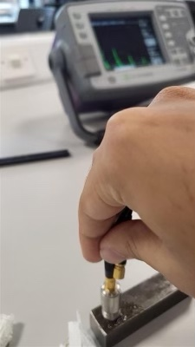
Figure 1: Ultrasonic Zero-Degree 5MHz Probe
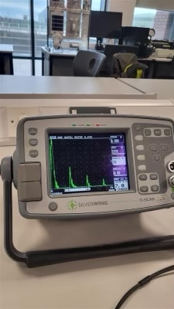
Figure 2: Ultrasonic Flaw Detector
Figure 3: Dial Clipper

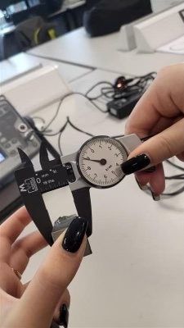
Figure 4: Gel

Introduction
There are two separate investigations within this report. The first investigation entails two material samples, a mild steel rectangular block and a brake disc with both materials having been tested using an ultrasonic flaw detector. From the raw data the attenuation coefficients can be calculated. This is due to the ultrasonic beams attenuating when passing through different materials. The attenuation coefficient refers to the amount of ultrasonic beam attenuation per millimetre in an isotropic material. Ultrasonic energy is lost when passing through a material which is dependent on two main factors; the first main factor is the microstructure properties of the material which refers to the gain size, orientation, any impurities withing the grain boundary and heat damage or treatment. The second of these factors is the characteristics of the ultrasonic beam used, referring to the frequency of the beam as well as the beam profile. Ultrasonic energy is also lost due to beam divergence as it propagates. (Zoofan, 2017).

The second investigation is part of a larger PoD study that has been used to assess a new ultrasonic thickness gauging procedure. The aim of this investigation is to assess the sizing accuracy of each of the ten technicians. This will be done via linear regression and statistical analysis.

The raw data for both investigations can be seen in the appendix.

Methodology

The following methodology was used for both the mild steel rectangular block and the brake disc:
- Connect the equipment.
- Measure the samples using the dial clipper.
- Clean the samples and apply styling gel to the surfaces where the probe will be applied, this acts as a lubricant between the sample and the probe. It also fills any air gaps that may have occurred giving a more accurate result.
- Place the transducer on the surface of the sample and adjust the gain oscilloscope accordingly, this means that the back wall reflections will be easier to read.
- These back wall reflections are what will be read for the results. The first, second and third reflections are recorded.
- This is repeated as many times as desirable to improve the reliability of the study. In this case, this is five readings per sample.
- The same test can then be applied to a different area of the sample, for this investigation five different positions were used.
- The attenuation coefficient is then calculated using the first three peaks.
- The data can then be plotted and evaluated using the equation and R² value for each graph.
- From this an average of all attenuation coefficients can be calculated.

Graphs of Raw Measurements

Investigation One
Figures 5 and 6 below shows the raw data from both the steel rectangular block and the brake disc (tables can be seen in the appendix).
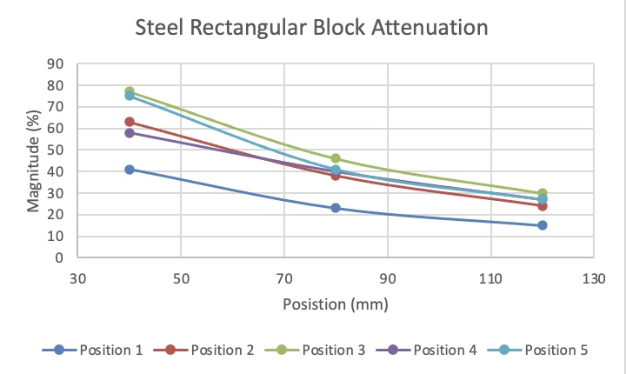
Figure 5: Steel Rectangular Block Raw Data Graph
As seen above the attenuation coefficients have been plotted showing a negative correlation, this would suggest that the attenuation coefficient largely decreases with each reading.
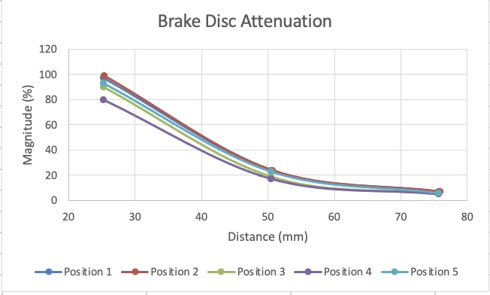
Figure 6: Brake Disc Raw Data Graph
The attenuation coefficients have also been plotted for the brake disc seen above. Again, there is a clear negative correlation though there is more of a curve in the data which would be expected due to ultrasonic energy loss and beam divergence.

Investigation Two
Table 1 below shows the raw data from the through wall sizing accuracy analysis. The true size can be seen on the right and the ten technician’s results follow it. This data will be analysed trough linear regression and statistical analysis.

Defect | true size | Op1 | Op2 | Op3 | Op4 | Op5 | Op6 | Op7 | Op8 | Op9 | Op10
A | 0.25 | 0.50 | 0.50 | 0.00 | 1.00 | 0.00 | 0.50 | 0.50 | 0.80 | 1.00 | 0.30
B | 0.27 | 0.73 | 1.20 | 0.50 | 1.00 | 0.00 | 1.00 | 0.50 | 0.80 | 1.00 | 1.20
C | 0.28 | 0.76 | 1.00 | 1.20 | 1.00 | 0.00 | 0.50 | 0.50 | 1.30 | 1.00 | 0.70
D | 0.40 | 0.91 | 0.50 | 1.00 | 1.20 | 1.00 | 1.00 | 0.60 | 1.50 | 1.00 | 0.80
E | 0.40 | 0.98 | 1.20 | 1.00 | 1.40 | 1.00 | 1.10 | 0.20 | 1.60 | 1.00 | 0.90
F | 0.50 | 0.79 | 0.90 | 1.00 | 1.10 | 1.00 | 0.80 | 0.00 | 1.00 | 1.20 | 0.50
G | 0.52 | 1.01 | 1.50 | 1.10 | 0.90 | 1.50 | 1.00 | 1.00 | 0.90 | 1.00 | 0.70
H | 0.55 | 0.96 | 1.20 | 0.80 | 0.50 | 0.90 | 1.20 | 1.30 | 1.60 | 1.00 | 0.40
I | 0.70 | 1.35 | 1.50 | 0.90 | 2.00 | 1.60 | 1.20 | 1.60 | 2.20 | 1.00 | 1.00
J | 0.98 | 1.31 | 1.00 | 0.80 | 1.90 | 2.00 | 1.60 | 0.50 | 1.80 | 1.00 | 1.40
K | 1.12 | 1.37 | 0.50 | 1.00 | 1.00 | 1.80 | 1.80 | 1.80 | 2.00 | 1.50 | 1.30
L | 1.15 | 1.56 | 1.80 | 1.30 | 2.20 | 1.00 | 1.50 | 1.80 | 2.00 | 1.50 | 1.20
M | 1.10 | 1.60 | 2.00 | 1.40 | 2.00 | 1.60 | 1.50 | 0.50 | 2.20 | 2.00 | 1.60
N | 1.30 | 1.73 | 2.10 | 0.90 | 2.20 | 2.00 | 2.00 | 1.70 | 2.00 | 1.50 | 1.70
O | 1.60 | 1.56 | 0.80 | 0.90 | 2.00 | 2.00 | 1.50 | 1.20 | 2.00 | 2.00 | 1.50
P | 1.80 | 2.14 | 2.00 | 1.40 | 2.40 | 2.00 | 3.20 | 2.20 | 2.50 | 2.50 | 1.10
Q | 2.10 | 2.49 | 1.80 | 2.30 | 3.50 | 2.50 | 3.00 | 2.00 | 3.20 | 2.00 | 2.60
R | 2.70 | 2.97 | 3.00 | 3.20 | 2.80 | 2.50 | 3.50 | 2.50 | 3.50 | 3.50 | 2.20
S | 4.90 | 4.87 | 4.50 | 4.50 | 5.70 | 4.50 | 4.40 | 4.20 | 5.40 | 5.50 | 5.50
T | 6.00 | 6.17 | 5.50 | 6.20 | 7.00 | 6.50 | 5.50 | 5.30 | 6.70 | 6.50 | 6.00
U | 7.50 | 6.99 | 6.00 | 6.25 | 8.00 | 7.20 | 6.50 | 6.50 | 6.90 | 8.00 | 6.50
Table 1:Through Wall Sizing Accuracy Analysis Raw Data

Calculations

Investigation One
For both materials the first thing calculated was the mean of all recorded values, calculated via:
$$X = \frac{∑x}{N}$$
Equation 1: Mean
Where:
$∑x$ = Sum of all data points
N = Number of data points

The next thing calculated was the standard deviation, this is a statistical measure of the dispersion of a dataset relative to its mean, this is helpful for data evaluation. This is calculated using:
$$σ = \sqrt{\frac{∑{{(x}_{i}-μ)}^{2}}{N}}$$
Equation 2: Standard Deviation
Where:
$x_{i}$ = Each value
$μ$ = Mean
N = Size of data group

After this, the mean +3 stand deviations and mean -3 stand deviations can be calculated using:
$$X + 3(σ)$$
Equation 3: Mean +3 Standard Deviations
$$X - 3(σ)$$
Equation 4: Mean -3 Standard Deviations

The attenuation coefficient was calculated using:
$$α_{dB/mm} = \frac{20}{x(mm)} \log_{10}\frac{E1}{E2}$$
Equation 5: Attenuation Coefficient
For example,
$$\frac{20}{25.23}\log_{10}\frac{99}{24} = 0.49dB/mm$$
Equation 6: attenuation Coefficient Example

Investigation Two
Absolute error and mean absolute error were calculated to show the amount of error in each technician’s readings. This shows the difference between the actual size and the measured size. This was calculated using the equation below:
$$∆x = x_{i} - x$$
Equation 7: Absolute Error
Where:
$x_{i}$ = Measured data
x = Actual size
The absolute mean error is simply calculated the same way as seen above in equation 1.

The standard deviation of each technician’s absolute error mean results was calculated using equation 2 above.

Error Estimates
Using the equation below the 95% confidence error values were found for each technician. The values can be seen below in table 2 below.
$$1.95 x σ$$
Equation 8: 95% Confidence Equation
Table 2: 95% Confidence Table
From the calculations above, technician one seems to be the most accurate as the 95% confidence is the lowest at 0.31. The standard deviation is also the lowest at 0.16.

Results and Discussion

Investigation One
The results of the steel rectangular block can be seen below in figure 7 and table 3.
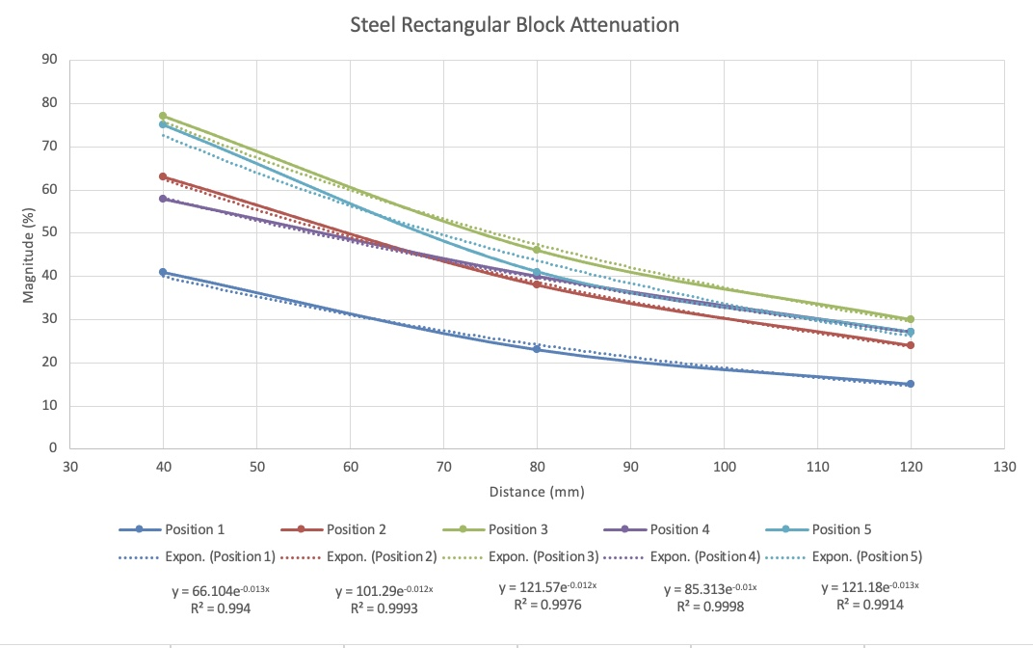
Figure 7: Steel Rectangular Block Attenuation Graph

Table 3: Steel Rectangular Block Attenuation Coefficients
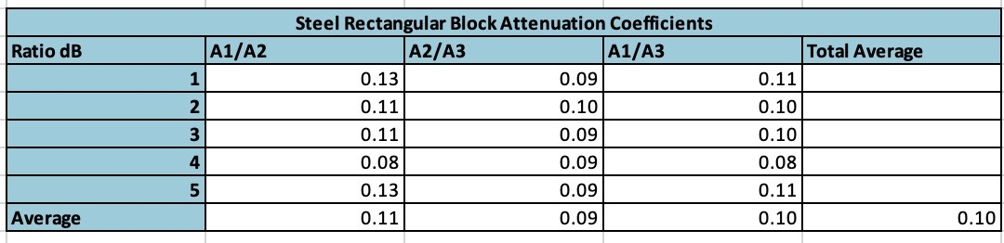
The graph above shows a steady decline in the attenuation coefficient which is to be expected due to the ultrasonic energy loss as well as beam divergence. When comparing this to the brake disc attenuation graph seen in figure 4, it’s clear that the attenuation coefficient of the brake disc is higher than the steel block. However, the second peak drops much lower in the brake disc which is due to the difference in size. As the brake is a much larger test subject, the ultrasonic energy loss and beam divergence is much higher due to the increase in surface area.

As seen above in figure 7, position 4 has the highest R² value, this suggests the exponential trendline approximates the data the best out of the five positions. R² is a statistical measure used to represents the proportion of the variance which is an independent variable in a regression model. The correlation explains the strength of the relationship between an independent and dependent variable while R² explains what the extent of the variance is (Beers, 2022).

As all R² values are close to 1 this means that all data that was taken shows a pretty accurate exponential curve (NCL, 2021). Table 2 below shows the average attenuation coefficient of 0.10dB/mm. When comparing this to other studies it seems to be very similar. In a study done by Ono, the value acquired was 0.103dB/mm (Ono, 2020). Due to this it is safe to say this test has been carried out fairly accurately. The standard deviation of all data from the steel block is 0.01435833, this shows that the data points are all relatively similar.

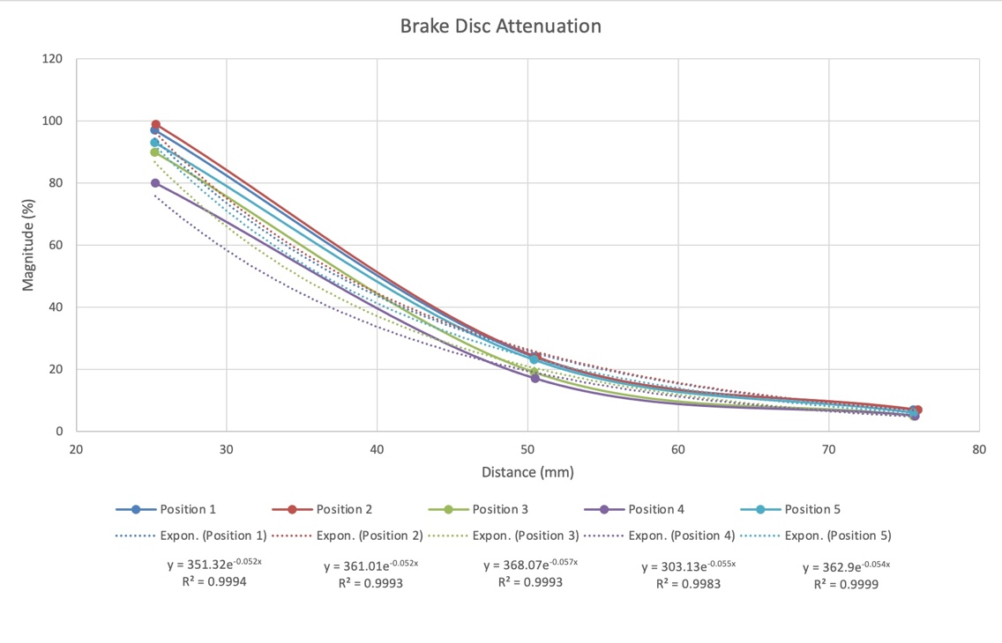
Figure 8: Brake Disc Attenuation Graph
Table 4: Brake Disc Attenuation Coefficients
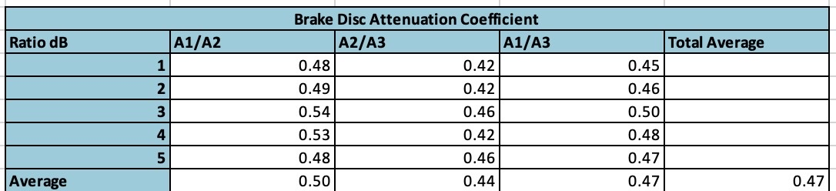

Figure 8 above shows the attenuation coefficient graph of the brake disc with the attenuation coefficients in table 4. From the R² values, position 5 is the closest to 1 suggesting that particular position almost perfectly matches the exponential curve. Again, all R² values in this case are close to 1. The average attenuation coefficient for the brake disc is 0.47dB/mm. The standard deviation of all data from the brake disc is 0.033533809, this shows again that the data points are all relatively similar.

Investigation Two
Normal distribution graphs, as well as the measured size vs true size, can be seen below for all ten technicians. For the measured size vs true size graphs the desirable trend would be the blue line, the more points that can be seen on this line would suggest more accuracy to the true size. The data has been displayed as a normal distribution graph which shows the probability distribution that is symmetric about the mean, showing that data near the mean are more frequent in occurrence than data far from the mean. This gives two parameters that are also useful for statistical analysis, the mean and the standard distribution (Chen, 2022).

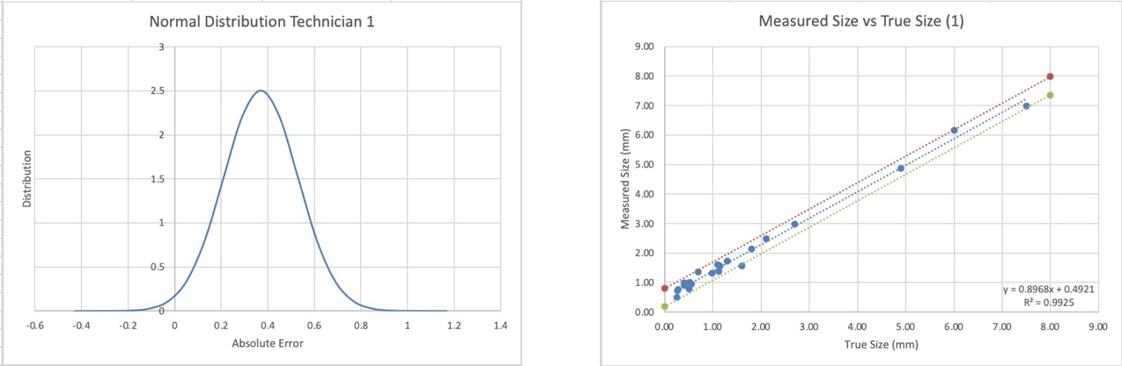
Figure 9: Results of Technician 1
The maximum peak point of normal distribution for technician one is 2.5 - this is the highest out of all of the technicians. This would suggest that the measurements taken by this technician has a higher distribution, than those will a lower maximum value. The measured vs true size graph shows all points within the 95% trend lines, again suggesting pretty good accuracy throughout. The R² value for this is 0.9925, this is the highest value out of all technicians.
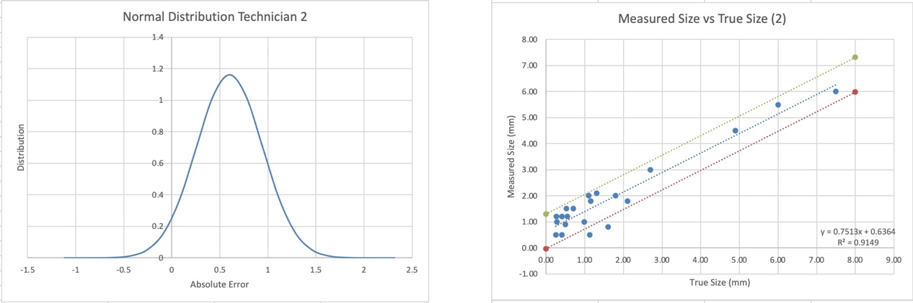
Figure 10: Results of Technician 2
Technician two, seen above in figure 10 can be seen to vary much more from the true size values, suggesting that this technician is less accurate. The R² value is also the lowest out of all technicians at 0.9149, although this is not an exceedingly low value, it does show more error when compared with the other technicians. There are also two points which don’t fit with any of the three trendlines, again suggesting very low accuracy.
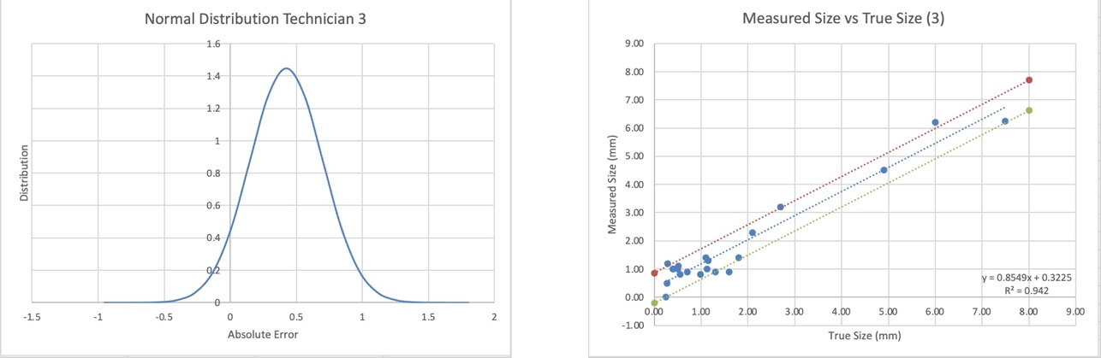
Figure 11: Results of Technician 3
Technician three also has a low R² value again suggesting lower accuracy. There are also three points which do not fit the trend lines, these variables could be anomalies, however as there are so many of them this would suggest very low accuracy.
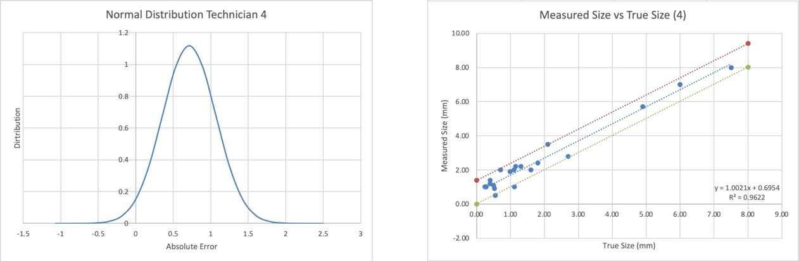
Figure 12: Results of Technician 4
Technician four also has many points outside of trend lines with a slightly higher R² value of 0.9622. Therefore, this technician is more accurate than the previous technician, but still not very accurate.

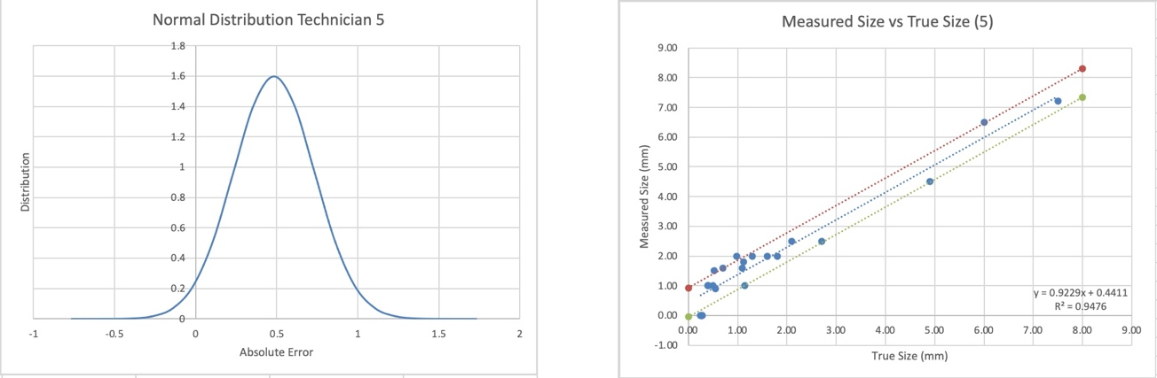
Figure 13: Results of Technician 5
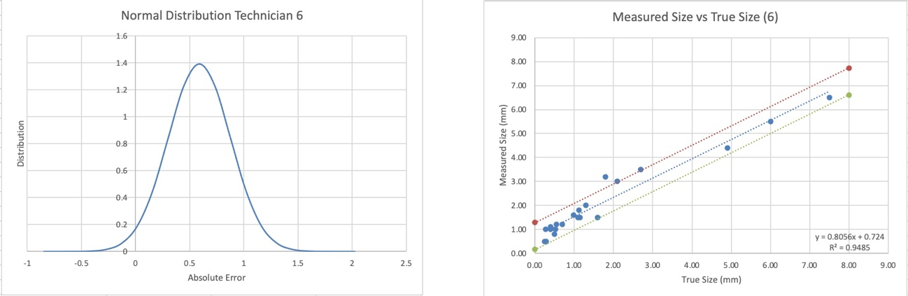
Figure 14: Results of Technician 6
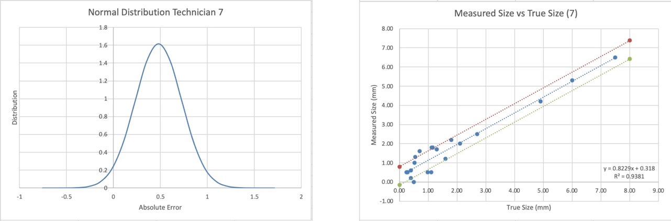
Figure 15: Results of Technician 7
Technicians five, six and seven all have low accuracy with the following R² values 0.9476, 0.9485 and 0.9381, all suggesting high distribution and low accuracy. This can be seen in figure 13, 14 and 15 respectively.
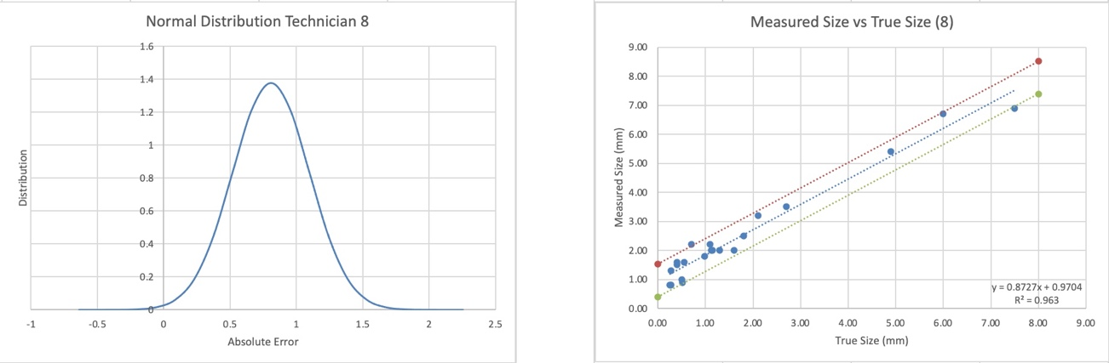
Figure 16: Results of Technician 8
Results from technician eight seen above again has low accuracy, however a slightly higher R² value can be seen here at 0.963. Suggesting higher accuracy and lower distribution.
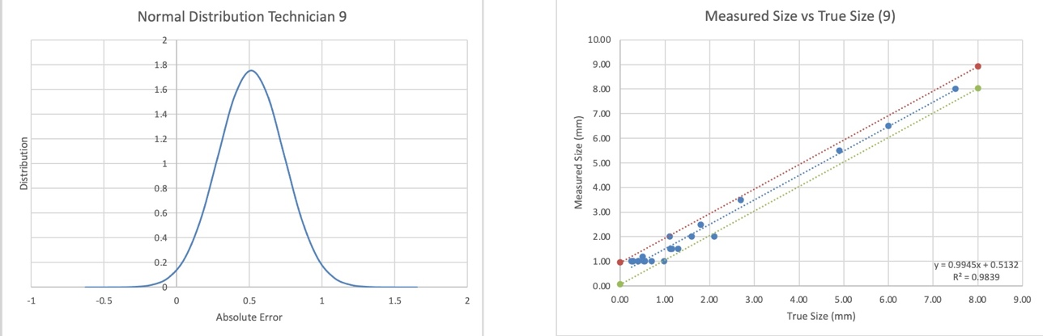
Figure 17: Results of Technician 9
Figure 17 shows the results from technician nine, as can be seen most of the points are within the trend lines and the R² value is the second highest of all at 0.9839. this implies that the trend line between each point is very close to matching the trend. The graph on the left also shows the smallest base of all the technician’s, this suggests that the results from this study are more accurate as the distribution isn’t as large from the true values.
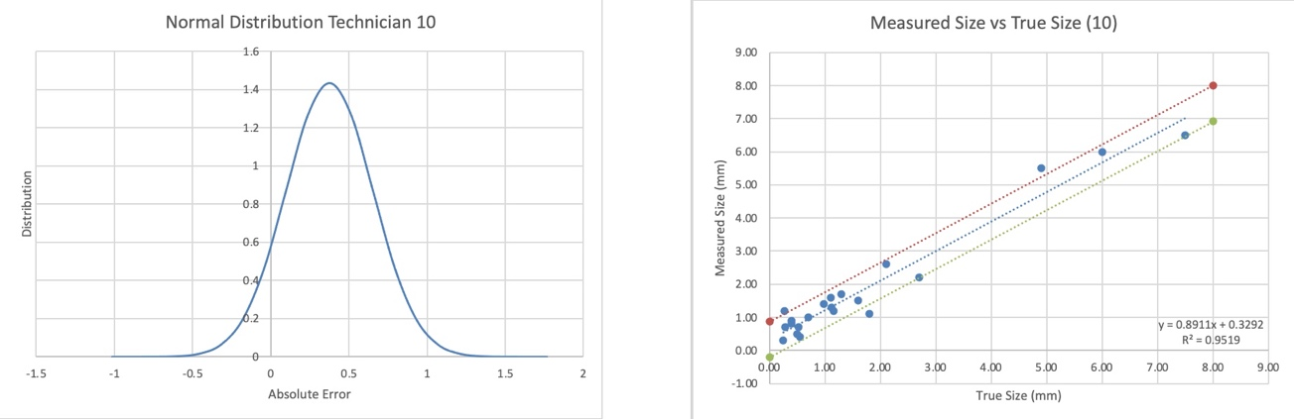
Figure 18: Results of Technician 10
Finally, technician ten above in figure 18. This one has a much lower distribution and an R² value of 0.9519, this is pretty accurate, however some anomalies may have occurred in this test with three outliers.

Conclusion
To conclude, the mild steel shows very high R² values and a clear negative correlation on the graph. The attenuation coefficients calculated also compares well with other studies. With all of this considered the testing carried out is very accurate. R² values of this testing can be seen below in table 5.
Table 5: Mild Steel Rectangular Block R² Values
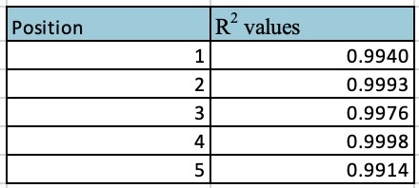

As the brake disc values remain without comparison it is not concrete evidence of how accurate the testing is. However, with very high R² values and a clear negative correlation, it’s considered to be fairly accurate. R² values of this testing can be seen below in table 6.
Table 6: Brake Disc R² Values
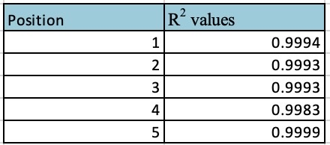
Through linear regression and statistical analysis, technician one seems to have the best sizing accuracy in their results out of all technicians. From the data acquired, this data set has the smallest distribution and the highest R² value suggesting higher accuracy than other technicians. Technician nine also has quite good sizing accuracy, this is a close second after comparison. However, through the study it was found that overall, the equipment was not particularly accurate as many of the technicians had a large difference between the true size and their measured sizes when compared to the results of investigation one.

6 Bibliography
Beers, B., 2022. Investopedia. [Online]
Available at: https://www.investopedia.com/terms/r/regression.asp
[Accessed 7 January 2023].
Chen, J., 2022. Investopedia. [Online]
Available at: https://www.investopedia.com/terms/n/normaldistribution.asp
[Accessed 7 January 2023].
NCL, 2021. Coefficient of Determination, R-squared. [Online]
Available at: https://www.ncl.ac.uk/webtemplate/ask-assets/external/maths-resources/statistics/regression-and-correlation/coefficient-of-determination-r-squared.html
[Accessed 7 January 2023].
Ono, K., 2020. A Comprehensive Report on Ultrasonic Attenuation of Engineering Materials, Including Metals, Ceramics, Polymers, Fiber-Reinforced Composites, Wood, and Rocks, California : Department of Materials Science and Engineering, University of California, Los Angeles (UCLA).
Zoofan, B., 2017. Measuring the Attenuation Coefficient of Ultrasonic Beams in Materials. NDT Technician Newsletter, 16(3), pp. 10-11.

Table of Figures
Figure 1: Ultrasonic Zero-Degree 5MHz Probe 4
Figure 2: Ultrasonic Flaw Detector 4
Figure 3: Dial Clipper 4
Figure 4: Gel 4
Figure 5: Steel Rectangular Block Raw Data Graph 6
Figure 6: Brake Disc Raw Data Graph 6
Figure 7: Steel Rectangular Block Attenuation Graph 10
Figure 8: Brake Disc Attenuation Graph 11
Figure 9: Results of Technician 1 12
Figure 10: Results of Technician 2 12
Figure 11: Results of Technician 3 12
Figure 12: Results of Technician 4 13
Figure 13: Results of Technician 5 13
Figure 14: Results of Technician 6 13
Figure 15: Results of Technician 7 13
Figure 16: Results of Technician 8 14
Figure 17: Results of Technician 9 14
Figure 18: Results of Technician 10 14

Table of Tables
Table 1:Through Wall Sizing Accuracy Analysis Raw Data 7
Table 2: 95% Confidence Table 9
Table 3: Steel Rectangular Block Attenuation Coefficients 10
Table 4: Brake Disc Attenuation Coefficients 11
Table 5: Mild Steel Rectangular Block R² Values 15
Table 6: Brake Disc R² Values 15
Table 7: Steel Rectangular Block Raw Data 18
Table 8: Brake Disc Raw Data 18

Table of Equations
Equation 1: Mean 8
Equation 2: Standard Deviation 8
Equation 3: Mean +3 Standard Deviations 8
Equation 4: Mean -3 Standard Deviations 8
Equation 5: Attenuation Coefficient 8
Equation 6: attenuation Coefficient Example 8
Equation 7: Absolute Error 8
Equation 8: 95% Confidence Equation 9

Appendix

Table 7: Steel Rectangular Block Raw Data
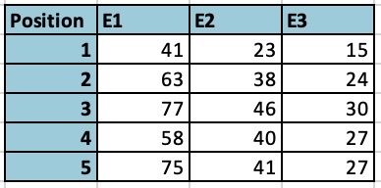

Table 8: Brake Disc Raw Data


