James Anthony Gladwin (1800150)

ECAD6008
CYCLE 3 PROFESSIONAL AND PEDAGOGIC STUDIES: LEADING THE LEARNING: WHAT, HOW AND WHY AM I TEACHING?

​​​​CONTENTS
PART ONE … 2

REFLECTION ON SUBJECT KNOWLEDGE DEVELOPMENT
ASSET ONE – LITERACY SKD …………………………….. 2
ASSET TWO – NUMERACY SKD…………………………… 2
ASSET THREE – DIGITAL COMPETENCE SKD…………... 3

REFLECTION ON PLANNIG FOR FOUR PURPOSES
PROFESSIONAL LEARNING TEMPLATE 1 - CRATER INVESTIGATION LESSON – FOUR PURPOSES FOR LEARNERS …………… 3
PROFESSIONAL LEARNING TEMPLATE 2 – SOLAR SYSTEM MODEL LESSON - FOUR PURPOSES FOR LEARNERS ……………. 4

REFLECTION ON PLANNING FOR PROGRESSION
PROFESSIONAL LEARNING TEMPLATE 1 – REFLECTION AND ROTATIONAL SYMMETRY LESSON - PROGRESSION IN LEARNING …. 5
PROFESSIONAL LEARNING TEMPLATE 2 - DASH? DESCRIPTIVE PARAGRAPHS LESSON – PROGRESSION IN LEARNING … 6
PART TWO … 7

REFERENCES …10
APPENDICES … 12
PART 1
Link to PLP: https://v3.pebblepad.co.uk/spa/#/public/kwhG4Zqn7xfddxzRrtWb7pb3qZ
Literacy SKD (Figure 1)
When I was able to teach face to face in PTE3, I was given the opportunity to teach all of the English language lessons. Throughout my other Primary teaching experiences, I had very little opportunity to work on literacy lessons and see the children improve over time. To make sure I delivered these lessons correctly with accurate knowledge, I used a twinkl PowerPoint to revise the areas that the children would be working on and used other websites such as BBC Bitesize to check this information. This involved revising definitions for adjectives, verbs and similes to make it easy and straightforward for the children to understand. The PowerPoint included breaking down descriptive paragraphs into a simple process known as DASH?. A DASH? Paragraph involves Description, Action, Speech, how is the character feeling and the question mark stands for a rhetorical question or cliff-hanger. This template involves the children writing a single sentence on each of these areas to improve the structure and quality of their writing. To help give the children good examples, I had a go at writing some high-quality sentences for myself to help point the children in the right direction which also helped me to prepare for any pitfalls that the children may fall into. I spent many hours preparing for these session as I feel less confident with the literacy subject knowledge compared to other Area of learning experiences (AOLE). This preparation helped me to plan and deliver these sessions effectively and allowed me and the children to produce high quality work and develop a real sense of confidence. This lesson focuses on the Welsh Governments language, Literacy and communication AOLE (2019). From the “literature fires imagination and inspires creativity” strand, I wanted to home in on “progression step 3” which states that “I can use my imagination and experiment with language to create my own literature”.

Numeracy SKD (Figure 2)

When the children came back to school, I decided to focus on symmetry in numeracy as it would be something that all the children could have a go at and didn't rely on much previous knowledge or mental maths skills. To make sure that I was ready to teach the children about symmetry, I used BBC Bitesize and a symmetry game I found on MathsFrame to look out for any pitfalls that the children may run into during my sessions. I specifically looked at a definition for the mirror line to share with the class as they could understand what it is and how they would use it to understand the rules of symmetry. I used BBC Bitesize to refresh my memory on the relationship between regular shapes, the number of sides and the number of lines of symmetry they have. This was vital in making sure that I could teach this area and make it as clear as possible for the children. Personally, I am much more confident with my maths subject knowledge which meant that I spent less time researching this before delivering my sessions. However, I did spend time refreshing my memory on symmetry as I hadn’t taught the area before and not had the opportunity to use my skills in this specific subject.

Digital Competence SKD (Figures 3 and 4)

During my placement I was forced to naturally develop my digital competence due to the nature of online learning through Google Classroom. For many sessions I used a program called Flipgrid. Flipgrid allows for the children to upload video and audio responses to a task that has been set. This program was used in a lot of PE sessions where the children competed against one another and entered by creating their own videos showing off their challenge attempts at home. The children also used a program called Jamboard through their google classroom. This allowed me to post a number of slides online and the children could collaborate together to share their ideas and feelings with me. This was mainly used in conjunction with leading live google meet sessions. The children seemed to really enjoy these tasks as they could now share how they were feeling and work together. Developing the skills to create and share these jamboards with the children enabled for greater interaction and engagement with the children on the google classroom. I used my digital competence skills to run live quizzes on a regular basis to give the children extra activities to increase engagement and extend their knowledge on different topics such as Chinese New Year. I also provided small daily activities using Jamboard which again pushed the children to log onto Google classroom to get involved with their learning.

Crater Investigation Lesson - Four purposes for learners (Figure 5)
The children had to demonstrate that they could be ambitious, capable learners ready to learn throughout their lives. Both activities required the children to complete them with very little support from the teacher to show that they could work independently. The crater investigation activity required the children to conduct a fair test by making sure that each object was dropped from the same height to see if there was a difference between the diameter of the crater left behind. All this had to be measured accurately using rulers to the nearest cm. Many children decided to be even more accurate and show their findings to the nearest 0.1cm. The other activity involved the children using an atlas to find different countries and then pinpoint them onto a blank world map. The children did this to expand their horizons about the world and find out where craters can be found and whether they were found near Wales. These activities were specifically designed to help the children be resourceful and independent in their learning. The children will have had to use an atlas in this session. Learning to use an atlas is a very important skill to have learnt especially for when the children have left school due its wide range of applications. This session’s main focus revolved around the children’s willingness to be ambitious and carry out their own investigation sensibly and accurately.
From this lesson I learnt that a practical activity linked to their theme is a perfect way to get the children engaged and involved. This helped to motivate them to carry out their own investigation making sure that it was a fair test which is a skill that can be used throughout their time in education and possibly throughout the rest of their lives. The children were also asked to use atlases to find countries and pinpoint them on their own blank map. The use of an atlas is an important skill to have as it can be used for many different areas of learning especially when they move onto high school/ comprehensive school. This activity may have been a struggle for some children, but they were encouraged to work together when stuck to improve their teamwork and help them to become ambitious capable learners. Some of the lower ability children may not have felt comfortable using an atlas as they may have struggled to read it or find the different countries listed. However, the children worked with partners on their table which enabled children to scaffold one another’s learning more effectively.
In the future, I will always aim to include one of the four purposes into every lesson to make sure that I am following the Successful Futures Report by Professor Graham Donaldson CB from 2015. This inclusion of the four purposes helped me to focus on what I want the children to learn whilst carrying out their activities. The Welsh Government have put a real emphasis on learning not just being about the facts and figures but also about the life lessons that underpin these experiences. I could carry on this learning by having the children look at different shaped objects and looking at what effect this has on the crater size. In the future I will also look to use other areas of the four purposes to help the children become more well-rounded individuals who can feel confident in any area of the curriculum and their own ability.

Solar System Model Lesson - Four purposes for learners (Figure 6)
Within this session, I was aiming for the children to become enterprising, creative contributors, ready to play a full part in life and work. I helped the children achieve this by setting them a creative task themed around their current topic from the Science and Technology AOLE. This creative activity involved the children utilising available objects from around their house to create a model of the solar system with an appropriate scale if possible. This took place during online/ remote learning which meant that some children will not have had the same access to materials as others. Therefore, I asked the children to be creative and resourceful with what they had at their disposal to complete the task and learn about the solar system. To help the children, I gave a list of everyday items that they could use to create their solar system models. I made sure to remind them that they didn’t have to use exactly what I had suggested and recommended that they should find alternatives in their own homes.
From this lesson, I have learnt that the children seemed to really enjoy this type of activity where they can be creative, no matter what their home situation is like. This activity managed to encourage a couple of children who hadn't normally participated in home learning to get involved. I believe that the nature of the task enabled her to feel less worried about what others had created and had a go at the activity for herself. When asking the children on a "meet" session, many said that they really enjoyed this activity and would like to do something similar in the future. This taught me to think about how every child could participate in the learning no matter what resources they had, with many not having any access to a printer or pens.
In the future, I would like to use a similar format as the children seemed excited and happy to carry out this task especially when doing something creative whilst at home during lockdown. I really enjoyed seeing the creativity and resourcefulness the children used to further their educational development and was very impressed with the quality of work that was produced. I would like to share the four purposes with the children in my class as much as possible and have them identify which ones they think they are working on in each lesson to involve the children further in their learning. The use of one of the four purposes helped me to focus on what the children needed to learn from this activity and would like to continue using this in the future to make sure that I am meeting the vision for the future of Welsh education.

Reflection and Rotational Symmetry Lesson - Progression in learning (Figure 7)
I decided to move from reflection to rotational symmetry to push the children who felt comfortable with their development. I decided to move on to rotational symmetry as it seemed like a natural evolution from looking at reflection symmetry. I felt that this needed to be done as I didn't have much time remaining with the class and I felt that some of the children were ready to progress while others still needed more time to work on using a mirror and finding the lines of symmetry. This progression was introduced to the children but wasn't forced upon them to make sure that the children felt comfortable to move on to something else which helped a number of children within the class. The next steps were offered to the children as a choice whether they would like to carry on working on reflection symmetry or move on if they felt ready. This decision was entirely down to the children, but I made sure to reinforce the idea that they must feel confident with the current work and show this off to me through their work before moving on.
From this lesson, I have learnt to plan appropriate next steps for the children's development whilst also not forcing it if the children aren't completely happy with their current progress. This should help develop children's confidence in their own abilities as they get to decide when they move on. I have also learnt to make sure that I select appropriate activities and areas for the children to work on as many of them understood the concept of rotational symmetry but wanted to improve on reflection symmetry before they moved on to something new. This should help colleagues as the children shouldn't be completely lost with the new topic which should enable them to work more independently and support can be focused on the children that need it the most. I believe that a more focused approach to progression enables children to be able to make greater strides in their learning whilst building greater confidence in their own abilities and understanding of subject knowledge.
​​​​​​​​​​In the future, I would continue to progress children through symmetry by allowing for more time to be spent on rotational symmetry and moving on to translational symmetry using a graph. I would then move on to looking at coordinates and graphs. This natural progression could allow the children to build up knowledge and confidence in their abilities to aid them in learning the next area of maths. I spent a few lessons on symmetry to help the children get used to being in school again after the lockdown. However, in more normal circumstances I believe that the children may have picked this up quicker and would've been able to move on at a faster pace.
DASH? Descriptive Paragraphs Lesson - Progression in learning (Figure 8)
Over the course of a number of lessons, I pushed the children to focus on writing higher quality sentences to write better descriptive paragraphs. Each lesson, I focused on a different aspect of writing an effective descriptive paragraph. This meant having the children focus on each portion of their paragraphs, as this is an area that they have struggled with in the past. I intended to have the children improve the quality of their descriptive writing by including different techniques such as adjectives, verbs and similes and by following the “DASH?” framework. This accumulation of lessons over a week and a half was used to help the children understand what a good descriptive paragraph looks like and what they could do to improve their writing. The DASH? model was selected as many children had struggled to write quality sentences in a similar task during online learning. As the children had struggled with a previous task, I made sure to spend plenty of time on each of the sections of the model so that the children fully understood what was expected from them and could use this time to craft high quality sentences using ideas discussed as a class.
I have learnt that the most progress can be made when small incremental changes and jumps in the children's education leads to greater engagement, understanding and development. It was important to learn this as I had previously been making too large a jump between different lessons which may have meant that some children didn't make as much progression as they could have. When planning sessions, a large jump between content could still provide a good lesson where the children seem to answer questions correctly and understand the content, but some children may be left feeling uncomfortable with the content due to a sharp change in direction. This was extremely important to consider as the children were returning to face-to-face learning for the first time in a few months and many children may have felt nervous and uncomfortable about returning to school to do work.
In the future, I would like to carry on using smaller, incremental changes to what the children are learning as opposed to larger jumps in content as it helps the children connect their experiences together. This should give the children a reason for learning what they are learning. In similar circumstances, I would have liked to have used this more in my online asynchronous lessons as I think it would have helped the children feel more confident and comfortable with their learning. Due to the limited number of sessions being delivered to the children on a weekly basis, I found it very difficult to weave the sessions together to without having to take larger jumps between content than I normally would.

PART 2
I decided to focus my attention towards developing children’s health and wellbeing through their education. The decision to focus on this aspect was heavily inspired by the recent events of COVID-19 where many children were forced to work from home, away from their school communities. This virus caused families to be separated from relatives and loved ones for extended periods of time. Many children may have had to come to terms with parents losing their jobs due to the pandemic which in turn could have resulted in financial issues arising. These factors will almost certainly have had a negative impact on the children’s health and wellbeing. These external factors cannot be controlled by teachers, but teachers can use their imagination and skills to find ways to improve the children’s education whilst developing confidence and helping to build better relationships with the class. I believe that this focus was vital for my time in primary teaching experience (PTE) 3 due to the massive changes that have occurred in children’s lives since the start of the pandemic and how this could affect their educational development.
The importance of Health and wellbeing has increased dramatically in educational settings in recent years due to a greater push from the Welsh Government. The Welsh Government (2020, a) highlighted the importance of Health and Wellbeing by including it as one of six AOLE’s, featuring alongside Mathematics and Numeracy, Languages, Literacy and Communication and Science and Technology. They acknowledge its importance by stating that the new AOLE “will support learners to understand and appreciate how the different components of health and well-being are interconnected” and that “good health and well-being are important to enable successful learning”. This increased focus has come about due to an apparent prevalence of emotional and mental health issues in school children. The National Assembly for Wales (2018, p. 22) states that “one in ten 5–16-year-olds suffers a diagnosable mental health disorder”. They also state that “the proportion of 15–16-year-olds self-reporting anxiety or depression has doubled in recent years”. This can be linked to primary schools as headteachers’ representatives have told them that “difficulties are more profound now than in the past and emerging among those of a much younger age than previously was the case”. This data suggests why Welsh Government has increased its attention and further highlights the importance of the Health and Well-being AOLE for the children as it aims to tackle the issues being seen later in their school life.
This importance placed on the Health and Wellbeing AOLE has improved significantly due to the emergence of the coronavirus. The virus has exacerbated these issues by putting added pressure on children and their families. The Mental Health Foundation (2020) illustrates that teachers felt the “most disadvantaged” children were not engaging with the online learning experience and that “the level of disadvantage of the school” was “influential on pupil engagement”. Levita PHD (2020, p.19) wrote an initial report on the impact COVID-19 was having on young people aged 13 to 24. From her research, she found that in both males and females, “the younger you are the higher your levels of anxiety”. This data specifically looks at children in high schools and above which may not be entirely suitable for comparisons to primary schools. However, reports from headteachers, as mentioned earlier, that they are seeing these types of issues at much younger ages than before does add a greater level of importance to these results. The Welsh Government (Feb 2021) showed that they recognised the importance of the “effect being away from school and regular support networks has had on young people during the pandemic”. They stated that an extra £9.4 million would be made available to mental health services after finding that “research showing mental health issues predominantly start when people are children”. This show of support by the Welsh Government again reflects the ever-growing importance to consider the Health and Wellbeing of the children as it is essential that they become “healthy and confident individuals” (Donaldson, 2015, p. 29).
A possible strategy to employ within the primary school classroom could be to help build a “tribal classroom” according to Cozolino (2013, page number unknown). Cozolino states that a tribal classroom is a concept “inspired by what we believe to be the basic interpersonal dynamics of the small-scale groups that humans evolved in for hundreds of thousands of years”. The idea of a tribal classroom focuses on generating strong relationships, teamwork and democratic leadership between all children within the class. Cozolino (2013, page number unknown) also outlines the importance of play in children’s education as it releases “happy hormones” like serotonin. Adrian Bethune (2018, page number unknown) reiterates its importance as the release of these hormones can “boost feelings of wellbeing, aid learning and foster social connectivity”. The theory behind a tribal classroom can be linked to Vygotsky’s theory of social constructivism where he believes that children learn socially through interaction which he refers to as “cooperative or collaborative dialogue” (Saul McLeod, 2020). This dialogue allows for children to use support from a “more knowledgeable other” to cross the “zone of proximal development” which extends the reach of children’s possible development compared to if they were working independently. Vygotsky (1933, 1966) solidifies his stance on play in education as he believes that “In play a child always behaves beyond his average age, above his daily behaviour; in play it is as though he were a head taller than himself”. These ideas can be related to Donaldson’s Successful Futures (2015, p.29) document which highlights the four purposes, in particular, the aim to help children become “enterprising, creative contributors who are ready to play a full part in life and work”. Vygotsky and Donaldson’s research and findings links with many of the positive effects of implementing a tribal classroom in an educational setting. However, many theorists question Vygotsky’s findings as he relied heavily on observation to collect his data. Another criticism of Vygotsky’s work is that there was no explanation of how some children who received constant support to develop their social skills couldn’t until they reached a certain age. Jean Piaget’s work manages to provide an explanation for this phenomenon as he believes that children develop through four stages linked to their age and this changes the way in which they approach their learning. McLeod (2018) outlines the four stages as the “Sensorimotor” which takes place from birth to 18-24 months, the “Preoperational” which takes place from 2-7 years old, the “Concrete Operational” which occurs ages 7-11 and “Formal Operational” which takes place from adolescence to adulthood. The first stage ends with the child understanding the permanence of objects. The second stage has the children using “Symbolic thought” where a word or object can be used to represent something else. The third stage involves the children using “logical thinking” and begin to understand that even though things can “change in appearance, certain properties remain the same”. The fourth and final stage believes that the children should be able to use “Scientific reasoning” and can cope with more “abstract ideas”. Piaget’s work has been vital and has shifted “how people viewed the child’s world and their methods of studying children” and his methods have been used in education systems for a long period of time. However, like Vygotsky, his work has some glaring weaknesses. Piaget’s use of stages to show how children learn are very simple and straightforward to understand. However, he has provided little to no proof that these stages exist and why those ages have been associated with each stage. Another drawback of Piaget’s work is the failure to consider that “social setting and culture” may have had an effect on cognitive development. After delving into the works of the two theorists, the researcher believes that Vygotsky’s work has more substantial links and possible benefits that relate to the implementation of the “tribal classroom” in education (Cozolino, 2013, page number unknown).
Another possible strategy to implement into schools to improve wellbeing is the use of Pupil Voice. Pupil Voice is the process in which children are actively listened to by schools to gain insight into their thoughts about their education. Mentally Healthy Schools highlights the benefits of Pupil Voice by stating that “Children and young people can offer unique perspectives on what it is like to be a pupil at their school; involving them in decision-making can create meaningful change and better academic outcomes, as well as facilitating a sense of empowerment and inclusion”. This approach to improving children’s wellbeing is usually considered as a whole school approach where value is placed on every child’s voice to foster healthier relationships between the school, its teachers and its students. According to Robinson and Taylor (2007, p. 15) the use of pupil voice within school could be “potentially significant in enabling school improvement through enhancing social justice”. However, Robinson and Taylor (2007, p. 14) also highlight the significance of how “listening to pupils itself is not sufficient” enough, “it is what happens with the information, what is done with it, that is also of great importance”. This reflects the idea that children’s opinions, thoughts and feelings must be collected and implemented effectively to improve their education whilst trying to avoid the notion of “tokenism” (Robinson and Taylor, 2007, p.10) where ideas are implemented for the sake of appearing like effective changes have been made. Another core aim of pupil voice is the inclusivity of children with all aspects of their education. Wood (2007, p. 9) shows that some schools have decided to “discuss with children what they have learnt and share with them any new ideas for possible future implementation” after returning from a staff development opportunity. Wood acknowledges this by stating that “one key thing that binds all partners and strengthens the school community is a desire and commitment to learn”. This improved focus on the school as a “community” from Wood suggests that children may have a greater interest in their education if they get to play a part in its inception and improvement further improving their wellbeing as an active member of their educational “community”.

From my review of relevant literature, I have learnt that a greater emphasis is being placed on children actively being involved in all aspects of schools decision making process. Many schools have taken this idea on board and thought of unique ways to implement the development of wellbeing to further the relationships between teachers and their students in the hope that children feel more connected to their school and take greater pride in what happens in their lessons, including performance, attention and behaviour. In future practices, I will look to use both of these strategies to further my relationship with the children as they be providing ideas and inspiration to help form their educational opportunities. If implemented correctly, this should have a positive effect on the children’s quality of work, attention in lessons and behaviour. I believe that this will be vital in the future due to the lack of time children have spent in school due to the COVID-19 pandemic. Young Minds (2020) charity recently carried out a survey with school staff with results that “88% of respondents agreed that a lack of structure and routine has had an effect on student wellbeing, while 79% thought that increased anxiety stemming from the pandemic has had an effect”. These results show the importance of preparing and planning ways in which children can build up their mental health and wellbeing whilst considering the implications that the pandemic has had on each student individually.
REFERENCES

Bethune, A. (2018) Wellbeing in the Primary Classroom. A Practical Guide to Teaching Happiness.
Available at: https://www.google.co.uk/books/edition/Wellbeing_in_the_Primary_Classroom/tNVVDwAAQBAJ?hl=en&gbpv=1
(Accessed: 30/04/21)

Cozolino, L. (2013) Attachment-Based Teaching: Creating a Tribal Classroom.
Available at: https://www.google.co.uk/books/edition/Attachment_Based_Teaching_Creating_a_Tri/YRR0AwAAQBAJ?hl=en&gbpv=1&printsec=frontcover
(Accessed: 30/04/21)

Levita, L. PHD. (June 2020) Initial research findings on the impact of COVID-19 on the well-being of young people aged 13 to 24 in the UK. University of Sheffield. Department of Psychology. COVID-19 Psychological Research Consortium (C19PRC).
Available at: https://www.rcpch.ac.uk/sites/default/files/2020-08/Impact%20of%20COVID-19%20on%20the%20well-being%20of%20young%20people%20aged%2013%20to%2024%20-%20University%20of%20Sheffield.pdf
(Accessed: 29/04/21)

McLeod, S. A. (2018, June 06). Jean piaget's theory of cognitive development. Simply Psychology.
Available at: https://www.simplypsychology.org/piaget.html
(Accessed: 01/05/21)

McLeod, S. A. (2020) Lev Vygotsky's Sociocultural Theory. SimplyPsychology.
Available at: https://www.simplypsychology.org/vygotsky.html
(Accessed: 30/04/21)
Mental Health Foundation (2020) Impacts of lockdown on the mental health of children and young people.
Available at: https://www.mentalhealth.org.uk/publications/impacts-lockdown-mental-health-children-and-young-people
(Accessed: 29/04/21)

Mentally Healthy Schools (No date available) Pupil Voice. Anna Freud National Centre of Children and Families.
Available at: https://www.mentallyhealthyschools.org.uk/whole-school-approach/pupil-voice/
(Accessed: 01/05/21)
Professor Donaldson, G. CB. (February 2015) Successful Futures. Independent Review of Curriculum and Assessment Arrangements in Wales.
Available at: https://gov.wales/sites/default/files/publications/2018-03/successful-futures.pdf
(Accessed: 29/04/21)

Robinson, C. and Taylor, C. (2007) Improving schools. Theorizing student voice: values and perspectives. Sage publications.
Available at: https://journals.sagepub.com/doi/10.1177/1365480207073702
(Accessed: 01/05/21)

Vygotsky, L. (1933, 1996). Play and its role in the mental development of the child. Psychology and Marxism.

Welsh Government (2020, a) Health and Well-being.
Available at: https://hwb.gov.wales/curriculum-for-wales/health-and-well-being/
(Accessed: 28/04/21)

Welsh Government (2020, b) Languages, Literacy and Communication.
Available at: https://hwb.gov.wales/curriculum-for-wales/languages-literacy-and-communication/descriptions-of-learning/
(Accessed: 28/04/21)

Welsh Government (February 2021) Pledge to support youth with extra £9.4m investment in children and young people mental health services.
Available at: https://gov.wales/pledge-support-youth-extra-ps94m-investment-children-and-young-people-mental-health-services
(Accessed: 29/04/21)

Wood, M. (2011) ‘Closer to the Ground’: Pupil ‘voice’ and the Development of Knowledge about Schools. York St John University. UK. ORCID.
Available at: https://ray.yorksj.ac.uk/id/eprint/369/1/TOJQI_2_1_Article_1.pdf
(Accessed: 01/05/21)

YoungMinds (19th June 2020) School staff warn of the extensive impact of COVID-19 pandemic on young people’s mental health - new survey.
Available at: https://youngminds.org.uk/about-us/media-centre/press-releases/school-staff-warn-of-the-extensive-impact-of-covid-19-pandemic-on-young-people-s-mental-health-new-survey/
(Accessed: 01/05/21)

APPENDICES

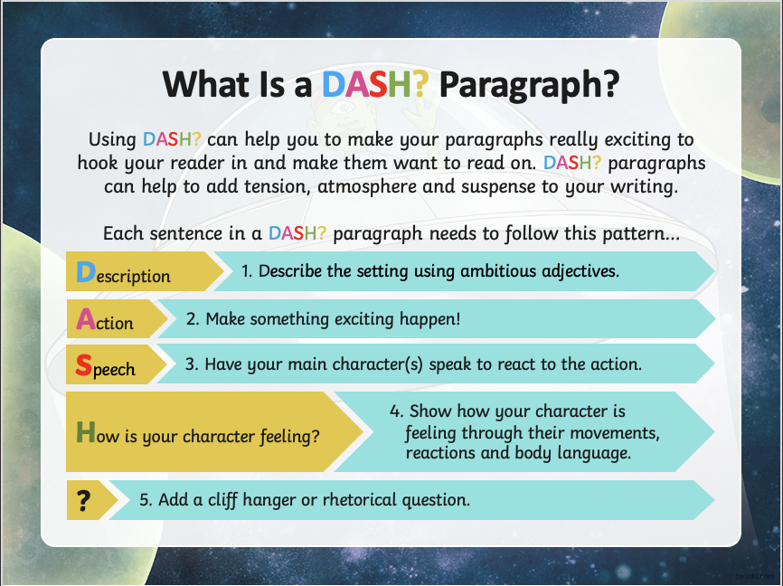
Figure 1

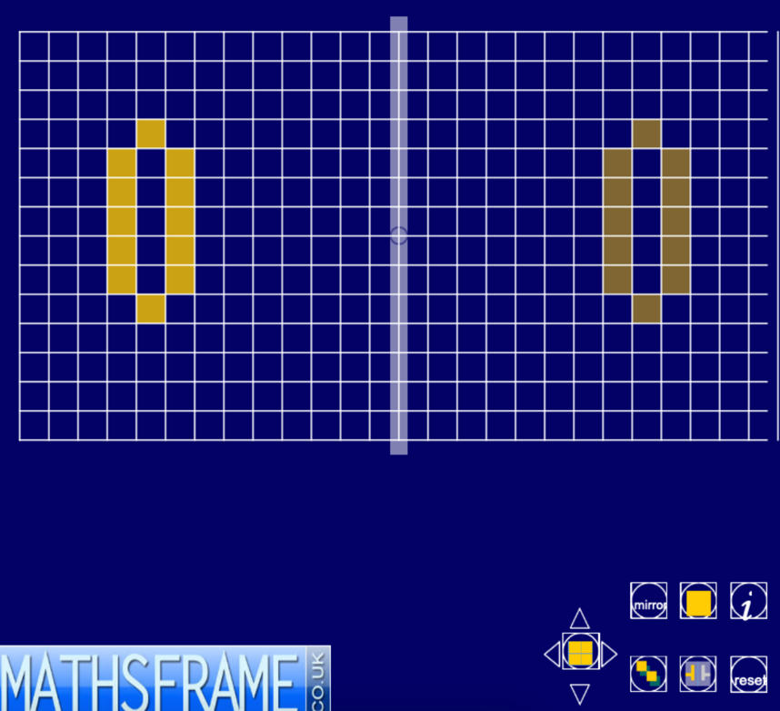
Figure 2

Figure 3
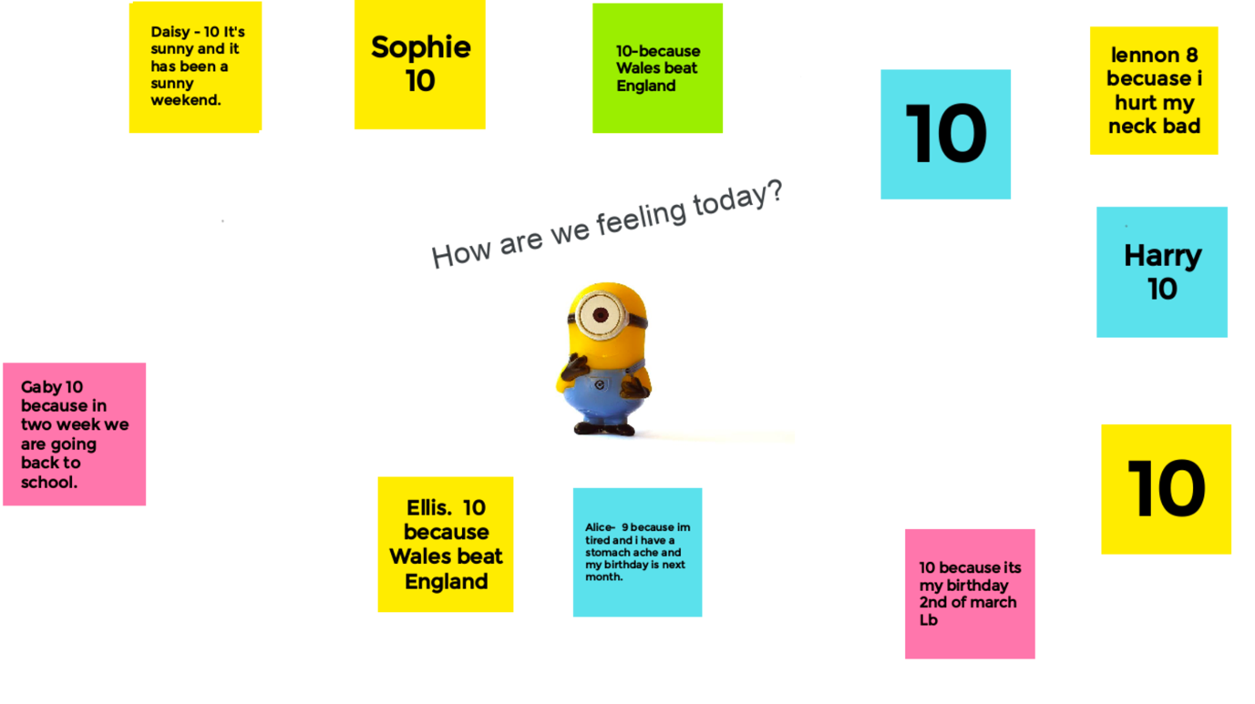

Figure 4

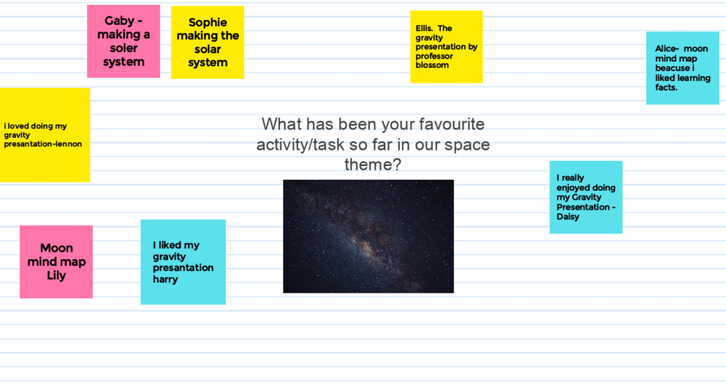

Figure 5
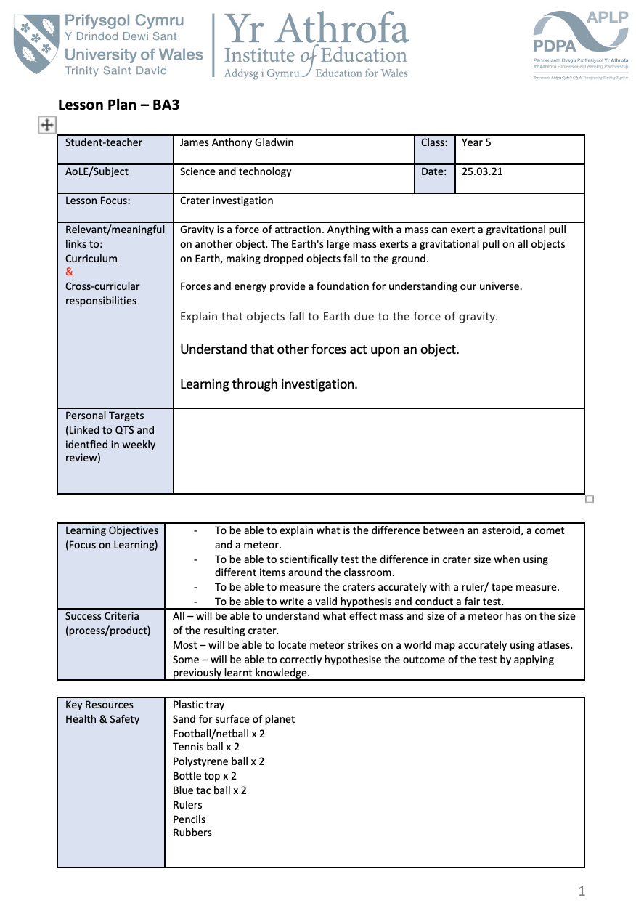

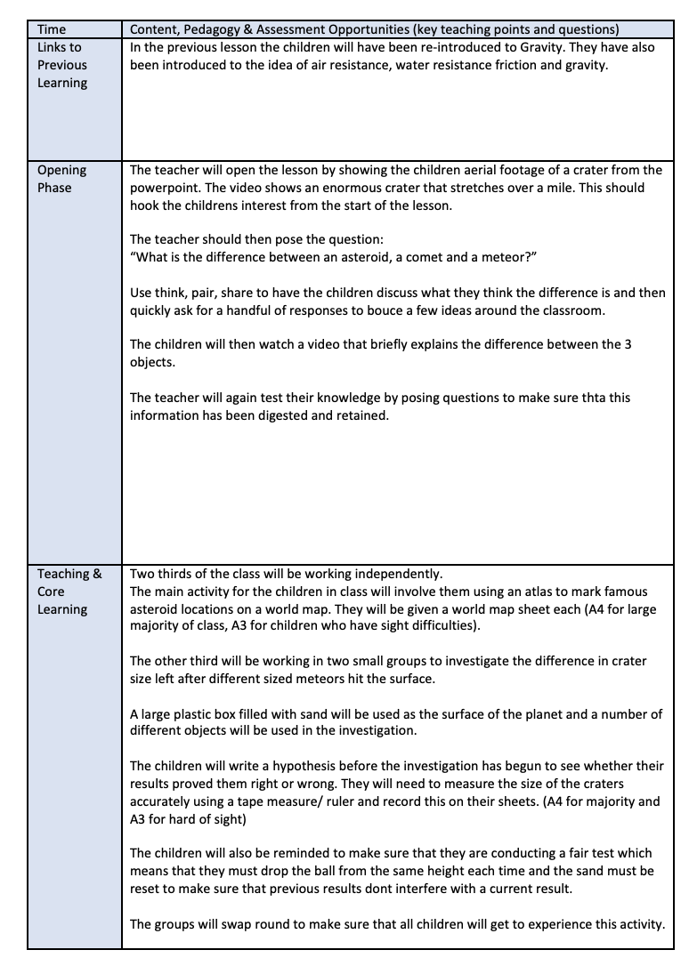

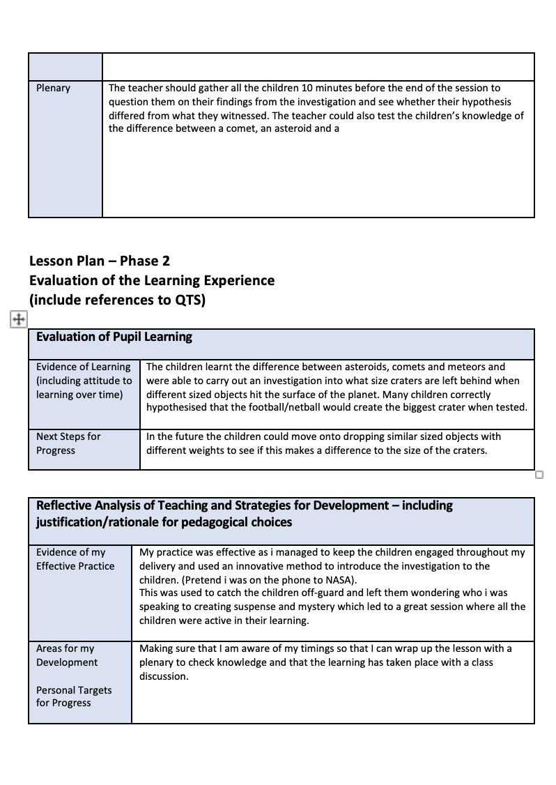

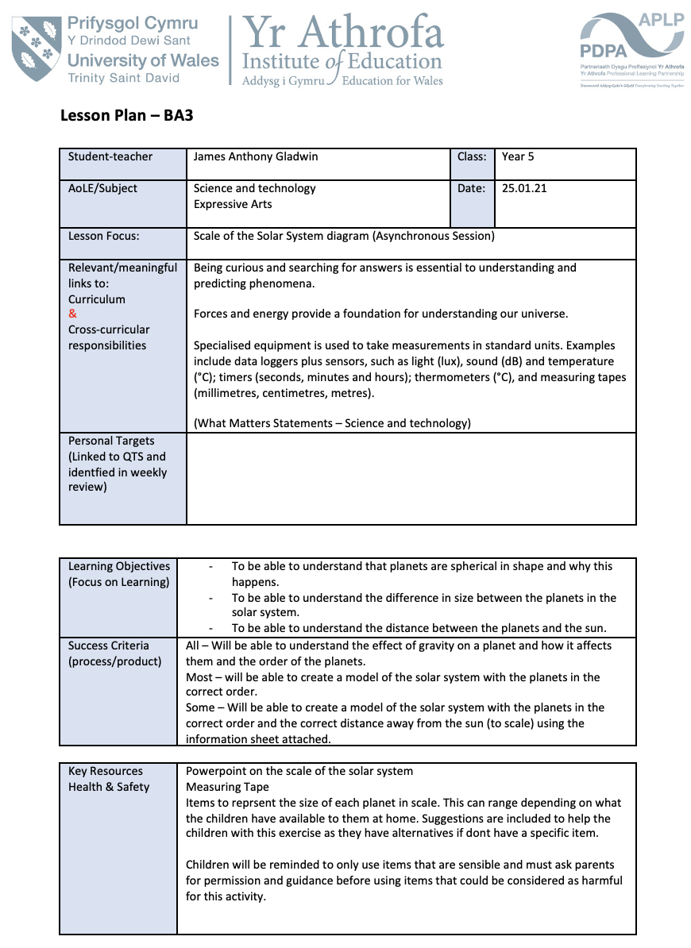
Figure 6
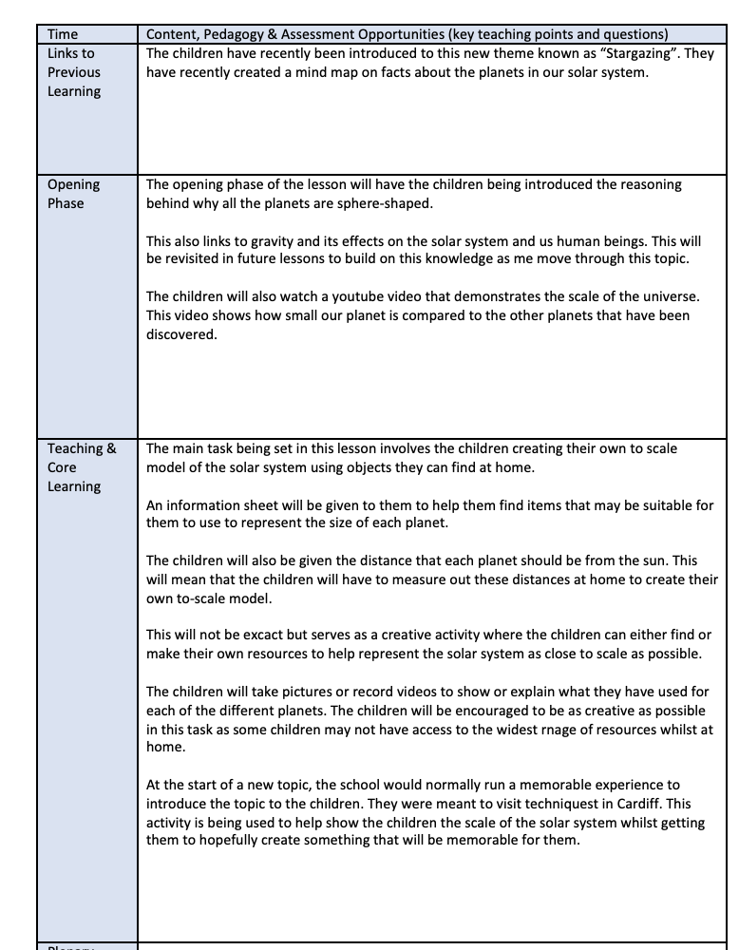

Figure 7
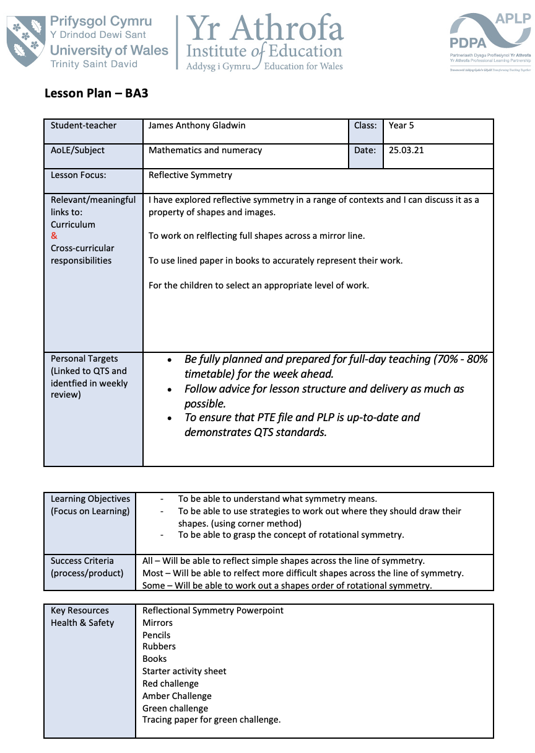

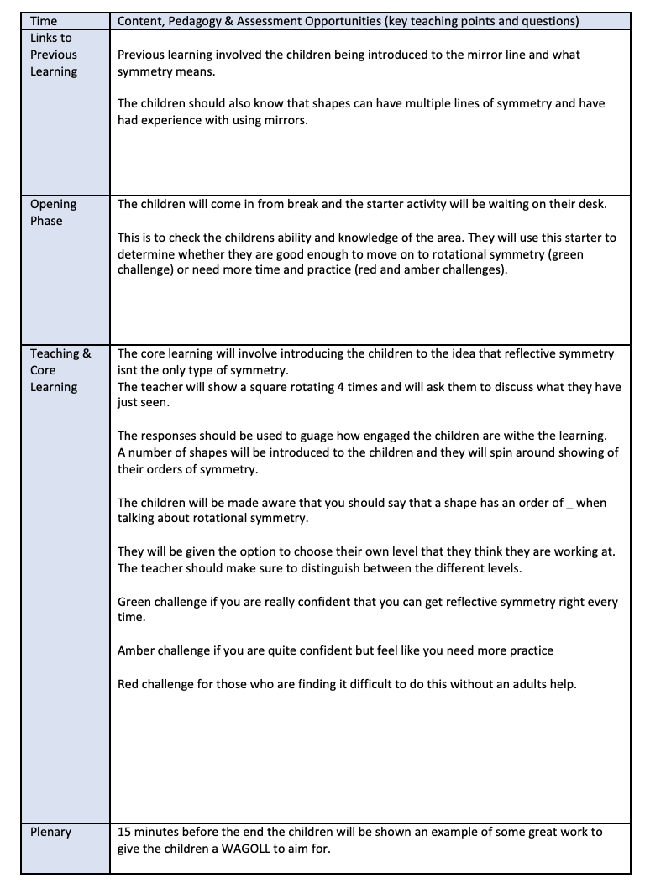
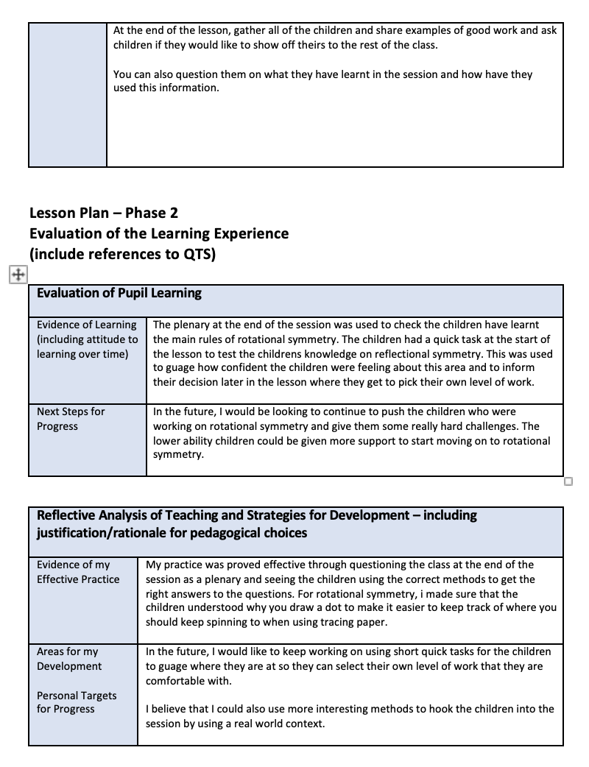

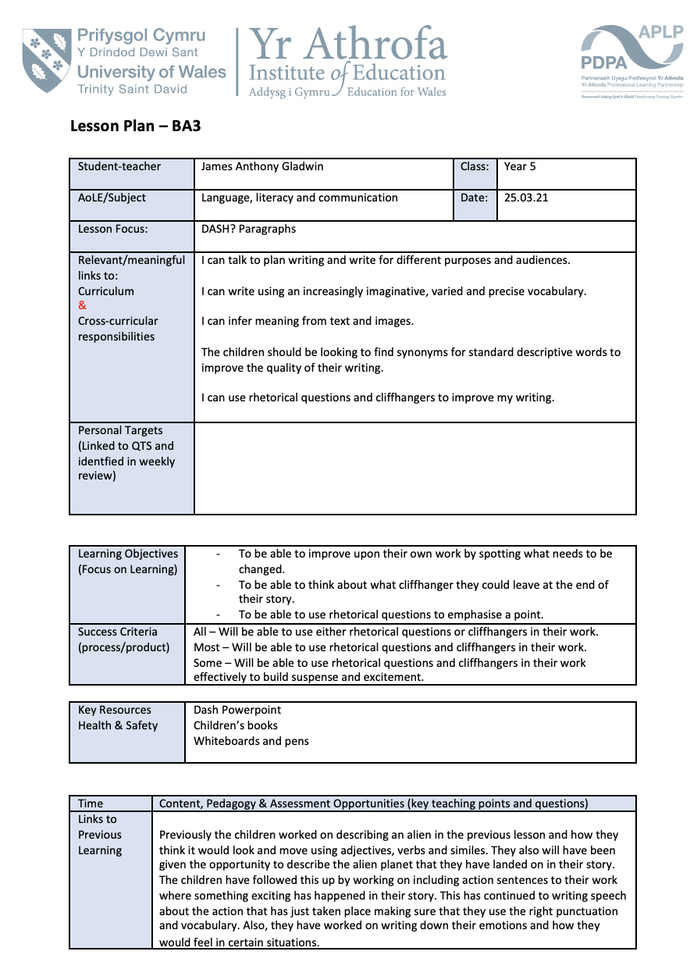
Figure 8


