

NVH Analysis
Ride Handling and NVH
Alex White
2204063

University of Wales Trinity Saint David
School of Engineering
BEng Automotive Engineering
05/12/2025

Contents Page
Introduction………………………………………………………………………………… Page 4
Task 1: Investigation of NVH concepts………………………………………….. Page 4
1.1 - Mechanical System from a Vehicle…………………………………………… Page 4
1.2 – Bearings………………………………………………………………………………. Page 5
1.3 - Gear Mesh Frequency (GMF)…………………………………………………… Page 6
1.4 - Component Harmonic Resonance…………………………………………… Page 7
1.5 - Mechanical Vibration……………………………………………………………… Page 8
1.5.1 – Installation………………………………………………………………………… Page 8
1.5.2 – Operation………………………………………………………………………….. Page 8
1.6 - Acoustic Sensors…………………………………………………………………… Page 9
1.6.1 – Installation………………………………………………………………………… Page 9
1.6.2 – Operation………………………………………………………………………….. Page 9

Task 2: Analysis of measured NVH data……………………………………... Page 10
2.1 – Methodology……………………………………………………………………… Page 10
2.2 - Engine Rig Data………………………………………………………………….. Page 13
Graph 1.1 – Four Cylinder Order…………………………………………. Page 14
Graph 1.2 – Four Cylinder FFT……………………………………………. Page 15
2.3 - Identifying Issues in the Engine…………………………………………….. Page 16
Graph 1.3 – Three Cylinder Order……………………………………….. Page 16
Graph 1.4 – Three Cylinder FFT…………………………………………… Page 17
2.4 - Vibration Data……………………………………………………………………. Page 18
2.4.1 - Engine Vibration Vertical, Four-Cylinder Test………………………… Page 18
Graph 2.1 – Four Cylinder Vertical FFT…………………………………. Page 18
Graph 2.2 – Four Cylinder Vertical Order……………………………… Page 19
2.4.2 - Engine Vibration Horizontal, Four-Cylinder Test……………………. Page 20
Graph 2.3 – Four Cylinder Horizontal FFT…………………………….. Page 20
Graph 2.4 – Four Cylinder Horizontal Order………………………….. Page 21
2.4.3 - Engine Vibration Vertical, Three-Cylinder Test………………………. Page 22
Graph 3.1 – Three Cylinder Vertical FFT……………………………….. Page 22
Graph 3.2 – Three Cylinder Vertical Order…………………………….. Page 23
2.4.4 - Engine Vibration Horizontal, Three-Cylinder Test…………………… Page 24
Graph 3.3 – Three Cylinder Horizontal FFT……………………………. Page 24
Graph 3.4 – Three Cylinder Horizontal Order…………………………. Page 24
2.4.5 - Engine Vibration Radiator Housing, Four-Cylinder Test…………… Page 25
Graph 4.1 – Four Cylinder Radiator Housing FFT……………………. Page 25
Graph 4.2 – Four Cylinder Radiator Housing Order…………………. Page 26
2.4.6 - Engine Vibration Radiator Housing, Three-Cylinder Test………….. Page 27
Graph 4.3 – Three Cylinder Radiator Housing FFT…………………… Page 27
Graph 4.4 – Three Cylinder Radiator Housing Order……………….. Page 28
Conclusion……………………………………………………………………………….. Page 29
References……………………………………………………………………………….. Page 30
Appendix………………………………………………………………………………….. Page 33
Introduction
This report looks at the concept of harmonic resonance and how it can affect components in a mechanical system. This includes how mechanical vibration and acoustic air pressure is measured. In addition, there will be analysis on a series of Order and FFT graphs for a four-cylinder and three-cylinder test completed on an engine rig.

Task 1: Investigation of NVH Concepts

1.1 - Mechanical System from a Vehicle
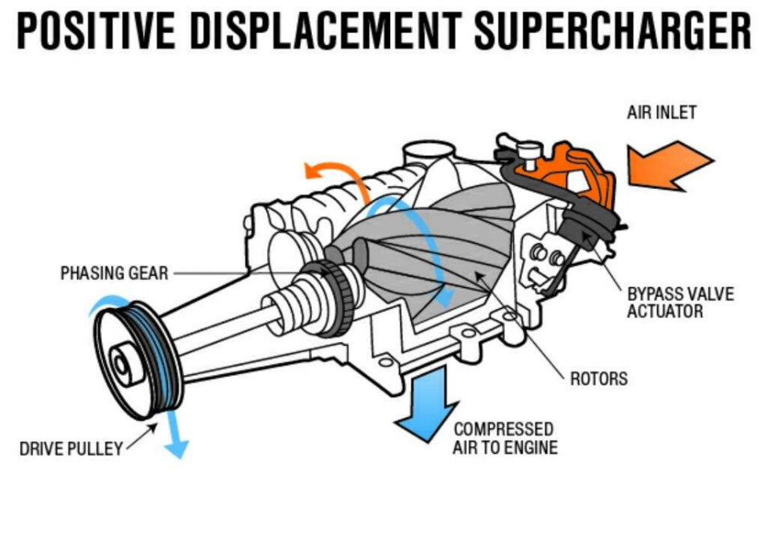
The mechanical system selected to complete an excitation order calculation on is an Eaton M112 supercharger compressor originating from a Jaguar 4.2 litre V8. The supercharger components include two twisting rotors, two phasing gears and four bearings. The phasing gears are directly connected by a drive pulley to the crankshaft of the engine, this means they match the crankshafts RPM.

Above is a basic diagram of a Supercharger, similar to the M112 (Imran Agassy, 2017).

Jaguar’s stock M112 setup uses a larger crank pulley vs a smaller SC pulley (PowerHouse, 1, 2025). The blower drive ratio for Jaguar superchargers is typically 1.83:1. This means the supercharger is operating 1.83 times faster than the crankshaft RPM.
Crank Shaft RPM | SC Pulley RPM
6000 | 10,980
If the crank is operating at 6000 RPM or 100 rotations per second (RPS), the pulley is operating at 183 RPS. One phasing gear spins clockwise and one anticlockwise. Both have 49 teeth, giving them the ratio 1:1. It is the same for the rotors, which are connected to the phasing gears. This is shown in the table below.

1 RPS = 1 Hz

Component | RPS | Rotational Frequency (Hz)
Crank Shaft | 100 | 100
SC Pulley | 183 | 183
Phasing Gears | 183 | 183
Rotors | 183 | 183

1.2 - Bearings
There are four bearings in the M112. Two are positioned between the rotors and the phasing gears in the middle of the rotor pack. Eaton rolls the casting onto the bearing outer race, permanently sealing them in with an oil bath extending their lifespan. Therefore, they are typically not included in M112 repair kits as to access them you would have to fracture the casting (PowerHouse, 2, 2025). This also means that you are unable to calculate the excitation orders of these bearings because you can’t buy them or measure them manually.
However, the second set of bearings are easily accessible. Their sizing information is shown in the table below with a basic diagram, gathered using a Caliper. This bearing has a total of 14 balls.

Circle | Diameter (mm)
Black | 29
Red | 25
Blue | 17
Green (Bearing) | 4
Purple | 21

From this information, the inner track speed, ball rotation frequency, ball precession, and ball spacing can be calculated. This is displayed in the table below.
Bearing Information | Figure | Unit
Inner Track | 9.77 | m/s
Ball Rotation | 775.4 | RPS
Ball Precession | 124.46 | RPS
Spacing between Balls | 0.000179 | mm

Figure calculations can be found in the appendix.

1.3 - Gear Mesh Frequency (GMF)
GMF - rate at which gear teeth engage during operation, calculated by multiplying the number of teeth on a gear by its rotational speed (Hocine Chibane, 2025).
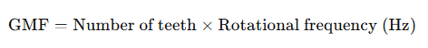

Phasing Gear GMF = 49 (teeth) x 183 Hz = 8,967 Hz
Rotor GMF = 3 (Lobes) x 183 Hz = 549 Hz

1.4 - Component Harmonic Resonance
Harmonic resonance occurs when a system is subjected to an oscillating or cyclic loading with a frequency similar or the same as the natural frequency of the system (Ross Performance Parts, 2024), including multiples of the components GMF. This results in oscillation at a much higher amplitude than the original load. An excitation table can be found in the appendix (Table 1). If a component lingers in this natural frequency for too long, it can be damaged via material fatigue.
Therefore, you can’t only check 1x speed (183 Hz), all significant orders must be checked. A table showing the components and the possible effects of excitations mentioned in table 1 can be found in the appendix (Table 2).
Because the rotors have a helical twist and the contact line moves continuously along the 190mm long rotors, you can also get modulation effects. As this sweep repeats three times per revolution, due to the three lobes, it produces a 3x shaft-speed excitation order.
This means that vibration energy is sent into the structure across a long contact path rather than at a single point. As a result, a tone that would otherwise appear as a narrow, sharp line in the spectrum becomes slightly broadened, because different parts of the casing and rotor structure are excited as the contact point travels. This can introduce spatial phasing, where the sweeping contact excites different bending mode shapes along the rotor length, further contributing to modulation of the vibration response (Holmberg & Andersson, 1994).
Low-frequency vibration between 1-20 Hz can cause discomfort, motion sickness, and reduced motor coordination due to resonance of internal organs and the vestibular system (Griffin, 1990). These human responses make NVH control a safety issue, not just a consideration for the vehicle itself.

1.5 - Mechanical Vibration
Mechanical vibration refers to the oscillatory motion of a mechanical structure or component about an equilibrium point. Measuring vibration helps in condition monitoring, fault diagnosis, and design validation of machinery and structures (Testbook, 2024). Common types of sensors used are accelerometers, velocity transducers and displacement sensors.
Considerations you must make when choosing a vibration sensor are shown in the table below, including limitations.
Frequency Range | The sensor should cover the range of expected vibration frequencies (1 Hz - 10 kHz).
Amplitude Range | Must handle expected acceleration levels without saturation.
Temperature Stability | Does the component change temperature during testing.
Mounting Method | Stud, adhesive, or magnetic mounts can affect frequency response.
Environment | Must resist oil, dust, humidity, or radiation if present.
Size and Weight | Smaller sensors for light structures to minimize mass loading.

1.5.1 - Installation
The most used vibration sensor for engines is the accelerometer. Accelerometers are full-contact transducers typically mounted directly on high-frequency elements, such as rolling-element bearings, gearboxes, or spinning blades. Orientation is based on what axis you want to measure in (vertical, horizontal, or longitudinal). Accelerometers are often chosen for this role because they include linearity over a wide frequency range and a large dynamic range (NI, 2025).

1.5.2 - Operation
The accelerometer contains a piezoelectric crystal and a seismic mass. When the engine vibrates, acceleration forces cause the mass to compress the crystal. The crystal generates a charge proportional to acceleration (Q = k·m·a). The signal is converted to a voltage and sent to the data recorder or vibration analyser (HBK, 2025).

1.6 - Acoustic Sensors
Sound pressure and sound pressure level are the variation in air pressure levels by sound vibrations. Typically expressed in pascals (Pa) or decibels (dB) and measures the amplitude or intensity of sound at a particular location (CSG, 2025). The most common sensor for measuring around engines is the condenser microphone.
Considerations you must make when choosing an acoustic sensor are shown in the table below, including limitations.
Frequency Response | Must cover the frequency range of interest (20 Hz-20 kHz for audible sound).
Sensitivity | Higher sensitivity required for quieter sounds.
Dynamic Range | Should accommodate both quiet and loud sounds without distortion.
Environmental Conditions | Consider humidity, temperature, and wind protection.
Size and Mounting | Small microphones minimize acoustic disturbance, mounting affects response.
Distance | Distance variation affects dB measurement accuracy.

1.6.1 - Installation
The condenser microphones are positioned around the engine bay or inside the cabin for NVH testing. A protective windscreen or acoustic enclosure may be used to minimize wind and airflow interference.

1.6.2 - Operation
The microphone has a thin diaphragm placed close to a backplate, forming a capacitor. Sound pressure waves from the engine cause the diaphragm to move, changing the capacitance. A polarization voltage is applied across the plates; capacitance variation creates a proportional voltage output. The output voltage corresponds to sound pressure in Pascals (Bruel & Kjær Sound Level Measurement Handbook, 2015).

Task 2: Analysis of Measured NVH Data

2.1 - Methodology
Using an accelerometer and condenser microphone, mechanical vibration and acoustic air pressure data was collected from an engine test rig. The engine was run in multiple conditions including running on four and three cylinders. All graphs have been generated on the software Dewesoft X 2023. Fast Fourier Transform (FFT) window was set to Hanning, and order resolution is 1/8. Order tracking relies on a clean, stable RPM signal, so any tachometer noise or jitter can smear narrow-order peaks and reduce accuracy. FFT resolution is limited at low rpm, where few cycles fall within each window, and default filtering or windowing settings can slightly affect amplitudes. These factors introduce small uncertainties when identifying sharp resonances or comparing amplitude levels.

Photos of how this was done are shown below.
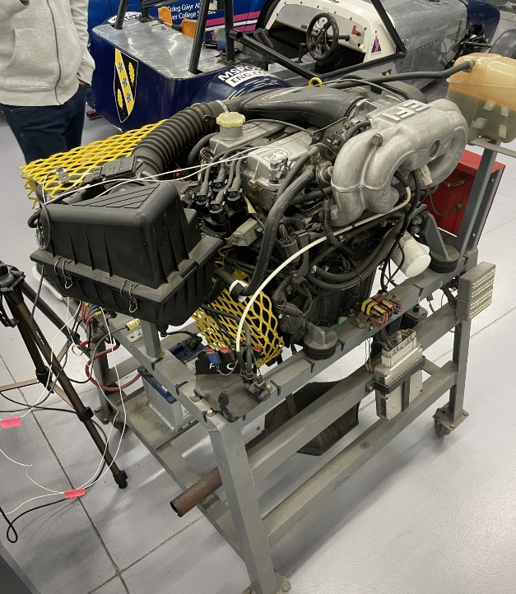

The above image shows the engine test rig used.
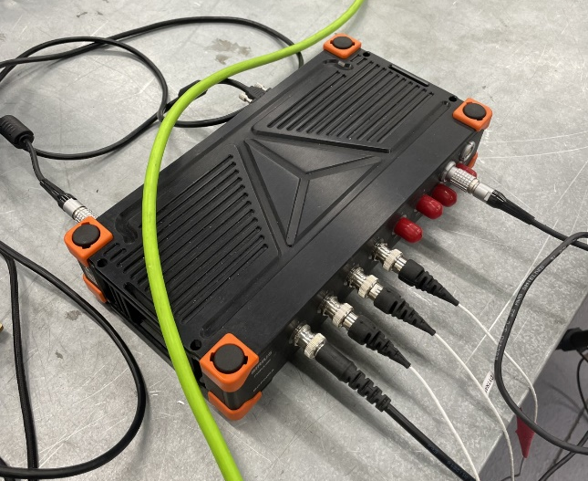

The above image shows the Dewesoft connections box which gathers inputs from the sensors.

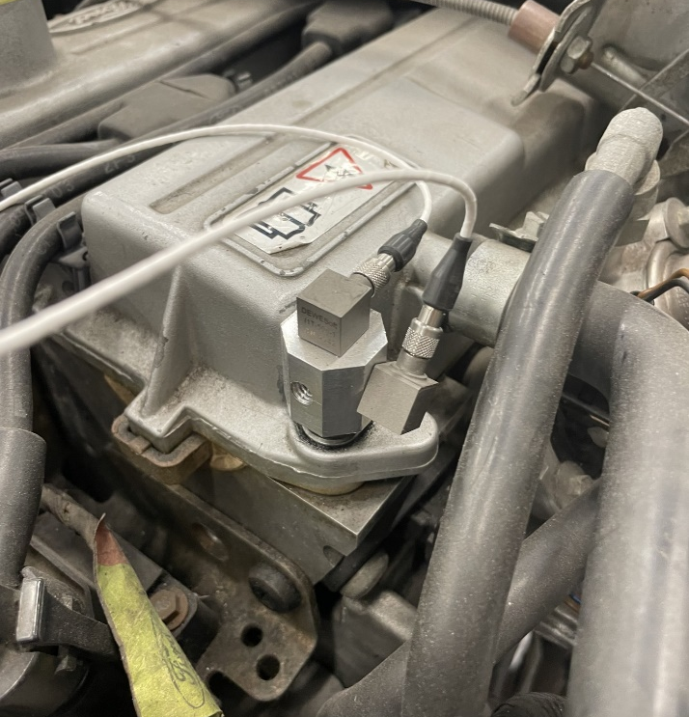

The above image shows the accelerometers measuring horizontal/vertical mechanical vibration directly from the engine.

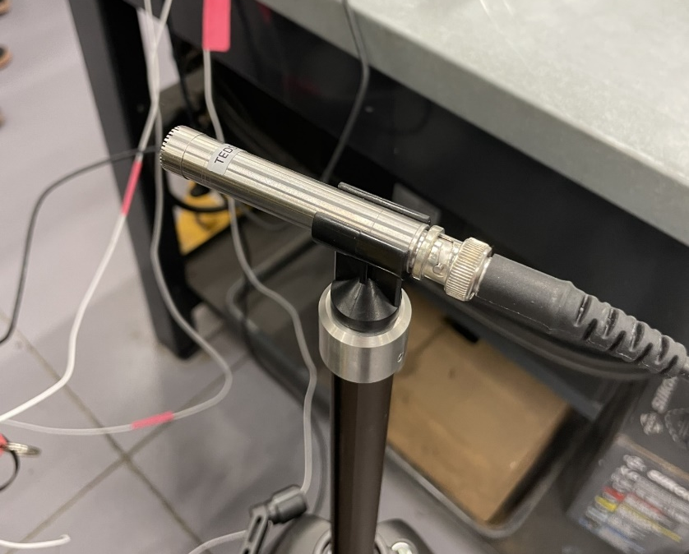

The above image shows the condenser microphone used to measure acoustic air pressure. It is mounted onto a stand positioned next to the engine rig.

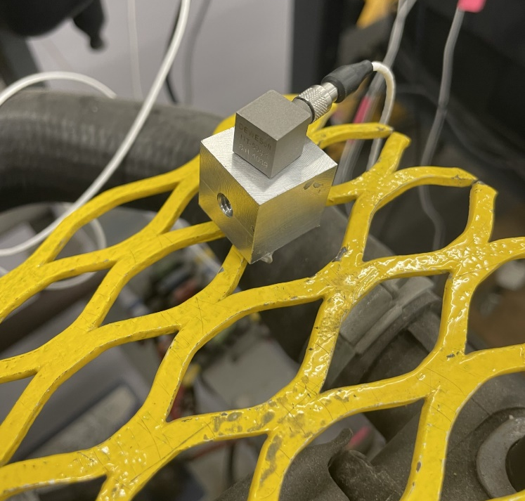

The above image shows a third accelerometer positioned on the radiators protective cage.

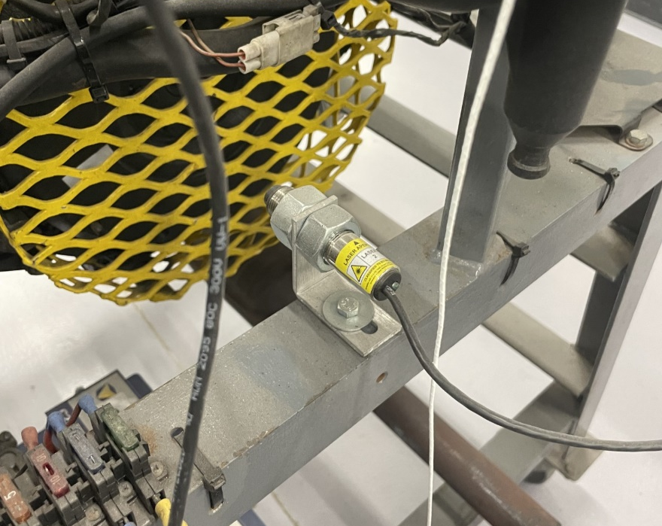

The above image shows a tachometer which measures the speed of the crankshaft in rotations per minute (RPM).

2.2 - Engine Rig Data
This section presents the airborne noise analysis obtained from the condenser microphone during the full-load engine sweep from 0 to 7000 RPM. The test was conducted in an active workshop and may have picked up reflected noise from surrounding surfaces. Therefore, unwanted noise may have been recorded, introducing small changes to the results. For this reason, the following data should be interpreted with these limitations in mind.
The first graph is an order plot. An order is a multiple of the rotational frequency. Rotational frequency is the crankshaft speed expressed in Hertz. It represents the number of revolutions per second and forms the basis for all engine order harmonics (M. M. Schirru, 2017). Because the order axis automatically scales with rpm, engine-related harmonics appear as straight, horizontal ridges. This makes order-locked analysis ideal for identifying individual engine orders that would otherwise overlap in a conventional frequency plot.

Graph 1.1 – Four Cylinder Order
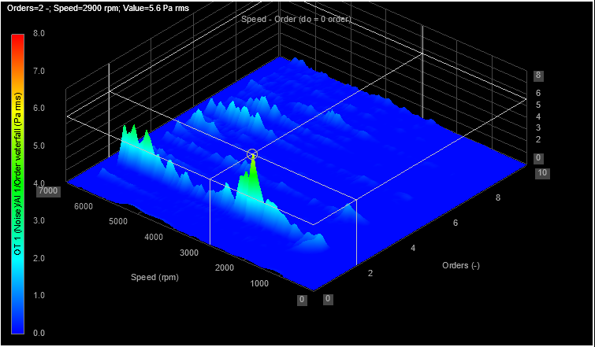

On graph 1.1, several distinct order lines can be seen. The 2nd order ridge is the strongest, which is expected for a four-stroke four-cylinder engine since firing occurs twice per crankshaft revolution. This clearly shows that combustion and firing pulses are the dominant airborne noise source.
The 1st order is present across the speed range but appears with much lower amplitude. At low RPM it is below the microphone detection range or masked by background noise, only becoming apparent at higher RPM. The first order is most likely created by crankshaft rotation and imbalance forces. That’s why it can’t be detected initially as it needs to reach a certain RPM to create enough noise from rotation to be detected.
Between the 3rd and 6th orders, the order plot shows increased harmonic activity at higher engine speeds. These higher orders are typically caused by valve-train excitations, intake/exhaust pulsations, and accessory drive components. Because they remain horizontal in the order plot, they can be separated and identified even when they overlap in actual frequency.
A harmonic resonance occurs when an engine order crosses a structural or acoustic natural frequency of the test rig or engine assembly (Eaton, 2025). On the 2nd order, the peak noise amplitude is 5.6 Pa rms at 2900 RPM. The rotational frequency at this speed is 48.3 Hz (2900/60), meaning the second order occurs at 96.6 Hz. This corresponds to the firing frequency of the engine. The sharp increase in amplitude at this rpm indicates that the 2nd order excitation is driving a natural resonance of the system.

Graph 1.2 – Four Cylinder FFT
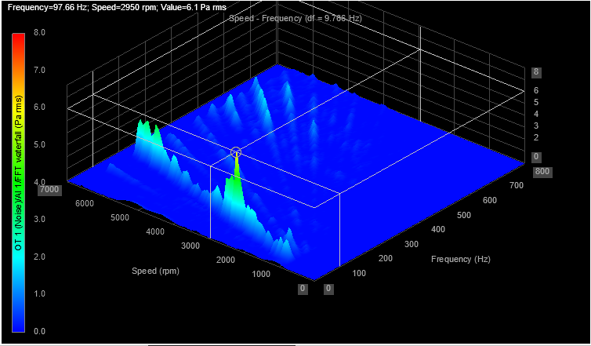
Graph 1.2 is the FFT plot, which shows noise amplitude as a function of frequency and engine speed (KEYSIGHT, 2025). Unlike the order plot, FFT frequencies do not track with rpm, so engine harmonics appear as diagonal ridges. The FFT graph shows a strong response at 97.66 Hz, matching the calculated 2nd order frequency from the order plot. This confirms that the peak observed in the order plot is due to the 2nd order excitation intersecting a structural/acoustic resonance at approximately 97 Hz.
Together, the order plot and FFT plot show that the dominant source of airborne noise is the 2nd engine order, and that a significant harmonic resonance occurs at 2900 RPM when this order excites a natural frequency near 97 Hz.

2.3 - Identifying Issues in the Engine
Data gathering like this can help technicians/engineers identify problems without having to disassemble the engine first. To demonstrate this, there are two further plots, where the engine is intentionally operated on three cylinders. Running on three cylinders can cause extensive damage to the engine over time including having unburnt fuel go through the exhaust damaging the catalytic converter (Tec, 2024). It is therefore an important failure to detect early on.
By comparing these results against the earlier four-cylinder plots, differences can be observed enabling diagnostic conclusions.

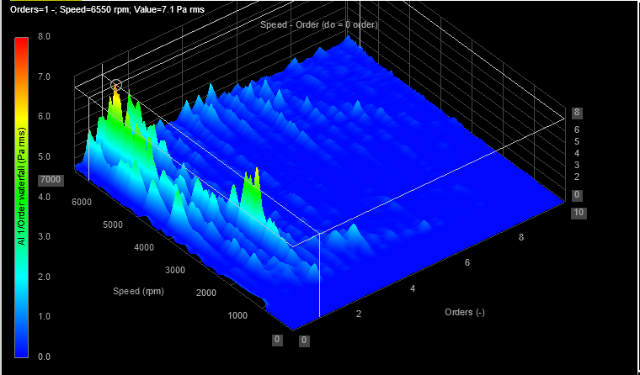
Graph 1.3 – Three Cylinder Order

Graph 1.4 – Three Cylinder FFT
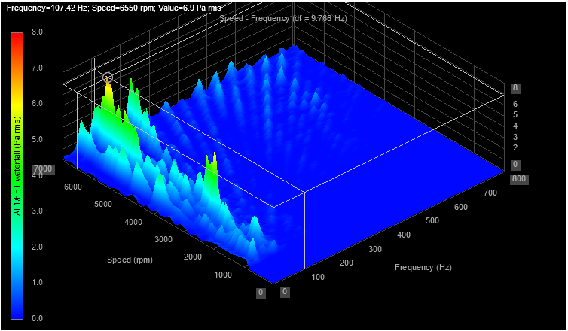
Primary firing occurs on the 2nd order, because there are two firing events per crankshaft revolution (720° cycle). With one cylinder inactive, the firing becomes irregular, and this loss of periodicity appears clearly in the order plot.
In the three-cylinder test, the 1st order (crankshaft rotational order) shows a noticeably higher amplitude to the previous graphs where all four cylinders are operating. This is due to increased rotational imbalance, with one cylinder not firing, the engine experiences larger cyclic variations in torque. These torque pulsations excite the crankshaft at the rotational speed (1st order), creating a stronger ridge in the plot (Huang, Y., Yang, S., Zhang, F. et al., 2012).
On the four-cylinder test, the 2nd order peaked at around 2900 RPM, corresponding to a resonance at approximately 97 Hz. In the three-cylinder test, although there’s still a spike at this speed, the largest peak shifts to around 6550 RPM, with a corresponding harmonic resonance near 107 Hz. This shift occurs because the firing pattern is no longer periodic. As a result, additional harmonic content and torsional disturbances are generated, shifting energy into higher orders and higher frequencies. The irregular combustion also increases broadband excitation at high RPM, making higher structural or acoustic modes easier to excite (K. Fridrichová et al, 2024).
Mechanical components such as the exhaust manifold, intake system, engine block, or mounting structures all possess natural frequencies (S.M. Aathif Akmal, 2022). When the three-cylinder operation produces stronger high-frequency excitation, the new vibration energy created by the irregular firing matches the natural frequency of a different part of the engine structure that is not significantly excited during normal smooth four-cylinder operation. This explains the new resonance at 107 Hz, which aligns with a higher-speed structural or acoustic mode of the system.
This shift from a 97 Hz resonance at 2900 RPM to a 107 Hz resonance at 6550 RPM demonstrates how order-locked and FFT analysis can reveal not only misfires or missing cylinders, but also the way an abnormal combustion pattern modifies the structural excitation of the engine.

2.4 - Vibration Data
Vibration data was recorded for both tests using an accelerometer. There are three different vibration data, two directly attached to the engine recording vertical/ horizontal data (engine born vibration) and one attached to the protective housing of the radiator (structure born vibration). Unlike the noise graphs, the vibration graphs are shown in 2D as they are easier to read in this format.

2.4.1 - Engine Vibration Vertical, Four-Cylinder Test

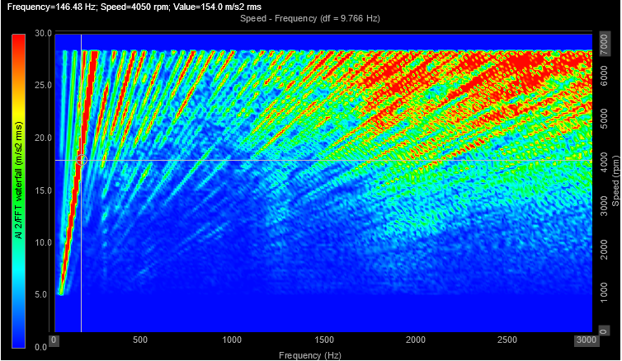
Graph 2.1 – Four Cylinder Vertical FFT

Graph 2.1 shows vertical vibration recorded on the engine head. FFT graphs would be more useful if the data is all out one RPM, however for a range of RPMs an order graph is used to draw conclusions from.

Graph 2.2 – Four Cylinder Vertical Order
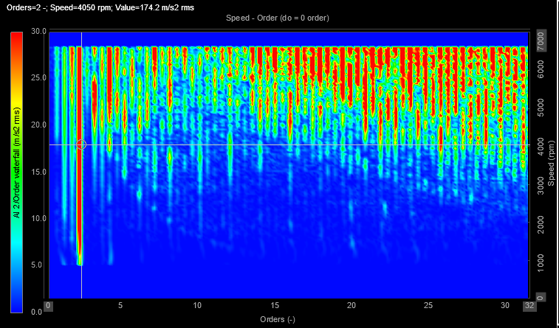
In a four stroke four-cylinder engine, piston and connecting rod inertia forces act mainly vertically. Therefore, at low RPM, the vertical excitation is relatively small, but at high RPM it grows dramatically, affecting orders equally across a wide range.
Engine mounts are typically designed with lower stiffness in the vertical plane to isolate cabin noise and provide smoother ride characteristics. Lower stiffness allows the block to move more freely vertically, as a result, once RPM increases, vertical motions are amplified by the mount system, filling the entire order range (Wen Bin Shangguan, 2009).
Between 8th and 13th order, there is a reduction in vibration compared to the other orders. This may be caused by the engine mounts, vertical engine mounts are usually soft at low frequency and stiff at high frequency, but they have a transition region where transmissibility dips (Yunhe Yu et al, 2001). This is called a mount damping zone and results in the reduction in vibration that can been seen on the graph.

2.4.2 - Engine Vibration Horizontal, Four-Cylinder Test

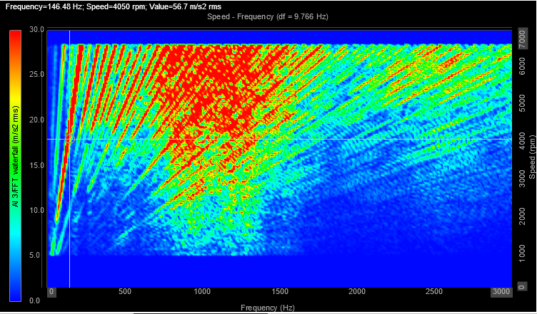
Graph 2.3 – Four Cylinder Horizontal FFT

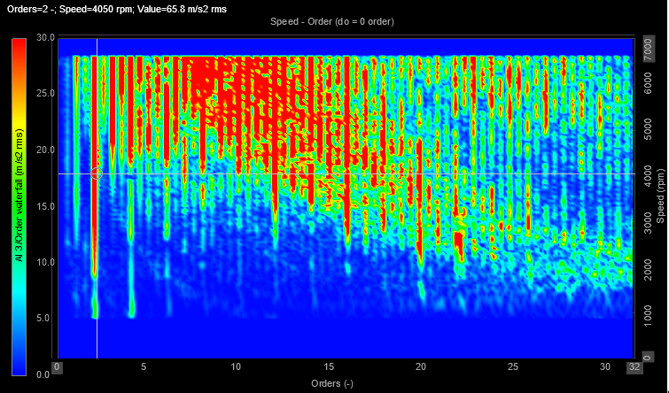
Graph 2.4 – Four Cylinder Horizontal Order

Horizontal vibration is mainly influenced by crankshaft torsional excitation and lateral structural stiffness (Shiwei Ni et al, 2020). These mechanisms generate stronger low to mid order harmonics, which is reflected in the concentration of amplitude between the 5th and 15th orders. The absence of strong higher-order content indicates that lateral components of the powertrain do not efficiently transmit higher-frequency harmonics, this is expected behaviour for a functional mount system.
In the horizontal direction, engine mounts are intentionally stiffer to control side-to-side displacement and maintain drivetrain alignment under load (Yunhe Yu et al, 2001). This higher lateral stiffness reduces the transmissibility of higher-frequency harmonics. However, at mid-range engine speeds (3000-7000 RPM), the excitation frequency approaches the natural frequency of the lateral mount-engine system, producing a local resonance and amplified transmissibility. This results in the mid-band horizontal amplification seen on the order plot.

2.4.3 - Engine Vibration Vertical, Three-Cylinder Test
Although airborne noise increased massively when running on three cylinders, accelerometer measurements on the block showed minimal change. This indicates the dominant change in NVH is acoustic and locally radiated (exhaust, manifold, intake or thin panels), rather than through the specific points of the head that the accelerometers are attached to. Engine mounts and structural damping reduce the transmission of these local excitations into the engine head accelerometers, so structural vibration levels remain similar (Wen Bin Shangguan, 2009).

Graph 3.1 – Three Cylinder Vertical FFT
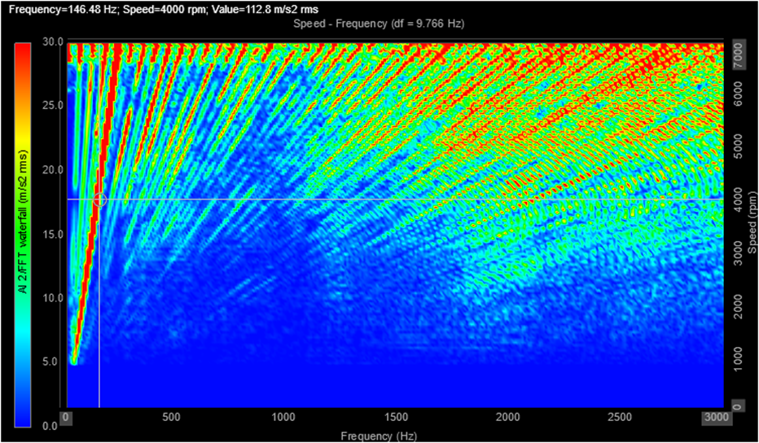

Graph 3.2 – Three Cylinder Vertical Order
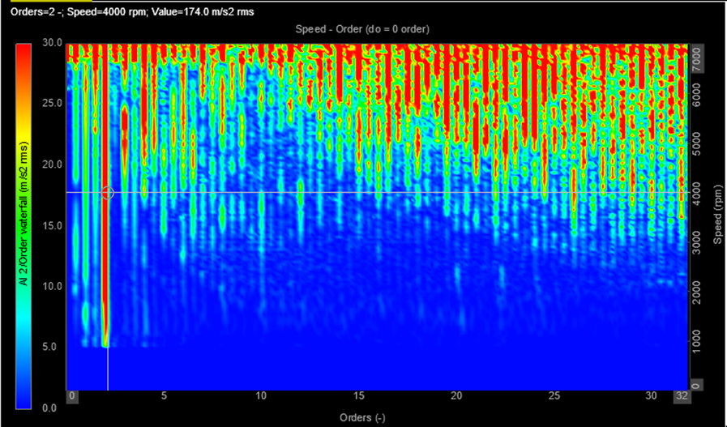

2.4.4 - Engine Vibration Horizontal, Three-Cylinder Test

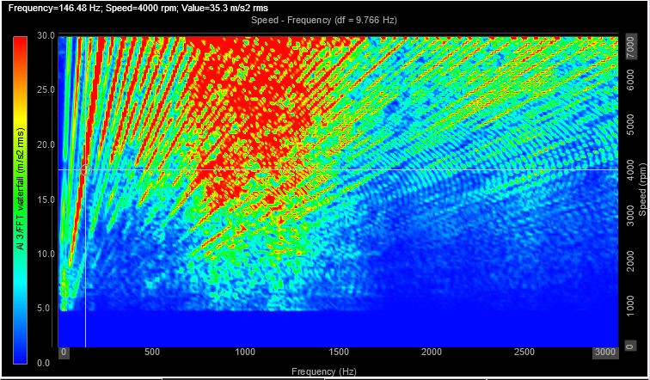
Graph 3.3 – Three Cylinder Horizontal FFT

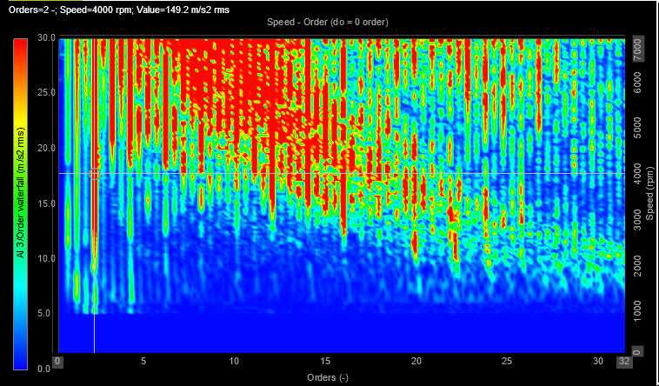
Graph 3.4 – Three Cylinder Horizontal Order

2.4.5 - Engine Vibration Radiator Housing, Four-Cylinder Test
The following graphs show the data taken from the accelerometer attached to the radiator protective housing. The purpose of this is to simulate vibrations that might be felt in other parts of the vehicle that are not attached to the engine itself, an important consideration in NVH analysis.
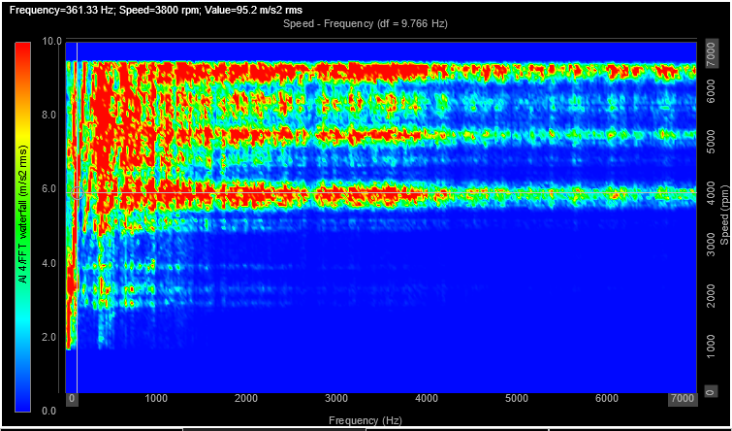
Graph 4.1 – Four Cylinder Radiator Housing FFT

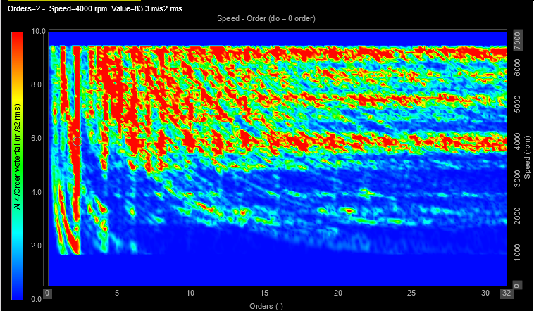
Graph 4.2 – Four Cylinder Radiator Housing Order

The radiator protective housing is a thin, lightweight grill connected through mounts and brackets. These structures behave as mechanical low-pass and band-pass filters (Robert Keim, 2019), meaning low-frequency excitation (1st – 3rd orders) is transmitted more easily. The radiator protective housing has multiple structural natural frequencies. When engine orders sweep through these frequencies, they excite these modes, producing the long, red horizontal bands seen between 4.5 and 9.5 m/s² rms. They are the radiator housing’s own resonances, excited by engine harmonics passing through them.
The increase in vibration across all orders at 4000, 6000, and 7000 RPM is caused by the interaction between engine excitation and the natural frequencies of the radiator housing. As engine speed rises, multiple orders coincide with structural resonances, leading to broadband amplification. Engine mount transmissibility increases at higher frequencies, allowing more vibration to reach the protective grill.

2.4.6 - Engine Vibration Radiator Housing, Three-Cylinder Test
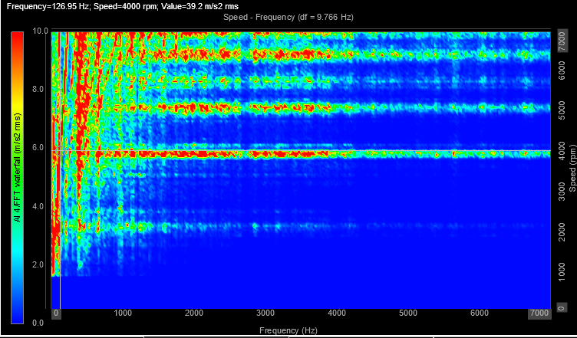
Graph 4.3 – Three Cylinder Radiator Housing FFT

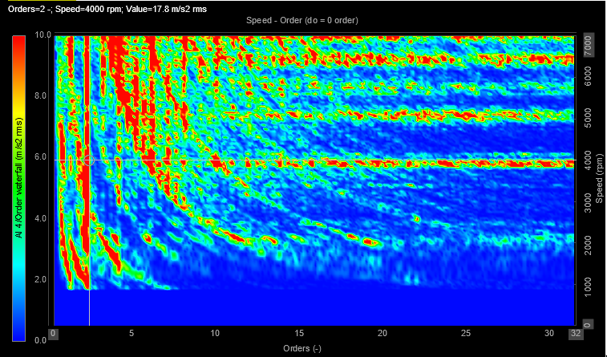
Graph 4.4 – Three Cylinder Radiator Housing Order

Although airborne noise increased in the three-cylinder run, from graph 4.4 you can see radiator protective housing accelerations decreased. This is likely because the altered combustion pattern changed the excitation path and frequency content in such a way that the radiator/protective grill and its mounts were less effectively excited.

Conclusion
The noise and vibration results show how engine order content, firing stability, and structural transmissibility govern NVH behaviour in vehicles. Order and FFT analysis in Dewesoft clearly distinguish the smooth, periodic excitation of four-cylinder operation from the irregular, broadband disturbances produced when running on three cylinders, causing the large rise in airborne noise despite minimal change in block-mounted vibration. Measurements from the radiator housing further demonstrate how lightweight vehicle structures and their mounts act as mechanical filters, amplifying certain resonant orders while reducing others.
Although Dewesoft’s accuracy depends on sensor placement and reliable speed signals, it remains a highly effective tool for identifying critical orders, diagnosing abnormal excitation patterns, and understanding how mechanical and structural paths shape overall NVH performance.

References
Ross Performance Parts (2024) Harmonic resonance and torsional vibration. Available at: https://rossperformanceparts.com/harmonic-resonance-and-torsional-vibration/#:~:text=Harmonic%20resonance%20occurs%20when%20a,as%20adversely%20affect%20ignition%20timing. (Accessed: 21 October 2025).
Griffin (1990) Handbook of Human Vibration. Available at: https://books.google.co.uk/books?hl=en&lr=&id=-_JV63L6RMcC&oi=fnd&pg=PP1&ots=vPhIUWWssW&sig=32IznL436VTMbxBkl2zpAUbQRjA#v=onepage&q&f=false
NI (2025) Measuring vibration with accelerometers. Available at: https://www.ni.com/en/shop/data-acquisition/sensor-fundamentals/measuring-vibration-with-accelerometers.html?srsltid=AfmBOoqyuOsHMAuDSJ_vdPdTnU14sWRg9FVd5mdDmHNrFZA1saY-AL6m (Accessed: 21 October 2025).
Imran Agassy (2017) How Car Stuff Works: Superchargers. Available at: https://aminoapps.com/c/garage/page/blog/how-car-stuff-works-superchargers/WJJt_XukblrgrvaGN03YmXEYpVrvje3
PowerHouse,1 (2025) Jaguar XJR XKR S-Type R XF 4.2 V8 Upper Pulleys. Available at: Jaguar XJR XKR S-Type R XF 4.2 V8 Upper Pulleys - Supercharger Rebuild
PowerHouse, 2 (2025) Eaton M112 Supercharger Rebuild Kits. Available at: Eaton M112 Supercharger Rebuild Kits • Powerhouse Automotive
Eaton (2022) What is harmonic resonance and how does it work? Available at: https://www.youtube.com/watch?v=4leGNzquIZA
Holmberg, K., Andersson, P. (1994). Dynamic Effects in Helical Twin-Rotor Machines. Available at: Journal of Sound and Vibration, 173(1): 1–21.
Testbook (2024) Mechanical Vibrations: Learn Definition, Types, Advantages, Disadvantages, and Applications. Available at: https://testbook.com/mechanical-engineering/mechanical-vibrations#:~:text=Mechanical%20vibrations%20refer%20to%20the,tear%2C%20and%20even%20structural%20failure.
CSG (2025) Acoustic Sound Pressure level. Available at: https://www.csgacoustics.co.uk/acoustic-sound-pressure-air-pressure-intensity-loudness-volume/#:~:text=Sound%20pressure%20and%20sound%20pressure,performance's%20overall%20volume%20and%20impact.
HBK (2025) Piezoelectric Accelerometers for Vibration Measurements. Available at: https://www.hbkworld.com/en/knowledge/resource-center/articles/piezoelectric-accelerometers#:~:text=A%20piezoelectric%20accelerometer%20is%20self,%2C%20Force%20=%20Mass%20x%20Acceleration.
Bruel & Kjær Sound Level Measurement Handbook. (2015). Microphone Handbook: Theory, Calibration and Application. Available at: https://www.hbkworld.com/en/knowledge#!ref_bksv.com
M. M. Schirru (2017) Rotational frequency. Available at: https://taylorandfrancis.com/knowledge/Engineering_and_technology/Systems_%26_control_engineering/Rotational_frequency/
Eaton (2025) What is harmonic resonance and how does it work? Available at: https://www.eaton.com/us/en-us/products/controls-drives-automation-sensors/harmonics/harmonics-faq-video-library/what-is-harmonic-resonance-and-how-does-it-work-.html#:~:text=And%20if%20I%20have%2C%20let's,this%20is%20the%20seventh%20harmonic.
KEYSIGHT (2025) What is FFT? : A Short Intro to the Fast Fourier Transform. Available at: https://www.keysight.com/used/us/en/knowledge/glossary/oscilloscopes/what-is-a-fft-fast-fourier-transform#:~:text=N%20log%20N).-,3.,most%20energy%20to%20the%20signal.
Tec (2024) Signs and causes of an engine running on fewer cylinders. Available at: https://tec2000.com/blogs/news/signs-and-causes-of-an-engine-running-on-fewer-cylinders?srsltid=AfmBOorHGA_FGgu7CeEBMldXBT2NbENjanww1gq2ghflAMyBQ1LLh0jE
Huang, Y., Yang, S., Zhang, F. et al. (2012) Non-linear torsional vibration characteristics of an internal combustion engine crankshaft assembly. Available at: https://link.springer.com/article/10.3901/CJME.2012.04.797#citeas
K. Fridrichová et al (2024) Comparative study of engine dynamics for rolling and selective cylinder deactivation. Available at: https://www.sciencedirect.com/science/article/pii/S0360544224017195?utm_
S.M. Aathif Akmal (2022) Analysis of engine mount material for automotive vibration and noise reduction. Available at: https://www.sciencedirect.com/science/article/pii/S2214785322018119?utm_
Wen Bin Shangguan (2009) Engine mounts and powertrain mounting systems: A review. Available at: https://www.researchgate.net/publication/245402153_Engine_mounts_and_powertrain_mounting_systems_A_review
Shiwei Ni et al (2020) Analysis of torsional vibration effect on the diesel engine block vibration. Available at: https://www.mechanics-industry.org/articles/meca/full_html/2020/05/mi190333/mi190333.html?utm_
Yunhe Yu et al (2001) A literature review of automotive vehicle engine mounting systems. Available at: https://www.sciencedirect.com/science/article/pii/S0094114X00000239?utm_
Robert Keim (2019) What Is a Low Pass Filter? A Tutorial on the Basics of Passive RC Filters. Available at: https://www.allaboutcircuits.com/technical-articles/low-pass-filter-tutorial-basics-passive-RC-filter/
Hocine Chibane (2025) Gear Mesh Frequency (GMF). Available at: https://www.linkedin.com/posts/hocine-chibane-86a0731a8_gear-mesh-frequency-gmf-is-a-critical-parameter-activity-7281790168775196673-b_fW#:~:text=The%20GMF%20is%20useful%20for%20identifying%20gear%2Drelated%20issues%20like,or%20additional%20peaks%20highlight%20issues.&text=How%20can%20we%20effectively%20monitor,interpretive%20biases%20of%20vibration%20monitoring?&text=I%20like%20the%20way%20a,we%20continue%20to%20always%20learn.

Appendix
Calculations
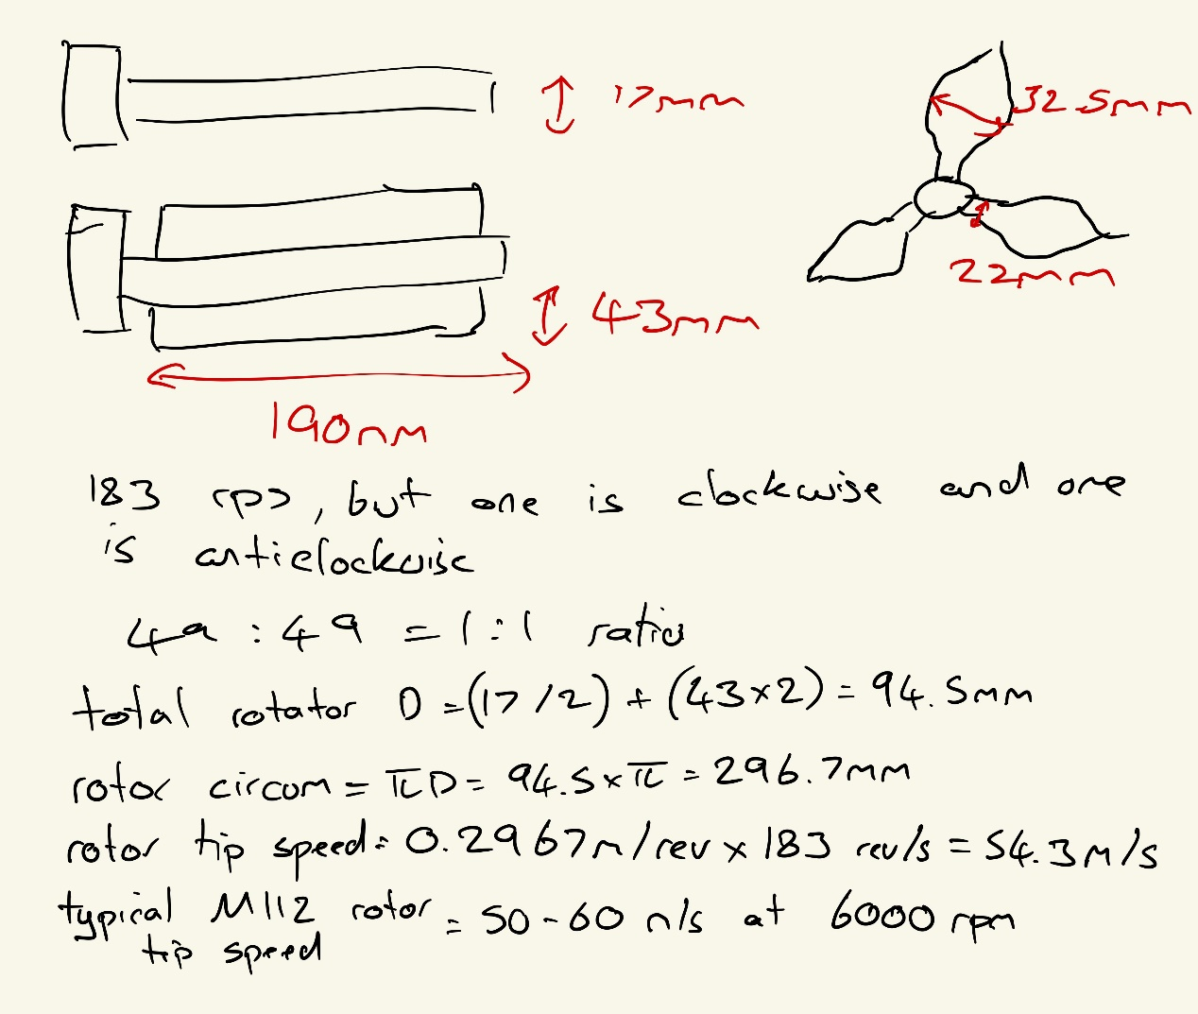
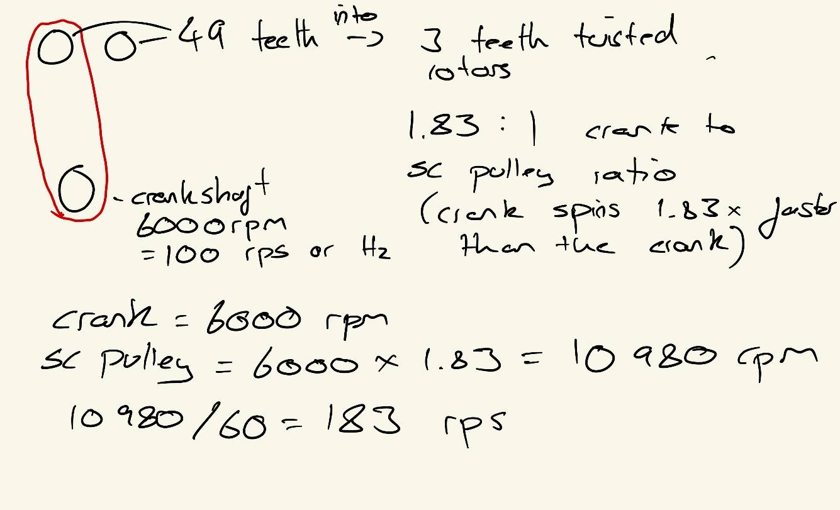
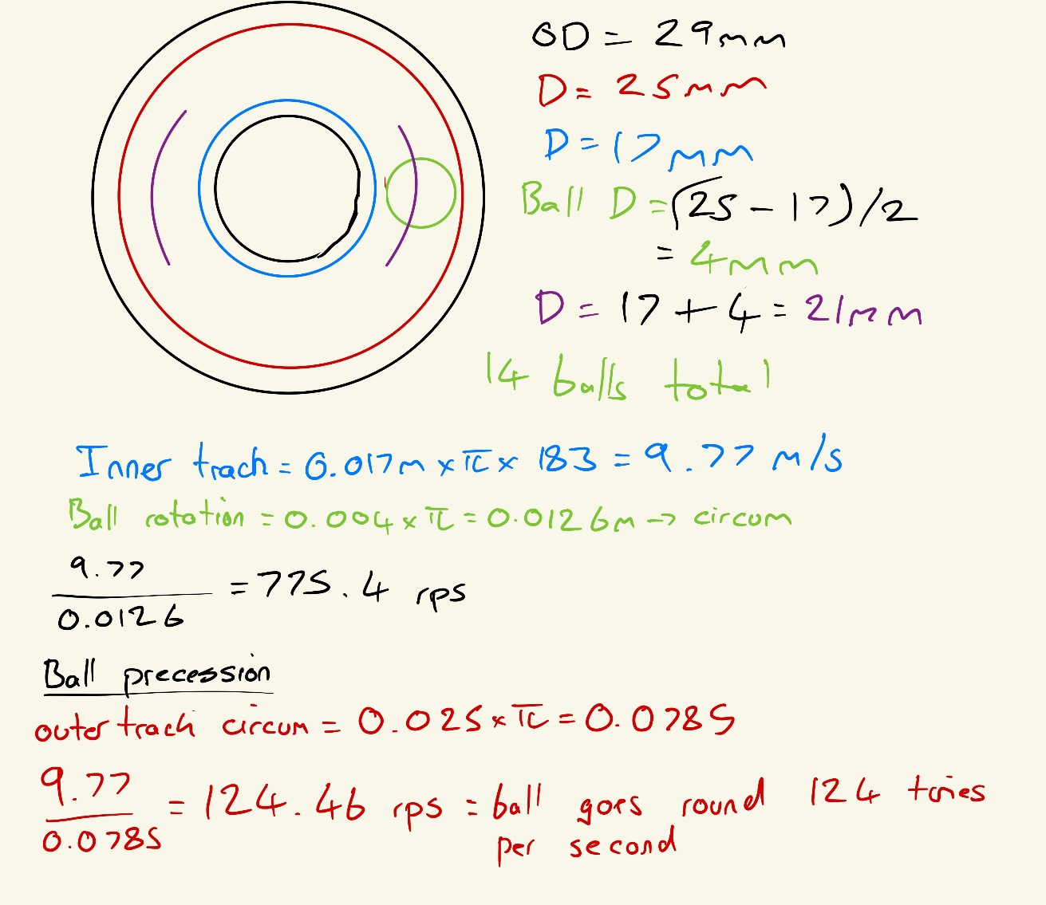

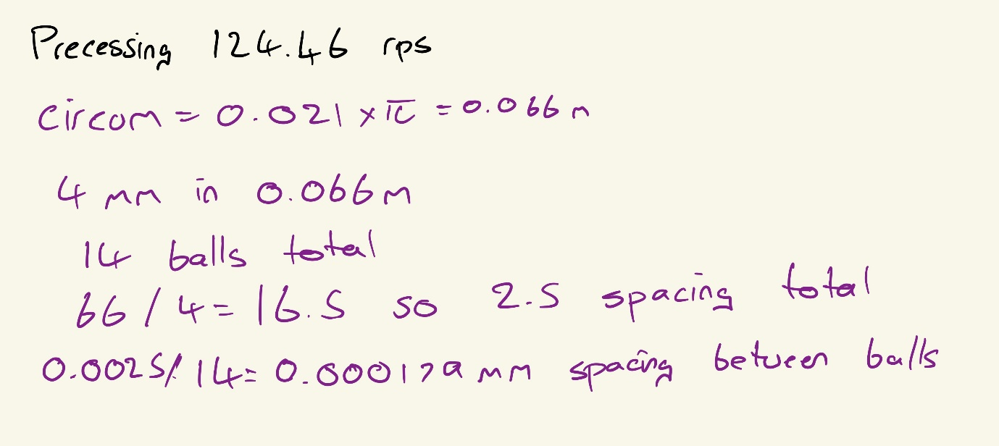

Table 1

Table 2
Component | Primary Excitation Orders | Possible Natural Modes | Potential Resonance Effects
Rotors (190 mm, 3-lobe) | 1x, 3x, 6x, sidebands (2x-4x) | Torsional, bending, axial modes (typically 400-700 Hz) | Lobe-passing resonance = casing noise, vibration amplification, torsional stress
Phasing Gear (49 teeth) | 49x = 8,967 Hz = 1x sidebands | Gear mesh stiffness, tooth-bending, housing resonance | Gear whine or chatter if housing or shaft modes near 9 kHz
Bearings | BSF = 775 Hz, FTF = 124 Hz, BPFI/BPFO = 1-2 kHz | Outer/inner race flexural modes (500-2,000 Hz) | Resonance amplifies bearing defect tones = high RMS vibration, noise rise. Rattling at idle
Supercharger casing | Coupled to rotor and gear excitations | Panel/acoustic modes (200-1,000 Hz) | Structure-borne noise, fatigue cracks at mounting lugs
Mounting brackets / supports | 1x-6x transmitted | Low-frequency structural resonance (50-200 Hz) | Large-amplitude vibration, loosened fasteners
Drive belt / pulley system | 1x, 2x torsional coupling | Tension and bending modes (10-100 Hz) | Belt oscillation or “whip” when matching drive harmonics

Table 2 Abbreviations
FTF - frequency of the cage (bearing retainer)
BSF - Ball Spin Frequency
BPFO - Ball Pass Frequency Outer race

