

Psychopathological Classifications and Provisions (BMHP6029_BIRM)

Student Name: Iqra Mohammad

Student Number: 2325946

Lecture name: Neale Haddon

Component 1 – Poster

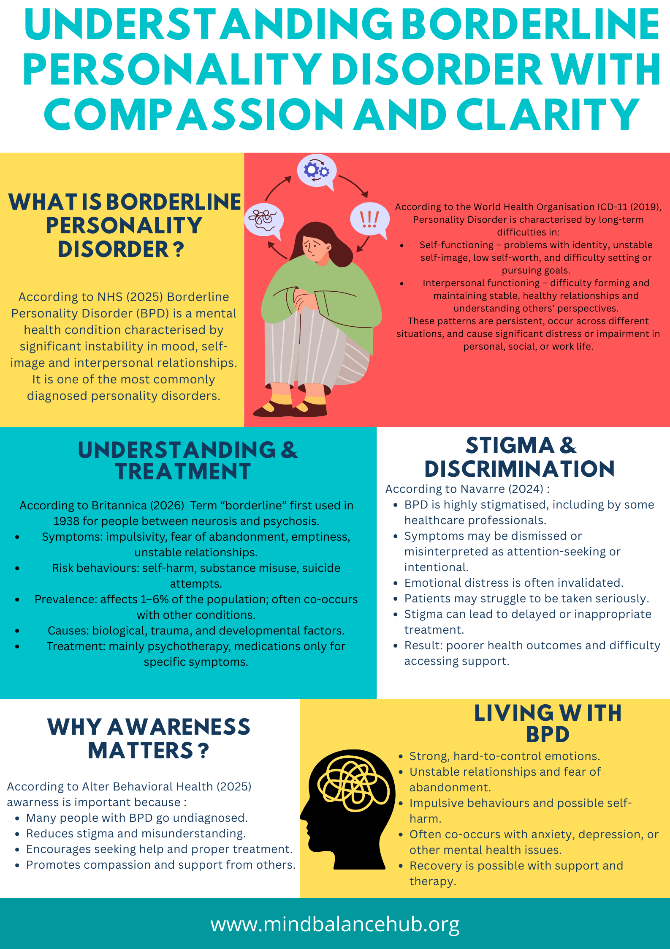
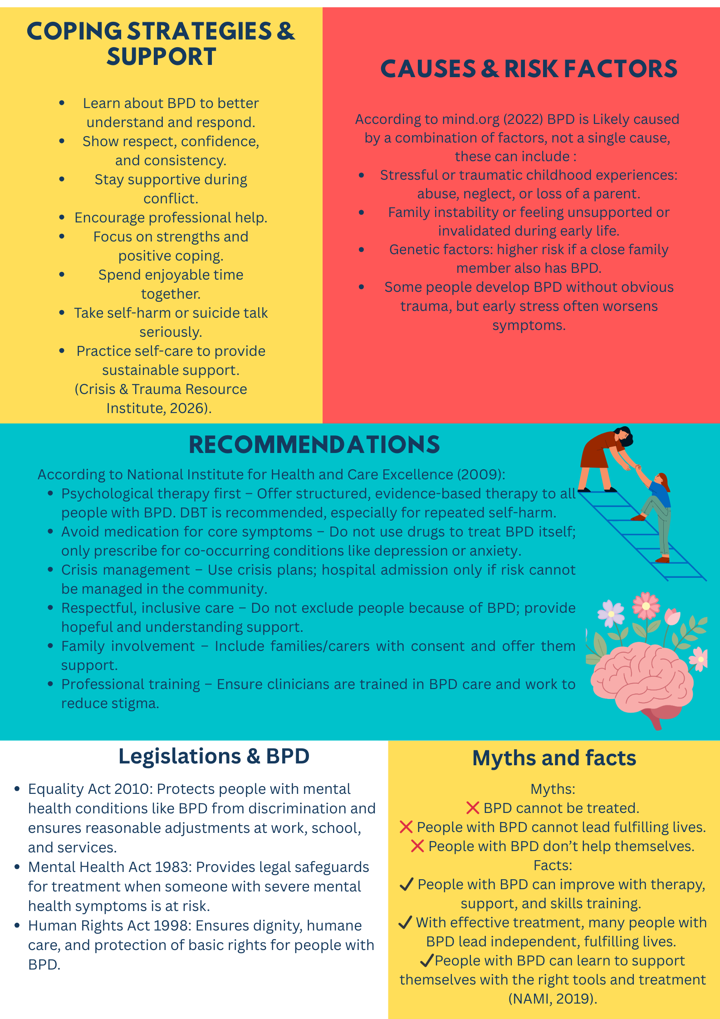

Reference list

Alter Behavioral Health (2026) BPD awareness. Available at: https://alterbehavioralhealth.com/blog/bpd-awareness/ (Accessed: 21 February 2026).
Crisis & Trauma Resource Institute (2026) 9 strategies for supporting someone with BPD. Available at: https://ctrinstitute.com/blog/9-strategies-supporting-bpd-2/ (Accessed: 21 February 2026).
Encyclopaedia Britannica (2026) Borderline personality disorder. Available at: https://www.britannica.com/science/borderline-personality-disorder (Accessed: 21 February 2026).
Mind (2026) Borderline personality disorder (BPD) – Causes. Available at: https://www.mind.org.uk/information-support/types-of-mental-health-problems/borderline-personality-disorder-bpd/causes/ (Accessed: 21 February 2026).
National Alliance on Mental Illness (NAMI) (2019) Borderline personality disorder myths and facts. Available at: https://www.nami.org/Blogs/NAMI-Blog/October-2019/Borderline-Personality-Disorder-Myths-and-Facts (Accessed: 21 February 2026).
National Center for Biotechnology Information (NCBI) (n.d.) Article on BPD stigma. Available at: https://pmc.ncbi.nlm.nih.gov/articles/PMC11586320/ (Accessed: 21 February 2026).
National Health Service (NHS) (2025) Borderline personality disorder – Overview. Available at: https://www.nhs.uk/mental-health/conditions/borderline-personality-disorder/overview/ (Accessed: 21 February 2026).
National Institute for Health and Care Excellence (NICE) (n.d.) Borderline personality disorder: recognition and management (CG78). Available at: https://www.nice.org.uk/guidance/cg78 (Accessed: 21 February 2026).
Rethink Mental Illness (n.d.) Borderline personality disorder (BPD). Available at: https://www.rethink.org/advice-and-information/about-mental-illness/mental-health-conditions/borderline-personality-disorder-bpd/ (Accessed: 21 February 2026).
UK Government (1983) Mental Health Act 1983 (as amended 2007). Available at: https://www.legislation.gov.uk/ukpga/1983/20/contents (Accessed: 21 February 2026).
UK Government (1998) Human Rights Act 1998. Available at: https://www.legislation.gov.uk/ukpga/1998/42/contents (Accessed: 21 February 2026).
UK Government (2010) Equality Act 2010. Available at: https://www.legislation.gov.uk/ukpga/2010/15/contents(Accessed: 21 February 2026).
World Health Organization (WHO) (2019) International Classification of Diseases (ICD-11). Available at: https://icd.who.int/ (Accessed: 21 February 2026).

