Sameeran Raveenthiran
2114454 UWTSD
Network Operating Systems and Services assignment 1

Name of the Team: Techie
Team Members:
Student Name | Student ID
Sameeran raveenthiran | 2114454
maciek kucinski | 2003891
Tony witter (Unresponsive) | 2114134

Team Evaluation:
 | Student 1 | Student 2 |  | Student 3 |  | Student 4 |  | Student 5
Student 1 | 5
Student 2
Student 3
Student 4
Student 5
Student 1: Was capable enough to share their knowledge and was able to tackle through any challenges together when going through the worksheet.

Contents
Introduction: 3
Part 1 Task 1: Building a Virtual LAN using Type 1 Hypervisor Management Software: 3
Task 2: Deploying a network directory service and creating and understanding active directory network objects. 8
Part 2 Task 3: 11
Conclusion: 17
Write a brief reflection on the tasks completed in this worksheet: 17
References: 17

Introduction:
Building a virtual LAN using Type 2 hypervisor management software and deploying a network directory service and creating and understanding Active Directory network objects are critical tasks for network administrators. These tasks involve working as a group of three or more and creating a virtual network environment, managing virtual machines, and deploying network directory services to manage user and computer accounts, security groups, and other network objects. Understanding how to set up a virtual LAN using Type 2 hypervisor management software and deploy network directory services such as Active Directory is essential for managing a network infrastructure securely and efficiently. It also helps develop practical skills for managing networks and ensuring their security and performance.

Part 1 Task 1: Building a Virtual LAN using Type 1 Hypervisor Management Software:
- BUILDING A VIRTUAL LAN USING TYPE 2 HYPERVISOR MANAGEMENT SOFTWARE
Create 4 Virtual Machines:
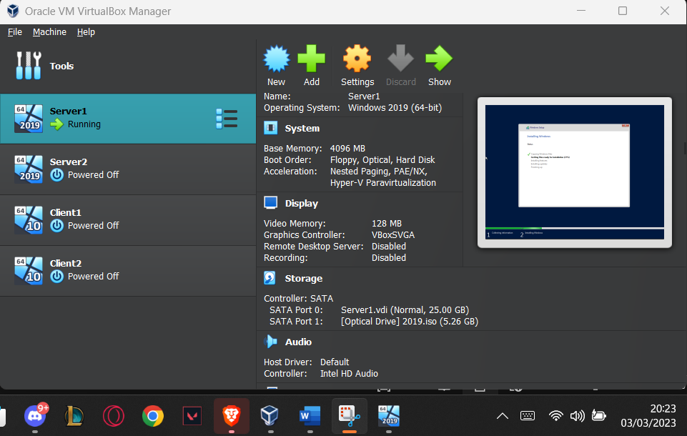

The user has created 4 virtual machines and each virtual machines has a Windows server ISO installed in it. Server 1 & 2 has Windows Server 2019 and Client 1 & 2 has Windows 10 Enterprise installed in it.
The user has enabled PAE/NX. This allows the Host CPU to be more alert and accessible to each virtual machine.

- VIRTUAL NETWORK CONFIGURATION
Server 1 and Client 1:
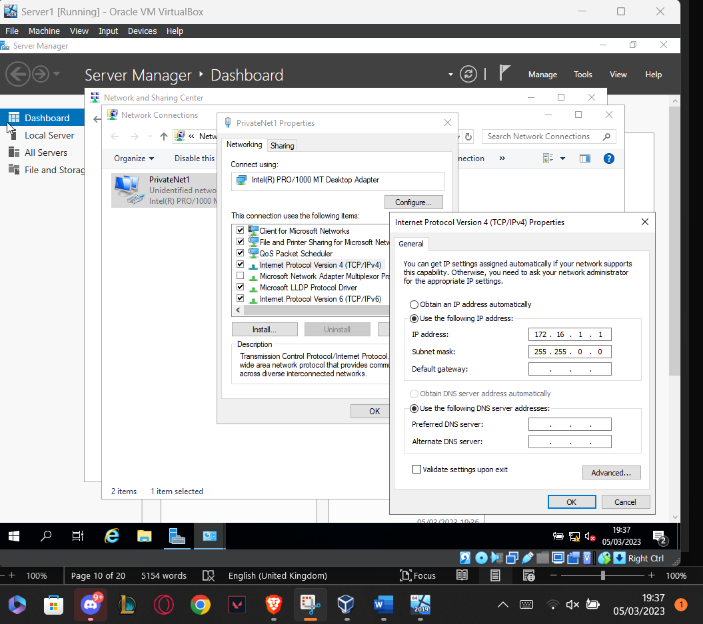

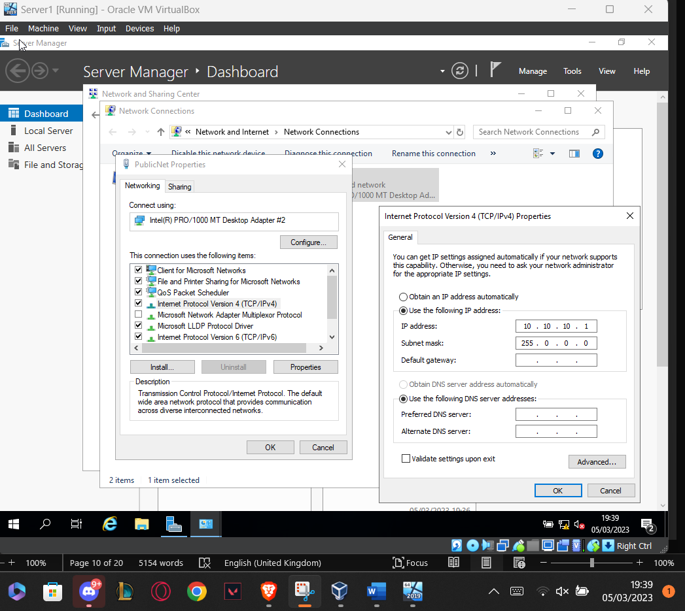

Each ISO got installed in each individual virtual machine. The network gets configured as the user created two adapters for Server 1 and Server 2. Adapter will be typically named “PublicNet” for either of the servers. Adapter 2 will be name “PublicNet1” for server 1, and “PublicNet2” for server 2. When starting up each virtual machine. Each adapter will be assigned with an IP address and subnet mask.
Client 1 and Client 2 each consist of only 1 adapter. Client 1 adapter will be PrivateNet1, which is connected to the same LAN as the 2nd adapter on Server 1. Likewise, Client 2 will be connected to the same LAN as the 2nd adapter on Server 2.

Turn off Firewall:
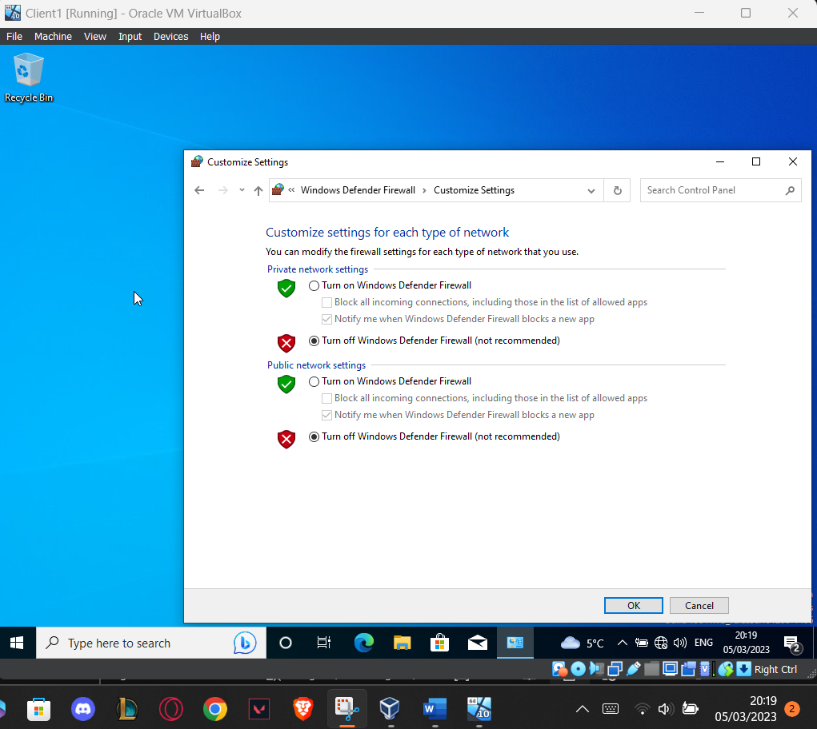

Once the network has been assigned and everything, the user has to make sure that Firewall is turned off when both Server 1 and Client 1 are running, because the ICMP Command is going to show the connectivity and firewall.

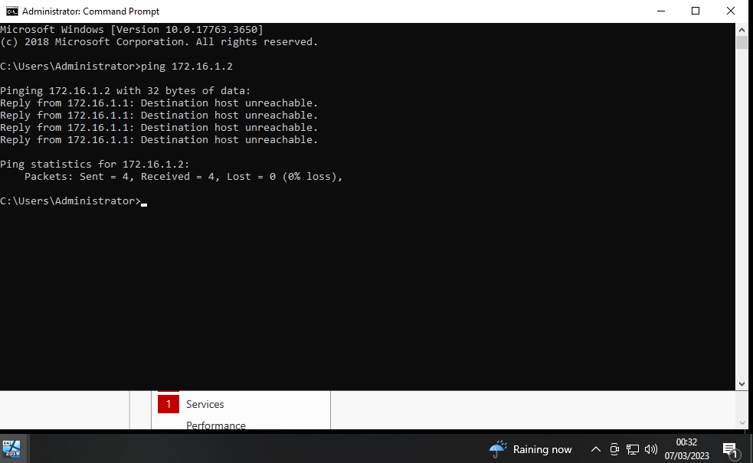
Checking Ping Connectivity:

The user checks if there is any connectivity between Server 1 and Client 1 by checking the ping using Command Prompt. If there is any response/reply, it generally means the configuration between Server 1 and Client 1 is complete.

Task 2: Deploying a network directory service and creating and understanding active directory network objects.
- Pre-requisite
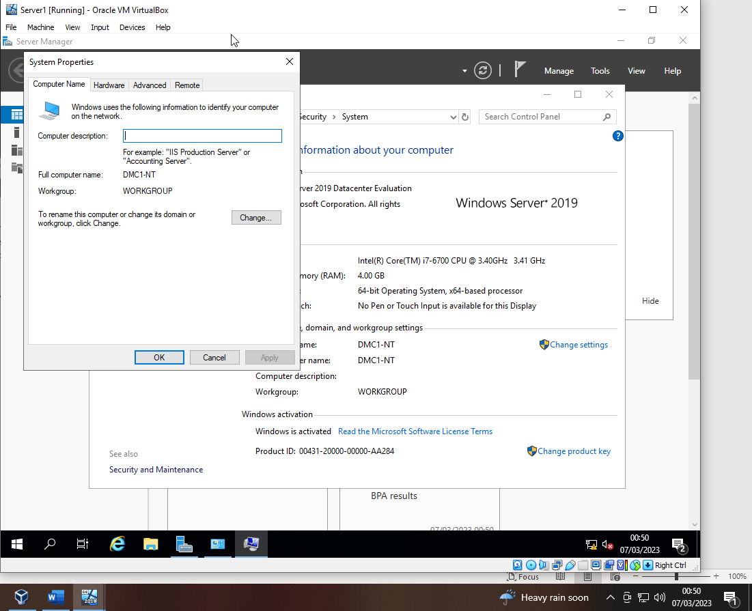

The name of the PC has been changed to “DMC1-NT”
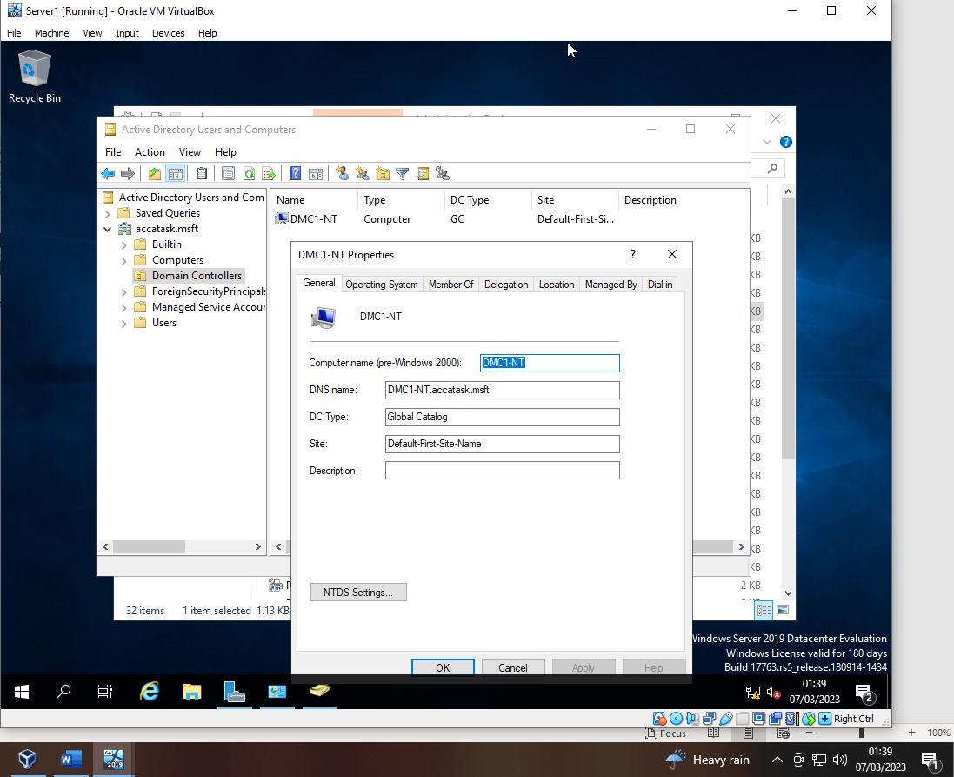

Screenshot of DMC1-NT listed as accatask.msft domain controller.
- Deploying active directory as a role or feature based installation
Active Directory has the responsibility to provide centralised authentication and authorisation services to users and computer in a windows-based network. It allows administrators to manage permissions and access controls for users and groups, in addition manage group policies and software deployment across the network.
- Creating user account objects using Active Directory Users and Computers snap in console
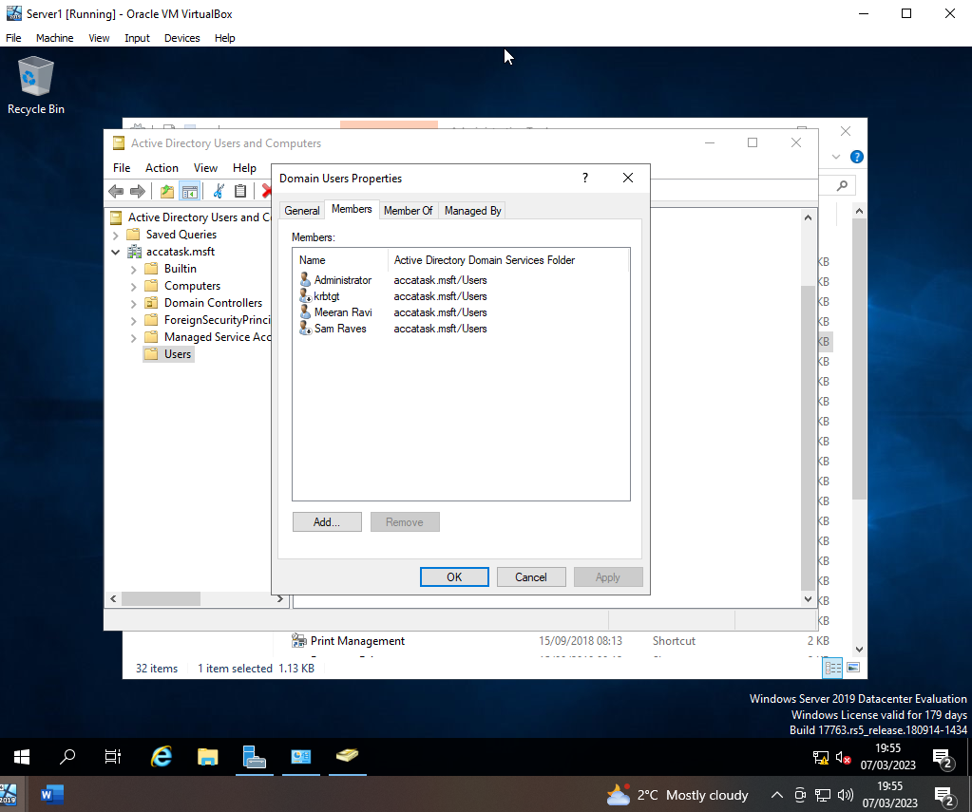
The user created two user accounts named “Sam Raves” and “Meeran Ravi”. The user account has to be first created in order to be added as an additional member of the Domain Admins group. The user had to manually add the first user account to the admins group. By doing so, when the second user account got created, it got automatically added to the admins group.

- Object attributes of interest
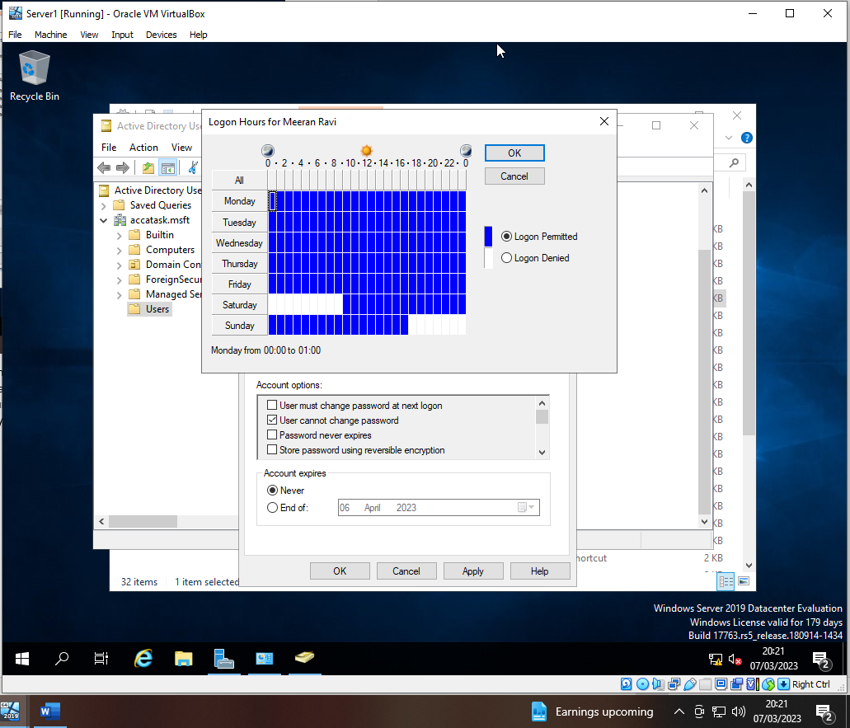
On the user account that has just been created (Meeran Ravi). The user added a logon hours, where you can log into the user account at a specific day and time.

- Adjoining the domain and testing user logins
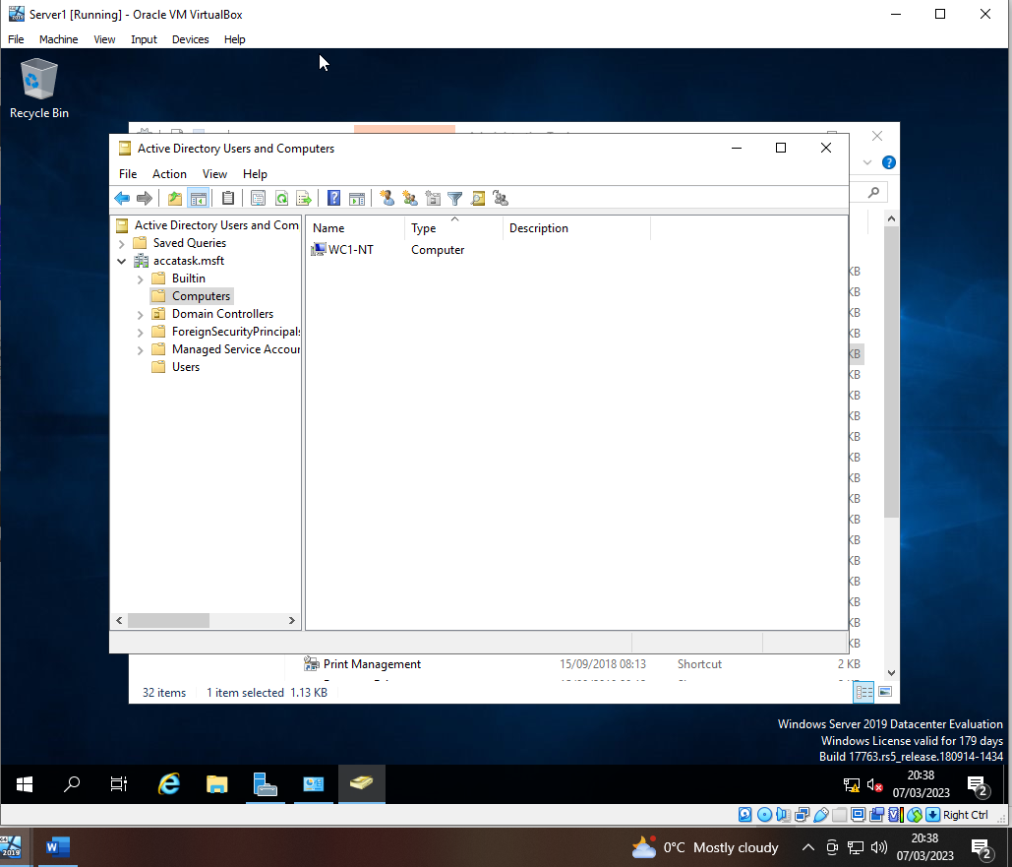
Computer account object gets implemented in the Active Directory. New computer has been added with the name WC1-NT.

Part 2 Task 3:
- Justify the reason why Type 2 Hypervisor is used in the above practical task?
A type 2 hypervisor, also known as a hosted hypervisor, is a software program that runs on top of a host operating system (OS) to enable virtualization of multiple guest operating systems.
Unlike a type 1 hypervisor, which runs directly on the hardware of a physical machine, a type 2 hypervisor requires an underlying operating system to provide hardware support and device drivers. The type 2 hypervisor then creates virtual machines (VMs) on top of the host OS, allowing each VM to run its own instance of an operating system and applications.
Type 2 hypervisors are useful when building a virtual LAN and deploying a network directory service in several ways due to several reasons:
Firstly, a Type 2 hypervisor runs on top of a host operating system, which allows it to leverage the hardware resources of the host system. This means that multiple virtual machines (VMs) can run simultaneously on the same physical hardware, which is essential for building a virtual LAN. By creating multiple VMs on a single host system, it is possible to simulate a network with multiple computers connected to it, allowing for testing and development of network directory services.
Secondly, Type 2 hypervisors provide a high degree of flexibility when it comes to configuring and managing VMs. They offer a range of features such as virtual networking, snapshotting, and cloning, which makes it easier to manage multiple VMs running on a single host system. This is important when deploying a network directory service in several ways, as it allows for easy replication of VMs across different hosts, making it simpler to test and deploy the directory service.
Finally, using a Type 2 hypervisor allows for easy isolation of VMs, which is essential for security purposes. By isolating each VM from the others, it is possible to prevent any potential security breaches from spreading across the network. This is particularly important when deploying a network directory service, as it often contains sensitive information such as user credentials and access controls.
Overall, a Type 2 hypervisor is useful when building a virtual LAN and deploying a network directory service in several ways due to its flexibility, scalability, and security features. By leveraging these capabilities, it is possible to create a virtual network that is easy to manage, secure, and can be replicated across different hosts with ease.
- DHCP - explain what it is, how it works (illustrations) and its significance.
DHCP (Dynamic Host Configuration Protocol) is a network protocol that automatically assigns IP (Internet Protocol) addresses to devices on a network. DHCP also assigns other network configuration parameters such as subnet masks, default gateways, and DNS (Domain Name System) servers. The protocol was designed to simplify network administration and to eliminate the need for network administrators to manually assign IP addresses to devices on the network.
DHCP provides several benefits to network administrators. One of the main benefits is that it simplifies the process of IP address assignment. With DHCP, network administrators can configure a DHCP server to automatically assign IP addresses to devices on the network, eliminating the need for manual IP address assignments. DHCP also allows for the easy reconfiguration of IP addresses, which is useful when devices are moved or added to the network.

Here's a step-by-step breakdown of how DHCP works:
- When a device connects to a network, it sends out a broadcast message called a DHCP Discover message, asking for an IP address.
- The message is received by a DHCP server on the network, which responds with a DHCP Offer message, offering an available IP address:
- The device sends a DHCP Request message, requesting the offered IP address:
- The DHCP server responds with a DHCP Acknowledge message, confirming the assignment of the IP address:
- The device then configures its network settings with the assigned IP address and other configuration parameters:
- The device can now communicate with other devices on the network using its assigned IP address:
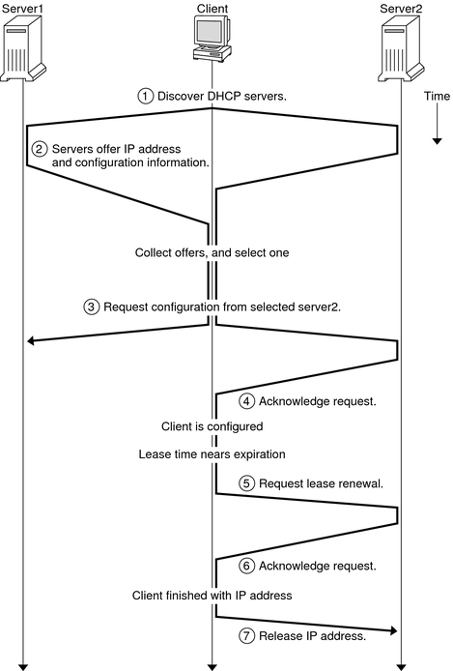

- Justify AD’s technology with illustrations and adequate evidence.
Active Directory (AD) is a directory service technology developed by Microsoft that provides a centralized and secure way to manage and authenticate network resources such as users, computers, and applications in a Windows-based environment.
AD uses a hierarchical structure consisting of domains, organizational units (OUs), and objects to organize and manage network resources. A domain is a collection of computers and other network resources that share a common directory database and security policies. An OU is a container that holds objects such as users, groups, and computers, and provides a way to apply policies and permissions to them.
AD uses a database called the Active Directory database to store information about network resources. This database is replicated to all domain controllers on the network, ensuring that changes made to the database are propagated to all controllers.
Here are some illustrations to help understand AD's technology:
- Active Directory domain hierarchy:
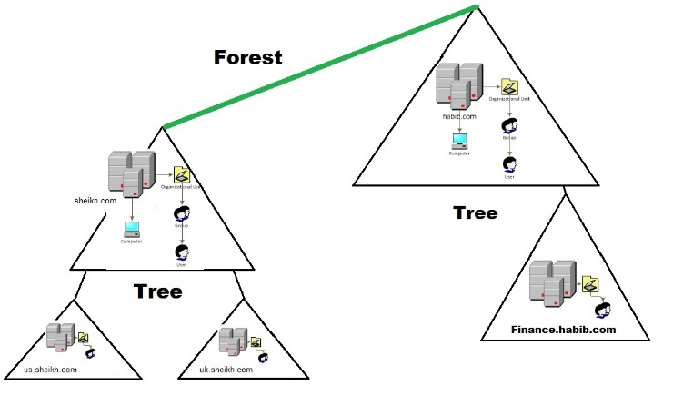

- Active Directory Organizational Units:
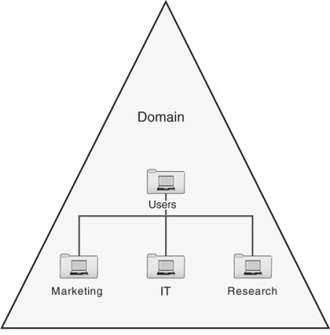

- Active Directory database replication:
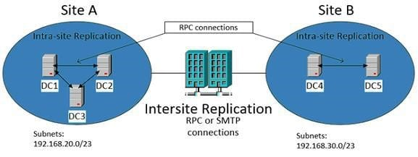

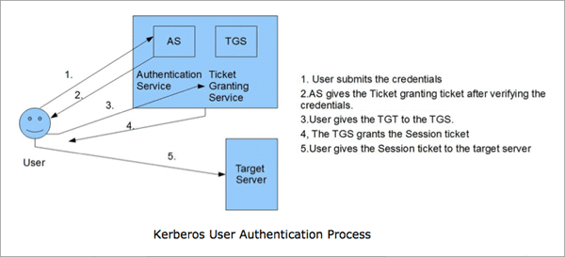
- AD authentication process:

- Give an in-detail description about the different terminologies (Ping, Server Management, Firewall, PAE/NX, OOBE etc) and its purposes.
  - Ping:
Ping is a computer network administration utility used to test the reachability of a host on an Internet Protocol (IP) network and to measure the round-trip time for packets to travel from the source host to the destination host. Ping works by sending an ICMP echo request message to the destination host and waiting for an ICMP echo reply message in response.
The purpose of ping is to diagnose network connectivity issues, determine network latency or delays, and test the status of a remote host. It is commonly used by network administrators to troubleshoot network issues, check if a host is online or offline, and assess network performance. Ping can also be used by software developers to test the functionality of their network-enabled applications.
  - Server Management:
Server management is the process of monitoring, configuring, and maintaining the hardware and software components of a server to ensure its availability, performance, and security. It involves tasks such as installing and updating server software, configuring server settings, monitoring server performance and health, and troubleshooting issues that may arise.
The purpose of server management is to ensure that the server runs smoothly and efficiently, and that it meets the needs of the users and applications that depend on it. Proper server management can help reduce downtime, prevent data loss, improve security, and optimize server performance.
  - Firewall
A firewall is a network security system that monitors and controls incoming and outgoing network traffic based on predetermined security rules. It acts as a barrier between a trusted internal network and an untrusted external network, such as the internet, and can prevent unauthorized access to a network or system.
The purpose of a firewall is to protect a network or system from unauthorized access, malicious attacks, and other security threats. Firewalls can be configured to block or allow specific types of traffic based on rules defined by network administrators. They can also provide logging and reporting features that allow administrators to monitor network activity and identify potential security breaches.
  - PAE/NX
Physical Address Extension (PAE) is a memory addressing scheme that allows a 32-bit processor to address up to 64GB of physical memory, compared to the 4GB limit imposed by traditional 32-bit addressing modes. This allows computer systems to support more applications and processes and can improve overall system performance.
NX (No eXecute) is a security feature that prevents the execution of malicious code by marking areas of memory as non-executable. This prevents certain types of malwares, such as buffer overflow attacks, from executing code in areas of memory that are intended for data storage.
Together, PAE and NX provide a powerful combination of improved system performance and enhanced security. PAE allows systems to access more memory, while NX helps prevent the execution of malicious code in areas of memory that are intended for data storage.
OOBE (Out of Box Experience):
OOBE stands for "Out-Of-Box Experience” and refers to the initial setup process that a user goes through when setting up a new computer or device for the first time.
The purpose of OOBE is to guide the user through the initial setup process, which typically includes tasks such as selecting a language and keyboard layout, connecting to a network, creating user accounts, and configuring basic settings. OOBE is designed to be intuitive and user-friendly and is intended to help users get up and running with their new device as quickly and easily as possible.
OOBE is an important part of the overall user experience for new devices, as it can have a significant impact on a user's perception of the device and the brand that it represents. A well-designed OOBE can help ensure that users have a positive first impression of the device and can help reduce the likelihood of user frustration or confusion during the initial setup process.
Compare your list of terminologies in the aspect of their operations/functionality with other Network Operating Systems.
Ping:
According to Cisco (2020), a network operating system (NOS) is software that runs on network devices such as routers, switches, and servers, enabling them to communicate with each other and manage network operations. NOS provides features such as network monitoring, device configuration, security, and routing protocols.
In contrast, Ping is a basic network utility that allows network administrators and users to test the connectivity between two devices on a network. Ping sends a small packet of data to the target device and waits for a response, allowing administrators to determine if a device is reachable on the network and measure its response time.
Compared to other NOSs such as Cisco IOS, Junos OS, and Microsoft Windows Server, Ping has a much narrower scope of functionality. NOSs provide a comprehensive set of features and tools for managing and controlling the entire network infrastructure, including routers, switches, servers, and other devices. They offer a GUI or CLI for administrators to manage the network, and provide features such as network monitoring, device configuration, security, and routing protocols.
Windows Server 2019 Firewall:
Windows Server 2019 Firewall is a built-in security feature in Microsoft Windows Server 2019 that provides network traffic filtering and security. According to Microsoft (2021), the firewall in Windows Server 2019 provides a range of features and functionalities that allow administrators to monitor and control incoming and outgoing network traffic.
Windows Server 2019 Firewall includes advanced security filtering features that allow administrators to configure firewall rules based on various criteria, such as port, protocol, IP address, and user or group identity. These rules can be configured to allow or block specific types of network traffic, providing a level of protection against potential security threats.
Linux provides a range of firewall solutions, such as iptables and nftables, that allow administrators to configure firewall rules based on various criteria, such as port, protocol, IP address, and user or group identity. These firewall solutions are highly configurable and offer a range of advanced features, such as intrusion detection and prevention, packet filtering, and network address translation.
In comparison, Windows Server 2019 Firewall is a more basic firewall solution that provides a limited set of features and functionalities. However, it does include advanced security filtering features that allow administrators to configure firewall rules based on specific criteria, such as port, protocol, and IP address, similar to Linux.
PAE/NX:
PAE/NX (Physical Address Extension/No Execute) is a hardware-based feature that provides additional memory protection for 32-bit processors. It allows the operating system to access memory beyond the 4GB limit of traditional 32-bit processors and also helps to prevent certain types of attacks that exploit memory vulnerabilities. PAE/NX is available on various network operating systems (NOS), including Linux and macOS.
In Linux, PAE/NX support is provided through the Physical Address Extension (PAE) kernel extension, which allows the operating system to access up to 64GB of memory on 32-bit processors (Red Hat, n.d.). In addition, Linux also provides a number of security features that help protect against memory-related attacks, such as Address Space Layout Randomization (ASLR) and kernel memory protection (KMP).
Similarly, macOS also supports PAE/NX and provides memory protection features to help prevent attacks. macOS includes the Execute Disable (XD) feature, which helps to prevent attacks that exploit memory vulnerabilities, as well as ASLR and KMP.

Conclusion:
In conclusion, building a virtual LAN using Type 2 hypervisor management software and deploying a network directory service and creating and understanding Active Directory network objects are critical tasks for network administrators. These tasks involve setting up a virtual network environment, managing virtual machines, and creating network directory services to manage user and computer accounts, security groups, and other network objects. Type 2 hypervisor management software, such as VirtualBox and VMware, provide a flexible and cost-effective solution for creating virtual networks.
Deploying a network directory service, such as Active Directory, is an essential step in managing user and computer accounts, authentication, and authorization in a network environment. Understanding the different Active Directory network objects, such as users, groups, and computers, is essential for configuring and maintaining a secure and efficient network infrastructure. With the proper tools and knowledge, network administrators can successfully build and manage virtual networks and deploy robust network directory services to support their organization's needs.

Write a brief reflection on the tasks completed in this worksheet:
Building a virtual LAN using Type 2 hypervisor management software and deploying a network directory service can be a complex and challenging task, but it is essential for managing networks and supporting the needs of an organization. This process involves setting up virtual machines, configuring virtual network settings, and deploying network directory services such as Active Directory. Understanding Active Directory network objects such as users, groups, and computers are also crucial for managing user and computer accounts and maintaining a secure network environment. Building a virtual LAN using Type 2 hypervisor management software and deploying a network directory service can provide a hands-on approach to learning about network infrastructure and management and can help develop practical skills for managing networks and ensuring their security and efficiency.
The challenges I faced when completing the worksheet were:
Hypervisor compatibility issues: My personal devices only consisted of 8GB of RAM which wasn’t enough as the main issue I faced was being unable to open two Virtual Machines at the same time, due to the lack of memory my system had. In addition to this, another hardware issue I faced was lack of storage to install the ISO for each Virtual Machines. Which led me start all over again using a different system to complete the tasks.
Building a virtual LAN and deploying a network directory service involves multiple configuration steps that are quite complex and time consuming. The issues I faced throughout the configuration steps was being unable to find a ping between Server 1 and Client 1. The reason for this is because I didn’t assign Client 1 adapter as “PrivateNet1”. This adapter needs to be connected to the same LAN as the 2nd adapter in Server 1.

References:
Part 2 Task 3:
Justify the reason why Type 2 Hypervisor is used in the above practical task?
- Kusnetzky, D. (2016). Why a Type 2 hypervisor is useful. ZDNet. Retrieved from https://www.zdnet.com/article/why-a-type-2-hypervisor-is-useful/
DHCP - explain what it is, how it works (illustrations) and its significance.
- Droms, R. (1997). DHCP: the Dynamic Host Configuration Protocol. RFC 2131, Internet Engineering Task Force. https://tools.ietf.org/html/rfc2131
- Comer, D. E. (2017). Internetworking with TCP/IP: Principles, protocols, and architecture. Pearson Education.
- Droms, R. (1997). Dynamic host configuration protocol. RFC 2131, Internet Engineering Task Force.
Give an in-detail description about the different terminologies (Ping, Server Management, Firewall, PAE/NX, OOBE etc) and its purposes.
Ping:
  - Comer, D. E. (2015). Computer networks and internets (6th ed.). Pearson Education.
Server Management:
  - Tulloch, M. (2014). Windows server 2012 inside out. Microsoft Press.
Firewall
  - Goodrich, M. T., & Tamassia, R. (2011). Introduction to computer security. Pearson.
PAE/NX
  - Russinovich, M., Solomon, D., & Ionescu, A. (2009). Windows internals: including Windows Server 2008 and Windows Vista, fifth edition. Microsoft Press.
OOBE:
  - Whitney, L. (2010). Windows 7: The Missing Manual. O'Reilly Media, Inc.
Compare your list of terminologies in the aspect of their operations/functionality with other Network Operating Systems.
Ping:
  - Chen, Y.-W., & Yen, N.-Y. (2017). Network operating systems: A survey. Journal of Network and Computer Applications, 81, 40-57.

  - Cisco. (2020). What is a network operating system (NOS)? Retrieved March 9, 2023
Windows Server 2019 Firewall:

  - Microsoft. (2021). Windows Firewall. Retrieved March 9, 2023, from https://docs.microsoft.com/en-us/windows/security/threat-protection/windows-firewall/windows-firewall-with-advanced-security
PAE/NX:
  - Apple. (n.d.). macOS security overview. Retrieved March 9, 2023, from https://support.apple.com/en-us/guide/mac-help/mh40596/mac
  - Linux Security Module Project. (n.d.). Kernel memory protection. Retrieved March 9, 2023, from https://selinuxproject.org/page/KernelMemoryProtection
  - Red Hat. (n.d.). What is Physical Address Extension (PAE)?. Retrieved March 9, 2023, from https://access.redhat.com/documentation/en-us/red_hat_enterprise_linux/6/html/installation_guide/s2-x86-pae

