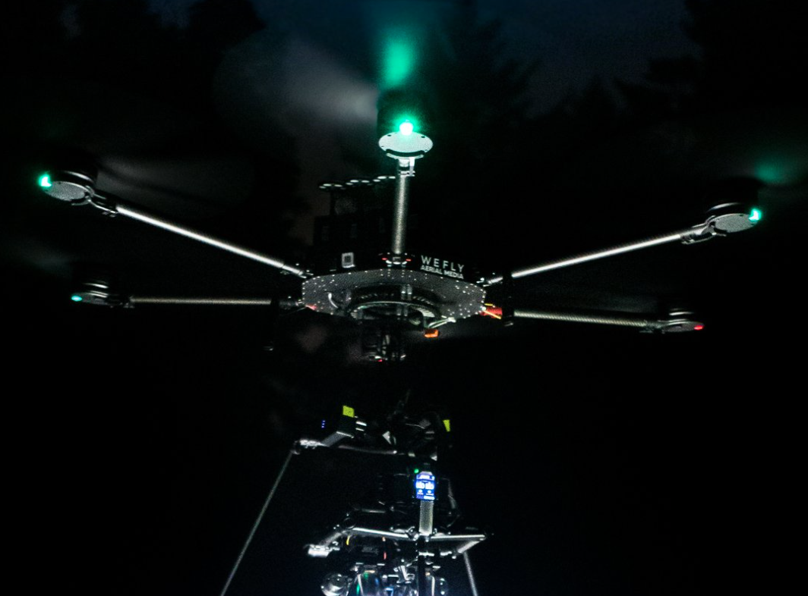  Level 5 Systems Engineering  ACDA5021 | Abstract  This report outlines the development of a solution to an OME-based problem using a structured approach with well-established systems engineering tools. A team of five members, each specializing in different aspects of the design process—including requirements and design, technical research and development, manufacturing, disposal, and safety—collaboratively developed the solution.  Rebecca Dingwall (2217521)

Table of Contents
1. Introduction 2
2. Key customer requirements 2
3. Critical system functionality 3
4. Concept derivation and design choices 3
5. Potential failure modes 3
6. Critical design features 3
7. Critical process steps 3
8. Process control measures. 3
Appendix 1. 5

Figure 1 Pairwise comparison results 3
Figure 2 QFD Phase 1: Functional Importances 4
Figure 3 Function means 4
Figure 4 Finite Function Means 5
Figure 5 Finite Pugh Matrix 5
Figure 6 DFMEA result. 6
Figure 7 QFD Phase 2: Feature importances graph. 7
Figure 8 What-Why table 8
Figure 9 Noise & Control Factors 8

Introduction
This report covers the development of a solution to an OME based problem, using a selection of well-established systems engineering tools. The team consisted of 5 team members with each member of the team taking on a design role. This team had delegated the following roles:

- Requirements and design
- Technical research and development
- Manufacturing
- Disposal
- Safety

This report will explain how the toolset was used to assist in the development and proposal of a solution. This report has been written from the technical research and development team members perspective.
The requirements and design section were worked on as a whole team collectively together, it was during this time that the majority of the toolset was used, how and why each tool was used will be outlined throughout the report.
Some tools were also used by the technical research and development these each have also been outlined during the report.

Key customer requirements
A simple set of customer requirements was given, collectively these were then redefined as customer requirements and designer originated requirements to adhere to the requests from the customer, this was due to the ambiguous generic stake holder demands for example ‘legal and safety requirements’ to more specified requirements to ensure the product complies with the international laws on engagement and other requirements that ensure safety.
A use case was requested and A Gemba visit was held to gather a better understanding of the requirements as well as the ability to get a better understanding from the end user. The input from the end users about the system currently being used held real value in this instance as a quality set of pros and cons were derived to gain an understanding of what currently works well for them and what to avoid if possible. See Appendix 1 for the Gemba Visit report. A pairwise comparison was performed by the whole team on the requirement set to assess the relative importance, and to demonstrate the areas for prioritization.
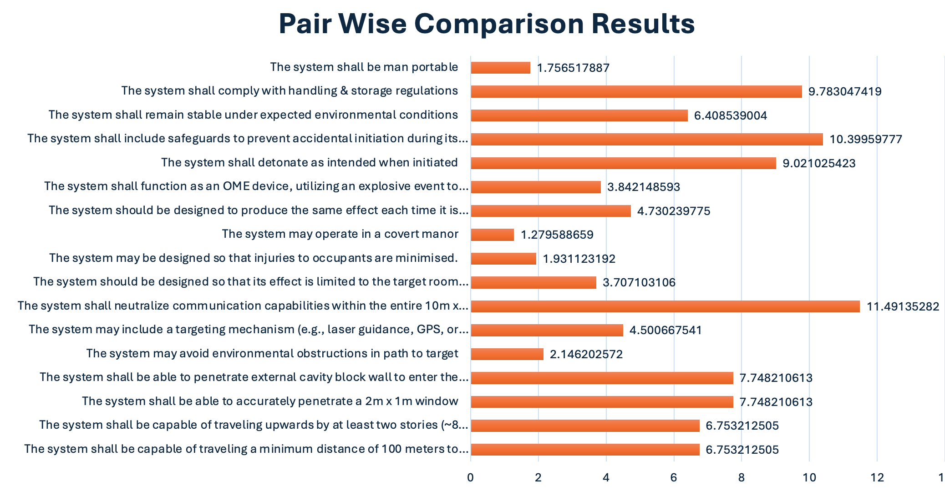
Figure 1 Pairwise comparison results
As seen in figure 1 the results show that the areas for prioritization are mostly safety, with the largest priority focusing on the neutralization of the target area this is expected, although it must be noted that if these were the only areas for focus, the current system being used complies to these 4 requirements.

Critical system functionality
Critical system functionality is the most essential operations that the whole system must perform in order to achieve its purpose, they are most often mission critical and will directly impact safety, reliability and efficiency. To find the critical system functionality for the case study, the design team performed the following steps.
A required functionality set was developed from the requested use case, and requirement set including relative importance normalized numeric values, gathered from the pairwise comparison. These were then input into QFD Phase 1 to give an output of the functional importances. This has been performed to understand the relationship between the functions and the requirements. Essentially ranking each required functionalities effectiveness of fulfilling each requirement [1]. This can be seen in figure 2.
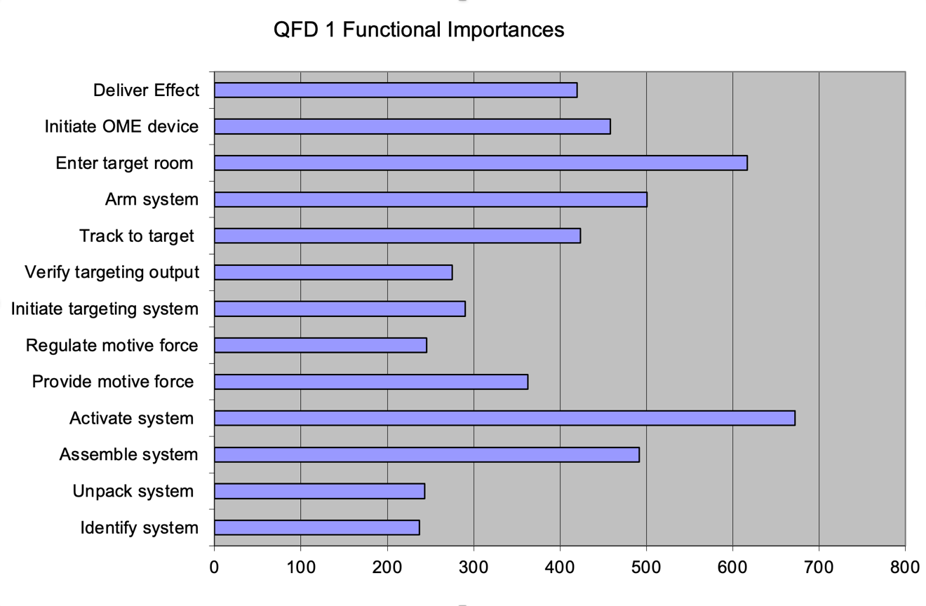
Figure 2 QFD Phase 1: Functional Importances

Concept derivation and design choices
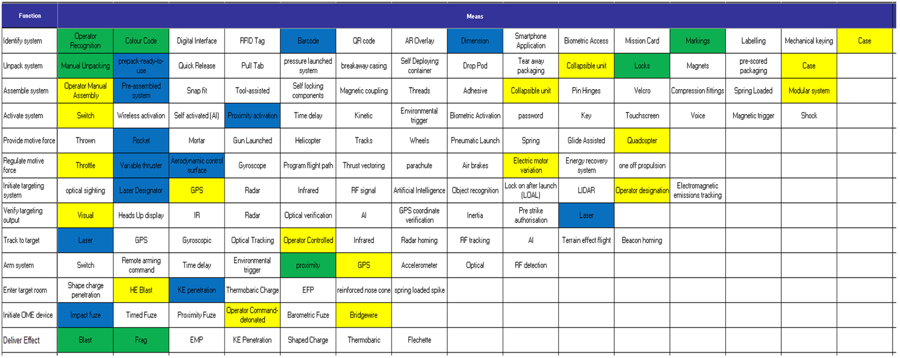
The whole design team used a function means for concept derivation. Thinking of a selection of either traditional or innovative solutions for how to achieve each of the functions. The function means used can be seen in figure 3. These options were then selected for two concept designs, and a Pugh matrix used to compare the two concept designs against the original requirement set to find the design that best correlates to the original requirement set. All the solutions selected for the winning concept are then fed into QFD Phase 2.
Figure 3 Function means

Technical research and design.
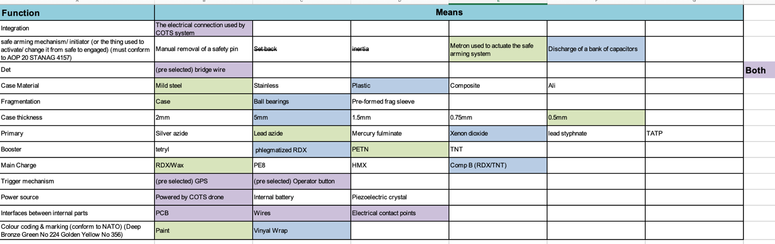
During technical research and design, more of the toolset was used for more in-depth finite decision making. Some functions having already been pre-selected by the whole design team on the original functional means, as seen in figure 4.
Figure 4 Finite Function Means

Some conventional means of safe arming in this instance was not possible due to the COTS drone selected. Following this another Pugh matrix was conducted against a criteria set to select between design 1 and design 2. As seen in figure 5, from the discussions and feedback held with the manufacturing team member the explosive used in D2 was changed from RDX/Wax to PE8.
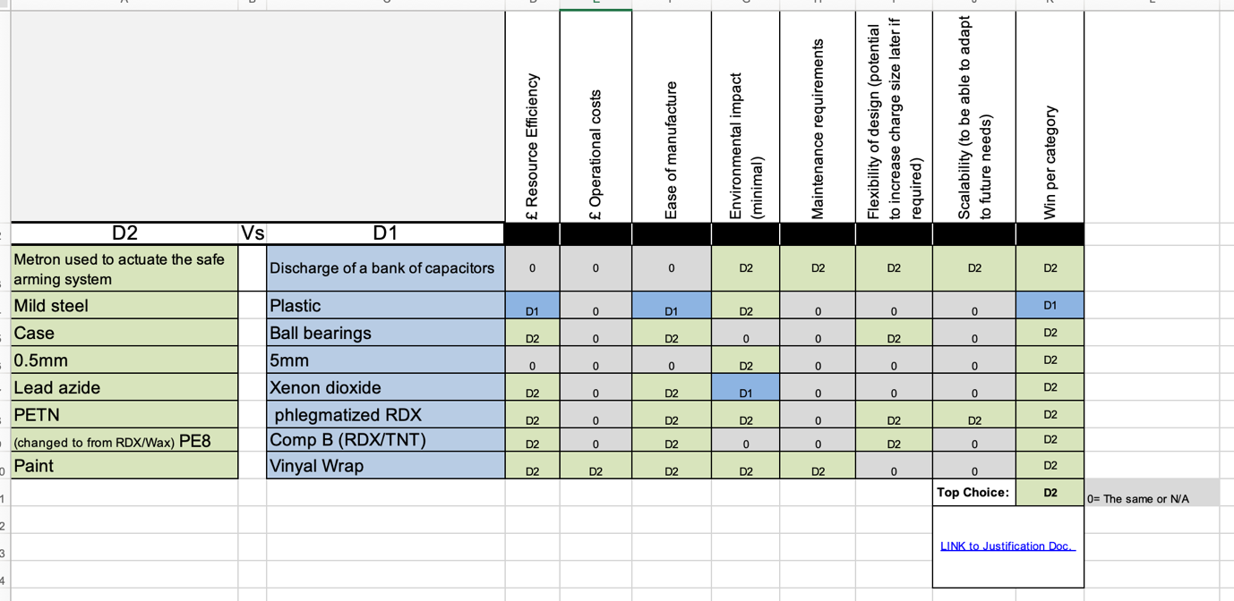
Figure 5 Finite Pugh Matrix

Potential failure modes
A Design Failure Mode and Effects Analysis (DFMEA) was performed. Using the design features and the 5 main failure modes consisting of:
- No feature
- Too Much feature
- Too little feature
- Intermittent feature
- Wrong feature
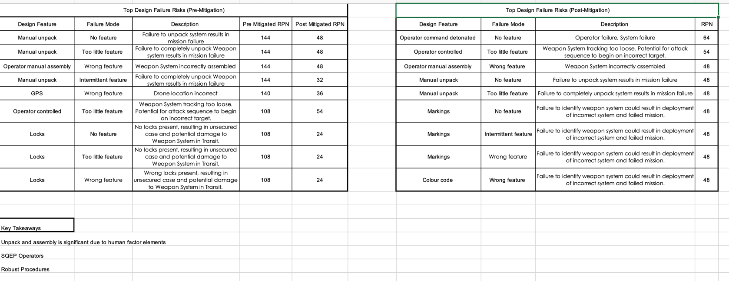
As well as the effects and severity of that failure as well as the causes and occurrence. This analysis also contained the current controls and form of detection.
Figure 6 DFMEA result.

The output from the DFMEA can be seen in figure 6. The RPN number represents the Risk Priority Number.

Critical design features
Critical design features are the design elements that ensure the product functions effectively and meets intended goals. QFD Phase 2 has been used to find the feature importance, this time ranking reach design features effectiveness of fulfilling each function. The output from QFD phase 2 again highlights the critical design features needed for the product to operate effectively. The results from QFD phase 2 can be seen in Figure 7.

TR&D
Some of the critical design features when designing the physical item to ensure functionality consisted of:
- Design of the Integration feature to the COTS system
- Safe arming mechanism design
- Dimensions of charge size
- Overall weight of munition
- 500g charge gives roughly the same amount of energy of a bare 416g TNT charge.
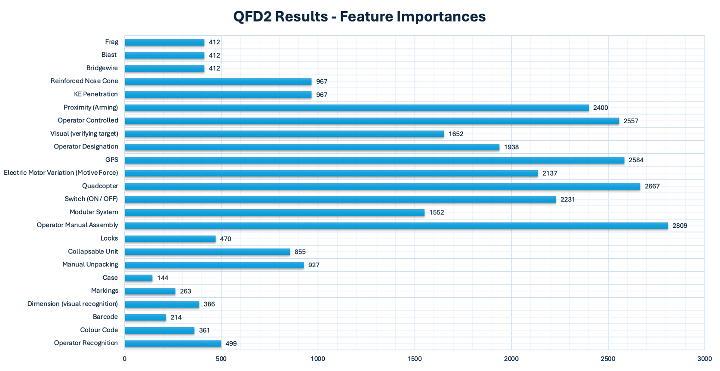
Figure 7 QFD Phase 2: Feature importances graph.

Critical process’
As part of the design process, some of the functions were met by using a commercial off the shelf system. The TR&D team member highlighted some of the performance criteria and requirements that must be met, to meet the original design requirements. Some of these consisted of the following:

- Collapsible unit
- Simple to Assemble
- Lifting capacity
- Operator interface
- GPS/IPS
- Camera
- Man portable
- Has the ability to be used manually while also having some autonomy

These analyses were conducted to certify the level of conformity to:
- The original requirement set
- Original functions means analysis as well as,
- Failure mode analysis conducted by the safety team.

Process control measures.
Following the DFMEA a P-diagram was done with the whole design team looking into noise factors from deterioration, unit to unit variation as well as external and signal factors. Including potential catastrophic outputs and control factors that can be implemented to reduce or remove the noise. Some of the control factors were recommendations following the DFMEA outputs.
A ‘what why’ was performed to assess the noise within the system with the control factors in place. It can be seen from that chart in figure 8 that the largest grouping of influence is around humans.
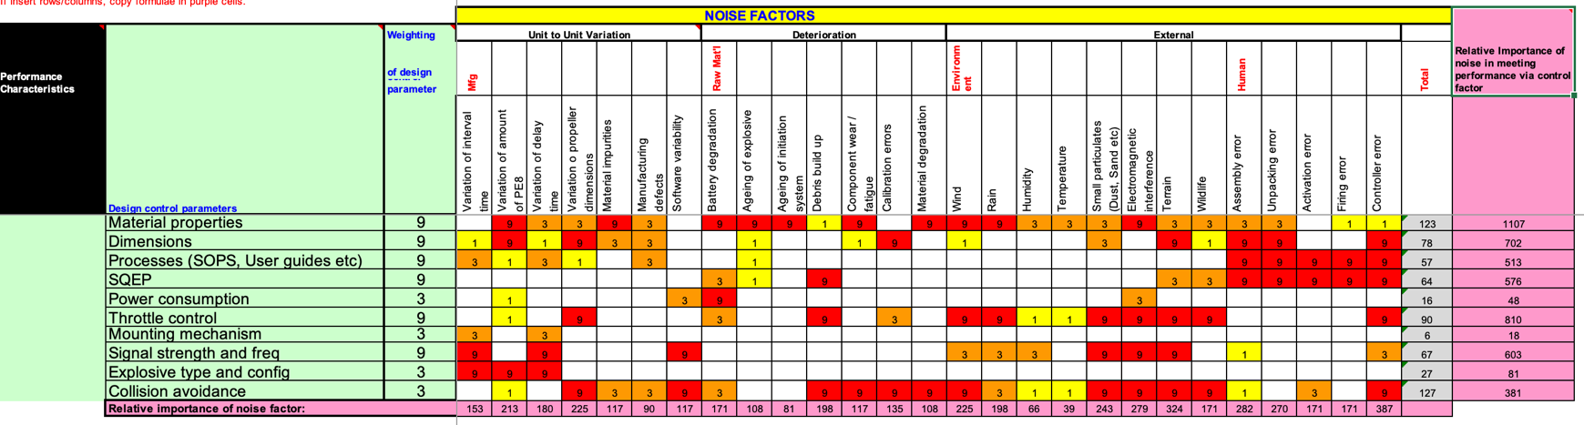
Figure 8 What-Why table

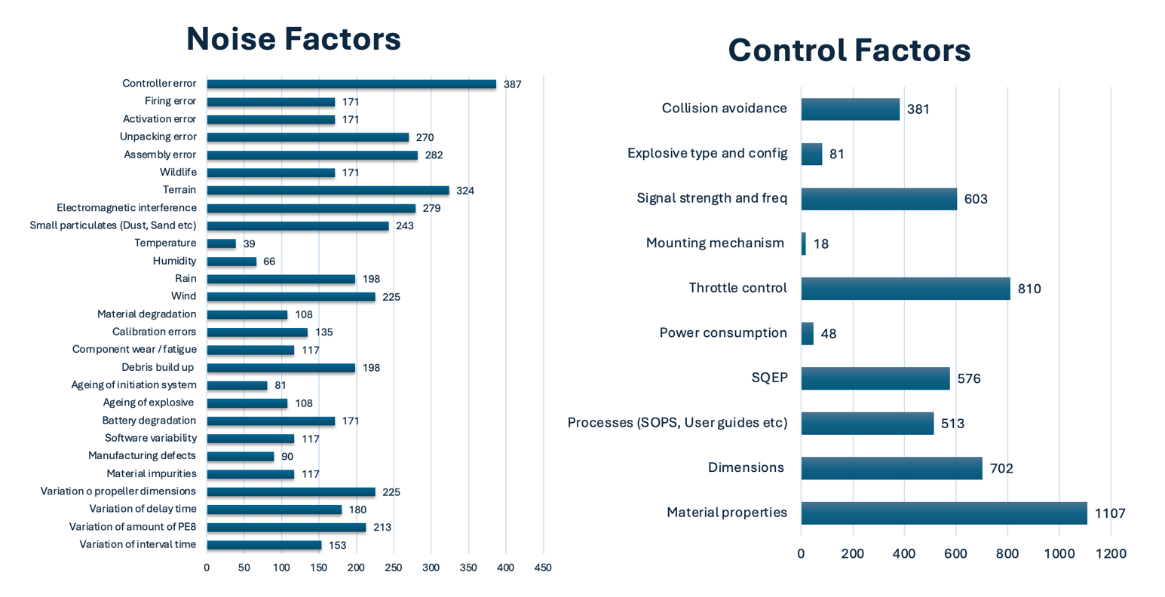
Figure 9 Noise & Control Factors

Figure 9 displays the noise factor and their relative importance, while the control factors chart shows the relative importance of the noise in meeting the performance via the control factor.

Bibliography

[1] | Quality-One International , “Quality Function Deployment (QFD),” Quality-One International , [Online]. Available: https://quality-one.com/qfd/#:~:text=Quality%20Function%20Deployment%20(QFD)%20is,manufacturing%2C%20healthcare%20and%20service%20organizations.. [Accessed 09 05 2025].

Appendix 1.

Gemba Visit Report
Gemba Visit Report – Salisbury Plain (Imber Village)
In Attendance:
- Development Team (All members)
- 2 Stakeholders
- 5 End Users

Objective:
To observe how end users engage with their existing weapon systems in an operational training environment, identifying challenges, risks, and potential areas for improvement in the new system development.

Observations:
During the visit, end users demonstrated their current system used to neutralize potential threats in an urban setting as part of a structured training exercise. The systems currently in use include:
- FGM-148 Javelin
- M141 SMAW-D
Both systems were observed in a realistic operational setting, demonstrating their compliance with both legal requirements and the mandatory performance criteria outlined in the customer’s requirement set. During the exercise, both systems successfully achieved full target room destruction, including the intended communications equipment.

However, several key observations were made:
- The current systems were identified as overmatched for the requirement, causing significant collateral damage beyond the target room, affecting adjacent rooms and the floor below.
- The effect of the system was assessed as incompatible with life for any occupants in the target room and posed a significant risk of catastrophic injury to personnel in the surrounding structure.
- End users noted that between firing and impact, only seconds elapsed, meaning people in the target room had little time to react before the effect was delivered.

Key Insights from End Users:
Preferred Features in Current Systems:
- Fire-and-forget capability
- Single operator firing capability
- Two-person portability
- Soft-launch capability (noted for improvement; see below)
- Consistent terminal effect on target when a hit is achieved
Challenges Identified in Current Systems:
- Overmatch in urban environments, causing excessive damage beyond the intended target.
- IR seeker performance issues, leading to decreased targeting accuracy.
- Backblast hazard, which can pose risks to the firing team in confined spaces.

Conclusion:
Discussions with stakeholders and end users confirmed that a system more closely matched to the requirement would be preferable, reducing unnecessary damage to surrounding structures while still ensuring complete neutralization of the target. Stakeholders acknowledged that while minimizing reaction time in the target room is critical, achieving this does not necessarily require the system to be fully covert.

Next Steps:
Following the stakeholder engagement and Gemba visit, the refined requirement set (as per the requirement table for full details) will now guide the next phase of development through Quality Function Deployment (QFD1) and functional means analysis. The customer-driven requirements establish core performance expectations, while the designer-driven requirements, informed by operational insights, ensure practical feasibility and mission effectiveness.

