‘A literature review and research plan of Assessment for Learning in the classroom’.

In this research plan of Assessment for learning in the classroom I will be reading key information from existing research and texts through a literature review and then using previous research as an aid to creating my own research plan based upon previous findings and my own experience as a classroom teacher. I will also be discussing possible limitations that may occur and potential conclusions from my own methodology for a research plan for assessment of learning.
Assessment for learning is an umbrella term used to refer to several assessment techniques a classroom teacher can use to check pupils progress and understanding. Assessment for learning can also be referred to as formative assessment. Formative assessment is a tool that classroom teachers use to check understanding and progress of pupils through testing. By using regular assessment for learning through different forms such as a starter quiz, exit ticket or a mock test it helps both the teacher and the pupil. The teacher can use various techniques to gage pupil understanding and spot potential knowledge gaps that the learners may have. The pupils over time become more efficient and independent for their own learning and this is a skill they can use throughout life.
A key to successful assessment for learning within classes is effective planning. By looking at a scheme of work as an overview a teacher can see where assessment for learning will take place if form of tests but also it can help them map lesson by lesson and input different techniques such as peer assessment or kahoot quizzes to engage learners but also check live understanding and end of lesson progress. By using the scheme of work as a guide, the teacher can use various techniques such as recall to gage pupil’s previous understanding and retention by asking a mix of current topic questions and previous lessons questions to engage a pupil’s prior knowledge and recall. Whilst using a scheme of work to plan lesson by lesson this can be used as a guide to see exactly where assessment for learning methods can be put into place and then include these in lesson plans and topic sections. Depending on which technique works best per lesson a teacher can use a range of assessment tools such as peer marking, tests or exit tickets to expose pupils to a range of techniques and tools. This will also help the pupils adapt to exam questioning and using memory recall in a safe environment where mistakes can be made and fixed at that time in the classroom rather than no prior testing and a loss of confidence from solely one end of term test, as this can have a huge knock on effect on learners confidence. Pupils can feedback to their teacher with how the lesson went and have a say on their own learning and what assessment techniques or tasks they prefer to help the teacher plan effective and engaging lessons. Also, these techniques help form a feedback loop between pupil and teacher on what teaching style and type of lesson they work best under which is useful knowledge for a teacher to have when planning future lessons. By using assessment for learning consistently and continuously this helps the teacher answer any potential misconceptions, keep a regular track on progress and gage any topics needing deeper explaining. Black and Wiliam (2001) conclude that teachers who regularly use assessment for learning effectively in their everyday lesson planning and heavily involve it into their scheme of work, then the pupils would learn at estimated double the rate. It is believed this style and cycle of teaching helps pupils store information efficiently in their long-term memory.
Assessment for learning has been a key focus and talking point for many schools in England and especially Wales in recent years with a key focus on ensuring learners are becoming more independent and prepare for their future with not only their grades but also have a wide range of skills for their future and professional life. The Welsh Government see assessment for learning (AFL) as the driving force for the ‘new curriculum’. (Donaldson, 2015). Cambridge (2017) refers to assessment for learning as an essential tool teaches can use to improve student’s attitude and performance. Hattie (2008) exclaims that by using assessment for learning you are making understanding and knowledge more accessible to the children by exposing them to new teaching techniques and learning styles that are inclusive to all learners and it also hands the learner the ability to take control of their own learning within the classroom. Hattie (2008) also believes assessment for learning is the ‘golden’ key to helping students stretch to their full potential. (Hattie, 2008).
The focus on assessment for learning was first brought to light in 1999 after it was decided an education overview was needed so in order to do this an assessment reform group was set up which consisted of world-renowned experts in their field during 1999 such as child psychologists, education specialists and subject leaders. The team put together set out to tackle progress and learning standards of pupils, the group consisted of many researches all able to look at reforming the education standard from different aspects. It consisted of teachers, other members of the education sector and top child psychologists. It was funded by the UK Government. They set out to critically analyse assessment for learning strategies and their effectiveness at that time. During this time, it was established that the majority of testing was done through single term tests such as end of a learning block or before a half term, to produce a grade or percentage and then fed back through end of term reports but found little evidence of regular assessment for learning techniques within the everyday lesson. Since the 1999 assessment for learning reform group posted their findings, after this it catapulted assessment for learning into the forefront of many schools focus. Black et al (2002) agreed that assessment of learning such as tests to produce a grade and reports to inform parents of termly progress is important but also highlighted a deeper focus on assessment for learning needing to occur to give pupils more control over their own learning and progress. Assessment of learning is a key tool in classrooms as gives the teacher a progress result in terms of a percent or grade, for example A* or 87%. This data can then be used to compare pupils and track termly progress using a range of termly tests to give an overall predicted grade whereas assessment for learning can give a teacher lesson by lesson progress and continual knowledge checks to assess live understanding and how much has been grasped. Kluger and deNisi (1996) believed the idea of using assessment of learning rather than assessment for learning sparks a competitive element between pupils and their peers due to the use of a grading system and this in turn will drive their learning but this statement is disputed by many educational researchers such as Black et al (2002) who states a teacher needs to use a combination of assessment of learning and assessment for learning to gain a more detailed progress timeline for their pupils with a lesson by lesson check rather than only a term by term check. By allowing pupils to have a deeper involvement in their own learning this engages the pupils further within lessons as they feel they are more in control of how they are being taught. This also helps the teacher to stop being the hardest worker in the room due to the learners being more engaged and in control. (Donaldson, 2015).
In more recent years, Donaldson (2015) has developed a new curriculum for Wales based around assessment for learning rather than assessment of learning at its core. The new curriculum named “successful futures” has creating independent learners at its core. Donaldson (2015) calls assessment for learning the most powerful tool a teacher can use within a classroom as it allows pupils to ‘be the teacher’ by peer assessing each other’s work and giving constructive feedback to their peers and also allowing time for them to reflect on their own work. By using a variation of these techniques through peer assessment or something as simple as an exit ticket it gives the classroom teacher a live lesson by lesson reflection of the pupils understanding and by using these knowledge checks it allows the classroom teacher to reflect on pupils grasp of the topic and see where focus needs to be driven in terms of re capping difficult terms or correcting any possible misconceptions as soon as the lesson ends rather than not finding out any misconceptions until the end of term test results. Donaldson (2015) has been a driving force in Wales for allowing learners to take more of a control of their learning and become more independent and efficient learners who take responsibility for their own learning. Successful futures prides itself on helping learners become more confident and adaptable young people ready for life outside of a classroom setting with the guidance of their classroom teacher. In 1997, Bandura was one of the first to voice his concern that their needed to be a continual use of a range of different assessment for learning techniques to ensure pupils were being stretched to their full potential which is a concept being researched heavily and being a key focus of a new curriculum for Wales even 21 years later by Donaldson (2015). Learners who can adapt and take responsibility for their own learning by being taught in the classroom on how to ‘think like a teacher’ is believed to be key in preparing them for their future in society, professional jobs and promotes greater confidence in general. (Cambridge, 2017). Black and Wiliam (2001) concluded that the reason assessment of learning was more dominantly used over assessment for learning was the due to the terminology used and easy to track grade by grade guidelines to compare pupils scores however this did not always check pupils general understanding and knowledge of lessons or allow them any assessment feedback in the run up to their formative tests. Assessment of learning is accused of creating schools that are acting like data machines and only focusing on data created by formative testing and summative reports (Harrison, 2013) instead of looking at the bigger picture and the individual pupil. By schools becoming solely data driven it is argued pupils with additional leaning needs (ALN) such as, on English Additional Language (EAL) or Special Education Needs (SEN) registers are often left behind when a school is only focusing on assessment of learning as these pupils may not perform well under test/ exam conditions whereas, assessment for learning is driven by being inclusive to all and will give a more well-rounded and over all view of knowledge gaps or specific places of excellent learning. (Donaldson, 2015). National Research Council (1999) found a link in higher achievement rates in free school meal pupils (FSM) due to assessment for learning being more accessible and inclusive to all.
Black and wiliam (2001) noticed a shift in schools change of attitude towards assessment for learning by having a greater focus on trailing new techniques such as peer assessment, pupils being taught how to properly self-evaluate and a feedback loop in the form of exit tickets. This was in turn promoting critical thinking and a boom in confidence amongst young learners as they became more involved in their own teaching and learning. This shows that by combining assessment for learning and assessment of learning a teacher can track pupil’s lesson by lesson progress in the form of a feedback loop or self-evaluation, as well as term by term through testing/ exam style practice to produce a grade. Black (1993) believes that formative assessment is a key tool to creating ‘well oiled’ independent learners who gain skills that are essential in their professional careers and future lives such as annotating and interpreting data and information such as a success criteria or processing feedback and acting on it effectively. Assessment for learning also teaches learners how to interact with peers on more of a professional level and how to deal with constructive criticism which is essential for their future. (Donaldson, 2015).
Bell and Cowie (2001) firmly believe the key to pupil’s success is through a teacher whose lessons are engaging by including a mix of methods of assessment for learning within their schemes of work and lessons discreetly and not forcing upon pupils. A teacher can then use the data from a formative assessment to track where any knowledge gaps are and address them based on the results but also by using assessment for learning a teacher can use starter tasks to perform a short quiz for example using a mix of recall questions and recent questions to see gaps in knowledge and understanding or any potential misconceptions. A teacher should be able to use an array of techniques to keep pupils engaged during a lesson and whilst being able to adapt tasks to ensure they are inclusive to all and this will close both attainment and knowledge gaps within a classroom. Assessment for learning is believed by some education researchers such as Dylan Wiliam (2011) and Donaldson (2015) as the ‘magic answer’ or ‘golden key’ to enabling teachers to build a bridge between teaching and learning and closing attainment gaps due to being accessible to all types of learners such as additional learning needs or free school meals in an everyday classroom. Dylan Wiliam (2011) goes on to say continual forms and variation of assessment within a classroom gives a teacher a wider view of what learning has taken place at that current time rather than a single formative assessment at the end of each large topic which usually spans over a whole term. Assessment for learning gives the classroom teacher a live end of lesson perspective of what learning and understanding has taken place at that exact moment. Four years later Donaldson (2015) whilst designing the new curriculum and reviewing the current Welsh education system he agreed with Dylan Wiliam (2011) findings, building upon the view that new assessment tools such as peer assessment are powerful because it gives pupils the ability to help each other and talk in a way that is more accessible and understanding than ‘teacher speak’. This is all part of learners taking more responsibility for their own learning and teaching. Both Donaldson (2015) and Dylan Wiliam (2011) agree that formative assessment needs to be kept discrete and seamlessly fit into schemes of work so pupils do not feel they are constantly being tested or it shouldn’t feel forced, but neither should formative assessment only be used as a ‘tick and a flick’ marking exercise with no purpose.
Cambridge (2017) identified that the in the build up to a summative assessment, the use of assessment for learning as the key to creating successful learners due to techniques such as peer assessment and self-evaluation showing them what higher level work looks like and showing them step by step what they need to improve to reach higher levels or simply how to grasp difficult concepts instead of spoon feeding learners information from a textbook without any engagement. In lessons pupils will be taught how to ‘think like a teacher’ and how to correctly evaluate and comment on peers work but introducing terms such as ‘what went well’ (WWW) and ‘even better if’ (EBI). By using different techniques in the classroom, it improves the quality of the pupils learning due to a range of techniques available to the teacher to use instead of monotonous and disengaging lessons. This is supported by Beaton et al (1996) whose research proved that assessment for learning leading up to formative assessment improves grades and attainment. It was the largest successful intervention undertaken by the educational reform system.
Donaldson (2015) believes in assessment for learning methods so much that education in Wales is shifting massively over the next few years by changing over to the “successful futures” curriculum for Wales. The curriculum is based around four core purposes:
- Ambitious Capable Learners.
- Ethically Informed Citizens.
- Healthy Confident Individuals.
- Enterprising Creative Contributors.
Donaldson (2015) believes that by using the four core purposes to help, a teacher can make an informed decision about lesson and schemes of work content, what pedagogy to use and how best to use assessment that this will develop the capacity of a self-improving system. (Donaldson, 2015).
The effectiveness and success of assessment for learning within a classroom setting is dependent on the classroom teacher creating an environment where learners feel safe and not scared to make mistakes. This will encourage learners to be bold and take risks which in turn will build confidence and create learners who are able to make mistakes without having the fear of being shouted at by the teacher or embarrassed to make mistakes in front of peers. (Dweck, 2006). Instead mistakes or misconceptions are avoided or improved by assessment for learning feedback loops where the classroom teacher can adapt and change style of questioning or teaching to help fill knowledge gaps. (Dweck, 2006). Busch (2018) agrees that peer assessment can help avoid potential pit falls such as pressure to do well form peers as pupils are taught by the classroom teacher how to mark work properly and how to give constructive feedback. A classroom teacher can use assessment for learning to create a comfortable learning environment where pupils can learn from mistakes and learn how to make corrections before a formative test or important exam. This allows not only more able and talented (MAT) pupils to be stretched and unlock their full potential but also is inclusive and applies to all learners. (Dweck, 2006).
The welsh assembly government (2010) heavily researched peer assessment as a they believe it plays a pinnacle role in the success and impact of assessment for learning. Peer marking is also known as peer to peer assessment for learning. This involves pupils being able to give constructive feedback to each other in a way where the information is broken down into ‘pupil speak’ that is easier to process rather than ‘teacher talk’. Depending on the school policy or teacher it is sometimes a ‘rule’ pupils mark in a set colour such as green to ensure consistency and being able to allow the pupils to get into a habit of only using that colour to peer assess and then the classroom teacher will usually mark in a different colour such as purple so the pupils can tell which comment is which. Cambridge et al (2017) agrees with the welsh assembly government (2010) and takes it a step further by stating that this is key to allowing teachers to differentiate and be inclusive to all learners as every peer will assess each other’s work fairly. By using this assessment for learning tool, it also hands more responsibility over to the pupils which allows the learners to become more independent and efficient. The teacher will still play an important role within the classroom but will no longer be the hardest worker in the room as the pupils take control of their own learning through careful and important planning structure from the teacher. In Donaldson’s (2015) new curriculum his prime focus is to take more pressure away from the teacher and hands more control and voice to the students to help them for their futures. Duschl (2003) refers to peer assessment as ‘constructive conversations’ between pupils that are focused on the work and topic within the classroom which allows the teacher to take a step back and hear the conversations between peers, pupils take control of their own learning giving constructive responses and helping each other achieve higher. (Edwards and Westgate, 1994). However, pupils do need to be taught and shown by the classroom teacher what constructive feedback looks like and how to correctly follow a success criteria for peer assessment and how to take part effectively in a constructive conversations to ensure it can be a helpful tool and not a hinderance in a classroom setting. Being able to have constructive conversations and processing feedback is a life skill a learner will need especially in professional careers and future life on general. (Donaldson, 2015).
Assessment for learning is used every day in lessons without even being detected by the learner through constant questioning and feedback loops that naturally occur during a lesson but when a teacher has effective teaching tools and up to date pedagogy such as peer assessment, exit tickets, Kahoot (kahoot.co.uk) or other forms of quizzes before a summative test or termly exam, this it allows less pressure on both the learner and teacher as the pupils are more independent and confident learners. Techniques used for assessment for learning are accessible to all including special educational needs (SEN) and free school meal (FSM) pupils. These groups of pupils usually fall behind in attainment and statistics which can cause an achievement gap but assessment for learning is proven to being key in helping to close the attainment gap for all. However, pupils need to be correctly shown how to ‘think and correct like the teacher’ for assessment for learning through peer assessment and other methods to be successful otherwise pupils will be inputting incorrect information into the feedback loop.
After researching assessment for learning through research papers, the new curriculum for Wales called “successful futures” by Donaldson (2015) and online articles I intend to use the key findings and figures from my readings and research to help form my own research plan for a key stage 3 class over a whole term. I used the information from my research and background reading to form a methodology and have created a term plan to put in place within my own classroom. Building upon Donaldson (2015) beliefs that learners need to be more involved in their own learning to encourage them to be more confident and independent learners, my research plan intends to keep this as a key focus. With schools currently finding themselves under huge pressures to produce grades despite factors affecting this such as funding becoming lower each year causing staff cuts such as teaching assistants becoming less and less even though they are a necessity for some pupils this highlights greater importance on classroom teachers ensuring lessons are accessible to all regardless of any additional learning needs or free school meal status. Assessment for learning is a key focus for school being involved in almost all school’s development plans due to its proven ability to be accessible to all and aiding learners’ confidence to grow. Also, by regularly using assessment for learning techniques effectively in my classroom I would hope to see an improvement in my learners grades as stated by Black and Wiliam (2001) who believed that “classroom teachers who regularly use AFL techniques into their everyday lesson planning, schemes of work and teaching, then their pupils will learn at almost double the rate”. (Black and Wiliam, 2001).
As a full time, member of the geography department I will perform my research over a term with classes that I see regularly to ensure consistency and fairness as part of my methodology. By doing my research over a term I can use a stretch of 12 lessons to notice any progress and create a longer timeline over an entire topic rather than only basing my research over two lessons. I will undertake my research with my key stage 3 classes. I will need to introduce assessment for learning techniques and terminology to my class slowly and clearly to ensure understanding. By choosing classes I regularly see I can use my repour with my class as an advantage as the class with not be afraid of trying something new or making mistakes due to them being in a comfortable environment and feeling safe within my classroom.
From my research I have factors such as promoting more independence and confidence within my pupils that I will be focusing on but also I would like to take my planning one step further and involve the learners parents and careers into each pupils learning to help gain support at home. With support and home and with parents and careers in the knowledge loop of what the child Is learning in school this will encourage further conversations and will spark interest at home.
Below is my proposed year 9 term plan for term one. Our focus will be on crime.

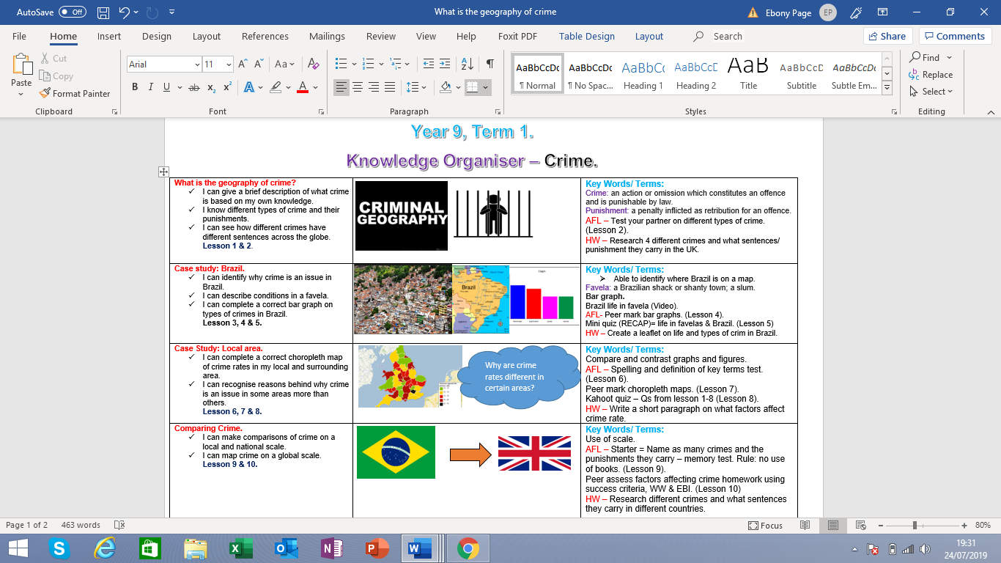

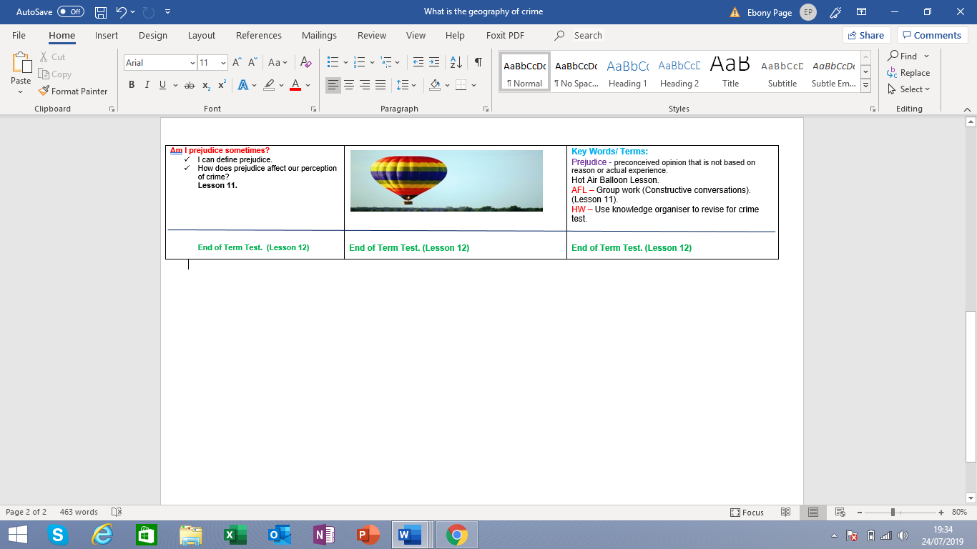

(Knowledge organiser word count: 465)

I have named my term plan a “knowledge organiser” which is laid out as an overview of what we will be covering and ticks for knowledge checks for each lesson, hence the name knowledge organiser. This knowledge organiser can then also be used as a revision guide. My idea is a copy of this is sent home to parents or careers as an overview to term 1 geography so they can be more involved and up to date about what their child is learning at that current time in geography or in this case, for example, term 1 = Crime which lasts for 12 lessons.
On the left-hand column it shows the questions or terms we will be learning and covering in that lesson. This way pupils can see what they are learning lesson by lesson by referring to the ‘success criteria ticks’ and they can also read and research ahead if they want to by checking the left-hand column. When sent home, this layout will also help parents or careers to understand what has been or will be covered in that lesson as each lesson number is included. This links to assessment for learning as it is showing the pupils the success criteria for each lesson and what they will be covering in future lessons. The pupils can then take control of their own learning by researching further, reading ahead of the current lessons or re-checking if they have grasped the current lessons success criteria. The success criteria are a mix of brief and advanced statements such as “I can define prejudice” and “I can identify reasons why crime is an issue in Brazil”, this keeps the work accessible to all while stretching learners to their full potential. In the plan there is also ‘big questions’ such as “how can prejudice affect our perception of crime?”, these style questions are there to provoke critical thinking within learners and to be used to form constructive conversations based upon their own opinion.
In the middle column, there are only images. These images feature in the slide shows or are based on what was taught in the number lesson shown in the left-hand column. The images are there to jog the learner’s memory on what the lesson was about and to use as a visual guide. This can also be used as a talking point when discussing with parents or carers when home. This links with assessment for learning by engaging their memory and recall ability. I can then use these images as starter tasks to engage peer conversations on what the learner can remember from the previous lesson. This is a useful tool for learners to use as it will help for future tasks such as tests or exams.
Lastly, in the right-hand column there are three things of importance. The first item in the column is key words or terms and their definitions. The key words will be referred to throughout the term and will need to be learnt and revised by the learner. They will be referred to and knowledge checked through assessment for learning techniques as low stake quizzes and spelling checks which will then be peer assessed. By this sheet also being sent home parents and carers can refer to key terms and test and recap knowledge at home. The key terms and words are highlighted in purple so pupils can learn to associate key terms will always be highlighted in that specific colour for the purpose of consistency. Underneath key terms the next category is AFL which stands for assessment for learning, the pupils will be aware of these abbreviations as it will become a habit and constantly be referred to during their lessons. Each assessment for learning category highlights which assessment for learning technique they will be using and when as the lesson number is notified for each one. The pupils will be able to see when and what the next knowledge check will be, for example a spelling and definition test. Assessment for learning techniques will vary from kahoot tests, spelling checks, exit tickets and peer assessment. The pupils will be shown how to successfully meet each of the assessment for learning criteria by the classroom teacher. By using a range of techniques that are inclusive to all pupils will not get bored or feel lessons are repetitive of tests but different tactics such as a kahoot quiz or peer assessment. The final section in the right column will be homework. This is a short task at the end of every few topics within the term to consolidate learning and help create a revision guide for the end of term test. Parents and carers can also see when homework is coming up and when it needs to be completed by. This structure also makes it not only accessible by the pupil but also the parents or carers at home as all the key information needed can be located on one sheet for each term or set project. By giving parents or carers at home the opportunity to be apart of the child’s learning this can aid with growing the learner’s confidence outside of a classroom setting when talking about what they have learnt or what they will learn by looking at the knowledge organiser.
Below is my basic scheme of work covering briefly each lesson for term 1. It is my copy of the knowledge organiser and what I will refer to in terms of when assessment for learning fits into my lesson in more detail such as what type of assessment for learning technique will be used. In my plan all assessment for learning tools are highlighted in green to ensure they stand out. The “diamond and pearl” structure of my plan is designed to form a continuous loop of learning. For example, the diamonds are core knowledge to be learnt during the unit of work and the pearls are ‘paths to explore’ and going into more depth or linking topics and support the learning of the fundamentals such as a guide to independent learning. A lesson will be one diamond and then two – three pearls as strands off the knowledge acquired in each lesson. The final section in my plan is a ‘knowledge check’ section as a reminder of when there is opportunity or planned opportunity to use assessment for learning techniques. With careful planning I can ensure assessment for learning fits seamlessly into my lessons without the learners feeling they are constantly being tested.
By linking my knowledge organiser and my scheme of work together I can map when to use recall methods, such as low stakes quizzes and use my planning to choose what questions come up from previous lessons to be able to spot any potential misconceptions or gaps in knowledge that will need recapping. These plans are set for a key stage 3-year 9 group who are mixed ability so I must ensure my planning is inclusive to all to ensure maximum engagement and participation from the class. With some topics being individual work and investigation such as the brazil case study this is promoting independent learning and stretching pupils to their maximum potential.

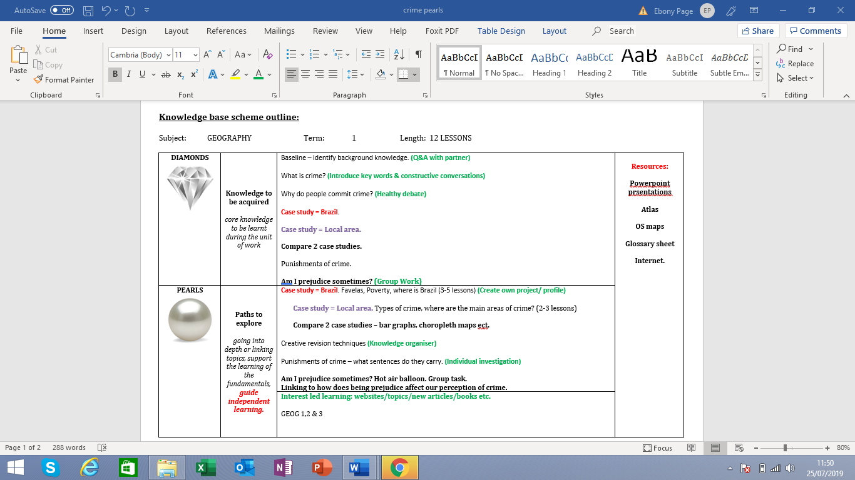

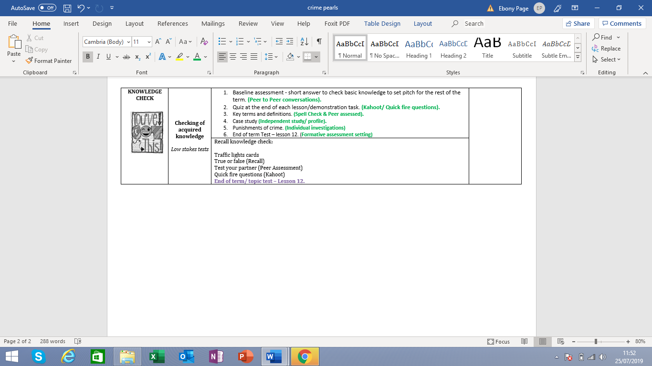

(Scheme of work word count = 288)

My lesson plans would be designed in the same style as my scheme of work with one diamond and two or three pearls to be covered per lesson and always intertwined with assessment for learning elements as shown in my knowledge organiser and my scheme of work. Lesson plans would include greater details such as what assessment for learning strand my starters or plenaries would achieve such as exit tickets with multiple choice or 2-3 short questions on. I would also have a more detailed focus in my lesson plans on how to stretch higher ability and more able and talented pupils (MAT) to their full potential.
This research plan has been set over a term to ensure myself enough time to produce a progress timeline for my leaners. By planning for a whole term, I feel this will give me a true reflection of the live learning taking place within each lesson and if this set up increased grades at the end of the term compared to other classes. I set it over a term due to Dylan Wiliam (2011) stating that “continual forms and variation of assessment within a classroom gives a teacher a wider view of what learning has taken place at that current time rather than a single formative assessment at the end of each large topic which usually spans over a whole term” (Dylan wiliam, 2011). My term plan is intertwined with assessment through learning the entire way through the term leading into the formative assessment which the pupils will already be aware of what lesson that will be through reading the knowledge organiser.
My design for the knowledge organiser was based on pupils having their own “scheme of work” or mini term overview to refer to in order to enable them to take more control of their own learning. This was also a way of engaging them with what was being taught next and when homework was due. Learners then have the option of researching upcoming topics or facts before the lesson has been taught or attempting homework before the date it is set to have it provisionally marked and returned before the due date so the pupil can improv it and achieve a higher mark than originally handed in. By taking it one step further and allowing parents to be involved this I would hope would create a larger feedback loop and encourage further input and conversation based around the work outside of the classroom setting with parents or carers and this in turn would help consolidate learning. However, this depends largely on the learner’s relationships and quality of life at home with the parent or carer. If the learner does not have support outside of the classroom setting, then there will be no scope to extend learning and constructive conversations outside of the classroom setting. Also, it would be hard to track and monitor what impact these discussions outside of the classroom have had on learning compared to inside the classroom setting.
Although the knowledge organiser is in place and learners will be encouraged to research further and read ahead, it is ultimately up to the learner to take control of their learning and become more independent or whether they wait for the classroom teacher to guide them lesson by lesson. Pupils who lack in confidence may find the freedom frightening or overwhelming and this could cause behavioural issues that may need to be managed if the pupils feel not enough support or engagement to all learners is provided. The plan Is designed to be simple and easy to follow so it is inclusive of all learners but I feel although it has some questions that would provoke critical thinking and deeper questioning it may not stretch higher ability learners out of their comfort zone or to their full potential. This would be something I would have to include as a classroom teacher within my lesson plans to ensure effective planning and extra work is prepared for these pupils.
In conclusion I feel my research plan would overall be effective, due to the careful planning in advance and involving pupils in their own learning by providing them with the information they will need in the form of a knowledge organiser that will show them an overview for the whole term right at the start of the term. This will give pupils an option of how they want to organise their own learning with using the knowledge organiser as a guide. A pupil will be encouraged within the classroom to use the knowledge organiser as a revision guide ready for the end of term formative assessment whilst being ‘mini progress checked’ in all the lessons leading up to it. By showing the pupils in advance what is expected as them , nothing will come as a shock to them, which in turn helps in building a comfortable classroom environment where pupils are not afraid of making mistakes or scared of feeling embarrassed in front of peers which in turn will build in confidence and encourage independent learning. As agreed by Dweck (2006), “This will encourage learners to be bold and take risks which in turn will build confidence and create learners who are able to make mistakes without having the fear of being shouted at by the teacher or embarrassed to make mistakes in front of peers”. (Dweck, 2006).
By giving parents or carers an option of becoming more involved in the pupils learning would like to believe this would have a positive impact on the learner in terms of confidence, organisation and creating a larger feedback loop. Parents or carers can see when upcoming homework is due and can also engage in constructive conversations or healthy debates based on what lesson has just been taught as lesson numbers are included in the knowledge organiser. I feel this is a good way as well as homework to help consolidate learning for the pupil and gain involvement from home. Although hard to monitor and track unlike homework records for example. I do feel if effectively used at home this would help build a learner’s confidence and guide them to becoming more independent learners who are in control of their own learning. (Donaldson, 2015).
I truly agree that Assessment for learning is the ‘magic answer’ or ‘golden key’ to enabling teachers to build a bridge between teaching and learning and closing attainment gaps due to being accessible to all types of learners such as additional learning needs or free school meals in an everyday classroom as stated by some education researchers such as Dylan Wiliam (2011) and Donaldson (2015). My research plan is aimed to reflect this statement as I believe it is of key importance to ensure learning is inclusive to all learners and pupils should be more in control of their own learning.

(Word count: 7,205)

Reference List:

Black, P. et al., 2002. Working inside the black box: Assessment for learning in the classroom. London: GL Assessment.
Busch, B., 2018. Research every teacher should know: growth mindset. The Guardian, 4 January.
Cambridge, 2017. Getting started with Assessment for Learning. [Online]
Available at: https://cambridge-community.org.uk/professional-development/gswafl/index.html
Cohen, L., Manion, L. & Morrison, K., 2017. Research Methods in Education. 8th ed. s.l.:Routledge.
Data Protection Act, 1998. Data Protection Act 1998
Available at: https://www.legislation.gov.uk/ukpga/1998/29/contents
Denzin, L., Norman, K., Lincoln & Yvonna, S., 2005. The Sage Handbook of Qualitative Research. 3rd ed. California: Sage.
Donaldson, G., 2015. Successful Futures.
Dweck, C., 2006. Mindset: The New Psychology of Success. New York: Random House.
Edwards, A. D. & Westgate, D. P., 1994. Investigating classroom talk. 2nd ed. London: Westgate.
Gilmore, T., Krantz, J. & Ramirez, R., 1986. Action based modes of inquiry and the host-researcher relationship, s.l.: s.n.
Hattie, J., 2008. Visible Learning: A synthesis of over 800 meta-analyses relating to achievement.. Melbourne: s.n.
Hughes, S., 2013. School banding. In Brief by Senedd Research, 13 December.
The Assessment Reform Group, 1999. Assessment for Learning: Beyond the Black Box, Cambridge: University of Cambridge.
Welsh Assembly Government, 2010. How to develop thinking and assessment for learning in the classroom, Cardiff#: Welsh Government.

