Effective Team Working and Communication
1712444
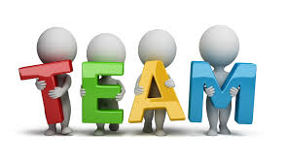

Executive Summary
The purpose of this report is to explain the importance of effective Team Working and Communication within the work place.
The report is based on a case study of a small convenience store which has grown rapidly within in a year from employing three members of staff to twenty. The company now resembles a large discount store.
Employees work variable shifts including night shift and some work part time.
The staff include four employees working in a stockroom accepting deliveries and filling shelves, two cleaners, twelve sales assistants and two managers, however one sales assistant is on maternity leave.
Due to the rapid expansion Sarah Davies the owner has asked the business consultant for advice on successful teamworking and communication.
The report includes information on
why communication is important in successful organisations.
Non-verbal and verbal communications.
Effective communication specific to the case study.
The theories of Tuckman and Belbin have been used to improve communication with the organisation.

Table of Contents
1.Introduction
2.Main Findings
2.1 Recommendations
3.Conclusion
4.Reference list

Introduction
Organisations often use business models to develop behaviour and effective teamwork within companies in 1965 Bruce Tuckman a psychology professor published an article on development sequences in small groups.
According to (Egolf 2013) Tuckman examined behaviours of a number of small groups consisting of three to nine individuals and came up with his theory which he describes as forming, storming, norming, performing Mary Jenson added another stage to his theory called Adjourning in the 1977.
Tuckman (1965) labelled forming as the stage where most team members are positive and polite. It is essential for leaders to play a dominant role in the forming phase as members roles are uncertain.
The forming stage can be slower as participants in the groups can take time to build relationships and feel contented with one another.
Storming is the stage where conflict starts to arise members start to challenge authority agendas start to become clear and members start to ask questions.
Norming is when the group finds ways to resolve conflict and become a cohesive unit, criticism is given constructively.
Performing is when members start to co-operate with one another to focus on a clear goal.
Adjourning is when the group has completed the intended goal and start to disperse members will start to feel a sense of loss or relief depending on the outcome of the task/ relationships with other members as quoted by (McGrath 2017).
Belbin is an additional method which is widely used Dr Raymond Meredith Belbin created the Belbin theory (team roles at work ,1981) the model was invented to assess how individuals behave within team environments, the assessment includes the individuals own evaluation of personal behaviour and how behaviour is perceived by others.
Belbin analysed the data and put the behavioural styles into nine categories of team roles he described them as:
Plants are highly creative and effective at solving problems
Monitor Evaluators are needed to provide rational thinking, making unbiassed judgements, evaluating the team’s options in a neutral way.
Coordinators focus on the team’s objectives draw out team members and delegate work appropriately,
Resource instigators provide inside knowledge, communicate naturally and seek to extend the range of the team’s useful contacts and partnerships.
Implementers are successful at planning they try to conduct a practical strategy and carry it out effectively
Completer Finishers are meritoriously known for being perfectionist often they are used to “polish at the end”, scrutinizing the work for errors to achieve perfection.
Team workers help the team to develop using their adaptability to recognize the work required to achieve the goal and carry it out successfully.
Shapers are stimulating individuals who provide necessary encouragement to the team ensuring that focus is not lost.
Specialist always has in depth knowledge of the subject as quoted by (monert 2015).
Morgan(2017) states that The Belbin questionnaire identifies individuals team roles reflecting on what individuals would do naturally and what they would do if they needed to respectively, The research carried out by Belbin and others suggests the more the team reflect on all the team roles the better the team performance is likely to be.
Main Findings
Employees need to communicate effectively in the workplace to achieve the best results, communication in the workplace is not simply a matter of computer cables emails and messages pinned on boards Eunson (2012) mentions that there are invisible networks of human interaction.
Communication is defined as a two- way exchange of information involving a sender and a receiver.
The four most common types of communication are interpersonal communication, non-verbal communication, written communication and oral communication.
Interpersonal communication is an exchange of information between two or more people it is not entirely about the words that are used the participants in the conversation usually examine the other participants tone of voice, facial expressions and body language these are known as non -verbal messages when two or more people are in the same place and aware of one another presence communication is taking place no matter how subtle or unintentional.
Without speech, when two or more people are in the same location and aware of the other person they are usually observing facial expressions, dress form, emotional state ,personality traits, intentions, posture, however messages we send to other participants in conversations or situations can be perceived differently to how we expected if the wrong type of body language tone of voice is used as managers it is essential to have certain skills to ensure teams work effectively, some important skills required to be a successful manager are listening skills, non-verbal communication, clarity and concision, friendliness, confidence, empathy, being open-minded and respectful at all times, trustworthiness is also important it is proven that teams usually work better when they have an incredible leader.
Written communication involves any time of communication that used written words there are various forms used in companies including memos, reports, bulletins, job descriptions, employee manuals, emails, letters and instant messages.
The advantages of written communication are there is usually no need for personal contact, it is usually written proof in-case of a dispute and can be effective in saving money instead of calling long distance in some cases email can be sent and received instantly.
Some disadvantages are the delay in communication it may take longer to reach the receiver in letter form and the receiver may not have checked email or instant message.
Lack of secrecy once its on paper anyone can read it can be costly if the sender and receiver are sitting next to each other it can be costly for internet and use of paper, however It can be a good way to exchange information and ideas in secret if there are two trustworthy participants whom have built relationships.
Oral communication implies communication through word of mouth whether it may be a telephone conversation, presentation or one to one dialogue in these types of conversation there is usually a high level of understanding especially with one to one conversations and presentations as observers can examine the sender’s non-verbal communication skills.
Although all the skills mentioned above are important to be a great communicator listening skills are the key to success when communicating in some cases the senders of messages are often more interested in what they have to say themselves rather than listening to what the receiver wants to say and taking on board any feedback.
Effective listeners convey messages and are able to listen to what is said according to Learmonth (2018) to listen effectively in a one to one manager to employee situation we must look at the speaker and hear what they say nod in agreement and send positive non-verbal signals such as nodding head to show you are actively listening an employee approaching a manager with a problem is going to feel more relaxed in the situation and gain more trust if the manager is displaying positive body language and expressing themselves in a calm and collected way rather than being alarmed by the message received, using a calm voice, eye contact, showing interest and being empathetic towards the employee letting facial expressions display to the observer that interest is being taken in what they have to say, removing all barriers and letting the employee express the message they want to be acknowledged.
Employees are not going to feel comfortable approaching a manager with a problem if for example they are showing no signs of listening presenting themselves in a negative way using body language such as crossed arms and angry facial expressions.
Overall effective communication between employees and managers leads to successful organisations.
Teamworking is another important aspect of organisations Maund (2017) argues that teams have tremendous potential to accomplish tasks well beyond the reach of single individuals although they are not without problems, working in teams can be exasperating teams can include members who have lack of commitment and poor leadership, sometimes members have interpersonal conflict with other members and lack of communication between members, it is not unknown for the majority of work in a team to be completed by only a few members this can result in loss of productivity due to poor structure lack of planning and organisational skills as mentioned above managers can help by observing members of the company in team work activities and creating teams that could be successful by identifying the personalities using the Belbin model.
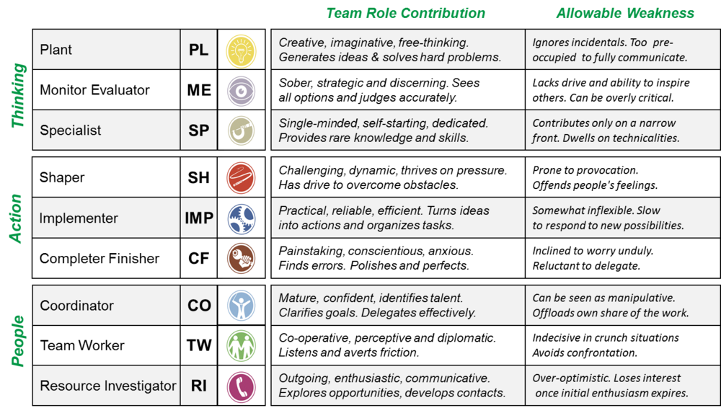

Recommendations
The Business consultant recommends that Sarah Davies can improve communication and team working in the organisation by ensuring managers are trained to the highest standard in communication skills and team working skills, if this is not the case there are accredited courses that can be attended to achieve qualifications and learn more about skills needed to be a productive manager. Managers should brief in a daily meeting to employees before the start of shifts what the strategy of the shift includes managers themselves should prioritize tasks from most important to least important.
All staff members apart from cleaners should be cross trained in all roles inside the store it is effective when staff members are not at work due to sickness, maternity, bereavement leave or termination of employment therefore there is always another member of staff trained in the role it improves flexibility and reduces costs and stress of finding another member of staff immediately.
Cross training will be fairly cost effective as members of staff will be trained by other employees this gives a chance to build some great interpersonal relationships it lets members of staff get to know people, they are usually unfamiliar with this is great for effective team working, while training is taking place managers should take some free time if available to observe and speak to the trainer and trainee individually and take on board any comments or feedback.
Managers should have knowledge of Tuckman and Belbin theories while observing the cross -training managers should gain knowledge of the personalities of employees using the Belbin theory he/she can learn the traits of employees and produce teams that should work successfully together.
When the managers have knowledge of the Tuckman theory they can lead positively and help during different stages, mediate between the “storming” stage to help get to the “performing” stage to complete the goal intended.

Managers should daily complete an end of shift report to pass on to the manager of the opposite shift this entails of tasks that are incomplete, tasks that should be completed any problems that have arisen and solutions needed, however they should frequently use oral and non-verbal communications when passing over shifts the business consultant recommends monthly meetings among managers to discuss any problems or new ideas to improve productivity and morale at the company when face to face communication is not available managers should use email to communicate.
Sarah Davies should visit the store very frequently at least once a week to talk to staff individually Listen to feedback from her employees as great listeners are great communicators, discovering any problems the business has and finding solutions can lead to more growth in the company, with happy employees and great advertising the company can increasingly expand again like it has done in the past year, happy employees are likely to recommend the company to friends and family to buy products and a great place to work.
Employees work better when they have managers, they have constructed great interpersonal relationships and trust with.
Written communication in the form of leaflets, adverts on the internet and social media is a great way of attracting new customers.
Conclusion
The writer agrees that effective communication is essential in organisations and if communication in an organisation is non-existent or poor there are ways managers can assist employees to improve it, having knowledge on models such as Tuckman and Belbin are great for observing employee behaviours in teams and getting to know personality traits of each employee and selecting appropriate teams.
When a manager has effective communication and strong leadership skills, they are a great asset to the company and can communicate successfully between all members of staff and customers in different situations mediating and using their skills to reach the best possible outcome.
Morgan (2017) argues that Successful managers can create a sense of togetherness in much larger groups and organisations by making employees feel part of team and creating their own identity within the group by communicating respectfully and sending a clear message meaning people will be more likely to commit effort when there is no external reward to do so.

References
Andrew Maund, Michaela Shreik, Paul k Tinkler (2017). Certificate in Higher Education, Skills for the Workplace Student Yearbook. london: SAGE Publications Ltd. 45.
Baden Eunson (2012). Communication in the workplace. 2nd ed. Australia: Baden Eunson. 21.
Communication in Groups and Teams. 3rd ed. Bloomington: iUniverse. 3.
Donald B Egolf (2013). Forming Storming Norming Performing: Successful
James McGrath (2017). The Little Book Of Big Managment Theories and How to Use them. 2nd ed. Harlow, England: Pearson. 44.
Lynne Learmonth (2018). An Introduction to Listening Skills. 2nd ed. Derbyshire UK: Lynne Learmonth. 12-18.
Nel M Montert . (2015). Belbin. the way forward for innovation teams. 1 (1), 2.
Peter Morgan (2017). The Business Students Guide To Study and Employability. London: SAGE Publications Ltd. 208.
Peter Morgan (2017). The Business Students Guide To Study and Employability. London: SAGE Publications Ltd. 215.
Tuckman, B.W. (1965) 'Developmental Sequence in Small Groups,' Psychological Bulletin, Volume 63, June 1965.

