
APPENDIX GA36a

LEVEL 4 ASSESSMENT SPECIFICATION

Student name: | Adam Clarke | Student ID number: | 1708038/1
Programme: | BSc/HND Computing (All Streams)
Module: | Internet Technology and Security
Module code: | ACCA4018 | Contribution to Overall Module Assessment (%): | 50%
Lecturer: | Kemi Ademoye | Internal Verifier:
Assignment Title: | HTML & CSS Web Development | Word count (or equivalent): | 1500 - 2000 words
Submission deadline: | 8th February 2019 | Return date of provisional marks & written feedback:
Submission method: | All written assessments, where practical and possible, must be submitted via Turnitin unless otherwise instructed by the Lecturer. (Please DO NOT put this assessment specification into Turnitin or it will match many similarities with other students’ submissions.)  Alternative submission method (if applicable):  Late submission of the assessment will result in a late penalty mark. Penalties for late submission: Up to one week late, maximum mark of 40%. Over one week late, 0%. Only the Extenuating Circumstances Panel may approve a change to submission dates.
Academic honesty / referencing: | Academic honesty is required. In the main body of your submission you must give credit to authors on whose research and ideas your work is based. Append to your submission a reference list that indicates the books, articles, etc. that you have used, cited or quoted in order to complete this assessment.

Module Learning Outcomes
(from module syllabus)
Demonstrate an understanding of the standards, concepts, principles and practice required in the implementation of websites and to select and deploy web languages to implement websites

TASK DESCRIPTION

In order to demonstrate your understanding of the standards, concepts, principles and practice required in the implementation of websites, you are required to complete the tasks outlined below.

Task 1: Design and hand-code a website using web standards
- Design and hand-code a website that is made up a reasonable number (minimum of 5) of relevant and related pages using web standards.
Possible examples of websites include a site:
- for an organisation of your choice, which may be fictitious in nature
- to promote a personal interest or hobby, a favourite band, a town/city, etc.
- Create a compressed (zipped) file containing your completed Website files and upload to the link provided on Moodle.

Task 2: Report
You are required to produce a specification report containing relevant documentation of your research and web development work as a single Word document file with the following sections:
- Title Page
- Containing your name, student number, course and the module name and the date
- Table of Contents:
- Outlining all other sections making up the report
- ‘Introduction’ section
- An abstract: a short summary description of the contents of the report
- ‘Requirements’ section:
- A brief introduction to the website, describing its purpose and subject matter, the target audience and its relevance.
- ‘Implementation’ section:
- Screen shots of all of the pages of the completed website (not code).
Note: If any of the pages are very long, it is okay to provide a cropped view showing a reasonable amount of content.
- Validation
Validate both your HTML and CSS code of your completed website and provide the validation results. If you have any errors, provide a brief description of how you corrected the error or what you think the errors are in cases where you are unable to correct the error. Please do not describe every single error – a general statement will do!
The validators can be found at:
  - HTML (http://validator.w3.org/) - you are only required to validate the HTML of your home page
  - CSS (http://jigsaw.w3.org/css-validator/) – you are only required to validate your website’s main CSS
- 'Evaluation' section:
- An Accessibility Evaluation of the Website.
With reference to WCAG 2.1, briefly discuss the accessibility of your website with respect to the four principles that provide the foundation for Web accessibility as applicable to your website. Some tools that may help you include:
  - Visual Studio
  - http://contrastchecker.com/
  - http://juicystudio.com/services/luminositycontrastratio.php
  - Google Chrome Extensions:
    - aXe
    - WAVE Evaluation Tool
  - Firefox Extensions:
    - AI Inspector Sidebar
- An evaluation of the completed website taking into consideration its design (look and feel), usability (functionality) and content (information), including recommendations for future improvements.
- An evaluation of your website’s on-page Search Engine Optimisation (SEO).
- References:
- Any information sources (e.g. relevant journals, books, online sources and articles) that you have consulted.

Submission Details
You are required to complete the tasks outlined in the 'Task Description' section and to submit:
- An electronic version of your Report via Turnitin.
- Upload the zipped files for Task 1 containing your web development work to Moodle.

GUIDANCE FOR Students IN THE COMPLETION OF TASKS

NOTE: The guidance offered below is linked to the five generic assessment criteria overleaf.

- Engagement with Literature Skills
Your work must be informed and supported by scholarly material that is relevant to and focused on the task(s) set. You should provide evidence that you have accessed an appropriate range of sources, which may be academic, governmental and industrial; these sources may include academic journal articles, textbooks, current news articles, organisational documents, and websites. You should consider the credibility of your sources; academic journals are normally highly credible sources while websites require careful consideration/selection and should be used sparingly. Any sources you use should be current and up-to-date, mostly published within the last five years or so, though seminal/important works in the field may be older. You must provide evidence of your research/own reading throughout your work, using a suitable referencing system, including in-text citations in the main body of your work and a reference list at the end of your work.

- Knowledge and Understanding Skills
At level 4, you should be able to demonstrate knowledge of the underlying concepts and principles associated with your area(s) of study. Knowledge relates to the facts, information and skills you have acquired through your learning. You demonstrate your understanding by interpreting the meaning of the facts and information (knowledge). This means that you need to select and include in your work the concepts, techniques, models, theories, etc. appropriate to the task(s) set. You should be able to explain the theories, concepts, etc. to show your understanding. Your mark/grade will also depend upon the extent to which you demonstrate your knowledge and understanding.

- Cognitive and Intellectual Skills
You should be able to present, evaluate and interpret qualitative and quantitative data, in order to develop lines of argument and make sound judgements in accordance with basic theories and concepts of your subject(s) of study. You should be able to evaluate the appropriateness of different approaches to solving problems related to your area(s) of study and/or work. Your work must contain evidence of logical, analytical thinking. For example, to examine and break information down into parts, make inferences, compile, compare and contrast information. This means not just describing what! But also justifying: Why? How? When? Who? Where? At what cost? You should provide justification for your arguments and judgements using evidence that you have reflected upon the ideas of others within the subject area and that you are able to make sound judgements and arguments using data and concepts. Where relevant, alternative solutions and recommendations may be proposed.

- Practical Skills
At level 4, you should be able to apply the basic underlying concepts and principles to evaluate and interpret these within the context of your area of study. You should be able to demonstrate how the subject-related concepts and ideas relate to real world situations and/or a particular context. How do they work in practice? You will deploy models, methods, techniques, and/or theories, in that context, to assess current situations, perhaps to formulate plans or solutions to solve problems, or to create artefacts. This is likely to involve, for instance, the use of real world artefacts, examples and cases, the application of a model within an organisation and/or benchmarking one theory or organisation against others based on stated criteria.

- Transferable Skills for Life and Professional Practice
Your work must provide evidence of the qualities and transferable skills necessary for employment requiring the exercise of some personal responsibility. This includes demonstrating: that you can communicate the results of your study/work accurately and reliably, and with structured and coherent arguments; that you can initiate and complete tasks and procedures, whether individually and/or collaboratively; fluency of expression; clarity and effectiveness in presentation and organisation. Work should be coherent and well-structured in presentation and organisation.

Guidance specific to this assessment:

Assignment Marking Scheme

- Engagement with Literature Skills (5%)
Marks will be awarded based on you demonstrating your engagement with literature skills and the use of appropriate reference sources to support your work.

- Knowledge and Understanding Skills (20%)
Marks will be allocated based on the appropriate use and quality of Web standards (HTML and CSS) used to implement your Website and the outcome and interpretation of your validation and accessibility testing.

- Cognitive and Intellectual Skills (30%)
Marks will be awarded based on the quality of the documented Evaluation section of the report.

- Practical Skills (40%)
Marks will be awarded based on the quality and functional use of the website. The overall design of the Website, including the design (creativity and look and feel), usability (functionality) and content (information) will also be taken into account.

Note:
You may be required to provide a demonstration of the implemented website.

- Transferrable Skills for Life and Professional Practice (5%)
Marks will be awarded based on the written and presentational quality of the report.

Student FEEDBACK FORM

This section details the extent to which the assessment criteria are demonstrated by you, which in turn determines your mark. The marks available for each category of skill are shown. Lecturers will use the space provided to comment on the achievement of the task(s), including those areas in which you have performed well and areas that would benefit from development/improvement.

Generic Assessment Criteria | Marks available | Marks  awarded
1. Engagement with Literature Skills
.
Engagement with a limited range of mostly relevant and credible sources but with some reliance on information gained through class contact. Some omissions and minor errors.  Referencing conventions evident though not always applied accurately or consistently. |  | 2.25
 | 5 | 2.25
2. Knowledge and Understanding Skills

Competent knowledge of the basic underlying concepts and principles. Exhibits very good understanding. |  | 12
 | 20 | 12
3. Cognitive and Intellectual Skills

Good evaluation of the underlying concepts and principles. Can interpret qualitative and quantitative data, with minor errors.  An emerging ability to use evidence to support the argument.  Mostly valid arguments and logical judgements. |  | 17.4
 | 30 | 17.4
4. Practical Application Skills

A very good website demonstrating an application of a range of basic methods, materials, tools and/or techniques.  Very good consideration of the context of the application. Very good evidence of different approaches to problem-solving in particular contexts and proposes appropriate solutions. |  | 26
 | 40 | 26
5. Transferable Skills for Life and Professional Practice

Work is accurate, coherent, fluent, well-structured and organised.  Can work effectively independently and/or as part of a team, with very good contribution to group activities. Demonstrates very good skills for employment requiring the exercise of some personal responsibility, with just occasional minor weakness. |  | 3.1
 | 5 | 3.1

Assessment Mark (Assessment marks are subject to ratification at the Exam Board. These comments and marks are to give feedback on module work and are for guidance only until they are confirmed. ) | Late Submission Penalties (tick if appropriate) |  | 60.75%
 | Up to 1 week late (40% Max) |  | 60.75%
 | Over 1 week late (0%) |  | 60.75%

GENERIC ASSESSMENT CRITERIA

Level 4
In accordance with the Framework for Higher Education Qualifications, at the end of Level 4 students will be expected to have demonstrated knowledge of the basic underlying concepts and principles of a subject, and an ability to evaluate and interpret these within the context of that area of study. They should be able to present, evaluate and interpret qualitative and quantitative data in order to develop lines of argument and make sound judgements in accordance with basic theories and concepts of their subject(s) of study. They will have learned how to evaluate different approaches to solving problems, and will be able to communicate the results of their study/work accurately and reliably, and with structured and coherent arguments. They will be able to undertake further training and develop new skills within a structured and managed environment and will have the qualities and transferable skills necessary for employment requiring the exercise of some personal responsibility.

Level 4 | FAIL | MARGINAL FAIL | SATISFACTORY  (3rd / Pass) | GOOD  (2.2 / Pass) | VERY GOOD  (2.1 / Merit) | EXCELLENT  (1st / Distinction) | EXCEPTIONAL  (1st / Distinction)
Category | 0-29% | 30-39% | 40-49% | 50-59% | 60-69% | 70-84% | 85-100%
Engagement with literature (including reading, referencing,  academic conventions and  academic honesty) | Little or no evidence of reading and/or reliance on inappropriate sources.  Views and findings mostly unsupported and non-authoritative.  Referencing conventions used incoherently or largely absent. | Poor engagement with essential reading. No evidence of wider reading. Reliance on inappropriate sources, and/or indiscriminate use of sources. Heavily reliant on information gained through class contact. Inconsistent and weak use of referencing. | Engagement with a limited range of mostly relevant and credible sources but with some reliance on information gained through class contact. Some omissions and minor errors.  Referencing conventions evident though not always applied accurately or consistently. | Engagement with an appropriate range of literature, including sources retrieved independently. Some over-reliance on texts rather than other sources. Referencing may show minor inaccuracies or inconsistencies. | Engagement with a wide range of literature, including sources retrieved independently.  Selection of relevant and credible sources. Generally sound referencing, with no/very few inaccuracies or inconsistencies. | Engagement with an extensive range of relevant and credible literature. Consistently accurate application of referencing. | Exceptional engagement with an extensive range of relevant and credible literature. High-level referencing skills consistently applied.
Knowledge and understanding (Knowledge of the basic underlying concepts and principles of a subject.) | Major gaps in knowledge and understanding of the basic underlying concepts and principles of the subject matter. Inclusion of irrelevant material. Substantial inaccuracies. | Gaps in knowledge of the basic underlying concepts and principles, with flawed or superficial understanding. Some significant inaccuracies and/or irrelevant material. | Limited knowledge and understanding of the basic underlying concepts and principles within the subject area. Some elements may be missing. | Knowledge of the basic underlying concepts and principles is accurate with a good understanding of the field of study but lacks depth and/or breadth. | Competent knowledge of the basic underlying concepts and principles. Exhibits very good understanding. | Excellent knowledge and understanding of the basic underlying concepts and principles of the subject. | Exceptional, detailed knowledge and understanding of the basic underlying concepts and principles
Cognitive and intellectual skills  (Evaluate underlying concepts and principles of a subject and interpret qualitative and quantitative data in order to develop lines of argument and make sound judgements.) | Wholly or almost wholly descriptive work. Little or no evaluation of the underlying concepts and principles.  Failure to develop arguments, leading to illogical or invalid judgements. Minimal or no use of  evidence to back up views. | Largely descriptive work, with superficial evaluation of the underlying concepts and principles. Weak interpretation of data, flawed development of arguments and judgements. Information accepted uncritically, uses generalised statements made with scant evidence and unsubstantiated opinions. Ideas sometimes illogical and contradictory. | Limited attempt at evaluation of the underlying concepts and principles, tending towards description.  Can interpret qualitative and quantitative data but with some errors. Some evidence to support emerging arguments and judgements but these may be underdeveloped or with a little inconsistency / mis-interpretation. | Good evaluation of the underlying concepts and principles. Can interpret qualitative and quantitative data, with minor errors.  An emerging ability to use evidence to support the argument.  Mostly valid arguments and logical judgements. | Sound evaluation of the underlying concepts and principles. Can interpret qualitative and quantitative data accurately. Ability to devise arguments using evidence to make mostly appropriate and valid judgements. | Excellent evaluation of the underlying concepts and principles. Can interpret qualitative and quantitative data accurately and with some insight. Excellent ability to devise arguments using evidence and make appropriate and valid judgements. | Exceptional evaluation of the underlying concepts and principles based evidence. Outstanding interpretation of qualitative and quantitative data.  Exceptional ability to devise arguments using evidence and make wholly appropriate and valid judgements.
Practical skills  (Different approaches to solving problems in particular contexts.) | Limited or no use of taught, basic methods, materials, tools and/or techniques.  Little or no appreciation of the context of the application.  Very weak evidence of different approaches to problem-solving in particular contexts. | Rudimentary application of taught, basic methods, materials, tools and/or techniques but without consideration and competence. Flawed appreciation of the context of the application.  Weak evidence of different approaches to problem-solving in particular contexts. | An adequate awareness and mostly appropriate application of basic methods, materials, tools and/or techniques.  Basic appreciation of the context of the application.  Can identify problems in particular contexts and propose basic alternative approaches or solutions though there may be errors. | A good and appropriate application of basic methods, materials, tools and/or techniques.  Clear appreciation of the context of the application.  Good evidence of different approaches to problem-solving in particular contexts and proposes mostly appropriate solutions. | A very good application of a range of basic methods, materials, tools and/or techniques.  Very good consideration of the context of the application. Very good evidence of different approaches to problem-solving in particular contexts and proposes appropriate solutions. | An advanced application of a range of taught, basic methods, materials, tools and/or techniques.  The context of the application is well considered, and insightful.  Excellent evidence of different approaches to problem-solving in particular contexts and proposes appropriate solutions. | Exceptional levels of application and deployment skills in particular practical contexts. Outstanding identification of problems in particular contexts and formulation of wholly appropriate, thoughtful solutions / different approaches.
Transferable skills for life and professional practice  (Communicate the results of their study/work accurately and reliably, and with structured and coherent arguments; the qualities needed for employment requiring the exercise of some personal responsibility within a structured and managed environment.) | Work is poorly structured, disorganised, inaccurate and/or confusingly expressed. Very weak use of language and/or very inappropriate style. Failure to work effectively individual or as part of a group. Little or no evidence of the skills for employment requiring the exercise of some personal responsibility. | Work is poorly presented in a disjointed manner. It is loosely, and at times incoherently, structured, with information and ideas often poorly expressed. Weak use of language and/or inappropriate style. Flawed approach to individual or group work, meeting only partial obligations to others. Limited evidence of the skills for employment requiring the exercise of some personal responsibility. | Mostly ordered presentation and structure in which relevant ideas / concepts are reasonably expressed. Work may lack coherence and/or accuracy in places. Can work as part of a group, meeting most obligations to others but perhaps with limited involvement in group activities.  Demonstrates the basic skills for employment requiring the exercise of some personal responsibility, with some areas of minor weakness. | Mostly coherent, organised and accurate work, in a suitable structure and is for the most part clearly expressed. Can work effectively independently and/or as part of a team, with clear contribution to group activities.  Demonstrates the skills for employment requiring the exercise of some personal responsibility, with some areas of strength and some of minor weakness. | Work is accurate, coherent, fluent, well-structured and organised.  Can work effectively independently and/or as part of a team, with very good contribution to group activities. Demonstrates very good skills for employment requiring the exercise of some personal responsibility, with just occasional minor weakness. | Work is coherent, very fluent and is presented professionally. Can work effectively independently and/or as part of a team, with an excellent contribution to group activities. Demonstrates excellent skills for employment requiring the exercise of some personal responsibility with an appetite for further development. | Work is accurate, exceptionally coherent, very fluent and presented well. Can work effectively independently and/or as part of a team, with an exceptional contribution to group activities. Demonstrates exceptional skills for employment requiring the exercise of some personal responsibility with an appetite for further development.

THIS DOCUMENT IS ALSO AVAILABLE IN WELSH

Website Report
HNC Year 2 - Internet Technology and Security
HTML & CSS Web Development

January 14, 2019
Authored by: Adam Clarke
Student Number: 1708038

Contents
Introduction: 2
Requirements: 2
Implementation: 3
Validation: 9
Evaluation: 10
Accessibility: 10
Design, functionality & content: 10
References 12

Introduction:
The following report will be describing and evaluating the website that has been created. It will include an implementation section with screenshots of the finished website along with a brief description of each page. As well as a description of its purpose, subject matter & target audience. There will also be an evaluation of the accessibility of the website and validate the code used to create it.

Requirements:
The website is based on a TV cookery show that is no longer aired; “Ready, Steady, Cook” created describe the show as if it were still currently being shown on TV. The purpose of the site is to promote the show and inform viewers what it is about as well as giving them more information on the show’s host; Ainsley Harriott. The target audience would be those who have access to a TV and are interested in cookery and/or Ainsley Harriott. There is also a “Contact Us” page where viewers can get in touch via email, fax, telephone or use the directions provided to visit the office headquarters directly which I have based this in Haverfordwest ( This is a fictitious office).

Implementation:

This section will show the implementation of the website and screenshots of all the completed pages:
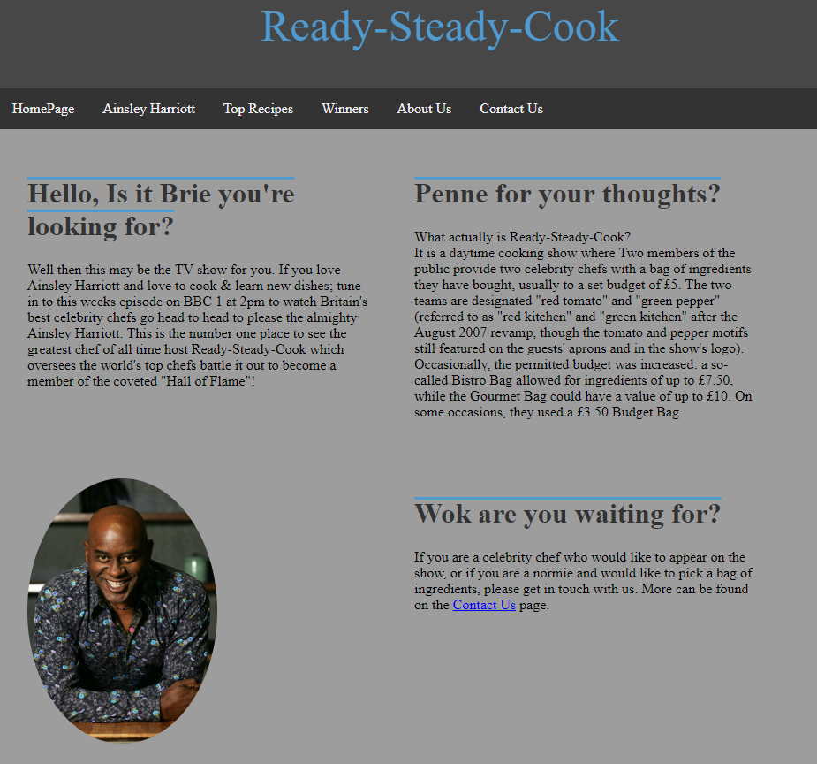
Above is the Homepage for the website; it includes a description of the TV show as well as a picture of Ainsley Harriott – The TV show’s presenter. There is also a link to the “Contact Us” page as well as the navigation bar at the top of the page. The navigation bar is on all pages and is kept consistent throughout along with the site’s colour scheme.
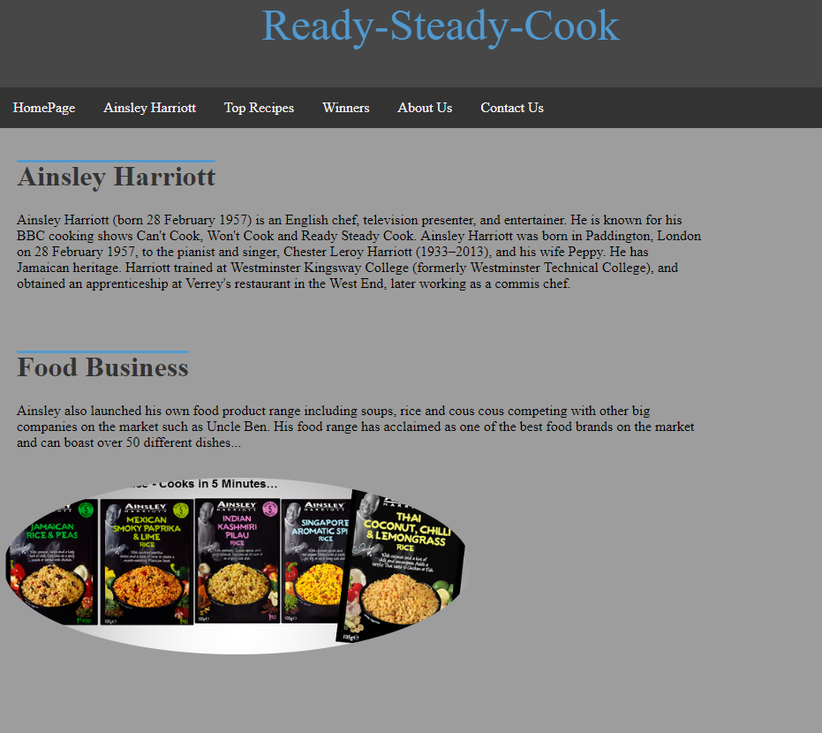
The above webpage is the “Ainsley Harriott” page that gives a brief description of him and his career as well as his food range. Some of the information on this page was obtained from the Ainsley Harriott Wikipedia page.
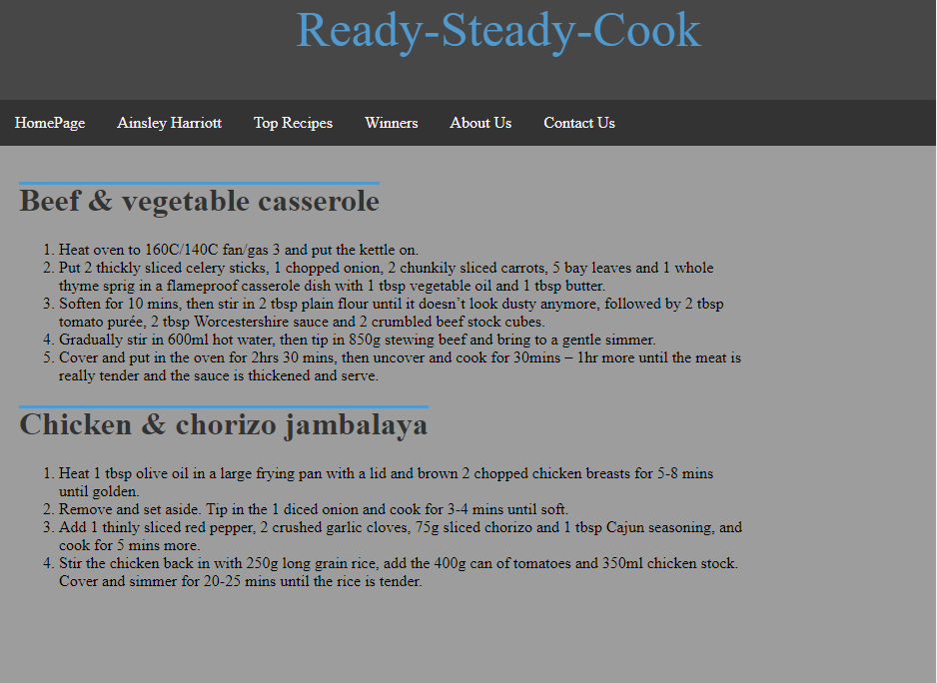
This is the “Top Recipes” page and includes some of the most popular recipes that have been created in the show so viewers at home can try to recreate them themselves. These recipes have been taken from another website and will include this in the “references” section. [1] [2]
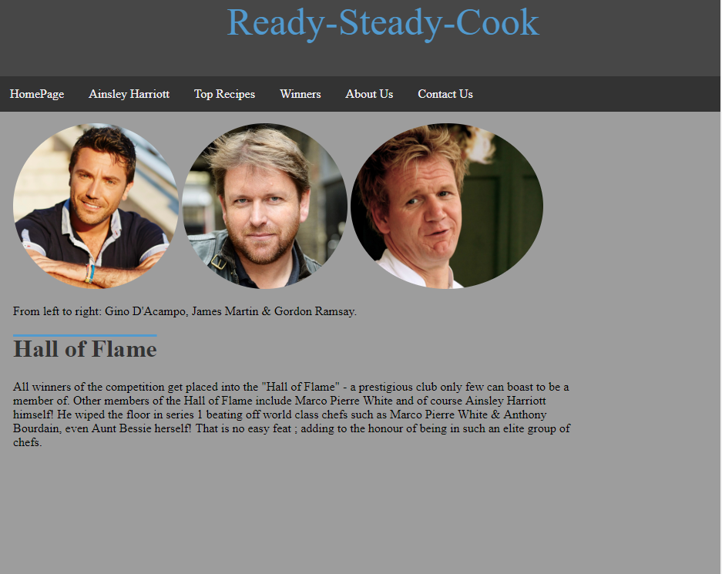
The “Winners” page briefly lists some of the show’s previous winners. The “Hall of Flame” is a club fictitious in nature used only for the purpose of this website.

When images on the site are selected they are opened up in a lightbox gallery – above is an example.
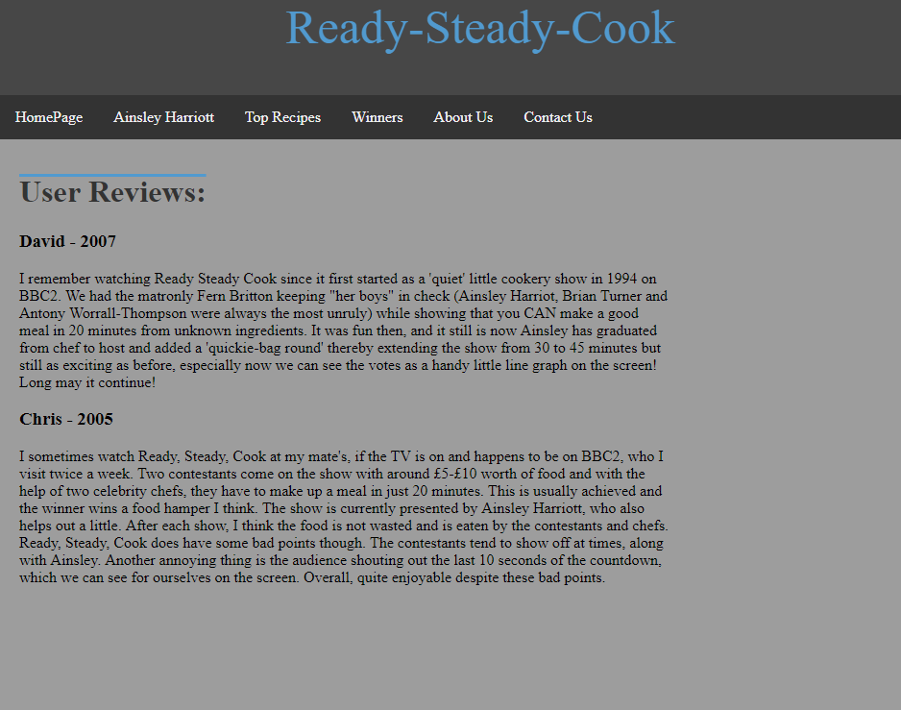
Above is the “About us” page and includes reviews of the TV show. These are actual reviews that have been written about the show and have been used in the website and will be credited in the “references” section. [3]
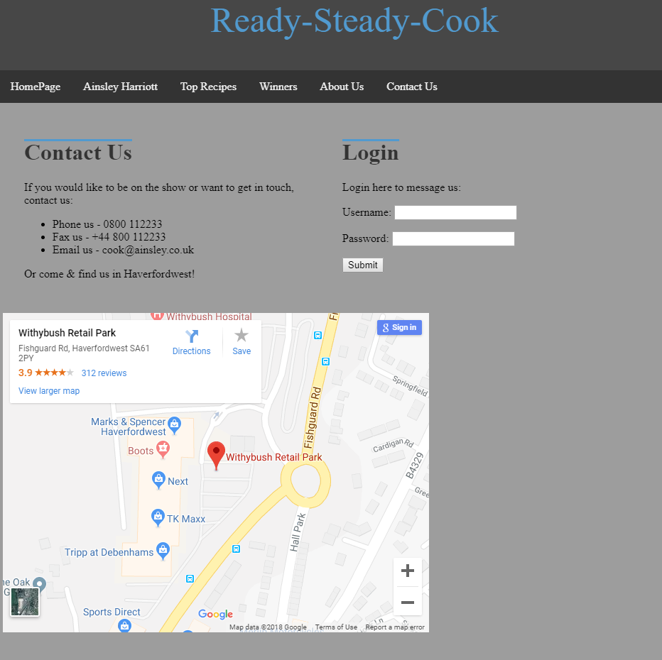
Above is the “Contact Us” page and includes contact details as well as directions to the show’s headquarters in Haverfordwest via an embedded Google Maps page. There is also an option to login.

Validation:

I have validated all of the HTML & CSS code used in my website. I validated the HTML using the following link: http://validator.w3.org/.
When I validated my code I received an error on the “contactUs” page; “The frameborder attribute on the iframe element is obsolete. Use CSS instead.” This error refers to the code I used to embed the map from Google maps. I embedded the map direct from Google maps using the HTML provided on the Google Maps webpage. For this reason I have chosen to ignore the error message as my website works correctly with it.
I also validated the CSS of my “HomePage” webpage and received 3 errors:
Firstly “File not found: import file://localhost/style.css: Operation not permitted”, secondly “Parse Error { box-sizing: border-box; }” and thirdly “File not found: import file://localhost/css/lightbox.css: Operation not permitted”.
I have chosen not to alter my code to fix these errors as the first and third errors state they cannot find my main CSS page for the website and the CSS page. However, my webpage works and includes the CSS used in the two CSS pages so I do not see how this would be considered an error. The second error is a parse error and to fix this I have removed that line of code from my page. The error has now gone and my website seems to be in working order.

Evaluation:

Accessibility:
The following section will be referencing Web Content Accessibility Guidelines (WCAG 2.1) [4]
Having read the WCAG 2.1, I have evaluated my website and have adhered to the guidelines to the best of my ability. Success criterion 1.4.1 – Use of colour indicates colour is not “the only visual means of conveying information” [4] and I have attempted to keep a contrast ratio of 3:1 with surrounding text. If I wanted to further improve compliance in section 1.4.1 I could add an option for the user to change colour of the text or other parts of the pages. Similar to this feature, another improvement to my site could be an option to resize text as stated in success criterion 1.4.4 – Resize text. Some users may require assistive technology such as an option for larger text so this would benefit the site hugely. This is later referenced in success criterion 1.4.8. If I were to edit my site in future, I would add the aforementioned features for improvement.
I have ensured that all functionality of the content is operable via a keyboard interface. As referenced to in Success Criterion 2.1 there are no keyboard traps on my website and the user is able to see and interact with the whole of each webpage and is not restricted. I have also met the criteria covered in section 2.1.3; “All functionality of the content is operable through a keyboard interface without requiring specific timings for individual keystrokes.” [4] This is true of my website as any and every link or image can be selected using the tab, enter & arrow keys; this allows for anybody to use and access all sections of my website with no problem.
Success criterion 3.2.3 – Consistent navigation states “navigational mechanisms … occur in the same relative order”. [4] I have achieved this by keeping the same navigation bar on every page, so every page is accessible the same way with consistency throughout. This also applies to criterion 3.2.4 – Consistent identification as “components that have the same functionality” [4] are identified relevantly and consistently throughout all pages.
Furthermore, I have included error message popups on the “Contact us” page when the user tries to press the “submit” button without entering a username and password. This is referred to in criterion 3.3.1 – Error identification; stating that any errors that are detected are identified and the “error is described to the user in text” [4].

Design, functionality & content:
I have kept a consistent colour scheme throughout the website that is not too harsh; it is black text on a light grey background and light blue text on a dark grey background along with white text on a dark grey navigation bar. I have avoided having light text on a light background and dark text on a dark background as this would be difficult to read. Along with easy readability, I have ensured to “Create a clear visual hierarchy” & have broken pages up into “clearly defined areas” [5] this hugely improved the flow of the website.
I have also used CSS features and JQuery to improve the aesthetics of my images such as a light-box gallery and a circular border on all images used throughout the website. I feel that my website looks adequate and can be navigated easily either using a mouse or keyboard. The navigation bar is the main source of navigation and is accessible on every page. I have included features that would probably be used on most websites such as an embedded “Google Maps” map and a login section which uses a form and a button. The submit button will only work if both the username and password box are filled.
The actual content of the website is concise and only really contains information that is relevant to the users viewing the website. “Web pages is similar to how we “read” a newspaper – quickly scanning titles, reading a few lines here and there. “ [5] Therefore I have not added unnecessary information to the content of my website. I have referenced some other websites for some of the content used in my website and will include these in my “references” section.
I have also included search engine optimization (SEO) into my website which will allow users to access and view the site on any device that they are using. I have done this by using a responsive Meta tag that will render the width of the page to the same size as the device the user is using; this optimizes the scalability of the page so the user can see all relevant content. Other factors for good on-page search engine optimization include page content; page content needs to supply demand of users who may be searching for the site or something relevant to the site’s content. The content of the site is also linkable, for example I have included a title tag in the head section.
Further to this I have included other Meta tags on my homepage such as the “description” & “keywords” tags. These provide users more of a chance to find the site and what they are looking for if they search for one of the words included in the “keywords” Meta tag.
If I wanted to further improve the search engine optimization of my website I could include alt tags to my images to offer a text alternative for my images.

References

[1] | S. Cook, “Beef & Vegetable Casserole Recipe,” February 2012. [Online]. Available: https://www.bbcgoodfood.com/recipes/1940689/beef-and-vegetable-casserole-.
[2] | B. G. Food, “Chicken & Chorizo Jambalaya,” March 2011. [Online]. Available: https://www.bbcgoodfood.com/recipes/1167651/chicken-and-chorizo-jambalaya.
[3] | D. &. Chris, “www.imdb.com,” 2005 & 2007. [Online]. Available: https://www.imdb.com/title/tt0233098/reviews.
[4] | W3C, “Web Content Accessibility Guidelines (WCAG) 2.1,” 05 June 2018. [Online]. Available: https://www.w3.org/TR/WCAG21/.
[5] | S. California State University, Spring 2010. [Online]. Available: https://chocchip.com.au/wp-content/uploads/webdesign.pdf.

