Customer relationship management at ASDA

Ethics, Sustainability and Quality
used to increase customer experience



Author: Adrian-Gigi Ciacareanu (1710292)
Host organisation: University of Wales Trinity Saint David
Date of report publication: 27/03/2020
Executive summary

In the following report, the author will discuss the impact that ethics, sustainability and quality have on ASDA, the giant retailer. The researcher will develop the topic upon these policies and will show the positive or the bad impact they can have on two other organisations from the retail industry. Customer relationship management is another major theme that will be introduced into the report and show its contribution to a successful organisation.
The findings of this report will be sustained using different management models, theories and concepts that are relevant for the retail market.
The researcher concludes that continuing to maintainin a good ethical policy will help ASDA attract new customers and will generate greater profit. From a longer-term point of view ASDA will become again the top supermarket in United Kingdom.
The author believes that few recommendations can be made in order to ensure ASDA’s relentless effort of maximising profits. In the near future, the retailer should be more concerned about the fingerprint that its logistics have on the environment.

Contents page no.

- 1.0Introduction………………………………………………………………………..3
- 2.0 Findings………………………………………………………………………………4
- 2.1 Customer relationship management…………………………………..4-5
- 2.2 Ethics and sustainability………………………………………………………5-8
- 2.3 Quality…………………………………………………………………………………8-10
- 3.0 Conclusions………………………………………………………………………….11
- 4.0 Recommendations………………………………………………………………12
- 5.0 Appendices…………………………………………………………………………13-15
- 6.0 Acknowledgements……………………………………………………………16
- 7.0 Reference list…………………………………………………………………….17-19

1.0 Introduction

The report was requested by Lecturer Maria Heffernan, Tutor at the University of Wales Trinity Saint David, Swansea Business Campus, and coordinator of module “Understanding and engaging in the customer experience.”
The purpose of the report is to critically evaluate the importance of ethics, sustainability and quality policies for ASDA.
The report is composed by Adrian-Gigi Ciacareanu, student at UWTSD, holder of the student number: 1710292.
The document will be structured on three main topics: ethics and sustainability, quality and CRM policies sustained by relevant models.
The date of submission for this report is the 27th of March 2020, at 15:00 hours.

2.0 Findings

2.1 Customer relationship management

Customer relationship management suggests the standards, practices and rules that an association follows while connecting with its clients, allowing it to increase the customer experience. (Hargrave, 2019)

CRM can be encountered in a wide range of business settings, from high-tech companies to consumer goods industrialists, acting as the main vehicle to develop beneficial interactions with retailers and customers. (Buttle, 2009)

A very important element of CRM is the customer life cycle, also known as CLC, which acts like an instrument through which organisations measures the behaviour of its clients over time. Clients start interactions with companies, and over time they decide to develop this interaction or to stop it, choosing a different company. Through CRM, corporations can collect valuable information from its customers, but CLC is the one that can predict if the customer is more or less likely to continue partnership with them. (Srivastava, 2016)

When it comes to establish the opinion and perception of a customer about a specific company, an essential role is attributed to the customer experience notion. Basically, this relates to the customer and his opinion about the products of an organisation. Companies must focus on this element, and by managing it properly companies will earn customer’s trust and customer’s loyalty. (Morgan, 2017)

In order to do so, ASDA has decided to invest in technology to make sure it will deliver a stable customer experience and stress-free shopping. In addition to these measures, ASDA’s CEO Roger Burnley stated that the company will focus on “winning on price, delivering consistent customer experience and driving growth where customers care”. (Hammett, 2015)
Due to customers’ forever changing shopping habits, ASDA faces a series of innovations so it can keep up with its customers. Nowadays, when shopping, customers are concerned more about saving time as well as saving money. ASDA must focus not only on keeping low prices at the shelves, but it should concentrate on offering the same high-quality products and high service for its loyal customers. ASDA understands the importance of both parcel delivery and parcel collection services, and therefore the retailer decided to use them in order to maintain a high level of customer satisfaction. A massive increase can be also observed at the self-scan checkouts, half of in-store transactions are made using these tills, helping customers to save time, instead of queuing up at the counters. (Reay, 2016)

ASDA’s online grocery sales have gone up by 10% in the first term of its financial year, as well as its George clothing line. As a result of its sustainability policy, the giant retailer has managed to remove 6500 tonnes of plastic from its operations, and from an ethical point of view ASDA is in continue talks with members of staff to make sure they receive a fair wage so they can feel esteemed at the workplace and raise the bar when it comes to serving customers.(Rigby, 2019)

As a vehicle of performance, ASDA realised that engagement is one of the most significant switches that can be used to guarantee that customer loyalty stays high. To be able to maintain a high customer loyalty, ASDA imposed a series of measures:
- Protect the environment
- Minimise customer complains in regards of products an prices
- Maximise sales using advertising campaigns and competitive pricing
- Offering low priced products and services without affecting quality. (Cipd, 2020)

Perhaps one of the most important concept when it comes to relationship marketing, is the loyalty ladder. This basically means that clients are progressively moving up through relationship stages, starting as prospects and ending up as loyal champions. (see loyalty ladder in appendices)
The main objective of this marketing concept is to provide personal services to clients and by doing so to grow customers’ enthusiasm towards the organisation. A satisfied clients comes back to the same organisation, and goes through all the stages of the loyalty ladder until reaches its climax, a point where the customer reaches the ultimate satisfaction in correlation with the company and starts recommending it to friends and family, contributing to the development of the company and to its success. Tesco understood the benefits that the loyalty ladder brings, and in 1995 created the Tesco Clubcard, in order to reward its loyal customers. Later on, in 2019 they launched the Tesco Clubcard plus, in an attempt to replace the old one. The new one though comes with monthly subscription of £7.99 that customers have to pay in order to take advantage of the special discounts proposed by the giant retailer. (Sewraz, 2019)
Clive Humby praises the way Tesco used customer data obtained through the Clubcard in order to develop its success. Implementing such a programme required many sacrifices, from the simple distribution of the plastic cards to the training that was provided to till clerks. This became a huge success and data show that 80% of total spending in Tesco stores is made on the loyalty cards. (Powell, 2004)

“LIDL Plus” is the newest loyalty programme launched back in 2018 by the German retailer. It is basically an app that can be installed on the phone by its customers, allowing them to gain benefits, discounts and coupons without having to own a physical card. It also gives the chance to its customers to win back the amount of money spent at the last visit, but only up to £50 in value. (Retail Analysis, 2018)

2.2 Ethics and Sustainability

Definition of ethics
Ethics is a word derived from “ethos”, which in Greek means character. “Ethics is a division of social sciences, which deals with concepts such as right and wrong, good and bad, fair and unfair, just and unjust, legal and illegal, moral and immoral, proper and improper in respect of human actions”.(Suresh and Rakesh, 2019)

Ethics are represented by a set of values and principles that an individual use as guidelines to conduct themselves in an adequate manner. In other words, the author defines ethics as a set of principles considered good and right by the society.
ASDA
In order to sustain the fact that ASDA embraced the ethical business code, in 2009 the management produced an idea to recruit 18,000 customers who were meant to have “a big influence on purchasing decisions”. ASDA decided to do so as an open-door policy towards its customers , showing transparency, and as chief executive Andy Bond said, to “involve customers in every aspect of the business, to lift the lid on how we do things, and enable our customers to help make decisions that have an impact on what we sell and how we sell it”. (Cooper, 2009)

Years later, ASDA made another bold statement, according to which its mission is to become the Most Trusted Retailer, having a sole goal in saving customers’ money so these can live a better life. ASDA also adheres to the Modern Slavery Act, and by doing so agrees to raise awareness of slavery, human trafficking, and child labour. (Modern Slavery Statement, 2017)

ASDA’s ethical policy has a series of benefits for its stakeholders. Nowadays customers are more interested in purchasing ethically sourced goods, even though the cost of these goods is bit higher. Paying its suppliers fairly, helps people in poor countries to live better and to increase both quality and productivity of goods. From this point of view, the author thinks there is a connection between ASDA’s ethical policy and Bentham’s utilitarianism concept. According to this ethical code, companies should maximise benefits and reduce damages for the better outcome. (MyTutor, 2020)
There are a series of benefits that derive from a responsible ethical policy, such as:

- Improves workers wellbeing
- Improves productivity and quality
- Benefits for both suppliers and customers (Ethical Trading, 2020)
- Improves living conditions of rural producers
- Guarantees decent prices to farmers
- Elimination of unfair middlemen that exploit producers
- Poverty reduction (Sylla, 2017)
- Earning consumer’s trust
In contrast to these benefits, the author identified few drawbacks caused by ethical policies:
- Higher costs
- Lower profit
- Danger of building up false expectations
- Higher overheads- training and communication of ethical policy (Macdonald and Thompson, 2019)
From a sustainable point of view ASDA is making huge steps to protect the environment, and it strongly believes that saving people’s money and saving the planet goes hand in hand. This is why ASDA took a series of measures to become an environmentally friendly company: reduced weight of packaging by 27%, transport emissions have been cut by half, they donate excess food to salvation army or community churches, and over 100 stores with electrical charging points. (YouTube, 2018)

Tesco
In 1919, Jack Cohen, founded a small shop, and in 1924, after buying tea from suppliers Thomas Edward Stockwell, formed the actual name of the company: TESCO, by adding the first two letters of his family name to the TED brand. (Haigh, 2018)

Like all big companies from the retail sector, Tesco also shows considerate interest when it comes to sustainable policies and ethical sourcing. Tesco wants to reassure its customers that the huge range of products they sell are ethically sourced without harming the environment and treating people with respect by paying them decent wages. Products such as bananas, tea and coffee come from farmers and suppliers certified by the Rainforest Alliance Sustainable Agriculture Standard, whose main goal is to protect workers income and preserve wildlife. (Our work with the Rainforest Alliance, 2019)

But not all the time things went as planned for the giant retailer. Few years ago, Tesco apologised for the poor condition of its recycling facilities at its Aberdeen superstore, where tons of bags full of donated clothes were left uncollected. A spokesman said: "We are reviewing the situation with our recycling contractor and apologise to customers for any inconvenience caused." (Tegeltija, 2016)

In 2018, Tesco was involved in another scandal, after The Competition and Market Authority discovered evidence according to which the largest supermarket chain tried to prevent landlords from letting property to its rivals. (Sky News, 2020)

LIDL

The next big player in the battle of the supermarkets is LIDL, the German retailer. Like the two previous players in the retail industry, LIDL also claims to have an ethical and sustainability programme. In the following paragraphs the author of this report will undertake secondary research in order to determine the good habits and the bad ones of LIDL’s ethics.

In a bold statement displayed on its official website, Lidl declares its active involvement towards sustainability strategies which are meant to ensure everyone’s access to good food, by protecting the planet, producers and consumers. (Sustainability Report, 2020)

Despite the ethics and sustainability policies displayed on its official website, LIDL is also facing controversy. Years ago, the retailer was selling throughout its chain of supermarkets jeans at the price of £5.99 per pair. How was this even possible? The answer lies within the exploitation of women workers in Bangladesh factories, whom were being paid only 23p per hour. (Chamberlain, 2016)

The researcher chose to present to the reader two situations for each organisation. A positive situation, where the organisations succeeded to implement a correct ethical and sustainable policy, and a negative example in which organisations achieved ethically sourced goods using less ethical strategies, failing to sustain workers from production areas paying them low wages in order to increase profit.
Despite both fair and unfair practices, the author thinks that the organisations have done so in order to satisfy customer demand and to increase customer experience.

Milton Friedman, the famous American economist and Nobel prize winner in Economic Science in 1976, claims that “the social responsibility of business is to increase its profits.” However, it should be done within legal norms and in respect of ethic and sustainable policies due to the fact that customers prefer to spend more on products and services who include on labels the claim of social responsibility. (Watson and Prevos, 2009)

2.3 Quality

The word “quality” is frequently used for numerous and distinctive connotations, and it is the main tool organisations use to measure the degrees of excellence of its products. The term of quality appeared since the beginning of factories, and these have continuously improved it. There are three main elements that contribute to the success of a good quality system:
- Quality management
- Quality control
- Quality assurance. (What is quality?, 2020)

In several occasions ASDA expressed its continuous interest on developing healthy quality products ,both sustainable and affordable. In 2010 the retailer launched an initiative called “Sustainable Agriculture”, that was focused on three key aspects: support farmers and communities, produce more food with less waste and fewer resources and sustain strategic agricultural products. (Environmental Audit Committee, 2012)
In order to expand productivity and support innovation, ASDA contacted Solutions 4 Retail Brand and asked to create a new quality management system. This system allows the giant retailer to provide its suppliers with vital information needed to improve products. Every single employee understands the fact that ASDA is focused on quality , making it the top priority because quality products that meet customer satisfaction is the key to increased profits. It is well-known that ASDA works closely with worldwide suppliers to create and deliver its own label items, such as groceries, wellbeing products and domestic goods. Gail Paddy, ASDA’s senior product development director admitted that the QMS allows them to store data about quality in one place, and also permits them to take any required actions to certify the delivery of constant quality experience for the customers. (Sillitoe, 2016)

As a proof that ASDA is always dedicated to assuring high quality products for its customers, back in 2011 the retailer invested £27 million for this cause. This amount of money was used to increase the number of quality control inspectors who are meant to perform check-ups at the internal depots as well as the external suppliers. Later on, in 2019 ASDA recalled products containing incorrect allergen information that posed serious health risks for customers. In addition, the Food Standard Agency also warned the public to avoid eating the revealed items. (Leaver, 2019)
In 2016, at the International Cheese Awards held in Cheshire, ASDA won 10 Trophy Awards, due to the high quality of the cheese that can be found on its shelves. This success is the result of a good quality control and the prosperous collaboration with the passionate cheese makers across the United Kingdom. Judge and Global Cheese Expert, Bob Savage added:

“I would agree that there has been a real focus on quality…It’s quite an art to select one that will withstand the packing process and still retain their taste and texture.” (ASDA good living, 2016)

Joseph Moses Juran, an American professor born in Romania in 1904, initiated the Quality Trilogy as a way to oversee for quality. In his opinion, quality management consists of three distinct processes: planning, control and improvement. (DeFeo, 2019)
It was back in 2013 when ASDA decided to invest £1.25 billion over a 5 years plan, to lower prices of its products and to improve the design, style and quality.
ASDA is already planning a partnership with Greggs, the high street bakery chain. By doing so, ASDA strongly believes that they will increase customer choice, offering them great value and great quality products, because convenience stores and food-on-the-go are now in trend. (Richardson, 2020)

Total quality management or TQM is a concept created by Armand Feigenbaum, an American quality control expert. According to this concept, the quality of the product cannot be separated by its production costs. In other words, Feigenbaum believed that TQM is a set of activities in which every member of the organisation is involved, contributing to an integrated effort toward improving performance at every level. Within this system, the client is the very core of the production process, and every single employee targets to satisfy customer needs. (Quality Gurus, 2020)
The American Society for Quality characterizes TQM as “a management approach to long-term success through customer satisfaction.” In other words, the author thinks that total quality management was born as a result of harsher norms and the client’s capability to better weigh the quality of products. (Lyle, 2013)
Nowadays, TQM is in close correlation with strategic planning, especially for organisations who thrive to offer good quality products and meet delivery dates. A TQM that is successfully implemented brings to the company multiple benefits, such as: increased market share, improved quality, lower costs and quick response. (Bolatan, 2019)
Feigenbaum’s TQM can be easily applied to ASDA, as the author presented in this report several occasions where the retailer allocated large amounts of money to be invested in the automation of the production process, being a time reducing cost measure.

3.0 Conclusions

Customer relationship management (CRM), developed into a major element of business strategy for many companies, and its main goal is to create and grow customer relationships in order to amplify company profits.
CRM is the one that establishes formation, development and optimisation of the relationships between the organisation and its customers, and also focuses on the satisfaction of customer’s needs. Its importance has worldwide recognition, and for every single business market has become the success strategy meant to ensure customer attraction and customer loyalty.
Managers know that is much harder to attract a new client, than to keep an old one. Loyal customers represent the strongest competitive gain of a company, if properly managed.
Business ethics integrates a system of values, ideologies and legal norms that exist between companies, and ensures smooth running of economic activities. A good ethical behaviour is represented by trust and honesty between business partners, companies and suppliers, fair negotiations and compliance with commitments.
Any successful business must have in place a good sustainability policy in order to protect the sources that generate its products. In the following report, the author will undertake adequate research in order to prove to the reader that ASDA is a company that adheres to actual ethics, sustainable and quality policies, in order to provide the best products for its customers, while protecting the environment and the rights of its suppliers.
Another important factor that contributes to the success of a business is the quality of the training that employees receive, and the devotion of the same employees towards the maintenance of high-quality standards.

4.0 Recommendations

The author understands how important ethics, sustainability and quality policies are for ASDA. Altogether, plus the most prolific customer relationship management, contribute to the main goal of any organisation: attraction and retention of loyal customers.
However, mammoth companies like ASDA, find it hard to keep up a constant pace and sometimes can face regression. To avoid failure, the author recommends that ASDA should continue to invest in innovation to keep up with the latest technological progress.
The world is facing new threats caused by the spread of Covid-19, the coronavirus. For most of the businesses this threat could be fatal, many small players from the retail industry will perish. Now, more than ever, ASDA should focus more on its distribution chain, and maintain a close connexion with its suppliers to ensure that they will keep delivering the same quality products in order to satisfy customers expectations.

5.0 Appendices

The Loyalty Ladder

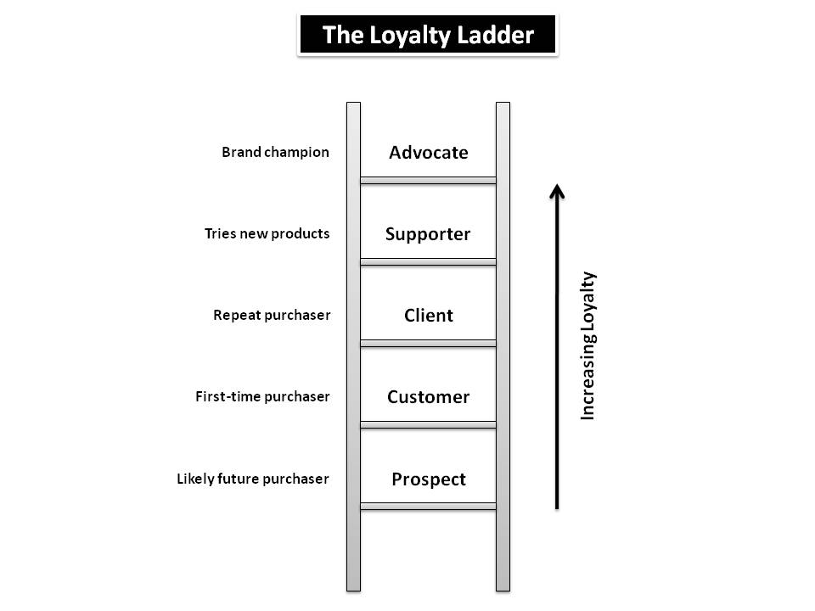
(Eightleaves.com)

The Juran Trilogy

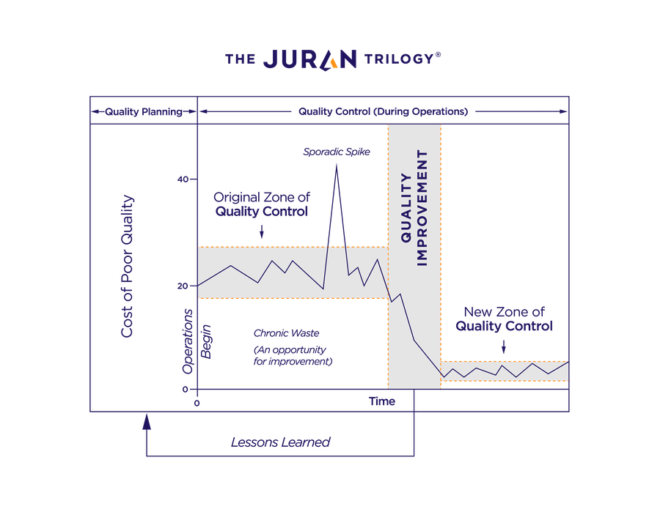

(Juran.com)

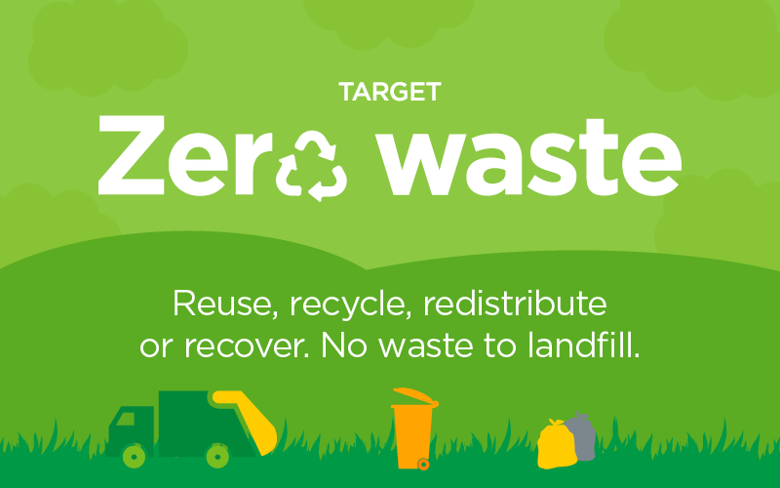

(asdasupplier.com)

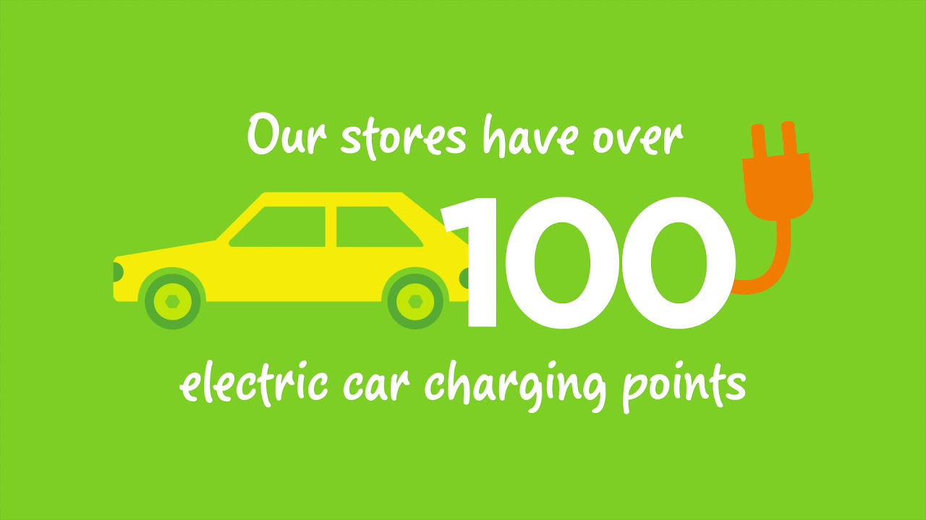

(youtube.com)

6.0 Acknowledgements

The realisation of this report would not have been possible without the benevolent encouragement of my classmates, friends and family.
I am also extremely thankful to the members of the University of Wales Trinity Saint David for all the support they have shown in the completion of this document.
Last, but not least, I would like to say a massive thank you to Lecturer Maria Heffernan, who despite her medical condition and the tough surgery that she has been through, still found time to respond to emails and provide cherished advice.

7.Reference list
- ASDA Good Living. 2016. Asda Wins Big At The 2016 International Cheese Awards. Available at: https://www.asdagoodliving.co.uk/community/cheese-awards (Accessed 26 March 2020).
- Asda Sustainability. 2018 Available at: https://www.youtube.com/watch?v=__L2Jn2ay7g (Accessed 25 March 2020).
- Buttle, F., 2009. Customer relationship management : concepts and technologies 2nd ed., Amsterdam ; London: Butterworth-Heinemann.
- Chamberlain, G., 2016. How Can Lidl Sell Jeans For £5.99? Easy … Pay People 23P An Hour To Make Them. Available at: https://www.theguardian.com/business/2016/mar/13/lidl-jeans-bangladesh-worker-pay-23p-an-hour (Accessed 24 March 2020).
- Cipd.co.uk. 2020. Available at: https://www.cipd.co.uk/Images/case-study-asda_tcm18-19985.pdf (Accessed 26 March 2020).
- Cooper, B., 2009. Asda And Sustainability – Better Things In Store? Available at: http://www.ethicalcorp.com/business-strategy/asda-and-sustainability-better-things-store (Accessed 16 March 2020).
- Environmental Audit Committee: Written Evidence Submitted By Asda. 2012 Available at: https://publications.parliament.uk/pa/cm201012/cmselect/cmenvaud/879/879vw21.htm (Accessed 20 March 2020).
- Ethical Trading. Available at: https://www.morrisons-corporate.com/cr/policy/ethical-trading/ (Accessed 16 March 2020)
- Haigh, P., 2018. Why Is Tesco Called Tesco And Its New Discount Store Called Jack's? Available at: https://metro.co.uk/2018/09/19/why-is-tesco-called-tesco-and-its-new-discount-store-called-jacks-7959163/ (Accessed 24 March 2020).
- Hammett, E., 2015. Asda Refocuses On Price And Experience Following Failed Sainsbury's Merger. Available at: https://www.marketingweek.com/asda-price-customer-experience/ (Accessed 25 March 2020).
- Hargrave, M., 2019. Customer Relationship Management. Available at: https://www.investopedia.com/terms/c/customer_relation_management.asp (Accessed 24 March 2020).
- Learn Quality Management, ISO 9001, Six Sigma, And Data Analysis. Available at: https://www.qualitygurus.com/armand-v-feigenbaum/ (Accessed 26 March 2020).
- Leaver, J., 2019. Tesco, ASDA, Sainsbury's And Morrisons Urgently Recalling Products. Available at: https://www.dailypost.co.uk/news/uk-world-news/tesco-asda-sainsburys-morrisons-urgently-17392283 (Accessed 26 March 2020).
- Lyle, M., 2013. TOTAL QUALITY MANAGEMENT. Quality, 52(2), pp.40–42.
- Macdonald, L. and Thompson, J., 2019. Advantages & Disadvantages Of Business Ethics.
- Modern Slavery Statement. 2017. Available at: https://cdn.corporate.walmart.com/49/58/e2b91b8b468886e33f9803b6b60d/asda-modern-slavery-statement-document-12-06-17.pdf (Accessed 16 March 2020).

- Morgan, B., 2017. What Is Customer Experience?. Available at: https://www.forbes.com/sites/blakemorgan/2017/04/20/what-is-customer-experience-2/ (Accessed 20 March 2020).
- Mytutor.co.uk. 2020. What Are The Main Differences Between Bentham And Mill's Utilitarianism And Which Theory Is Better? Available at: https://www.mytutor.co.uk/answers/18310/GCSE/Philosophy-and-Ethics/What-are-the-main-differences-between-Bentham-and-Mill-s-utilitarianism-and-which-theory-is-better/ (Accessed 26 March 2020).
- Our Work With The Rainforest Alliance. 2019. Available at: https://www.tescoplc.com/updates/2019/our-work-with-the-rainforest-alliance/?category=sourcing (Accessed 24 March 2020).
- Powell, S., 2004. "The success of the Tesco Clubcard in winning customer loyalty", International Journal of Retail & Distribution Management, Vol. 32 No. 7. https://doi.org/10.1108/ijrdm.2004.08932gab.001
- Reay, C., 2016. Asda: Putting The Customer First - Retail Connections. Available at: https://www.retailconnections.co.uk/articles/qa-hayley-tatum-senior-vp-of-people-asda/ (Accessed 22 March 2020).
- Retailanalysis.igd.com. Lidl’S New Digital Loyalty App Available at: https://retailanalysis.igd.com/news/news-article/t/lidl-plus-lidls-new-digital-loyalty-app/i/20119 (Accessed 26 March 2020).
- Richardson, H., 2020. Asda Set To Be First Supermarket To Open Greggs Counters Inside Stores. Available at: https://www.dailymail.co.uk/femail/article-7996207/Asda-set-supermarket-open-Greggs-counters-inside-stores.html (Accessed 24 March 2020).
- Rigby, C., 2019. Asda Puts Its Focus Firmly On The Customer. Available at: https://internetretailing.net/customer/customer/asda-puts-its-focus-firmly-on-the-customer-19638 (Accessed 25 March 2020).
- Sewraz, R., 2019. Is The Tesco Clubcard Plus Scheme Worth It? Available at: https://www.which.co.uk/news/2019/10/tesco-to-launch-new-clubcard-plus-loyalty-scheme-is-it-worth-the-cost/ (Accessed 26 March 2020).
- Sillitoe, B., 2016. Asda Managing Private Label Quality In The Cloud. Available at: https://www.essentialretail.com/news/56fa476e29f52-asda-managing-private-label-quality-in-the-cloud/ (Accessed 26 March 2020).
- Sky News. 2020. Tesco Rapped For 'Unlawfully' Preventing Rival Store Openings. Available at: https://news.sky.com/story/tesco-rapped-for-unlawfully-preventing-rival-store-openings-11933847 (Accessed 22 March 2020).
- SONMEZTURK BOLATAN, Gulin Idil, 2019. Analysis of the Relationship between Strategic Planning and Total Quality Management. Cag University Journal of Social Sciences, 16(2), pp.1–20.
- Srivastava, M., 2016. Customer Relationship Management. 1st ed. New Delhi: Vikas Publishing House.
- Suresh, A. & Rakesh, R. 2019, "Relationship between Consumerism and Business Ethics in India", Journal of Marketing and Management, vol. 10, no. 2, pp. 1-19.
- Sustainability Report. 2020. Available at: https://corporate.lidl.co.uk/sustainability (Accessed 24 March 2020).
- Sylla, N., 2017. Fairtrade Only Really Benefits Supermarkets. A Rethink Is Needed | Ndongo Samba Sylla. Available at: https://www.theguardian.com/fairtrade-benefits-supermarkets-global-southoutdated-model (Accessed 16 March 2020).
- Tegeltija, S., 2016. Clothes Donated To 'Clothes Bank' Left In Piles And Ignored. Available at: https://www.walesonline.co.uk/news/local-news/tesco-apologises-mess-piles-donated-11911413 (Accessed 24 March 2020).
- Watson, I. and Prevos, P., 2009. Milton Friedman On Corporate Social Responsibility Available at: https://lucidmanager.org/milton-friedman-corporate-social-responsibility/ (Accessed 26 March 2020).
- What Is Quality?. Available at: http://www.quality.org/article/what-quality (Accessed 26 March 2020).

